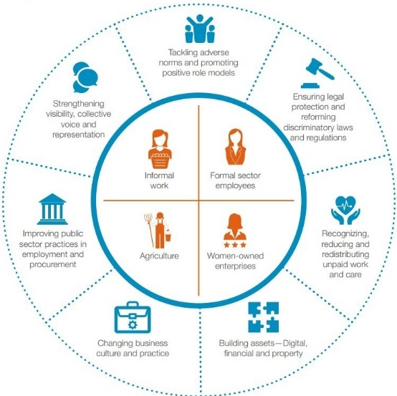
Women’s Economic
Empowerment drivers:
An evidence review of progress since the
UN High-Level Panel in 2016
WOW HELPDESK, APRIL 2023
The United Nations High Level Panel (UN HLP) on women’s economic empowerment was launched in 2016, supported by UN Women in collaboration with the UK government. The panel identified seven primary drivers of transformation for women’s economic empowerment.

The Work and Opportunities for Women (WOW) Helpdesk conducted a rapid desk-based review of what has changed globally on women’s economic empowerment since 2016. Below, each primary driver is summarised and how progress is currently measured is outlined. Key findings on current status and trends are highlighted.


Driver 1: Tackling adverse norms and promoting positive role models
DRIVER: Norms are the rules of conduct considered acceptable by a dominant group or society. Driver 1 focusses on tackling adverse gendered social norms, for example norms around women’s responsibility for unpaid care work, and economic norms, such as norms which stigmatise informal economy workers. Tackling these adverse norms provides women a greater range of economic opportunities.
Around 50% of the world’s population believe that children suffer if the mother takes on paid work outside the home
DATA AND MEASUREMENT: The OECD Development Centre’s Social Institutions and Gender Index (SIGI) measures discrimination against women in social institutions across 180 countries and the Advancing Learning and Innovation on Gender Norms (ALIGN) programme has undertaken significant research in recent years.
STATUS AND TRENDS: There is some evidence that attitudes and social norms around women's economic empowerment are slowly improving, particularly around girls' education and the transition to work. However, some norms remain deeply rooted such as women's responsibility for childcare. No evidence was found on status and trends of promoting positive role models.


Driver 2: Ensuring legal protection and reforming discriminatory laws and regulations
DRIVER: Laws that provide equal rights for women and men in inheritance, land tenure and access to employment provide economic opportunities for women. Weaker legal rights are associated with lower labour force participation for women, decreased asset ownership, fewer women-owned businesses, fewer women as business leaders and a higher gender wage gap.
DATA AND MEASUREMENT: The World Bank’s Women, Business and the Law index has measured the laws and regulations that affect women’s economic opportunities in 190 economies since 2009. Using eight indicators of women’s economic life, the WBL index score assesses how discriminatory the laws are in each economy, with a higher score indicating more gender equal laws (a score of 100 indicates legal gender parity).

STATUS AND TRENDS: There is strong evidence on the status and changes in legal protection and discriminatory laws since 2016. The World Bank’s Women, Business and the Law index has shown steady improvement in women’s legal rights since the UN HLP was launched. However, women globally still only have three-quarters of the legal rights of men, with high regional disparities.

Driver 3: Recognising, reducing and redistributing unpaid work and care
During periods of COVID-19 related school closure from January to October 2020, on average, in low- and middle-income countries, working age (15-64) women worked 217 additional unpaid hours compared to 70 for men.

DRIVER: Care is essential for the development of people who can participate fully in economic, social and political life and for the reproduction of the workforce. Due to gendered norms around women’s roles, globally women spend more time on unpaid work and care. This reduces their time available for paid work, leading them to seek lower paid part-time and/or informal work, as well as having to forego leisure time. Recognising, reducing and redistributing unpaid work and care drives improved social and economic outcomes for women.

DATA AND MEASUREMENT: There is no systematic global database that measures trends in women’s unpaid care work.
STATUS AND TRENDS: Women do three times as much unpaid and domestic work as men. There is mixed evidence on whether women’s time spent on unpaid care work has changed over the last decades, but a clear impact of COVID-19 was an increase in unpaid care work.

Driver 4: Building assets – digital, financial and property
DRIVER: Women’s ownership, use of and benefits from assets are more limited than men’s, even when women’s property rights are guaranteed by law. Women tend to own fewer assets, and assets of lower value, than men resulting in a “gender-asset gap”. This is despite the wide-reaching benefits when women can build their digital, financial and property assets. For example, ownership and use of property and mobile phones facilitates women’s access to formal credit, mobile banking and is associated with the registration of women’s businesses.
Women remain 7% less likely than men to own a mobile phone and are 16% less likely to use mobile internet.

DATA AND MEASUREMENT: Data on women’s control over assets is scarce, especially on ownership, control or management of land. The OECD Gender, Institutions and Development Database (GID-DB) includes indicators related to laws and practices on land, non-land and financial assets.
STATUS AND TRENDS: There are persistent and wide gender asset gaps, although there has been some progress is observed on women’s access to digital and financial assets.

Driver 5: Changing business culture and practice
DRIVER: As a major employer, the private sector is an important driver of women’s economic empowerment, as well as a critical contributor to other drivers through partnerships with the public sector and other key actors. The cultures and practices of private sector businesses therefore have significant impacts on women’s economic opportunities.
DATA AND MEASUREMENT: There is no systematic tracking system of private sector culture
and practice.
STATUS AND TRENDS: The Women’s Empowerment Principles (WEPs) offer guidance to business on how to advance gender equality and women’s empowerment including equal pay for work of equal value, gender-responsive supply chain practices and zero tolerance against sexual harassment in the workplace. Signatories to the WEPs have been increasing. The global #MeToo movement has led to major changes in the culture around sexual harassment in many workplaces.

A new public
procurement strategy in the Dominican Republic led to an increase of 16% in contracts awarded to smaller businesses owned and led by women from
2012 to 2019.

Driver 6: Improving public sector practices in employment and procurement
DRIVER: In developing countries, public procurement accounts for more than 30% of gross domestic product (GDP). Yet women-owned businesses receive only an estimated 1% of the total annual spent. Women form the majority (52%) of employment in the public sector globally, yet on average receive less pay than their male counterparts. Improving public sector practices in employment and procurement with a gender lens, for example through procurement targets for women-owned enterprises, can drive women’s economic empowerment outcomes.
DATA AND MEASUREMENT: There is no systematic international tracking system for public sector practices in employment and procurement. However, some data is available to understand the current status and trends for both.
STATUS AND TRENDS: Gender-sensitive procurement in the public sector has been gaining momentum, both by national governments and international organisations. There are many recent guidance materials on gender-sensitive procurement. The Worldwide Bureaucracy Indicators show that women have entered the paid public sector workforce in increasing numbers globally, making up 46% of employees in 2021.

Driver 7: Strengthening visibility, collective voice and representation
DRIVER: The rights to freedom of association and collective bargaining are fundamental labour and human rights, enshrined in ILO conventions such as Convention 89 and Convention 87. Organising allows working women to voice their needs and demands more effectively, advocate for an enabling legal and policy environment, enhance their bargaining power, and increase access to markets on fair and efficient terms.
DATA AND MEASUREMENT: Women’s visibility, collective voice and representation is not tracked systematically and there is no comparable quantitative data to show trends.
STATUS AND TRENDS: Women’s membership in trade unions and cooperatives is increasing. The ILO has recently emphasised the importance of the social and solidarity economy, a grouping of a wide range of entities to serve the collective and/or general interest, based on principles such as voluntary cooperation.

To read the full report, please see: https://bit.ly/3LN9nQz

