Application Decision
Site Visit conducted on 25 April 2023
by Rory Cridland LLB (Hons) PG Dip, Solicitor
an Inspector appointed by the Secretary of State for Environment, Food and Rural Affairs
Decision date: 8 June 2023

Application A: COM/3311223
Streatham Common – Temporary Events 2023
Register Unit No: CL29
Commons Registration Authority: London Borough of Lambeth

- The application, dated 4 November 2022, is made under Article 12 of the Greater London Parks and Open Spaces Order 1967 (“the Order”).
- The application is made by EventLambeth (Part of London Borough of Lambeth) (“the applicant”) to construct temporary works on common land.
- The application seeks consent for the creation of temporarily enclosed fenced sites for four separate temporary events permitted under Article 7 of the Order, for fixed periods of time, on the grassed areas of Streatham Common. The temporary structures include fencing, funfair rides and amusements, big top tents, concession stands, catering units, gazebos, toilets and welfare facilities, back of house units, staff cabins and plant enclosures.
Application B: COM/3316215
Streatham Common – AfriFest 2023
Register Unit No: CL29
Commons Registration Authority: London Borough of Lambeth

- The application, dated 3 February 2023, is made under Article 12 of the Greater London Parks and Open Spaces Order 1967 (“the Order”).
- The application is made by EventLambeth (Part of London Borough of Lambeth) (“the applicant”) to construct temporary works on common land.
- The application seeks consent for the creation of a temporarily enclosed fenced site for one event permitted under Article 7 of the Order for a fixed period of time, on a grassed area of Streatham Common. The temporary structures include one event stage, concession stands, marquees, toilets and welfare facilities, back of house staff units, staff cabins and plant enclosures.
_________________________________________________________________________

Decisions

Application A
- Consent for the erection of temporary structures to include fencing, funfair rides and amusements, concession stands, catering units, gazebos, toilets and welfare facilities, back of house units, staff cabins and plant enclosures is granted in accordance with the application dated 4 November 2022 and the accompanying plan, subject to the condition set out in Schedule 1, to facilitate the following events on parts of Streatham Common (Register Unit CL:29):

- Bensons Funfair (22 May - 12 June 2023)
- Bensons Funfair (31 July – 14 August 2023)
- For the avoidance of doubt, consent for the works proposed for Zippo Circus (23 April – 1 May 2023) and Streatham Common Kite Day (14 May 2023) is not granted for the reasons set out below.

Application B
- Consent for the erection of a temporarily enclosed fenced site to include one event stage, concession stands, marquees, toilets and welfare facilities, back of house staff units, staff cabins and plant enclosures is granted in accordance with the application dated 3 February 2023 and the accompanying plan, subject to the condition set out in Schedule 1, to facilitate the AfriFest 2023 event.

Preliminary Matters
- Application A seeks consent for temporary fencing and other structures in order to facilitate a number of events during the summer of 2023. The events are listed below:
      - Zippo Circus (23 April – 1 May 2023)
      - Streatham Common Kite Day 2022 (14 May 2023)
      - Bensons Funfair (22 May - 12 June 2023)
      - Bensons Funfair (31 July – 14 August 2023)
- A separate application, Application B, was made in relation to a single event - AfriFest 2023 (28 August 2023 – 6 September 2023).
- The applications are linked in so far as they are made by the same applicant, raise similar issues, generally involve the same parties and the works would be carried out over the same general area of the common. Having considered all of the information submitted, I am satisfied that there is sufficient cross over to enable me to consider them in a single decision and I deal with them on that basis.
- The applications are not retrospective; both were made in advance of the works. In addition, all the proposed works are temporary and at the time of writing, the events listed in paragraph 4(i) and 4(ii), Zippo Circus and Streatham Common Kite Day, have already taken place. As a matter of principle, there is no good reason to provide consent for something which no longer exists. It follows that the outcome for those works must be that the consent is not granted.
- Accordingly, the remainder of my decision relates solely to the events listed in paragraphs 4 (iii), 4(iv) and 5.
- For the purposes of identification only the locations of the relevant works are shown on the attached plans.

Description of the Land
- Streatham Common (“the common”) covers a large area of open land in Lambeth and is registered as common land under the Commons Registration Act 1965. The common is owned by the applicant and is sited in a highly populated urban area in London. It is bounded to the north and west by the A214 and the A23 respectively and to the south and east by a number of residential streets.

Main Issues
- Article 12 of the Order restricts the erection of any building or other structure on any part of a common to which the Order applies without consent from the appropriate national body. In determining such applications, Defra’s Common Land Consents Policy (November 2015) advises that regard should be had to the matters listed in section 39 of the Commons Act 2006 (“the 2006 Act”). These include:

a. the interests of those occupying or having rights over the land (and in particular, persons exercising rights of common over it);

b. the interests of the neighbourhood;

c. the public interest; and

d. any other matter considered to be relevant.
- Section 39(2) of the 2006 Act provides that the ‘public interest’ includes the public interest in:

a. nature conservation;

b. the conservation of the landscape;

c. the protection of public rights of access to any area of land; and

d. the protection of archaeological remains and features of historic interest.

Reasons

The interests of those occupying or having rights over the land
- The common is owned and managed by the applicant which seeks consent for the installation of fencing and other structures associated with the operation of the events listed in paragraphs 4(iii), 4(iv) and 5 above. The applicant explains that the fences and structures are needed to fully enclose the event sites, facilitate the staging of the events, and to provide food, drink, welfare and toilet facilities. They would also include works to create separate areas for event operatives and to manage event security and crowd control.
- There are no rights of common recorded over the land. Subject to my consideration of the effect on public rights of access below, there is nothing which would indicate that the proposed works would negatively impact on any others occupying or having rights over it. Consequently, I do not consider the proposed works would not adversely impact on the interests of those occupying or having rights over the land.

The interests of the neighbourhood
- The applicant explains that the common has a long history of hosting commercial and charitable public entertainment, leisure and recreation events permitted under Article 7 of the Order. I accept that all of the remaining events planned for 2023 would fall within the types of events permitted by the Order and would promote the use and enjoyment of the common both for nearby residents and the wider public. This would have a positive impact on the interests of the neighbourhood.
- However, I note the concerns raised by the Friends of Streatham Common in relation to the potential impacts of noise, particularly in relation to the proposed timing of the AfriFest event. Furthermore, I acknowledge the potential impact that the holding of large music events on the common can have on those living and working nearby. However, the interests of the neighbourhood test relates to whether the works would unacceptably interfere with the way the common is used by local people. Matters relating to noise, disturbance and general nuisance emanating from the events themselves will have been considered in detail under separate consent regimes such as planning and licensing and I have no reason to believe that they will not be properly applied and enforced by the relevant authorities.
- Furthermore, the common is located in a highly populated urban area near busy roads. In this context, the noise generated by the erection and removal of the temporary fencing and other structures required would be minimal, would be of limited duration and is unlikely to have any material impact on background noise levels.
- Moreover, while I accept that, in view of the wider use of the common by the public for both formal and informal sports and general recreation, temporary fencing and/or the erection of structures over large areas and for long periods would have a negative impact on the interests of the neighbourhood, in the present case it is clear that the works sought would be limited, both in their extent and duration.
- I also note that a number of similar events have been held on the common previously and there is no robust evidence to indicate that the works required to facilitate them has had any significant adverse impact on the interests of the neighbourhood as a whole
- Overall, I consider the works proposed would not adversely impact on the interests of the neighbourhood, either individually or cumulatively.

The public interest

Nature conservation and conservation of the landscape
- Natural England (“NE”) advises that the site is one of Lambeth’s most important wildlife sites, has been designated as a Site of Importance for Nature Conservation and that part of the common has been designated as a Local Nature Reserve (LNR). However, they also note that the area covered by the LNR does not extend to those areas where the proposed events would take place (which consist mostly of amenity grassland) which would not be expected to have any notably high levels of biodiversity.
- The Open Spaces Society (OSS) have raised concerns with the impact that events which require the movement of large vehicles and equipment have on the common, particularly where these activities take place during periods of wet weather. In addition, it raises concerns regarding the overuse of the common and the impact it has had on its overall condition.
- As part of the application, the Applicant has provided an Ecological Impact Assessment which recognises that some areas of grassland have deteriorated both in extent and species composition which is likely to be attributable to increased visitor use. However, this does not include the areas on which the events would be held - which are identified as being of low ecological sensitivity and likely to be capable of accommodating the occasional large scale public event.
- Moreover, while the applicant acknowledges that vehicles associated with the holding of previous events in this location have caused some localised damage to the common, it points out that this has always been repaired. It explains that damage deposits are taken from all event organisers before each event and a programme of repair agreed post event to bring the common back to its previous, pre-event condition. There is no evidence which would indicate that these measures have proved to be deficient in previous years or have resulted in any material degradation of this part of the common or its ability to be used by the public for other purposes following the removal of the temporary structures.
- Overall, I consider the proposed works would not have a materially adverse impact on nature conservation.
- Likewise, in terms of landscape impact, I acknowledge that the proposed works would impede views across part of the common. However, in view of the short periods of time involved, I consider the impact on the landscape would be limited and would not materially detract from the overall enjoyment of those visiting the site.
- Consequently, I am satisfied that the proposed works would not have a materially negative impact on the public interest in nature conservation or conservation of the landscape.

The protection of public rights of access
- The public have rights of access including under section 193 of the Law of Property Act 1925 which includes access for informal recreation. It was clear from my site visit that these are well used and the common provides an important area of urban greenspace for people to enjoy informal recreation activities.
- The proposed fencing and other structures associated with the events would inhibit access to parts of the common to varying extents and for various periods of time. However, the longest that access would be restricted would be for a period of around three weeks to accommodate the first Bensons’ Funfair event.
- Both the first and second funfair are for relatively short periods and I understand have been a regular feature on the common for a number of years. There is no evidence that the holding of these events or the fencing and structures associated with them have materially impacted on public access or on the ability of the public to enjoy the rest of the common. Similarly, the public access restrictions which would result over the area of the common in relation to the AfriFest event would be, at 10 days in total (including set up and de-rigging), limited in terms of its impact on public access.
- While in total the three remaining events would result in restrictions over part of the common for a period of around 7 weeks, these would be spread out and would only affect a small part of the common. The Order clearly provides for such restrictions so long as they remain within the permitted levels.
- Accordingly, although the erection of fencing and other structures would impede public access to part of the common, this would be for limited durations and on a small area. A considerable area of the common would remain available for general recreation. As such, I do not consider the fencing of the areas proposed for these limited periods of time would materially affect public rights of access to, or over, the common as a whole.

Archaeological remains and features of historic interest
- The works are temporary and below ground excavation is not proposed. The application notes that the event sites are not located within an archaeological priority area and are sufficiently distant to ensure the proposed works do not impact on nearby heritage assets.
- This is confirmed in the applicant’s heritage statement which notes that the event location has been confined to the western portion of the common in order to limit the effects on local heritage assets. While it recognises that there would be some change to the setting of some local heritage assets, it notes that it would be limited in both time and extent and would not adversely impact on their significance. I have no reason to conclude otherwise.
- Furthermore, I note that Historic England were consulted on the application and have raised no concerns. No other concerns have been raised in this respect and, on the evidence before me, I am satisfied that the proposed works will not harm any archaeological remains or features of historic interest.

Conclusion on the public interest
- I have found above that the proposed works would not have a materially negative impact on the public interest in nature conservation or conservation of the landscape. Furthermore, I have found that they would not harm any archaeological remained or features of historic interest. However, I have also found that there would be some temporary visual impacts and temporary restrictions on public access over parts of the common. Nevertheless, in view of their limited extent and duration I afford this only limited weight.
- Accordingly, I find that overall, there would be no harm to the public interest in granting consent for the works.

Other relevant matters
- I note that the proposed works would enable events to proceed that would provide cultural, charitable and social engagement opportunities for different public audiences. Indeed, they are of the very type and nature as those envisaged by the Order. They promote the common to other users, provide a public benefit to those attending as well as increasing the ways in which the common can be used and enjoyed by the public. All of this would provide a public benefit which I consider weighs positively in favour of granting consent.
- I have noted the representations in respect of the suitability of the Council to manage the common. However, these are not matters that have a bearing on the determination of this application.
- The application indicates that the largest of the events, AfriFest, would result in restrictions over a maximum area of 26,120m² - which the applicant indicates would be no more than one tenth of the common. However, the OSS have raised concerns that the applicant’s figures are incorrect and the enclosure of the site for this event would exceed the limit imposed by Art 7(1)(i) of the Order.
- There is a paucity of evidence before me on this point and I am not in a position to reach any useful conclusion either way. However, the Order explicitly restricts the ability of the local authority to set apart or enclose the common for entertainment events to no more than one-tenth of the common. In order to ensure that any consent accords with the requirements of the Order, I have imposed a condition limiting any enclosure to such an area.

Overall Conclusions
- I have found above that the erection of the proposed fencing and other temporary structures would not harm the interests of persons having rights in relation to or occupying the land. I have also found that it would not adversely impact on the interests of the neighbourhood.
- Furthermore, I am satisfied that the proposed works would not be harmful to the public interest in nature conservation or conservation of the landscape or on archaeological remains or features of historic interest.
- While I acknowledge there would be some restriction on public access over a small area of the common for limited periods of time, this needs to be balanced against the cultural, charitable and social engagement opportunities that arise from the facilitation of the events proposed. Overall, and taking into account the limited periods of time that the proposed structures would remain in place, I consider it would be in the public interest to permit the works in order to enable the events to take place.
- Accordingly, for the reasons set out above, and having had regard to all other matters raised, I conclude that consent should be granted for the erection of fencing and other structures associated with the three remaining events, for the dates and periods set out in the applications, but subject to the condition set out in Schedule 1 below.

Rory Cridland

Inspector

Schedule 1

Condition:

No more than one-tenth of the common shall be enclosed by the consented works at any one time.

Schedule 2 – Plans

Plans A – Bensons Funfair, Streatham Common Kite Day

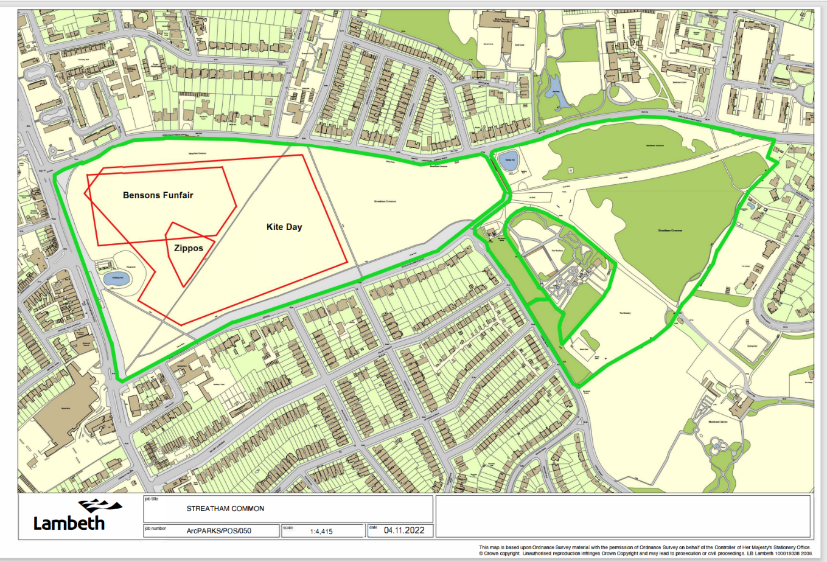

Plan B – AfriFest

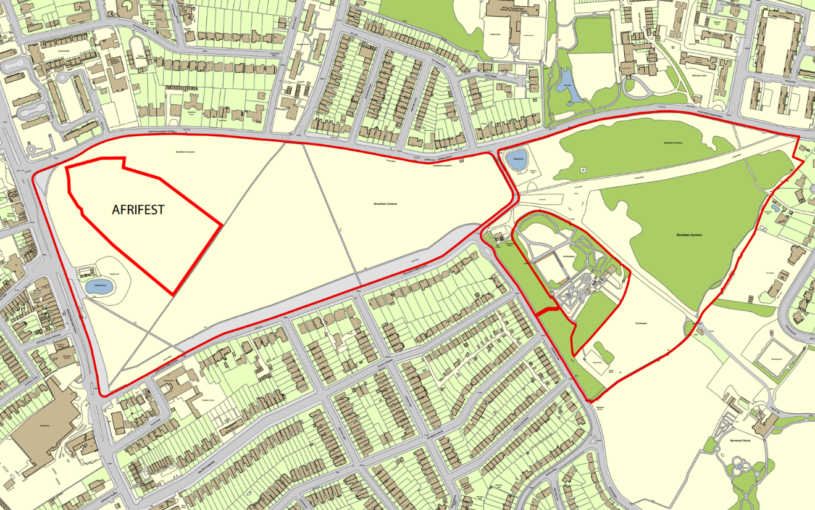

Ecological Impact Assessment for Streatham Common (July 2020), Salix Ecology.

