Application Decision
Site Visit conducted on 25 April 2023
by Rory Cridland LLB (Hons) PG Dip, Solicitor
an Inspector appointed by the Secretary of State for Environment, Food and Rural Affairs
Decision date: 8 June 2023

Application A: COM/3312124
Clapham Common – Temporary Events 2023-2024
Register Unit No: CL73
Commons Registration Authority: London Borough of Lambeth

- The application, dated 25 November 2022, is made under Article 12 of the Greater London Parks and Open Spaces Order 1967 (“the Order”).
- The application is made by EventLambeth (on behalf of London Borough of Lambeth) (“the applicant”) to construct temporary works on common land.
- The application seeks consent for the creation of temporarily enclosed fenced sites for twelve temporary events permitted under Article 7 of the Order, for fixed periods of time on the grassed areas of Clapham Common. Temporary structures include fencing, event stages, funfair rides, marquees, gazebos, concession stands, event gantries, event related obstacles, toilets and welfare facilities, back of house cabins and plant enclosures.
Application B: COM/3307440
Clapham Common – Permanent works at Cock Pond
Register Unit No: CL73
Commons Registration Authority: London Borough of Lambeth

- The application, dated 21 September 2022, is made under Article 12 of the Greater London Parks and Open Spaces Order 1967 (“the Order”).
- The application is made by the London Borough of Lambeth (“the applicant”) to construct permanent works on common land.
- The application seeks consent for the installation of ‘splashpad’ play equipment, jets and nozzles complete with new safety surfaces in the centre of the existing disused paddling pool, renovation of the existing paddling pool basin and apron together with the demolition of the existing brick plant kiosk, installation of two new modular buildings, one containing water and electrical plant for the splashpad and the other public WCs and the relocation of the boundary entrance from the west to south apex of the site and adjustment of the paths to suit.
_________________________________________________________________________

Decisions

Application A
- Consent for the erection of temporary structures to include fencing, event stages, funfair rides, marquees, gazebos, concession stands, event gantries, event related obstacles, toilets and welfare facilities, back of house cabins and plant enclosures on parts of Clapham Common (Register Unit CL73) is granted in accordance with the application dated 25 November 2022 to facilitate the following events:

- British Heart Foundation London to Brighton Bike Ride (16-18 June 2023)
- Run Through 5k & 10k (9 July 2023)
- Luna Cinema (18-24 July 2023)
- Run Through 5k & 10k Chase the Sun (16 August 2023)
- Colourscape (5-21 September 2023)
- Skyline London to Brighton Bike Ride (10 September 2023)
- Doppelgängers – Oktoberfest (2–11 October 2023)
- Run Through 5k & 10k (22 October 2023)
- George Irvin’s Funfair (25 November 2023 – 2 January 2024)
- For the purposes of identification only the locations of the relevant works are shown on Plan A.
- For the avoidance of doubt, consent for the works proposed to facilitate George Irvin’s Funfair (18 March –16 April 2023), Moonwalk (15– 24 May 2023) and Cancer Research UK Race for Life and Pretty Muddy, (26-27 May 2023) as set out in the application dated 25 November 2022 is not granted for the reasons set out below.

Application B
- Consent for the installation of ‘splashpad’ play equipment, jets and nozzles complete with new safety surfaces in the centre of the existing disused paddling pool, renovation of the existing paddling pool basin and apron, demolition of the existing brick plant kiosk and installation of two new modular buildings, one containing water and electrical plant for the splashpad and the other public WCs, relocation of the boundary entrance from the west to south apex of the site and adjustment of the paths to suit at Cock Pond, Clapham Common (register Unit CL73) is granted in accordance with the application dated 21 September 2022.
- For the purposes of identification only the locations of the relevant works are shown on Plan B.

Preliminary Matters
- Planning consent was granted on 1 February 2023 for the construction of a new 'splashpad' water play area within the basin of the existing pond, including refurbishment of the surfaces, improved access, relocation of the entrance gates and addition of two modular buildings containing WCs and new plant equipment plus provision of cycle parking spaces. A further application seeking a change to the location of the two modular buildings was granted on 12 April 2023. I have had regard to these consents in my consideration of the application and have assessed the application against the amended location of the modular structures as approved in the latter consent.
- Application A and Application B are linked in so far as they are made by the same applicant, raise similar issues, generally involve the same parties and would be carried out over different parts of Clapham Common. Having considered all of the information submitted, I am satisfied that there is sufficient cross over to enable me to consider them in a single decision and I deal with them on that basis.

The Applications

Application A
- The application for temporary works, dated 25 November 2022 seeks consent for temporary fencing and other structures in order to facilitate a number of events spanning a period from March 2023 to January 2024. The events are listed below:
- George Irvin’s Funfair (18 March – 16 April 2023)
- Moonwalk (15 – 24 May 2023)
- Cancer Research UK Race for Life and Pretty Muddy (26 – 27 May 2023)
- British Heart Foundation London to Brighton Bike Ride (16 – 18 June 2023)
- Run Through 5k & 10k (9 July 2023)
- Run Through 5k & 10k Chase the Sun (16 August 2023)
- Luna Cinema (18 – 24 July 2023)
- Colourscape (5 – 21 September 2023)
- Skyline London to Brighton Bike Ride (10 September 2023)
- Doppelgängers – Oktoberfest (2 – 11 October 2023)
- Run Through 5k & 10k (22 October 2023)
- George Irvin’s Funfair (25 November 2023 – 2 January 2024)
- The application for temporary works is not retrospective; it was made in advance of the works. At the time of writing, the first three events have already taken place and any works associated with them should have already been removed. As a matter of principle, there is no good reason to provide consent for something which no longer exists. It follows that the outcome for those works must be that the consent is not granted.

Application B
- The application dated 21 September 2022 relates to proposed permanent works which form part of the redevelopment of the paddling pool at Cock Pond. The works proposed are listed in the application. In summary they consist of the installation of ‘splashpad’ play equipment, jets and nozzles complete with new safety surfaces in the centre of the existing disused paddling pool; the renovation of the existing paddling pool basin and apron; the demolition of the existing brick plant kiosk and the installation of two new modular buildings (one for electrical plant and storage and the other as a public WC); and the relocation of the boundary entrance from the west to the south of the site as well as the adjustment of the paths within the enclosed site.

Description of the land
- The common covers a large area (around 78 to 83 hectares) and is registered as common land (CL73) under the Commons Registration Act 1965. The common is owned by the applicant and is sited in a densely populated urban area in London. It is bounded to the north by the busy A3, to the east by the A24 and with the A205 running along and through the western boundary. Beyond these busy roads are a number of residential streets as well as industrial, retail and leisure areas.

Main Issues
- Article 12 of the Order restricts the erection of any building or other structure on any part of a common to which the Order applies without consent from the appropriate national body. In determining such applications, Defra’s Common Land Consents Policy (November 2015) advises that regard should be had to the matters listed in section 39 of the Commons Act 2006 (“the 2006 Act”). These include:

a. the interests of those occupying or having rights over the land (and in particular, persons exercising rights of common over it);

b. the interests of the neighbourhood;

c. the public interest; and

d. any other matter considered to be relevant.
- Section 39(2) of the 2006 Act provides that the ‘public interest’ includes the public interest in:

a. nature conservation;

b. the conservation of the landscape;

c. the protection of public rights of access to any area of land; and

d. the protection of archaeological remains and features of historic interest.

Reasons

The interests of those occupying or having rights over the land

Application A and Application B
- There are no rights of common recorded over the land. Subject to my consideration of the effects on public rights of access below, there is nothing which would indicate that the proposed works (both temporary and permanent) would negatively impact on any others occupying or having rights over the land affected. Consequently, I do not consider that the proposed works would have a detrimental impact on the interests of those occupying or having rights over the land.

The interests of the neighbourhood

Application A
- The common has a long history of hosting various commercial and charitable events, public entertainment, and other leisure and recreation events. All of the remaining events listed in paragraph 8 above would fall within the types of events permitted by the Order and would promote use and enjoyment of the common for both nearby residents and the wider public. This would be of positive benefit to the neighbourhood.
- However, I recognise that the installation of fencing and other structures would have some adverse impacts on the visual amenity of those living and working nearby.
- In the present case, it is clear that both the fencing and structures proposed are limited - both in the area they would cover and the time they would remain on site. While I acknowledge some would appear prominent in close up views, they would be seen in the context of the surrounding urban area, would be clearly temporary in nature and, in many cases, would be erected on areas where regular users were used to seeing events take place.
- Furthermore, it would be evident to many of those living or working nearby that the structures were intended to facilitate a wider programme of events taking place on the common for the benefit of the neighbourhood and the wider public.
- Accordingly, while I accept there would be some effect on visual amenity, I do not consider it would be so great as to materially impact on the interests of the neighbourhood or discourage those living and working nearby from using the common for general recreation.
- Turning then to the impact that restrictions on access would have on those living and working nearby, while I acknowledge there would be some adverse impacts over parts of the common (a matter I consider further below), a considerable area would remain available. While I accept there may be some inconvenience to regular users, these would be time limited and I note the events have been deliberately spread throughout the year and located on different areas of the common helping to limit their overall impact.
- I also note that some of the events are likely to attract large numbers of people, resulting in increased noise, traffic and other disturbance. All of this is likely to prove to be an annoyance to some local residents and businesses. However, it is the proposed works themselves (i.e. the fencing and other temporary structures required to facilitate the events) that this application is concerned with, and not the noise or other disruption which might result from the holding of the events themselves. Those are matters the Council will have taken into account when deciding whether or not to permit the events as part of the planning and licensing regime. Any additional noise, traffic or other disruption generated by the erection of the fences or other structures would be short lived and is, in my view, unlikely to materially impact on the interests of the neighbourhood.
- Consequently, I do not consider the erection of temporary fencing or associated structures, on the areas and for the periods proposed, would adversely affect the interests of the neighbourhood.

Application B
- Cock Pond is located in the north-eastern part of the common, north of the busy A3 and adjacent to the B224. It sits adjacent to the Holy Trinity Church, a Grade II* listed building located to the west of the site while to the immediate south is the Clapham Common War Memorial, beyond which is the larger area of the common.
- The existing paddling pool site has been used for this purpose for many years. It is fenced with low metal railings and accessed via a small gate along the western boundary. It is located on the periphery of the common close to a number of shops and residential premises. All of the works would be carried out within the existing paddling pool enclosure.
- I have received no representations which would indicate that the renovation of this once popular facility would negatively impact on the interests of the neighbourhood. Indeed, of the limited number of representations received, most express support for the proposed renovation and recognise the benefit that it would have to the neighbourhood and the wider public. I have no reason to conclude otherwise and consider the works proposed would have a positive impact on the interests of the neighbourhood.

The public interest

Nature conservation and conservation of the landscape
- The Common is not subject to any landscape designation. However, it is clearly an important area of greenspace that, amongst other things, provides some welcome visual relief in this otherwise densely populated urban area. It is also recorded as a Site of Importance for Nature Conservation.

Application A
- I acknowledge that where damage was to occur to the surface of the common as a result of the proposed fencing and structures it has the potential to negatively impact on nature conservation, particularly in areas with high levels of biodiversity or high sensitivity.
- However, as with previous events, the 2023/24 events are located of parts of the common where NE have advised that there are no known areas of high-level biodiversity. Furthermore, the applicant has proposed a number of mitigation measures to limit damage to the surface of the common and to ensure that, where damage does occur, adequate provision has been made to ensure suitable repair/reinstatement takes place. These include measures to protect the surface of the common as well as securing damage deposits from event organisers, inspections before and after events, and agreed programmes of repair. I also note that many of the events take place on hard surfaced areas, have small footprints, are of short duration or require only minimal fencing and/or structures.
- While I note NE does not envisage any benefits to nature conservation arising, there is similarly no robust evidence which would indicate that the proposed fencing or other structures would have a negative impact on existing biodiversity. Any impacts would be temporary, limited in extent and overall the condition of these areas of the common would be only marginally affected.
- Nevertheless, I acknowledge that the fencing and other temporary structures would result in some visual impact and impede views across parts of the common. They would appear prominent in close up views and incongruous alongside the open and spacious nature of the parts of the common where they were erected. However, these impacts would be seen in the context of the surrounding urban area, would be clearly temporary in nature and, in many cases, would be erected on areas where regular users were used to seeing events take place.
- Furthermore, I am mindful that most events are for very short periods with only 4 of the remaining events requiring structures to remain in place for periods exceeding a week. Even these are for relatively modest periods and in all cases the area of common affected would be relatively limited. Overall, I am satisfied that the visual impacts would be highly localised and would have no long term effects.
- Accordingly, I find that the proposed works would not be detrimental to the public interest in nature conservation or conservation of the landscape.

Application B
- There is nothing which would indicate that the proposed works would have a negative impact on nature conservation or biodiversity. NE advise that the area within which the works are proposed has low levels of biodiversity and that there would be no increase following completion of the works. I have no reason to conclude otherwise and find no harm in this respect.
- Nevertheless, it is clear that the proposed works would result in some adverse visual impacts. They would introduce new, modern structures into this part of the common the largest of which would be the proposed modular structures. At around 3.5m in height and covering a total area of around 50m², they would block some views towards the common from a short section of the B224 and a small area alongside the Holy Trinity Church.
- However, in view of their proposed location within the existing paddling pool enclosure, coupled with their proposed natural cladding and green roofs, I consider the overall visual impact would be limited. They would be seen in the context of the existing paddling pool enclosure and would, to most casual observers, appear as ancillary structures associated with the use of the site as a paddling pool. In this context, the effects would be highly localised and I do not consider they would materially harm visual amenity in this part of the common.
- Likewise, while I acknowledge the proposed bright colours of the new splash pad and play equipment may not appeal to everyone, in view of the site’s historical use as a children’s paddling pool, this is to be expected. As with the modular structures, they would be contained within the footprint of the existing site and would have only a limited impact on visual amenity in this part of the common.
- Turning then to the other works proposed, including the renewal of pathways, alterations to gates, and cycle parking, I consider these would be unlikely to have any greater visual impact to that of the modular structures. They would not appear out of place with the other paraphernalia that would no doubt fill the site on busy days. Overall, I consider their likely impact on the wider landscape would be minimal.
- Overall, while I acknowledge there would be some harm to visual amenity in so far as the works would introduce additional built form, all of the impacts would be highly localised, seen in the context of the existing paddling pool enclosure and confined to this part of the common. Taken together, they would have only a limited impact on their wider surroundings. Accordingly, I am satisfied they would not negatively impact on the public interest in landscape conservation and find no material harm in this respect.
- Consequently, I conclude the proposed works would not be detrimental to the public interest in nature conservation or conservation of the landscape.

The protection of public rights of access
- The public have rights of access under section 193 of the Law of Property Act 1925 which includes access for informal recreation. The site is well used by both individuals and groups, including numerous schoolchildren, and the common provides an important area of urban greenspace for people to enjoy both formal and informal recreation activities.

Application A
- The application proposes to restrict access to various parts of the common for around 72 days spread out over approximately 8 months. Two of the events would overlap where the Skyline London to Brighton Bike Ride event (1 day) would be held during the period of the Colourscape event. However, these events would occupy different areas of the common in locations where events have taken place over a number of years. While I acknowledge the proposed fencing and other structures associated with the planned events would, to some extent, inhibit access to these parts of the common, this would be for limited periods of time. A considerable proportion of the common would remain accessible to those wishing to use it for formal and informal recreation.
- Furthermore, around half of the remaining restrictions would arise from George Irwin’s Funfair which would be held on the site set aside for this purpose. Such events have taken place in this location for many years and there is nothing to indicate that it has had any significant effect on public access rights over the common or on the ways in which members of the public are able to access and use the remainder of the common for general recreation
- While it is clear that each of the proposed works would have some impact on public access, in view of their limited duration and extent, I am satisfied that the overall impact would remain within acceptable levels.
- Turning then to the potential for further restrictions on areas of the common which become damaged as a result of the erection of the fences and other structures, I note that the applicant proposes a number of mitigation measures to reduce the likelihood that such damage would occur. Nevertheless, even with these measures in place, it is possible that there will be some further restrictions on access while any damage that did occur was remedied.
- Nevertheless, I do not consider the impact would be likely to result in significant or long term damage to the common or require any lengthy restrictions on access. Accordingly, I consider any further restrictions which are likely to result would be of short duration and would have only a limited impact on public access to, and over, the common more generally.

Application B
- All of the works proposed would take place within the existing boundary of the enclosed paddling pool site. There would be some restrictions on public access while the works are carried out but these would be temporary and have only a limited impact. Following construction, notwithstanding the altered layout, the site would mostly remain accessible to the public.
- However, the erection of the modular buildings would result in permanent restrictions on public access over around 50m² of land within the paddling pool site itself. In general, the loss of any common land should be avoided unless it provides some public benefit. I consider this further in my overall conclusions below.

Archaeological remains and features of historic interest

Application A
- The application was accompanied by a heritage statement which identifies nearby heritage assets and considers the impact of the proposed fencing and other temporary structures on their significance. It concludes that, while some change would occur to the setting of a number of identified heritage assets, the proposed works, in view of their temporary nature, would not materially harm the heritage context. Furthermore, I note that Historic England was consulted on the applications and has raised no concerns. Likewise, no below ground excavation is proposed and there is nothing which would indicate that any buried archaeological remains would be affected.
- On the evidence before me, I conclude that the proposed temporary fencing and structures would not result in harm to archaeological remains or features of historic interest.

Application B
- Cock Pond is located within the Clapham Conservation Area and in close proximity to a number of heritage assets including the Grade II* listed Church of Holy Trinity and Churchyard, a nearby Grade II listed drinking fountain and the Clapham Common War Memorial.
- The proposed modular structures would be located close to the Grade II* listed Holy Trinity Church and would adversely impact on the setting of this grade II* listed building. However, these matters were considered as part of the planning application where it was considered that the impact of these structures on the nearby assets would be outweighed by the public benefits of bringing the site back into use as a paddling pool. Having viewed the site in tis surrounding context, I have no reason to conclude otherwise.
- Accordingly, while I acknowledge there would be some adverse impact on the setting of some designated heritage assets, and have had special regard to the desirability of preserving them, these impacts would be modest. I consider they would be outweighed by the public benefits that would result from the proposed works.

Conclusions on the public interest

Application A
- Drawing the above threads together, while I note there would be some temporary visual impact, I am satisfied that there would not be a material impact on the public interest in nature conservation or the conservation of the landscape. Likewise, while it is clear that the proposed temporary fencing and structures would have some impact on public access and would restrict the way people access and enjoy the common, in view of their limited duration and extent, I am satisfied that the overall impact would remain within acceptable levels.
- Furthermore, I am satisfied that the proposed works will not result in harm to archaeological remains or features of historic interest.
- Overall, I consider the temporary fencing and structures proposed would not be detrimental to the public interest.

Application B
- I have found above that the proposed works would not be detrimental to the public interest in nature conservation or the conservation of the landscape. While I acknowledge that the proposed modular structures would result in some localised visual impacts, generally these would be confined to the site itself and its immediate surroundings. They would be seen within the existing urban context clearly evident in this part of the common and would not appear incongruous or out of keeping with the long-term use of the site as a paddling pool. Even taken together, they would have only a limited impact on their wider surroundings. As such, this does not weigh heavily against the proposal and I afford these impacts only limited weight.
- Likewise, I have found that in view of their permanent nature, the proposed modular structures would reduce the area available by around 50m², negatively impacting on public access rights over this part of the common. However, in view of the limited area lost and their location within the existing enclosed paddling pool site, I consider that the adverse impacts on public access would be minimal.
- Similarly, while I acknowledge there would be some impact on nearby heritage assets, I consider these impacts would be clearly outweighed by the public benefits of the proposed works. Accordingly, I do not consider the proposed works would be detrimental to the public interest in the preservation of archaeological remains or features of historic interest
- In considering the effect on the public interest, I am mindful that all of the works proposed fall within the types permitted under Art 7 of the Order and are intended to encourage and facilitate public recreation on the common. Furthermore, they would provide a number of public benefits. At a time when public toilets are increasingly being closed down, the provision of such facilities in this part of the common would no doubt be welcomed by many of those utilising both the paddling pool site and the wider common. I afford this moderate weight.
- Overall, notwithstanding the limited harm identified above, I consider that the proposed works would be in the public interest.

Other Relevant Matters
- I note the concerns of the Battersea Society and others in relation to the increase in the number of temporary events being held on the common. Indeed, I concur that an overuse of the common for commercial activities has the potential to negatively impact on the site as a valuable and irreplaceable resource. However, the Order clearly envisages a range of activities taking place on metropolitan commons and I note that all of the temporary events proposed fall within the scope of those permitted. Furthermore, while the Order limits these events in terms of the spatial area they may occupy, I have no reason to conclude that the proposed temporary works would exceed those limits.
- I also note that the proposed works would enable events to proceed which would provide cultural, charitable and social engagement opportunities for different public audiences. They would also increase the variety of ways the common can be used and enjoyed by the public. This would provide a public benefit which I consider weighs positively in favour of the proposal.
- There is nothing to suggest that the proposed works would have any significant or long term impact on levels of antisocial behaviour, noise or traffic levels which I note will have been taken into account by the Council when deciding on whether or not to grant consent for the various events under the planning and licensing regimes.
- I have noted the concerns raised in relation to the use of the proceeds generated by the events. However, I consider the Council is best placed to decide how to use any income generated and I do not consider this is a matter would have any material bearing on the conclusions I have reached above.

Overall Conclusions

Application A
- I have found above that the erection of the proposed fencing and other temporary structures would not harm the interests of persons having rights in relation to, or occupying, the land. I have also found that it would not have a materially negative impact on the interests of the neighbourhood.
- Furthermore, I do not consider it would negatively impact on the public interest in nature conservation, the conservation of the landscape or on archaeological remains or features of historic interest. While I acknowledge there would be some localised visual impact and a restriction on public access over some small areas of the common for limited periods of time, this needs to be balanced against the cultural, charitable and social engagement opportunities that arise from the facilitation of the events proposed. Overall, and taking into account the limited periods of time that the proposed structures would remain in place, I do not consider there would be any significant impact on the public interest in granting consent for the fencing and other temporary structures proposed.
- Accordingly, for the reasons set out above, and having had regard to all other matters raised, I conclude that consent should be granted for the erection of fencing and structures associated with the 9 remaining events listed in paragraph 8(iv) to 8(xii) above as set out in the application and accompanying plan.

Application B
- The 2015 Guidance makes clear that the government wishes to see common land delivering a range of benefits while ensuring they are safeguarded for current and future generations to use and enjoy. In order to achieve these aims, the consent process seeks to, amongst other things, ensure the stock of common land is not diminished, that its use is consistent with its status and that works take place only where they maintain or improve the condition of the common or where they provide some wider public benefit.
- I have found above that the proposed works would not harm the interests of those having rights in relation to, or occupying, the land. Likewise, I have found that the proposed works would have a positive impact on the interests of the neighbourhood.
- However, I have also found that there would be some localised visual impacts on this part of the common and that the proposed works would have an adverse impact on public access within the existing enclosed site and result in the loss of around 50m² of registered common land. They would also affect the setting of a number of heritage assets. This weighs against the granting of consent for the proposed works.
- Nevertheless, in view of the intended purpose of the proposed works, I consider the public benefits that would result from the regeneration of this well used site clearly outweigh the limited harm I have found above.
- Accordingly, for the reasons set out above, and having had regard to all other matters raised, I conclude that consent should be granted.

Rory Cridland

Inspector

Schedule - Plans

Plan A – Temporary Events Plan (Application A)

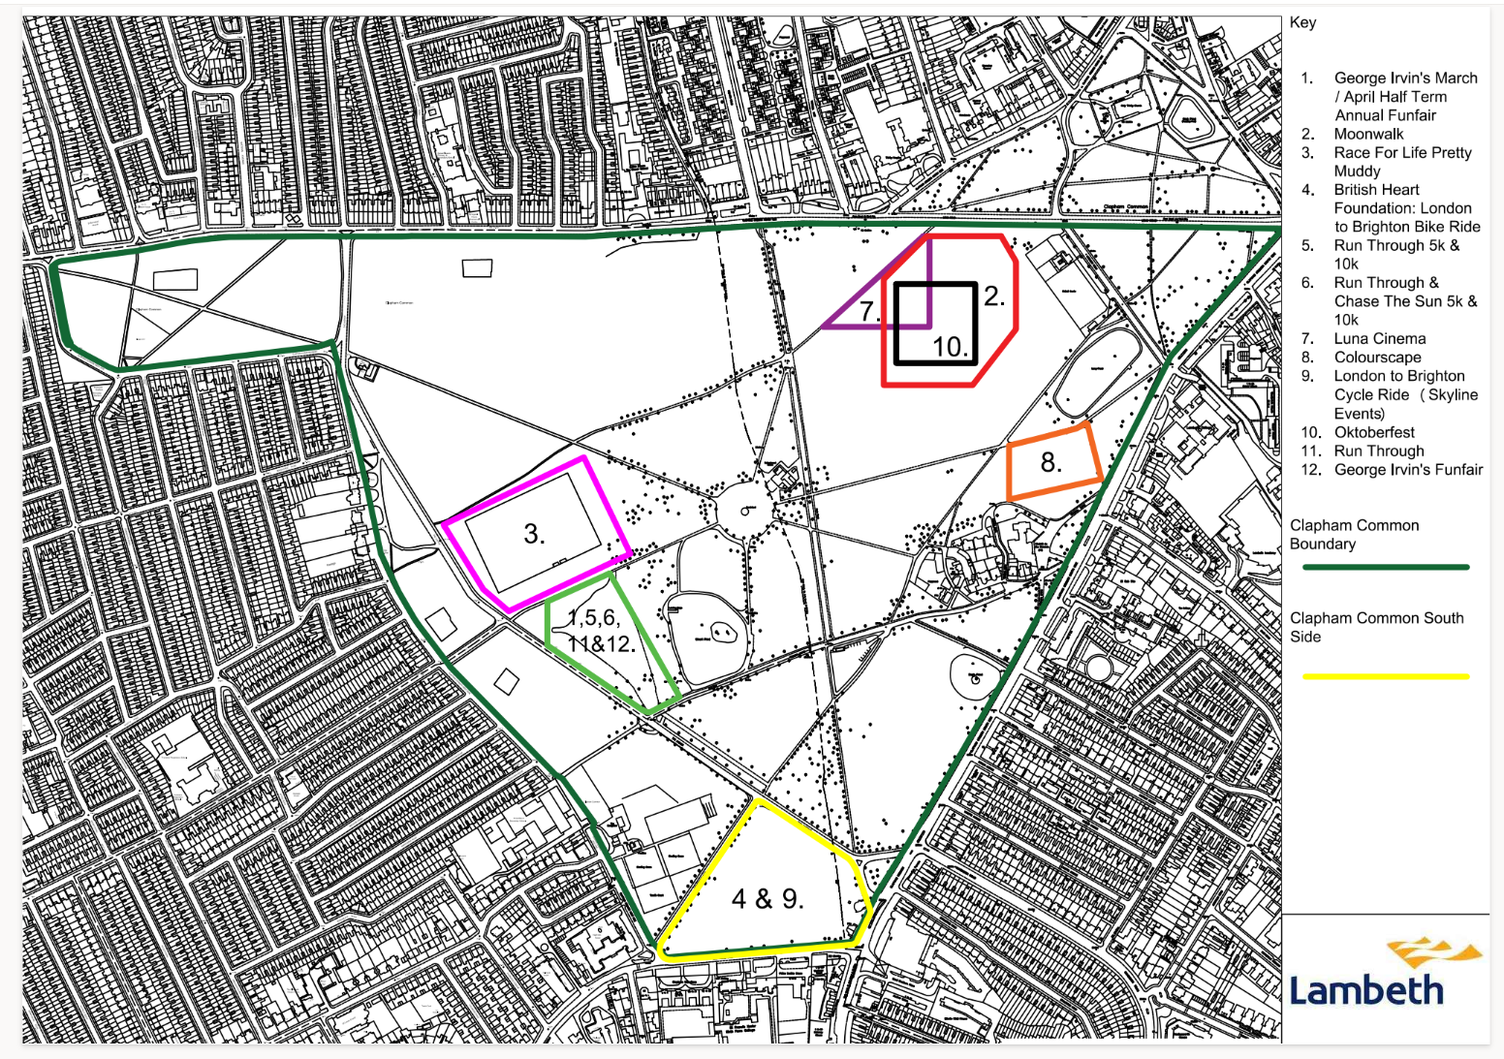

Plan B – Permanent Works Plan (Application B)

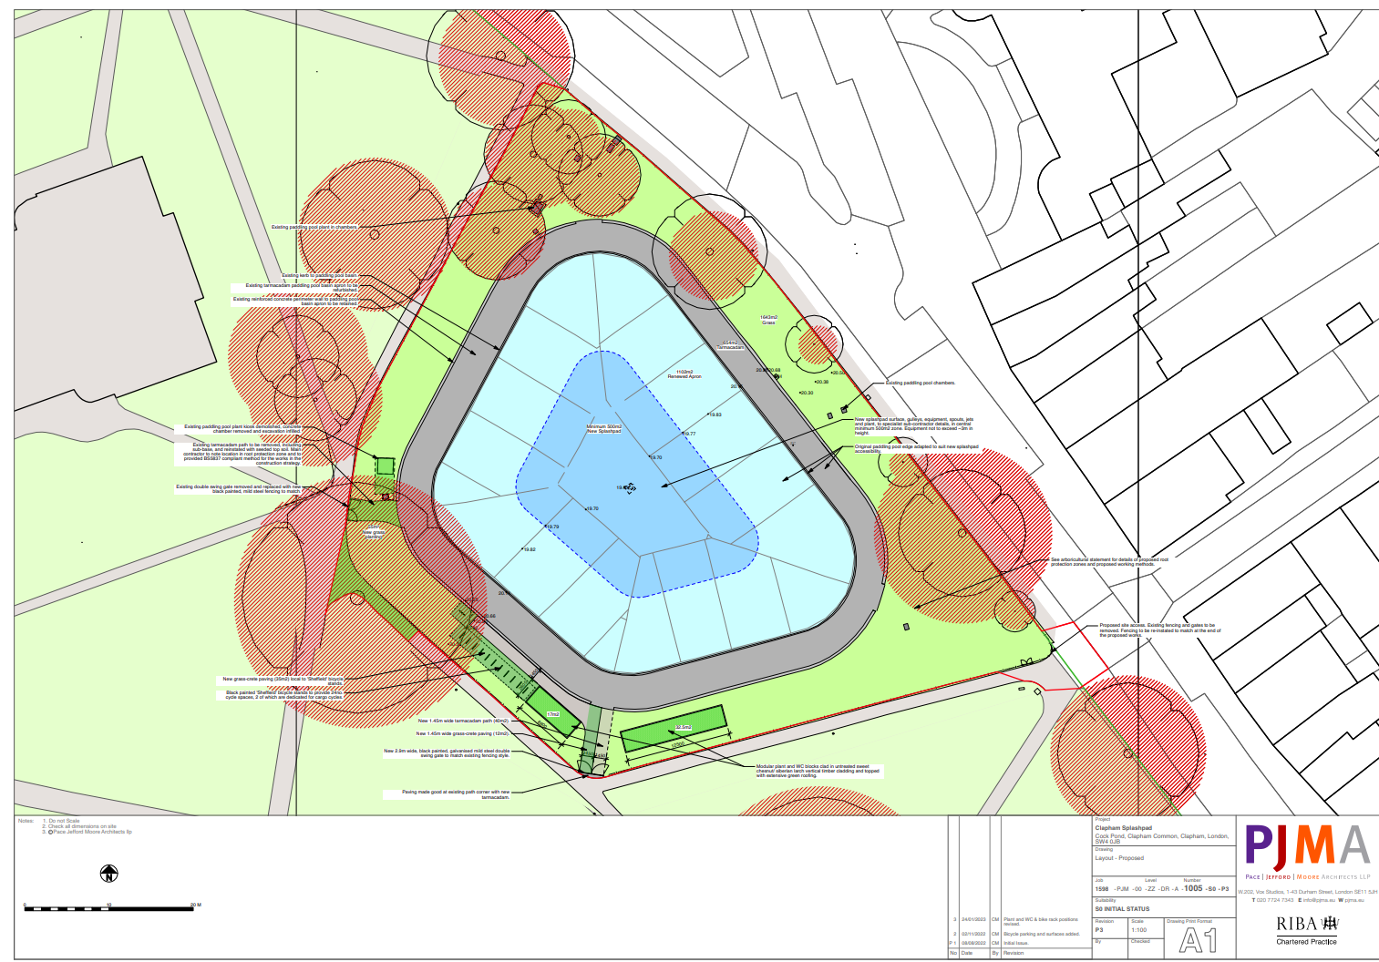

Ref: 22/03020/FUL
Ref: 23/00844/NMC
Heritage Statement, Turley (2022).

