NOTICE OF ORDER

Highways Act 1980 – Section 119
&
Wildlife and Countryside Act 1981 – Section 53
WILTSHIRE COUNCIL
The Wiltshire Council Bratton 42 (Part) Diversion and Definitive Map and Statement Modification Order 2021

Notice is hereby given that the above referenced Order has been submitted to the Secretary of State for Environment, Food and Rural Affairs for determination. An Inspector will be appointed by the Secretary of State to determine the Order.

The start date for the above Order is 1 June 2023.

Consideration of the Order will take the form of a public local inquiry.

The Inquiry will be held at Bratton Jubilee Hall, Melbourne Street, Bratton, Westbury, Wiltshire BA13 4RW on Tuesday 31 October 2023 at 10.00am.

The appointed Inspector will also open the Inquiry as a virtual event on Tuesday 31 October 2023 at 10.00am.

Anyone wishing to attend the Inquiry virtually must register that interest with the Council as soon as possible prior to the Inquiry, either by E-mail or Telephone, details of which are set out in this notice.

To take part using video, participants will need to have access to Microsoft Teams (via an app or web browser). The link https://support.microsoft.com/en-us/office/welcome-to-microsoft-teams-b98d533f-118e-4bae-bf44-3df2470c2b12 gives further information on how to use this. Alternatively, you can take part by telephone. Registered participants will receive individual joining instructions, providing details of any requirements, guidance and support, whether joining by Teams or telephone.

The effect of the Order, if confirmed without modifications, will be to divert Footpath Bratton 42 at east of Luccombe Mill, Imber Road, Bratton leading from Ordnance Survey Grid Reference ST 9205-5204 leading in a broadly east north easterly direction for approximately 170 metres to OS Grid Reference ST 9222-52207, to a new route at OS Grid Reference ST 9206-5204, leading in a broadly east north easterly direction for approximately 160 metres to OS Grid Reference ST 9222-5207. Having a width of 2 metres, and thereupon the Warminster and Westbury Rural District Council area definitive map and statement dated 1953 shall be modified accordingly.

Any queries relating to this Order should be referred to Helen Sparks at The Planning Inspectorate, Rights of Way Section, Room 3/A Eagle Wing, Temple Quay House, 2 The Square, Temple Quay, Bristol, BS1 6PN. Telephone: 0303 444 5646.
Email: helen.sparks@planninginspectorate.gov.uk Please quote reference number ROW/3287255 on all correspondence.

Any person wishing to view the statements of case and other documents
relating to this Order may do so by appointment at Wiltshire Council,
County Hall, Trowbridge, Wiltshire, BA14 8JN from 0900 to 1700 Monday
to Friday. To book an appointment to view the documents or if there are
any queries, please contact Ali Roberts at E-mail Address:
definitivemap@wiltshire.gov.uk or by Telephone: 01225 756178.

Timetable for sending in statements of case and proofs of evidence

Within 8 weeks of the start date by [by 27 July 2023]

The Order Making Authority must ensure their statement of case is received by the Secretary of State. As soon as possible after the deadline, the Secretary of State will send a copy (excluding copies of any supporting documents - these will be available to view at the Authority’s offices) to everyone who has made an objection or representation and the applicant and any other person who has written to us in respect of the Order.

Within 14 weeks of the start date [by 7 September 2023]

Everyone who has made an objection or representation and anyone who wishes to give evidence at the Inquiry must ensure their statement of case is received by the Secretary of State. As soon as possible after the deadline, the Secretary of State will send full copies to the Authority. Copies will also be sent to the applicant, every person who has made an objection or representation and any other person who has written to us in respect of the Order (excluding copies of any supporting documents - these will be available to view at the Authority’s offices).

Within the same period the applicant (if applicable) must ensure their statement of case is received by the Secretary of State. As soon as possible after the deadline, the Secretary of State will send a full copy to the Authority. Copies will also be sent to everyone who has made an objection or representation and any other person who has written to us in respect of the Order (excluding copies of any supporting documents - these will be available to view at the Authority’s offices).

4 weeks before the date of the inquiry [by 3 October 2023]

The Authority, everyone who has made an objection or representation, the applicant (if applicable) and anyone who wishes to give evidence at the Inquiry must ensure their proof of evidence (together with any summary) is received by the Secretary of State. As soon as possible after the deadline, the Secretary of State will send copies of:

- the Authority’s proof of evidence to everyone who has made an objection or representation, the applicant and anyone who has submitted a statement of case (excluding copies of any supporting documents – although none should be submitted with a proof of evidence);

- the applicant’s proof of evidence to the Authority, everyone who has made an objection or representation and anyone else who has submitted a statement of case (excluding copies of any supporting documents – although none should be submitted with a proof of evidence); and

- all other proofs of evidence to the Authority, the applicant, everyone who has made an objection or representation and anyone else who has submitted a statement of case (excluding copies of any supporting documents – although none should be submitted with a proof of evidence).

All parties must keep to the timetable set out above and ensure that statements of case and proofs of evidence are received by the Secretary of State on time. Late documents will be returned.

We cannot accept any libellous, racist or abusive comments. Any documents containing such comments will be returned.

Notice of order for inquiry

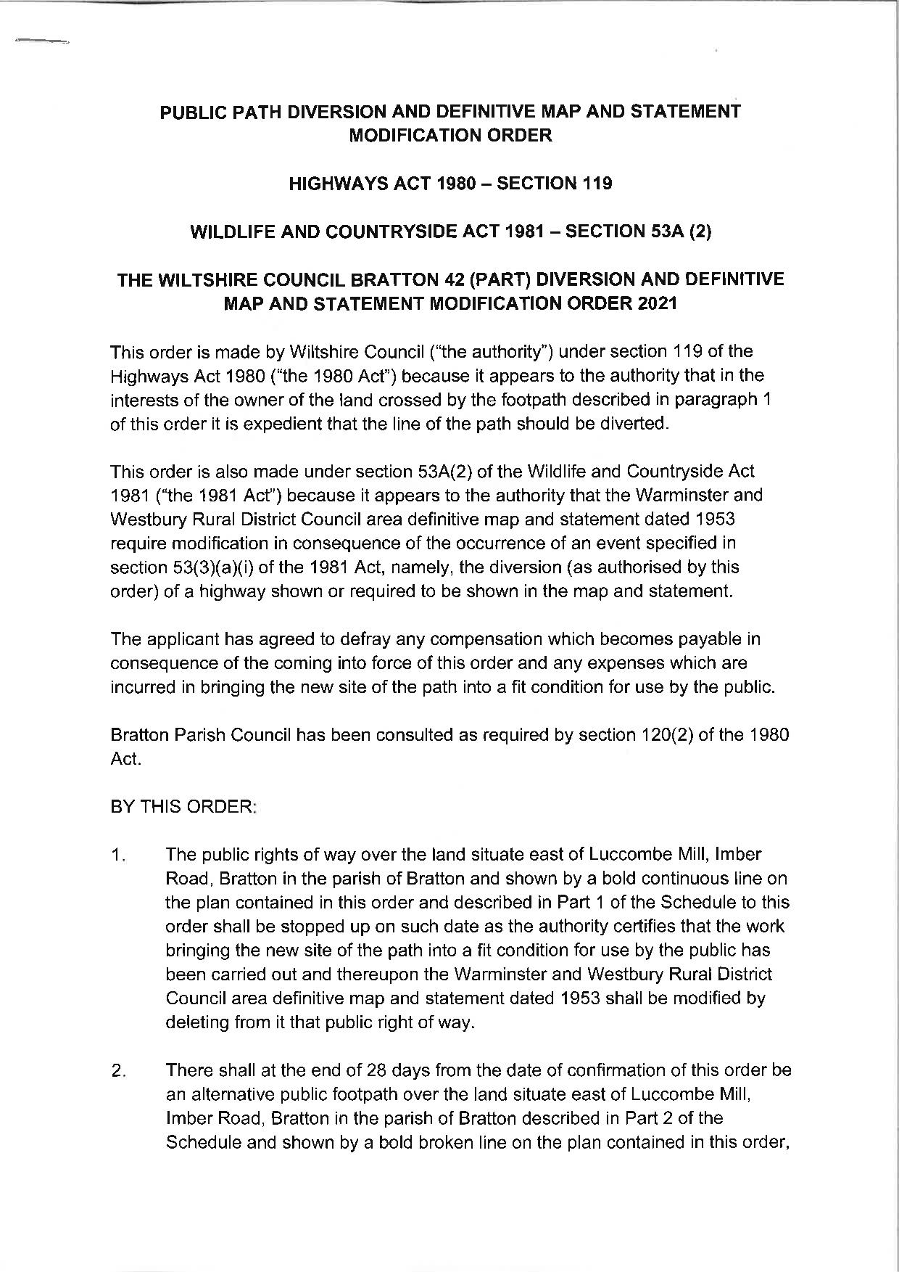

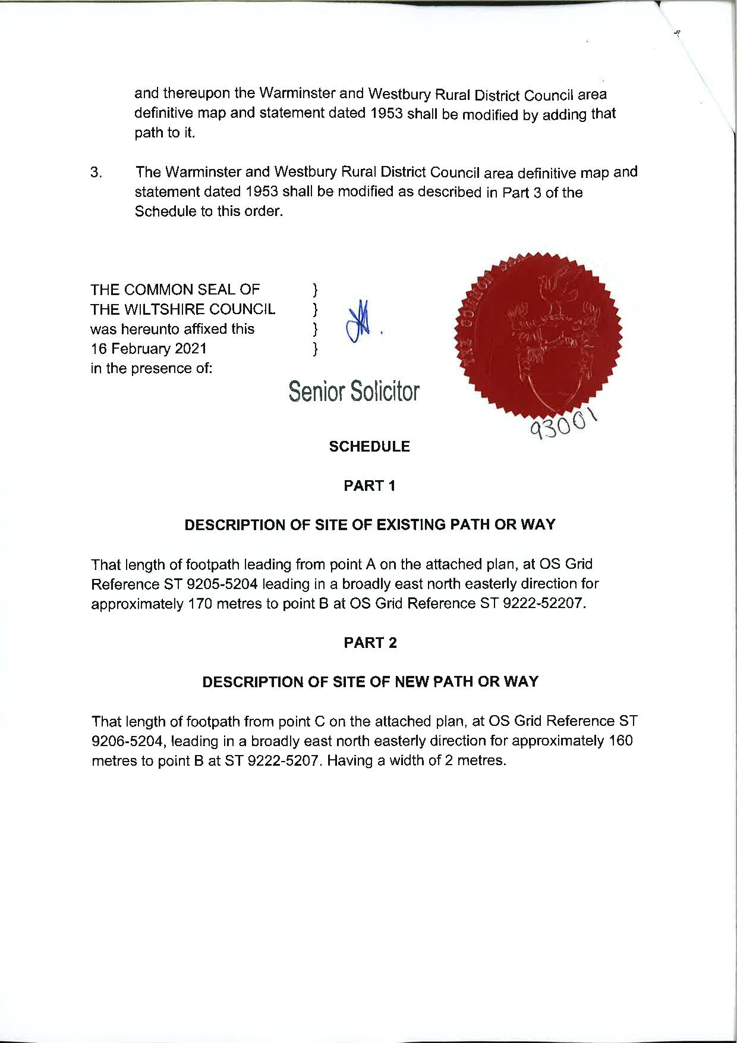

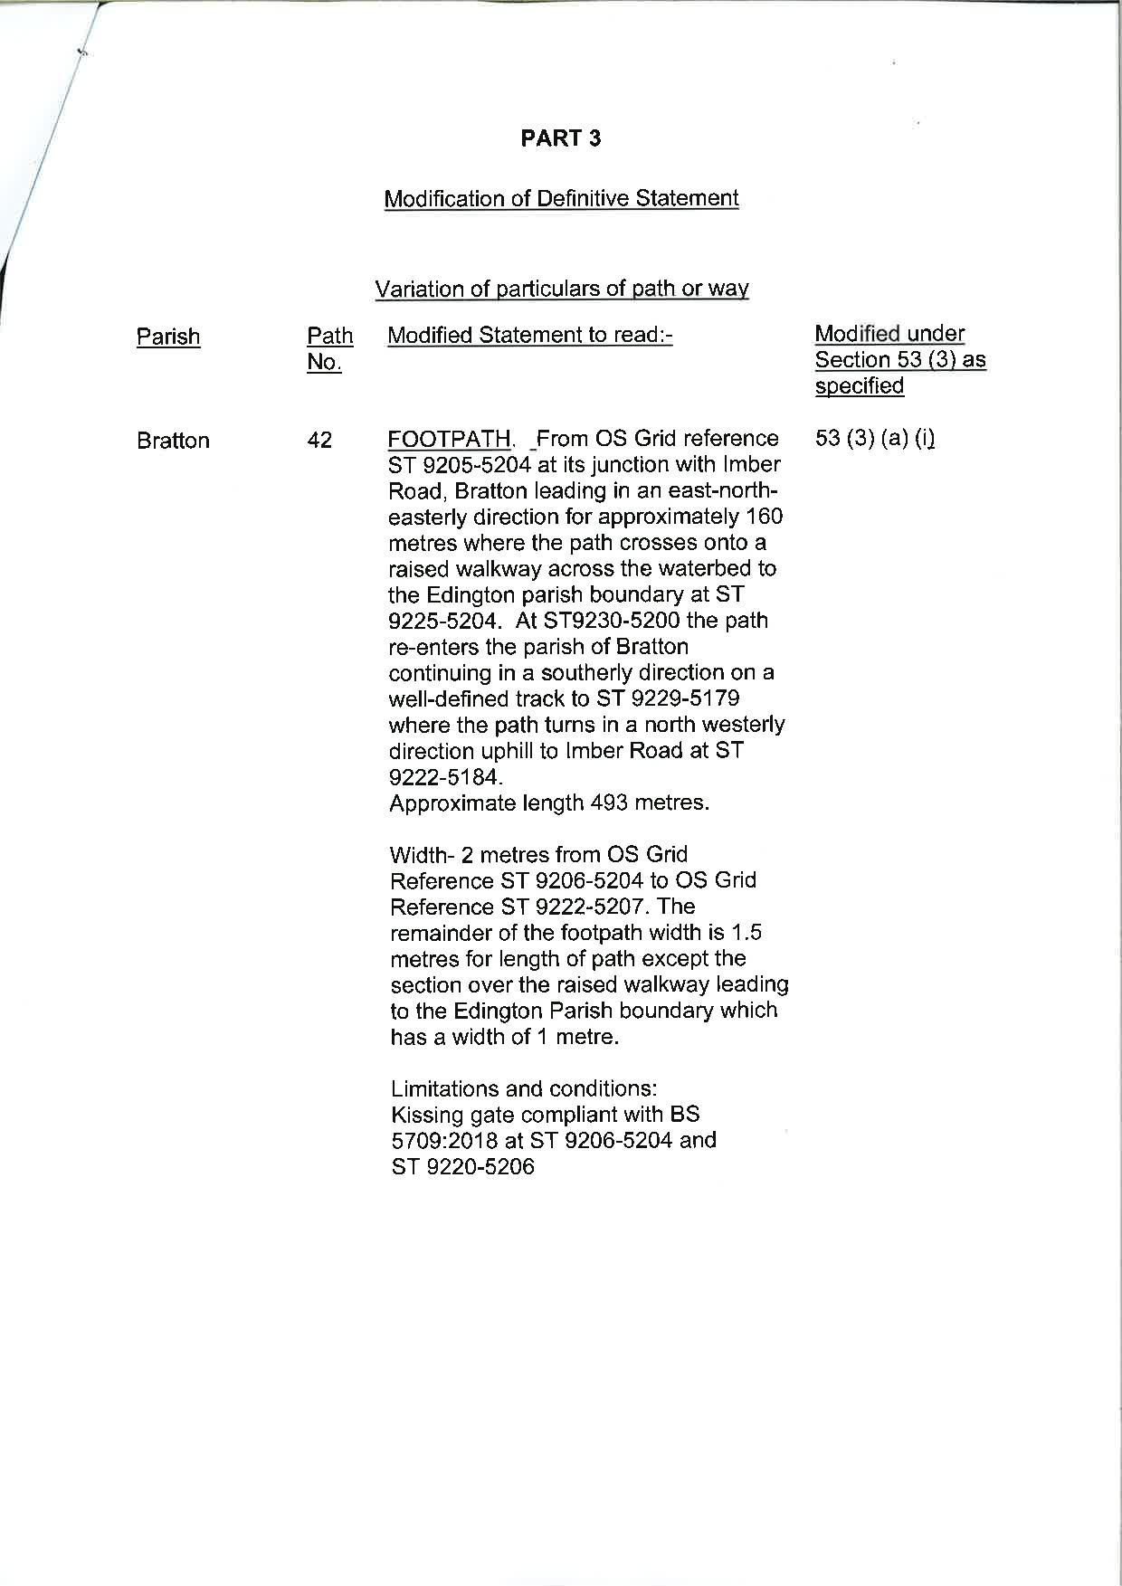

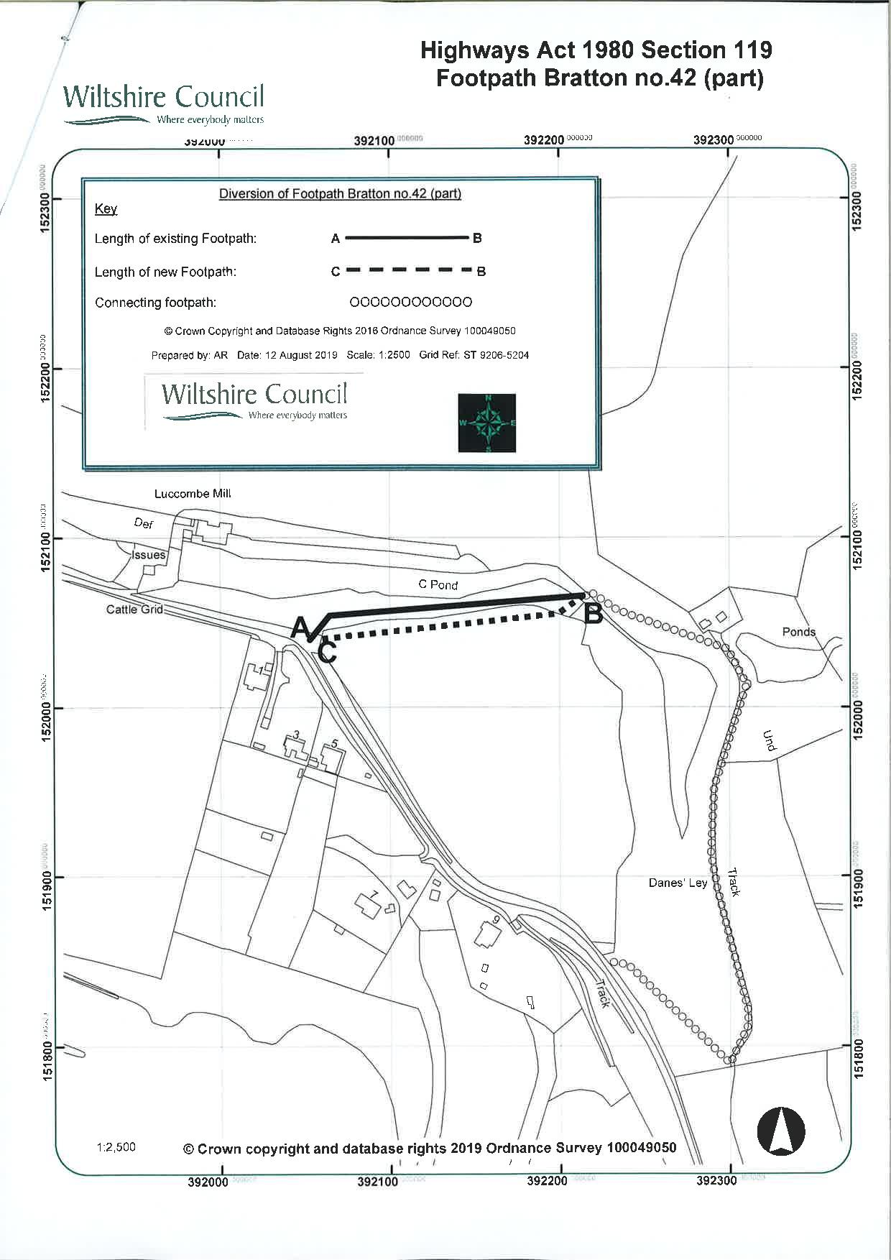

If you wish to make a legal submission, this should be submitted at the same time as your statement of case. Otherwise legal submissions will have to be submitted in writing on the day of the inquiry.

