Explanatory Memorandum on Amending Agreement No.l between the United Kingdom of Great Britain and Northern Ireland and the Republic of Moldova to amend the Strategic Partnership, Trade and Cooperation Agreement between the United Kingdom of Great Britain and Northern Ireland and the Republic of Moldova

Title: Amending Agreement No.l between the United Kingdom of Great
Britain and Northern Ireland and the Republic of Moldova to Amend the

Strategic Partnership, Trade and Cooperation Agreement between the United Kingdom of Great Britain and Northern Ireland and the Republic of Moldova

Command Paper No 859

1. Introduction
This explanatory memorandum has been prepared by the Department for Business and Trade and is laid before Parliament as an un-numbered Act Paper.

2. Subject matter and purpose of the Treaty
The purpose of Amending Agreement No. 1 between the United Kingdom of Great Britain and Northern Ireland and the Republic of Moldova ("the Amending Agreement") is to amend the Strategic Partnership, Trade and Cooperation Agreement to temporarily liberalise all tariffs for an initial 12 month period. This is intended to provide economic support to Moldova to help them deal with the impacts of the war in Ukraine, which has disproportionately affected them as a direct neighbour of Ukraine. The initiative also acts as a symbol of the UK's support to an important strategic ally in the region.

3. Background
The Strategic Partnership, Trade and Cooperation Agreement between the United Kingdom and the Republic of Moldova ("the Agreement") was signed 24 December 2020 and was provisionally applied on 1 January 2021. Under the Agreement, all products are tariff-free with the exception of tomatoes, garlic, grapes, apples, cherries, plums and grape juice which are subject to tariff rate quotas (TRQs).
Following a request from the Government of Moldova for economic support in light of the impacts of the Ukraine war on Moldova, the United Kingdom and Moldova agreed to temporarily eliminate all customs duties on goods originating from Moldova and signed the Amending Agreement on 25 May 2023 to deliver this.

4. Content
The Amending Agreement will temporarily remove all customs duties and tariff rate quotas on goods originating from Moldova into the United Kingdom. This primarily involves amending the core customs duties obligations in the Goods section of the Agreement, and in particular by substituting paragraph 1 of Article 124 of the Agreement to impose an obligation on the United Kingdom to eliminate all customs duties on goods originating in the Republic of Moldova.
The Amending Agreement provides for its entry into force on 31 July 2023 , provided the United Kingdom has notified Moldova of its completion of internal procedures for entry into force by that date. The Amending Agreement applies until 3 1 July 2024 but may be extended by mutual agreement of the Parties.
The tariff liberalisation will be reviewed by the Parties within 12 months of entry into force. The Amending Agreement may be terminated by either Party by giving three months written notice.
The Amending Agreement contains specific dates for its entry into force and termination in order to ensure the period of tariff liberalisation (12 months) reflects the agreed approach and provides legal clarity on the treaty period for the Parties and stakeholders, including ensuring domestic implementation is appropriately aligned with the treaty period.
The specific amendments made to the Agreement through the Amending Agreement are subject to Article 386 (Amendments) of the Agreement. The Amending Agreement itself may be further amended by agreement between the Parties.
Safeguards
A safeguard mechanism has been agreed within Articles 3 to 7 of the Amending Agreement that would allow a temporary safeguard mechanism to be applied to prevent or remedy serious injury and to facilitate the adjustment of the domestic industry. The safeguard mechanism allows the importing party (United Kingdom) to increase the rate of customs duty on the good to a level that does not exceed the rate of customs duty set out in the original set of tariff schedules under the Agreement.

5. Implementation
The Customs Tariff (Preferential Trade Arrangements) (EU Exit) Regulations 2020 (S.I. 2020/1457) will be amended to implement the liberalised tariffs under the Amending Agreement. The Government will lay a Statutory Instrument to implement the tariff liberalisation until 31 July 2024, in order to align with the date on which the Amending Agreement terminates.

6. Territorial Application
The Agreement applies, in respect of the United Kingdom, to the extent that and under the conditions which the EU-Moldova Association Agreement applied immediately before it ceased to apply to the United Kingdom, to the United Kingdom and the following territories for whose international relations it is responsible: Gibraltar, The Channel Islands and the Isle of Man. For the Amending Agreement, the amendments made for tariff liberalisation apply to the United Kingdom, the Channel Islands, and the Isle of Man.

7. Financial
Tariff revenue has the potential to be impacted across the seven products to be fully liberalised. There will otherwise be no direct financial implications beyond those needed to cover the process of ratifying this Treaty.

8. Human Rights
The measures have no associated human rights implications.

9. Reservations and Declarations
No reservations or declarations have been made in relation to the Amending Agreement.

10. Consultation
Devolved Administrations (DA)
The Amending Agreement is not considered to relate to a devolved matter. However, given that the tariff regime applies to the whole of the UK, including Scotland, Wales and Northern Ireland, the Devolved Administrations were notified and updated prior to the signing of Amending Agreement.
Crown Dependencies and Overseas Territories
The Channel Islands and the Isle of Man were notified of the Amending Agreement and the changes this would have to the Agreement.

12. Ministerial Responsibility
The Secretary of State for Department for Business and Trade has overall responsibility for regulation of international trade and for this Treaty.
The Secretary of State for His Majesty's Treasury also has as a policy interest, given HMT's responsibility in implementing the Amending Agreement in domestic legislation.
The Secretary of State for Foreign, Commonwealth and Development Affairs has overall responsibility for UK policy relating to the UK's relations with Moldova and the conclusion and implementation of treaty obligations.
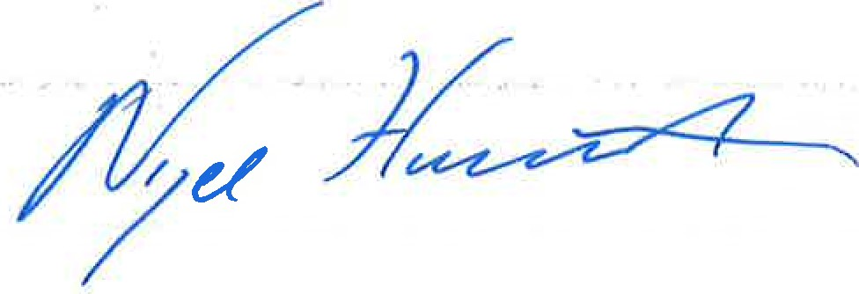
NIGEL HUDDLESTON MP
Minister of State for Business and Trade

