Sustainability Calculator - Equity Loan  GUIDANCE NOTE March 2018 |  | 

The calculator and associated policy set out here and in the Capital Funding Guide have been developed to support long term sustainability of equity loan investments.

Policy

This document outlines Homes England’s policy towards ensuring long term sustainability of equity loans, and sets out relevant information and guidance to be used in assessment of income and other influencing factors.

Sustainability checks are in place to protect Homes England’s (government) investment and households against factors such as increases in interest rates which could add pressure on households paying mortgage finance. This policy attempts to mitigate against the effects of such risks by ensuring mortgages repayments are sustainable, in the interests of protecting government investment and preventing repossessions where possible.

Help to Buy equity loan is Homes England’s primary equity loan product. When using the Help to Buy equity loan scheme the 1st charge mortgage must be at least a minimum of 25% of the full purchase price. This ensures that it is the main mortgage. The calculator will check this using the numbers inserted.

It is important to note that a Help to Buy equity mortgage is repayable either in 25 years or when triggered by a redemption activity - including ‘staircasing’ to buy further shares (partial redemption), selling outright (full redemption) or full settlement of the first charge mortgage. Therefore, if the first charge mortgage is paid off within 10 years, the second charge equity loan is also due for re-payment. This must be considered when IFAs are looking at assessments for Help to Buy.

NOTE to Help to Buy Agents

The policy is intended as guidance and where cases fall outside of this, if the Help to Buy Agent believes there to be exceptional circumstances the case may continue outside of this policy and a common sense approach taken, where appropriate sign- offs have been received at the correct stage in the purchase process. However, the higher limit caps stated within this guidance are ceilings for long term sustainability and cannot be breached. Please be aware that the 4.5x income is an absolute cap and cannot be breached under any circumstances nor can the 45% net to debt income ratio. A minimum 5% deposit from the purchaser is also a scheme requirement.

Queries on individual cases for Help to Buy Equity loan should always be sent to Homes England’s local office contact by the Help to Buy Agent directly. A copy of the calculator will always be required.

Equity Loan Calculator

The equity loan calculator is available from within Homes England’s Capital Funding Guide:
https://www.gov.uk/guidance/capital-funding-guide

For consistency of process all Help to Buy Agents should use the calculator when assessing a Homes England funded equity loan products. ALL cases of Help to Buy should have a copy of the calculator on file for future audits by Homes England/and or the NAO.

Details of how to use the calculator can be found below. For each Help to Buy case the relevant Help to Buy Agent is responsible for populating the calculator using information submitted through the Property Information Form (PIF). Where IFAs have done this on the Agents/applicants behalf all salary information must match the PIF.

IFAs can use this calculator for guidance, however IFAs must not confirm any applicants as ‘eligible’ for Help to Buy, and under no circumstance should a mortgage application be submitted to a lender without a valid Authority to Proceed (ATP) being in place from an Homes England Help to Buy Agent. Diagrams outlining the buying process via Help to Buy equity loans can be obtained from the Help to Buy Agent. Relevant Agents can be found at www.helptobuy.gov.uk

The Calculator

The calculator requests the following information

Applicant Income
- gross income of both applicants (I15 and I17)
- Annual overtime, bonuses and commissions amounts in full ( J16 and J18)
Additional Income
Universal Credit (UC) means that applicants receive one lump sum payment. However UC is still broken down to ensure recipients know what they are receiving and for them to ensure that they are entitled to the benefits being received. The calculator therefore still request benefits separately.
- Working tax credits – accepted
- Disability allowance – accepted
- Guaranteed maintenance – accepted
- Other income source is there to allow applicants to include any other payments they receive and may want to include. N21 captures the total.
- Please note for clarity, the calculator will allow you input figures into child tax credit and child benefit. These amounts do not count towards the mortgage multiple calculations and are not accepted forms of payment.
- Further info is available in the ‘handy hints’ section of this guidance.

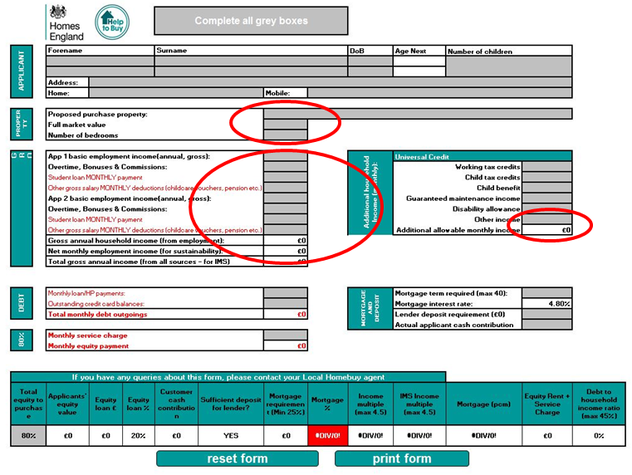

Reductions in income
- The purchaser’s income is deducted from the gross household figure to create a net income figure. (I20) we realise some applicants may pay slightly different tax levels this assessment allows for tax free allowance and adjusts over 31,866 in line with the new tax allowances and again at 150,000. This matches calculations carried out on http://www.listentotaxman.com/index.php
- 50% of any bonus and overtime money is taken (J16 & J18) this is the maximum Homes England will accept. We acknowledge that lenders may take more into account however as a ranking second charge holder we will only accept 50% of these payments.
- Monthly contribution to student loan debt should also be included and will form part of the gross salary reduction
- An additional gross salary reduction box is available to add monthly payments to childcare voucher schemes and pensions etc. Where figures appear in this cell the payment type should be listed in the comments box.
- Other additional income is then added onto the total net pay (N23)
Debts after Net payment
- Debt - Loans, credit card debt, and any other credit commitments are deducted from the net income to create a net mortgagable income
- Monthly loan commitments should be input and are multiplied by 12 and deducted from the net income – do not use outstanding loan figures
- Credit cards - 36% of the debt from the mortgagable/disposable income per year (3% per month). This is equivalent to repaying 1% of the capital per month and an interest rate of 24% apr.“ the total debt outstanding should be input into this cell.
- Child care costs and maintenance costs are not included in this calculator. Homes England is aware that lenders may reduce incomes further for those who have children. This calculator is looking at the pure cost of housing and ensuring that it takes no more than 45% of the net income after the above reductions. This leaves a minimum of 55% towards, fuel and living costs. It is also important to note that this is a maximum and should lenders offer a lesser amount due to their own criteria the lender is followed. The calculator is designed to state the maximum allowed to protect investment, the purchaser and to ensure long term sustainably. It does not insist that all parties are treated uniformly or insist that all applicants use 45% of their net income to purchase.
- The monthly equity payment is generated by the calculator and deducted
- Any service charge commitments should be added as a monthly outgoing

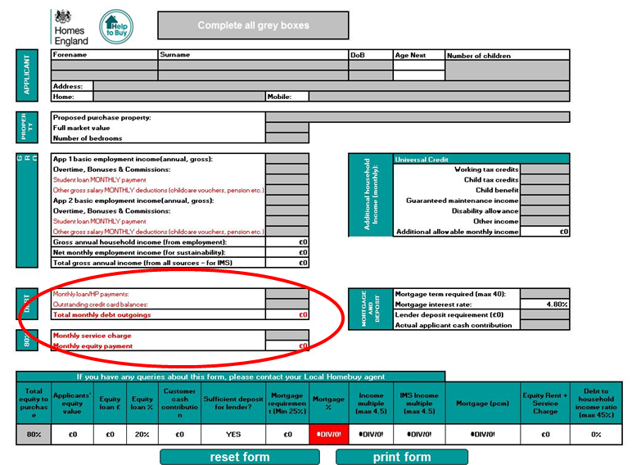

How is the results bar calculated?
- The calculator uses the purchase price and checks that the required mortgage and deposit level fits within Homes England’s guidance. (sustainability requirements are set out below)
- The calculator accesses sustainability on debt to net income, it will take into account mortgage payments, service charge and the equity fee for year 6 as housing cost, this is to ensure long term sustainability and is recommended by the majority of lenders. The FCA has also requested this is used in the assessment from day one.
- The interest rate (circled in the image below) is set as the average standard variable rate of lenders and will be reviewed on an on-going basis. The calculator is not designed to check sustainability of particular/actual mortgage offers, it is designed to check long term sustainability to protect investment and avoid mortgage default. This should not be altered.
- Other factors the calculator will take into consideration are as follows (all these fields can be altered to make results as accurate as possible)

  - Mortgage term
  - Lender deposit requirement/cash contribution

As standard all assessments should be based on 25 years, the Help to Buy Agent has discretion to approve the extension of the mortgage term up to 40 years should the first charge lender support this, the term on the calculator should mirror the term that appears at Solicitor Form One.
Any changes would prompt the assessment being done again and could potentially have a negative outcome for the buyer causing the sale to break down if it’s not affordable.
The purchasers must have the relevant working years for their mortgage, the maximum age for the agencies assessment is up to 75 years of age. This is not a requirement, but means any applicant wanting a 40 year mortgage would have to be 35 or under. The extension of the first charge mortgage does not impact the 2nd charge equity loan. Please read the equity mortgage terms to ensure the payment mechanisms of the equity loan document are fully understood, any questions should be fully explored by a purchaser’s solicitor. Standard policy is that an applicant can take a mortgage up to the age of 75.

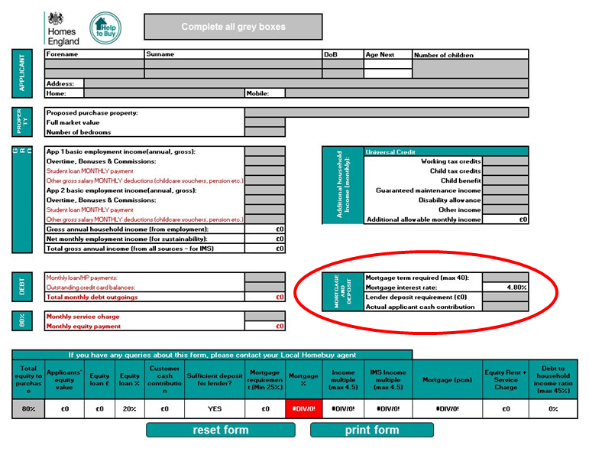

Results Bar

A minimum 5% cash contribution must be contributed by the purchasers. They must also have a minimum 25% first charge mortgage. The lender deposit percentage circled in the image above can be altered should a higher cash contribution be utilised.

The results bar then checks that the mortgage which is determined from the result in the total equity purchaser box (circled below) minus the total cash contribution in N26 is at least 25% of the full purchase price and sustainable in line with this policy long term. The total equity purchaser box provides options via a drop down of 80, 85 or 90%.

If the share fits the sustainability parameters (i.e. does not breach the cap) the case can continue.

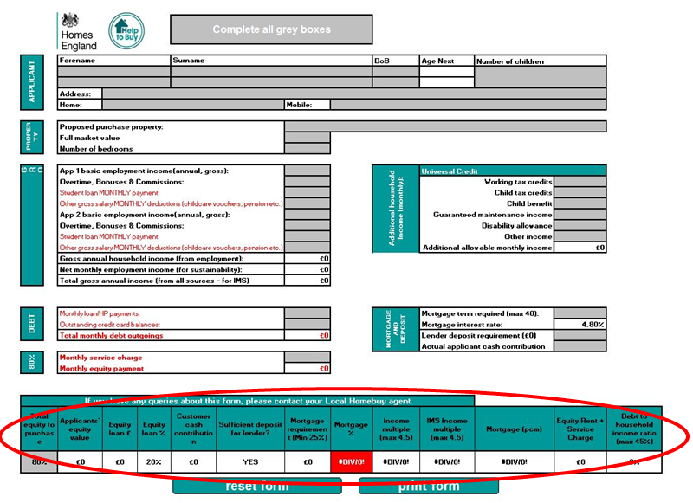

Flexibility – Important

Homes England does not want to put barriers in front of Help to Buy sales; however we must ensure that the property is sustainable long term to protect investment.

Applicants should avoid borrowing amounts deemed as unsustainable. Homes England considers a 45% household debt to net income ratio as maximising their contribution to home ownership yet not over stretching in order to allow applicants to adapt to market changes in interest rates etc. and allow for the introduction of fees in year 6. A multiple of 4.5 x income is also the maximum applicants can use to purchase their share.

Applicant’s mortgage must also be for a minimum of 25% of the property purchase price, ensuring that the first charge is the ‘main mortgage’

Affordability is assessed using a 25 year mortgage, this can be stretched if needed but the applicants must have the available working years. Homes England will only allow working years to be counted up until 75 which is viewed as the upper end of retirement age. The date of birth of the 1st applicant will determine this, if it is a joint application please put the DOB of the oldest applicant.
To note, the equity mortgage is redeemed once the first charge mortgage is.

There is no minimum multiple or ratio for Help to Buy equity loan, nor do applicants have to use 4.5x their income or 45% of their net pay towards housing costs. This is a cap and housing providers should ensure that mortgages are sustainable long term.

Further flex

If applicants are concerned about what owning a house could mean they can use the budget tool www.moneyadviceservice.org.uk this helps applicants make the most of their money and realise the financial commitments of owning a property. All Help to Buy Agents should have a link to this website on their websites.

Handy Hints for using the Equity Loan Calculator

- When you open the Excel spread sheet you will be asked about macros – you must click on ‘Enable Macros’ the calculator will not work without this active.
- The calculator is an excel spread sheet you must click off each field for the info to registered as if working on a ordinary spreadsheet.
- Child tax credits and child allowance are not included in the household income and are benefits for the child and therefore cannot be taken as part of the purchaser’s income. They are left out of all calculations. Other forms of benefits are available to help if guardians are struggling to house dependants, the intention of child benefit is not to support parental home ownership, and it is not a benefit tied to the mortgage holder but only paid whilst the child is under 16.
- If the purchaser pays additional tax, student loans or towards a pension or guaranteed maintenance (maintenance payments can only be the required amount not over payments) these payments can be input into the loan payments as a monthly sum.
-The date of birth field at the top of the calculator can only hold one applicants details and should be based on the oldest applicant to work out the maximum years available.

Other policy notes

All 1st charge mortgages must be on a repayment basis and mortgage guarantors are not accepted
No mortgages applications should be applied for without a valid Authority to Proceed (ATP) from an Homes England Help to Buy Agent.

Married couples jointly own assets and therefore if one owns a property it is considered as a jointly owned asset and they are both treated as home owners and this must be disposed of prior to buying via Help to Buy.

Only those named on the first charge mortgage can submit their income on the calculator, the purchase must be sustainable for the individual/s tied to the mortgage without requiring further income. Applicants with an eligible second applicant (by eligible they must not own any property by completion, if they do not fit the Help to Buy criteria they cannot put their income towards the purchase, they must also be on the Property Information Form) can use up to a third of their income.

***
NOTE:

From 11th May 2020 and until further notice, Homes England will accept applications for the Help to Buy Equity Loan using furloughed income to form part of the sustainability assessment. All applicants must make clear on the PIF that their income is furloughed income.

Bonus, overtime and commission payments or income are not eligible to be included in sustainability assessments.

