Advisory Committee on Borderline Substances: how to request a change to the ACBS application form and/or guidance
Published 18 May 2023

Contents
Guidance 2
Flowchart 4
Change control form 5

Guidance
This guidance is illustrated in the flowchart on page 4.

Proposing a change
Change proposals may be made by:
- the British Specialist Nutrition Association (BSNA)
- the Department of Health and Social Care (DHSC)
- the Advisory Committee on Borderline Substances (ACBS)
- a manufacturer or stakeholder
Use the form below for all change proposals.
Send the completed change control form to the ACBS (acbs@dhsc.gov.uk).

Assessment of the proposed change
The completed change control form will be shared with ACBS and BSNA so they may make their assessments of the proposed change.
The ACBS or BSNA, via the ACBS Secretariat, might request further information to help better understand the change being proposed.
Based on the assessments, and the scale of the change being proposed, the Secretariat will decide whether to convene a meeting of the ACBS-BSNA Working Group to discuss the proposal.
Following discussions, if the ACBS and BSNA have not managed to reach a mutual agreement, BSNA will have an opportunity to appeal. The ACBS will then reconsider the proposal taking the appeal into account before making a final decision of whether the change should be implemented or not.

Proposed change accepted
If ACBS and BSNA both agree to the change then they will arrange to implement it after the next application window closes. However, if the change concerns work where there has been long-term investment in acceptability or clinical trials, the ACBS and BSNA will agree the transition arrangements with the view to implementing the change at the earliest opportunity.
Where the ACBS' final decision is that it wants to implement a change that the BSNA does not, it may do so on the understanding of the risks, which the ACBS Secretariat will communicate to the DHSC. Otherwise, the process for implementing the change remains the same as that set out above.

Proposed change rejected
If ACBS and BSNA both agree the proposed change should not be implemented, then the process ends and the application form and guidance will not be amended.
Where the ACBS' final decision is to reject a change that the BSNA is in favour of, it may do so on the understanding of the risks, which the ACBS Secretariat will communicate to the DHSC. The process ends and the application form and guidance will not be amended.

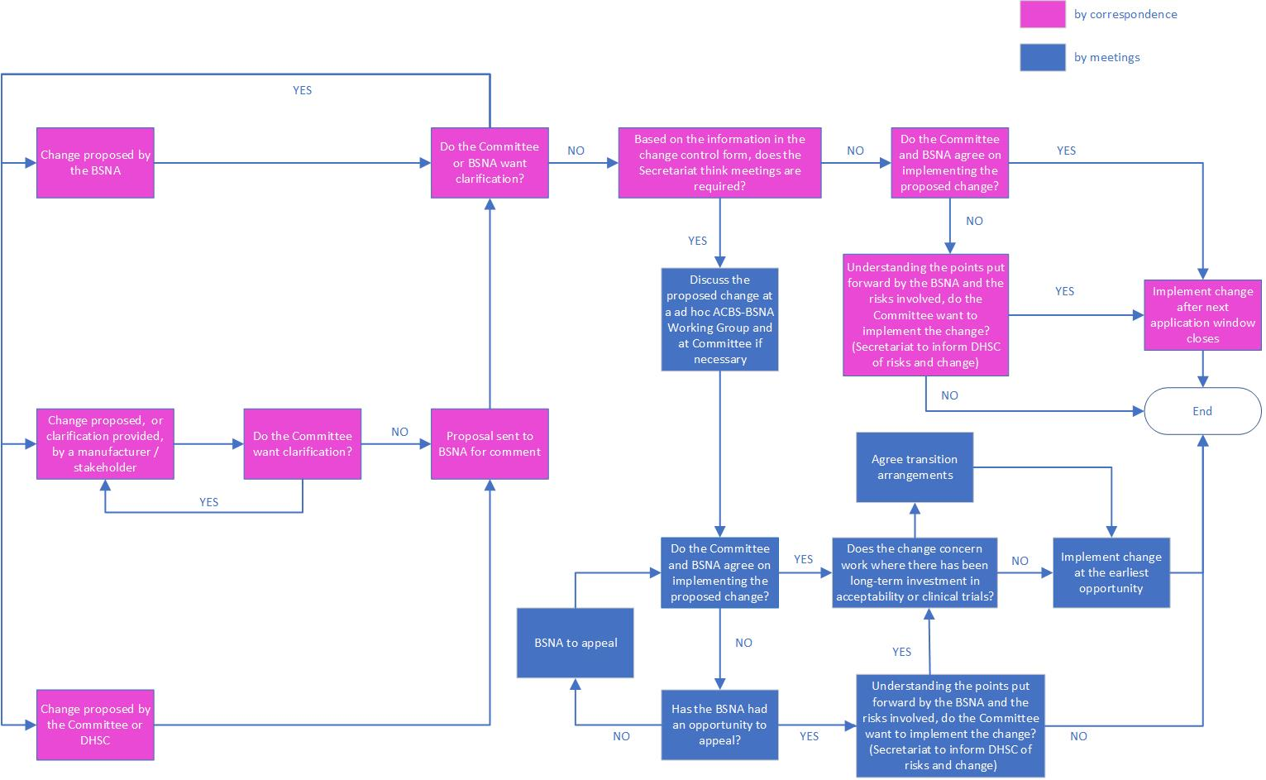
Flowchart

Change control form

Information about the change

Change name
Enter your response here.

Requested by
Enter your response here.

Date (dd/mm/yyyy)
Enter your response here.

Describe the proposed change
Enter your response here.

What is the reason for the change?
Enter your response here.

For ACBS use only

What is the ACBS' assessment of the change?
Enter your response here.

Describe all possible risks to making the change
For each risk, include the probability, impact and cumulative score (see image below).
Enter your response here.

For BSNA use only

What is the BSNA's assessment of the change?
Enter your response here.

Describe all possible risks to making the change
For each risk, include the probability, impact and cumulative score (see image below).
Enter your response here.

For secretariat use only

What is your outcome report?
Explain the final decision and how it was reached, include timing of implementation if any.
Enter your response here.

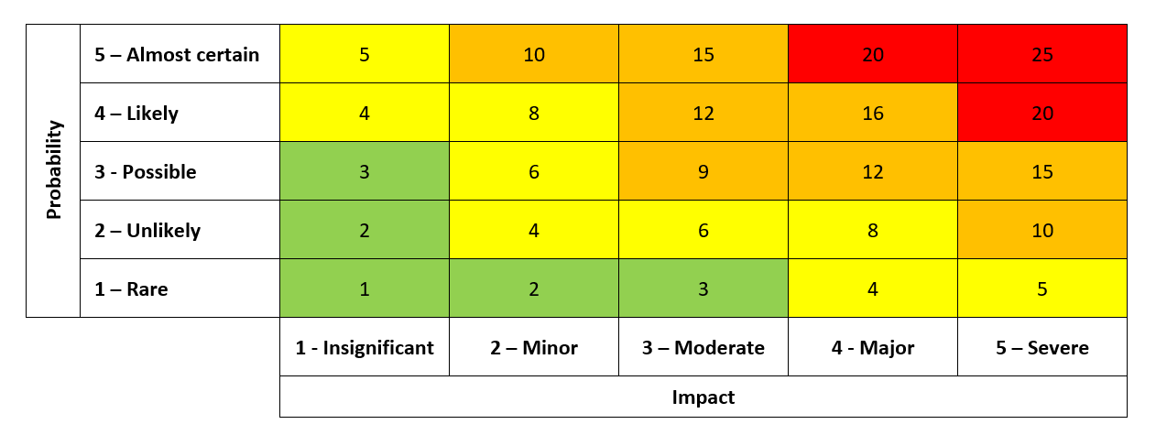
© Crown copyright 2023
www.gov.uk/dhsc
This publication is licensed under the terms of the Open Government Licence v3.0 except where otherwise stated. To view this licence, visit nationalarchives.gov.uk/doc/open-government-licence/version/3.
Where we have identified any third party copyright information you will need to obtain permission from the copyright holders concerned.

