Sustainability Strategy

rategy

2022-2025

The Insolvency Service2022-2025

The Insolvency Service

The Insolvency Service

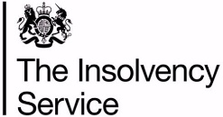

The Insolvency Service Sustainability Strategy 2022-2025

Foreword

By Chris Pleass – Director of Finance and Commercial

It is my great pleasure to present the Insolvency Service Sustainability Strategy, the first strategy of its type for our agency. Following on from the ratification of our Environmental Policy in March this year, this strategy sets out how we will deliver our environmental and wider sustainability objectives.

This strategy sets out our vision for a sustainable agency and the key themes that we have identified to enable us to deliver this vision. Our key themes are carbon and energy management, waste and resource management, sustainable procurement, sustainable travel, biodiversity and nature recovery, and a sustainable workforce. Each theme is accompanied by a set of objectives and targets that set out our plans for delivery. We are also committed as a partner agency to deliver the outcomes and targets set out in the BEIS Sustainability Strategy, and in the wider Greening Government Commitments.

We have a bold ambition to become a leading government agency for sustainability. We will do this by developing our estate into a low-carbon environment; by equipping our staff with the skills they need to become carbon literate citizens; by working with our supply chain to promote just societies and reduce waste and emissions; and by using our influence to promote sustainable behaviours amongst our customers.

As the chair of the Environmental Strategy Group, I am looking forward to steering the agency on this sustainability journey. Sharing our experience and learning with others, to meet our collective objectives for a sustainable society.

Table of Contents

- Introduction 4
  - About us 4
  - Our Vision for a Sustainable Future 5

- Our Approach 6
  - The Sustainable Development Goals 6
  - National Policy Obligations 7
  - Our Environmental Policy 7
  - Sustainability Review 8

- Leadership and Governance 8

- Scope 9
  - Our Estate 9
  - Our Employees 10
  - Our Customers 10

- Key Themes 11
  - Carbon and Energy Management 12
  - Waste and Resource Management 14
  - Sustainable Procurement 16
  - Sustainable Travel 18
  - Biodiversity and Nature Recovery 20
  - A Sustainable Workforce 22

- Monitoring and Reporting 23

- Appendices 24
  - A: Overview of Policy Development 24
  - B: Useful Links and Resources 24
  - C: Glossary of Terms 25

- Introduction
  - About us
The Insolvency Service is a Government Executive Agency, sponsored by the Department for Business, Energy and Industrial Strategy (BEIS). We are the government agency that provides services to those affected by financial distress or failure. We play a vital part in promoting long-term economic growth by dealing with financial failure and giving confidence to lend. We work across boundaries within government and collaborate with our partners in the insolvency sector. Our purpose is delivering economic confidence and we do this by:
- supporting those in financial distress
- tackling financial wrongdoing
- maximising returns to creditors.
Our agency strategy has seven strategic themes that underpin everything that we do and our plans for the future:

We have identified where the Sustainability Strategy can support the overarching agency strategy, and further details are included in sections 5 and 7.1 of this document.
  - Our Vision for a Sustainable Future
An agency that is resilient and adapted to a changing climate

A digital first agency providing equitable access to our services for all of our customers. An employer that promotes hybrid working and supports employees to choose sustainable transport options
An agency that collaborates across its supply chain to deliver social, economic and environmental benefits
An agency that uses resources wisely and applies circular economy principles
A carbon literate workforce that embeds the principles of sustainability into all of our activities
An agency that recognises and promotes the importance of nature and its links to improved employee wellbeing

- Our Approach

Sustainable development is a priority for us as an agency. We are committed to addressing the commitments set out internationally, nationally, and by us as an agency. We recognise that it is a shared responsibility, and that our employees will need the knowledge and skills to integrate sustainability into the activities and decisions that we undertake.

  - The Sustainable Development Goals

In 2015, United Nation member states agreed a shared agenda for Sustainable Development. Central to this was the determination of 17 shared goals, the Sustainable Development Goals or SDGs. These 17 SDGs are an urgent call to all nations to recognise that ending poverty, reducing inequalities, improving health, and tackling the climate crisis must be factored into all decision-making if we are to achieve a safe and just society.

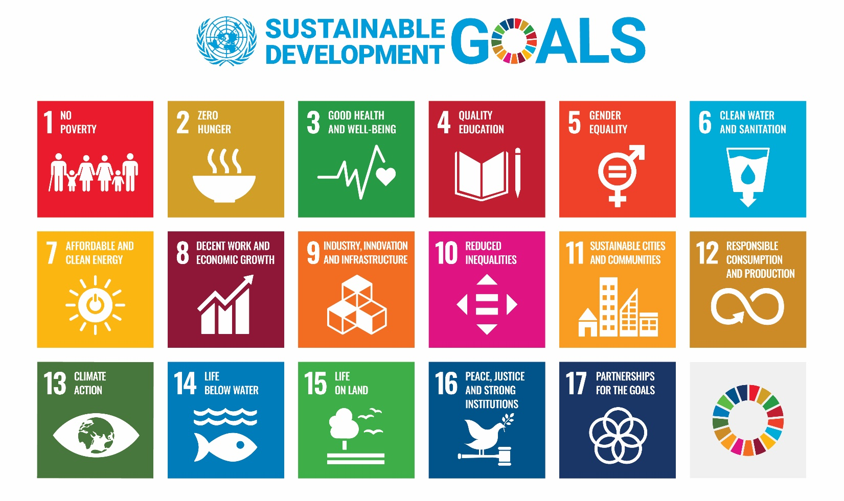
As a government agency we have a responsibility to help to deliver the SDGs. We have incorporated the SDGs into the development of this Strategy and as an agency we are committed to playing our part in their delivery. In section 5, we have highlighted the relevant SDGs and how we can deliver change through our daily business activities, by how we manage our estate, and via our supply chain.

  - National Policy Obligations

We have a number of key government requirements that we have to meet including the Greening Government Commitments (GGCs), The Climate Change Act (2008), The Ten Point Plan for a Green Industrial Revolution (2020), Build Back Better (2021), Waste Regulations, the Environmental Act (2021), and the 25 Year Environment Plan. Additionally, as a partner organisation to BEIS, we are also fully committed to helping in the delivery of the BEIS Sustainability Strategy 2021/22 – 2025/6. We have as a minimum aligned our objectives and targets accordingly.

  - Our Environmental Policy

Here at the Insolvency Service we are committed to protecting and enhancing the environment both locally and globally. In March 2022, our Executive Leadership Team endorsed a new Environmental Policy to clearly set out our objectives in this area. In this respect we will make every effort to:

EP1. Reduce the impact of our activities on global environmental issues such as climate change, resource depletion, loss of habitat and biodiversity.
EP2. Prevent environmental pollution arising from our own operations by meeting the requirements of all relevant environmental legislation and use our powers to minimise the impact of others.
EP3. Minimise the volume of waste generated by the Agency, whilst embedding the Waste Hierarchy of Reduce, Re-use and Recycle into all our waste procedures.
EP4. Preserve and enhance biodiversity on our sites where we have the opportunities and scope to do so.
EP5. Encourage the use of sustainable modes of transport or consider alternative working practices where practical e.g. proportionate hybrid working, to mitigate the environmental impact of travel.
EP6. Support environmental initiatives that improve health and wellbeing.
EP7. Encourage the reduced consumption of natural resources, water and energy.
EP8. Operate a procurement policy that minimises the use of environmentally damaging products, packaging and services by considering whole life costs; encourages the reuse and use of recycled materials; and incorporates Social Value considerations within procurement activities.
EP9. Provide information and support to staff and customers to promote the skills and knowledge required for sustainable development.
EP10. Commit appropriate levels of staff and financial resources to deliver the aims of the environmental policy.
EP11. Develop strategic partnerships with local, regional and national organisations to improve the management of environmental issues.
EP12. Review the Environmental Policy every three years and annually assess the effectiveness of our [this] Sustainability Strategy to reflect the current objectives and targets of the Agency.

The Sustainability Strategy builds upon this earlier work and sets out how we intend to deliver against each of these objectives, whilst setting them into the wider sustainability agenda.

  - Sustainability Review

The agency has recently completed a Sustainability Review. This included a mapping exercise of all the agency’s activities, across each of the nine Directorates. These activities were identified via interviews with existing colleagues and via two separate sustainability workshops. For each identified activity that the agency undertakes, the associated environmental and social impacts (positive and negative) have been identified.

There has also been a review of current agency policies and targets to ascertain if any existing management controls are effective in reducing or mitigating our impacts. This Strategy sets out how we are going to measure, monitor and manage these impacts, and also fulfil any associated legal compliance obligations. Recommendations for future policies and targets have been established where existing management controls are absent or deemed currently ineffective.

- Leadership and Governance

Our sustainability aims and objectives are set and delivered through a number of strategic groups. Our Board, Executive Leadership Team, Environmental Strategy Group, Sustainable Procurement Working Group and Environmental Champion network; are responsible for the leadership, support, oversight and implementation of this Strategy. However, we recognise that every employee has a role to play, whether directly employed by us or working for one of our suppliers.

- Scope

We have recently established two new groups to shape and deliver our path towards sustainable development. The Environmental Strategy Group provides strategic leadership on local and global environmental issues in support of the agency’s Sustainability Strategy and associated Environmental Policy. The group informs policy development and sets our environmental priorities including reducing energy costs and our path to Net Zero. Membership comprises of senior representatives from each directorate and importantly a representative from the newly established Environmental Champions network.

We have set up a separate working group to embed the principles of this Strategy into all our procurement activities. We will benchmark our current practices against Defra’s Flexible Framework and identify how we as an agency can work with suppliers to improve sustainability in our supply chain.

Building upon the foundations established by our Grass Roots employee network, we will set up a new and invigorated employee led Environmental Champions network. We recognise that for the objectives of our Environmental Policy and Sustainability Strategy to be embedded throughout the agency, we will need well informed and committed staff. Our Environmental Champions will have the skills they need to feel empowered and supported in their role.

  - Our Estate

The agency is currently embarked on an estate rationalisation programme as our estate needs to evolve with the increased use of online and telephony channels by our employees, customers, and other stakeholders. We have more space than we need, and the costs of retaining and upkeeping sites that are not fully utilised is becoming less sustainable. Under our Transforming Workplaces (TWP) programme we will transition the estate over the next five years to 11 multi directorate and multifunctional Regional Centres. Ensuring that we maintain a presence in Wales, Scotland and each of the English regions is in line with wider Government requirements e.g. Rural Proofing and Levelling Up. Our Sustainability Strategy will be focused on delivery at these 11 locations:

Region/ Country | Location​ | Region/ Country | Location
East Midlands​ | Nottingham​ | South West | Exeter
Eastern | Ipswich​ | Wales | Cardiff
London | Stratford East​ | West Midlands | Birmingham
North East | Newcastle​ | Yorkshire and Humber | Leeds
North West​ | Manchester​ | Scotland | Edinburgh
South East | Croydon​

  - Our Employees

We currently employ approximately 1700 staff across the nine Directorates. We recognise how important a healthy, happy workforce is to deliver a sustainable agency. Our People Strategy aims to support the delivery of a diverse and inclusive work force. We want a workplace where everyone feels comfortable to be their authentic selves and share their experiences. Where everyone feels open to discuss issues that matter, where wellbeing is treated as a priority and where we have a culture that is inclusive and supported by a clear set of agency values and behaviours.

We have a Wellbeing Strategy ‘Wellbeing 4 Everyone’ that aims to:

- Create a safe and healthy working environment (at home or in the office) to improve physical and emotional wellbeing;
- Encourage and support our people to develop and maintain a healthy lifestyle;
- Support with manageable health problems or disabilities to maintain access to or return to work;
- Improve people satisfaction, recruitment and retention.

The Strategy is supported by dedicated Wellbeing leads, online accessible resources and advice, and a number of staff networks including ‘Break the Stigma’, Carers Network, LGBT Network Group, The Shed Men’s Network, and the Womens Network Group. We are working to ensure that all of our initiatives complement each other, including highlighting the links between the environment, employee health and wellbeing, and the economic sustainability of the agency.

  - Our Customers

Our vision is for the Insolvency Service to be at the centre of a fair, efficient, and effective insolvency system that is a global leader in insolvency solutions for citizens and for businesses; underpinned and supported by a profession that is recognised for the highest professional, technical, and ethical standards when carrying out its work. In its operations, we want the agency to provide value for money services to those affected by financial distress or failure, and for it to play an important role in supporting the integrity of the marketplace for business and citizens through its investigation and enforcement activities.

We administer debt solutions that help people get back on their feet, including debt relief orders (DROs) and bankruptcy orders and the work of our Official Receivers and Redundancy Payments Service plays a vital role in helping and supporting people in times of financial distress. Our Redundancy Payments Service provides crucial funds to people who have lost their jobs and whose employers cannot pay them statutory redundancy entitlements, primarily as a result of insolvency. Rogue directors who dissolve their companies and avoid paying liabilities including to their employees, creditors and the taxpayer, can now be pursued. New legislation has extended our powers, on behalf of the Business Secretary, to investigate, disqualify and prosecute company directors who abuse the company dissolution process.

Our ambitions include fewer avoidable insolvencies through new guidance and education initiatives upstream of financial failure by providing:

- A clear and accessible user journey for people in financial distress
- More connectivity across government and the insolvency industry to share best practice
- An insolvency framework that delivers the best outcomes possible for our stakeholders

In its first year, our Breathing Space scheme helped over 58,000 customers that were in financial difficulty. We have an opportunity as an agency to use our sphere of influence to help our customers even further. With increasing energy bills having an adverse effect on many of our customers, we have an opportunity as a government agency to provide additional support in the form of links to resources and energy efficiency advice e.g. signposting to The Energy Saving Trust, and Local Authority affordable warmth/fuel poverty schemes. This will not only help our customers make savings on their energy bills, but help to decrease greenhouse gas emissions in support of the Climate Change agenda, also promoting innovation and growth in the green jobs sector.

- Key Themes

We have identified six key thematic areas upon which our objectives and targets are focused. These are Carbon and Energy Management, Waste and Resource Management, Sustainable Procurement, Sustainable Travel, Biodiversity and Nature Recovery, and a Sustainable Workforce. These themes have been identified through the Sustainability Review of the agency’s activities and are key to both our vision for a Sustainable Agency (see section 1.2) and the objectives outlined in our Environmental Policy (see section 2.3).

  - Carbon and Energy Management

 | 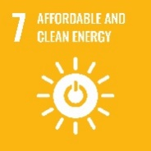 | 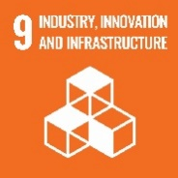 | 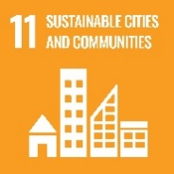 | 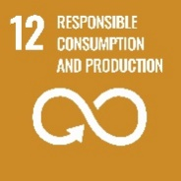 | 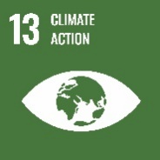 | 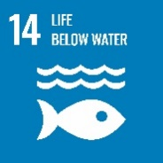
 | 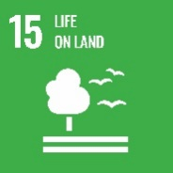

According to the latest report by the Intergovernmental Panel on Climate Change (IPCC, 2022), climate change is a grave and mounting threat to our wellbeing and our planet. The report concludes that human activities are causing climate change, and this change is resulting in more extreme weather events including heat waves, increased heavy rainfall, and more frequent and severe droughts. Fossil fuel based heating and electricity in commercial and residential buildings equates to approximately 20% of the global emissions of greenhouse gas emissions (GHGs), the main cause of climate change.
How big is your carbon footprint?

Take the WWF test now to see what you can do to make a difference: WWF Footprint Calculator

The UK Government were the first government to enshrine in law a national requirement to reduce GHGs. The Climate Change Act (2008) states that the UK will reduce carbon dioxide and other targeted GHGs emissions by at least 100% by 2050, from a 1990 baseline. Heating and electricity use in our offices is also the source of our Scope 1 and Scope 2 GHG emissions, of which we have a statutory requirement to reduce by 60% by 2024/5 from 2017/18 levels.

According to the World Health Organisation the use of fossil fuel based heating and electricity in our buildings is also contributing to excessive levels of air pollution in both the UK and globally. Furthermore, the Clean Air Act 2019 states that air pollution is the top environmental risk to human health in the UK. As a nation, moving away from fossil fuels will help to clean our air, and promote green growth and innovations in renewable alternatives. As an agency, reducing our reliance on fossil fuels will help us to play our part in delivering the Governments’ targets under the Clean Air Act and other associated commitments including The Climate Change Act (2008), The Clean Growth Strategy (2018) and the 25 Year Environment Plan.

Over 10% of the agency’s estates expenditure is spent on heating and powering our buildings (~0.5 M pa). Even with our future plans to rationalise the estate, increases in the cost of gas and electricity will mean that this is a considerable ongoing financial outlay to the organisation. By reducing our energy costs through efficiencies and other means, we will set the path for a more economically sustainable agency, with increased social value in terms of value for money for public expenditure.

Our Aim
An agency that is resilient and adapted to a changing climate.

Our Objectives | Targets
Establish our approach to achieving net zero.  Assess options for carbon offsetting in the context of achieving net zero.  Have effective energy management across our sites.  Support our staff to reduce their emissions while working from home.  Accountability - departments should establish clear lines of accountability for climate adaptation in estates and operations and engage in wider governance and risk structures when appropriate.  Improving the condition and sustainability of the existing estate where this offers good value for money, recognising that many of the buildings in use today will still be operational in 10-20 years’ time [Government Property Agency, GPA]  EP1 Reduce the impact of our activities on global environmental issues such as climate change, resource depletion, loss of habitat and biodiversity.  EP2 Prevent environmental pollution arising from our own operations by meeting the requirements of all relevant environmental legislation and use our powers to minimise the impact of others.  To reduce operational energy consumption and associated carbon emissions. | Reduce the overall greenhouse gas emissions by 62% from a 2017 to 2018 baseline and also reduce direct greenhouse gas emissions by 30% from estate and operations from a 2017 to 2018 baseline [by 2024/25].  Transfer all electricity supplies to 100% available  renewables tariffs, if available, by 2024/25.  Requirement for minimum energy DEC rating of B for newly refurbished offices [GPA].  New office refurbishments to be certified BREEAM ‘Very Good’ [GPA].  New cross-directorate Environmental Strategy Group established and to meet on a quarterly basis. 1st meeting September 2022.  Establish an accurate baseline of gas and electricity use at the 11 Regional Centres by 2023/24.  A new Carbon and Energy Management Plan/ Net Zero Strategy to be in place by 2024/25. The ‘Plan’ to include Science Based Targets to identify emission reductions required for our trajectory to Net Zero.  Identify measures to report on climate related financial risks and opportunities in decision making in line with TCFD reporting by 2023/24.  A new F Gas operational control procedure to manage our fugitive emissions and demonstrate legal compliance to be in place by 2023/24.  Identify energy efficiency measures for home workers, linked geographically to local support and resources where available. Online guidance to be made available by 2023/24.  Investigate developing staff home energy efficiency guidance for a wider audience e.g. Breathing Space customers by 2023/24.
Agency Strategic Themes 5, 6 and 7.
Note, wider government/ BEIS objectives and targets in italics.

  - Waste and Resource Management

 | 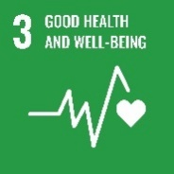 | 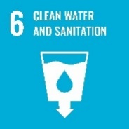 |  | 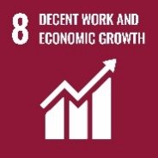

In line with a number of emerging governmental priorities including the Ten Point Plan, Build Back Better and Levelling Up; we have an opportunity to help to drive green growth and innovation by adopting the principles of a circular economy in the way that we manage our waste and resources.
According to WRAP, over half of us put items in the general waste that could otherwise be successfully recycled.

Transitioning towards a circular economy can bring about long-lasting benefits. The main principles of this approach are to eliminate waste and pollution, to circulate products and materials, and to regenerate nature; driving growth in the green jobs sector.

We will do this by managing and reducing the amount of waste that we produce in line with the Waste Hierarchy. We will aim firstly to prevent waste being generated where we can e.g. through behaviour change campaigns such as reducing the amount of paper that we use and water efficiency measures. We will aim to keep materials in use for as long as possible e.g. through redistribution or repair of goods and items. We aim to have a zero to landfill approach where items that cannot be re used in this way, become recirculated in the economy as components or raw materials. Through recirculation of raw materials we are reducing the need for further extraction, and helping to build an economy focused more on regeneration.

By adopting circular economy principles, we are helping to promote nature recovery and we are keen to further explore nature-based solutions in how we can adapt to a changing climate. More details on this will be included in our upcoming biodiversity and nature recovery plan (see section 5.5 for further details).

Our Aim
An agency that uses resources wisely and applies circular economy principles.

Our Objectives | Targets
Reduce paper consumption.  Reduce water consumption.  Reduce waste generation and increase recycling.  Have effective environmental management across our sites.  Increase efficient and sustainable use of resources.  Increase efficient and sustainable use of resources.  Reduce the environmental impact of our ICT equipment.  EP1 Reduce the impact of our activities on global environmental issues such as climate change, resource depletion, loss of habitat and biodiversity.  EP2 Prevent environmental pollution arising from our own operations by meeting the requirements of all relevant environmental legislation and use our powers to minimise the impact of others.  EP3 Minimise the volume of waste generated by the Agency, whilst embedding the Waste Hierarchy of Reduce, Re-use and Recycle into all our waste procedures.  EP4 Encourage the reduced consumption of natural resources, water and energy.  EP8 Operate a procurement policy that minimises the use of environmentally damaging products, packaging and services by considering whole life costs; encourages the reuse and use of recycled materials; and incorporates Social Value considerations within procurement activities.  EP9 Provide information and support to staff and customers to promote the skills and knowledge required for sustainable development.  EP11 Develop strategic partnerships with local, regional and national organisations to improve the management of environmental issues.  Move towards a paperless office environment in line with the agency’s digital first principles. | Achieve the GGC target of a 50% reduction in paper use by 24/25 from a 2017/18 baseline.  Ensure all water is measured by 24/25.  Carry out a qualitative assessment of water use to show how we are encouraging the efficient use of water by 24/25.  Achieve the GGC target of an 8% reduction in water use by 24/25 from a 2017/18 baseline.  Reduce the overall amount of waste generated by 15% by 24/25 from a 2017/18 baseline.  Reduce landfill to less than 5% of waste by 24/25 from a 2017/18 baseline.  Increase recycling to at least 70% by 24/25 from a 2017/18 baseline.  Report on the introduction of reuse schemes by 24/25.  Remove avoidable consumer single use plastics by 24/25.  Have effective environmental management across our sites (e.g. ISO14001) by 25/26.  Report on the adoption of the Greening Government: ICT and Digital Services Strategy and targets yearly.  A new Carbon and Energy Management Plan/ Net Zero Strategy to be in place by 2024/25. The ‘Plan’ to include Science Based Targets to identify emission reductions required for our trajectory to Net Zero.  Establish an accurate baseline for all waste streams in each regional centre by 2022/23.  Complete a waste matrix of all office waste in our regional centres by 2023/24.  New waste procedures (location specific – regional centres) for office waste in place by 2023/24.  New waste procedure for contractor waste included in TWP tender documents.  Prepare online guidance for home workers in respect to reducing waste and sustainable use of resources by 2022/23.
Agency Strategic Themes 5, 6, and 7.
Note, wider government/ BEIS objectives and targets in italics.

  - Sustainable Procurement

 | 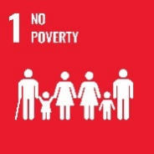 | 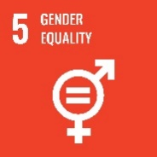 |  |  |  | 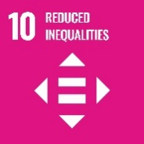

Almost a third of the agency’s annual expenditure is on the goods and services that we procure. The Public Services (Social Value) Act (2012) requires relevant public authorities that commission public service contracts to consider how they can secure wider social, economic and environmental benefits. To this end we will be incorporating opportunities to create Social Value in our procurement processes. We expect our suppliers to demonstrate transparency in their supply chains, ensuring that they are compliant with Health and Safety legislation and The Modern Slavery Act (2015). We also encourage suppliers to offer employment or development opportunities in support of our local communities and the Government’s agenda on Rural Proofing.

According to the Global Slavery Index, over 40.3m people are in some form of modern slavery, with up to 13,000 suspected cases in the UK alone.

We understand that the goods and services that we procure have an impact on the environment both locally and globally. Our new Environmental Policy (see section 2.3) sets out our objectives to reduce and mitigate these impacts. We also expect our suppliers to demonstrate how they will meet these objectives when operating on our behalf. Our suppliers must be both compliant with environmental legislation e.g. the Waste Regulations and The Finance Act 2021; and demonstrate alignment with existing and upcoming International and National priorities e.g. the Sustainable Development Goals (SDGs) and the UKs 25 Year Environment Plan. We also expect our suppliers to demonstrate best practice and support innovative approaches including the application of Circular Economy Principles.

Our suppliers will demonstrate value for money, though this does not necessarily mean that the cheapest bid will be awarded a contract. We expect our suppliers to demonstrate both price and quality in their submissions. In line with our role as an agency to ‘Deliver Economic Confidence’, we encourage suppliers to demonstrate how they will help to build sustainable businesses and support a growing green economy.

Our Aim
An agency that collaborates across its supply chain to deliver social, economic and environmental benefits.

Our Objectives | Targets
Meet the commitment to improve sustainable  procurement alongside the GGC targets.  EP8 To operate a procurement policy that minimises the use of environmentally damaging products, packaging, and services by considering whole life costs; encourages the reuse and use of recycled materials; and incorporates Social Value considerations within procurement activities. | To establish a cross-directorate working group to develop an agency-wide Sustainable Procurement Policy. New Sustainability Procurement Working group to meet on a quarterly basis. 1st meeting September 2022.  New Sustainable Procurement Policy in place by December 2023.  Apply a minimum 10% Social Value weighting to all tender documents in scope.  Apply a minimum 10% Environmental Sustainability weighting to all tender documents in scope.  Benchmark the agency against the Defra Flexible Framework and identify targets for continuous improvement by June 2023.  Identify measures to report on climate related financial risks and opportunities in decision making in line with TCFD reporting by 2023/24.
Agency Strategic Themes 5,6, and 7.
Note, wider government/ BEIS objectives and targets in italics.

  - Sustainable Travel

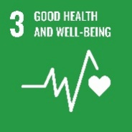

Transport is the largest source of air and noise pollution in the UK. It also a considerable source of the UK’s greenhouse gas emissions. According to Public Health England, switching more journeys to walking or cycling will improve physical and mental wellbeing, whilst reducing both local air pollution and carbon emissions.

Motorised transport accounts for 27% of the UKs greenhouse gas emissions and is the largest source of noise and air pollution.

The agency’s business travel and commuting activities account for a large proportion of our carbon emissions. We already operate a hybrid working policy that allows for proportionate home working, reducing the need for our employees to travel into our offices. We will build upon this further with a new Sustainable Travel Plan to help our employees to explore more sustainable choices when commuting into work.
We are also working to avoid unnecessary travel by our customers. Our ‘Digital First’ programme is providing customers with what they need through greater automated communication and self-serve opportunities. The benefits of this work will be felt by both our customers and our people. Customers will be able to engage with us via channels that are convenient for them and fit their needs. Our efforts can be focused on handling complex enquiries rather than processing enquiries and chasing missing information, potentially also reducing our operational costs.

Our Aim
A digital first agency providing equitable access to our services for all of our customers. An employer that promotes hybrid working and supports employees to choose sustainable transport options

Our Objectives | Targets
Minimise the impact of staff commuting and encourage the use of efficient modes of transport that reduce environmental impact, traffic congestion and air pollution.  EP1 Reduce the impact of our activities on global environmental issues such as climate change, resource depletion, loss of habitat and biodiversity.  EP2 Prevent environmental pollution arising from our own operations by meeting the requirements of all relevant environmental legislation and use our powers to minimise the impact of others.  EP5 Encourage the use of sustainable modes of transport or consider alternative working practices where practical e.g. proportionate hybrid working, to mitigate the environmental impact of travel.  EP6 Support environmental initiatives that improve health and wellbeing.  EP7 Encourage the reduced consumption of natural resources, water and energy.  EP9 Provide information and support to staff and customers to promote the skills and knowledge required for sustainable development. | Meet the GGC target of reducing the distance travelled by domestic business flights by at least 20%, and report distance travelled by international business flights by 24/25.  Assess options for carbon offsetting in the context of achieving net zero in respect to business travel by 24/25  New agency Sustainable Travel Plan in place by 2023/24.
Agency Strategic Themes 5, 6 and 7.
Note, wider government/ BEIS objectives and targets in italics.

  - Biodiversity and Nature Recovery

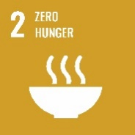

The UK is one of the most nature depleted countries in the world, ranking 189thout of 218 countries and territories (WWF).
According to the latest Living Planet Index (2020) we have seen a global decrease in species abundance of 68% since 1970. This is as a direct result of human intervention including habitat loss and climate change. The UK is one of the worst performing countries in terms of biodiversity. 41% of UK animal species are in decline and 1 in 10 are threatened with extinction.

The Government’s 25 Year Environment Plan sets out its long-term goals to protect and enhance the UK’s natural landscapes and habitats. This includes looking at how we manage our green spaces and how we can create new habitats for wildlife. Our environment can help to deliver real economic benefits, both in delivering opportunities to manage our carbon e.g. from rewilding, through to promoting new green jobs.

There is also strong evidence that access to nature can help to improve our health and wellbeing. The mental health charity MIND states that nature can improve our mood, reduce stress, and improve confidence and self-esteem. Through our Transforming Workplaces Project, we will identify opportunities to enhance and promote biodiversity and access to green space at our regional locations. We will also support volunteering activities that staff can undertake to increase their access to nature.

As part of our role as a government agency, we will develop a biodiversity and nature recovery plan. Not only to address how we might promote nature on our estate, but how we might develop partnerships with other agencies and organisations to promote and conserve nature on a larger scale in line with the Government’s 25 Year Environmental Plan, and the government’s support of the United Nations pledge to reverse biodiversity loss by 2030.

Our Aim
An agency that recognises and promotes the importance of nature and its links to improved employee wellbeing

Our Objectives | Targets
All other departments and partner organisations should consider what they can do to support the government’s commitment to improve nature and develop and deliver Nature Recovery Plans for their organisations, where suitable.  EP1 Reduce the impact of our activities on global environmental issues such as climate change, resource depletion, loss of habitat and biodiversity.  EP2 Prevent environmental pollution arising from our own operations by meeting the requirements of all relevant environmental legislation and use our powers to minimise the impact of others.  EP4 Preserve and enhance biodiversity on our sites where we have the opportunities and scope to do so.  EP6 Support environmental initiatives that improve health and wellbeing.  EP7 Encourage the reduced consumption of natural resources, water and energy.  EP9 Provide information and support to staff and customers to promote the skills and knowledge required for sustainable development. | Prepare a Nature Recovery Plan to include plans across estates to manage public land for nature and care for natural assets by 22/23.  New Biodiversity and Nature Recovery Plan (to include office greening, and links to locally accessible green space, footpaths and cycle paths for each Regional office location) in place by 2022/23.  Promote the agency’s volunteering scheme to increase uptake of staff volunteering in sustainable activities.
Agency Strategic Themes 5 and 6.
Note, wider government/ BEIS objectives and targets in italics.

  - A Sustainable Workforce

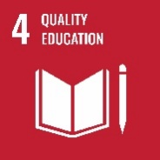

A sustainable organisation aims to enhance societal, environmental and economic systems. One of the agency’s main objectives is to deliver economic confidence. To do this we need to ensure that we consider all aspects of sustainability in the decision-making process. We have undertaken a sustainability appraisal of our Five Year Plan and our TWP estate plan, and will continue to ensure that a sustainability appraisal of future plans and activities is undertaken as part of ‘business as usual’ practices.

According to the Chartered Institute of Personnel and Development, when employees are healthy, engaged and performing, an organisation is likely to get better results.

Our vision is that all of our employees are aware of our sustainability objectives and targets, and that they have the knowledge and support to identify what this means for their work and day to day activities. We will support our staff to become carbon literate by providing the resources and managerial support they need to undertake the appropriate training and learning. Furthermore, our new Environmental Champions will run focused campaigns and behavioural change programmes to increase staff awareness and action on our sustainability objectives.

We also have an opportunity to support our employees to bring about positive changes in their wellbeing and lives outside of work. Being carbon literate can help to influence decisions on how we heat and power our homes, what we eat, and how we travel. Staff will have the knowledge to improve their carbon footprints, their health and potentially reduce their household bills.

Our Aim
A carbon literate workforce that embeds the principles of sustainability into all of our activities

Our Objectives | Targets
EP1 Reduce the impact of our activities on global environmental issues such as climate change, resource depletion, loss of habitat and biodiversity.  EP2 Prevent environmental pollution arising from our own operations by meeting the requirements of all relevant environmental legislation and use our powers to minimise the impact of others.  EP6 Support environmental initiatives that improve health and wellbeing.  EP7 Encourage the reduced consumption of natural resources, water and energy.  EP9 Provide information and support to staff and customers to promote the skills and knowledge required for sustainable development.  EP10 Commit appropriate levels of staff and financial resources to deliver the aims of the environmental policy. | A new Environmental Champion Scheme in place by 2022/23 with a minimum of one employee per floor per regional centre.  Roll out carbon literacy training for all staff by 2023/24.  Work with Wellbeing leads to identify how the Sustainability Strategy can support the delivery of the agency’s Wellbeing Strategy ‘Wellbeing 4 Everyone’.  Undertake a sustainability appraisal of all large projects and programmes.  Promote the agency’s volunteering scheme to increase uptake of staff volunteering in sustainable activities.
Agency Strategic Themes 4, 5, 6, and 7.

- Monitoring and Reporting

The objectives, targets and key performance indicators associated with this Strategy will be owned and monitored by the agency’s Environmental Strategy Group (ESG). The ESG will produce an annual update report to ELT to ensure that the appropriate resources are available to implement the agency’s Sustainability Strategy.

The targets and objectives shared with the agency’s Annual Plan will also be reported on in the agency’s Annual Report.

- Appendices
  - Appendix A: Overview of Policy Development

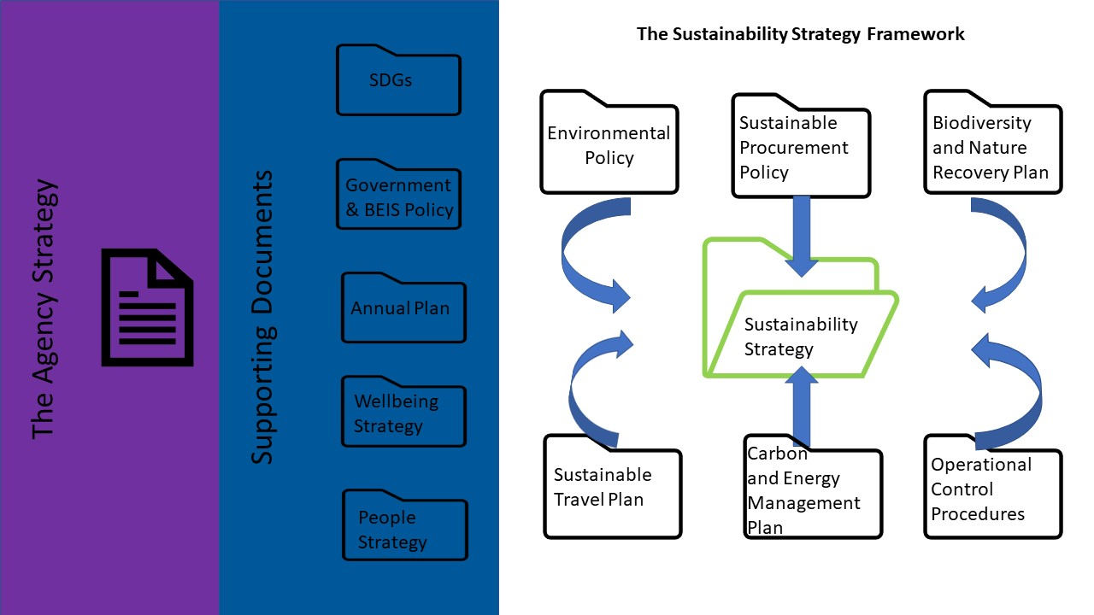

  - Appendix B: Useful Links and Resources

About us - The Insolvency Service - GOV.UK (www.gov.uk)

Department for Business, Energy & Industrial Strategy - GOV.UK (www.gov.uk)

Home - United Nations Sustainable Development

IPCC — Intergovernmental Panel on Climate Change

25-year environment plan - House of Commons Library (parliament.uk)

Biodiversity 2020: A strategy for England’s wildlife and ecosystem services - GOV.UK (www.gov.uk)

Build Back Better - our plan for growth (publishing.service.gov.uk)

Climate Change Act 2008 (legislation.gov.uk)

Home - Leaders Pledge for Nature

The Ten Point Plan for a Green Industrial Revolution (publishing.service.gov.uk)

Sustainable procurement in government: Guidance to the flexible framework - GOV.UK (www.gov.uk)

Task Force on Climate-Related Financial Disclosures | TCFD) (fsb-tcfd.org)

WRAP - The Climate Crisis: Act Now

Energy Saving Trust

Home - Sustrans.org.uk

Global Slavery Index

Corporate Standard | Greenhouse Gas Protocol (ghgprotocol.org)

Sector by sector: where do global greenhouse gas emissions come from? - Our World in Data

WWF Footprint Calculator

Biodiversity | WWF

Information & Support - Mind

Social value in procurement – Procurement Essentials - CCS (crowncommercial.gov.uk)

Introduction to line manager support materials for people professionals | Support materials | CIPD
  - Appendix C: Glossary of Terms

Circular Economy – is an economic model which will see us keeping resources in use as long as possible, extracting maximum value from them, minimising waste and promoting resource efficiency.

Climate Change – is a long-term shift in temperatures and weather patterns. These shifts may be natural, such as through variations in the solar cycle. But since the 1800s, human activities have been the main driver of climate change (through the greenhouse effect), primarily due to burning fossil fuels like coal, oil and gas.

Greenhouse Gases – are any gas that has the property of absorbing infrared radiation (net heat energy) emitted from Earth’s surface and reradiating it back to Earth’s surface, thus contributing to the greenhouse effect. Carbon dioxide, methane, and water vapour are the most important greenhouse gases (and to a lesser extent, surface-level ozone, nitrous oxides, and fluorinated gases which also trap infrared radiation). Many of these gases are associated with the burning of fossil fuels.

Intergovernmental Panel on Climate Change (IPCC) - is the United Nations body for assessing the science related to climate change. The IPCC prepares comprehensive Assessment Reports about the state of scientific, technical and socio-economic knowledge on climate change, its impacts and future risks, and options for reducing the rate at which climate change is taking place.

Rewilding - Rewilding seeks to reinstate natural processes and, where appropriate, missing species – allowing them to shape the landscape and the habitats within. Rewilding encourages a balance between people and the rest of nature. It can provide opportunities for communities to diversify and create nature-based economies; for living systems to provide the ecological functions on which we all depend; and for people to reconnect with wild nature.

Sustainability – is the integration of environmental health, social equity and economic vitality in order to create thriving, healthy, diverse and resilient communities for this generation and future generations.

Sustainable Development Goals - The 2030 Agenda for Sustainable Development, adopted by all United Nations Member States in 2015, provides a shared blueprint for peace and prosperity for people and the planet, now and into the future. At its heart are the 17 Sustainable Development Goals (SDGs), which are an urgent call for action by all countries - developed and developing - in a global partnership.

Version Control Information
Issue | Status | Date | Author
1 | First daft | 1st September 2022 | Dr Hannah Matthews, Head of Sustainability, INSS.
1 eds | First draft plus initial feedback | 18th October 2022 | Dr Hannah Matthews, Head of Sustainability, INSS.
Final | ELT and Board approval received | 29th November 2022 | Dr Hannah Matthews, Head of Sustainability, INSS.

