NOTICE OF ORDER

Wildlife and Countryside Act 1981 – Section 53
SUFFOLK COUNTY COUNCIL
Suffolk County Council (Parish of Great Cornard) Modification Order 2021

Notice is hereby given that the above referenced Order has been submitted to the Secretary of State for Environment, Food and Rural Affairs for determination. An Inspector will be appointed by the Secretary of State to determine the Order.

The start date for the above Order is 11 April 2023.

Consideration of the Order will take the form of a public local inquiry.

The Inquiry will be held at The Stevenson Centre, Stevenson Approach, Great Cornard, Sudbury, Suffolk, CO10 0WD on Tuesday 19 September 2023 at 10.00am.

Should it be necessary for you to attend virtually please contact the Order Making Authority; details are below. To take part using video, participants will need to have access to Microsoft Teams (via an app or web browser). The link https://support.microsoft.com/en-us/office/welcome-to-microsoft-teams-b98d533f-118e-4bae-bf44-3df2470c2b12 gives further information on how to use this. Alternatively, you can take part by telephone. Registered participants will receive individual joining instructions, providing details of any requirements, guidance and support, whether joining by Teams or telephone.

The effect of the Order, if confirmed without modifications, will be to modify the definitive map and statement for the area by adding a restricted byway from the junction with the U8625 Joe’s Road/Prospect Hill at Ordnance Survey Grid Reference (OSGR) 59001,23959, progressing in a north-westerly direction for 523 metres and terminating at a junction with footpaths 13 and 17 at OSGR 58966, 23993 as shown on the order map.

Any queries relating to this Order should be referred to Helen Sparks at The Planning Inspectorate, Rights of Way Section, Room 3/A Eagle Wing, Temple Quay House, 2 The Square, Temple Quay, Bristol, BS1 6PN. Telephone: 0303 444 5646.
Email: helen.sparks@planninginspectorate.gov.uk Please quote reference number ROW/3295952 on all correspondence.

Any person wishing to view the statements of case and other documents relating to this Order may do so by appointment at Phoenix House, 3 Goddard Road, Ipswich, Suffolk, IP1 5NP. The contact for any queries is Mr David Last on Telephone Number: 01473 264770 (Tue-Fri).

Timetable for sending in statements of case and proofs of evidence

Within 8 weeks of the start date by [by 6 June 2023]

The Order Making Authority must ensure their statement of case is received by the Secretary of State. As soon as possible after the deadline, the Secretary of State will send a copy (excluding copies of any supporting documents - these will be available to view at the Authority’s offices) to everyone who has made an objection or representation and the applicant and any other person who has written to us in respect of the Order.

Within 14 weeks of the start date [by 18 July 2023]

Everyone who has made an objection or representation and anyone who wishes to give evidence at the Inquiry must ensure their statement of case is received by the Secretary of State. As soon as possible after the deadline, the Secretary of State will send full copies to the Authority. Copies will also be sent to the applicant, every person who has made an objection or representation and any other person who has written to us in respect of the Order (excluding copies of any supporting documents - these will be available to view at the Authority’s offices).

Within the same period the applicant (if applicable) must ensure their statement of case is received by the Secretary of State. As soon as possible after the deadline, the Secretary of State will send a full copy to the Authority. Copies will also be sent to everyone who has made an objection or representation and any other person who has written to us in respect of the Order (excluding copies of any supporting documents - these will be available to view at the Authority’s offices).

4 weeks before the date of the inquiry [by 22 August 2023]

The Authority, everyone who has made an objection or representation, the applicant (if applicable) and anyone who wishes to give evidence at the Inquiry must ensure their proof of evidence (together with any summary) is received by the Secretary of State. As soon as possible after the deadline, the Secretary of State will send copies of:

- the Authority’s proof of evidence to everyone who has made an objection or representation, the applicant and anyone who has submitted a statement of case (excluding copies of any supporting documents – although none should be submitted with a proof of evidence);

- the applicant’s proof of evidence to the Authority, everyone who has made an objection or representation and anyone else who has submitted a statement of case (excluding copies of any supporting documents – although none should be submitted with a proof of evidence); and

- all other proofs of evidence to the Authority, the applicant, everyone who has made an objection or representation and anyone else who has submitted a statement of case (excluding copies of any supporting documents – although none should be submitted with a proof of evidence).

All parties must keep to the timetable set out above and ensure that statements of case and proofs of evidence are received by the Secretary of State on time. Late documents will be returned.

We cannot accept any libellous, racist or abusive comments. Any documents containing such comments will be returned.

Notice of order for inquiry

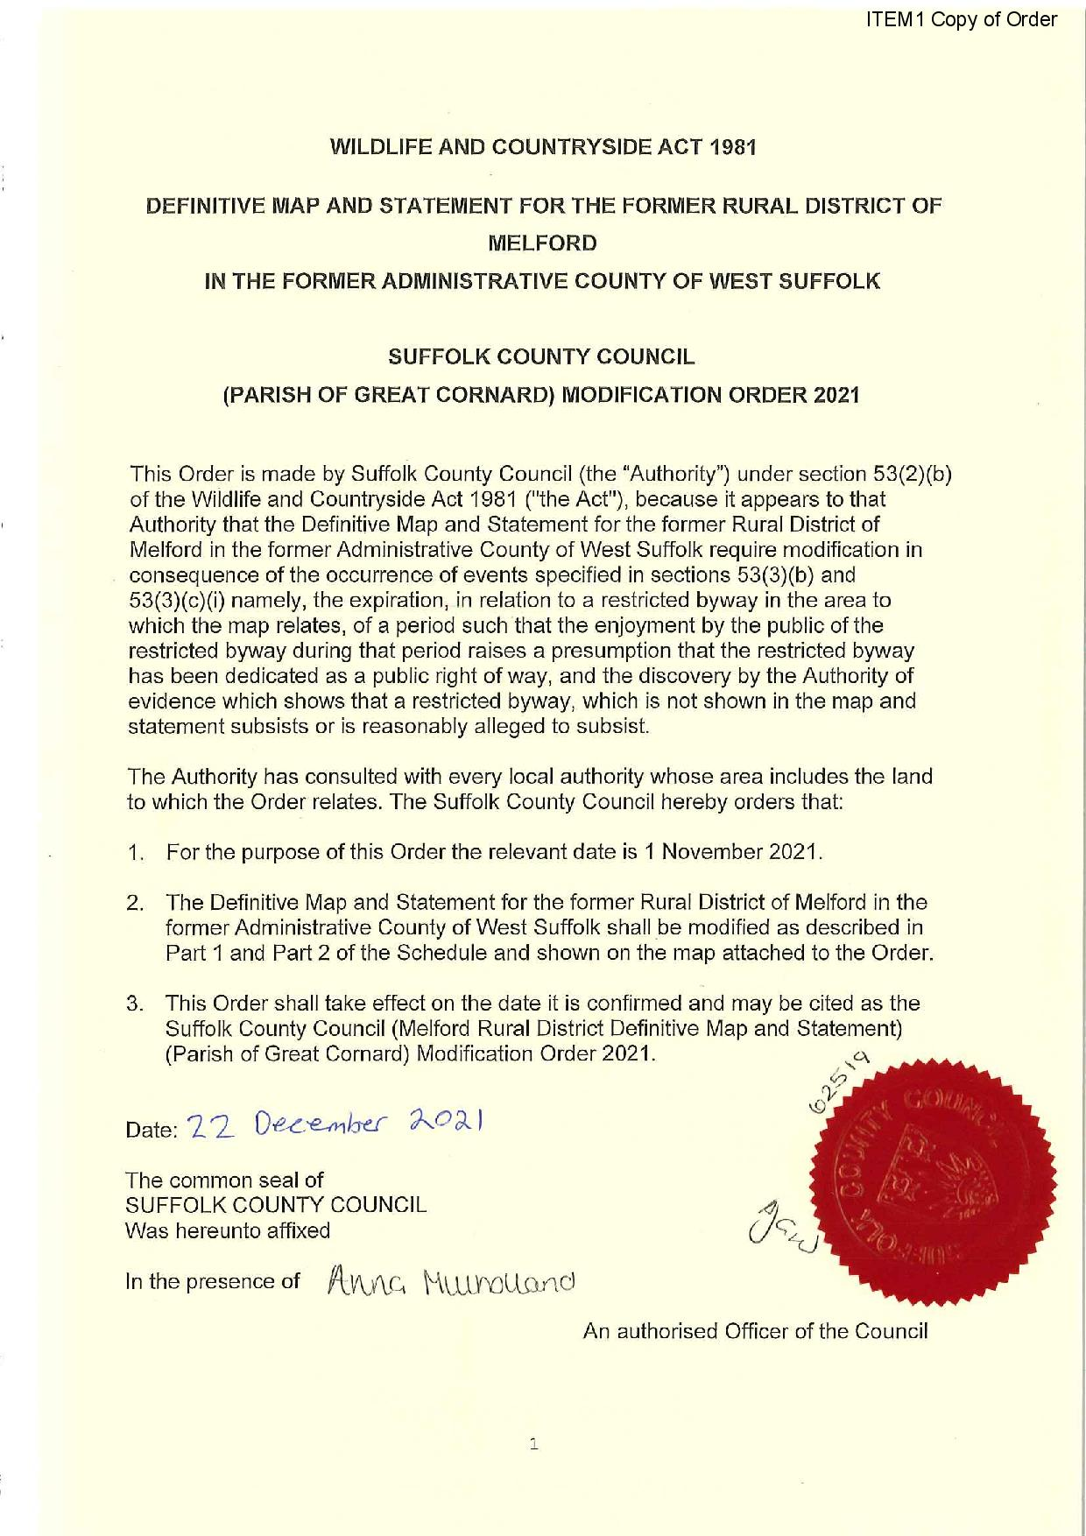

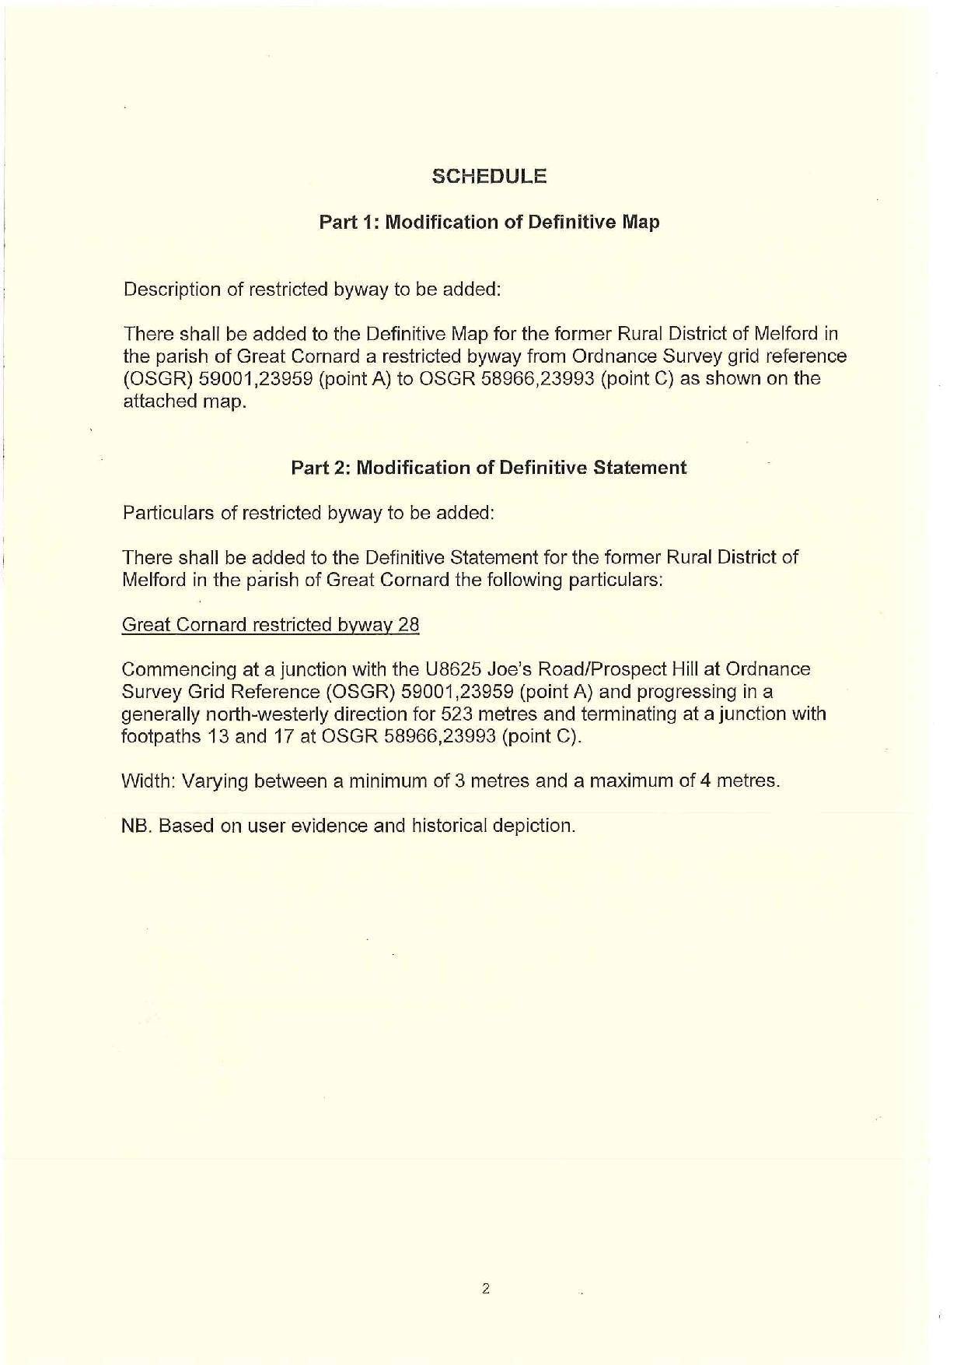

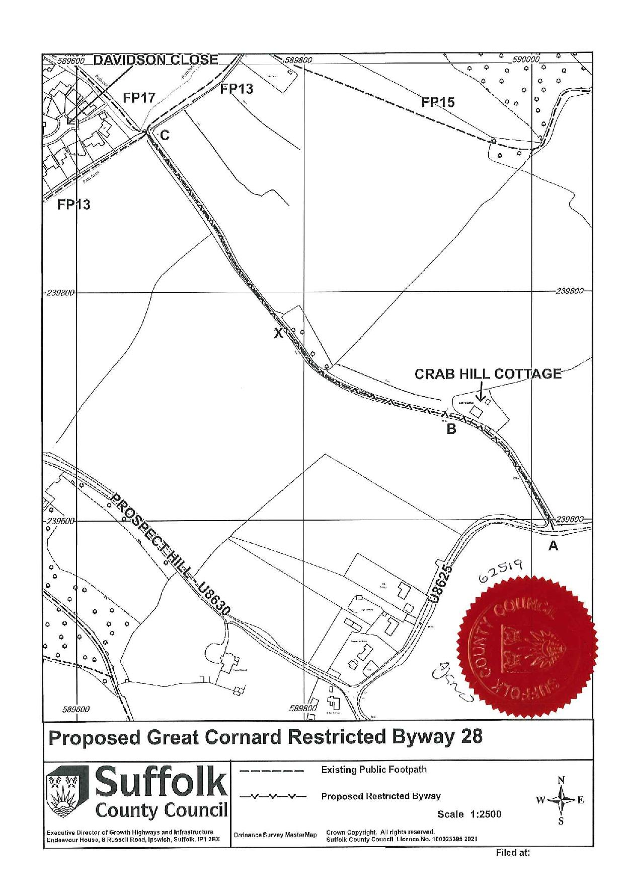



If you wish to make a legal submission, this should be submitted at the same time as your statement of case. Otherwise legal submissions will have to be submitted in writing on the day of the inquiry.

