NOTICE OF ORDER

Wildlife and Countryside Act 1981
Cumberland Council
Parish of Hayton - District of Carlisle Definitive Map Modification Order (No 3) 2020

Notice is hereby given that the above referenced Order has been submitted to the Secretary of State for Environment, Food and Rural Affairs for determination. An Inspector will be appointed by the Secretary of State to determine the Order.

The start date for the above Order is 25 April 2023

Consideration of the Order will take the form of a public inquiry.

The Inquiry will be held at The People First Conference Centre, Milbourne Street, Carlisle, CA2 5XB on 21st November 2023 at 10.00am (scheduled for 12 days Tuesdays – Fridays)

The effect of the Order, if confirmed without modifications, will modify the Definitive Map and Statement for the area by adding the following lengths of public footpath at Hayton Woods in the parish of Hayton:

from GR NY 5170 5775 south-eastwards and eastwards for about 342 metres to GR NY 5198 5765 then continuing eastwards for a further 189 metres to GR NY 5217 5766 then eastwards and north eastwards for about 258 metres to GR NY 5234 5778 then eastwards for about 42 metres to GR NY 5238 5778;

from GR NY 5182 5747 northwards for about 79 metres to GR NY 5182 5755 then northwards and northeastwards for about 213 metres to GR NY 5198 5765 then northnortheastwards and north-northwestwards for about 231 metres to GR NY 5196 5785;

from GR NY 5211 5744 northeastwards for about 117 metres to GR NY 5219 5752 then northeastwards and north-northeastwards for about 339 metres to GR NY 5238 5778 then north-northeastwards for about 143 metres to GR NY 5242 5792;

from GR NY 5217 5786 southwards for about 178 metres to GR NY 5216 5768 then south-southeastwards for about 28 metres to GR NY 5216 5766 and continuing southsoutheastwards to GR NY 5219 5752;

from GR NY 5182 5755 eastwards for about 389 metres to GR NY 5219 5752;

from GR NY 5216 5768 northeastwards eastwards and southeastwards for about 267 metres to GR NY 5234 5778;

from GR NY 5184 5805 south-southeastwards for about 91 metres to GR NY 5187 5797 and a further 127 metres to GR NY 5192 5785;

from GR NY 5196 5805 southwestwards for about 127 metres to GR NY 5187 5797;

from GR NY 5241 5794 eastwards for about 49 metres to GR NY 5246 5794 then continuing for a further 202 metres to GR NY 5267 5795;

from GR NY 5262 5825 southwards and southwestwards for about 156 metres to GR NY 5256 5812 then curving southwestwards for about 226 metres to GR NY 5246 5794;

from GR NY 5224 5841 northeastwards and east-northeastwards for about 344 metres to GR NY 5252 5858 then east-northeastwards and southwards for about 419 metres to GR NY 5264 5825;

from GR NY 5317 5738 north-northwestwards for about 248 metres to GR NY 5303 5759 then a further 291 metres to GR NY 5298 5783 then a further 324 metres to GR NY 5284 5809 turning north-northeastwards for about 327 metres to GR NY 5294 5840 then northnortheastwards and west-northwestwards for about 226 metres to GR NY 5283 5853 continuing west-northwestwards for about 370 metres to GR NY 5256 5867 then southsouthwestwards for about 106 metres to GR NY 5252 5858;

from GR NY 5282 5839 northwestwards for about 437 metres to GR NY 5256 5867;

from GR NY 5281 5834 southwestwards for about 156 metres to GR NY 5274 5820 then southeastwards and eastwards for about 184 metres to GR NY 5284 5809;

from GR NY 5271 5833 south-southwestwards for about 207 metres to GR NY 5264 5814 then southwards for about 198 metres to GR NY 5267 5795 then southeastwards for about 413 metres to GR NY 5296 5773;

from GR NY 5256 5812 east-northeastwards for about 84 metres to GR NY 5264 5814 then continuing east-northeastwards for about 120 metres to GR NY 5274 5820;

from GR NY 5298 5726 northwards for about 295 metres to GR NY 5292 5754 then northnortheastwards for about 201 metres to GR NY 5296 5773 then northeastwards northwestwards and eastwards for about 137 metres to GR NY 5298 5783; and

from GR NY 5303 5759 west-southwestwards for about 128 metres to GR NY 5292 5754. The width of the new sections of public footpath will be 1.8 metres.

And adding a new section of public bridleway at Hayton Woods in the parish of Hayton from GR NY 5282 5839 southeastwards and southwestwards for about 59 metres to GR NY 5281 5834 then east-northeastwards for about 150 metres to GR NY 5294 5840. The width of the new section of public bridleway will be 3 metres.

Any queries relating to this Order should be referred to Michael Edwards at The Planning Inspectorate, Rights of Way Section, Room 3/A Eagle Wing, Temple Quay House, 2 The Square, Temple Quay, Bristol, BS1 6PN. Telephone: 0303 444 0554. Email: michael.edwards@planninginspectorate.gov.uk. Please quote reference number ROW/3296708 on all correspondence.

Any person wishing to view the statements of case and other documents relating to this Order may do so by appointment at The Parkhouse Building, Kingmoor Business Park, Carlisle, Cumbria, CA6 4SJ. Contact Sandra Smith on sandra.smith@cumbria.gov.uk or on 07920 711254

Timetable for sending in statements of case and proofs of evidence

Within 8 weeks of the start date by [by 20 June 2023]

The Order Making Authority must ensure their statement of case is received by the Secretary of State. As soon as possible after the deadline, the Secretary of State will send a copy (excluding copies of any supporting documents - these will be available to view at the Authority’s offices) to everyone who has made an objection or representation and the applicant and any other person who has written to us in respect of the Order.

Within 14 weeks of the start date [by 01 August 2023]

Everyone who has made an objection or representation and anyone who wishes to give evidence at the Inquiry must ensure their statement of case is received by the Secretary of State. As soon as possible after the deadline, the Secretary of State will send full copies to the Authority. Copies will also be sent to the applicant, every person who has made an objection or representation and any other person who has written to us in respect of the Order (excluding copies of any supporting documents - these will be available to view at the Authority’s offices).

Within the same period the applicant (if applicable) must ensure their statement of case is received by the Secretary of State. As soon as possible after the deadline, the Secretary of State will send a full copy to the Authority. Copies will also be sent to everyone who has made an objection or representation and any other person who has written to us in respect of the Order (excluding copies of any supporting documents - these will be available to view at the Authority’s offices).

4 weeks before the date of the inquiry [by 24 October 2023]

The Authority, everyone who has made an objection or representation, the applicant (if applicable) and anyone who wishes to give evidence at the Inquiry must ensure their proof of evidence (together with any summary) is received by the Secretary of State. As soon as possible after the deadline, the Secretary of State will send copies of:

- the Authority’s proof of evidence to everyone who has made an objection or representation, the applicant and anyone who has submitted a statement of case (including copies of any supporting documents – although none should be submitted with a proof of evidence);

- the applicant’s proof of evidence to the Authority, everyone who has made an objection or representation and anyone else who has submitted a statement of case (including copies of any supporting documents – although none should be submitted with a proof of evidence); and

- all other proofs of evidence to the Authority, the applicant, everyone who has made an objection or representation and anyone else who has submitted a statement of case (including copies of any supporting documents – although none should not be submitted with a proof of evidence).

All parties must keep to the timetable set out above and ensure that statements of case and proofs of evidence are received by the Secretary of State on time. Late documents will be returned.

We cannot accept any inflammatory, discriminatory or abusive comments. Any documents containing such comments will be returned.

Notice of order for inquiry

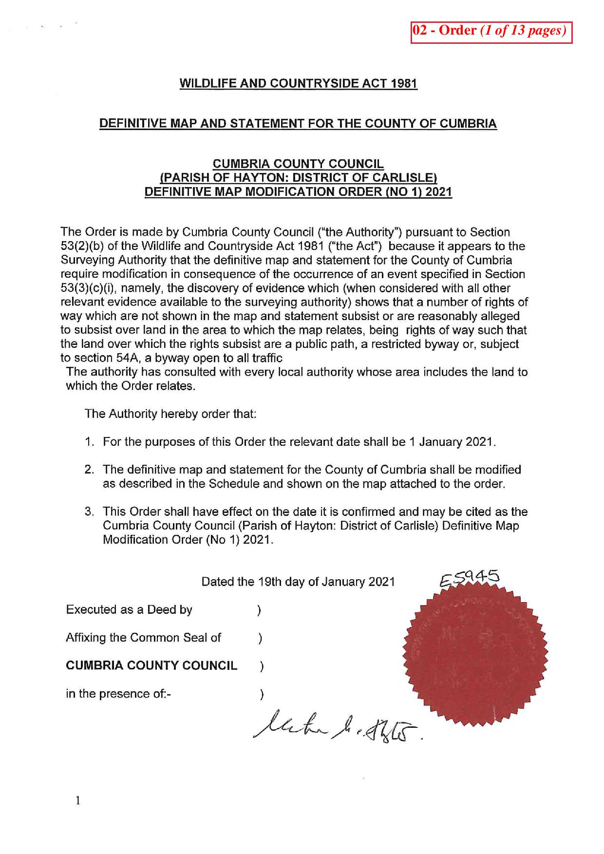

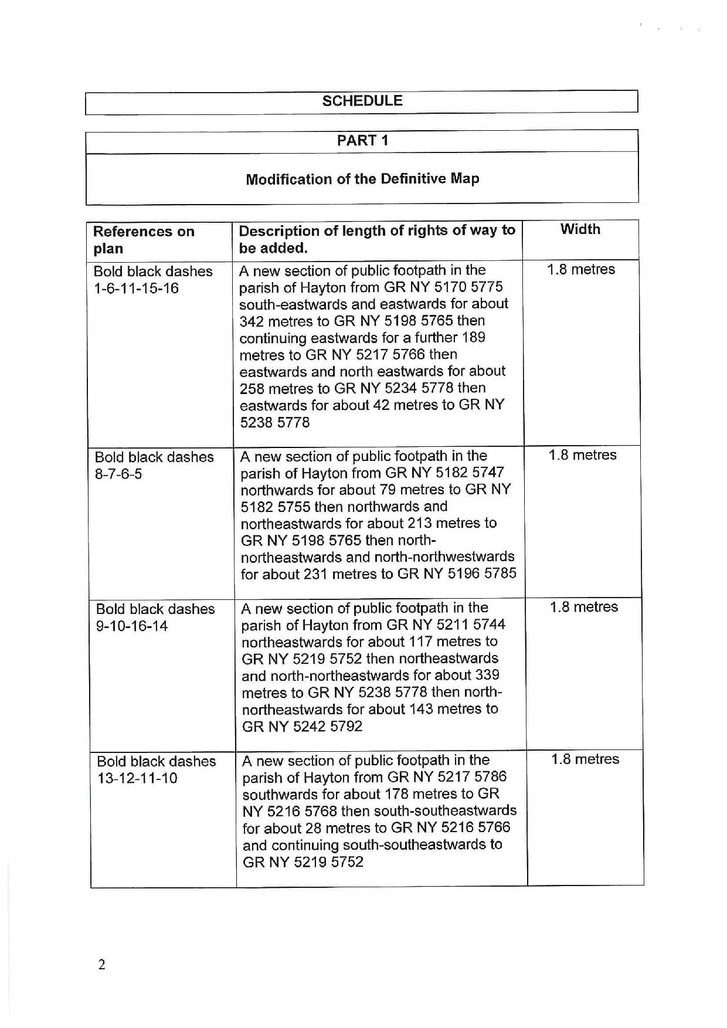

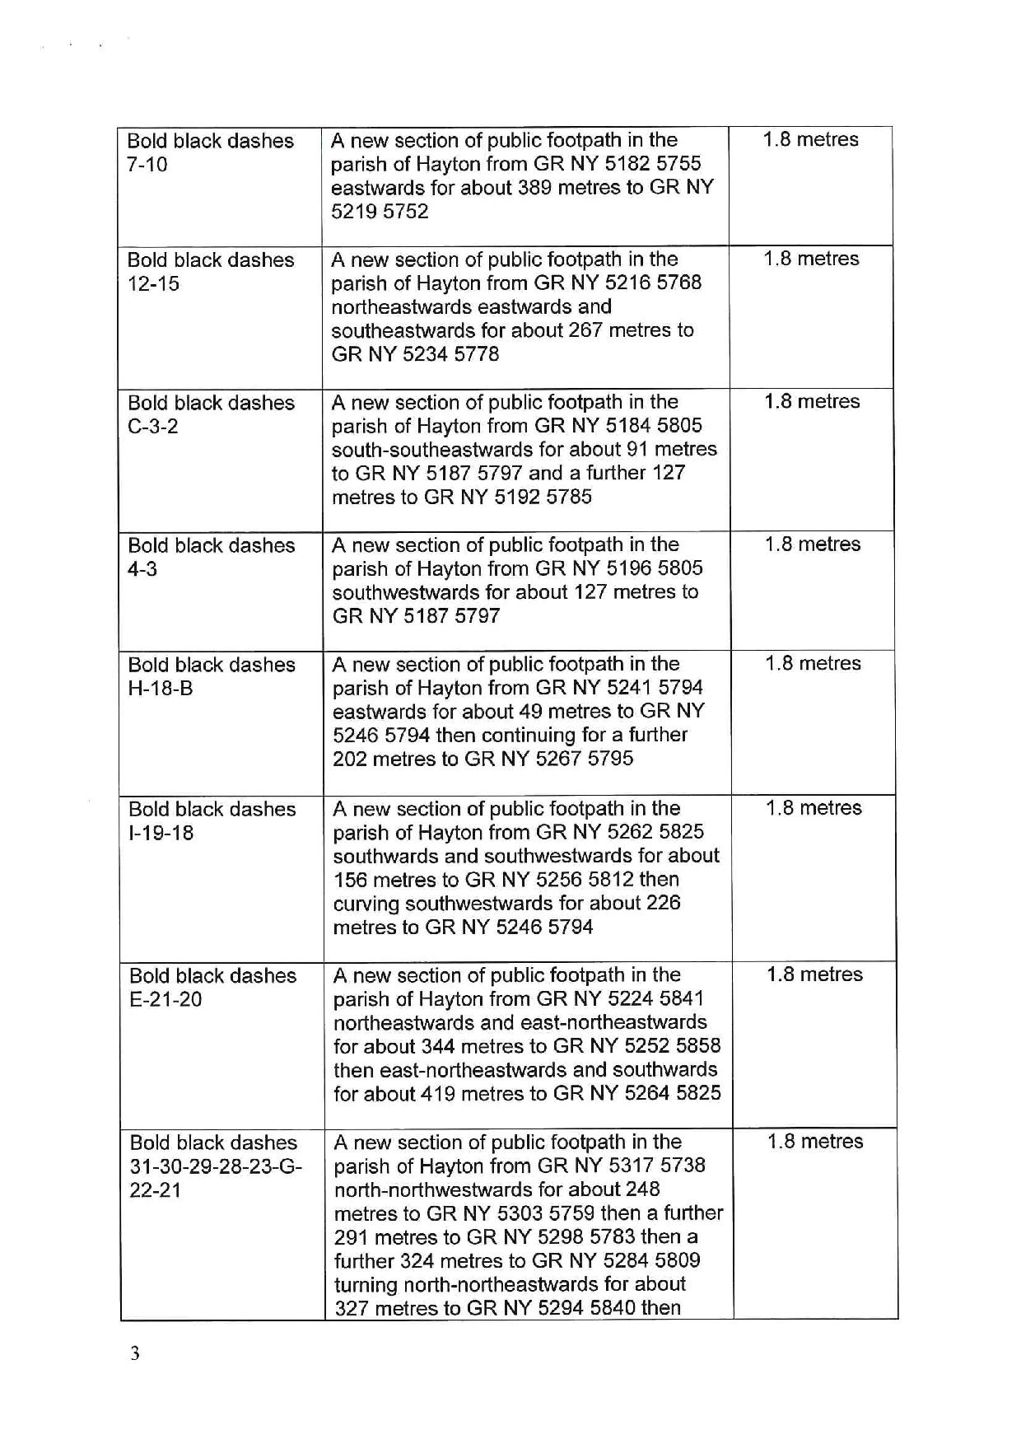

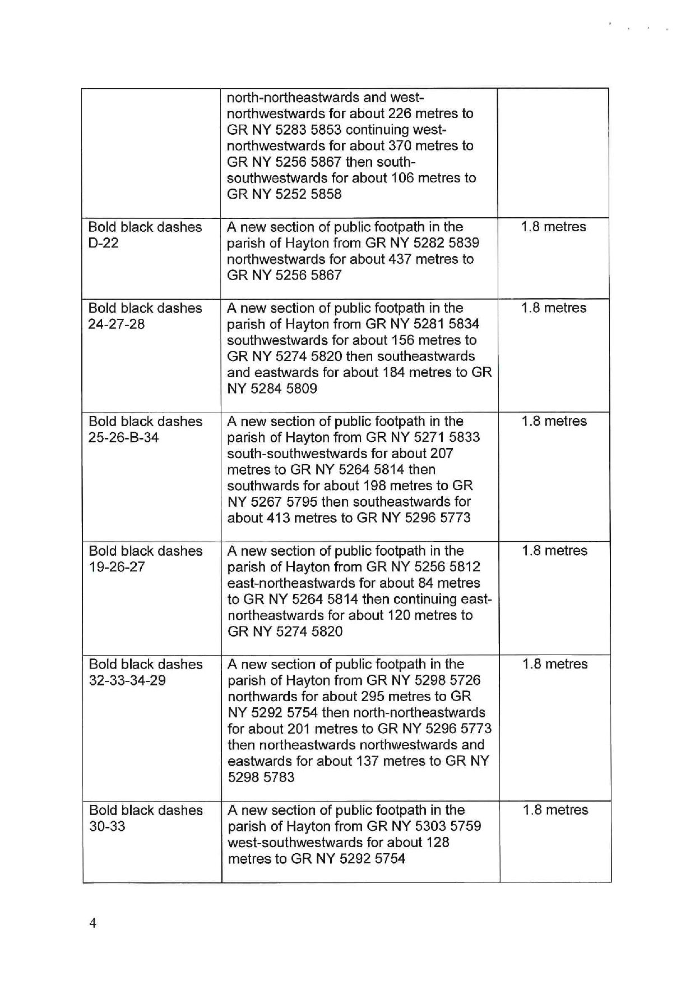

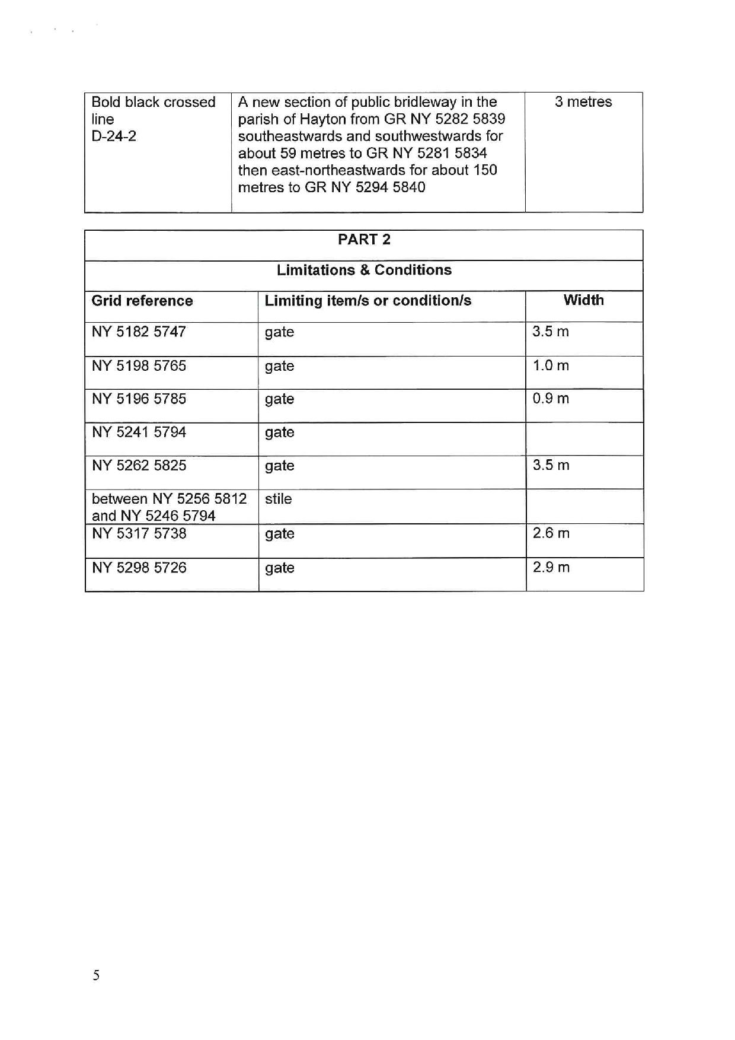

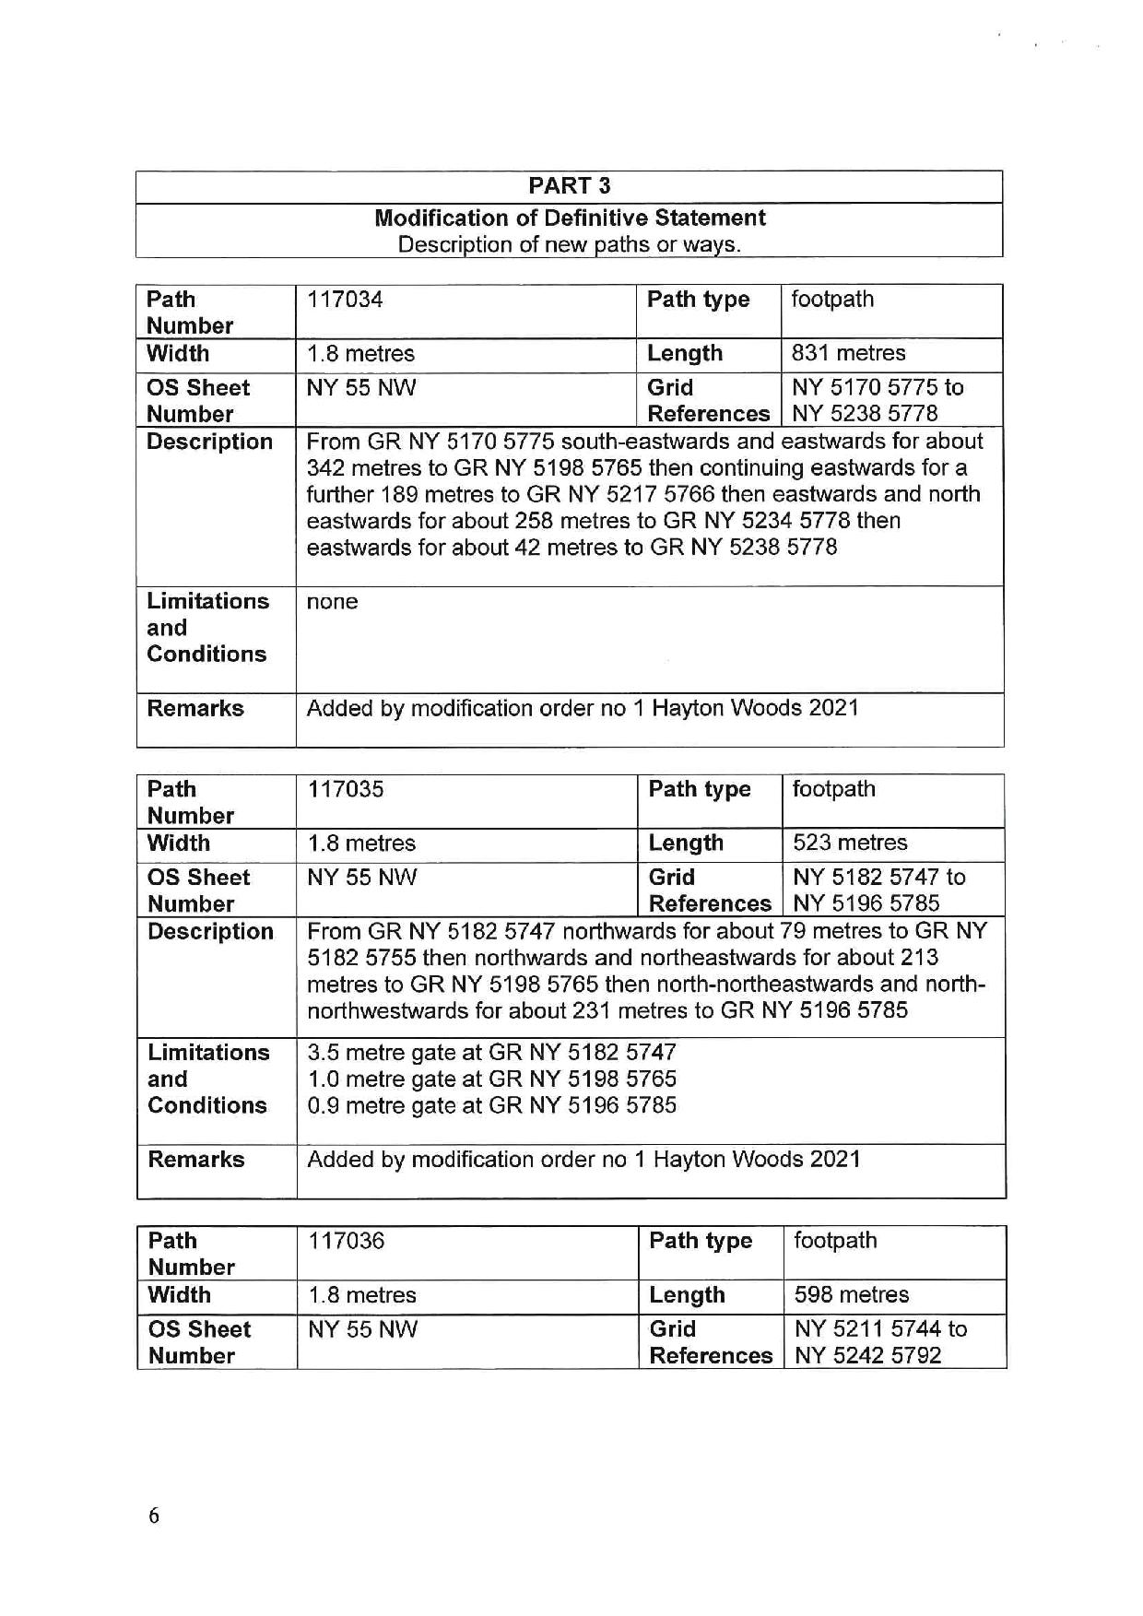

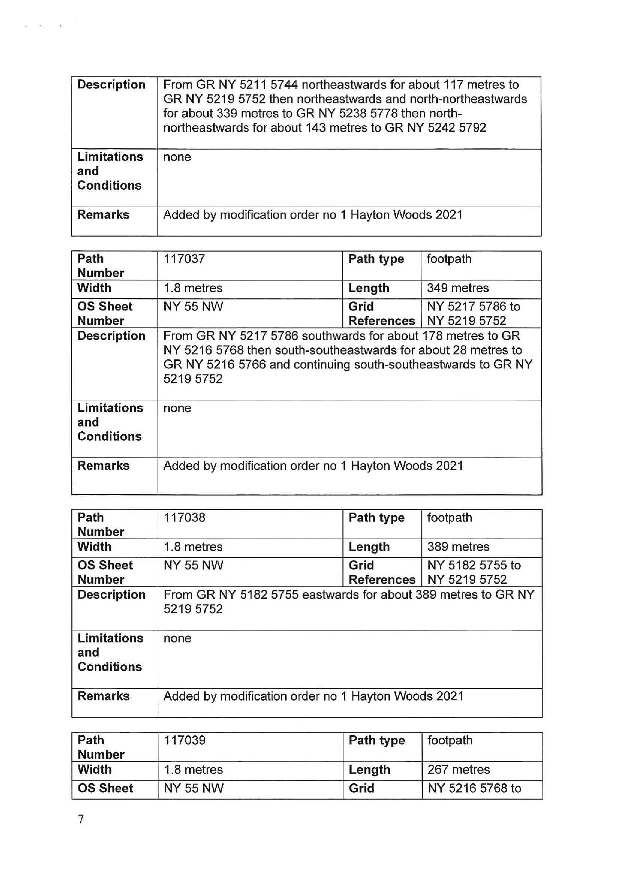

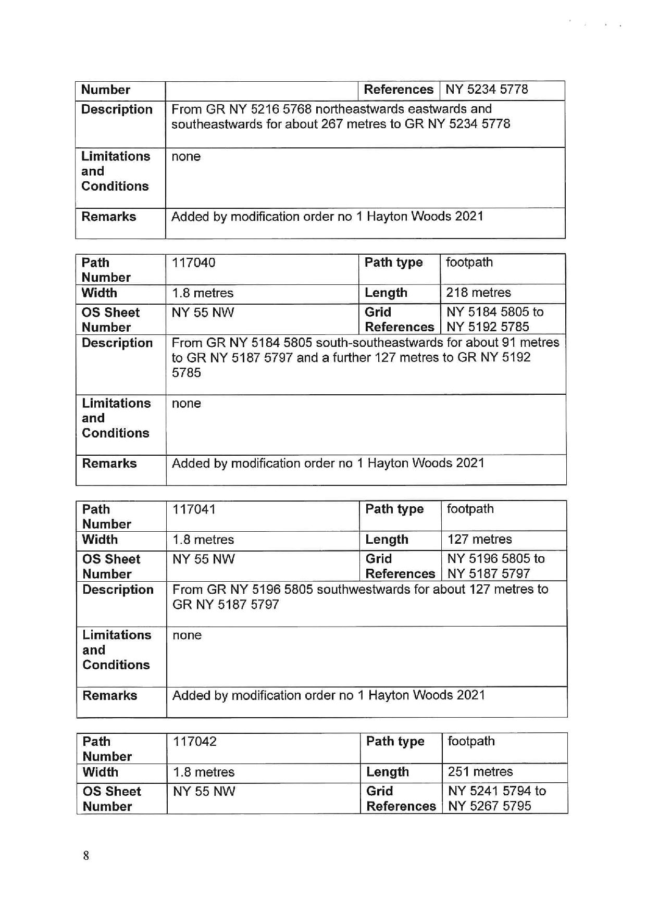

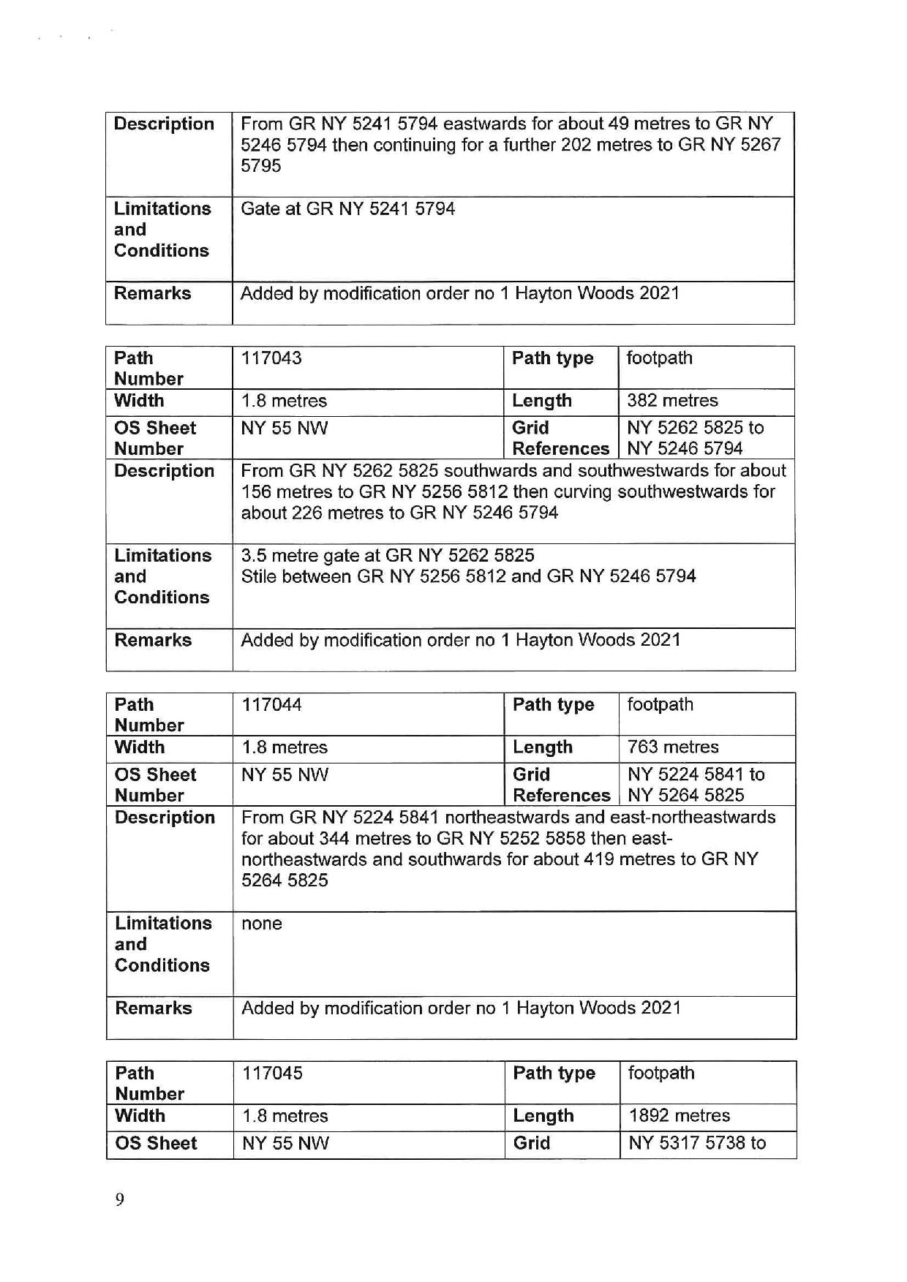

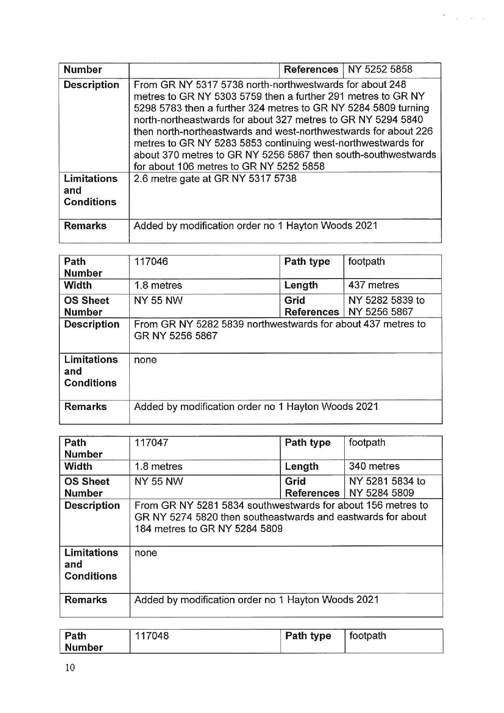

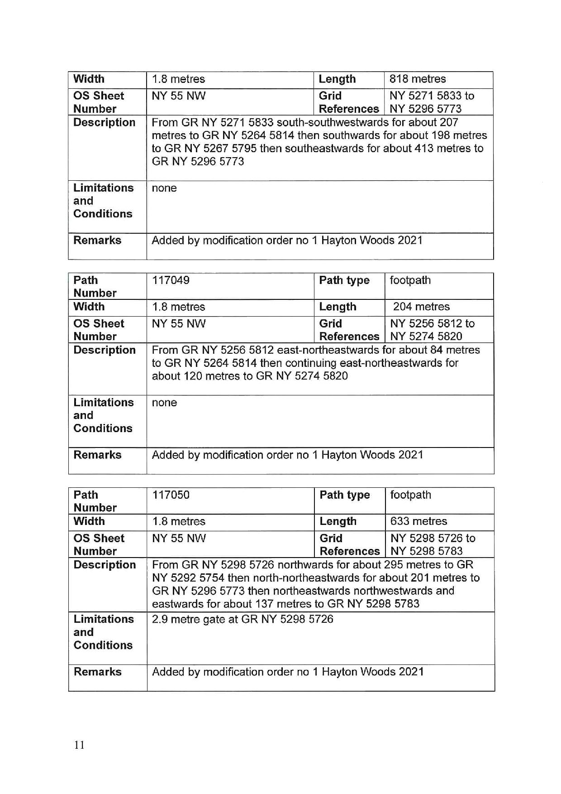

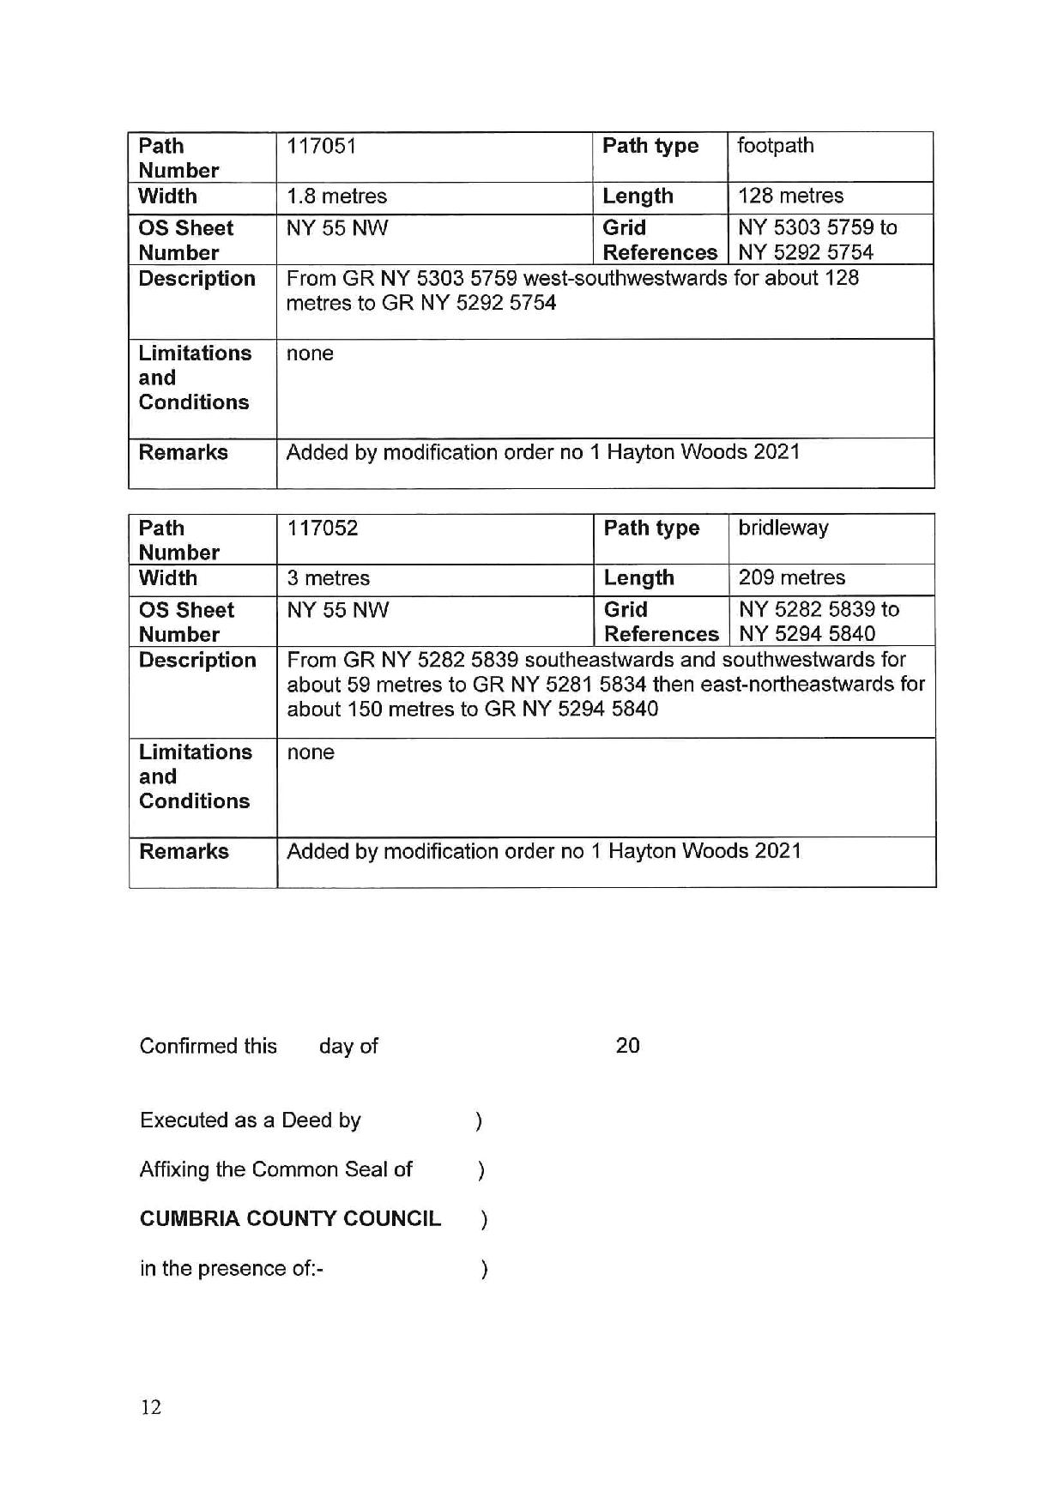

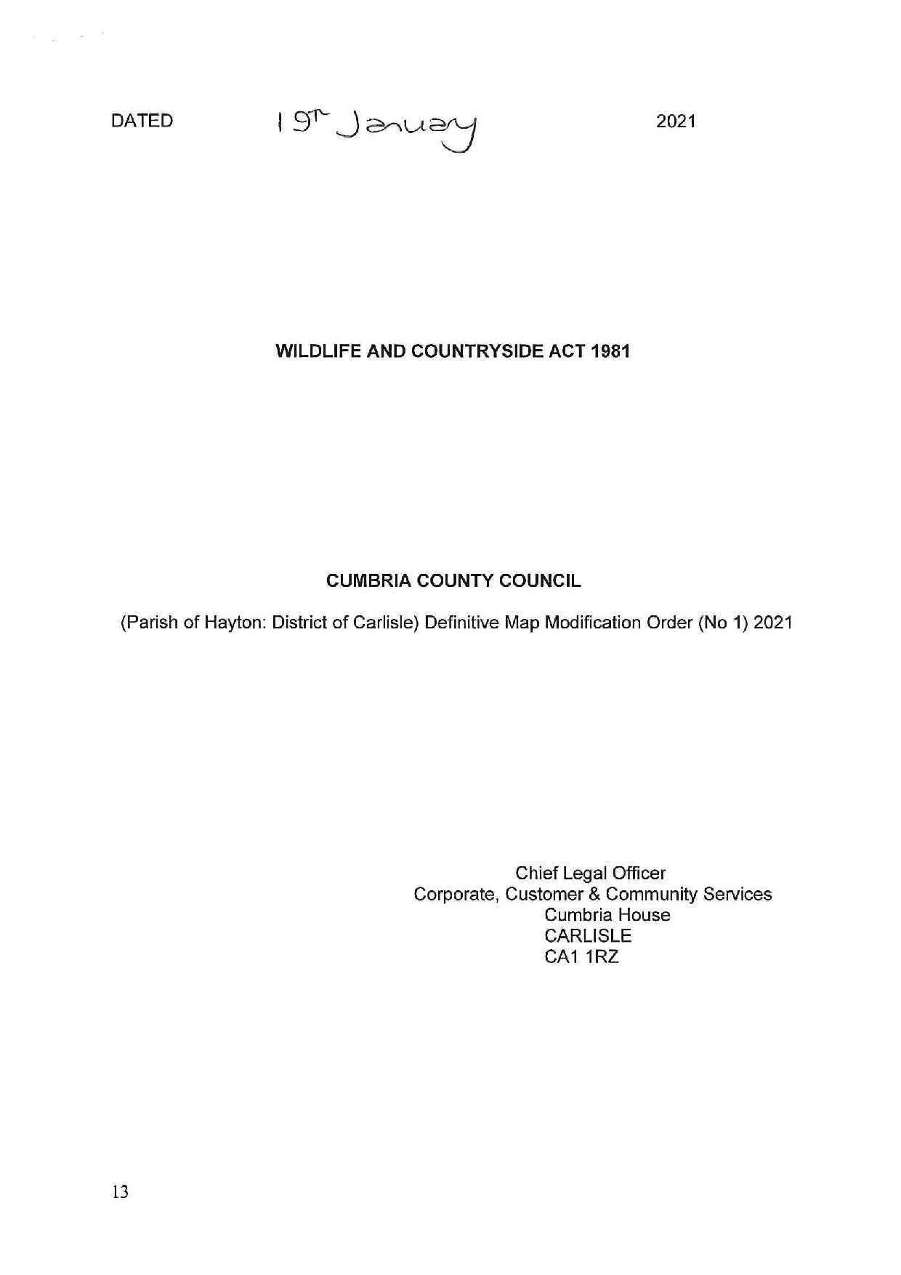

If you wish to make a legal submission, this should be submitted at the same time as your statement of case. Otherwise legal submissions will have to be submitted in writing on the day of the inquiry.

