NOTICE OF ORDER
Wildlife and Countryside Act 1981 Rotherham Metropolitan Borough Council
Rotherham Metropolitan Borough Council (Public Footpaths No. 38, 39, 40, 41, 42, 43 & 44 Kimberworth) DMMO 2021

Notice is hereby given that the above referenced Order has been submitted to the Secretary of State for Environment, Food and Rural Affairs for determination. An Inspector will be appointed by the Secretary of State to determine the Order.

The start date for the above Order is 6th March 2023

Consideration of the Order will take the form of a public local inquiry.

The Inquiry will be held at The Town Hall, The Crofts, Moorgate Street, Rotherham, S60 2TH on 19th September at 10.00am.

The effect of the Order, if confirmed without modifications, will be to modify the Definitive Map and Statement for the area by adding to them in the parish of Kimberworth.

- Footpath 38 from OSGR SK 3943 9399 at its junction with Droppingwell Road generally south south west then west direction for approximately 165 metres to a junction with Public Footpath No.20 at OSGR SK 3930 9391, the path has a width of 5 metres

- Footpath 39 from OSGR SK 39249392 at the junction with Public Footpath No.20, in a generally west north west for approximately 120 metres to OSGR SK 3914 9395 and continuing generally west for approximately 270 metres to OSGR SK 3887 9396 at its junction with Public Footpath 40. The path has a width of 5 metres from SK 3924 9392 to SK 3914 9395, the remaining length is 2 metres in width.

- Footpath 40 from OSGR SK 3914 9421 at a junction with Public Footpath 20, generally south west for approximately 360 metres to OSGR SK 3887 9396 at its junction with Public Footpath Nos. 39 and 41, the path has a width of 2 metres.

- Footpath 41 from OSGR SK 3887 9396 at its junction with Public Footpath Nos.39 and 40, generally south west then south for approximately 350 metres to OSGR SK 3869 9365 at its junction with Public Footpath No. 43, the path has a width of 2 metres.
- Footpath 42 from OSGR SK 3869 9365 at its junction with Public Footpath 41 generally east for approximately 450 metres to OSGR SK 3913 9367 at its junction with Public Footpath No 44, the path has a width of 2 metres.

- Footpath 43 from OSGR SK 3870 9360 at its junction with Public Footpath No.41, generally east north east for approximately 430 metres to OSGR SK 3913 9364 at its junction with Public Footbath No. 44, the path has a width of 2 metres.

- Footpath 44 from OSGR SK 3914 9395 at its junction with Public Footpath 39 in a south direction for approximately 260 metres to OSGR SK 3913 9367 at its junction with Public Footpath Nos.42, continuing south for approximately 10 metres to OSGR SK 3913 9364 at its junction with Public footpath 43, then generally south for approximately 50 metres to OSGR SK 3913 9361 then generally north east for approximately 330 metres to a junction with Public Footpath 20 at OSGR SK 3936 9384, the path has a width of 2 metres.

Any queries relating to this Order should be referred to Jessica Weatherby at The Planning Inspectorate, Rights of Way Section, Room 3/A Eagle Wing, Temple Quay House, 2 The Square, Temple Quay, Bristol, BS1 6PN. Telephone: 0303 444 5137. Email: Jessica.weatherby@planninginspectorate.gov.uk. Please quote reference number ROW/3299844 on all correspondence.

Any person wishing to view the statements of case and other documents relating to this Order may do so by appointment at Rotherham Metropolitan Borough Council, Riverside House Main Street, Rotherham. S60 1AE. Please contact Ms Michelle Scales at michelle.scales@rotherham.gov.uk or on 01709 823145.

Timetable for sending in statements of case and proofs of evidence

Within 8 weeks of the start date by [by 1st May 2023]

The Order Making Authority must ensure their statement of case is received by the Secretary of State. As soon as possible after the deadline, the Secretary of State will send a copy (excluding copies of any supporting documents - these will be available to view at the Authority’s offices) to everyone who has made an objection or representation and the applicant and any other person who has written to us in respect of the Order.

Within 14 weeks of the start date [by 12th June 2023]
Everyone who has made an objection or representation and anyone who wishes to give evidence at the Inquiry must ensure their statement of case1 is received by the Secretary of State. As soon as possible after the deadline, the Secretary of State will send full copies to the Authority. Copies will also be sent to the applicant, every person who has made an objection or representation and any other person who has written to us in respect of the Order (excluding copies of any supporting documents - these will be available to view at the Authority’s offices).

Within the same period the applicant (if applicable) must ensure their statement of case is received by the Secretary of State. As soon as possible after the deadline, the Secretary of State will send a full copy to the Authority. Copies will also be sent to everyone who has made an objection or representation and any other person who has written to us in respect of the Order (excluding copies of any supporting documents - these will be available to view at the Authority’s offices).

4 weeks before the date of the inquiry [22nd August 2023]

The Authority, everyone who has made an objection or representation, the applicant (if applicable) and anyone who wishes to give evidence at the Inquiry must ensure their proof of evidence (together with any summary) is received by the Secretary of State. As soon as possible after the deadline, the Secretary of State will send copies of:

- the Authority’s proof of evidence to everyone who has made an objection or representation, the applicant and anyone who has submitted a statement of case (excluding copies of any supporting documents – although none should be submitted with a proof of evidence);

- the applicant’s proof of evidence to the Authority, everyone who has made an objection or representation and anyone else who has submitted a statement of case (excluding copies of any supporting documents – although none should be submitted with a proof of evidence); and

- all other proofs of evidence to the Authority, the applicant, everyone who has made an objection or representation and anyone else who has submitted a statement of case (excluding copies of any supporting documents – although none should be submitted with a proof of evidence).

All parties must keep to the timetable set out above and ensure that statements of case and proofs of evidence are received by the Secretary of State on time. Late documents will be returned.

1 If you wish to make a legal submission, this should be submitted at the same time as your statement of case. Otherwise legal submissions will have to be submitted in writing on the day of the inquiry.
We cannot accept any libellous, racist or abusive comments. Any documents containing such comments will be returned.

Notice of order for inquiry

WILDLIFE AND COUNTRYSIDE ACT 1981Section 53

Definitive Map and Statement of Public Rights of Way
for the Metropolitan Borough of Rotherham

The Rotherham Metropolitan Borough Council
(Public Footpaths Nos. 38, 39, 40, 41, 42, 43 and 44 Kimberworth) Definitive Map Modification Order 2021

This Order is made by Rotherham Metropolitan Borough Council under section 53 (2)(b) of the Wildlife and Countryside Act 1981("the Act") because it appears to the Authority that the Definitive Map and Statement of Public Rights of Way for the Metropolitan Borough of Rotherham require modification in consequence of the occurrence of an event specified in section 53(3)(c)(i) of the Act, namely the discovery of evidence which (when considered with ail other relevant evidence available to them) shows that a right of way which is not shown in the map and statement subsists or is reasonably alleged to subsist
The Metropolitan Borough Council of Rotherham hereby order that:

  - For the purposes of this Order the relevant date is 1 September 2021.

  - The Definitive Map and Statement of Public Rights of Way for the Metropolitan Borough of Rotherham shall be modified as described in Part I and Part II of the Schedule and shown on the map attached to the Order.
  - This Order shall take effect on the date it is confirmed and may be cited as The Rotherham Metropolitan Borough Council (Public Footpaths Nos. 38, 39, 40, 41, 42, 43 and 44, Klmberworth) Definitive Map Modification Order 2021

The COMMON SEAL of


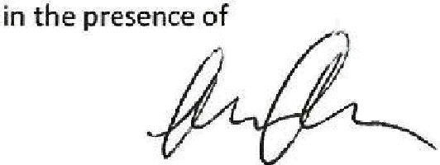
Rotherham Boroush Council was hereunto affixed this 25th_ day of August 2021
Duly authorised officer
(

Position of path as indicated  on the map | Description | Width
E-G-H | A public footpath from OSGR SK 3887 9396 (point Eon the map) generally south west then south for approximately 350 metres to OSGR SK 3869 9365 (point G on the map) and continuing south for approximately 50 metres to OSGR SK 3870 9360 (point H  on the map). | 2m

Position of path as indicated  on the map | Description | Width
G-1 | A public footpath from OSGR SK 3869 9365 (point G on the map) generally east for approximately 450 metres to OSGR SK 3913 9367 (point I on  the map). | 2m

Position of path as indicated  on the map | Description | Width
H-J | A public footpath from OSGR SK 3870 9360 (point H on the map) generally east north east for approximately 430 metres to OSGR SK 3913 9364 (point J on the map). | 2m

Position of path as indicated  on the map | Description | Width
D-1-J-K-L | A publlc footpath from OSGR SK 3914 9395 (point Don the map) at its junction with Public Footpath 39 in a south direction for approximately 260 metres to OSGR SK 3913 9367 (point I on the map), then south for approximately 10 metres to OSGR 3913 9364 (point Jon the map), then generally south for  approximately 50 metres to | 2m
 | OSGR SK 3913 9361 {point K  on the map) then generally | 2m

SCHEDULE PART I
Description of path or way to be added

Position of path as indicated  on the map | Description | Width
A-8 | A public footpath from Dropplngwell Road at OSGR SK 3943 9399 (point A on the map) generally south south west then west direction for approximately 165 metres to a junction with Public Footpath No. 20 Kimberworth at OSGR St< 3930 9391 (point Bon the  map). | Sm

Position of path as indicated on the map | Description | Width
C-D-E | A public footpath from OSGR SK 3924 9392 (point Con the map) at the junction with Public Footpath No. 20 Kimberworth, in a generally west north west for approximately 120 metres to OSGR SI< 3914 9395 (point D  on the map) and continuing generally west for approximately 270 metres to OSGR SK 3887 9396 (Point Eon  the map) | Between Sm and 2m

Position of path as indicated  on the map | Description | Width
F-E | A public footpath from OSGR SK 3914 9421 (point Fon the map) at a junction with Public Footpath 20. Kimberworth, generally south west for approximately 360 metres to OSGR SK 3887 9396 (point Eon  the map). | 2m

north east for approximately 330 metres to a junction with Droppingwell Road at OSGR SK 3936 9384 (point Lon the
map.

PART II
Modification of Definitive Statement
·The statement for Klmberworth shall be modified as follows:

Path No. | Grid  Reference | Description of Route | Nature of  Surface | Approx. Length | Appro1<. Width | General
38 |  | Footpath from OSGR SK 3943 9399 at its junction with Dropplngwell Road generally south south west then west direction for approximately 165 metres to a junction with Public Footpath No. 20 at OSGR  SK 3930 9391. | Tarmac | 165m | Sm
39 |  | Footpath from OSGR SK | Tarmac/Natural | 390m | Between
 |  | 3924 9392 at the junction | Ground/Grass |  | 5mand
 |  | with Public Footpath No.  20, In a generally west |  |  | 2m
 |  | north west for
 |  | approximately 120 metres
 |  | to OSGR SK 3914 939S and
 |  | continuing generally west
 |  | for approximately 270
metres to OSGR SK 3887
9396 at Its junction with
 |  | Public Footpath 40.
40 |  | Footpath from OSGR SK 3914 9421 at a junction with Public Footpath 20, generally south west for approximately 360 metres  to OSGR SK 3887 9396 at  its junction with Public Footpath Nos. 39 and 41. | Natural Ground/Grass | 360m | 2m

(

41 |  | Footpath from OSGR SK 3887 9396 at Its junction with Public Footpath Nos. 39 and 40, generally south west then south for approximately 350 metres  to OSGR SK 3869 9365 at  its junction with Public Footpath 42 and continuing south for .,pproximately 50 metres to OSGR SK 3870 9360 at its junction with  Public Footpath No. 43. | Natural Ground/Grass | 400m | 2m
42 |  | Footpath from OSGRSK 3869 9365 at Its junction with Public Footpath 41 generally east for approximately 450 metres  to OSGR SK 3913 9367 at  its junction with Publfc Footpath No 44. | Natural Ground/Grass | 450m | 2m
43 |  | Footpath from OSGR SK 3870 9360 at Its junction with Public Footpath No.41, generally east north east for approximately 430 metres to OSGR SK 3913 9364 at its junction with  Public Footpath No. 44. | Natural Ground/Grass | 430m | 2m
44 |  | Footpath from OSGR SK 3914 9395 at its junction with Public footpath 39 in a south direction for approximately 260 metres  to OSGRSK 3913 9367 at  its junction with Public Footpath Nos. 42, continuing south for approximately 10 metres to OSGRSK 3913 9364 at its  ju1lction with Public Footpath 43, then generally south for approximately 50 metres to OSGR SK 3913 9361 then generally north east for approximately 330 metresto a junction with Public Footp,llh 20 at OSGR  SK 3936 9384. | Natural Ground/Grass | 645m | 2m | Gate  with adjacent gap (SK 3914  9395)

Wildlife and Countryside Act 1981 Section 53
The Rotherham Metropolitan Borough Council (Public Footpaths Nos 38, 39, 40, 41, 42, 43 and 44 Kimberworth) Definitive Map Modification Order 2021
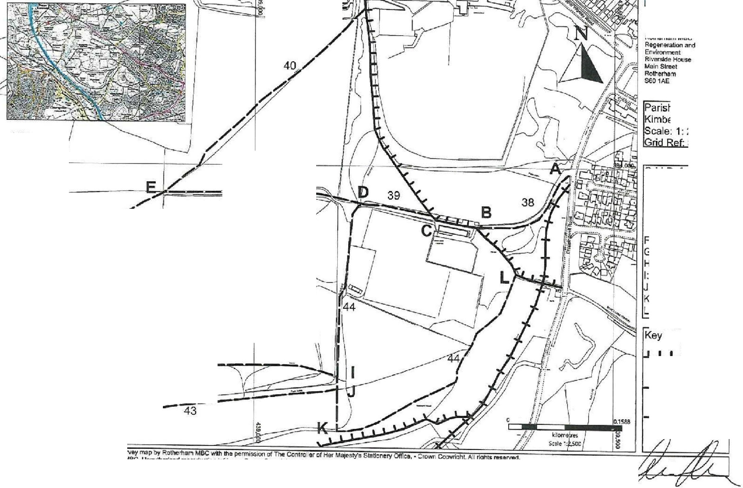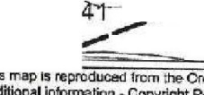
=:·
.·
Rotherham •).
:>-
Borough Council a
Metropotit>n ._-,i
rishNVard: erworth
2,500
SK 39
32L,OOO
,
J/
I
I
39. -
IGrid References
A.: SK 3943 9399
B: SK 3930 9391
C: SK 3924 9392
-
1:+-5.Jl ID: SK 3914 9395
E: SK 3887 9396
F: SK 3914 9421
G: SK 3869 9365
H: SK 3870 9360
i
r
lj
II
(

---- -
.,,,._,.,,
'
\
µ:SK 3913 9364
K: SK 3913 9361
L: SK 3936 9384
I: SK 3913 9367
!
,J
42
I-
-//
Existing Public
Footpath
Existing
1-1--1-Public
Bridleway
Footpath to
--beAdded
H\
Thi• mafio reproduced from Ofd""nc,, SuTVey map by Ro\he,1\am M8C wich th• permission of Tho C<lntrolior of He, Majesty's STo!cne,y Olflco, • Crown C<lµyrlghl. All rights reserved.
A.ddition&I lnform;)lion. Copyright Rotherl'lam MSC. UnBUthorlsed re?f'Oductioo Infringes Crown Cor,yrighl and may le!:ldlo iiro,ecution or civil prc edlogs_ License r,lumber. 100019587.



