Order Decisions
Inquiry Held on 24 & 25 January 2023
Site visit made on 25 January 2023
by Graham Wyatt BA (Hons) MRTPI
an Inspector appointed by the Secretary of State for Environment, Food and Rural Affairs
Decision date: 28 March 2023

Order Ref: ROW/3286729
- This Order is made under Section 118 of the Highways Act 1980 (the 1980 Act) and is known as the Kent County Council (Public Footpaths AE639 (Part), AE338 and AE337A Sevington) Public Path Extinguishment and Definitive Map and Statement Modification Order 2021.
- The Order is dated 17 March 2021 and proposes to extinguish the public rights of way as shown on the Order plan and described in the Order Schedule.
- There were 20 objections outstanding when Kent County Council and the Department for Transport submitted the Order to the Secretary of State for Environment, Food and Rural Affairs for confirmation.
Summary of Decision: The Order is confirmed.

Order Ref: ROW/3314821
- This Order is made under Section 26 of the 1980 Act and is known as the Kent County Council (Public Bridleway AE672 Sevington and Mersham) Public Path Creation and Definitive Map and Statement Modification Order 2021.
- The Order is dated 17 March 2021 and proposes to create the public right of way shown on the Order plan and described in the Order Schedule.
- There were 20 objections outstanding when Kent County Council and the Department for Transport submitted the Order to the Secretary of State for Environment, Food and Rural Affairs for confirmation.
Summary of Decision: The Order is confirmed.
Order Ref: ROW/3314823
- This Order is made under Section 26 of the 1980 Act and is known as the Kent County Council (Public Bridleway AE673 Mersham) Public Path Creation and Definitive Map and Statement Order 2021.
- The Order is dated 17 March 2021 and proposes to create the public right of way shown on the Order plan and described in the Order Schedule.
- There were 20 objections outstanding when Kent County Council and the Department for Transport submitted the Order to the Secretary of State for Environment, Food and Rural Affairs for confirmation.
Summary of Decision: The Order is confirmed.

Procedural Matters
- It was suggested at the start of the Inquiry that the advertising of the event had not been extensive enough to ensure that all those that wished to attend the event, could do so. However, in accordance with Rule 16 (3) (a) and (b) of the Rights of Way (Hearings and Inquiries Procedure) (England) Rules 2007, a notice had been erected at the right of way and a notice was published in the Kent Messenger during the week ending 16 December 2022, confirming the date and venue of the Inquiry.
- In addition, I also noted that the venue for the Inquiry on the notifications was incorrect and referred to the Mission Hall, Forge Hill, Aldington, Kent TN25 7DT which is some 300m from the correct venue at Aldington Village Hall. The Order Making Authority (OMA) contacted all those that had made representations on the Orders, to ensure that they were aware of the correct venue. An individual was also present at the Mission Hall to redirect those that wished to attend the village hall.
- Thus, I am satisfied that the correct notification of the Inquiry had been carried out, and those that may have visited the Mission Hall would have been directed to the correct venue, and I continued with the Inquiry
- A late written representation was received on 20 January 2023 from The British Horse Society. All parties were provided with a copy of this representation before the Inquiry opened and given an opportunity to comment on its contents during the event. Thus, I am satisfied that no one was prejudiced in accepting this representation at such a late stage.

Background to the Orders
- The applicants for the above Orders are Kent County Council, the OMA, and the Department for Transport (DfT). Following the decision of the UK to leave the European Union and its Customs Union and Single Market, it became necessary for His Majesty’s Government (HMG) to provide facilities where inbound customs checks could be carried out.
- Therefore, to address this issue, an Inland Border Facility (IBF) at Sevington was created. Consequently, it was necessary to seek the temporary closure of footpaths AE639, AE337A and AE338 under a Temporary Traffic Regulation Order (TTRO) to allow the construction of the IBF. Such closures under a TTRO are valid for a 6 month period and should additional time be required, further extensions to the TTRO would need to be applied for. The applicants state that as the IBF is now complete, it is no longer able to apply for temporary closure of the footpaths through a TTRO and thus, it is prudent to seek the extinguishment of the aforementioned footpaths and the creation of an alternative route around the site.
- The alternative route is a bridleway and as a result, the footpath to the southeast, currently footpath AE363 is also a bridleway and renumbered to form bridleway AE673.

Main Issues
- In relation to the Creation Orders, the main issue is whether there is a need for a bridleway indicated on the plan attached to the order and whether it is expedient to create it having regard to:
- The extent to which the path or way would add to the convenience or enjoyment of a substantial section of the public, or to the convenience of persons resident in the area; and
- The effect which the creation of the path or way would have on the rights of persons with an interest in the land, account being taken of the provisions as to compensation.
- In relation to the Extinguishment Order, the main issue is whether it is expedient to confirm the order having regard to the extent (if any) to which it appears that the path or way would, apart from the order, be likely to be used by the public, having regard to the effect which the extinguishment of the right of way would have as respects land served by the path or way, taking into account the provisions as to the compensation contained in the Act.
- Section 118(5) of the 1980 Act provides that where proceedings preliminary to the confirmation of a public path extinguishment order are taken concurrently with proceedings preliminary to the confirmation of a public path creation order, then the Secretary of State may have regard to the extent to which the public path creation order would provide an alternative path or way. This is re-iterated in paragraph 5.55 of Rights of Way Circular 1/09. Therefore, I shall consider the Creation Orders first.

Reasons

The Creation Orders
- The construction route of the Creation Orders for Bridleways AE672 and AE673 has already been carried out and I was able to walk the length of the routes around the IBF and on to Merhsam to the southeast. The Creation Orders would create a new bridleway AE672 which largely follows the perimeter of the IBF where it meets Footpath AE363 which itself runs in a southeast/northwest direction between Blind Lane and Highfield Lane. The Creation Order for Bridleway AE673, would subsume and follow the alignment of Footpath AE363.
- The total length of the newly created bridleway is some 1600m in length and connects Sevington to Merhsam. Thus, it is evident that the Creation Orders route would provide a longer and indeed, a much less direct route for users approaching from the northwest to destinations to the southeast and vice versa. I accept that the description of Bridleway AE672 and AE673 is indeed lengthy and is an indication of the turns that one would need to navigate around the IBF. I also acknowledge that the use of the Creation Orders route would extend journey times for users travelling between Sevington and Merhsam, adding some 5-8 minutes walking time from its entry point of AE672 on Church Road to its junction with the AE673, which equated to my experience of walking the routes.
- However, that additional time and distance must be balanced against the dis-benefits of using Footpath AE639 to reach the same point on Highfield Lane. Part of Footpath AE639 comprised an unsurfaced, natural grass route and involved users to navigate over a stile, restricting both its appeal and usability to able bodied persons that were walking. Such obstacles would deter those that may wish to use the footpath, and it is unlikely that it would be a route that those with low mobility would choose to countenance.
- In contrast, Bridleways AE672 and AE673 are some 3m wide with a firm, all weather surface with a gated entrance, that is accessible to walkers, cyclists, and horse riders. Whilst some of the surface had degraded in places, it was still a far better route in terms of accessibility than Footpath AE639, and the Creation Orders route provide a level terrain on a hard surface which would be more accessible to those with mobility constraints.
- Moreover, the upgrading of the footpath to a Bridleway would add to its appeal, aligning with the Kent County Council Rights of Way Improvement Plan 2018-2028 which seeks to evolve the rights of way network through securing higher status routes, such as bridleways and restricted byways, that provide a greater range of access for all users.
- Having regard to the above, I consider that the Creation Orders route would add to the convenience of a substantial section of the public, as well as to the convenience of persons resident in the area. There is no evidence before me that the Creation Orders route would adversely affect the rights of persons with an interest in the land. Accordingly, the expediency tests in Section 26 of the 1980 Act are met.

The Extinguishment Order

The extent that the path would, apart from the order, be likely to be used by the public
- The Orders relate to the extinguishment of three Footpaths, AE338, AE337A and AE639. It is clear from the evidence produced at the Inquiry that there is no objection to the extinguishment of Footpaths AE338 and AE337A from their junction with Footpath AE639. These footpaths are not particularly lengthy at 190m for AE338 and 400m for AE337A and are both ‘dead end’ routes that do not lead on to or connect with other footpaths. They discontinue as they meet the A2070 requiring users to turn around and walk back from whence they came. I therefore accept that the nature of Footpaths AE338 and AE337A would significantly limit their usage in the event that they are not extinguished.
- It must be recognised that my duty is not to examine the question of need, but to assess the extent to which the footpath might be used by the public. Additionally, although the IBF has been constructed, I must also envisage a situation where the Order route for AE639 is in a useable condition. It is evident from the OMA’s and applicant’s maps, that there are a number of public rights of way in the vicinity. However, no substantive evidence has been provided regarding the level of usage of the footpath.
- As a direct route between Sevington and Mersham, I acknowledge that Footpath AE639 would be used by those able to navigate its route across a field. However, the imposition of a stile and the unmade nature of the footpath is likely to deter those with less mobility, and indeed those that were not prepared for the weather and the conditions underfoot. Therefore, the footpath has its limitations.
- Thus, I have found that the Creation Order route would provide an alternative that is as convenient to a substantial section of the public, as well as to the convenience of persons resident in the area. The availability of a convenient and safe alternative path means that there would be no need for the Extinguishment Order routes.

Other Matters
- I acknowledge that the Footpath has been in existence for some time, featuring on the Ordnance Survey Map of 1876 and could possibly be older. Whilst this may be the case, it is not a reason in itself for the Order not to be confirmed. I also acknowledge the visual link that is said to exist between the churches in Sevington and Mersham. However, there is nothing before me to demonstrate that Footpath AE639 is a fundamental element of that link. Indeed, the consultation response from English Heritage (EH) when it considered a planning permission in 2017 for an employment development at the site, fails to mention Footpath AE639 as forming part of the significance of either designated heritage asset at Sevington or Mersham. Furthermore, despite EH’s objection to the 2017 proposals for employment development, it is evident that planning permission was still granted for two very large warehouse style buildings either side of the footpath.
- In addition, in the event that the Extinguishment Order was not confirmed, it is likely that those who wish to cross through the IBF would come into conflict with large vehicles. There is also a security concern, not only for goods that are bonded and animals that may be in quarantine, but also through potential action from disaffected groups. As a facility that operates 24 hours a day, all year round, I share the applicant’s concerns that walkers could potentially stray into areas away from the footpath and that it would be very difficult to manage or escort walkers through the IBF, as they are highly likely to arrive unplanned and potentially during busy periods. The analogy used of tours to deserted villages used by the Ministry of Defence is of little assistance, as such visits are planned and guided.
- Much was said about the potential future use of the IBF, given that it only has a temporary permission until the end of 2025 and would need to be removed at the end of this period. Arguments were made that the applicant should continue with the use of a TTRO to continue with the temporary closure of Footpath AE639 and, should permanent planning permission for its continued operation not be obtained, the use of the footpath could be restored.
- I have carefully considered this matter and indeed the evidence from Mr Cliff regarding the future use of the IBF. Although the DfT is considering its options regarding the permanent use of the site, the applicant could not guarantee that it was HMG’s intention to retain the IBF beyond 2025. Nonetheless, it is evident that talks had started with the Council regarding this very matter. Moreover, notwithstanding the closure of other IBF’s, such as that at Dover, it was argued that HMG requiring Sevington IBF as a customs border facility will, in all likelihood, extend beyond 2025 and therefore, it will be retained.
- Moreover, even if the IBF was not to continue past 2025, I must have regard to the Order before me which seeks the permanent extinguishment of Footpath AE639 now, and not during the consideration of any future planning application at the site. Whilst a legal agreement seeking reinstatement of the footpath once the land is no longer required by the applicant is being pursued under section 106 of the Town and Country Planning Act 1990 (as amended), it is of little assistance as I have only received a heavily redacted draft copy of the agreement. Moreover, the matter of reinstating Footpath AE639 would be for the OMA and applicant to contemplate at a later date and was not an issue that was relied upon in support of the Order before me.
- Furthermore, the circumstances where a TTRO can be made are no longer applicable as works to create the IBF have now ceased. The argument that a TTRO could be used as the IBF presented a ‘danger to the public’ is not what such Orders are designed to be used for. As the evidence of Mr Hutchison revealed, TTRO’s are used in circumstances where, for example, a bridge had failed, or there was serious damage to a road surface. His professional opinion was that a TTRO could not be used in the scenario that walkers may come into conflict with vehicles. In the absence of compelling evidence to the contrary, I see no reason to disagree with his interpretation of the use of TTROs. Moreover, I am not persuaded that the planting of additional landscaping around the IBF constitutes development that would advocate the use of a TTRO.
- The land surrounding the footpath is also allocated as future employment land by Ashford Borough Council. Consequently, planning permission was granted in 2017 for an employment use at the site, which comprised two very large warehouse type buildings being placed upon the land. Although I accept that the illustrative masterplan for the employment development at the site indicated that a ‘green corridor’ would be created, retaining Footpath AE639, one has to accept that the development would have fundamentally altered the openness one would experience, with very large warehouse buildings either side of the footpath creating a tunnel effect between the two areas of development.
- I am also not persuaded that there is the possibility that a corridor could be created, as this would need to be completely enclosed in order to prevent unlawful entry into the IBF. It would also not be possible to have gated access at either end of the footpath as it would still require users to cross over roads within the IBF.

The effect that the extinguishment of the path would have as respects land served by the path, account being taken to the provisions as to compensation
- The Applicant owns the land over which the Order routes run. No evidence was adduced to suggest that the extinguishment of the Order route would have any adverse effect on land served by it and I have no reason to believe that any such effect would result.

Rights of Way Improvement Plan
- As stated earlier, the Kent County Council Rights of Way Improvement Plan 2018-2028 seeks to evolve the rights of way network through securing higher status routes, such as bridleways and restricted byways, that provide a greater range of access for all users. That is what the created routes intend to do.

Conclusion
- Having regard to these and all other matters raised at the Inquiry and in the written representations, I conclude that all three Orders should be confirmed.

Formal Decisions

Order Ref: ROW/3286729
- The Order is confirmed

Order Ref: ROW/3314821
- The Order is confirmed.

Order Ref: ROW/3314823
- The Order is confirmed.

Graham Wyatt

INSPECTOR

APPEARANCES

For the applicant:

Miss Daisy Nobel Counsel for the Order Making Authority and the Applicant

She called:

For the Order Making Authority:

Mr Andrew Hutchinson Rights of Way and Access Manager, Kent County Council

Mr Christopher Wade Principal Case Officer, Definitive Map Team, Kent County Council

Mr Sam Yates Project Manager, Highways and Transportation Department, Kent County Council

For the Applicant:

Mr Kyle Cliff Head of Operational Policy and Infrastructure, Logistics and Borders Directorate, Department for Transport

Objectors to the Order:

Councillor Paul Bartlett

Mr Padraig Herlihy Local resident & Ramblers Association

Mrs Linda Arthur Local resident

DOCUMENTS SUBMITTED AT THE INQUIRY
- Advert from The Kent Messenger and email dated 9 December 2022 confirming advertisement of event
- Draft and redacted Legal Agreement
- Opening Statement on behalf of Order Making Authority and Applicant
- Text of statement read out by Mrs Linda Arthur
- Text of statement read out by Mr Padraig Herlihy
- Closing statement on behalf of the applicant
- Closing statement on behalf of the Order Making Authority and Applicant
- Copy of 1876 Ordnance Survey Map
- Photographs of views across Inland Border Facility

MAP NOT TO ORIGINAL SCALE

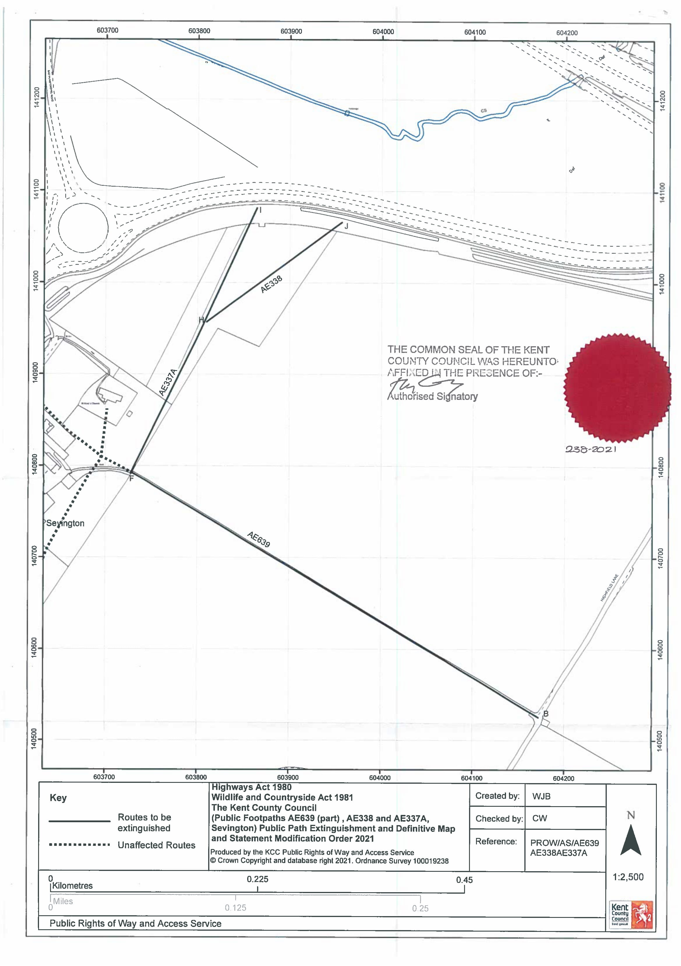

MAP NOT TO ORIGINAL SCALE

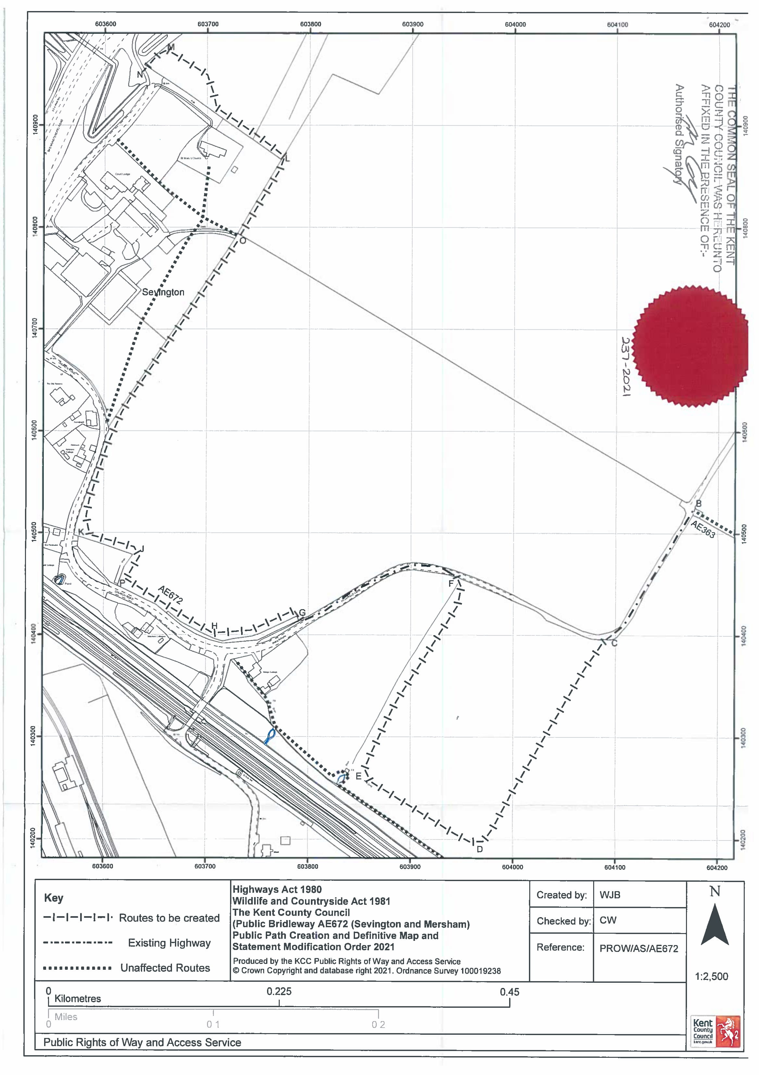

MAP NOT TO ORIGINAL SCALE

