Order Decision
Papers on file

by Claire Tregembo BA (Hons) MIPROW
An Inspector appointed by the Secretary of State for Environment, Food and Rural Affairs
Decision date: 08 March 2023

Order Ref: ROW/3308829
- This Order is made under Section 53(2)(b) of the Wildlife and Countryside Act 1981 and is known as the Cumbria County Council (City of Carlisle) Definitive Map Modification Order (No 2) 2022.
- The Order is dated 17 May 2022 and proposes to modify the Definitive Map and Statement for the area by adding two footpaths at Deer Park as shown on the Order Plan and described in the Order Schedule.
- There was one objection outstanding when Cumbria County Council submitted the Order to the Secretary of State for Environment, Food and Rural Affairs for confirmation.
Summary of Decision: The Order is confirmed.

Preliminary Matters
- The objection to the Order has subsequently been withdrawn and I am determining it based on the written documents before me.
- I will refer to various sections of the Order routes using the letters shown on the Order Plan appended to the end of my decision.

The Main Issues
- The Order has been made under Section 53(3)(c)(i) of the Wildlife and Countryside Act 1981 which requires me to consider if, on the balance of probabilities, the evidence shows that public footpaths subsist along the Order routes. This is a higher standard of proof than the reasonably alleged to subsist test to determine if an Order should be made.
- The evidence submitted in support of the Order relies on the presumption of dedication arising from tests laid out in Section 31 of the Highways Act 1980 (the 1980 Act). This requires me to consider if the public have used the routes as of right and without interruption, for a period of twenty years immediately prior to their status being brought into question. I must establish the date when the public’s right to use the routes was brought into question and determine if use by the public occurred for a twenty year period prior to this that is sufficient to raise a presumption of dedication. If this is the case, I must then consider if there is sufficient evidence that there was no intention on the part of the landowners to dedicate public footpaths during this period.

Reasons

Bringing into question
- For the public’s right to use the Order routes to be brought into question, some actions or events must occur that bring home to at least some of those using them that their right to do so is being challenged. These must be sufficiently overt to bring the challenge to the attention of the public using the Order routes.
- A definitive map modification order application (DMMOA) was made in April 2021. The developer, which purchased the land from the previous landowners in 2021 following the granting of planning permission, believes that it was made to frustrate the development of eighty homes. Cumbria County Council considers the Order routes were brought into question when they received the DMMOA and there are no other identifiable events in the evidence before me that call into question their use.
- In the absence of evidence of overt acts bringing the right of the public to use the routes into question, Section 31(7a) and (7b) of the 1980 Act provides that a DMMOA made to the surveying authority can serve as a challenge to use for the purposes of Section 31(2) of the 1980 Act. Therefore, I consider the receipt of the DMMOA to be the date of challenge, with the relevant twenty year period of use being April 2001 to April 2021.

Analysis of use
- To satisfy the requirements of Section 31, use must be by those who can be regarded as the public. For use to be as of right it must be without force, secrecy, or permission. Use should be without interruption and to be effective, any interruption must be by the landowners, or someone acting on their behalf. The interruption should be with the intention of preventing use of the way by the public and not for other purposes such as car parking or building works. I must also be satisfied that there was sufficient use by the public to raise a presumption of dedication.
- The Order routes run over the grounds of a former property called Deer Park. There is an existing public footpath across it which was recorded on the definitive map and statement in 2009 following a DMMOA in 2008. The Order routes provide access to Kingmoor Sidings Nature Reserve to the west and are also used for short recreational loops. This means that the amount of use varies over different sections of the Order routes.
- There is evidence of use from thirty five people between 1972 and 2021 and an additional two years of use between 1968 and 1970 by one person. Section A to C was used by twenty people for twenty years or more and seventeen people used section C to F for twenty years or more. Section C to O was used by twelve people for twenty years or more and ten people used sections O to K and J to H for twenty years or more. Other people also used the Order routes for shorter periods varying between two and nineteen years.
- None of the path users were given permission to use the Order routes during the relevant period. One person states that he had permission from ‘BR’ when he worked for them between 1968 and 1970. ‘BR’ is presumed to be British Rail which owned the railway sidings to the west of the Order routes.
- The only notices or signs referred to are those for the existing public footpath and the nature reserve.
- Path users indicate gates or stiles into the nature reserve at points F and K and on the existing footpath. Three people refer to fences and hedges near points A and K. These do not appear to have prevented access and users refer to gaps. One person explained that when the existing footpath was claimed in 2008, mesh fences were erected. These were replaced by ‘industrial’ fences just before it was confirmed. However, they did not impede access and walkers never had to force, clamber, or fight a way through. They just walked straight into the field. Documents from the previous landowners’ agent indicate that the hedges and fences were in a poor state of repair in 2000 and 2005. One person refers to fences from December 2021 to January 2022, but this is after the relevant twenty year period.
- One person refers to a challenge by an agent for Persimmon Homes in 2007 which led to the DMMOA for the existing footpath. This challenge is likely to have been on the existing footpath rather than on the Order routes. Although Persimmon Homes were considering purchasing the site, they did not own it and there is no evidence that their agent was acting on behalf of the landowners. I do not consider that a single challenge on a connecting route, by someone who did not own the land, is sufficient to interrupt use of the Order routes.
- One of the user evidence forms is from the applicant for the 2008 DMMOA. The developer argues that he would have also claimed the Order routes if they were being used. Furthermore, the 2003 aerial photograph does not show ‘desire lines’ over the Order routes. Therefore, insufficient time has passed for the Order routes to have been dedicated as public highways.
- However, the user evidence shows use of the Order routes during all of the relevant period with additional use between 1972 and 2000. Additionally, an email in 2008 between Taylor Hardy Limited, the agent for Persimmon Homes, and White Young Green, their consultants, describes three paths leading into the nature reserve. Based on the descriptions given, one of these is the existing footpath and the other two appear to be sections E to F and H to K of the Order routes. It also states that “most people appear to walk to the northwest corner” of the site which is at point K.
- Some of the path users indicate that the route they used across Deer Park depended on ground conditions with some sections being used less in winter. The developer argues that this caused sporadic and interrupted use. In my opinion, choosing which route to use due to ground conditions is unlikely to have reduced use to such a low level that it would cause an interruption. Furthermore, the weather caused the wet conditions, not the previous landowners.
- The developer considers that use was not by the public because most path users lived on Kingmoor Road. Although use of the Order routes appears to have been by residents living nearby, it has long been established that local use is use by the public.
- I consider that there is sufficient use of the Order routes by members of the public as of right during the relevant period to demonstrate a presumption of dedication.

Lack of intention to dedicate
- To demonstrate a lack of intention to dedicate, landowners must take action to make the public aware that they have no intention of dedicating public rights of way. There are various ways of demonstrating this, but the most common ways are erecting notices denying public rights or granting permission, physical obstructions, or verbal challenges.
- The property was subject to grazing licences until 2000. The developer considers that agricultural use of the land for grazing would have been inconsistent with the use of multiple footpaths and recreation. However, many public rights of way cross agricultural land. The letting of land for grazing does not demonstrate a lack of intention to dedicate.
- The developer also argues that permission is indicated by the public rights of way signs on the existing footpath. Highway authorities have a duty to signpost public rights of way where they leave the metalled road to indicate the line of the path and the right to use it. They do not indicate permission from landowners and are unlikely to have been erected by them. I have concluded in paragraph 19 that the user evidence shows use of the Order routes as of right.
- The agent for the previous landowners, who owned the site during the relevant period, advises that they took an active interest in the property and were kept informed of its condition and works undertaken. However, there is nothing in the documents to indicate that they, or their agent, took any action to demonstrate that they did not intend to dedicate public rights over the Order routes.
- Furthermore, some of the documents show that the previous landowners and their agent were aware of public use of paths across the site. An email between them in 2008 states that “for as long as anyone can remember, local residents have walked through the land for access to the nature reserve”. Documents relating to the repair of a wall and gates show that the agent intended to install a kissing gate robust enough to stop vehicles from gaining access whilst allowing limited access on foot. Although these gates are not on the line of the Order routes, they show that the previous landowners accepted use of the site on foot.
- None of the path users recall any obstructions, signs, or notices preventing or challenging public use, or indicating permission to use the Order routes. One person was challenged, but not by any of the landowners and there is nothing to indicate that the challenger was acting on their behalf. Therefore, this challenge does not demonstrate a lack of intention to dedicate public rights.
- The developer states that neither they, nor their predecessors, intended to dedicate any public rights of way across Deer Park. However, there is no evidence before me to demonstrate a lack of intention to dedicate the Order routes during the relevant twenty year period.

Conclusions on Section 31
- I conclude that there is sufficient evidence of use of the Order routes as of right and without interruption between 2001 and 2021. There is no evidence of challenge, permission, or overt actions by any of the landowners to demonstrate a lack of intention to dedicate public rights of way.
- I am satisfied that the evidence before me is sufficient to show that, on the balance of probabilities, public footpaths subsist over the Order routes.

Conclusions
- Having regard to these and all other matters raised in the written representations, I conclude that the Order should be confirmed.

Formal Decision
- I confirm the Order.

Claire Tregembo

INSPECTOR

Order Plan

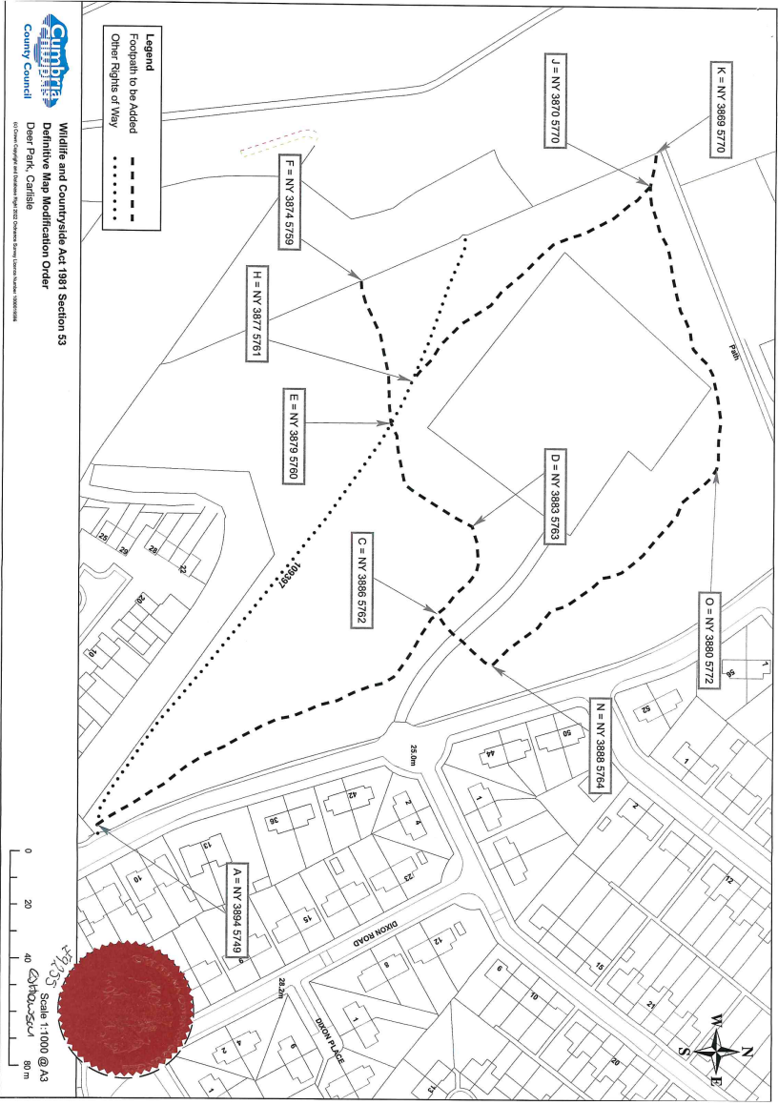

COPY - MAP NOT TO ORIGINAL SCALE

