Blue Economy Financial Flows
Caribbean Region

2022

Notice
This document and its contents have been prepared and are intended solely as information for the UK Foreign, Commonwealth and Development Office, and use in relation to Caribbean Region Blue Economy Financial Flows.
SNC-Lavalin assumes no responsibility to any other party in respect of, or arising out of, or in connection with this document and/or its contents.
This document has 13 pages including the cover.

© copywrite UK Government, enquiries to SIDSHub@FCDO.GOV.UK

Contents
Chapter Page
1. Introduction 1
1.1. The Commonwealth Marine Economies Programme 1
1.2. Background to the report 1
2. Methodology 2
3. Results 4
3.1. Total flow of ODA investments into the blue economy 4
3.2. Type of entity implementing project 5
3.3. Source of investment into the blue economy 5
3.4. Location of ODA funded projects 7
3.5. Size of investments into the blue economy 8
3.6. Target of investments into the blue economy 9

Figures
Figure 3-1 - Official Development Assistance pro rata flow 2012 – 2021 in USD million 4
Figure 3-2 - The number of projects being implemented by different types of implementing entities (2012 – 2021) (number of projects is shown at end of bar) 5
Figure 3-3 - The source of investment into the blue economy (2012 – 2021) 6
Figure 3-4 - Number of ODA funded Blue Economy investments by country from 2012 – 2021 7
Figure 3-5 - Relative value of ODA funded Blue Economy investments by country from 2012 – 2021 7
Figure 3-6 - Number of projects by frequency in financial size categories (2012 – 2021) 8
Figure 3-7 - Target of ODA blue economy investment (2012 – 2021) 9

Introduction

The Commonwealth Marine Economies Programme

FCDO’s Commonwealth Marine Economies (CME) Programme was launched in 2016 and aimed to support 17 Caribbean and Pacific Small Island Developing States (SIDS) in conserving their marine environments and making the most of their maritime resources to catalyse sustainable economic development. It was designed to promote growth, innovation, jobs, and investment whilst safeguarding healthy seas and ecosystems, and helped to address climate change, the UN Sustainable Development Goals (SDGs) and the Paris Climate Change Accord. The programme became an important part of FCDO’s new Small Island Developing States Hub when this was launched in 2020.
The concept of the ‘blue economy’ emerged during the 2012 Rio+20 United Nations Conference on Sustainable Development, recognising the need to maximise the vast economic potential of the ocean while also preserving it. . The blue economy concept encapsulates the same principles of low carbon, resource efficiency and social inclusion as the Rio+20 Green Economy concept, but it is grounded in a developing world context and fashioned to reflect the circumstances and needs of countries whose future resource base is mainly marine. These ideas reflect both the issues and opportunities of SIDS.
The CME Programme supported the aims of the Commonwealth Blue Charter and is an integral part of the UK’s effort to protect the health of the world’s oceans and promote the growth of blue economies.

Background to the report

This study sits within the context of the overall CME Programme, which was completed in March 2022, to help determine the future shape and direction of overseas support for the blue economy. The UK Government remains committed to supporting Commonwealth nations to realise the potential of their blue economy in a post-COVID world.
This report presents a data analysis of national Official Development Assistance (ODA) financial investments that are relevant to the blue economy in the Caribbean region. The analysis is based on available data of financial flows from 2012 to 2021.

Methodology
The present study analysed data for 12 Caribbean SIDS.
Data was collected from several sources:
- Financial information collected and published by Hills et al. in 2019 during the Enhancing Pacific Ocean Governance project, funded by the Department of Foreign Affairs and Trade, Australia (DFAT).
- Official financial flows as laid out in the Creditor Reporting System under the Development Assistance Committee (DAC) of the Organisation for Economic Co-operation and Development (OECD); and
- Additional ODA supported projects were identified or mentioned in other miscellaneous sources and were captured through entity websites.
Data collected includes project name, project budget, start and end date, countries of implementation, source of ODA and implementing entity.
Blue economy components of the project in most cases did not make up the entire project budget, thus each project’s blue economy component required a weighting to be applied. Weightings were in four categories from ‘very low’ to ‘high’ to represent the proportion of blue economy components in the project:
- Very low = 1 – 24% of the total project budget aligned to blue economy,
- Low = 24 – 49%,
- Medium = 50 – 74%,
- High = 75 – 100%.
In subsequent calculations, the mid-point of these categories was used for estimates. The estimate of the proportion of total project budget aligned to blue economy was conducted by expert assessment based on a review of the project title and summaries or abstracts, if unclear from the title alone.
Multicounty projects were divided equally between involved countries to obtain country-project budgets (assumption: allocation of total project budget was equal between SIDS). This may have led to some under / over estimation of specific project budgets to countries.
To determine annual blue economy flows, each country project amount was allocated equally across the start and end year (assumption: project allocation was equal across each active project year). Where the project end date was not available, projects were estimated to last 4 years, which appeared to be the mode duration of the projects for which start and end data was available (assumption: if not known projects were assumed to last for 4 years).
All blue economy flows were coded into one of six categories based upon their main purpose:
- Economic,
- Environmental,
- Governance,
- Technology & Capacity,
- Society, and
- Innovation.
These categories were developed from the analysis of blue economy by Voyer et al. in 2018 and further developed by research with a Pacific focus through the FCDO Global Challenges Research Fund (GCRF) One Ocean Hub project. Coding was conducted through expert assessment but was difficult for some projects (assumption: a single category could reflect projects which were operating in a number of blue economy areas of activity).
This analysis allowed various numerical estimates and graphs to be developed which are presented in section 3 and in the national profiles produced for each country.
Country profiles have also been produced for five SIDS from the Indian and Atlantic Oceans, however no overview report has been produced for these regions, due to the small number of countries analysed in each region (two and three respectively).

Results

Total flow of ODA investments into the blue economy

A total of US $74M was identified as Blue Economy targeted ODA in the 12 countries from 2012 to 2021. This averaged to US $7.4M per annum, however, there was much annual variation (see Figure 3-1).

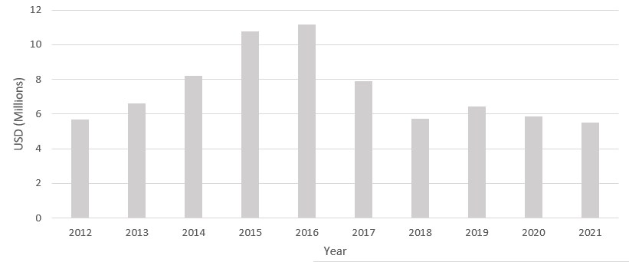
Figure 3-1 - Official Development Assistance pro rata flow 2012 – 2021 in USD million
ODA flow into the blue economy gradually rose from 2012 to a peak of just over US $11M in 2016. From this high, ODA flow decreased to between US $5.4M and US $6.4M over the period of 2018 to 2021.
The variation may be related to project cycles, but this is unclear. Some data related to 2021 may not have been reported at the time of the analysis.
None of the individual countries analysed show the same or similar patterns of ODA investment as the overall regional picture, suggesting there are few generalisations that can be made about ODA investment across the region during this period.

Type of entity implementing project

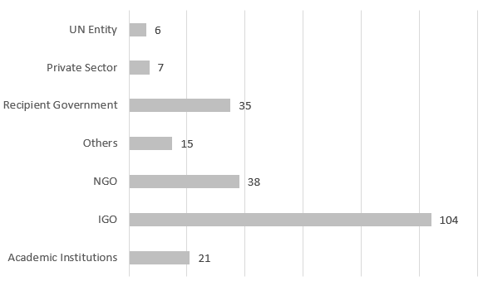
NGO = non-governmental organisation
IGO = intergovernmental governmental organisation, but with UN family as separate category
Regional organisations are included within the IGO category

Figure 3-2 - The number of projects being implemented by implementing entities (2012 – 2021) (number of projects is shown at end of bar)
The majority of projects in the Caribbean were implemented via IGOs (46%). NGOs and the recipient governments together accounted for a further 32% of all projects. The remaining 22% of projects were implemented by a variety of other organisations, however there was significant variation in implementing entities across the individual countries, with several having no projects implemented by academia, the UN, or the private sector.

Source of investment into the blue economy
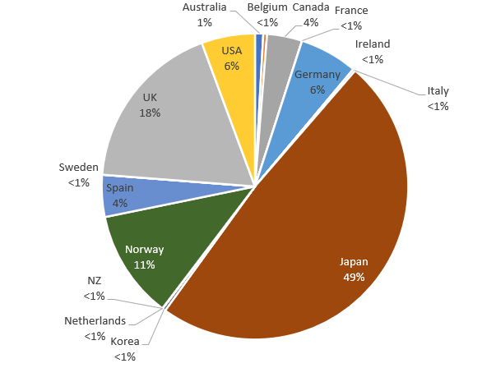
Figure 3-3 - The source of investment into the blue economy (2012 – 2021)
The main source of investment in blue economy in the Caribbean region as a whole is Japanese project-based funding, representing 49% of investment flows. The UK is the second largest contributor with 18% of all flows, followed by Norway with 11%. Germany and the USA both provide 6%, while Spain and Canada both provide 4%. A number of other sources provide the rest in smaller amounts, including Australia, Belgium, Ireland, Italy, Sweden, the Netherlands, New Zealand, and Korea.
Unlike the Pacific, UN institutions and the World Bank are not a source of blue economy investment to the Caribbean. This may simply be due to different priorities that do not match blue economy categories.

Location of ODA funded projects

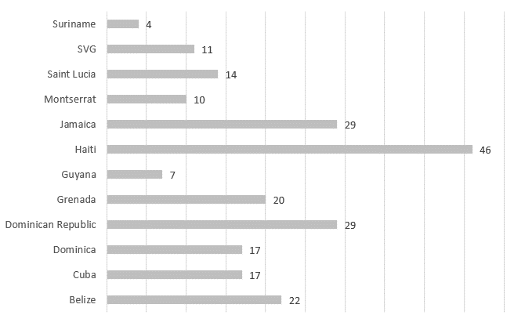

Figure 3-4 - Number of ODA funded Blue Economy investments by country from 2012 – 2021

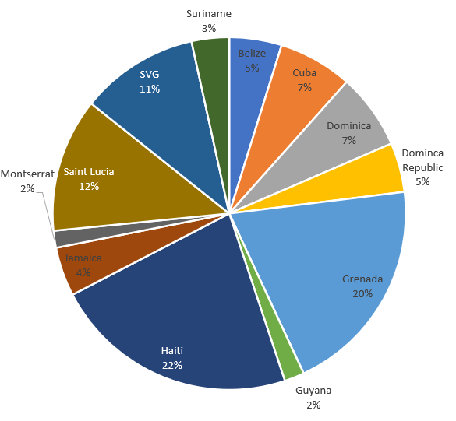
Figure 3-5 - Relative value of ODA funded Blue Economy investments by country from 2012 – 2021
Haiti received by far the greatest number of projects over the period of the analysis (20%). This is reflected in the relative value of blue economy investments for Haiti across the region (22%) (see Figure 3-4).
Jamaica and the Dominican Republic both had 29 projects (13%). When considering the proportion of the value of these projects (see Figure 3-5), this translates to 4% and 5% respectively, suggesting that a larger number of smaller projects have been implemented in these countries. Conversely, Grenada received 20% of the overall blue economy funding across 20 projects (9% total number), suggesting larger value projects. When the individual country profiles are examined for these countries, Grenada received three project investments over US $1M, while Jamaica and the Dominican Republic both received only one project over US $1M over the period of the analysis.
Saint Vincent and the Grenadines (SVG), and Saint Lucia were the other countries to receive more than 10% of the total blue economy investment in the region (see Figure 3-5). This was also across a relatively low number of projects; 11 and 14 respectively (see Figure 3-4), suggesting higher value individual investments than in other countries with a larger number of projects, such as Belize, Dominica, and Cuba.
Guyana and Suriname received the fewest project investments as well as the lowest value of investments. This may be a reflection of their greater inland areas compared to their coast, such that most ODA investments are targeted towards inland projects.

Size of investments into the blue economy
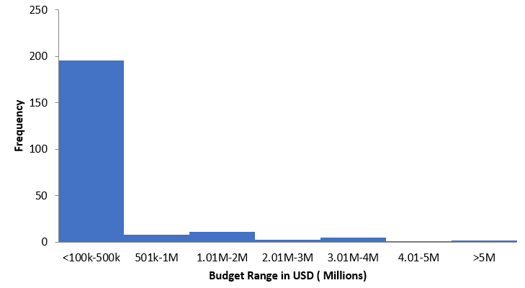
Figure 3-6 - Number of projects by frequency in financial size categories (2012 – 2021)
Out of the 226 project investments into the Caribbean region only two were over US $5M. The majority of project investments (87%) were below US $500,000.
This large number of relatively small investments across the region will place a high administrative burden on both individual countries and the organisations providing the funds.
This is a similar pattern to the ODA blue economy investments seen in the Pacific region, however most investments were in the US $500,000 to US $1M category. There was also a greater number of projects with larger budgets of over US $5M, and a few with very large budgets of US $35 – US $50M.

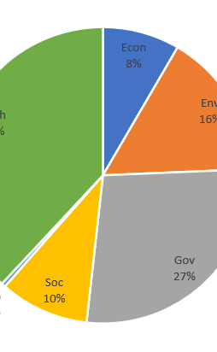
Target of investments into the blue economy
Figure 3-7 - Target of ODA blue economy investment (2012 – 2021)
The target of the ODA blue economy investment as a proportion over the 10-year period was based on assigning finances to one of six categories which represent the primary purpose of the blue economy investment (Economy, Environment, Governance, Innovation, Society, and Technology & Capacity).
The largest category of ODA investment (38%) was targeted Technology & Capacity, followed by Governance (27%). These were the two largest categories of investment in all countries analysed accounting for over 50% all ODA investments into the blue economy in every country. In Guyana, these were the only two categories receiving ODA investment.
The Environment category received the next highest proportion of investment (16%). When examining the individual country profiles, this category received between 9% and 25% investments in most countries.
Society and Economy received 10% and 8% respectively. There was significant variation in the blue economy investment in these categories in individual countries, with several receiving no investment in one or both of them.
Investment in the Innovation category was just 1%. There was no investment in the Innovation category in all the countries analysed, with the exception of Saint Vincent and the Grenadines, which therefore accounts for all the regional investment in this category.

About FCDO SIDS Hub:

The FCDO SIDS Hub provides support on policy and programming for the world’s most vulnerable island states. The Hub supports SIDS in their efforts to access appropriate development finance through initiatives such as the Call to Action on Access to Finance. The UK’s vision for SIDS is set out in the Strategy for International Development:

Our vision is that by 2030 Small Island Developing States (SIDS), will have the economic and climate resilience not only to graduate from ODA with sustainable economies, but also to withstand economic and climate shocks. The UK will continue to work to help SIDS make best use of international aid and finance and improve how it works for them.

Enquiries: SIDSHub@FCDO.GOV.UK

The methodology used is the same as that applied to a similar, but more detailed analysis of 14 SIDS in the Pacific.
Hills et al. (2019) The disjuncture between regional ocean priorities and development assistance in the South Pacific. Marine Policy: https://www.sciencedirect.com/science/article/abs/pii/S0308597X18304305?via%3Dihub
Voyer et al. (2019) Shades of blue: what do competing interpretations of the Blue Economy mean for oceans governance? https://www.tandfonline.com/doi/full/10.1080/1523908X.2018.1473153
All financial flows in this analysis are “weighted” based on the estimated proportion of the overall project budget that are targeted at blue economy activities.

