Pacific Blue Economy Financial Flows

2022

Notice
This document and its contents have been prepared and are intended solely as information for DRAFT and use in relation to Pacific Blue Economy Financial Flows – Final Report
SNC-Lavalin assumes no responsibility to any other party in respect of or arising out of or in connection with this document and/or its contents.
This document has 55 pages including the cover.

© copywrite UK Government, all enquiries to SIDSHub@FCDO.GOV.UK

Contents
Abbreviation and Acronyms 1
1. Introduction 3
1.1. The Commonwealth Marine Economies Programme 3
1.2. Objectives of the study 3
1.3. Structure of the report 4
2. Scope and Methodology 5
2.1. Scope 5
2.2. Methodology – financial flows 5
2.3. Methodology – stakeholder engagement 6
3. Blue Economy Overview 8
3.1. Context 8
3.2. Stakeholder perspectives 9
4. Initiatives and Programmes 12
4.1. Context 12
4.2. Stakeholder perspectives 14
5. Funding the Blue Economy 17
5.1. Context 17
5.2. Stakeholder perspectives 21
6. Monitoring and evaluation of the blue economy 23
6.1. Context 23
6.2. Stakeholder perspectives 26
7. Case Studies 27
7.1. The role of case studies 27
7.2. Vanuatu 27
7.3. Republic of Fiji 30
8. Funding Gaps and Opportunities 33
9. Recommendations 36
Annex A - Briefing sheet used for stakeholder consultation 40
Annex B – Stakeholders consulted 42
Annex C – National blue economy ODA financing profiles for case study countries 43
Blue Economy Financing Profile: Vanuatu 44
National profile 44
Total flow of ODA investments into the blue economy 44
Target of investments into the blue economy 45
Size of investments into the blue economy 45
Source of investment into the blue economy 46
Type of entity implementing project 46
Blue Economy Financing Profile: The Republic of Fiji 47
National profile 47
Total flow of ODA investments into the blue economy 47
Target of investments into the blue economy 48
Size of investments into the blue economy 48
Source of investment into the blue economy 49
Type of entity implementing project 49
Figures

Figure 3-1 - Regional organisations in the Pacific relevant to the blue economy 8
Figure 4-1 - ODA funded blue economy projects in 14 PSIDS, 2012 - 2021 12
Figure 4-2 - The distribution of the number of projects categorised by the proportion of the project budget spend on Blue Economy outcomes 13
Figure 4-3 - Number of ODA funded Blue Economy investments by country from 2012 – 2021 13
Figure 5-1 - Annual flows of ODA to blue economy outcomes for 14 PSIDS 17
Figure 5-2 - Source of blue economy funds 18
Figure 5-3 - Distribution of ODA blue economy finance between PSIDS 19
Figure 5-4 - All projects distributed by US $5M categories 20
Figure 5-5 - Projects <US $5M 20
Figure 5-6 - Distribution of total blue economy investment across categories of intervention 21
Figure 7-1 - Domestic expenditure on blue economy, from National Budget for 2022 29
Figure 9-1 – The relationship between proposed Work Packages 36

Tables

Table 7-1 – Largest ODA projects in Fiji identified in the study 31

Abbreviation and Acronyms

ADB Asian Development Bank
AToNs Aids to Navigation
BBNJ Biodiversity of areas Beyond National Jurisdiction
BPOR Blue Pacific Ocean Report
CBD Convention on Biological Diversity
CITES Convention on International Trade in Endangered Species of Wild Fauna and Flora
CME Commonwealth Marine Economies Programme
CROP Council of Regional Organisations of the Pacific
CSO Civil Society Organisations
DAC Development Assistance Committee
DFAT Department of Foreign Affairs and Trade, Australia
EEZ Exclusive Economic Zone
ESCAP Economic and Social Commission for Asia and the Pacific
ESS Environmental and Social Safeguards
FCDO Foreign, Commonwealth and Development Office, UK
FAO Food and Agriculture Organisation
FCAS Fragile and Conflict-Affected Situations
FFA Pacific Islands Forum Fisheries Agency
FPO Framework for the Pacific Oceanscape
FSM Federated States of Micronesia
GCF Green Climate Fund
GCRF Global Challenges Research Fund
GFCR Global Fund for Coral Reefs
GEF Global Environment Fund
GIZ Deutsche Gesellschaft fűr Internationale Zusammenarbeit
GNI Gross National Income
IED Independent Evaluation Department
IGO Intergovernmental Organisation
IMarEST Institute of Marine Engineering, Science & Technology
IUCN International Union for Conservation of Nature
IRR Internal Rate of Return
LDC Least Developed Countries
MACBIO Marine and Coastal Biodiversity Management in Pacific Island Countries
MER Monitoring, Evaluation and Reporting
MFAT Ministry of Foreign Affairs and Trade, New Zealand
MGR Marine Genetic Resources
MLAFFB Ministry of Agriculture, Livestock, Forestry, Fisheries and Biosecurity, Vanuatu
MPAs Marine Protected Areas
MSP Marine Spatial Planning
MSWG Marine Sector Working Group
NDC Nationally Determined Contributions
NGO Non-Governmental Organisations
NOPs National Ocean Plans / National Ocean Policies
NSDP National Sustainable Development Plan
ODA Official Development Assistance
OECD Organisation for Economic Co-operation and Development
OPOC Office of the Pacific Ocean Commissioner
PEUMP Pacific-European Union Marine Partnership
PFM Public Financial Management
PICs Pacific Island Countries
PIFS Pacific Islands Forum Secretariat
PIPA Phoenix Islands Protected Area
PIROP Pacific Islands Regional Oceans Policy
PIRT Pacific Islands Roundtable for Conservation
PNG Papua New Guinea
POA Pacific Ocean Alliance
POC Pacific Ocean Commissioner
PPFD Procurement, Portfolio and Financial Management Department
PSIDS Pacific Small Island Developing States
SDG Sustainable Development Goals
SIDS Small Island Developing States
SPC The Pacific Community (formerly South Pacific Commission)
SPOCC South Pacific Organisations Coordinating Committee
SPREP Secretariat of the Pacific Regional Environment Programme
SPTO South Pacific Tourism Organisation
UN United Nations
UNDP United Nations Development Programme
UNCDF UN Capital Development Fund
UNEP United Nations Environment Programme
USP University of the South Pacific
WB World Bank
WRI World Resources Institute
WWF World Wide Fund for Nature

Introduction

The Commonwealth Marine Economies Programme
FCDO’s Commonwealth Marine Economies (CME) Programme was launched in 2016 and aimed to support 17 Caribbean and Pacific Small Island Developing States (SIDS) in conserving their marine environments and making the most of their maritime resources to catalyse sustainable economic development. It was designed to promote growth, innovation, jobs and investment whilst safeguarding healthy seas and ecosystems, and it helps to address climate change, the UN Sustainable Development Goals (SDGs) and the Paris Climate Change Accord. The programme became an important part of FCDO’s new Small Island Developing States Hub, when this was launched in 2020.
The concept of the ‘blue economy’ emerged during the 2012 Rio+20 United Nations Conference on Sustainable Development and recognises the need to maximise the vast economic potential of the ocean while also preserving it. It includes economic and trade activities that integrate the conservation and sustainable use and management of the seas and coasts. The blue economy concept encapsulates the same principles of low carbon, resource efficiency and social inclusion as the Rio+20 Green Economy concept, but it is grounded in a developing world context and fashioned to reflect the circumstances and needs of countries whose future resource base is mainly marine. These ideas reflect both the issues and opportunities of Small Island Developing States (SIDS).
The CME Programme supports the aims of the Commonwealth Blue Charter and is an integral part of the UK’s effort to protect the health of the world’s oceans and promote the growth of blue economies.
The Pacific region has been particularly hard hit by COVID-19. Pacific Island Countries (PICs) are resource constrained, highly dependent on imports and with economies that are reliant on tourism and fishing. The main sources of economic productivity and imports / exports of vital supplies were effectively halted. Government and health care resources came under unprecedented levels of pressure.

Objectives of the study
This project sits within the context of the overall CME Programme, which includes nine PICs - Fiji, Vanuatu, Nauru, Kiribati, Samoa, Solomon Islands, Tuvalu, Papua New Guinea and Tonga. The CME Programme completed in March 2022. The UK Government remains committed to supporting Commonwealth nations to realise the potential of their blue economy in a post-COVID world.
This project aims to provide development actors in the Pacific with a clearer picture of the current activities, and resources available in the region for blue economy issues, to understand where future support to the region might be focused. The focus of the study is on resources that supported through Official Development Assistance (ODA), as defined by OECD-DAC.
The approach to the report was not to re-iterate or combine other fully accessible reports from the region, but to generate novel information and analysis and use this as a catalyst to promote a structured discussion with stakeholder perspectives around blue economy. This catalyst was considered important as there is enduring stakeholder fatigue around oceans and blue economy in the region. Much of the reporting in this document does not repeat previously published work but uses this as a basis for further understanding of blue economy in the region.
The study had the following specific objectives:
- Context of ‘blue economy’ review: a review of the current context for Pacific SIDS (PSIDS) in the development of the blue economy, including geopolitical factors, and their policy, financing, commercial and economic constraints and opportunities.
- Identification of regional ‘actors’: identify all actors in the region relevant to the development of the blue economy, including but not limited to representatives of Pacific Island governments, international funding institutions, multilateral development banks, bilateral development agencies, regional organizations and knowledge hubs.
- Ongoing initiatives and programmes: identify the ongoing initiatives and programmes at the national, regional and international level relating to the development of the blue economy. This would include recently completed, current and planned initiatives and programmes, their expected outputs and impacts, as well as their planned delivery timeline.
- Gap analysis and identification of opportunities for intervention. This should build on the work from objectives 2 and 3 to identify specific interventions needed in the region and the changes that support could bring about through support to fill these gaps.

Structure of the report
To provide a report that meets the objectives of the study and sets out the approach that has undertaking, the following structure has been used:
- 1 - Introduction and context – this section.
- 2 - Scope and Methodology – a description of the methods used in the study.
- 3 - Blue Economy Overview - economy initiatives and programmes and identification of which stakeholders are implementing blue economy projects.
- 4 - Initiatives and Programmes - an analysis of Official Development Assistance (ODA) funds flowing into the blue economy in the region, the scale and distribution of funds to countries and their source.
- 5 - Funding the Blue Economy – an analysis of annual ODA flows, their source and the main blue economy purpose of the interventions.
- 6 – Monitoring and evaluation of the Blue Economy.
- 7 - Case Studies –Vanuatu and Fiji are examined in more detail.
- 8 - Funding Gaps and Opportunities.
- 9 – Recommendations.

Scope and Methodology

Scope
The study looked at the nine PSIDS in the CME Programme, along with five additional countries to cover a total of 14 PSIDS: Cook Islands, Federated State of Micronesia, Fiji, Kiribati, Nauru, Niue, Palau, Papua New Guinea, Republic of the Marshall Islands, Samoa, Solomon Islands, Tonga, Tuvalu and Vanuatu.
Blue economy investment information for each country was collected for ODA financial flows for a ten-year period (2012 – 2021).
Regional and national stakeholders were engaged during the consultation phase, drawn from entities involved in the blue economy, including governmental representatives, intergovernmental organisations, Non-Governmental Organisations (NGOs) and the academic sector.
The study took place over a period of approximately four months between October 2021 and March 2022. The relatively short timescale meant the work took a broad, multicounty approach to provide a view of the regional status of the blue economy. It was not possible to undertake a fully detailed programming analysis of each of the countries included in the study, nor of the programme outcomes or value against stated aims or investments.
Following feedback from the region to include an element of national focus, case studies for Fiji and Vanuatu were included in the scope. National blue economy ODA financing profiles and more in-depth national case studies were produced for the case study countries. The diversity of PSIDS means that case studies will only provide a flavour of how individual countries vary from the overall regional picture. The timescale for the project, along with significant pressures on some of the countries in region, due to COVID outbreaks and natural emergencies, meant that only a high level view of countries that were able to respond at the time could be undertaken. The overall focus of the study was on capturing the regional status of blue economy, which provides a backdrop to all future activities or investments in the future.
This work adds to the existing and published detailed analysis of progress in oceans in the region as reported in detail in the Blue Pacific Ocean Report of 2021 produced by the Office of the Pacific Ocean Commissioner (OPOC).
As desk-based study, two main sources of information were collected, collated and analysed during this work: ODA financial flows and stakeholder engagements, with interviews taking place remotely via web-based platforms.

Methodology – financial flows
A financial analysis of ODA Blue Economy investment of the 14 targets PSIDS was undertaken. Data was collected from several sources:
- Financial information collected and published by Hills et al. in 2019 during the Enhancing Pacific Ocean Governance project, funded by the Department of Foreign Affairs and Trade, Australia (DFAT);
- Official financial flows as laid out in the Creditor Reporting System under the Development Assistance Committee (DAC) of the Organisation for Economic Co-operation and Development (OECD); and
- Additional ODA supported projects that were identified or mentioned in other miscellaneous sources and were captured through entity websites.
The data used in this study was limited to the ODA funding reported by the countries to the OECD database. The private investment and individual Government domestic spending that was not reported to the OECD, was not included in this study. An exception to this is the case study of Vanuatu (section 7.2), which also examined blue economy flows linked to the national budget.
Data collected included project name, project budget, start and end date, countries of implementation, source of ODA and implementing entity.

Blue economy components of the project in most cases did not make up the entire project budget, thus each project’s blue economy component required a weighting to be applied. Weightings were in four categories from ‘very low’ to ‘high’ to represent the proportion of blue economy components in the project:
- Very low = 1 – 24% of the total project budget aligned to blue economy,
- Low = 24 – 49%,
- Medium = 50 – 74%,
- High = 75 – 100%.
In subsequent calculations, the mid-point of these categories was used for estimates. The estimate of the proportion of total project budget aligned to blue economy was carried out by expert assessment based on a review of the project title and summaries or abstracts, if unclear from the title alone.
Multicounty projects were divided out equally between involved countries to obtain country-project budgets (assumption: allocation of total project budget was equal between PSIDS). This may have led to some under / over estimation of specific project budgets to countries.
To determine annual blue economy flows, each country-project amount was allocated equally across the start and end year (assumption: project allocation was equally across each active project year). Where the project end date was not available, projects were estimated to last 4 years, which appeared to be the mode duration of the projects for which start and end data was available (assumption: if not known projects were assumed to last for 4 years).
All blue economy flows were coded into one of six categories based upon their main purpose:
- Economic,
- Environmental,
- Governance,
- Technology & Capacity,
- Society, and
- Innovation.
These categories were developed from the analysis of blue economy by Voyer et al. in 2018 and further developed by research with a Pacific focus through the FCDO Global Challenges Research Fund (GCRF) One Ocean Hub project. Coding was carried out through expert assessment but was difficult for some projects (assumption: a single category could reflect projects which were operating in a number of blue economy areas of activity).
This analysis allowed various numerical estimates and graphs to be developed which are presented in sections 4 and 5 and in the national profiles produced for each country.

Methodology – stakeholder engagement
The stakeholder consultation was intended to provide insights and thought on the objectives of this work. Due to high-levels of stakeholder fatigue in such consultations, it was intended to use some of the outcomes of the financial analysis as a precursor for the consultation and to spark engagement and dialogue. A briefing sheet incorporating some outcomes of the financial analysis and a set of leading questions was sent out as part of the consultation invitations (see Annex A).
The list of stakeholders to be contacted was agreed with the FCDO, with input from UK and Pacific regional staff. Stakeholders in regional organisations (intergovernmental and NGO) were contacted in the first tranche of engagement. This was followed up by stakeholders in individual Pacific countries. It was not possible to contact all possible blue economy stakeholders in all countries and organisation across the region.
Consultations took place mostly using Microsoft Teams software and lasted for about an hour each. Consultations were carried out by individual institution, however, the number of stakeholders representing the institution on the call varied between one and five, such that a range of views from within and between organisations were collected.

Each consultation followed the same structure:
- Introductions of all those on the call.
- An introduction to the CME programme.
- An outline of the objectives of the study.
- A structured discussion based around the areas identified in the briefing sheet.
Meeting notes were taken of the discussions by a member of the project team. The list of stakeholders contacted is provided in Annex B.
The outcomes and findings of the consultations are presented in the following sections under the sub-heading ‘Stakeholder Perspectives’. The anonymity of individuals and organisations is maintained, but specific quotes by stakeholders are included in speech marks.

Blue Economy Overview

Context
The ocean plays a fundamental role in Pacific culture and identity The blue economy concept is a fairly new term that attempts to describe some of this role in modern terms or economics and governance. The recognition, adoption and use of the term blue economy is unequal across the region and at national and local levels; however the recognition of the importance of the ocean to Pacific life is widely and naturally accepted.
The Pacific has multiple, long-established and capable regional inter-governmental organisations covering many of the key economic and security aspects of the Pacific region, such as environment, fisheries, tourism and electricity. The Council of Regional Organisations of the Pacific (CROP) was set up in 1988 to provide regional coordination across key areas to support high-level objectives such as the fulfilment of the UN Sustainable Development Goals. The CROP’s Marine Sector Working Group (MSWG) developed a Pacific Islands Regional Oceans Policy (PIROP), which was endorsed in 2002. MSWG has been operating since, but it has recently ceased to function.
The region has high-level leadership through a Pacific Ocean Commissioner (POC). Notwithstanding the MSWG, the updated regional oceans policy ‘Framework for Pacific Ocean space’ (FPO, 2010) called for a strengthening of the regional institutional framework for ocean governance and policy coordination by establishing a Pacific Ocean Commissioner (POC). The POC would provide high-level representation, commitment and dedicated advocacy to ocean priorities, decisions and processes at national, regional and international levels. The POC facilitates the Pacific Ocean Alliance (POA), an open-ended network of government, non-government, private sector and civil society organisations launched in 2014, to advance coordinated and cooperative approaches towards integrated ocean management, including for the high seas.
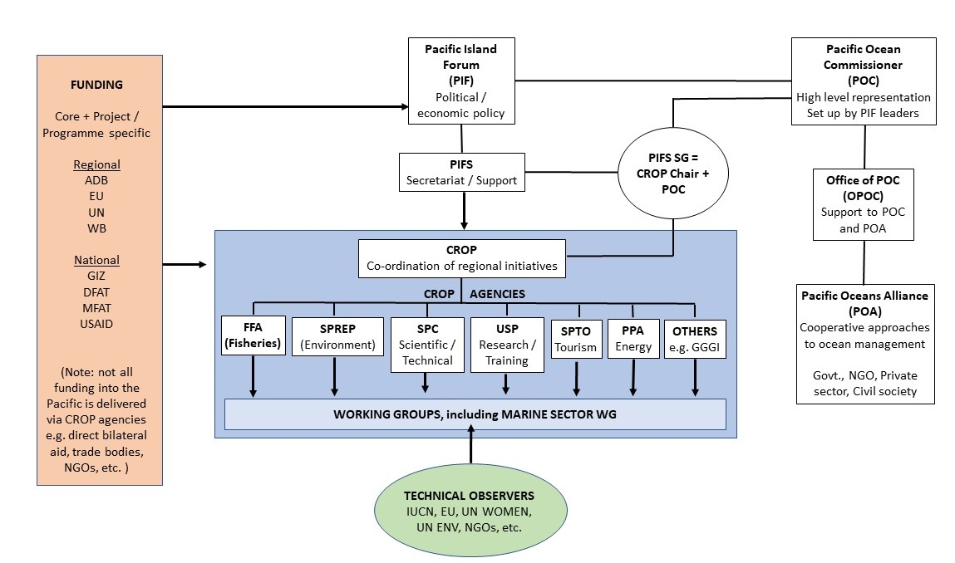
Figure 3-1 - Regional organisations in the Pacific relevant to the blue economy

The region has a number of ‘blue’ narratives and ‘blue’ terms in use. At the regional level, a disjuncture between the blue economy and the Blue Pacific regional Communique (from PIF 2017) from Pacific Leaders is apparent. At the national level, the lack of uptake of the term into policy development is notable; Fiji has just produced its first National Ocean Policy which makes no mention of the blue economy. At the local level, manifestation of contemporary Pacific Ocean challenges may not align with blue economy paradigms.
The regional geopolitical positing of the Pacific reflects increasing outside interest. The interplay between national and regional is important to capture and the influence of non-Pacific and global influence must also be recognised.

Stakeholder perspectives
In terms of the overall understanding and perception of the term blue economy and its application to the Pacific region, stakeholders expressed the following perspectives, which have been grouped into seven statements.
1 - Blue economy has been used as a term for well over a decade in the region but is yet to be nationally framed.
Blue economy was first used in the region by the Pacific Islands Roundtable for Conservation (PIRT) in 2010 and was closely based on the global Club of Rome and UNEP definition of that period. Awareness of blue economy was considerably strengthened through various projects, which included more specific financial or valuation techniques, such as MACBIO and blue carbon projects.
There has been a positive momentum in use and understanding of blue economy, and the “cascading of those global narratives” was ongoing, but it is still lacking national framing, especially in relation to what exactly “sustainability” means in a PSIDS context. One experienced consultee noted that blue economy had “not made much of an inroad into the Pacific” and another partly dismissed it as the “flavour of the month”.
2 - Blue economy was recognised by some as needing guardrails by using a prefix: “Sustainable Blue Economy”.
It was stated a number of times that it was important to use the term “Sustainable Blue Economy” to create a distinction from blue economy, which had been used to describe unsustainable blue growth by certain actors. Blue economy was seen by some to have “exploitative connotations”.
For some the sustainability component for blue economy was largely about capturing ecosystem services and ecosystem-based management as the core for sustainability, rather than sustainable economies of societies.
There was recognition of the use or capturing of the term by various actors in the region for supporting advancements which would be considered by many as not being generally accepted as blue economy. Consequently, there was a concern expressed about the “exploitative connotations” of the term.
3 - Blue economy was considered an undefined but useful term.
The general view was that the undefined nature of the term did not mean that it had no value. As one respondent noted “definitions differ by who you ask”. Similarly, one regional agency representative comfortably stated “I don’t have an answer to what Blue Economy is” although ocean sustainable development was the core of their remit.
Some accepted the presence of blue economy in regional and / or international narratives, but do not think it has made “much of an inroad into the Pacific” in ways of governing the ocean. One consultee stated that they had “not heard it used a lot in my country but had heard it in international arenas”.
The term was primarily discussed at a scaling associated with local or national economies. It was rarely considered at a regional scale, with one stakeholder noting that it had been used as a regional narrative but that “I don’t really see it”. Regional blue economy was shared in relation to some common key topics with strong regional elements, specifically tuna fisheries and shipping.

4 - Blue economy should not surpass the already culturally embedded ocean stewardship.
Forging a definition or national framing of blue economy may not be a useful undertaking, but the ocean already has a strong cultural and spiritual basis which inculcates ongoing stewardship. The use of blue economy, as a term or way of thinking about the ocean, should not surpass or usurp the indigenous cultural basis of ocean steward already in the region.
It was expressed in a number of ways in relation to blue economy that “we’ve been doing it for millennia”. However, it was also recognised that there were strong economic and geopolitical drivers in the modern world which had a close linkage to development and achievement of the Sustainable Development Goals (SDG). Thus, expansion of the dialogue beyond the rather passive perception of “stewardship”, through narratives on blue economy was of value in this contemporary setting.
5 - There are many shades of “blue” in the Pacific and their use is somewhat congested and confounded.
Other “blues” may have more specific value in the region, especially the emerging agenda associated with “blue” carbon and associated ecosystem services, and the broader Blue Pacific (Leader’s Communique of 2017) which primarily focussed on economic development but within a societal perspective.
The framing of the region as a “Blue Continent” in the Blue Pacific Communique, is about reclaiming identity and regionalism, rather than a term emerging from musings on blue economy. Blue economy is only one shade of blue for the Pacific, and other shades may be more relevant and poignant from a development perspective.
Some called for a better policy interpretation of blue economy in the region. It was recognised that the work subsequent to Pacific 2050 led by PIFS may produce some of this policy basis moving forward.
6 - Blue economy can be seen as a distant outcome as much needs to be done over many years to realise it.
There is still much need to fulfil ongoing national requests for dealing with poverty through economic development, be it through improved infrastructure or strengthened and inclusive banking sectors. Blue economy was framed as “something to come” and “an end goal we strive towards, but it does not paralyse us”. It was also stated that blue economy in the Pacific is “not well understood in how it contributes meaningfully to social, economic and environmental capital”. The inherent assumption that there was “untapped potential” in the Pacific was seen as a reason for the growth in the use of the term.
7 - Discussion on blue economy largely took place in the realm of management or governance; geopolitics was largely ignored.
All the discussions were carried out with a focus on improved management, strengthened policy or stronger governance of the blue economy of the region. The challenges and constraints discussed on blue economy were mainly internal looking, such as limited capacity, inadequate finance, weak technical skills and low institutional strength.
Some external pressures were identified, but these were mainly in relation to commercial enterprises wanting to exploit Pacific resources with inadequate regard (deep sea mining was mentioned in this regard a number of times). The role of geopolitics in blue economy was largely absent in such discussions, suggesting that geopolitical pressures are not pervasive in blue economy or that the blue economy implementing constituency largely operate in a geopolitical vacuum.
Figure 3-2 summaries some of the stakeholder responses about blue economy:

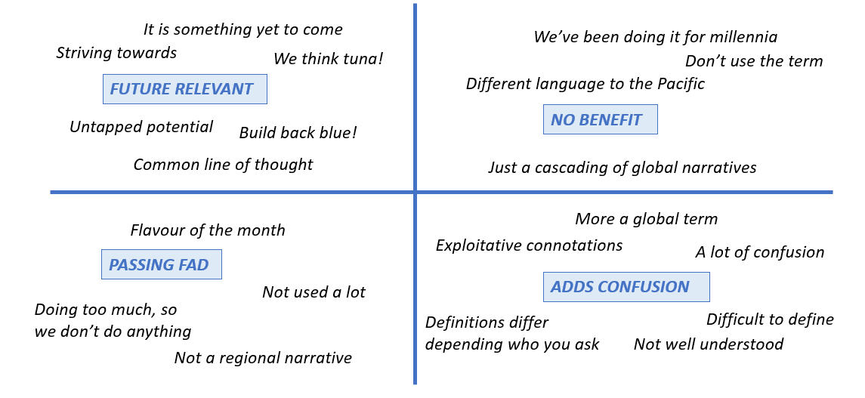
Figure 3-2 – A summary of comments from stakeholders about blue economy in the Pacific region

Initiatives and Programmes

Context
The following charts set out the findings in relation to the ODA funded blue economy projects identified across all 14 PSIDS in the study, over the whole 10-year period examined from 2012 – 2021.
A total of 197 ODA funded blue economy projects were identified in the 14 PSIDS 10 year period. These projects could be targeted at a single country or multiple countries.
The implementing entities for these projects were approximately a third by governments, a third by intergovernmental governmental organisations (IGO and UN entity categories) and the final third by others, including NGOs, private sector and academic institutions (see Figure 4-1).

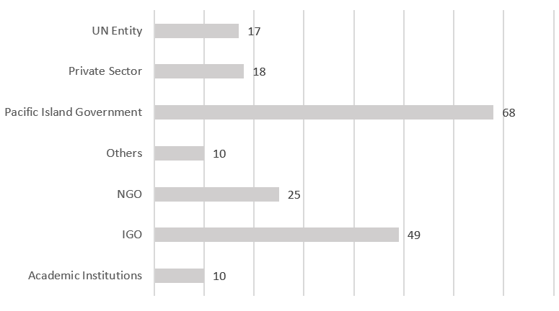
NGO = non-governmental organisation
IGO = intergovernmental governmental organisation, but with UN family as separate category).
Regional organisations are included within the IGO category
Figure 4-1 - ODA funded blue economy projects in 14 PSIDS, 2012 - 2021

Most projects were not exclusively targeted at blue economy.
Through the weighting methodology which estimated the proportion of the total projects budget spent on blue economy, it was possible to assess the number of exclusive or mixed-target projects.
Exclusive blue economy projects, (deemed to be 75% of more of funds targeted at blue economy), represented 34% of the 197 projects (see Figure 4-2). Nearly equal in number were projects which had a relatively small component of blue economy (1 – 24% of project budget). The remaining third was made of the mid-categories of blue economy expenditure (25 – 49 and 50 – 74%) in which blue economy was a significant but not exclusive component of the project.

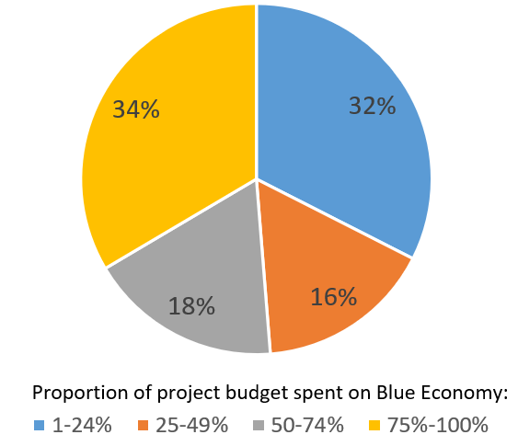
Figure 4-2 - The distribution of the number of projects categorised by the proportion of the project budget spend on Blue Economy outcomes
Blue Economy projects were not equally distributed between PSIDS.
When the 197 discrete projects were broken down into country-based investments (e.g. a three country project would be separated into three country-specific investments), a total of 443 country-specific investments were identified. This suggests that each project targeted on average just over two countries (average = 2.2 PSIDS), although there were a number of single country projects as well as a number which covered most or all of the 14 PSIDS.
Fiji and Solomon Islands received the largest number of investments (50 and 47 country-level investments), followed by Kiribati and Tuvalu (Figure 4-3). The least number of investments were received in Nauru (21), Cook Islands (20) and Niue (18).
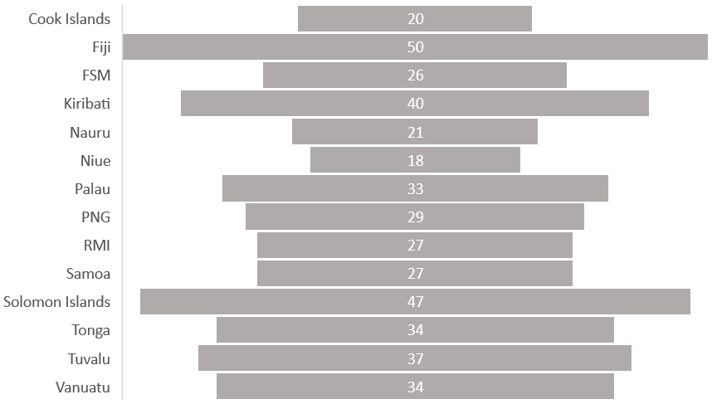
Figure 4-3 - Number of ODA funded Blue Economy investments by country from 2012 – 2021
There was a negative link between blue economy ODA flows and GNI per capita across the Pacific countries.
There was a significant negative correlation between blue economy ODA flows and Gross National Income (GNI) (correlation of -0.61), meaning that countries with higher GNI tended to have lower blue economy ODA flows (Figure 4-4). This trend line was partly due to the small islands of Nauru, Palau and Niue along with the Cook Islands having high GNI and low ODA flows.
The three Least Developed Countries (LDCs) of Tuvalu, Solomon Islands and Kiribati have higher levels of ODA flow than most other countries. Papua New Guinea (PNG), the Federated States of Micronesia (FSM) and Tonga are below the trendline, so tend to receive less blue economy ODA for their GNI status.
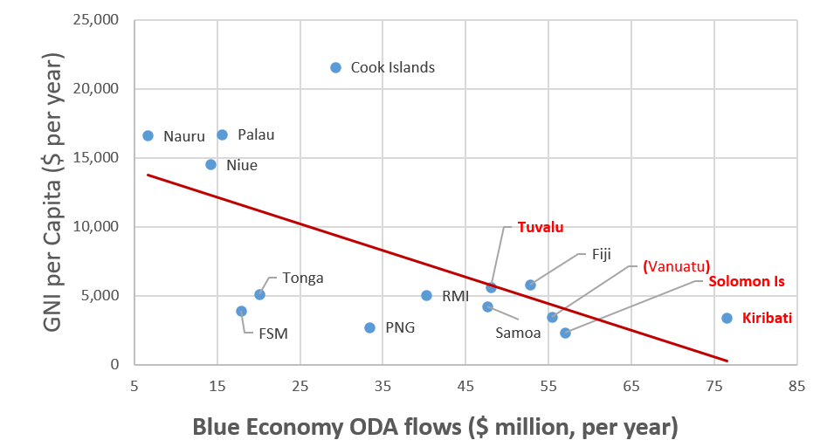
Figure 4-4 – Link between ODA Blue Economy flows and GNI per capita
Note: LDCs are shown in red. Vanuatu is shown in brackets as it graduated from LDC in December 2020

Stakeholder perspectives
Stakeholders expressed the following perspectives, which have been grouped into seven statements, in relation to the initiatives and programme targeting the blue economy in the Pacific.
1 - Blue economy was not used as a basis for direct project programming by development agencies.
Blue economy was commonly applied as an umbrella term by development agencies, but once programming of development cooperation was discussed it was discarded. Programming of funds along themes or sub-programmes always reverted to more traditional nomenclature, such as climate change impacts, biodiversity, nature-based solutions, or sustainable production-systems. This seemed to be the point of bifurcation from the triple-bottom line of blue economy (economy, environment and society) to more discipline or thematic programmes in climate, ecosystems, etc.
In other words, the holistic nature of blue economy was rapidly discarded when funds, programmes and projects were discussed.

2 - Recent retrenchment towards non-sustainable “blue growth” has occurred in response to COVID-19.
There has been a recent detachment away from a bearing towards sustainability, and a reversion towards expanding economic flows in response to the COVID-19 pandemic through extraction of primary productivity, including fisheries.
The recent application of blue economy is thus used more as “blue growth” (economic expansion driven by marine resources) rather than by the triple bottom line (sustainable environment, society and economy).
Use of “sustainable” as a prefix to blue economy (“Sustainable Blue Economy”) may help with semantic clarity as well as to ensure that usage meets criteria for sustainability (as mentioned above).
3 - Fisheries was likened to the “gold” of the regional blue economy.
The importance of offshore fisheries, especially in relation to license revenue, coupled to inshore fisheries for local economies and subsistence was likened to the consistent value of gold. However, the sector has limits to growth and the focus was more on sustainable catch - offshore and inshore - and possible climate change impacts on migratory species, rather than expansion of the sector.
The real focus of blue economy for the region was simply recognised by one representative as the “sustainable economic returns yet to be realised from the ocean” and whilst recognising fisheries, this also includes many of the nascent or potential sectors.
4 - Many projects were considered to be too complicated and unimplementable.
There was a recognition of the inter-related and indivisible nature of ocean systems, however, there was also a general feeling that many projects were too complicated to implement. Some noted that the main focus of the work was increasingly compromised by the need for multiple-benefits to be addressed and called for there to be more “work on the basics”.
One example provided was a rare species biodiversity study, which was required to have so many multiple co-benefits in terms of livelihoods, income-generation, gender and climate, that it was considered impossible to implement and was dropped by the executing entity.
Aggravating the challenges of implementation was the movement of non-Pacific experts into projects roles, which tended to be expensive and not effective due to lack of experience of operating in the region. The risk of early departure of individuals, and delay in further recruitment / replacement, regularly acts as a drag to project performance and delivery. The inadequacy of the pool of experts in the region was frequently noted.
5 – Involvement of the private sector was recognised as vital but challenging.
The need for greater inclusion of the private sector in blue economy was noted by many respondents. The low level of involvement seemed to be attributed to a limited and weak private sector and a lack of capitalistic fervour. There is also a lack of investment-ready projects which the Global Fund for Coral Reefs (GFCR) funded by UNDP/UNEP/UNCDF project is trying to address. Some NGO respondents suggested that projects should focus on inclusive economic development with co-benefits. There were various suggestions for blue-incubators, or similar, for private sector enterprise in blue economy, however, many areas of support (e.g. banking, financial capacity, project management) are needed to get this off the ground. Structural change in tax regimes and associated financial regulations were also recognised as important in their ability to either incentivise or quash private sector expansion.
6 - Development partner harmonisation needs to be strengthened.
Harmonisation of development investment needs to be enhanced, beyond existing formal and informal mechanisms. Development partners often programme in the region on the basis that nothing has happened in the sector before, when in fact there are many legacies, known pitfalls and functioning structures in existence. Harmonisation needs to be beyond meeting, and needs harmonisation tools or instruments to provide substantive insight.
7 - The region is so dynamic that planning norms threaten programme delivery.
There is an ongoing fatigue for “classical” and fixed development planning. The focus is on planning tools such as logical frameworks and theory of change that provide set outcomes over a fixed period of time for a defined budget.
This pre-set “projectisation” makes sense in a fixed and static world, however, in PSIDS there is ongoing flux, of political, climate disaster, extreme weather / natural events, economic pressures (such as oil price) and societal issues such as pandemics etc. (the designation of the 408,250 km2 Phoenix Islands Protected Area (PIPA) in Kiribati in 2008, and then subsequent opening to commercial fishing in 2021, was quoted as an example). During the course of the study timeframe Tonga suffered a volcanic eruption and tsunami as well as a COVID outbreak. The need to respond to this, quite naturally took precedence over many other ongoing activities and actions as well as knocking out internet communication for several weeks. Traditional programme delivery needs to be designed to both plan for and react to such occurrences.
As a result, there are calls for a differing approach which inculcates the dynamic nature of the region, such as establishment of an overarching investment vision or mission, but then a focus on identification and following of opportunity which lends itself to the mission in a more flexible way, based on changing needs and circumstances over the programme timeframe.

Funding the Blue Economy

Context
A total of USD $417 million was identified as Blue Economy targeted ODA in the 14 PSIDS. This averaged as USD $ 41 million per year for the 14 PSIDS from 2012 to 2021 (Figure. 5-1).

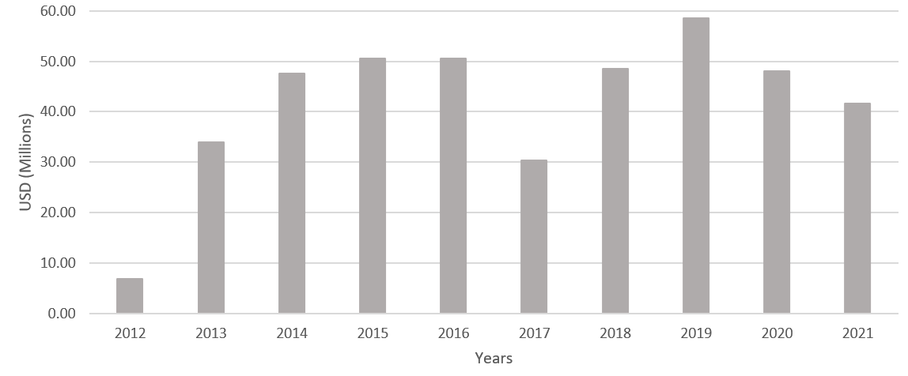
Figure 5-1 - Annual flows of ODA to blue economy outcomes for 14 PSIDS

There was no clear trend of increase or decrease over these years, though it is possible that 2021 was under-accounted as some budget figures would not have been collated by the time the analysis was done.
Volatility in the figures was noticeable, especially around 2017 where a notable drop of about $10m from the running average was recorded. Recovery form 2017 (the year of the UN Oceans Conference) was rapid though, with maximum annual flows of nearly $60m recorded in 2019.

The source of the blue economy investment was from multiple funders but with a few major contributors.
Sources of blue economy ODA could be divided into three main categories each representing around one third (Figure 5-2). UNDP is the largest single funded representing 34%. This includes funds they have sourced through financial instruments such as GEF and GCF. The World Bank is another major donor to the region providing 29% of the blue economy flows, which is likely to be in a blended form (loan, grant and other modalities). The final third is made from a miscellaneous group made up mainly of bilateral donors (e.g. Sweden, Australia, France, Korea, Germany, etc.) plus multilaterals such as ADB, FAO and UNEP, and WWF as an NGO.

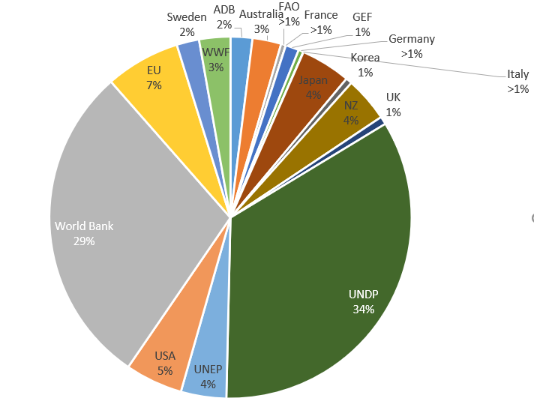
Figure 5-2 - Source of blue economy funds

The flow of finance was not equally distributed between the 14 PSIDS.
The proportion flow of blue economy ODA varied between 1% and 11%, suggesting unequal allocation between PSIDS (Figure 5-3). The largest proportion was to Kiribati (15%), then Solomon Islands and Vanuatu (11%) followed by Fiji (10%) and Tuvalu (9%). A small proportion was allocated to the smaller PSIDS of Palau and Niue (3% each) and Nauru (1%).
Linked to the outcomes of the graph of number of projects between countries (Figure 4.3), this analysis suggests that Kiribati had some relatively large blue economy projects, and that Fiji and Solomon Islands had a larger number of smaller projects.

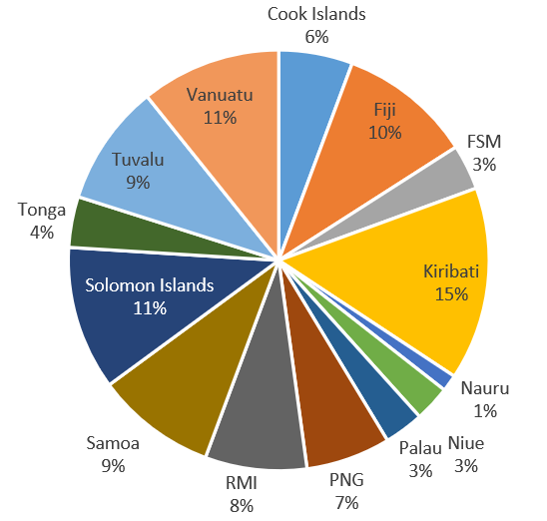
Figure 5-3 - Distribution of ODA blue economy finance between PSIDS

Most blue economy project investments were relatively small, with a few medium and large investments.
Most blue economy project budgets were relatively small (US $1m – US $5m, and this was often divided between a number of countries), but a few had large budgets of $35 – 50m (Figure 5-4).
Of projects less than $5m, most projects were in the $100K to $1m range, with $0.5m to 1m being the most common category (Figure 5-5).
It is worth noting that as many projects were divided between a number of PSIDS (average 2.2 PSIDS per project), actual financial flows into each country would be divided up and thus be smaller, and these flows would be achieved over a number of years related to the project duration.

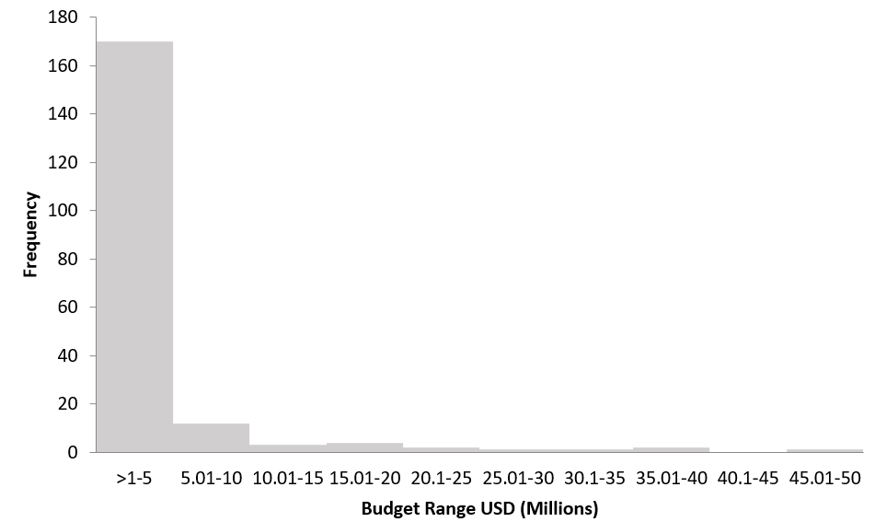
Figure 5-4 - All projects distributed by US $5M categories

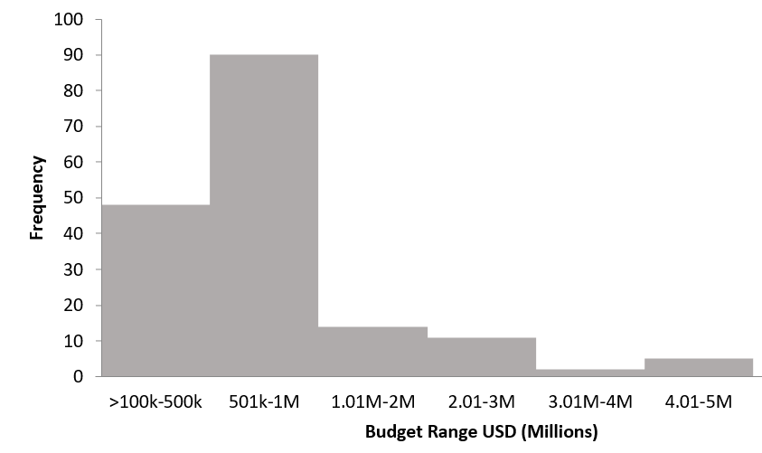
Figure 5-5 - Projects <US $5M

There was a diversity in the main focus of the blue economy investments.
Analysis of the main focus of the blue economy investment identified that there was quite a variety of approaches to blue economy interventions (Figure 5-6).
The largest investment was into the Technology & Capacity building category, representing 29% of total blue economy investment, followed by Environment (26%) and Governance (21%). Investments which were focussed predominantly on Economy represented 16%, which is quite low considering the focus of the investments is the blue economy. The smallest investment category was Innovation, which was <1% of total blue economy investment.
These results should be viewed as indicative, as coding projects which often have multiple outcomes in more than one category to a single category is challenging and subjective.

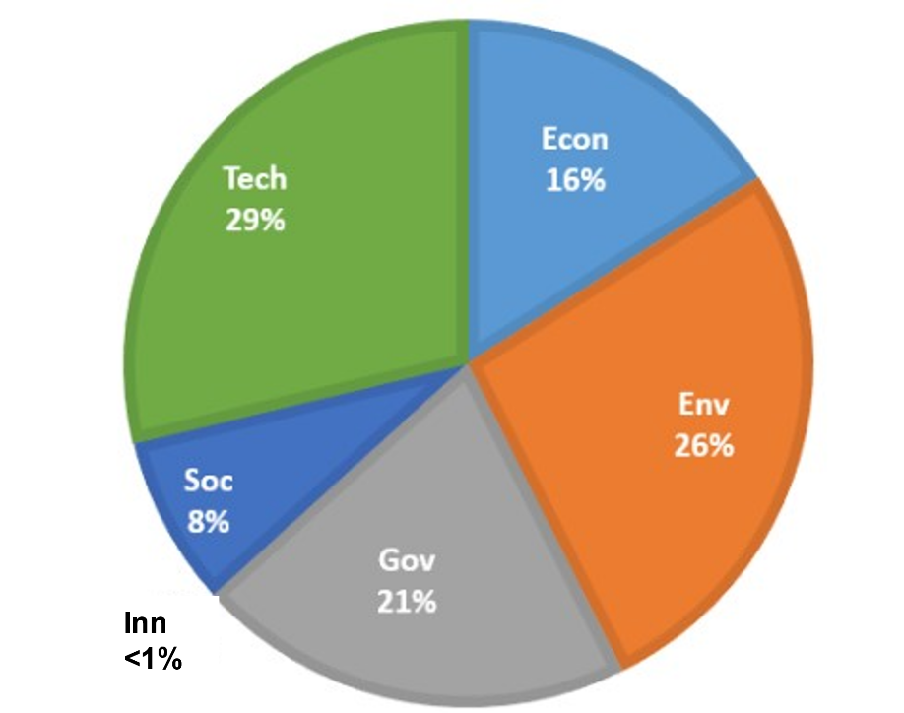
Econ = Economy
Env = Environment
Gov = Governance
Inn = Innovation
Soc = Society
Tech = Technology and Capacity

Figure 5-6 - Distribution of total blue economy investment across categories of intervention

Stakeholder perspectives
In terms of the funding of blue economy initiatives, stakeholders expressed the following perspectives, which have been grouped into seven statements.
1 - The national driver behind blue economy needs to be economic policy and national development.
Blue economy needs to be primarily driven through economic policy and associated national development agendas. It is ultimately aiming at a transformation, rather than an expansion of status quo.
As a transition it needs many leverage points to work which all focus energy towards “encouragement of the sustainable development of the sea”. For example, the positioning of a champion in a convening role is vital, as demonstrated by the Parties to the Nauru Agreement for tuna fishing licensing.
2 - Effective absorption of funds is a larger challenge in the region than the availability of funds.
ODA fund availability has led to the establishment of significant regionally-focussed institutions that are loosely coordinated under the CROP mechanism led by PIFS. The CROP agencies are “owned” by member countries, which are the PSIDS, but also include the non-PSIDS of Australia and New Zealand. The CROP agencies have become well-honed for absorption of funds, and intra-CROP competition for funds in areas of overlapping mandates has been apparent, including oceans and climate change.
3 - There is a “real dilemma” in terms of selecting implementing entities.
Questions were raised as to the extent to which the CROP agencies align fully to the needs of member countries and whether flows of funds to them obfuscate institutional and capacity strengthening of PSIDS governments.
Some development partner entities, such as the World Bank, are constrained to work directly with national government systems for a majority of their portfolio, and to develop investment fully aligned to national government requests.
Other development partners have a mixed modality of working across regional organisations, government and non-state actors. Recognising the benefits of flexibility with donor financing modalities, mainly for grant-based investments, was identified as an important consideration for designing funding packages.
4 - More support to regional CROP organisations is a “double edged sword”.
The important work of CROP entities and other regional or sub-regional agencies was noted, and their concrete achievements recognised. It was widely recognised that funds were often programmed to such entities due to their fiduciary standards, project management competence and strong technical abilities (or Human Resources function to recruit-in such expertise). Some respondents noted how effective at fund absorption many of these entities had become and that competition for funds between regional organisations was apparent (see statement 2 above).
It was also recognised that funds flowing to such entities perpetuated some of the weaknesses of Pacific governments and that there were some issues with such organisations responding to country needs and equitability between sub-regions and countries. Stakeholders noted the lack of homogeneity across CROP agencies and could usually point to CROP organisations which were delivering for the countries as well as others that were not.
5 – Some CROP agencies occasionally acted with a sense of sovereignty, rather than as agencies owned by sovereign states.
A few respondents noted that the longevity of existence of some organisations seemed to bestow on them a sense of sovereignty. Rather than acting as a country member-owned organisation, guided by a consensus of countries’ needs, they could see themselves as being empowered to directly “represent” the countries.
The degree to which country ownership shapes the priorities of CROP agencies, when funding is largely predicated to development partners, seems to vary. One large multilateral development partner noted that working with certain CROP agencies was more bilateral in nature (i.e. more of a development partner to nation state type relationship).
6 – The ongoing existence of the CROP architecture was not questioned.
No conceptual- or macro-intention for a progressive shift to more country-led programming and country-targeted funding was raised by respondents, suggesting that levers or drivers for a change to the status-quo are limited. This suggests that the CROP architecture is generally accepted to be purposeful, yet weak in certain dimensions of delivery.
Movement towards less development finance in the region was not mentioned by any respondent. This suggests a tacit acceptance of established levels of aid-dependency. This may, in part, be due to the timing of the consultations during the COVID-19 pandemic.
There was an acceptance in some CROP agencies of the need to “re-allocate our gaze” and to be “expansive and not parochial”. Quite how this would be manifested was not yet clear, although two clear themes emerged: (i) a focus on efficiency of delivery, and (ii) valuing integration.
7 - There was limited ability to articulate value-added components of regionality in relation to the flow of funds.
The regional need for ocean governance was clear, and in many ways reflected through long-standing regional policy (such as the Framework for Pacific Oceanscape). In addition, the national responsibilities in relation to SDGs, Nationally Determined Contributions (NDCs), the Convention on Biological Diversity (CBD) and other agreements was clear. However, the interplay between regional and national in relation to ocean sustainability and blue economy was not clear. There was an inability to articulate what the value-added components of regional ocean work could be, which could be assigned to regional organisations, and what components of work need to be nationally focussed and led.
Regionalism has been a strong narrative and promoted by Leaders, but the benefits are somewhat confounded in relation to oceans, beyond enforced regionalism such as agreements dealing with migratory pelagic fish such as tuna, or Biodiversity of areas Beyond National Jurisdiction (BBNJ) relating to pockets with multiple neighbouring marine national jurisdictions. While many of the larger blue economy investments are multi-country, they only weakly capture regionalism (sensu PIFS, and the Framework for Pacific Regionalism).

Monitoring and evaluation of the blue economy

Context
Monitoring and evaluation of investments is an imperative to determine efficiency and effectiveness.
Pacific countries and development cooperation entities have signed up to the aid effectiveness agenda through the Paris Declaration (of 2005) and Accra Agenda for Action. The Paris Declaration aims to improve the quality of aid and its impact on development, and contains five principles:
- Ownership: Developing countries set their own strategies for poverty reduction, improve their institutions and tackle corruption.
- Alignment: Donor countries align behind these objectives and use local systems.
- Harmonisation: Donor countries coordinate, simplify procedures, and share information to avoid duplication.
- Results: Developing countries and donors shift focus to development results and results get measured.
- Mutual accountability: Donors and partners are accountable for development results.
The Paris Declaration established a monitoring system to assess development stakeholders' progress towards more effective development co-operation.
One of the headline findings of the 2019 global report was that development partners’ alignment to partner country priorities and country-owned results frameworks was declining and that forward visibility in medium-term expenditure predictability is decreasing, particularly for three years ahead.

The Pacific countries have limited reporting on SDGs and reporting on SDG 14 is negligible.
The SDG framework provides a reporting system on progress being made towards the 2030 Goals, including SDG14 - life below water.
The Pacific is not on track to achieve any of the 17 SDG goals by 2030, although progress has been made on a number of goals. Only 38% of the 231 SDG indicators (i.e. 88 indicators) had sufficient data for reporting in 2021. This was an increase from 26% in 2019 (60 indicators).
In 2018, no indicators for SDG14 were reported because there were no established methodologies for reporting them. By the 2022 report of the Economic and Social Commission for Asia and the Pacific (ESCAP), some progress in SDG14 was noted in SDG14.1 (pollution), SDG14.5 (conservation) and SGD14.7 (SIDS marine resources), although there was a need to accelerate progress to reach the 2030 target. This progress was mainly because of improvements in beach litter collection and coastal eutrophication, however in relation to SDG 14.7, the share of sustainable fisheries in GDP is still less than 10% across the subregion. In fact according to the UN SDG tracker the share of sustainable fisheries in GDP is also very low globally: 0.1%
Even with improved monitoring, recording, and reporting, there remains insufficient data for all the indicators of SDG14 to allow a comprehensive evaluation of blue economy to be undertaken in the Pacific.

The most substantive reporting on oceans is through the Pacific Ocean Commissioner (POC).
The Pacific has undertaken substantive periodic regional monitoring and reporting on oceans. Pacific Leaders devolved responsibility to the POC to report on delivery of the Framework for the Pacific Oceanscape (FPO). This work culminated in the first attempt at the regional level to compile a comprehensive, multi-facetted, cross-cutting and holistic review and stocktake of the state of affairs of ocean governance in the region. The outcome is known as the Blue Pacific Ocean Report (BPOR, of 2021).
FPO reporting was undertaken through a consultative process with mandated regional and national organisations, and was largely based on expert consensus rather than being data-driven. The BPOR serves as a dedicated resource for supporting regional and national ocean policy development and decision making in the future.
The BPOR surmises that that there has been “moderate positive change progress” on the implementation of existing regional ocean policies and commitments. It also acknowledges that much remains to be done in terms of strategically progressing the implementation of key regional and global commitments. The BPOR produced a “Report Card” of progress in oceans based on the FPO Outcomes, comparing prior analysis undertaken with 2016, with the status as of 2020 (see Figure 6-1).
Reporting on progress in oceans at a regional scale is increasing, including tracking of investments.
In addition to the reporting on FPO through the BPOR, OPOC are in the process of establishing a regional policy Monitoring, Evaluation and Reporting (MER) system. To inform the MER, an online dashboard is presently being developed through stakeholder engagement which will include the following information:
    - Country
    - Pacific Ocean Project / Initiative
    - Financing Agency
    - Budget
    - Implementing Agency
    - Status of project / initiative
    - Ocean theme (e.g. understanding, protection, food, safety, etc.)
    - Focus (e.g., Capacity Building, Infrastructure, etc.)
    - Alignment to SDG14 targets
    - Alignment to FPO Strategic Priorities
The FPO reporting as outlined in the BPOR provides a general overview of progress to ocean sustainability for the region. The MER system then gives a more detailed national view of specific initiatives (such as projects, voluntary commitments) in the past and which are ongoing.
Reporting at national scale, beyond the national-level reporting on SDG / POC approaches, is limited. Those countries with National Ocean Policies (NOPs), or similar, tend to have monitoring and evaluation components to them, but reporting to date has been limited.

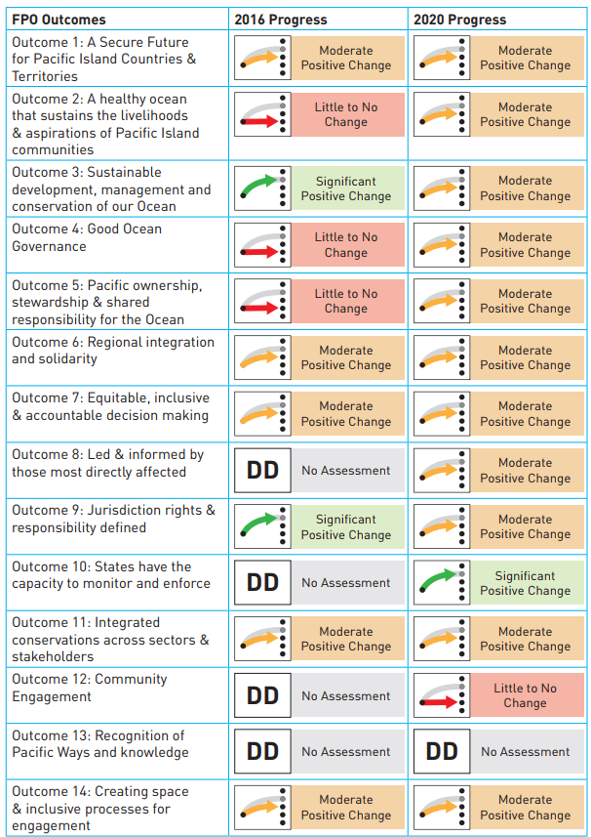
Figure 6.1 Blue Pacific Ocean Report (BPOR) Report Card for the Framework for a Pacific Oceanscape (FPO).

The relationship between the “state of the ocean” and investments which are made is confounded.
The BPOR reporting and MER provide a review of ocean progress and initiatives of the past or presently ongoing, but they do not assess the degree to which the investments (i) achieved progress in defined indicators of SDG 14 or FPO, or (ii) were efficient and effective investments to achieve their outcome.
At a project level, mid-term and final monitoring and evaluation is generally undertaken by the established development partners. However, these reports are dispersed, in varying formats and on multiple systems (e.g. the ADB’s website). In addition, these evaluations tend to report on the delivery of the projects’ outcomes / outputs, but how this links to macro-level indicators such as SDG14 or other international commitments, is sometimes unclear.
The linkage of evaluation reports to the MER system would be useful to start to build up a picture of learnings in efficiency and effectiveness of investments.
Development partners do produce efficiency and effectiveness reviews of their own portfolios.
ADB, for example, produces an annual Development Effectiveness Review which looks at the delivery across its portfolio. However, the focus is on delivery by the institution, rather than the impact at the country level. ADB’s 2020 report is not broken down into a Pacific sub-region, although differentials in the combined group of ADB Developing Member Country SIDS and FCAS (Fragile and Conflict-Affected Situations) is examined.
The ADB Development Effectiveness Review complements the institutionally-focussed Annual Portfolio Performance Report prepared by the Procurement, Portfolio and Financial Management Department (PPFD), and the Annual Evaluation Review prepared by the Independent Evaluation Department (IED).
An improved linkage between investment and effectiveness of blue economy outcomes could be usefully developed through a detailed and substantive review of monitoring and evaluation documents in relation to oceans, to emerge efficient and effective practise within national diversity of Pacific SIDS.

Stakeholder perspectives
In terms of monitoring and evaluation; and efficiency and effectiveness of delivery of blue economy initiatives, the following perspectives were expressed:
1 - The main thrust was on developing more bankable projects, rather than effectiveness of delivery.
The main focus of stakeholder attention was on the development of further bankable projects to build on existing investments. A number of regional and national stakeholders use the outcomes of present and recently completed projects to help shape future investment portfolios in an informal and ad hoc way, which is more based on personal reflection and expertise than formal monitoring and evaluation processes.
Project-based funding seemed to be considered as an established and perpetual part of the financing environment for most stakeholders. Comments on ways to make ODA more efficient or reducing ODA flows were little discussed, although some respondents noted the need to “reallocate our gaze”, although concrete ways to do this were not expressed.
2 – The lack of flexibility within ODA delivery systems was sometimes considered a constraint.
Formal project constructs such as goals, outcomes, and outputs, which are advanced through the proposal development stages and which become the key areas for subsequent project-level evaluation, were mainly considered as constraining delivery. Generally, the focus of discussion seemed to be about project activity, rather than coherent project design (logical frameworks, and links to higher-order outcomes) or project assessment or evaluation.
It was recognised that projects can be significantly influenced by many externalised factors (from natural hazards to COVID) and thus a more flexible delivery process for projects must be accommodated if projects are to be more effective. This has consequences for monitoring and evaluation process which consequently must also be more flexible to allow for project re-orientations, especially at the lower level (Input – Activity - Outcome) where external influences create flux in activity and delivery mechanisms.
3 – The complexity of projects often built in weaknesses in delivery at the design stage which also confounded evaluation.
There was a general realisation at the complexity of blue economy related projects, especially those covering social, environmental and economic goals. However, some respondents identified that projects were too complicated to deliver within the constraints of the Pacific country-context. Commonly this was seen as being due to many factors, including limited project management skills and insufficient technical capacity in delivery.
The need to meet development partner’s institutional objectives, which tend to require a multiplicity of outcomes and co-benefits (such as into pro-poor, gender etc), confounded projects’ delivery. However, inadequate project design which fails to set baselines for outcomes or established co-benefits, means that progress and evaluation of efficiency and effectiveness are obscured.
Definitive attribution of project outcomes to national-level indicators is weak or absent. One technically competent respondent with over a decade of experience in the coastal community development in the region, was clear in their experience that there were “no successful outcomes of blue economy” initiatives.

Case Studies

The role of case studies
The purpose of the case studies is to demonstrate the different national situations across the Pacific countries and how the national context is important in determining blue economy priorities. The two case studies- Vanuatu and Fiji - try to reflect two countries which are at different stages of the path of blue economy; with Vanuatu using its NOP for establishing its governance system and with Fiji using the NOP underpinned by legalisation to leverage blue finance to deliver ocean outcomes.
The case studies do not provide an example of country-based programming, as more analysis and a broader stakeholder consultation would be required, which was not possible in the timeframe for the project. They do, however, demonstrate some of the necessary processes of policy-, financial- and situation-analysis as well as stakeholder consultation, that are necessary to identify country-defined priorities for future investment that recognises the national variation from a regional overview.

Vanuatu

Context
Policy setting
Vanuatu is a “blue” country with over 50 times more sea area than land under national jurisdiction; the coastline is 1,920 km, and the vast Exclusive Economic Zone (EEZ) is 680,000 km2. Fisheries is an important livelihood for men and women with more than 10% of households (5,200 households) in Vanuatu receiving some income from small-scale fishing.
Blue economy is a component of national development and is promoted through national policies. The National Sustainable Development Plan 2016-2030 (NSDP; “the People’s Plan”) is a national interpretation of the UN’s SDGs that Vanuatu has developed to implement over the 15-year period of the plan. Blue economy is recognised in the NSDP as one of the Environmental National Sustainable Development Goals - “Env. 2 – Blue-Green Economic growth - An economy which fosters sustainable growth and development through low impact industries and modern technologies to ensure the well-being of future generation”.
To implement this blue economic growth a number of priorities are identified. NSDP Priority 6 is “Improved Resilience and Natural Resources Management”. This includes outcomes related to development and implementation of a marine spatial plan, as well as strengthening institutions and governance that protect the environment and natural resources, increasing ecosystem resilience and reducing pollution impacts. Additionally, NSDP Priority 2 “Improved Resilient Infrastructure” includes improved port infrastructure and capacity development of personnel and Safer Marine approaches through an increased installation of a marine Aids to Navigation (AToNs) network.
Vanuatu’s NOP of 2016 captures the multiple dimensions of the ocean through its framing around a traditional Nakamal. The NOP lays out the policy paths: a path of unsustainable use of our ocean resources or a transition to more ecologically sustainable, ecosystem-based ocean management. A set of policy objectives is laid out for the second choice, with a vision “To conserve and sustain a healthy and wealthy ocean for the people and culture of Vanuatu, today and tomorrow”. Key actions areas are: marine spatial planning, fisheries management, marine tourism, maritime transport, deep sea mining and climate change & disasters. The drafting dialogue on a national marine spatial plan is underway.

Blue finance
Vanuatu receives sizeable ODA investments into blue economy, in the order of USD $4 – 9m per year, although there is a declining trend over the last four years. The main sources of investment were UN agencies (72% from UNDP and UNEP), but many other donors provided smaller amounts of support. The focus of the investment has been on the blue economy categories of Society (52%) and Environment (36%). 79% of projects were < $1 million in value. The full blue economy ODA analysis of Vanuatu is provided in Annex C.
In terms of domestic investment in the blue economy Vanuatu is still suffering from the combined impacts of the COVID-19 pandemic and Tropical Cyclone Harold. It is notable that amid the pandemic, the fishing sub-sector continues to grow, with projections of 8.1% growth in both 2021 and 2022 and an annual average growth of 4.2% over the medium term. The largest growth in fishing is without boats (+500% in 2020) and exports, especially to China, are expected to increase.
In response to the compromised position of Vanuatu, the 2022 National Budget drives for economic diversification. Under 2022 budget priority 1 for “enhanced business opportunities and investment environment”, the establishment of a Ministry of Fisheries, Ocean, and Maritime Affairs is identified. This may reflect the importance of blue growth in COVID recovery.
The National Budget 2022 states that the Government will continue to broaden its focus in a way that can leverage Vanuatu’s abundant ocean resources. The government of Vanuatu and its partners will continue to implement strategic policies that both address the impacts of the pandemic and also drive growth across the three main sectors of the economy, namely (i) Agriculture, Forestry & Fisheries, (ii) Industry and (iii) Services. Over the medium term, real economic growth is expected to average 3.2% per year.
Domestic blue economy financing can be found in the National Budget estimates and includes the following. No weighting is applied to these figures as they are taken direct from national data:
- Coordinating ministry - The Ministry of Foreign Affairs, International Cooperation & External Trade (MFAICET) is designated as the lead national agency for implementing the Ocean Policy through the establishment and secretarial support to the National Oceans Council. This agency is explicitly mandated to take on this role and to provide a coordination role among all national agencies with a responsibility for the management of ocean space and resources. MFAICET has an allocated budget of VT 824m under the banners of
  - Cabinet Support (budget code MOA),
  - Foreign Affairs (MOB); and,
  - External Trade (MOG).
Cabinet Support has a 2022 budget of VT 115m. This represents a slight increase from 2021 (VT 108.5m, revised budget) and 2020 (VT 92.3m, actual). There are eight core objectives under Cabinet Support, one of which is “to manage Vanuatu’s unresolved maritime boundaries, sovereign territorial disputes and the National Ocean’s Policy”; an estimated VT 14.3m is aligned to NOP coordination and marine territorial boundaries as well as developing marine spatial planning.
- Line ministries – further blue economy related investments can be found across a range of administrative units of the government including:
  - Ministry of Agriculture, Livestock, Forestry, Fisheries and Biosecurity (MALFFB) in relation to fisheries,
  - Ministry of Lands, Mines and Water Resources in relation to deep sea mining,
  - Vanuatu Meteorological Services in relation to forecasting,
  - Ministry of Tourism, Trade, Commerce and Ni Vanuatu Business in relation to tourism and climate change; and,
  - Ministry of Infrastructure and Public Utilities and Ministry of Internal Affairs in relation to the maritime sector.
Total estimated blue economy investment is US $8.6 million with maritime and fisheries and aquaculture taking the majority of the funding (see Figure 7-1). Domestic expenditure is larger than the recently declining ODA flows into blue economy.
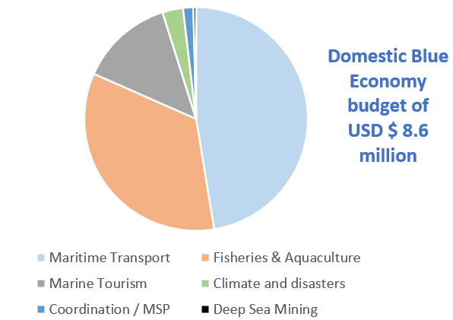
Figure 7-1 - Domestic expenditure on blue economy, from National Budget for 2022
Blue Revenue
Vanuatu has significant marine assets. Estimates of the economic value of marine and coastal ecosystems has been valued at US $38.2 million per year. Services provided for coastal protection are the most significant (US $14.6m per year), but tourism (US $7.6m), commercial fisheries (US $6.0m) and subsistence fisheries are also significant. The blue economy provides significant opportunities for formal employment and informal activities in Vanuatu. In addition to employment opportunities, blue economy related activities provide significant direct revenue to the country.
MALFFB revenue estimates in the 2022 budget from fisheries where in total VT 665m. This is mainly from selling fishing licences (VT 536m). A further VT 18.8m is projected revenue from newly constructed fishing boats. Shipping Services are expected to provide a total of VT 300.9m, mainly through dues and fees. The Ministry of Finance and Economic Management projects revenue of VT 22K for live fish export (presumably, for the aquarium trade). Prospector licenses and registration also provide revenue of VT 8m, but it is not clear if this is for deep sea mining or land-based exploration.
The estimated 2022 domestic annual investment in the blue economy as identified above ($8.588m) is closely balanced to the direct total blue economy government revenue ($8.837m). However, this is just revenue to the government and not revenue from the sector to fishers, tourist operators etc.
The government intention is to further lever blue economy revenue. The Department of Fisheries expects a sizeable increase in their revenue collections given their new policies to upgrade their licensing fees and full operation of the SINO VAN Tuna Cannery.
Other Ministries will receive additional recurrent funding in 2022 designated to revenue-producing activities to encourage revenue generation; some of these may apply to the blue economy.

Stakeholder perspectives.
From the national governmental respondents, a number of relevant perspectives were identified in making progress in blue economy and key areas for intervention.
The respondents noted that although they knew of the term they had “no specific definition of blue economy”. They spoke more in terms of what they were trying to do, this was succinctly stated as “drive revenue without depletion [of coastal and marine resources]”. This closely aligns to the thrusts identified in the 2022 National Budget of diversification and revenue expansion.
The NOP was seen as the core policy for driving forward ocean-related initiatives. Two bottlenecks were identified in the further delivery of the NOP: (i) the formal and legal designation of coastal and marine zones and institutional jurisdictional responsibilities of these zones (this is in progress and expected to be completed by mid-2022), (ii) the refrain in establishing a Ministry for the Ocean and other associated institutional apparatus such as the National Ocean Council, as identified in the NOP.
Three areas for investment were identified by the respondents to further the NOP:
- Information collection. It was felt that there was a large gap in relevant information. This was noted particularly in relation to areas associated with governance: government capacity, application of technology and awareness and understanding of jurisdictions and responsibilities. Filling gaps in these areas through structured intervention would support delivery of the NOP.
- Securing maritime trade. The reliance of Vanuatu on maritime trade was noted, as was the need for safe and secure passage of vessels, including the docking of tourist cruise ships. The need for improved hydrographic mapping and charts as well as enhanced safety-at-sea procedures and responses, were identified.
- Safeguarding biodiversity. It was noted that Strategic Area 3 of the National Biodiversity Strategy and Action Plan of 2018 was still relevant but had not been adequately progressed. The target for Strategic Areas 3 was: “By 2030, at least 10% of important marine biodiversity areas, and areas of livelihood and kastom importance are conserved through effective community and government management areas”. A number of focus area are identified associated with conservation, inshore and offshore fisheries. Priorities noted were to map mangrove and seagrass areas to determine the extent of these vital habitats, develop biodiversity inventories and maps of key areas and assistance with the Convention on International Trade in Endangered Species of Wild Fauna and Flora (CITES). Species-specific priorities were also noted in relation to management plans for sharks, turtles and dugongs
It was raised by respondents that the creation of a Vanuatu Centre for Oceans Science, or similar, could be a modal institution to support capacity development, technology transfer and knowledge management.

Republic of Fiji

Context
In 2020, Fiji had recently consolidated its intention for sustainable ocean management in its first National Ocean Policy. The NOP intends to deliver sustainable management to 100% of the marine area under national jurisdiction, including 30% for protected areas. The NOP provides a route towards “A healthy ocean that sustains the livelihoods and aspirations of current and future generations for Fiji”. As stated by the Minister for Economy in the Forward “Our purpose is to secure and sustainably manage all of Fiji’s ocean and marine resources. Fiji will not pursue a short-sighted exploitation of ocean ecosystems at the expense of bigger, bluer opportunities of a sustainable ocean economy”. The NOP intends to support, synergise, promote and establish best practice standards for oceans management within the Fijian Government and for all relevant stakeholder groups including community groups, non-government organisations and the private sector.
Legal underpinning of the NOP has been achieved through the gazetting of the Climate Change Act in September 2021. The Climate Change Act 2021 consists of 112 clauses and sections, divided into 17 parts reflecting both Fiji’s current National Climate Change Policy and the Paris Agreement. Part 13 of the Act is relevant to oceans and notes that marine areas under national jurisdiction shall “be 100% sustainably and effectively managed” (ART 81-1), and that successive NOPs shall be produced (ART 83-1). The legal underpinning through a legislative Act of a NOP is novel for the Pacific.
Fiji has received more blue economy ODA than many countries and also has implemented the most projects of the 14 countries analysed in this study (a total of 50 between 2012 and 2021). The largest ODA financed projects are identified below:

Table 7-1 – Largest ODA projects in Fiji identified in the study
Title of Project | Weighted blue economy budget in US$ (Millions) | Funding Source | Implementer
Improve Climate Resilience and Sustain Livelihoods in Fiji (Fiji R2R) | 33.14 | UNDP (GEF) | UNDP
Reinforcing the capacity to Responding to Climate Change and Ocean Management | 4.52 | Australian Government | Central Government
Pacific-European Union Marine Partnership (PEUMP) | 3.25 | EU & Sweden | SPC
Pacific Islands Oceanic Fisheries Management – II | 2.28 | UNDP | Forum Fisheries Agency
Discovering Nature-based Products and Build National Capacities for the Application of the Nagoya Protocol on Access to Genetic Resources and Benefit Sharing | 1.36 | UNDP (GEF) | Centre for Drug Discovery and Conservation, USP
Regional Ridge to Reef - Pacific Island Countries | 1.06 | UNDP | SOPAC

To invest further in oceans, Fiji is pursuing capitalisation through the issuance of blue bonds. The Fijian Government will work closely with the UK Government (through the Blue Planet Fund), the UN Development Programme, and the UN Capital Development Fund (UNCDF) to develop and issue the bond in 2022.
This blue bond will raise up to US$50 million for investments intended to help create a supportive environment for sustainable ocean finance in Fiji; supporting projects that will improve ocean health and support the livelihoods of coastal communities. Areas identified by respondents for investment from the blue bonds were green shipping, sustainable fisheries and Marine Protected Areas (MPAs).

Stakeholder perspectives
The focus coordinating agency for oceans (the Ministry of Economy) and close allied agency of the Ministry of Fisheries is bringing oceans to the limelight through the NOP and then “building back together, building back blue” as a response to the economic damage caused by the COVID-19 pandemic. The socio-economic imperative of the oceans was underlined and that planned interventions needed to have “spill-over effects to other people on the edge of the sector” to help fulfil societal needs. With clear policy guidance through the NOP and Climate Change Act, there was strong direction to “shift away from policy and reports” and move towards concrete actions.
A partnership forming a Blue Recovery Hub has been developed with the OECD and the World Resources Institute (WRI). This was established to try to fill the “missing middle” between higher level NOP objectives and socio-economic needs. The Blue Recovery Hub will focus on most affected communities and those areas which need support for recovery; and will include issues such as economic diversification and equity. Areas under analysis include enhancement of the present Environmental and Social Safeguards (ESS) of blue sectors, recovery of the tourism sector and identification of synergies in shipping.

Areas identified for future funding included:
- Development of bankable projects. The capacity and mechanisms to develop bankable projects is seen as a priority. With funding flowing from ODA, the blue bond and other sources, there is a need for community-based, and / or country driven projects to be developed. The projects need to be “bankable” in the sense that they need to be feasible, justified, designed and structured around a Theory-of-Change, have a timeline and be fully costed. There is a need to develop structured institutional strengthening for project development in this area, through a “project development farm” or similar.
- Strengthen stakeholder engagement. Under the NOP there are possibilities to set up dialogues that bring a broader consistency to the NOP and the direction of its work. This can be through thematic working groups, such as for community development, or as a broader network (e.g. a national version of the Pacific Ocean Alliance ).
- Develop a sustainable investment portfolio. Building on the work of the Blue Recovery Hub, there will be a need to advance various financial mechanisms to secure inward funding for oceans. As well as leveraging existing financial sources, new sources will need to be progressed, such as involvement of the private sector in public-private initiatives and government financial tools such as risk backing and fiscal policy through tax and other measures. Capacity, Public Financial Management (PFM) and new partnerships will need to be developed to advance these non-traditional routes of supporting the blue economy.

Funding Gaps and Opportunities
The analysis of financial flows through the PSIDS, along with the review of two countries in more detail and discussions with stakeholders has identified several gaps and opportunities for future funding initiatives in the region. These have been grouped under the following 10 headings.
1 - There is still the need for basic ocean science that is directed and purposeful.
Management and governance decisions are undermined by an ongoing lack of science and information. As one bilateral donor stated, “we don’t know what we don’t know” and that “there is real opportunity in that space”.
In particular, the opportunities exist outside fisheries (pelagic and increasing small-scale fisheries) but link into other blue economic sectors and have close alignment to themes of biodiversity and climate change.
Recognising “thoughtful science”, the science that needs to happen rather than “science for science’s sake” is necessary. For example, it was recognised that the UK is the principal charting authority and building the capacity of hydrographic services and maritime safety information, including marine weather forecasting, would build on this long-established credibility. In terms of blue economy, this could be related to hydrographic upgrading of charts with entry passages in selected ports for which passenger cruise liners are a significant component of the economy.
In addition, realising science which helps frame the drastic changes that may well happen in the Pacific in the future decades is an imperative, and this covers physical and natural science, but also socio-economic dimensions.
2 - There were recognised important scientific thematics that were viewed as “orphans”.
These “orphans” were not central to the recognised present and pressing needs of national governments and were not substantively taken up by development partners but could offer future possibilities.
These areas would fail to deliver on project national budgeting criteria such as Internal Rate of Return (IRR) and thus fall through the filters on national economic ministries as they would be “too innovative to pay back”.
Recognised “orphans” included blue carbon and associated financial mechanisms, the science driving climate change impacts, nature-based solutions and ocean resilience / adaptation responses. Picking up such “orphans” within longer-term grant-based financing can be seen as a priority and may be most relevant to more flexible bilateral grant support mechanisms.
3 - Emerging marine sectors require relevant and targeted science and technology transfer.
New sectors such as marine renewable energy and marine genetic resources (MGR) require scientific analysis in order to determine scope and feasibility, to set out regulatory and private sector enabling environments for demonstration and expansion where appropriate. Pressures on government for meeting IRR and other assessment metrics, especially for loan-based financing, compresses such innovation space. Targeted investment in specific areas in nascent marine sector economies would have risk but significant upside that would not be realised without targeted support.
4 - Transformation of the blue economy would need to focus on multiple levels to achieve profound outcomes.
Transformation must cover a number of levels, including:
- Niche-level or showcase style outcomes,
- Macro-level or regime changes in which the policy and political framework is enhanced, and
- Macro-level or societal level change through enhanced knowledge and understanding (such as ocean literacy) and the ability to engage in key public debates, such as “blue growth” versus “blue sufficiency”.

5 - A comprehensive and Pacific-led Marine Spatial Planning (MSP) process may have significant benefits to the region.
Improved integration and multi-stakeholder planning could be promoted through MSP. However, the MSP process would need to be led through the culture and sensitivities of the region, rather than a western-defined analytical process.
In addition, it would need to be based around accessible and free-to-use software rather than propriety systems which are unsustainable through national funds.
Delimiting and zoning ocean space for different uses is borne out of western town planning approaches and sits uncomfortably with the holistic views of the ocean and associated relational interpretations.
MSP could sit under the growing number of NOPs in the region, and act as an approach which spatialises the policies and agendas identified in the NOPs and associated national and regional sector policy. One donor warned though of the planning challenge risks “doing too much, so we don’t do anything”.
6 - There is an imperative for purposeful assemblies with influence / decision making power to cross the multiple sectors of blue economy.
These can be thought of as “engine rooms” or “catalyst incubators” or similar which include technical and managerial representatives. The institutional architecture has been developed for this in some countries under the NOPs (e.g. Vanuatu, Solomon Islands, and Fiji), but it is relatively early to assess the longevity and impact of such entities. However, securing national funds, once ODA support finishes, has been an issue in some counties, which has led to the breakdown of the implementation of NOPs. This ultimately undermines the planning process, as it is seen to not work.
7 - Developing “ocean leaders” in the region is an imperative.
The need for leadership and championing of ocean affairs is paramount in the Pacific. Even with 50 years of higher-level education in marine subjects at the University of the South Pacific (USP), leadership skills among the graduate indigenous population who progress their career in the marine sector have the potential to be expanded.
Regional promulgation of the UN Decade for Ocean Science and Sustainable Development has identified ocean capacity and leadership as one area to target, and specifically Early Career Ocean Professionals, and the need to make gains in gender parity in the maritime economy.
Aligning with regional partners involved with this, such as SPC (potentially with EU support) supporting Pacific Early Career Professional network, through the Decade, may be an opportunity.
8 - Further stakeholder inclusion should be advanced, depending on national circumstance.
There is an ongoing need for more participation in an effort for a blue economy transition. This should include at the very least:
- Civil Society Organisations (CSOs) / NGO involvement to help provide a more consolidated view on matters, and,
- Media sector involvement, for which enhanced clarity in reporting would help reduce confusion and complications and focus on the key challenges or conflicts that exist.
The necessary inclusion of groups would be dependent on the needs of the blue economy and the national context.

9 - Empowered participation of CSOs and community groups in blue economy initiatives can be challenging.
In order to disperse funds at local levels, the creation of micro-funds or local grant opportunities can be a powerful tool for local action. However, such local funding mechanisms are required to operate in an environment of basic financial and project management structures in the recipient entities. In many cases this is not apparent, e.g. through the lack of a legal entity of a CSO or a lack of a bank account for payments, meaning that such dispersed flows become challenging. This is especially the case in the more disadvantaged or vulnerable communities, and prevalent especially in sub-regions of Micronesia and Polynesia. Investing to unblock constraints for local level dispersion of funds could be effective to the promulgation of local level action in blue economy.
10 - Partnering between development partners with differential but aligned investments would be effective.
Recognition of the significant finance flowing into the region and multiple development partners with long established track records is important in programming investments. Furthermore, recognition of the differential strengths of different development partners, but invariably aligned outcomes, means that partnerships can be valuable. Forging close allegiance mechanisms, such as co-financing, may be challenging and not necessary.
Many development partners were open to discussion on aligning funds in a strategic but less formal way than co-joined co-financing etc., which emphasises development partners strengthens and operational realities.

Recommendations
The following Recommendations to are intended to provide a lens to support programming of possible UK investment support associated with blue economy in the region. Financial instruments for which the recommendations are relevant include the Blue Planet Fund, and other ocean / resilience / governance focussed financial instruments.
Based on the analysis, consultation and experience in the region, a programme frame is proposed as a point for further discussion. The programme frame covers the regional-scale to a sub-national scale where concrete actions occur, and tries to form an integrated approach to advancing the blue economy by targeting constraints and focussing on concrete outcomes. Country-led progress and the inclusion of multiple stakeholders will be vital for successful delivery over the projected five year timeline.
The proposed programme is structured in three interrelated work packages (WPs) (see Figure 9-1):
- WP1 - Regional co-ordination and advocacy.
- WP2 - Strengthen national delivery.
- WP3 - Concrete national action.

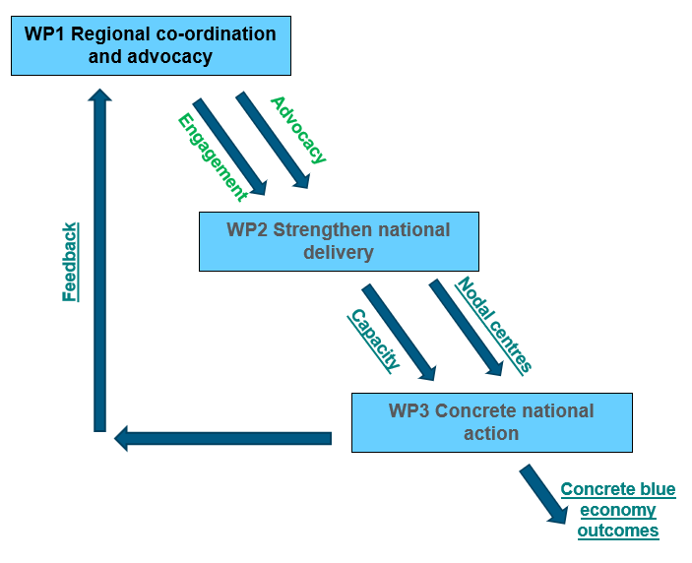
Figure 9-1 – The relationship between proposed Work Packages

At the regional level:
WP1 Regional co-ordination and advocacy

Objective 1 – Strengthen regional co-ordination and stakeholder engagement through advocacy for effective and efficient investment in blue economy
WP1.1 Identify key principles and practices for effective and efficient investment in blue economy.
The region has much activity in the blue economy, as evidenced by this report and others, however, progress to collate an integrated understanding of the regional blue economy is limited. With more ODA expected to be centred around blue economy in the region, the development of principles for efficient and effective investment need to emerge from existing practice. Detailed analysis of mid-term and final-evaluation reports, stakeholder reflections, and identification of entry points for other stakeholders (such as the private sector) need to be determined.
Building off the introductory work of the World Bank and others, innovative but additive financial mechanisms need to be considered as leverage, including private sector support such as risk backing / guarantees.
A move towards integrated financing frameworks and sustainable financing will be vital to capitalise on all available opportunities.
WP1.2 Promote co-ordination and engagement of broad stakeholder base through the mandated organisation.
The Office of the Pacific Ocean Commissioner is mandated by regional Leaders to coordinate and advocate for oceans. Further support can be provided in a number of areas to advance coordination and engagement. This could include support towards the regional monitoring, evaluation and reporting process for the region, which is at a nascent stage and could be enhanced by further support and technical input.
The holistic view that regional analyses would produce, would derive narratives that would be disseminated through the advocacy work of OPOC, the Pacific Ocean Commissioner, and PIFS in relation to the Pacific 2050 Strategy.
Support could also be provided to strengthen the Pacific Ocean Alliance, the broader stakeholder group sitting alongside OPOC, through building awareness, exchanging ideas and as docking for emerging outputs through the project.

At the national level:
WP2 Strengthen national delivery

Objective 2 – Strengthen national entities to deliver efficient and effective blue economy solutions.

WP2.1 Assess needs and delivery mechanisms for strengthening blue economy delivery.
For each selected target country, a country-led needs assessment should be carried out determine national gaps in delivery. The assessment should cover areas identified by respondents as being constraints, especially
- Governance and institutional arrangements,
- Project management and delivery capacity,
- Technical capacity and technology transfer,
- Knowledge management; and,
- Innovation and enterprise.
The assessment should cover the range of stakeholders involved in blue economy delivery including government, NGOs, CSOs and the private sector. Through documentary evidence and broad consultation, target areas for further investment should be identified and a portfolio of interventions identified.
WP2.2 Establish country-based processes for enhancing capacity.
A suite of country-based training centres should be developed to deliver national training. Nodal centres for delivery in four areas (tentatively, governance, project management, technical capacity and knowledge management) should be set up in different countries using established entities as appropriate (e.g. Solomon Islands National University, University of Fiji, SPC - Pacific Community Centre for Ocean Science).
Through a Train-the-Trainer approach, a cadre of trainers should be developed in the nodal centres who can then deliver targeted training to each of the countries in their specialised area, as defined by the needs assessment. The specialist subject areas of the nodal centres should be finalised by the needs assessment (WP2.1) and informed by WP1.1.
A number of stakeholders in the consultations identified the need for capacity to create “bankable projects”. This could be a key theme under the project management target area. After the Train-the-Trainer stage, the process could be led by South – South engagement, but with external technical support.
Developing nodal expertise in elements of blue economy across the region would help build regional capacity, as well as act as a landing point for further investments. Linkage to profession organisations, such as Membership or Chartership through the Institute of Marine Engineering, Science & Technology (IMarEST) would add to the professionalisation of marine careers in the region.
A dedicated Ocean Leaders phased capacity building and mentoring action may also be of benefit targeting active recipients of the national training.

At the national or subnational level:
WP3 Concrete national action

Objective 3 – Deliver concrete blue economy action based on country priorities.

WP3.1 Determine national priority blue economy actions to undertake.
For each selected target country, a broad review needs to be made of the progress of the blue economy in order to identify practical and defensible concrete actions. The country-led review can utilise expertise developed during capacity building stage (WP2.2). The case studies presented in section 7 may provide entry points for further national consultation.
This process could be structured around the country-led prioritisation model developed under the UK Government GCRF One Ocean Hub programme for building transdisciplinary ocean interventions and implemented in Fiji and Solomon Islands. This approach emphasises the place-based contextual development of blue economies required for sustainability.
Priority interventions can be drawn from:
- National or provincial policy development or reform,
- Supporting or developing planning and decision support tools, (such as Marine Spatial Planning. Ocean Accounts, Ecosystem Service Valuations),
- Creation of enterprise incubators, possibly through micro-finance; and,
- Delivering tailored support to key priority areas, such as species management plans, creation of MPAs, hydrographic charting, or climate change impact assessment.
The scale of implementation should be focussed at national provincial or more local scales. The proposed workplan should take into account the flexibility of bilateral support and the alignment of interventions which catalyse other financial flows (domestic, ODA, etc); thus engagement with present and future developments partners would be vital.
All outputs of this work should deliver concrete outcomes in terms of strengthening the blue economy in a sustainable and equitable way, as well as providing demonstrable examples for regional dissemination and uptake.
The national document would identify justified interventions, involved actors (government, NGOs / CSOs, the private sector, etc.) and could be structured similar to other country programming documents (such as the GCF Country Programme).
A generic blue economy results framework should be determined to create a monitoring and evaluation baseline and platform for outcomes and outputs; this can be informed through the engagements of WP1.2.
WP3.2 Deliver priority blue economy national actions.
The second phase of WP3.2 would be to deliver the action as identified in the programming document. Strict progress evaluation and review procedures would need to be implemented. This is not just to provide additional support to lagging projects, but to accommodate varying external events (such as pandemics and Tropical Cyclones) and utilise opportunities that appear through new finance, new knowledge, etc.
Capacity developed through WP2.2 should be used in projects delivery, and further South-South cooperation used to strengthen national capacity where necessary.
Outcomes and lessons of projects at national level feedback to the regional level and advocacy through the region (WP1.2).

Annex A - Briefing sheet used for stakeholder consultation
Blue Economy in the Pacific
This sheet is intended as a brief on the topic areas for discussion under the Pacific blue economy work under the Commonwealth Marine Economies Programme. Under 4 main headings we set the scene with a number of constructs and then identify 3 questions to help direct our discussion.

- What blue economy?
Constructs:
- The use of the blue economy agenda is increasing at the global and regional scale.
- Blue economy has been represented as a way to sustainably develop the ocean and its resources, which is especially important to SIDS.
- A blue recovery is seen as an opportunity for economic recovery from the COVID-19 pandemic.
Questions:
- What is the present status of blue economy in the region?
- What are the constraints on further application of blue economy?
- What are some demonstrable outcomes or benefits of blue economy approaches to the region?

- Whose blue economy?
Constructs:
- The blue economy term applies from global to local level.
- Definitions of blue economy are not solely about economic expansion, but equitable and inclusive economies.
- The degree to which different stakeholder groups are involved in blue economy initiatives varies.
Questions:
- Which stakeholder groups are mostly involved in blue economy?
- Which stakeholder groups should have increased involvement in the blue economy?
- Are there robust examples from the Pacific of stakeholder benefits of blue economy?

- Who is funding the blue economy?
 | Constructs:  - We have tracked over USD $400 million of ODA investments representing 197 projects in blue economy in 14 PSIDS over the last 10 years.  - These ODA investments are from a wide variety of sources (see graph).  - Implementation of these ODA projects is done predominantly by Governments and Intergovernmental Organisations (such as SPREP, FFA and UN). |  | 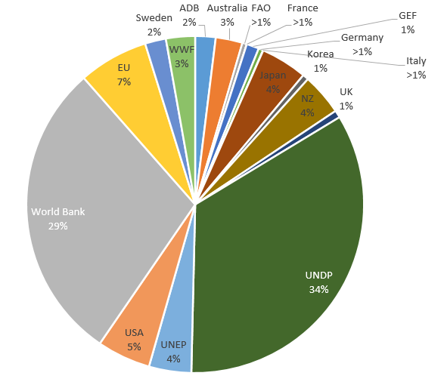
Questions:
- Is there adequate financing for blue economy?
- How large and in what areas is there a funding gap?
- Is the ODA finance reaching the organisations that really need it?
- How to shape the future blue economy?
Constructs:  - The blue economy narrative is likely to grow in the future years.  - Our analysis has shown that most investment is in areas of Technical & Capacity, Environment and Governance; areas of Society, Economy and Innovation seem to receive limited investment.  - Policy development in the region such as The Blue Pacific communique and the PIFS Pacific 2050 Strategy will be influential in setting the course of development. | 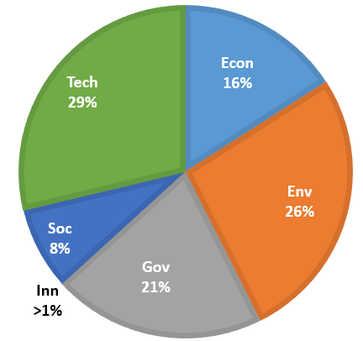
Questions:
- What areas of blue economy need further investment in the future?
- Should blue economy be further embedded in regional policy, or is it unnecessary or a diversion?
- How does blue economy relate to The Blue Pacific and Pacific 2050?

The information obtained in this consultation will only be for the use of the Commonwealth Marine Economies Programme and the UK Foreign, Commonwealth & Development Office. The information will not be distributed to third parties. Any information used in reports produced under this initiative will be anonymous by name and institution.

Annex B – Stakeholders consulted
All stakeholders were contacted by email to invite them to a stakeholder consultation video call. All stakeholders who attended a video call responded to the original email. If the stakeholder did not attend the video call, they did not respond to the original email. Attendance to the video call can be seen in the final column.
Organisation | Attended video call?
International organisations
Deutsche Gesellschaft fűr Internationale Zusammenarbeit (GIZ) (3 attendees) | Yes
World Bank | Yes
World Bank (Problue) | Yes
European Union (EU) (Fiji Team) (3 attendees) | Yes
EU (Lead on Agriculture/ Climate Change) | Yes
International Union for Conservation of Nature (IUCN) (4 attendees) | Yes
Organisation for Economic Co-operation and Development (OECD) - Blue Recovery Hub Lead | Yes
World Resources Institute (WRI) -Blue Recovery Hub | Yes
Asian Development Bank (ADB) | No
USAID | No
Regional organisations
ForumSec | Yes
Office of the Pacific Ocean Commissioner (OPOC) | Yes
Pacific Islands Forum Secretariat (PIFS) (2 attendees) | Yes
The Pacific Community (SPC) (3 attendees) | Yes
Pacific Islands Forum Fisheries Agency (FFA) (2 attendees) | Yes
Secretariat of the Pacific Regional Environment Programme (SPREP) | No
South Pacific Tourism Organisation (SPTO) | No
National Organisations and NGOs
iTUNA Intel | Yes
SeaShaw Conservation | Yes
Development Alternatives with Women for a New Era, DAWN | No
Government Bodies
Ministry of Foreign Affairs and Trade, New Zealand government (3 attendees) | Yes
Vanuatu Biodiversity Officer | Yes
Vanuatu Ocean Policy | Yes
Vanuatu Oceans Office | Yes
Vanuatu government | Yes
Vanuatu Ports and Harbours | Yes
Vanuatu Environmental Protection and Conservation | No
Fiji Ministry of Economy | Yes
Fiji Ministry of Economy, Climate Change & Oceans | No
Department of Foreign Affairs and Trade, Australia (3 invitees) | No

Annex C – National blue economy ODA financing profiles for case study countries

Blue Economy Financing Profile: Vanuatu
The following information provides an overview of the national Official Development Assistance (ODA) financial investments that are relevant to the blue economy. The analysis is based on available data of financial flows from 2012 to 2021, including multi-county projects that have been split into individual country allocations on a pro rata basis.

National profile
Land area | 12,189 km2 | Ocean area (Exclusive Economic Zone, EEZ) | 626,424 km2
Population | 299,882 | Marine Protected Area (MPA) coverage | <1%
Gross National Income (GNI)  per capita | US $3,450 | Fisheries value | 0.6% of GDP

Total flow of ODA investments into the blue economy
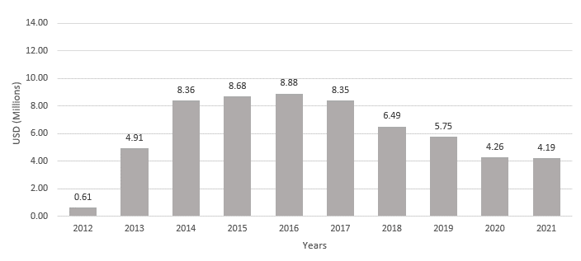
Figure 1 - Official Development Assistance pro rata flow 2012 – 2021 in USD million

Average annual flows in Vanuatu were US $6m per annum, however, there was much annual variation. Vanuatu saw a rapid increase in ODA flow into the blue economy between 2012 and 2014. A fairly constant flow of US $8m per year followed between 2014 and 2017, before experiencing a steady decline over the last four years analysed. The relatively low flow in 2017 which is seen in the combined Pacific regional flow data,
does not seem to have affected Vanuatu as strongly as other countries in the region. Some data related to 2021 may not have been reported at the time of the analysis.

Target of investments into the blue economy
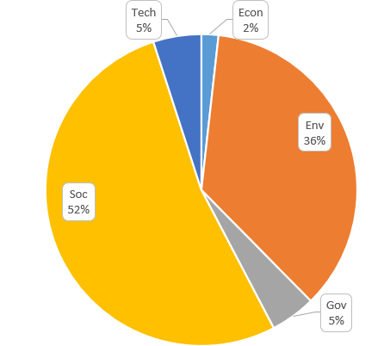
The target of the ODA blue economy investment as a proportion over the 10 year period was based on assigning finances to one of six categories which represent the primary purpose of the blue economy investment (Economy, Environment, Governance, Innovation, Society, and Technology & Capacity).
The majority of ODA investment (52%) was targeted at the Society category. This is somewhat different to many other countries, where only a relatively small proportion of funding has been directed to the Society category.
Over a third of investment was targeted at Environment projects.
The remaining flows were targeted mainly at Technology & Capacity, and Governance.
Investment in Economy was 2%. There was no investment in Innovation.

Figure 2 - Target of ODA blue economy investment (2012 – 2021)

Size of investments into the blue economy
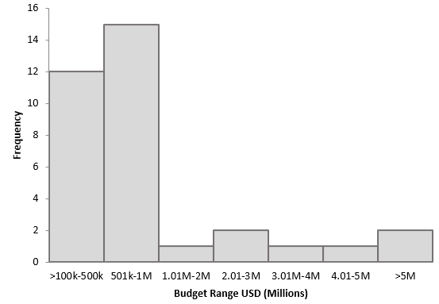
Figure 3 - Number of projects by frequency in financial size categories (2012 – 2021)

Only two total project investments into Vanuatu were over US $5m (US $13m; US $25m), the remaining 32 investments were <US $5m. Most projects (79%) were below US $1m, with a roughly even split between the number of projects between US $ 500k and US $1m and those below US $500k.

Source of investment into the blue economy

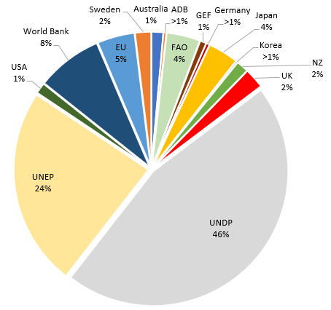
Figure 4 - The source of investment into the blue economy (2012 – 2021)

The main source of investment in blue economy in Vanuatu is UNDP project-based funding, representing 46% of the weighted pro rata investment flows. The other significant source of investment is UNEP with 24% of flows. The World Bank, the European Union, FAO, and Japan contribute between 4 and 8% of flows. A number of other sources provide the rest in smaller amounts, including New Zealand, Sweden, Australia, Germany, USA, GEF, Korea and ADB. The UK contributed 2% of total input.

Type of entity implementing project

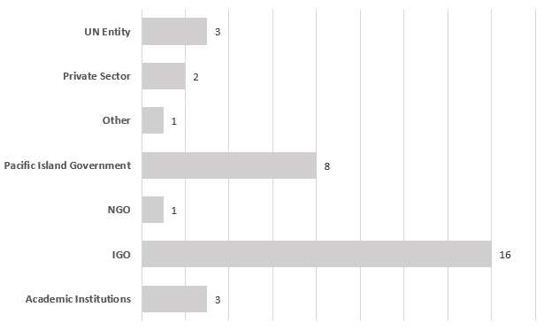
NGO = non-governmental organisation
IGO = intergovernmental governmental organisation, but with UN family as separate category).
Regional organisations are included within the IGO category
Figure 5 - The number of projects being implemented by different types of implementing entities (2012 – 2021) (number of projects is shown at end of bar)

The majority of projects in Vanuatu were implemented via IGOs (47%), which includes the Regional Pacific Organisations. The Government of Vanuatu implemented 8 projects (24%).

Blue Economy Financing Profile: The Republic of Fiji
The following information provides an overview of the national Official Development Assistance (ODA) financial investments that are relevant to the blue economy. The analysis is based on available data of financial flows from 2012 to 2021, including multi-county projects that have been split into individual country allocations on a pro rata basis.

National profile
Land area | 18,270 km2 | Ocean area (Exclusive Economic Zone, EEZ) | 1.3 million km2
Population | 889,955 | MPA coverage | <0.1%
Gross National Income  (GNI per capita) | US $5,800 | Fisheries value | 1.6% of GDP

Total flow of ODA investments into the blue economy
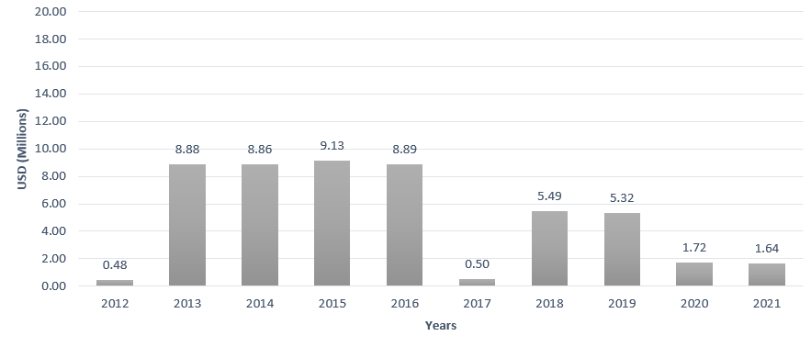
Figure 1 - Official Development Assistance pro rata flow 2012 – 2021 in USD million

Average annual flows in Fiji were USD $5.2m per annum, however, there was much annual variation. Fiji demonstrates a downward trend of ODA flows into the blue economy over the 10 analysed years. Annual ODA flows were in the order of USD $ 8 – 10m per year during 2013 – 2016 but have declined to an estimated USD $1-2m in 2020 and 2021. Relatively low flows in 2012 and 2017 are also seen in the combined Pacific regional flow data and may be related to project cycles, however this is unclear. Some data related to 2021 may not have been reported at the time of the analysis.

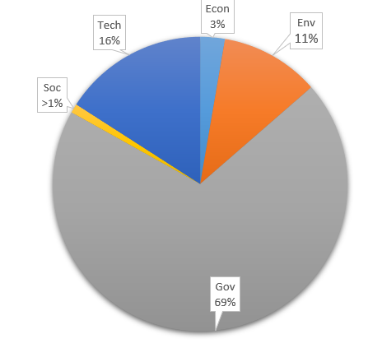
Target of investments into the blue economy

The target of the ODA blue economy investment as a proportion over the 10 year period was based on assigning finances to one of six categories which represent the primary purpose of the blue economy investment (Economy, Environment, Governance, Innovation, Society and Technology & Capacity).
Nearly 70% of the ODA investment was targeted at investments categorised as Governance.
The remaining flows were targeted mainly at Technology & Capacity, and Environment.
Categories of Economy, Society, and Innovation were all <2%. There was no Innovation investment.

Figure 2 - Target of ODA blue economy investment (2012 – 2021)

Size of investments into the blue economy

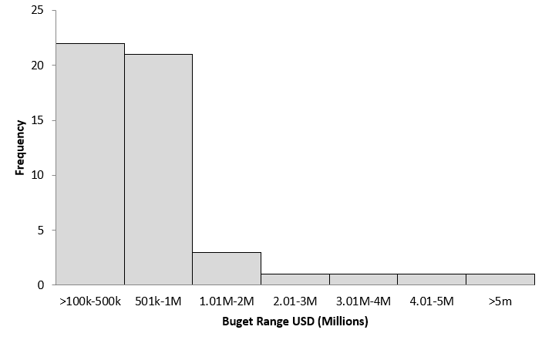
Figure 3 - Number of projects by frequency in financial size categories (2012 – 2021)

Only one total project investment into Fiji was over US $5m (US $33m), the remaining 49 investments were <$5 million. Most projects (87%) were below USD $1m, with a roughly even split between projects below USD $500k and those between USD $500k and USD $1m.

Source of investment into the blue economy

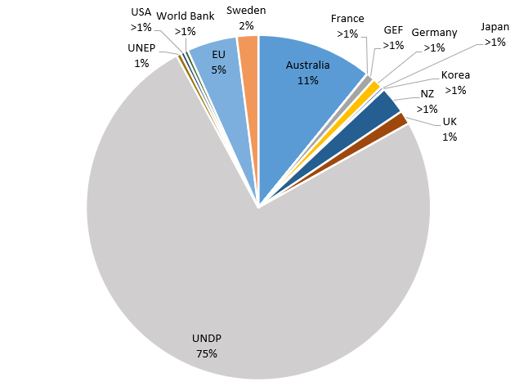
Figure 4 - The source of investment into the blue economy (2012 – 2021)

The main source of investment in blue economy in Fiji is UNDP project-based funding, representing 75% of the weighted pro rata investment flows. Australia and the European Union contribute between 5 and 11% of flows. A number of other sources then provide the reminder in smaller amounts, including New Zealand, France, Germany, Japan, Korea, the US, and Sweden. The UK contributed 1% of total input.

Type of entity implementing project

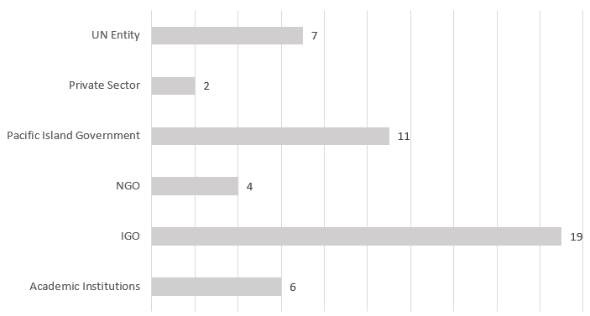
NGO = non-governmental organisation
IGO = intergovernmental governmental organisation, but with UN family as separate category).
Regional organisations are included within the IGO category
Figure 5 - The number of projects being implemented by different types of implementing entities (2012 – 2021) (number of projects is shown at end of bar)

The majority of projects in Fiji were implemented via IGOs (39%), which includes the Regional Pacific Organisations. The Government of Fiji implemented 11 projects (22%).

- About FCDO SIDS Hub:

The FCDO SIDS Hub provides support on policy and programming for the world’s most vulnerable island states. The Hub supports SIDS in their efforts to access appropriate development finance through initiatives such as the Call to Action on Access to Finance. The UK’s vision for SIDS is set out in the Strategy for International Development:

Our vision is that by 2030 Small Island Developing States (SIDS), will have the economic and climate resilience not only to graduate from ODA with sustainable economies, but also to withstand economic and climate shocks. The UK will continue to work to help SIDS make best use of international aid and finance and improve how it works for them.

Enquiries: SIDSHub@FCDO.GOV.UK

This report is the work of Atkins and the content is the work of the consultants. The views expressed are those of the consultants or interviews and the report does not represent the policy of the UK Government.
Blue Pacific Ocean Report by the Pacific Ocean Commissioner (2021): https://library.sprep.org/content/blue-pacific-ocean-report-2021
Hills et al. (2019) The disjuncture between regional ocean priorities and development assistance in the South Pacific. Marine Policy: https://www.sciencedirect.com/science/article/abs/pii/S0308597X18304305?via%3Dihub
Voyer et al. (2019) Shades of blue: what do competing interpretations of the Blue Economy mean for oceans governance?: https://www.tandfonline.com/doi/full/10.1080/1523908X.2018.1473153
Formerly, the South Pacific Organisations Coordinating Committee, SPOCC.
Climate change was also largely regarded as an external pressure, caused by developed nations, and for which full restitution should be forthcoming.
UNDP has started approaching this through its integrated SIDS offer: Rising Up for SIDS: UNDP's integrated service offer (sparkblue.org) to ensure more coherence (and integration) in its programmatic approach
https://mptf.undp.org/project/00130842
Which has an estimated USD $9 billion ocean-related global portfolio.
https://www.undp.org/publications/making-development-co-operation-more-effective-how-partner-countries-are-promoting
https://www.unescap.org/sites/default/d8files/knowledge-products/ESCAP-2022-FG_SDG-Progress-Report.pdf
https://www.forumsec.org/wp-content/uploads/2020/05/Pacific-SDG-Progress-Wheels.pdf
https://data.undp.org/sids/portfolio
https://opocbluepacific.org/publications/
https://www.adb.org/search0/type/evaluation_document
https://www.adb.org/sites/default/files/institutional-document/695916/defr-2020.pdf
https://www.nab.vu/document/economic-assessment-and-valuation-marine-ecosystem-services-vanuatu#:~:text=Subsistence%20fishingThe%20economic%20value%20of,to%20an%20estimated%2015%2C500%20households
https://www.dailypost.vu/news/dialogue-on-national-marine-spatial-plan-underway-vanuatus-marine-spatial-plan/article_fd02f790-5406-51cd-b4e1-3ed97a09586f.html
http://macbio-pacific.info/wp-content/uploads/2017/08/Vanuatu-MESV-Digital-LowRes.pdf
A Melanesian word for traditional culture, including religion, economics, art and magic.
https://library.sprep.org/content/republic-fiji-national-ocean-policy-2020-2030
https://www.economy.gov.fj/images/CCIC/uploads/Climatechangeact/20210927_161640.pdf
https://opocbluepacific.org/pacific-ocean-alliance/
Such as Digital Earth Pacific prototypes at SPC that uses the advancement of cloud computing, machine learning and Artificial Intelligence. More disaggregated, real-time and scalable data and analytical capabilities will create products and services to support growth for the entire blue economy. See: https://tinyurl.com/3cvks53c and needs assessment: https://tinyurl.com/4jedkpe4
Although we do see that, through a number of GCF supported projects, as well as projects like the €45m Pacific-European Union Marine Partnership (PEUMP) in which Sweden co-finances an identified part of the programme.
https://www.ffa.int/node/2612
https://sdgintegration.undp.org/INFF
A Strategy for this with IMarEST was developed under the EU – Sweden Pacific-European Union Marine Partnership (PEUMP) project.
e.g. https://doi.org/10.1016/j.envsci.2022.01.001
https://www.greenclimate.fund/document/country-programme-guidance
Data from World Bank 2019 (https://data.worldbank.org/country/vanuatu ), EEZ (https://www.marineregions.org/eezsearch.php), MPA accessed February 2022 (https://mpatlas.org/countries/ ),and fisheries accessed February 2022 (https://www.fao.org/fishery/en/facp/search).
All financial flows in this analysis are “weighted” based on the estimated proportion of the overall project budget that are targeted at blue economy activities. Study limitations: The data used in this study was limited to the ODA funding reported by the countries to the Organisation for Economic Cooperation and Development (OECD) database. The private investment and individual Government domestic spending that was not reported to the OECD, was not included in this study.
Data from World Bank 2019 (https://data.worldbank.org/country/fiji?view=chart), EEZ (https://www.marineregions.org/eezsearch.php), MPA accessed January 2022 (https://mpatlas.org/countries/ ),and fisheries accessed January 2022 (https://www.fao.org/fishery/en/facp/search).
All financial flows in this analysis are “weighted” based on the estimated proportion of the overall project budget that are targeted at blue economy activities. Study limitations: The data used in this study was limited to the ODA funding reported by the countries to the Organisation for Economic Cooperation and Development (OECD) database. The private investment and individual Government domestic spending that was not reported to the OECD, was not included in this study.

