NOTICE OF ORDER
Highways Act 1980 – Section 119
Essex County Council
Public Path Diversion Order 2020 Bridleway 32 Alphamstone in the District of Braintree

Notice is hereby given that the above referenced Order has been submitted to the Secretary of State for Environment, Food and Rural Affairs for determination. An Inspector will be appointed by the Secretary of State to determine the Order.

The start date for the above Order is 05 January 2023.

Consideration of the Order will take the form of exchanges of statements of case and comments on statements of case.

The effect of the Order, if confirmed without modifications, will be to divert a part length of Bridleway 32 Alphamstone commencing from a grid reference 58813,23437 to the south of the buildings of Clees Hall and running in a generally west north westerly direction along the existing track for a distance of 160 metres to grid reference 58798,23442 where it connects to the highway to a new route commencing at the same above point and running in a south-south westerly direction for a distance of 12 metres to gris reference 58812,23436 then in a west north westerly direction along the field boundary for a distance of 246 metres to grid reference 58789,23444 where it connects to the highway. There will be a gap at the east end of the highway which the public will have the option access.

Any queries relating to this Order should be referred to Joanne Drury at The Planning Inspectorate, Rights of Way Section, Room 3/A Eagle Wing, Temple Quay House, 2 The Square, Temple Quay, Bristol, BS1 6PN. Telephone: 0303 444 8928. Email: Rightsofway2@planninginspectorate.gov.uk Please quote reference number ROW/3280814 on all correspondence.

Any person wishing to view the statements of case and other documents relating to this Order may do so by appointment at Essex County Council Offices, County Hall, E block main reception, Market Road, Chelmsford, Essex CM1 1HQ between the hours of 8.30am to 4.30pm Monday to Friday, copies can also be posted or emailed on request. Contact Andrew Ritchings on 07597 799573 or emailing andrew.ritchings@essexhighways.org or publicpathorders@essexhighways.org to arrange any of the above requirements.

Timetable for sending in statements of case and comments

Within 2 weeks of the start date [by 19 January 2023]
The Order Making Authority must ensure their statement of case is received by the Secretary of State. As soon as possible after the deadline, the Secretary of State will send a copy (excluding copies of any supporting documents - these will be available to view at the Authority’s offices) to everyone who has made an objection or representation, the applicant and any other person who has written to us in respect of the Order.

Within 8 weeks of the start date [by 02 March 2023]
Everyone who has made an objection or representation or any other written representation or any other person wishing to make representations in writing must ensure their statement of case is received by the Secretary of State. As soon as possible after the deadline, the Secretary of State will send full copies to the Authority. Copies (excluding copies of any supporting documents - these will be available to view at the Authority’s offices) will also be sent to the applicant, every person who has made an objection or representation and any other person who has written to us in respect of the Order.

Within the same period the applicant (if applicable) must ensure their statement of case is received by the Secretary of State. As soon as possible after the deadline, Secretary of State will send a full copy to the Authority. Copies will also be sent to everyone who has made an objection or representation and any other person who has written to us in respect of the Order (excluding copies of any supporting documents - these will be available to view at the Authority’s offices).

Within 14 weeks of the start date [by 13 April 2023]
Everyone who has made an objection or representation, the Authority, the applicant (if applicable) and anyone who has written to us in respect of the Order must ensure that their comments on any or every other statement of case is received by the Secretary of State. As soon as possible after the deadline, the Secretary of State will send copies of these comments to everyone else.

In fairness to the other parties everyone should keep to the timetable to ensure that statements of case and comments are received on time. Late documents will be returned.

We cannot accept any inflammatory, discriminatory or abusive comments. Any documents containing such comments will be returned.

Notice of order for w/r
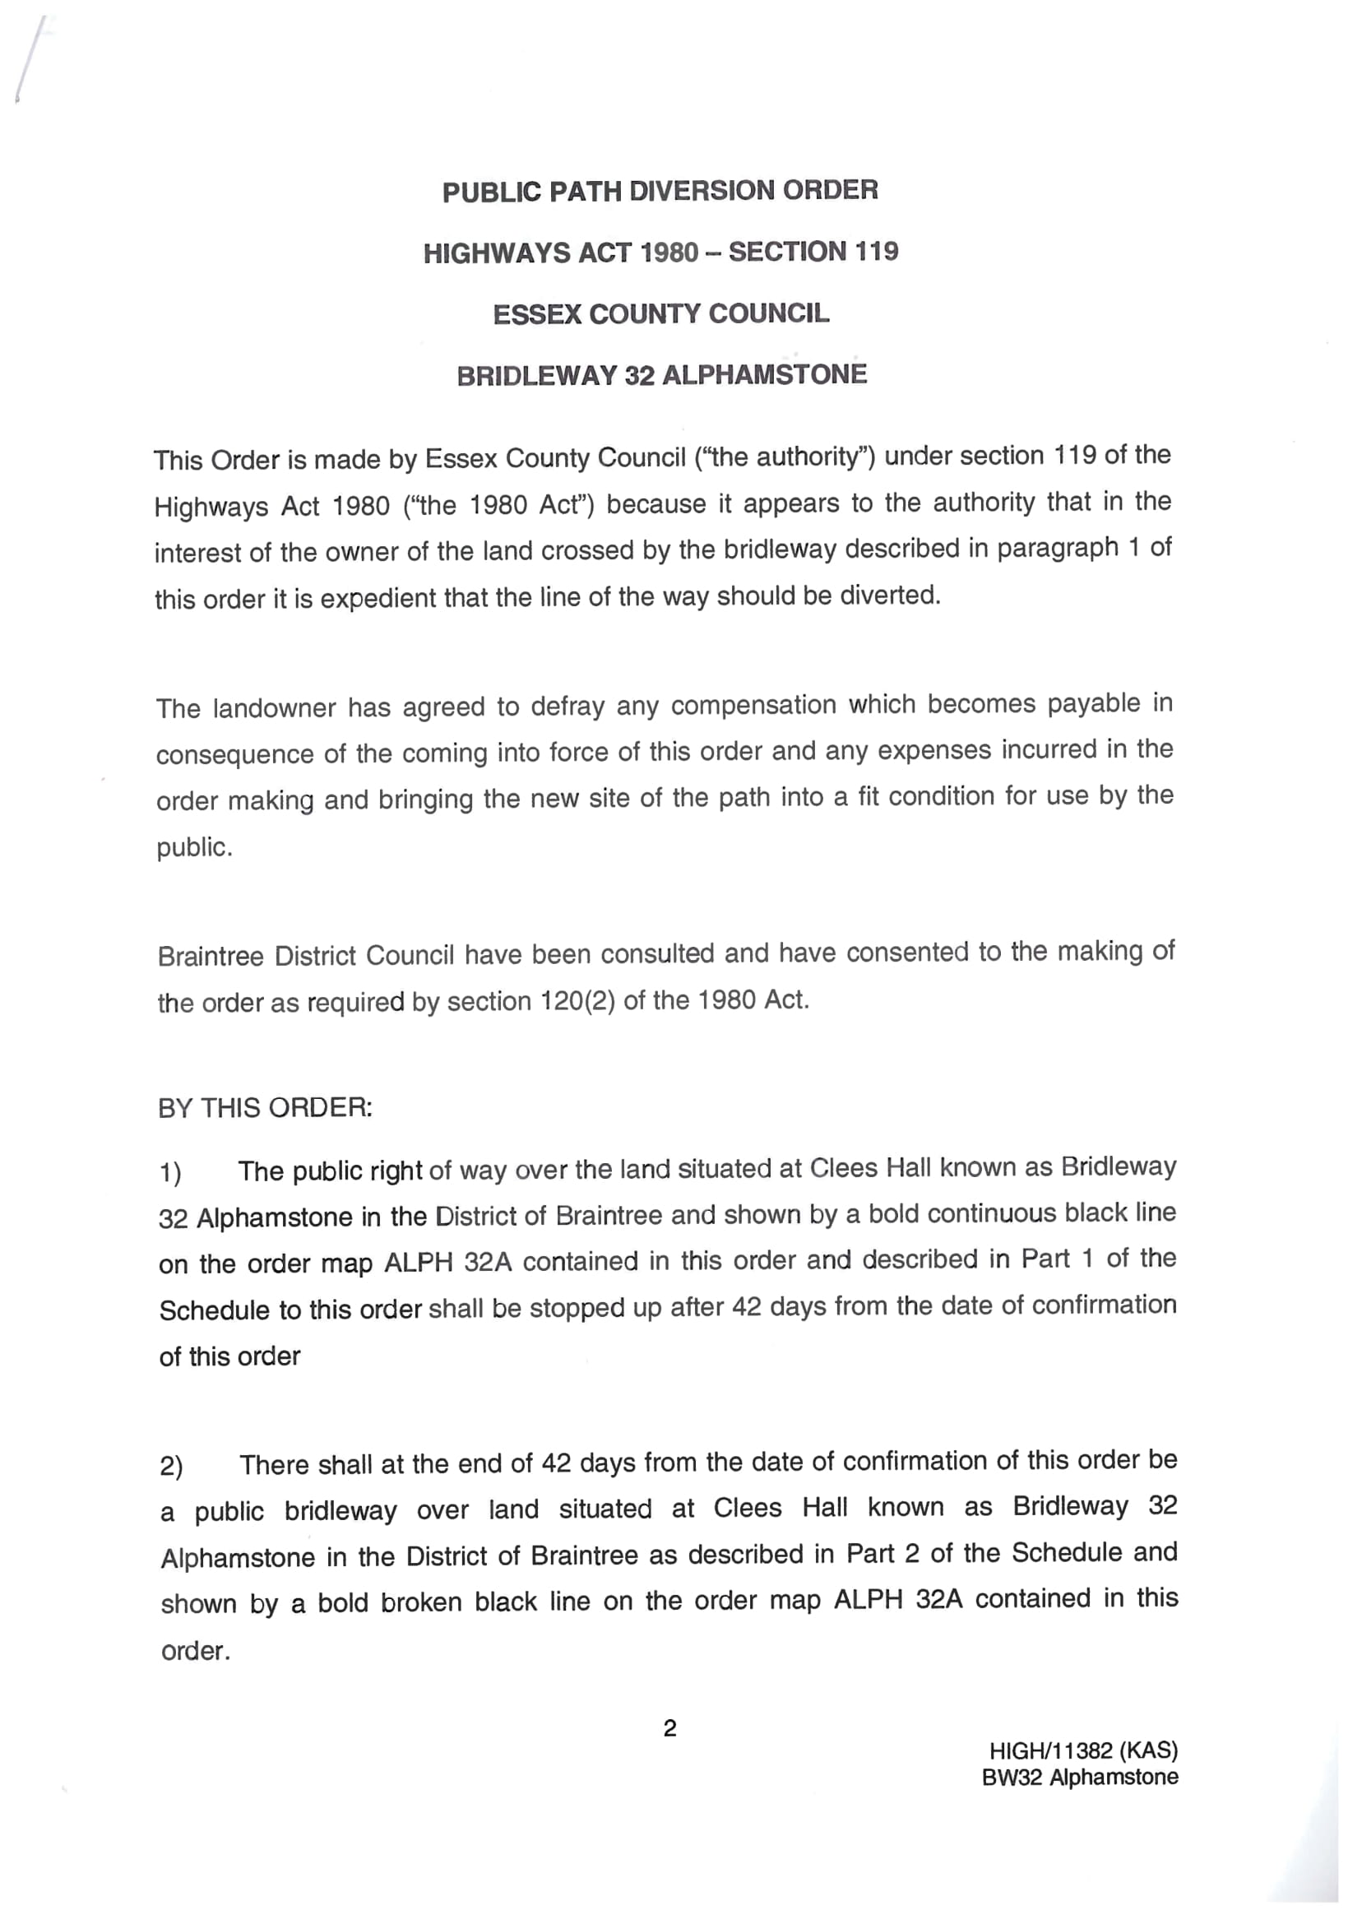
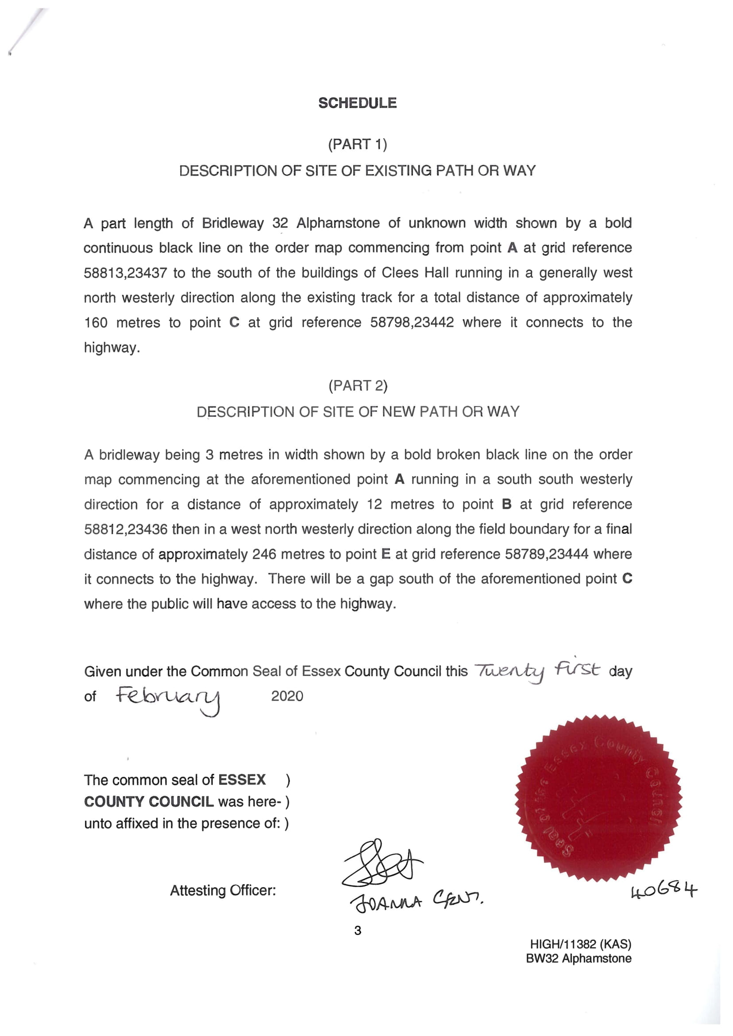
ORDER MAP – COPY – NOT TO SCALE

