The Hoops
Ickleton Road
Elmdon
Saffron Walden
Essex
CB11 4LT
Grade II

C18 timber-framed and plastered house with lean-to additions at the east and west ends. Renovated. Two storeys. Three window range of double-hung sashes with glazing bars. Modern gabled central porch with slate roof and a 6-panel door. Roof thatched, half hipped at east and west ends, with a central chimney stack.

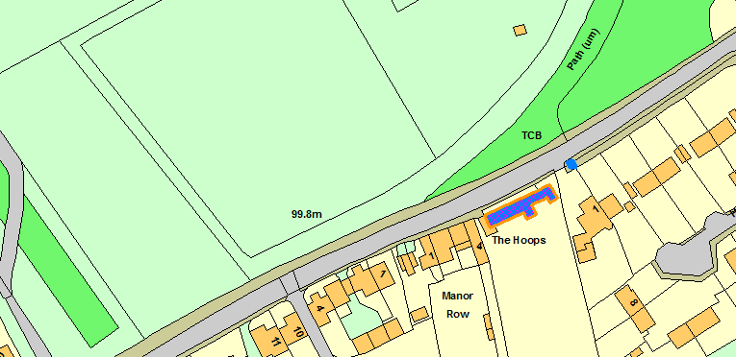

Telephone Kiosk Ickleton Road Elmdon
Grade II

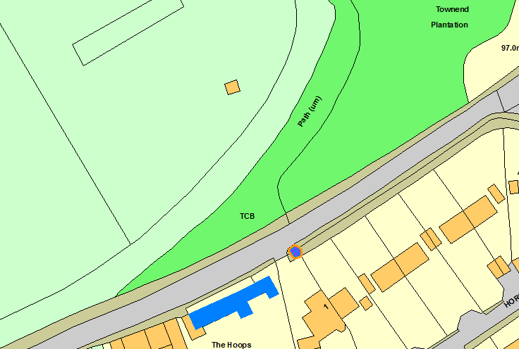

Mulberry Cottage
Ickleton Road
Elmdon
Saffron Walden
Essex
CB11 4LT
Grade II
C18 timber-framed and plastered building with a later single storey addition on the east. One storey and attics. Small casement windows. Roof tiled, half hipped, with a central chimney stack and one sloping roofed dormer on the front.

