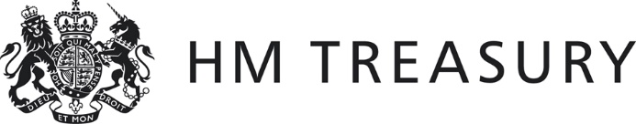 | Form CG03

2021-22 WGA

Confirmation of Minor Body Status

Name of body:
Body CPID:
(if one has been assigned)

I confirm that the details below were extracted from the 2021-22 and 2020-21 statutory accounts:

Item | 2021-22 £’000 | 2020-21 £’000
Gross annual expenditure for the year
Gross annual income for the year
Net book value of property, plant and equipment as at 31 March 2022 / 2021
Gross assets as at 31 March 2022 / 2021
Gross liabilities as at 31 March 2022 / 2021
Net assets as at 31 March 2022 / 2021

I hereby certify that the above body meets the criteria for being treated as a minor body during 2021-22, whereby amounts are below £30m. Note – to meet the minor body criteria, this must apply for both years.

Signed

Consolidation Manager

[ Date ]

This form should be sent to the Treasury WGA team by 31 January 2023

This form should also be copied to the consolidation manager in your sponsoring department.

Note that bodies who meet the criteria for 2021-22 will be added to the initial list of minor bodies in the 2021-22 Whole of Government Accounts.

