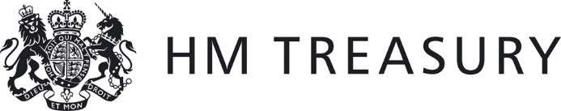 | Form CG02

2021-22 WGA

Notification of Completion of the WGA Agreement Process

Name of Body: [PLEASE ENTER HERE]
Body CPID: [PLEASE ENTER HERE]

I certify that, for the purposes of the 2021-22 Whole of Government Accounts, and in accordance with the 2021-22 WGA Guidance:

- I have agreed all balances at 31 March 2022 and transaction streams in the year ending 31 March 2022 with other central government bodies, which exceeded £5 million on a gross basis (except for taxation balances with HM Revenue and Customs).
- I acknowledge the requirement to submit CG-01 forms directly to HM Treasury.
- If transactions and balances have not been agreed on a gross basis, details are provided below:
[PLEASE PROVIDE DETAILS HERE]
- Emailed to HM Treasury along with this form are:
  - CG01 forms with any other central government body with whom I have transactions and balances exceeding the £5 million threshold
  - Supporting papers where there are significant differences (more than £200,000) between amounts recorded by two bodies.
  - CG02 Annex Form ‘Departments’ balances with Local Authorities’ listing any transactions or balances above £1 million with local government entities
[PLEASE ENSURE THESE DOCUMENTS ARE SENT ALONG WITH THIS FORM]
- Amounts not agreed with differences greater than £200,000 are summarised below:
[PLEASE SUMMARISE BELOW & PROVIDE FURTHER DETAILS ON SUPPORTING PAPERS]
Amount | CPID | SCOA | Rationale

- Sub-consolidating Departments’ Declaration [Delete if not applicable]:
All bodies within the departmental consolidation group, and any funds administered by the group, have agreed their 2021-22 transaction streams and balances as stood at the date this form was completed in accordance with guidance provided by the Treasury.

Signed by Consolidation Manager: [PLEASE PROVIDE NAME HERE]
Date: [PLEASE PROVIDE DATE HERE]

Bodies should send this form to the Treasury WGA Team.

