Order Decision
Site visit made on 22 November 2022
by Gareth W Thomas BSc(Hons) MSc(Dist) DMS MRTPI
an Inspector appointed by the Secretary of State for Environment, Food and Rural Affairs
Decision date: 22 December 2022

Order Ref: ROW/3278139
- This Order is made under Section 53 (2) (b) of the Wildlife and Countryside Act 1981 (the 1981 Act) and is known as the South Gloucestershire Council (Footpath between Prospect Road and Public Footpath ORN 51 at Severn Beach) Definitive Map and Statement Modification Order 2019.
- The Order is dated 1 August 2019 and proposes to modify the Definitive Map and Statement for the area by adding a Footpath at a point at the end of Prospect Road to a point on the recorded footpath ORN 51 as shown on the Order plan and described in the Order Schedule.
- There were two objections outstanding when the South Gloucestershire Council submitted the Order to the Secretary of State for Environment, Food and Rural Affairs for confirmation.
Summary of Decision: The Order is not confirmed

Procedural Matters
- I made an unaccompanied site visit on 1st December 2022 when I was able to view Public Footpath ORN 51 in the vicinity of the Order route. The Order route itself was not passable on this day.
- Two objections had been received at the time of the making of the Order by the Order Making Authority (the OMA); a number of comments were also received. The OMA has adopted a neutral stance.

The Main Issues
- The Order has been made under Section 53(3)(c)(i) of the Wildlife and Countryside Act 1981 (the 1981 Act) which requires me to consider if, on the balance of probabilities, the evidence shows that a public footpath subsists along the Order route. This is a higher standard of proof than the reasonably alleged to subsist test to determine if an Order should be made.
- Where there is evidence of use of a route, Section 31 of the Highways Act 1980 (the 1980 Act) is normally relied upon. Subject to certain criteria, it provides a statutory presumption of dedication as a highway where it has been actually enjoyed by the public as a right of way and without interruption for a full period of twenty years unless there is sufficient evidence that there was no intention during that period to dedicate it. The period of 20 years is to be calculated retrospectively from the date when the right of the public to use the way was brought into question.
- Also, common law requires me to consider whether the use of the path, and the actions of landowners (or lack of action), have been of such nature that they intended a way to be dedicated as a highway and where the public have accepted that dedication. In such circumstances, the dedication of the path by inference that a way has been dedicated for public use may be drawn.
- Use by the public can be evidence of the intention to dedicate. For an inference of dedication, this use should be as of right without force, secrecy, or permission. There is no fixed period of use at common law and use may range from a few years to several decades, based on the facts of the case. The more intensive and open the use, the shorter the period required to raise the inference of dedication. The burden of proof lies with the claimant to demonstrate that the evidence is sufficient to indicate an intention of dedication.

Reasons
- Limited documentary evidence supporting the confirmation of the Order was submitted in the form of aerial photography, which I deal with later in this decision. Given these limitations, the determination of the Order depends primarily on the evidence of public use of the claimed route that is available and whether this would indicate that a public footpath can be presumed to have been dedicated in accordance with the provisions of the 1980 Act (statutory dedication) or inferred to have been dedicated at common law.

Date when public use was brought into question
- The OMA’s Committee report suggests that the event that brought the Order route into question was the erection of a close boarded fence by Western Power following maintenance work undertaken during the summer of 2016. Rubble and other detritus that had cumulated at the entrance into the field of Public Footpath ORN 51 from Prospect Road was removed by the utilities operator to facilitate maintenance of power lines. Following completion of these works, the company was asked by local residents to replace the fence that had previously been broken down, presumably to gain access to the field. This was done and the previously cleared rubble returned.
- In the absence of an alternative date corroborated by evidence, I am satisfied that the public’s right to use the Order route was brought into question in 2016 and thus the 20-year period for consideration is 1996-2016.

Whether the Order route was used by the public as of right and without interruption
- In addition to the applicant’s submissions, 24 User Evidence Forms (UEFs) were submitted in support of the Order. The UEFs describe use by foot of the claimed route between 1966 and 2016. Prospect Road was built around 1976.
- The OMA has produced a timeline which summarises the dates given in the UEFs. The timeline refers to the claimed period 1966-2016 as opposed to 1996-2016. Frequency of use varied from between 3 times a year to 1000s of times a year with 14 people stating that they have used the route over 100 times a year for the purposes of dog walking, leisure, visiting friends with one claiming use by riding a horse onto the field. All UEFs claim that they had never observed any obstruction to the use of the route during this period.
- There is no suggestion that the claimed use took place with secrecy or force.
- Objections to the Order were received from two residents of Prospect Road and do not comment about the use of the Order route other than to state that there is an access to Public Footpath ONR 51 from Abbott Road some 60m away. The Pilning and Severn Beach Parish Council commented that they believed that the path has been used “for some years” in the past but their main comment concerns fears that the field would be accessed for fly tipping and exposed to anti-social activities.
- Landowners were served notice in accordance with statutory requirements. Taylor Wimpey, the owners of the ransom strip at the head of the cul de sac at Prospect Road confirmed that they had never constructed any fence, other barrier or erected any notice at their boundary with the field in question. They also confirmed that they do not believe the route to be public.
- Further investigations were undertaken by the OMA to establish whether on balance, the route had been used as of right by the public. The Order route is not depicted on the plans drawn up during the preparation stages of the Definitive Map and Statement for the former Thornbury Rural District or any historic Ordnance Survey maps. The Council possessed useful aerial photographs for the periods 1991, 1999, 2005, 2006, 2008, 2015 and 2017.
- The photographs may indicate a worn path in the vicinity of the claimed route, which is particularly clear on the 2014 photograph. The photograph in 1999 shows the field subdivided for the keeping of horses, which coincides with the Council’s planning records which confirm that horses had been kept on the land since at least 1997 and which refer to a number of locations along the field edges where fences and other structures had been erected along with overgrown vegetation. A Google Map Streetview photograph was also submitted by the OMA, which shows the situation in 2014 where the boundary at the head of the cul de sac was overgrown with brambles apart from one area where a fence had been erected. The positioning of the fence did not correspond to the aerial photograph depiction of the worn access path.
- The OMA carried out non-statutory consultation prior to making the Order, which elicited a number of responses. Five residents of Prospect Road commented that the boundary around the time that the properties were completed had a wire fence, which was not well-maintained, and people started to access the land for fly tipping, dumping of garden waste and dog walking. Rubble was also deposited on the land allegedly by the local authority as a measure to prevent access. Residents also confirm that the electricity undertaker carried out maintenance work and reinstated the rubble and, on the request of local residents, replaced the fence with a close-boarded fence.
- Two responses to the OMA’s consultation from people living in other parts of the village claimed that they have used the Order route to gain access to the public footpath to reach Church Road and to take a short cut to work.

Conclusions regarding Statutory Dedication
- The documentary evidence does not provide convincing evidence of status of the Order route; however, the aerial photographs must be looked at in the round and do assist, so far as they can, in showing a physical feature in this location from at least the time that the photographs were taken, most evidently in 2014. From perusal of some of the photographs, the use of the Order path appears more likely to have been intermittent. This view is supported through evidence that the precise entry point was not consistent.
- That said, there is some consensus from user evidence that the Order route has been regularly used between the relevant dates. However, there is also evidence, albeit conflicting in part, that there has been some form of fencing of the land since the 1970s when Prospect Road was built. This included a wire fence initially. Over the years, probably as the original fence was trampled down and through a combination of tipping of rubble and the erection of temporary wooden fencing in around 2011, the route became increasingly difficult to navigate. Eventually, in 2016 a permanent close boarded timber fence was erected across the access point from the ransom strip into the field. I cannot therefore be satisfied that the use of the Order path has been without interruption.
- This view is further supported by the fact that the field was used and indeed subdivided to provide paddock areas for horses, which would have inevitably led to users of the land wishing to better secure the field. I agree with the OMA that the use of the Order route was by the public at large but that this occurred in “chunks of several years punctuated by various obstructions” and not as of right over a consistent 20-year period.

Common Law
- An inference that a way has been dedicated for public use may be drawn at common law where the actions of landowners (or lack of action) indicate that they intended a way to be dedicated as a highway and where the public have accepted it.
- In this case, there is some evidence of public use from the 1960s onwards and no substantive actions by landowners that would indicate a lack of intention to dedicate it as a public right of way before 2016. However, although the landowner appears not to have taken much interest in the land, given my findings that the use was both inconsistent and intermittent, this does not necessarily imply dedication as the landowner either may not have known about its use or have acquiesced about its use.
- I do not therefore believe that dedication of the Order route can be inferred at common law.

Other Matters
- A number of concerns were raised by objectors and the Parish Council relating to the possibility of vandalism, fly tipping and other anti-social behaviour and damage to the environment that might occur from the Order route becoming a public right of way. Whilst I appreciate these concerns, they lie outside the criteria set out in the relevant legislation and they have not been determinative in my decision.

Conclusions
- The burden of proof in this case lies with the applicant to demonstrate that public use of the route occurred for at least 20 years prior to the use being brought into question. For the reasons given, I do not consider the evidence adduced in this case meets the requisite standard for confirmation. I have also found there is insufficient evidence to show dedication of the route at common law.
- Having regard to the above reasons and all matters raised in the written submissions, I conclude that the Order should not be confirmed.

Formal Decision
- I do not confirm the Order.

Gareth W. Thomas

INSPECTOR

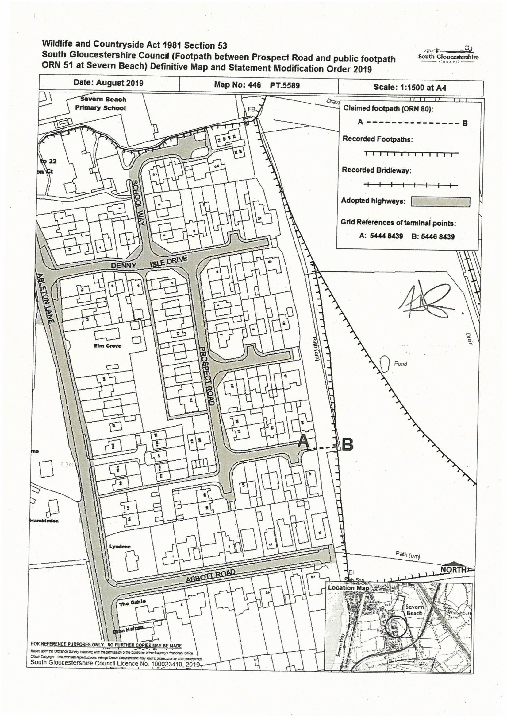

Appendix 4 to South Gloucestershire Council Public Rights of Way and Commons Registration Committee 13 September 2018

