Order Decision
Inquiry Held on 15 November 2022
Site visit made on 15 November 2022
by Gareth W Thomas BSc(Hons) MSc(Dist) DMS MRTPI
an Inspector appointed by the Secretary of State for Environment, Food and Rural Affairs
Decision date: 5 January 2023

Order Ref: ROW/3272929
- This Order is made under Section 53 (2) (b) of the Wildlife and Countryside Act 1981 (the 1981 Act) and is known as the BCP Council (Public Footpath 135 – James Road, Branksome) Definitive Map and Statement Modification Order 2020.
- The Order is dated 12 May 2020 and proposes to modify the Definitive Map and Statement for the area by adding a public footpath as shown in the Order plan and described in the Order Schedule.
- There were six objections outstanding when Bournemouth, Christchurch and Poole Council submitted the Order to the Secretary of State for Environment, Food and Rural Affairs for confirmation
Summary of Decision: The order is confirmed.

Procedural Matters
- I made an unaccompanied site inspection on 15 November 2022 following the close of the inquiry. I did however avail myself of the offer made at the inquiry by Mr White of 53 Wroxham Road to view part of the Order route from his property as the route is no longer accessible from Sheringham Road itself and is only accessible from James Road to a point where Mr White’s property meets No.24 James Road. At this point, a physical barrier has been erected, which prevents onward passage towards Sheringham Road. I was however able to peer through the hedgerow at the top of the garden to No. 53 Wroxham Road and noted the condition of the route as it heads towards Sheringham Road and becomes impenetrable from this point westwards.
- I was able to walk the Order route from James Road to a point at the westernmost part of the garden boundary of No.24 James Road.
- The objector who requested the public inquiry did not attend the inquiry itself and I was informed that he had now sold No.104 Sheringham Road and had left the area. Nevertheless, the inquiry proceeded with a mix of in-person participants and those who attended online ‘virtually’.

The Main Issues
- The requirements of Section 53(3)(c)(i) of the Wildlife and Countryside Act 1981 (the 1981 Act) is that the evidence discovered by the surveying authority, when considered with all other relevant evidence available, should show that a right of way that is not shown on the definitive map and statement subsists along the Order route.
- All of the evidence in this case relates to usage of the route by members of the public. In respect of this, the requirements of Section 31 of the Highways Act 1980 (the 1980 Act) are relevant. This states that where it can be shown that a way over land has been enjoyed by the public as of right and without interruption for a full period of 2o years, the way is deemed to have been dedicated as a highway unless there is sufficient evidence that there was no intention during that period to dedicate it. The period of 20 years is to be calculated retrospectively from the date when the right of the public to use the way was brought into question.
- In Redcar it was held that for use to be ‘as of right’ it must be without force, without secrecy and without permission. In addressing these issues, I must be satisfied that the relevant tests have been met on a balance of probabilities.
- Common law also requires me to consider whether the use of the path and the actions of the landowners have been of such nature that the dedication of the path by the landowners can be inferred. The issues to be addressed would be whether, during any relevant period, the owners of the land had the capacity to dedicate a public right of way, whether there was express or implied dedication by the owners and whether there is evidence of acceptance of the claimed right by the public.

Reasons
- No documentary evidence supporting the confirmation of the Order was submitted.
- Accordingly, the determination of the Order depends entirely on the evidence of public use of the claimed route that is available and whether this indicates that a public footpath can be presumed to have been dedicated in accordance with the provisions of the 1980 Act (statutory dedication) or inferred to have been dedicated at common law.

Statutory Dedication

Date when public use was brought into question
- In October 2015, Mr Atherton moved into the property and believed that the strip of land the subject of the Order route running alongside 104 Sheringham Road formed part of the residential curtilage of that property and was being used as a bin store, with a photograph dating from 2014 clearly showing that use. Mr Atherton proceeded to utilise this area for the parking of his vehicle. Mr Atherton fenced the land at the eastern end of his property to prevent access from James Road at about April 2017. Mr Atherton’s written evidence explains that the land had become overgrown and unpassable; an oak tree had grown in the middle of the Order route, which further inhibited passage.
- The issue of the fence appears in Mr White’s landowner evidence form when he also explained that the route became blocked by Mr Atherton’s actions in about 2017
- I therefore conclude that for the purposes of section 31(2) of the 1980 Act, the public’s use of the claimed path was brought into question in 2017 and the relevant period is 1997 to 2017.

Whether the claimed footpath was used by the public as of right and without interruption for a period of not less than 20 years ending on the date the public’s right to do so was brought into question
- Ten User Evidence Forms (UE Forms) were submitted in support of the Order. The UE Forms were supplemented by two written statements. According to the OMA, the UE Forms and statements explain the nature of the use of the path up until around 2018 with the period of use extending in one or two instances from between 1960 and 2017/2018 and between 1980 and 2017/2018. The OMA acknowledges that the date when the path became unpassable remains unclear; however, the OMA confirms that it would have become overgrown over a period of several years prior to the fencing off the land by Mr Atherton.
- At the inquiry, I heard that the route would have served a useful purpose as a short cut from James Road through to corner shops that once were located at 49 and 51 Wroxham Road. The owners of those retail properties applied for planning permission in about 2015 to redevelop the site for housing; a statement accompanying the planning application explained that although the status of the path was unclear, it had been shown in that position since the 1954 Ordnance Survey Map and therefore presumed to be a public right of way. The developers did not dispute that interpretation and sought to maintain access during construction of the dwellings.
- Mr Atherton, the principal objector and supported by six UE Forms together with a petition counters the claim that the use of the path has been ‘of right’, alleging that only some of the landowners enjoy a private ‘right of way’. In this, he claims that the use of the path, which would have been infrequent at the very most, has not only been very sporadic but used only by a few individuals, as part of their private rights. These rights are mentioned in the title deeds to some properties but that this is very different to a use ‘as of right’. According to Mr Atherton, statutory dedication has not been established but in any event, the way that the land has been used demonstrates that there has been a lack of intention to dedicate, albeit since 2017.
- Mr Atherton also points out that the path at the Sheringham Road end is completely overgrown and in part has been used as a vegetable patch. I have to agree with the OMA that the path appears to have been allowed to become overgrown with most of the vegetation grown over from adjoining properties and that the shaded nature of this area would have made it unlikely to have had any utility as a vegetable allotment. The linearity of the path is still most evident on the ground apart from the section of land that has been widened to facilitate parking.
- Upon questioning the objectors at the inquiry, it was clear that there had been opposition to the opening of the route on the grounds that this would lead to anti-social behaviour and that the path would not serve any useful purpose for local people. There was a fear that the incidence of car theft and vandalism would increase if the path was opened. However, there was a sense that the objectors recognised that the path did once offer a shortcut to local shops as well as to a local bus stop on Wroxham Road. Mrs Milton who has lived on James Road for 26 years explained that the path was used regularly to reach the shops and the postbox on Sheringham Road.
- Extracts from the Ordnance Survey maps of 1941-1950 and 1951-1960 show the entire route as a footpath (labelled FP) although the later edition of 1961-1980 records the Sheringham Road end of the route as a path. OS Maps do not however hold the same status as the Definitive Map and are merely indicative.
- I found the evidence of Mr White who was supported by others at the inquiry convincing. His property had been in family ownership since 1984 and that he or other family members had maintained the hedgerow running alongside the path for some 33 years. Objectors did not offer any counter evidence at the inquiry. The representations supporting the objection to the Order mainly related to the fear of anti-social behaviour and that many did not realise that a path existed at all. However, these points do not amount to evidential evidence and have been discounted on the basis of having no relevance in law.
- I conclude on balance that use of the Order route by the public was of right and without interruption for the 20-year period under consideration, and indeed in excess of 20 years for some individuals.

The evidence and actions of landowners
- Mr Atherton the former landowner of the route following the side boundary of 104 Sheringham Road erected a fence across the width of the path at the easternmost part of his residential curtilage in 2017. Although he also submitted photographs of bins being stored at the entrance to his property at No. 104, this does not necessarily mean that there was an intention to prevent access. Photographs of this nature are mere snapshots in time.
- It is appreciated that the land through which the path crossed has become overgrown and a semi-mature tree had grown in the middle of the path. I was shown a video at the inquiry, which showed the extent of this vegetation growth. However, it was also clear that the path could still be passed albeit with some difficulty. At my site visit, I was able to walk up from James Road towards Sheringham Road to the point where the fence had been erected with relative ease. I was able to inspect the path through a gap in the hedge in the rear garden of No.53 and noted the width and alignment and a sense that this appeared very much as a former path.
- Although Mr Atherton was successful in blocking the path in 2017, this does not mean that he succeeded in preventing use of the path by members of the public before this date. On the basis of what was presented to me at the inquiry, supported by my own observations at the site visit, it is my view that there is not sufficient evidence of actions by landowners indicating their lack of intention to dedicate the Order route as a public footpath in the period 1997 to 2017 to rebut the presumption that it had been so dedicated.

Conclusions regarding Statutory Dedication
- There is sufficient quantity and reliability of evidence of public use of the Order route throughout the period from 1997 to 2017 and indeed earlier which is sufficient to raise the presumption that it had been dedicated as a public footpath in accordance with the provisions of the 1980 Act. Although Mr Atherton has submitted various legal documentation of Title, these do not undermine the veracity of the evidence, which relates to a specific timeframe. No other substantive evidence that might successfully rebut this presumption has been provided. Accordingly, I conclude that the route has been dedicated as a public footpath as a result of use by the public during the period 1987 to 2017.

Common Law Dedication
- As a claim under statute succeeds, I do not need to give consideration to the evidence of common law i.e. where an inference that a way has been dedicated for public use where the actions of landowners (or lack of action) indicate that they intended a way to be dedicated as a highway and where the public have accepted it. The OMA did not rely on common law dedication and similarly, I have no need to do consider this either given my findings on statutory dedication.

Conclusions
- Having considered the evidence of the applicant and supporters of the Order, I consider this to meet the requisite standard for confirmation. The evidence of the objectors although meaningful and well-intended, do not lead me to question the period of dedication.
- Having regard to the above reasons and all other matters raised at the inquiry and in written submissions, I conclude that the Order should be confirmed.

Formal Decision
- I confirm the Order.

Gareth W Thomas

INSPECTOR

APPEARANCES AT THE INQUIRY

Mr White

Mrs D Milton

Mr Andy Smith

Ms M Smith

Mr M Forward

Mrs R Forward

Ms Chamina Eaton

Mr A O’Brien

Mrs I O’Brien

Mrs M Lloyd

Mr P. J. Elias Senior PROW Officer

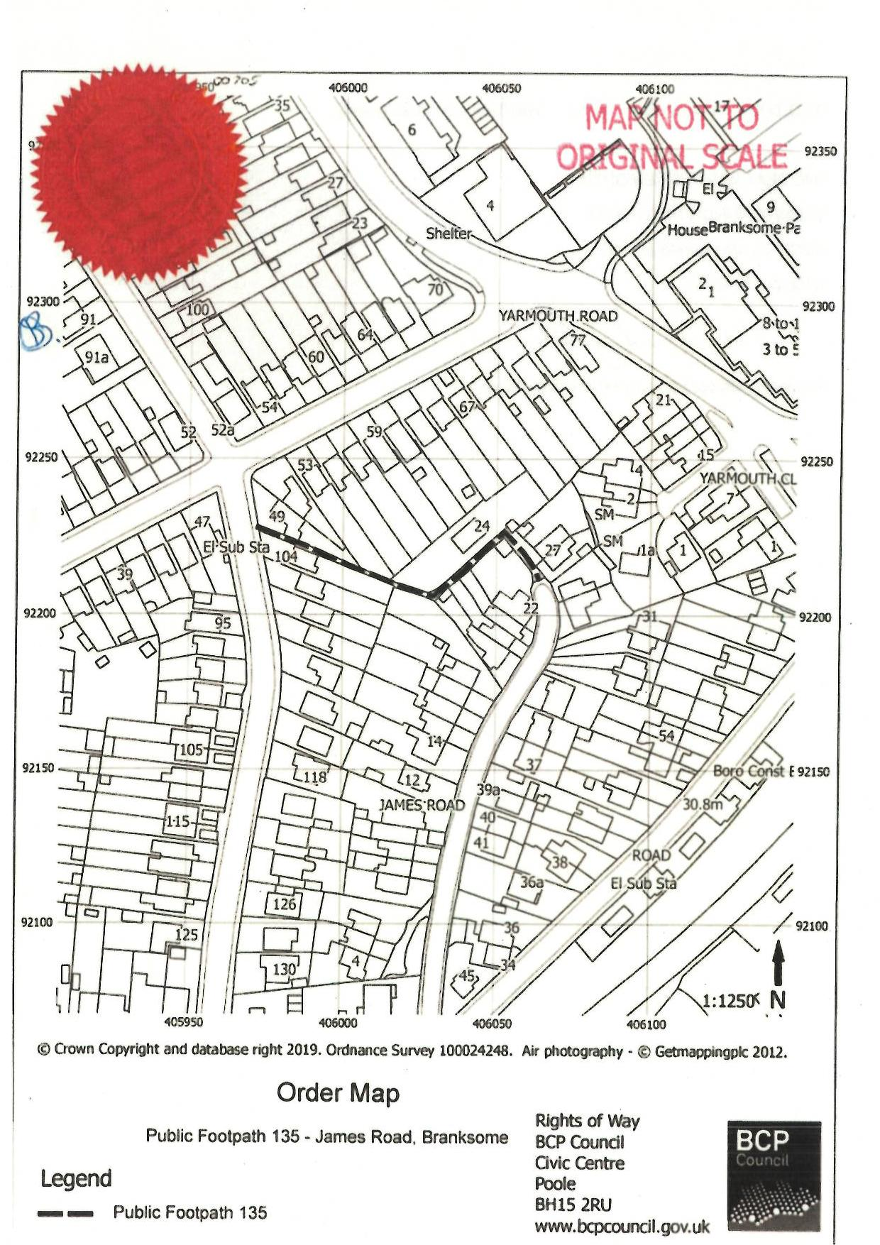

R (Lewis) v Redcar and Cleveland (No2), [2010] UKSC1 11

