Appeal Decision
Site visit made on 1 December 2022
by Gareth W Thomas BSc(Hons) MSc(Dist) DMS MRTPI
an Inspector appointed by the Secretary of State for Environment, Food and Rural Affairs
Decision date: 9 January 2023

Appeal Ref: FPS/G3300/14A/23
- The appeal is made under section 53(5) and Paragraph 4(1) of Schedule 14 of the Wildlife and Countryside Act 1981 against the decision of Somerset County Council not to make an Order under section 53(2) of that Act.
- The application dated was refused by Somerset County Council on
- The appellant claims that the Definitive Map and Statement of Public Rights of Way should be modified so that footpaths between St Mary’s Church, the Mandeville Arms and Rectory Lane in the parish of Hardington Mandeville are added.
Summary of Decision: The appeal is dismissed

Preliminary Matters
- I have been directed by the Secretary of State for Environment, Food and Rural Affairs to determine this appeal under section 53(5) and Paragraph 4(1) of Schedule 14 of the Wildlife and Countryside Act 1981 (the 1981 Act).
- Given the nature of the evidence, I made an unaccompanied site visit on 1 December 2022 in order to better familiarise myself with the surroundings and the relationship of the appeal routes with existing public rights of way and other highways.
- I attach a copy of the claimed routes for ease of reference.

Main Issue
- The principal issue is whether on the discovery by the authority of evidence which, when considered with all other relevant evidence available, the appeal routes should be recorded in the definitive map and statement (the DMS). Thus, if the surveying authority has ‘discovered’ evidence, then the question arises as to whether it can be concluded that a public right of way subsists or can be reasonably alleged to subsist.
- As set out by the High Court in the case of R v Secretary of State ex parte Norton and Bagshaw an Order to add a route should be made if either of two tests is met:
- Test A: does a right of way subsist on a balance of probabilities, in this case, sufficient to warrant modifying the DMS to include the appeal routes?

Test B: is it reasonable to allege on the balance of probabilities that such a right of way subsists? For this possibility to exist, it will be necessary to show that a reasonable person, having considered all the relevant evidence available, could reasonably allege that such a right of way subsists.
- The evidence adduced is documentary. Section 32 of the 1980 Act requires a court or tribunal to take into consideration any map, plan or history of the locality, or other relevant document, which is tendered in evidence, giving it such weight as is appropriate, before determining whether or not a way should be dedicated as a highway.
- I will turn first to the various documents and then turn to the question of whether it can be said that evidence has been ‘discovered’ such that section 53 (3) is engaged and whether public rights of way subsist or can be reasonably alleged to subsist.

Background
- The appeal concerns three distinct but interlinking routes the first of which crosses from St Mary’s Church into a small field in a south westerly direction to point B on the attached Plan before turning southwards to point E which meets public footpath Y 10/17 on Rectory Lane. The route is approximately 215m in length. A second route cuts diagonally in a north-westerly direction from the former Mandeville Arms, crossing the first route before reaching point C and linking with the existing public footpath Y 10/18. The third route from the Mandeville Arms travels in a westerly direction to meet with the first appeal route on Rectory Lane at point E. These arrangements are shown on the annotated map at Appendix 1 to this decision.

Documentary evidence
- The appellant relies principally on a House of Lords Short Debate where a local landowner was giving evidence and later clarified her recollections in emails to the appellant where she referred to a historic footpath being used by the local vicar in days gone by as a short cut between the church and the rectory and which passed through her garden.
- Whilst the OMA accepts that this might have been so and indeed, the first appeal path did have public rights of way status until the two sections A to B and B to E were formally diverted in 1983 and 1970, respectively. Rights to that section of the path A to B was extinguished in 1983 when public footpath Y 10/16 was diverted to the south of the appeal route. The 1970 Order diverted public footpath Y 10/17 on to the footway along Rectory Lane, presumably when new houses were constructed and in so doing extinguished the southern section of the first appeal route between points B and E.
- The appellant acknowledges that this process occurred; the House of Lords debate is therefore of mere interest and does nothing to support the appellant’s case that the path might still enjoy rights.
- The appellant argues that the second and third paths should also be included in the definitive map and statement as they were recorded together with the first path on the 1886 First Edition Six Inch Map as “public footpaths”; however, although they were depicted using the abbreviations ‘F.P.’, their inclusion on OS maps cannot in isolation provide evidence of the existence of a public highway. They are surveys of land and are useful in so far as they are indicative of what is on the ground at any given time. But they do not enjoy any legal status in the manner of a definitive map and statement.
- The appellant also believes that the fact that the appearance of the diverted route on maps (presumably historic maps) is the same as other parts of the appeal routes would suggest a reasonable allegation of the existence of other routes. No further evidence is provided by the appellant regarding the Council’s alleged failure to consider other evidence (described in the appeal as “all available evidence”) and I am unable to comment further on this allegation.
- The OMA investigated a large number of historical maps, documents and old highway records. Whilst it does not rely on any one piece of evidence as conclusive, the OMA submits that none of the information gleaned from their investigation would point towards public rights of way subsisting or being reasonably alleged to subsist. I now turn to this question having regard to the evidence.
- Tithe maps were concerned with identifying land on which a tithe was due to the church and officially recorded the boundaries of all areas on which the tithe-charge was apportioned. The purpose of tithe maps was not to identify highways. Various roads appear to be depicted; however, the apportionment in respect of the immediate vicinity of the appeal routes does not provide any information pertaining to the appeal routes although it is acknowledged that other public rights of way shown in the DMS are not shown either.
- The appellant claims that the appeal routes have been shown in previous OS maps. However, for the reasons given above, while indicating these routes at various past iterations, including their marking with the letters P.F., OS maps do not define the status of public rights of way and indeed later maps clarify their legal standing by carrying a disclaimer to this effect.
- Highway authority records have been scrutinised dating from 1929. The initial Handover Map and List 1929 recorded highways maintained at public expense at the time. Various roads in the locality are shaded according to their status but the accompanying schedule of maintained roads do not mention the appeal routes.
- All three routes are shown in the subsequent 1930s Road Records Map as they were partly based on the OS First Edition 6 Inch Map and used as the base for the highway map. However, they are neither shaded nor annotated in the manner of public highways.
- The 1950 Roads Records show the first appeal route but is not shaded and it cannot therefore verify public status. The Modern Road Records do not show any of the three routes.
- Whilst the OMA acknowledges that the purpose of highway mapping records is to confirm the County Council’s acceptance of maintenance liability; they are internal documents and are not the subject of public scrutiny or challenge. By the same token, where a route is not recorded does not necessarily mean that they do not enjoy public rights. In any event, the road documents do not ordinarily indicate public footpaths. However, I share the OMA’s conclusions regarding the veracity of highway documents that such information does not support the appeal case.
- The OMA confirms that none of the appeal routes are depicted on any of the following commercial and other similar maps:

Day & Masters 1782 commercial map, which provide very little information other than the depiction of settlements and major roads and rivers.

Greenwood Map 1822, considered to be robust evidence of a route’s physical existence at the time of the survey as the surveyor would have focussed on those roads that were believed to be publicly accessible.

Bartholomew’s Map 1902, originally aimed at tourists and cyclists, these maps used OS Maps as source documents and provided information on roads and other features provided by engineers, surveyors and local authorities. However, they did not distinguish between private and public highways and this was clarified in later editions with the caveat that ‘the representation of a road or footpath is no evidence of a right of way’.

Map of the Manor and Parish of Hardington Mandeville 1808, similar in design as a tithe map, although the field numbers along with roads are depicted, the references to any public paths through the actual fields the subject of the Order routes are not recorded.
- In addition to the documentary evidence, the OMA carried out public consultation of the application. Other than in two cases, respondents concentrated upon the utility of the appeal routes rather than providing evidence of historic usage.
- However, the owner of Beech Cottage stated that part of a path runs through their land and repeated evidence provided to the House of Lords as described above. The inference is that this path was the same as the first appeal route. The owner of the former Mandeville Arms asserted that there is no mention of public rights of way recorded in the title deeds to the property. The Hardington Mandeville Parish Council suggested that any rights along the appeal routes would have been extinguished many years ago.
- As stated elsewhere, the first route has been the subject of legal proceedings to extinguish public rights. This is conclusive evidence that the route has been stopped up. The DMS however is silent in relation to the second and third routes. From the documentary evidence explored above, there is nothing to suggest that the second and third routes have enjoyed any public rights despite being shown on OS maps at some time. The Definitive Map preparation records are similarly unhelpful to the appellant’s claims.

Other matters
- I understand that part of the second and third routes are now built upon and may affect private gardens and even houses. These matters clearly have practical consequences if an Order is made, but they cannot influence a decision on whether the appeal should succeed thereby leading to the making of an Order.
- The need for a public path is also not something I can consider.

Conclusion
- On the balance of probabilities, I consider that the evidence as a whole is not of such substance to displace the presumption that the definitive map is correct. It follows that I do not consider that the tests outlined in paragraph 6 above are satisfied.
- Accordingly, having regard to the above reasons and all other matters raised, I conclude that the appeal be dismissed.

Formal Decision
- I dismiss the appeal.

Gareth W Thomas

INSPECTOR

Appendix 1 – Annotated Map showing Appeal routes

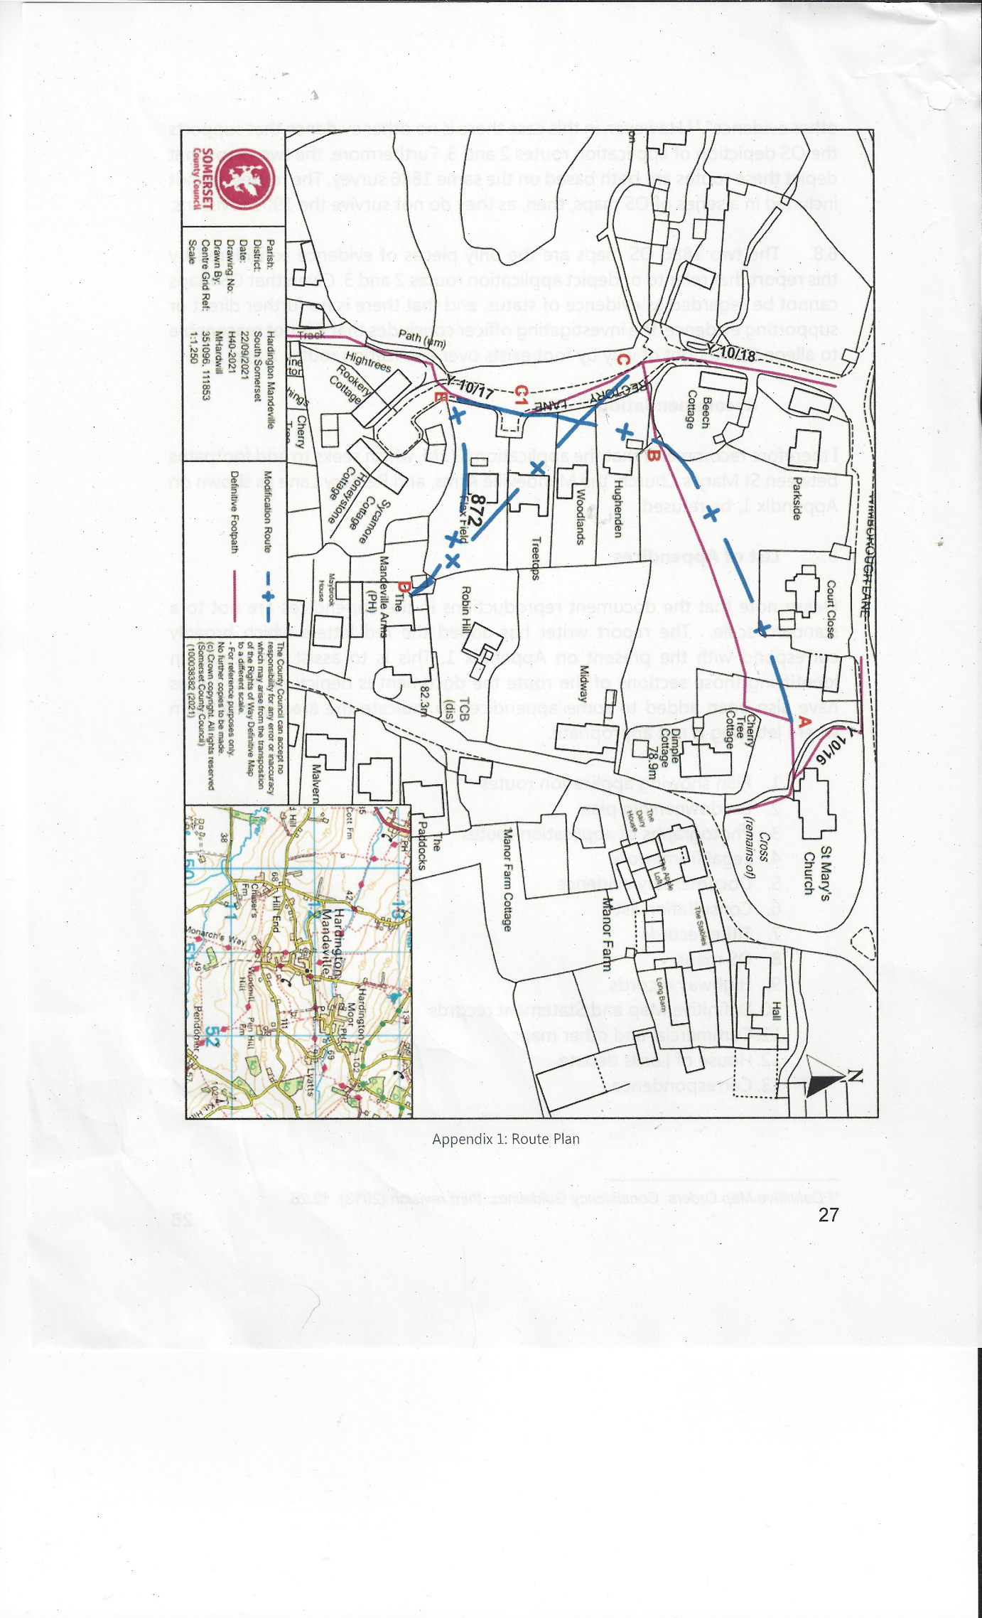

[1994] 68 P & CR 402
‘Historic Rights of Way’ – House of Lords Short Debate – Hansard (https://hansard.parliament.uk/Lords Reference: Volume 797, 2 April 2019 Appendix Number:12

