Application Decisions
Site visit made on 7 November 2022
by Alan Beckett BA MSc MIPROW
An Inspector appointed by the Secretary of State for Environment, Food and Rural Affairs
Decision date: 14 December 2022

Application Ref: COM/3300759 (Application A)
Land at Charlton Common, Almondsbury, South Gloucestershire
Register Unit Number: CL 289
Commons Registration Authority: South Gloucestershire Council
- The application dated 9 August 2022 is made under section 16 of the Commons Act 2006 (‘the 2006 Act’) to deregister and exchange land registered as common land. The application has been made on behalf of BAE Systems plc and Redrow Homes Limited.
- The release land comprises 770m² of CL 289.
- The replacement land comprises 1294m² of land adjacent to those parts of the common unaffected by the proposed deregistration.

Application Ref: COM/3300763 (Application B)
Land at Charlton Common, Almondsbury, South Gloucestershire
Register Unit Number: CL 289
Commons Registration Authority: South Gloucestershire Council
- The application dated 17 August 2022 is made under section 38 of the 2006 Act for consent to carry out restricted works on common land.
- The application is made on behalf of BAE Systems plc and Redrow Homes Limited.
- The works comprise: (a) the installation of permanent low timber bollards (0.8m x 140mm x 140mm) erected at 1.8m intervals to partly enclose the large parcel of the common to the east of Charlton Common Road - the bollards would occupy 42m² of the common; (b) the creation of a temporary works area on 1885m² of the common to ensure a 3.5m single lane or 5m two lane carriageway width for refuse vehicle access throughout the construction period; (c) 259m of temporary fencing around the temporary works area.

Decision (Application A)
- The application is granted.

Decision (Application B)
- Consent is granted for the works above in accordance with the application dated 17 August 2022 and the plans submitted with it subject to the following conditions:
- the temporary work area and temporary fencing permitted by this consent shall be removed not later than twelve months from the date of the commencement of those works;
- that part of the common affected by the temporary works shall be restored upon completion of the temporary works;
- the works permitted by this consent shall begin no later than 3 years from the date of this decision.

Preliminary Matters
- I carried out an unaccompanied site inspection on 7 November 2022. My decision has been made on the basis of my observations on this visit, taking account of the application and representations received in response to the advertisement of the application.

Charlton Common
- Charlton Common (‘the Common’) was registered as common land under the Commons Registration Act 1965. The Common is located to the south of the former Filton Airfield and a property known as Cedar House. A property known as Cedar Lodge is located immediately to the east along with a site (Cedar Lodge Kennels) which has been developed into a 13-unit residential scheme. To the south of the Common is Charlton Road and to the west is land which is identified in the South Gloucestershire Core Strategy as being part of the Cribbs/Patchway New Neighbourhood (‘CPNN’).
- The Common is split into three principal areas by the single lane access road known as Charlton Common Road (‘CCR’) which serves Cedar House, Cedar Lodge and Paynes Orchard Park. Between the western boundary of the common and CCR is a narrow strip of land which was heavily overgrown at the time of my site visit. To the north of the access road which serves Cedar House and Cedar Lodge is a second parcel of the Common which was also heavily overgrown.
- The largest area of the common is located to the east of CCR between Charlton Road and the access road which serves Cedar House and Cedar Lodge. Within this area of the common are a number of mature or maturing trees, some large apple and hawthorn trees but the majority of the ground is covered with thick, overgrown head-high bramble scrub. At the time of my visit, some intrepid individuals had created paths through the scrub to reach the apple trees, but other than these minor incursions into the bramble, there was little evidence of public access to the common being possible and little evidence of the common having been managed in the recent past. There was some short grassy vegetation on the site, although this appeared limited to the verges of the Common abutting the access roads.

The Main Issues
- Section 16 (1) of the 2006 Act provides, amongst other things, that the owner of any land registered as common land may apply for the land (‘the release land’) to cease to be so registered. If the area of the release land is greater than 200m² a proposal must be made to replace it with other land to be registered as common land (‘the replacement land’).
- Section 38 of the 2006 Act provides that a person may apply for consent to carry out restricted works on land registered as common land. Restricted works are any that prevent or impede access over the land, including the erection of fencing.
- In considering such applications I am required by section 16 (6) and section 39 of the 2006 Act to have regard to the following:
- the interests of persons having rights in relation to, or occupying, the land (and in particular persons exercising rights of common over it);
- the interests of the neighbourhood;
- the public interest;
- any other matter considered to be relevant.
- As regards the public interest (paragraph 9(c) above), section 16 (8) of the 2006 Act provides that the public interest includes the public interest in: nature conservation; the conservation of the landscape; the protection of public rights of access to any area of land; and the protection of archaeological remains and features of historic interest.
- There are additional requirements in section 40 of the Natural Environment and Rural Communities Act 2006, under which I must have regard to the Secretary of State’s duty to conserve biodiversity.
- I have had regard to the Department for the Environment, Food and Rural Affairs Common Land Consents Policy Guidance, published in November 2015, which sets out the benefits which common land should deliver, and the outcomes that it considers must be ensured by the consents process. This document has been published for the guidance of both the Planning Inspectorate and applicants. However, the application will be considered on its merits and a determination will depart from the published policy if it appears appropriate to do so. In such cases, the decision will explain why it has departed from the policy.
- The outcomes sought by the guidance is that: “our stock of common land and greens is not diminished so that any deregistration of registered land is balanced by the registration of other land of at least equal benefit”, and that “works take place on common land only where they maintain or improve the condition of the common or where they confer some wider public benefit and are either temporary in duration or have no significant or lasting impact”.
- The published policy also assumes that the release land will cease to be available for recreation and access unless a legally binding provision is intended to be made to assure continued use.

The applications
- The applications have been made on behalf of BAE Systems plc (‘BAE’) and Redrow Homes Limited (‘Redrow’) as the owners of the land proposed for deregistration and as owners of the replacement land. Redrow owns that parcel of replacement land between the Common and Charlton Road; BAE owns that parcel of replacement land adjacent to the common to the west of CCR.
- Deregistration of part of the Common abutting CCR is sought to enable part of the existing single-track road to be upgraded to double track, and to provide a continuation of access to that part of CCR where a double track road is not required. The upgrading of part of CCR is intended to provide vehicular and pedestrian/cycle access into a site immediately west of the Common for which full planning permission has been granted to provide 80 residential dwellings. Redrow purchased the Common in 2015 but only holds a possessory title to it. Redrow also has an option to purchase from BAE the land to the west of the Common and seeks to improve the existing access road to implement the planning permission already obtained.
- Network Rail (‘NR’) owns a small parcel of the Common above its railway tunnel to the east of CCR, but NR’s landholding is not part of the land proposed to be deregistered, not does NR have any interest in the proposed replacement land.
- Redrow and BAE also seek consent for the erection of short timber bollards at the boundary of the largest parcel of the Common to the east of CCR and the access road which serves Cedar House and Cedar Lodge. Consent is also sought for a temporary working area on part of the Common to facilitate the improvement of CCR together with temporary fencing around that working area. Redrow/BAE estimate that the temporary work area and fencing will be required for a period of approximately 12 weeks.

The Release Land
- The release land comprises 770m² of the Common. BAE and Redrow propose the deregistration of two parcels of land within CL 289 which lie either side of the southern part of CCR. These parcels are shown edged red on Plan 1 appended to this decision.
- The release land is not subject to any statutory designations for nature conservation; the nearest statutory designated site is Gorse Covert Local Nature Reserve which is approximately 1.6Km to the north of the Common. The release land is not subject to any non-statutory designated sites of nature conservation interest; the nearest non-statutory designated site is Filton Railway Cutting Site of Nature Conservation Interest which is adjacent to the south western part of the Common.

The Replacement Land
- The replacement land comprises 1294m² of land in two separate parcels, both of which adjoin the Common. The parcel located between the Common and Charlton Road is owned by Redrow and measures 653m²; the other parcel owned by BAE is adjacent to the Common west of CCR and measures 641m². At the time of my site visit, both parcels of replacement land were uncultivated, unmanaged, and overgrown with scrub and dense brambles. The proposed replacement land is shown edged light green on Plan 1 appended to this decision.

The proposed works
- To facilitate the future management of the common and to prevent encroachment and access to it by unauthorised vehicles, BAE/Redrow propose to erect short (0.8m) wooden bollards at 1.8m centres on the edge of the largest parcel of the Common adjacent to CCR and the access track leading to Cedar House and Cedar Lodge (as shown by red dots on Plan 2 appended to this decision). In addition to the bollards a temporary work area of 1885m² with 259m of temporary fencing is sought as part of the works to improve CCR. The improvement works would facilitate access to Redrow’s housing site to the west of the Common. The location of the temporary work area is shown by a solid blue line on Plan 2 appended to this decision.

Representations and objections
- Representations were received from Natural England (‘NE’), the Open Spaces Society (‘OSS’); Almondsbury Parish Council (‘APC’) and South Gloucestershire Council (‘SGC’). The representation made on behalf of SGC supported the deregistration and exchange application. The representation made by APC was to the effect that all wildlife and trees at the site should be protected.
- NE were broadly supportive of the proposed works. NE was of the view that the prevention of vehicle incursion onto the common by the use of bollards had the potential to give rise to nature conservation benefits and to the enhancement of the local landscape that might otherwise be damaged by vehicles. The works proposed under the Ecology Statement and the Landscape and Ecological Management Plan (‘LEMP’) were likely to enhance and protect the common although confirmation was sought as to what arrangements had been made for the ongoing management and maintenance of the Common once the initial works had been completed.
- The OSS were broadly supportive of the s16 application as the proposed measures to improve the management of the Common would be of benefit to the local community and nature conservation. Queries were raised with regard to (a) the ownership of the Common as in 1976 the Commons Commissioner had found that the Common had no known owner; and (b) to any interest NR may have in the replacement land under which its tunnel passes.
- Whilst recognising the need to prevent vehicle access to and over the common, the OSS considered that the short bollards subject to the s38 application would have an adverse impact upon the openness of the Common as the line of bollards would be discordant and visually intrusive. It was suggested that a shallow ditch with occasional crossovers to facilitate access by the mobility impaired, children and horseriders would be less visually intrusive whilst remaining effective.

Assessment

The interests of those occupying or having rights over the land
- Rights of grazing for two ponies are attached to Cedar House and Cedar Lodge Kennels. Cedar Lodge Kennels is also recorded as having a right to mow grass for winter feed; the right to exercise 50 dogs in conjunction with business; the right of discharge of water into the dyke boundary between the two properties; the right of access to the Common to maintain the dyke; and the right to access to the Common to the mains water stopcock which serves the house and business the supply of which runs under the common.
- Redrow submit that the rights of grazing registered to Cedar Lodge Kennels have not been exercised during its period of ownership of the Common and as the site of Cedar Lodge Kennels have recently been converted to 13 separate dwellings, it is unlikely that those grazing rights will be exercised in the future. BAE have confirmed that it held the freehold interest in Cedar House between 1993 and 2021 and to its knowledge, grazing rights were not exercised during that period.
- I understand that Cedar House is now owned by a third party as a private residence; whether grazing rights are to be exercised in the future is unknown. However, the proposed deregistration and exchange will result in the overall area of the Common increasing; the interests of those holding grazing rights are unlikely to be adversely impacted by the proposals. Similarly, the proposed bollards to be installed along part of the largest area of the Common would not inhibit grazing or the ability of grazing ponies to move, or be moved, from one part of the Common to another.
- The proposed deregistration of parts of the common is unlikely to adversely impact the right of access to the common for maintaining the eastern boundary ditch or for access to any water supply which runs under the common.
- It is noted that Redrow is registered as the owner of the Common on a possessory title. Whereas in 1976 the Commons Commissioner recorded the Common as having no known owner, Redrow submits that it had employed an archivist to investigate the question of ownership and through that research had in 2013 identified the owner of the Common, with purchase and transfer of the Common taking place in 2015.
- Redrow had provided statutory declarations, statements of truth and other documentation to Land Registry in support of its application to register ownership of the Common. The documents provided were insufficient for absolute title to the land to be granted; nonetheless, Redrow are the registered owners of the Common and can therefore make an application under s16.
- Whilst the railway runs underneath the Common by means of a tunnel, the only interest NR appears to have in the Common is in a small parcel immediately above the tunnel near the western portal. This part of the Common is unaffected by the proposal, nor is NR’s access to the tunnel from CCR. I do not consider that the proposed deregistration and exchange would have any adverse impact upon NR’s interest in the tunnel.
- The replacement land above the tunnel was acquired by Redrow on 29 April 2019; there are no claims to ownership by NR of any part of the land acquired. As part of the proposed development to the west of the Common, NR had been consulted and made no objection to the proposed development as it would not prohibit access to their land. From the evidence before me, it appears that NR has no legal interest in the release or replacement land and would not therefore be required to join the applications.
- The proposed deregistration and exchange would enable Redrow to undertake improvements to CCR as part of its proposed development of land to the west of the Common and would be in the interests of the owner of the release land.

The interests of the neighbourhood
- The 2015 guidance indicates that the issues to be considered in this context include whether or not the proposal will offer a positive benefit to the neighbourhood, whether or not the works would prevent local people from using the Common in the way they are used to, and whether or not there would be an interference with the future use and enjoyment of the Common, whether by commoners, the public or others. For example, would the fencing sterilise part of the land rendering it inaccessible.

Positive benefit
- Although distinct from, and separate to, the proposed residential development to the west, the Common has been included within the ambit of the Landscape and Ecological Management Plan (‘LEMP’) for the housing development site under the conditions attached to the planning permission for the development and associated s106 agreement.
- The LEMP is a 15-year commitment to a comprehensive landscape and ecological management programme which includes proposals to undertake extensive bramble and scrub clearance, the retention of native trees and hedgerows of high quality; and the enhancement of tree cover on the Common by replanting to replace lost Elm. Part of the proposed future management would be to reduce the scrub and bramble encroachment that exists throughout much of the Common to introduce wildflower seed mixes.
- As noted above, the extensive bramble scrub which is present over much of the Common precludes access other than for the highly determined. The clearance of this scrub from parts of the Common and the cultivation of wildflower seed mixes is likely to be of benefit to those already resident in the immediate vicinity of the Common as access to and over the Common for air, exercise and informal recreation would be enhanced.
- It is suggested that the residential development to the west of the Common would also provide an increase in the degree of casual surveillance across the Common. The Common is not overlooked by current residential development other than to a limited extent on its southern side. In facilitating the development of the site to the west, the increased potential for surveillance of the Common is likely to enhance its useability, security, and recreational value. There may also be other benefits as the incidences of fly-tipping and other anti-social behaviour may reduce as access to and management of the Common is improved.
- I understand that concerns over fly-tipping and other aspects of anti-social behaviour were expressed by those resident in the vicinity of the Common as part of the response to the proposed housing development. I also understand that there is general support amongst residents for the installation of bollards along the eastern side of CCR to prevent unauthorised access with vehicles.
- The OSS consider that the creation of a boundary ditch with access points would be a less visually intrusive means of addressing the issue of vehicular access to the Common. However, the proposed bollards would not prevent access to the Common as pedestrians would be able to walk between them whereas a ditch is likely to limit the number of points at which access would be possible without having to negotiate the ditch. Furthermore, the Common is on the fringe of an urban area which is set to expand significantly with the development of the CPNN. The low timber bollards would not be out of place within that urbanised and urbanising environment.
- The CPNN will be centred on the development of the former Filton airfield to the north of the Common. The new neighbourhood is designed to provide 5700 new dwellings, employment land, schools, community facilities and open spaces. The Common will form part of a strategic green infrastructure corridor within this wider development and the improvements to CCR will provide a means by which the wider development can be accessed from the south by public transport. The proposals can therefore be seen as enabling the delivery of new homes to the west of the Common and providing a means of sustainable travel between suburban Bristol and CPNN to the north of the Common.
- I consider that the proposals are likely to provide wider societal and public benefits without having any adverse effects upon the Common. The evidence before me suggests that the concerns of those persons resident in the immediate vicinity of the Common have been addressed and that there is unlikely to be adverse impact upon neighbouring properties arising from the proposals.
- I consider that the proposed deregistration and exchange and the associated works are unlikely to have any adverse impact upon how the Common is used by those persons resident in the neighbourhood. The Common is currently dominated by bramble and other scrub which limits the opportunity for access and recreation. The projected future management of the Common under the LEMP is likely to improve the opportunities for access and informal recreation. The proposed bollards would not impinge upon the ability of commoners or others to access the Common.
- I consider it unlikely that the proposed exchange and works would have a significant adverse effect upon the ability of residents in the neighbourhood to enjoy the area for informal outdoor recreation or that the interests of the neighbourhood would be unduly harmed by the proposals.

The public interest

The protection of public rights of access
- In relation to public rights of way, the preferred means of access through any boundary is a gap. In the absence of the possibility of a gap (because of the need for stock control) a gate is preferable to a stile in the light of the requirements of the Equality Act 2010. There is no reason why the same principles cannot apply to access to common land.
- The Common is registered as Open Access Land under the Countryside and Rights of Way Act 2000. The proposal would not result in public access to the Common being restricted. Although the bollards would prevent access at the points at which they are located, there would be 1.8m between each post through which access would be available. The bollards are designed to prevent unauthorised access to the Common with vehicles but are unlikely to present any barrier to access on foot.

Nature conservation
- As noted above, the Common is not subject to any nature conservation designation. Whilst Almondsbury Parish Council has expressed concerns regarding the protection of wildlife and trees as part of the proposals, an Ecological Statement has been prepared as part of the submissions made by Redrow and BAE. This assessment concluded that the intrinsic ecological value of the land proposed for deregistration was low and that similar habitats would remain within the Common following the exchange. The assessment also concluded that the proposed works (including the temporary work area and fencing) was unlikely to have any adverse impact upon protected or other species.
- Redrow submit that any proposed works to trees are provided for in the submitted Tree Protection Plan developed in response to Condition No. 5 of the planning permission for its development to the west of the Common. The Tree Protection Plan and the LEMP both encompass the Common as part of the planning permission granted. As part of the wider Redrow development, the Common would be subject to ongoing management under the LEMP which is likely to result in an increase in the nature conservation and biodiversity value of the Common.

Conservation of the landscape
- Although the Common appears to be unmanaged scrub, it is likely to provide visual amenity to those persons resident in adjacent properties or who walk along CCR towards Cedar House or Paynes Orchard Park. There is likely to be a localised impact upon the landscape as a small number of trees would require removal from the deregistered land to enable the road to be widened and improved. The landscape masterplan for the wider development recognises the impact this may have on the landscape in the immediate vicinity of CRR and proposes the planting of native trees to compensate for any lost as part of the road improvement works.
- The proposals set out in the LEMP are designed to retain and enhance the semi-natural character of the Common by reducing the scrub cover currently present and by developing areas of open grassland. The future management of the Common under the LEMP is likely to enhance the visual amenity of the Common and enhance its appearance in an otherwise urban landscape.

Archaeological remains and features of historic interest
- Historic England were consulted regarding the proposals but made no comment. There are no designated heritage assets identified within the Common. There is no evidence before me that the exchange and works will have any adverse effect upon archaeological remains or features of historic interest.

Loss of existing use or interference with future use
- The proposed deregistration, exchange and works are unlikely to interfere with the current or future use of the Common by commoners, local residents, or visitors. There are no fences proposed as part of the works which would sterilise any part of the Common or prevent access by the public or the commoners.
- Whilst the use of part of the Common for a temporary work area in association with the proposed improvement of CCR would prevent access to and use of that part of the Common which would be enclosed by temporary fencing, such restrictions are intended to be of short duration (approximately 12 weeks) and on the completion of those works, access to the Common would be restored.
- Given the projected short duration of the works and the need for the public to be segregated from an active work site, I consider that the temporary works would not unreasonably interfere with current or future use of the Common.

Other relevant matters
- Collectively, the replacement land to be provided is 1294m² in area whereas the release land is 770m². There will therefore be a net increase in common land as a result of the exchange which accords with Government objectives that the stock of common land should not be diminished.

Conclusions
- Having regard to these and all other matters raised in the applications and in the written representations I conclude that in respect of the interests set out in paragraph 7 above, the proposed exchange and works would not have any adverse effect upon those interests and that it is expedient that the applications should be granted, and that an Order of Exchange should be given in respect of Application A and that consent should be given for the works in respect of Application B.

Alan Beckett

Inspector

Order

On behalf of the Secretary of State for Environment, Food and Rural Affairs and pursuant to section 17 (1) and (2) of the Commons Act 2006, I HEREBY ORDER the South Gloucestershire Council, as Commons Registration Authority for the area in which the release lands and the replacement lands are situated:
- to remove the release lands from its register of common land, by amending register unit CL 289 to exclude the release land;
- to register the replacement lands as common land, by amending the register unit CL 289 to include the replacement lands;
- to register as exercisable over the replacement lands (in addition to remaining exercisable over the remainder of the land comprised in register unit CL289) any rights of common which, immediately before the date on which the release lands are removed from the register, are registered as exercisable over the release lands and the remainder of the land comprised in register unit CL289.

First Schedule – the release land

Colour on Plan | Description | Extent
Edged Red | Land to the south and west of Charlton Common Road; land to the north-east of Charlton Common Road. | 770m²

Second Schedule – the replacement land

Colour on Plan | Description | Extent
Edged light green  Edged light green | Land to the west of Charlton Common.  Land to the south-east of Charlton Common abutting Charlton Road. | 641m²  653m²

APPENDIX: Plan 1

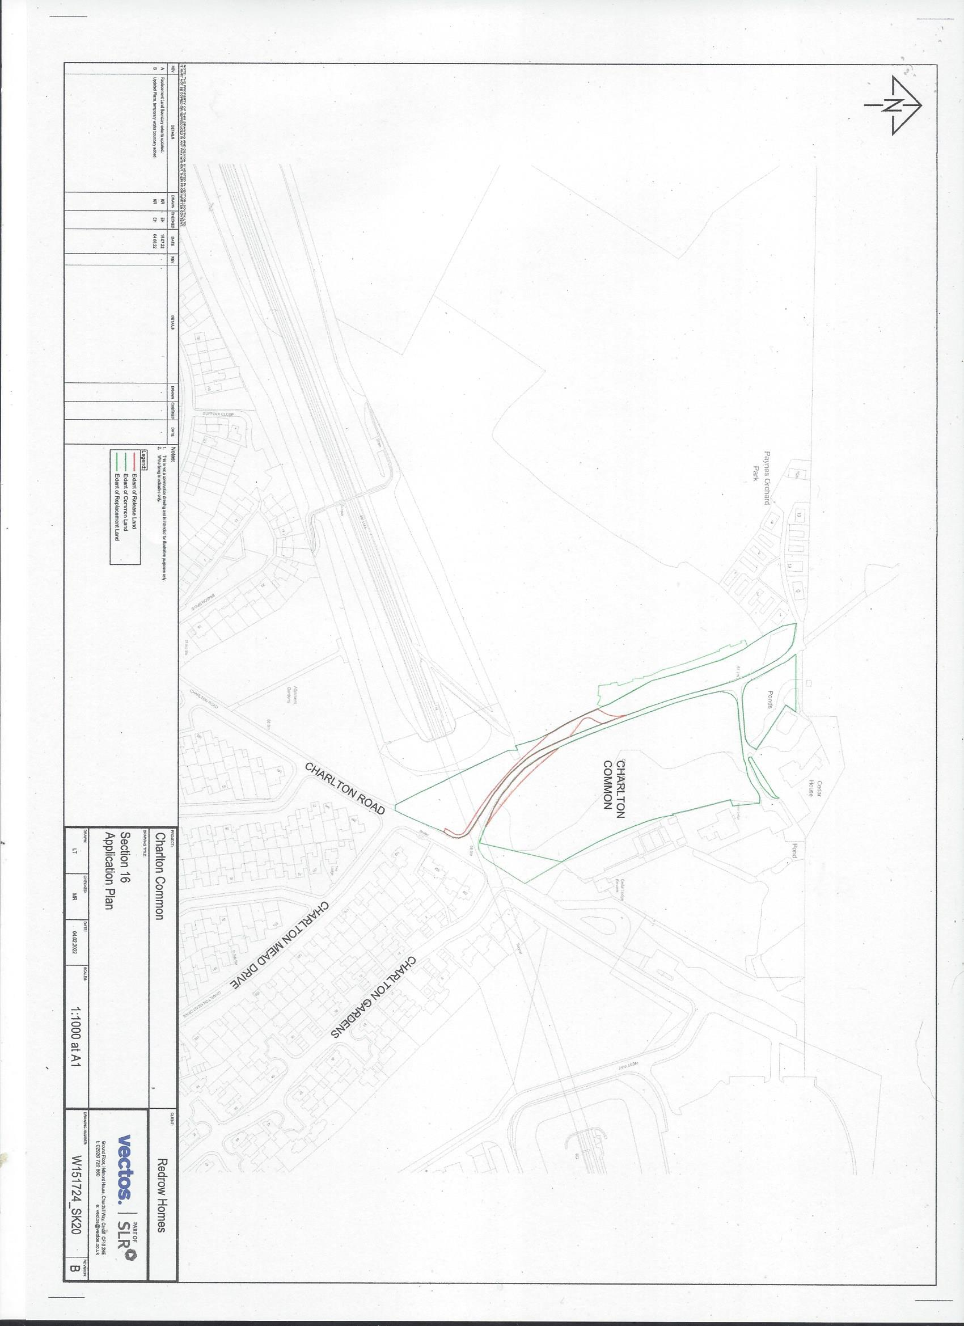

APPENDIX: Plan 2

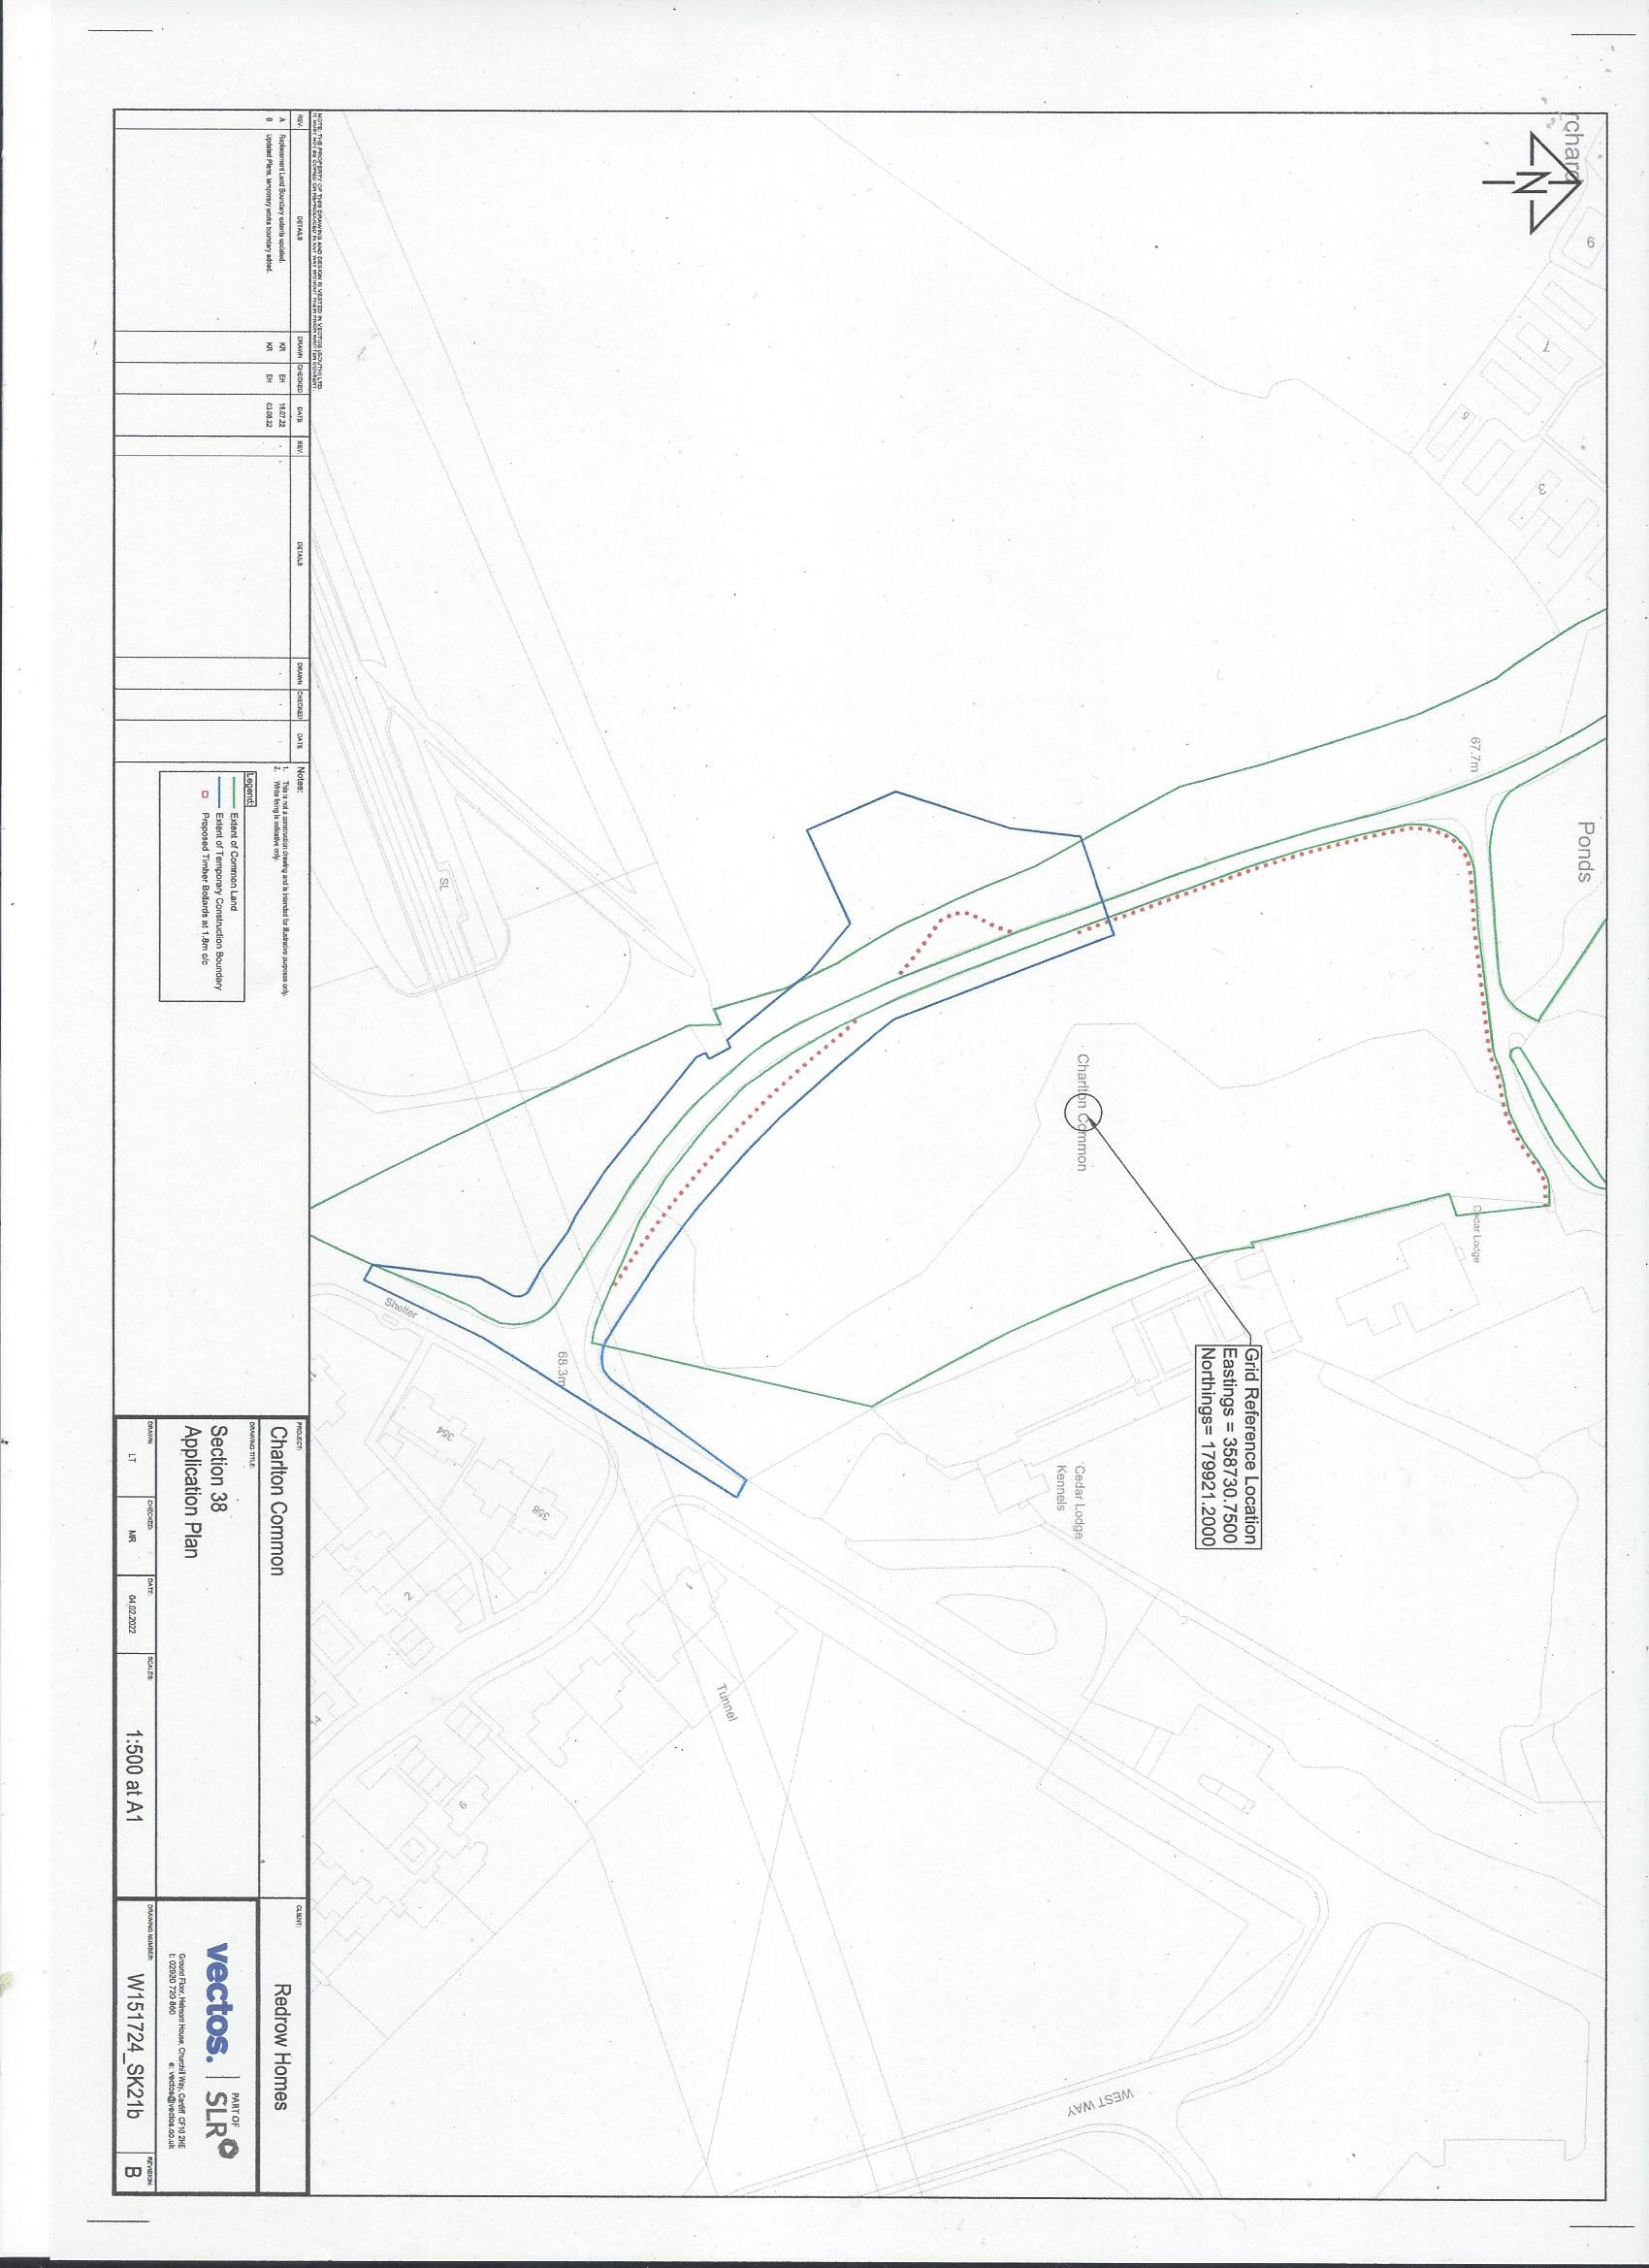Plan 2

