

CORPORATE
PLAN
2022 – 2025



Contents

Chief Executive Officer’s Foreword 3
Our Vision 4
Mission Statement 5
Who We Are 5
What We Do 5
How We Work 7
Our Values 6
Our Governance 8
b. NSO Executive 8
c. NSbS Board 8
d. Shipbuilding Enterprise for Growth 8
Who We Work With 11
Our Definition of the UK Shipbuilding Enterprise 10
Achievements 21

Chief Executive Officer’s Foreword

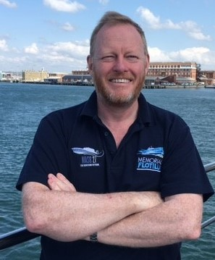
The last 12 months has seen some significant milestones for the UK shipbuilding enterprise. On 10 March 2022, the publication of the National Shipbuilding Strategy (NSbS) Refresh was announced by the Prime Minister and Shipbuilding Tsar. The strategy sets out the Government’s commitments to the entire UK shipbuilding enterprise and the rich supply chain that underpins it. Not only is this an ambitious strategy, but one that reflects well over £4bn of investment in UK shipbuilding over the next three years alone. It is the product of significant work from several Government Departments and developed in close collaboration with industry and other organisations, but it has been worth it. However, while the publication of the strategy marks a significant milestone, it is by no means the end-point as we seek to create a globally successful, innovative and sustainable UK shipbuilding enterprise. In all my discussions with industry, I am heartened by the positive response it has received, but the challenge is that we must now deliver.

The first step to delivering the strategy was to put in place the organisational structures needed. That is why, well ahead of publication, the National Shipbuilding Office (NSO) was announced by the Shipbuilding Tsar in September 2021 at London International Shipping Week. We reached Full Operating Capability in December 2021; the NSO is now up and running. Similarly, the Department for International Trade’s Maritime Capability Campaign Office (MCCO) is now operational and supporting valuable maritime exports. In addition to the NSO’s creation, the strategy set out our new governance approach to shipbuilding and this too is now firmly in place. We have held inaugural meetings with the Shipbuilding Inter-Ministerial Group (IMG), Shipbuilding Enterprise for Growth (SEG) and NSbS Board. These are critical to our success, demonstrating real Ministerial and senior official buy-in and drive together with the shared Government and industry focus on action that comes through the newly formed SEG. And, as we emerge from COVID-19, the NSO has been busy getting out on the ground and visiting the sector whom we are working to deliver the shared vision set out in the National Shipbuilding Strategy.

As we are all aware, publication is far from the final step, and we now have great expectations placed upon us. Collectively, we have been tasked to successfully deliver the implementation of the NSbS Refresh and this corporate plan sets out clearly how we will deliver our vision for the shipbuilding enterprise. It focuses not only on what we will do, but how we will measure our success, how we will work and our approach.

Looking forwards, the NSO will firmly establish our footprint and become the clear focal point in Government for all issues related to shipbuilding. We will continue to work across Government and industry to deliver the strategy and to ensure the 30-year cross-Government pipeline contributes to achieving the overall ambition of the strategy. We will work closely with industry to seize opportunities and to overcome barriers and embrace the ambition we have set out here and in the NSbS Refresh. It is only with all stakeholders engaged, committed and working cooperatively that we will be able to truly reinvigorate UK shipbuilding.

I recognise this will involve a considerable commitment from the NSO, our colleagues across Government, and from all those in our shipbuilding enterprise, but I am certain that collectively we will be able to achieve the high expectations placed on us.

Rear Admiral Rex Cox
Chief Executive Officer, National Shipbuilding Office

The Corporate Plan

This Corporate Plan sets out the planned activity and ways of working for the NSO as we deliver the NSbS ambition. The Plan covers the period 2022 – 2025.

Our Vision

The graphic below sets out “Our Vision for the Shipbuilding Enterprise” and identifies some of the key activities that we will be carrying out to deliver the strategy. Details of specific workstreams and targets are included within the NSbS Refresh which is available at:
www.gov.uk/government/publications/refresh-to-the-national-shipbuilding-strategy
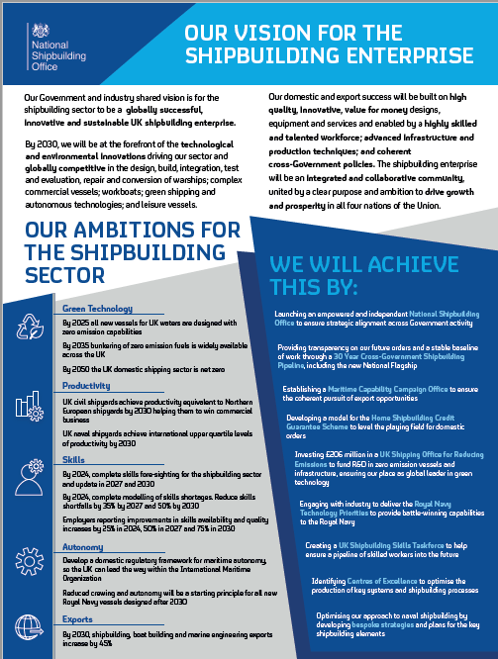

Mission Statement

The NSO will drive transformative change, with strategic oversight of all the Government's interests in UK shipbuilding. Working in partnership across the enterprise, we will collaboratively support growth in the sector to encourage innovation, nurture skills, improve productivity and drive international competitiveness.

Who We Are

The NSO was established in September 2021 to galvanise and promote the UK’s shipbuilding enterprise. The NSO drives transformative change to empower a globally successful, innovative and sustainable shipbuilding sector that works for all parts of the UK. The NSO is made up of a multi-disciplinary team of Civil Servants, Armed Forces Personnel and Industry Secondees, who provide expertise, advice and support to our stakeholders and the wider shipbuilding community.

NSO Structure

Below is a high-level diagram of our structure showing the breadth of our team and role within the sector.

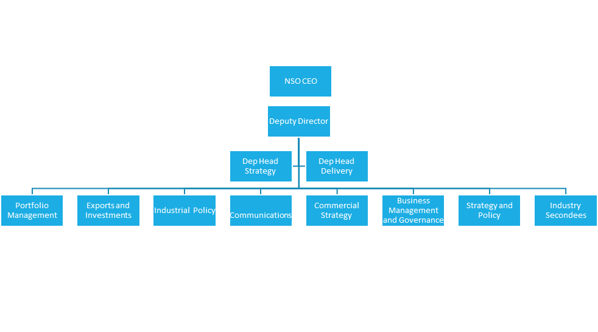

What We Do

We oversee all of the Government's interests in UK shipbuilding, support growth in the sector, and work with industry to improve productivity and competitiveness.

We are responsible for driving forward one of the Government’s key domestic priorities, working in close collaboration with sector industrial partners and the wider supply chain.​

Our mandate includes the design; build; integration; test and evaluation; repair; refit; conversion; and support of warships; commercial vessels; workboats; leisure vessels; systems and sub-systems.

Our Values

The NSO’s values underpin the way the NSO operates as an organisation and as individuals. These values guide our behaviours and they should be reflected in our stakeholders’ experiences of working with us.

How We Work

Building upon our Values, the NSO Ways of Working Charter sets out our commitment to creating a positive, respectful, and productive working environment. We acknowledge that our staff have varied approaches to how they thrive at work, and this charter aims to provide a clear set of guidelines that allow all of us to work to our full potential.

As an organisation, the NSO abides by the following commitments within our Ways of Working Charter:

Our Governance

The Secretary of State for Defence in their role as the Shipbuilding Tsar has Ministerial responsibility for the NSO and oversees all of the UK government’s interests in UK shipbuilding. This section describes the main governance under pinning the NSO’s delivery of the NSbS Refresh.​

Shipbuilding Inter-Ministerial Group
The Shipbuilding Inter-Ministerial Group (IMG) is chaired by the Shipbuilding Tsar and attended by Secretaries of State and Ministers with portfolios relevant to the UK shipbuilding enterprise. It is a mechanism to escalate issues to the Tsar and for action to be taken. It provides Ministerial oversight of the NSbS and promotes a collaborative approach to addressing opportunities and challenges in the UK’s Shipbuilding enterprise.

NSbS Board
The NSbS Board is chaired by the CEO of the NSO and is comprised of senior officials from relevant cross-government Departments and encompasses all the UK Government’s interests in UK shipbuilding, whilst acknowledging the dependencies with activity in other sectors of the shipbuilding enterprise. The core focus of the board is on decisions around the development and delivery of the NSbS and any future publications.

Shipbuilding Enterprise for Growth
The Shipbuilding Enterprise for Growth (SEG) is a joint Government and Industry Board, co-chaired by the CEO of the NSO and a senior representative of the UK shipbuilding enterprise, with membership from across the shipbuilding sector, supply chain and Government. An integrated community, it supports Government and Industry joint working and action to implement the NSbS Refresh. Its initial priorities are to identify actions to improve productivity and competitiveness through technology, innovation, supply chain and skills development.

NSO Executive
The NSO Executive is the senior leadership body of the NSO, responsible for the effective operation of the organisation and ensuring delivery against its strategic objectives. It is comprised of the CEO and Deputy Director of the NSO and the Senior Independent Non-Executive Director. It will be held to account through the NSO Sponsor Board (Performance and Risk Review).

NSO Sponsor Board
The NSO Sponsor Board (Performance and Risk Review) is the mechanism to hold to account the NSO Senior Leadership for business performance and delivery, as well as a forum to discuss risks and escalate issues. It is chaired by the NSO’s Sponsor, a senior official from the Host Department of the NSO (the MOD).

A diagram of how these groups interact to form our overall governance framework is shown overleaf.

Our Definition of the UK Shipbuilding Enterprise

This graphic is intended to represent the geographical breadth of the UK shipbuilding enterprise, and the range of sub-sectors and activities that fall within our definition of the term “shipbuilding enterprise.” It demonstrates the breadth of the NSO’s remit.

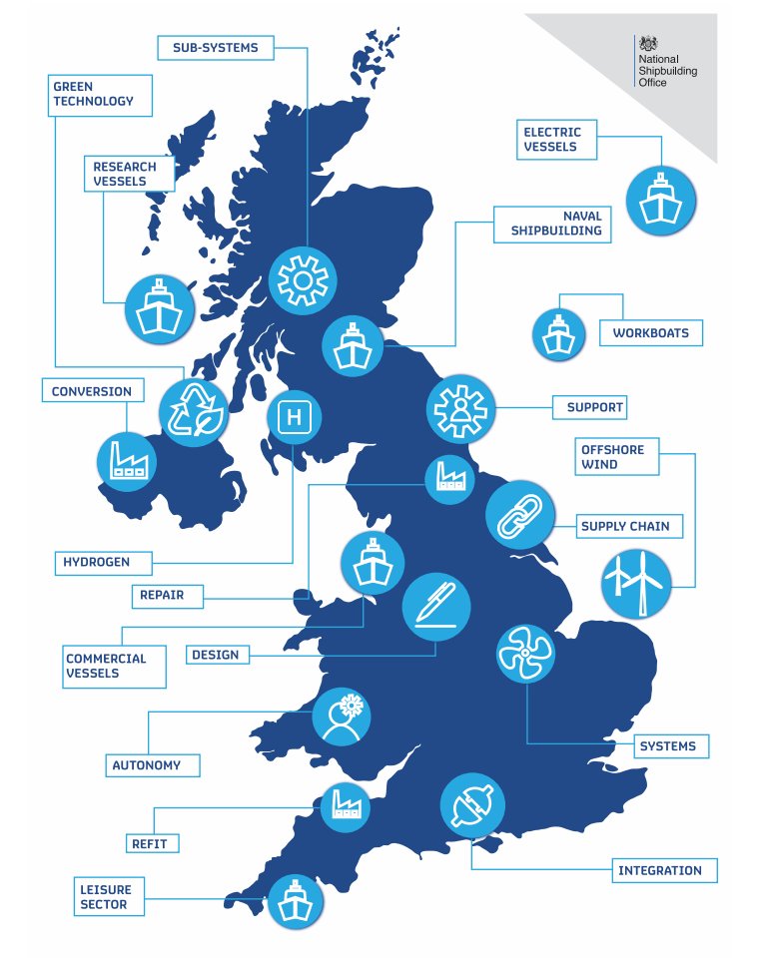

Who We Work With

Given our broad remit, the NSO must work collaboratively with stakeholders across the enterprise.

The NSO coheres the shipbuilding-related activity of other Government Departments including Business Energy and Industrial Strategy (BEIS), Department for Interntional Trade (DIT) through its export arm the Maritime Capability Campaign Office (MCCO), Department for Transport (DfT), Department for Eduation (DfE), Department for Enviroment Food & Rural Affairs (DEFRA), Foreign and Commonwealth Development Office (FCDO), Home Office, Cabinet Office, and HM Treasury, in addition to the Devolved Administrations. This patnership is underpinned by the NSO Memorandum of Understanding (MOU) which was agreed in October 2021.

Industry stakeholders include the UK’s shipbuilders and companies across the extensive national supply chain as well as the wider sector associations, Trade Unions and academia.

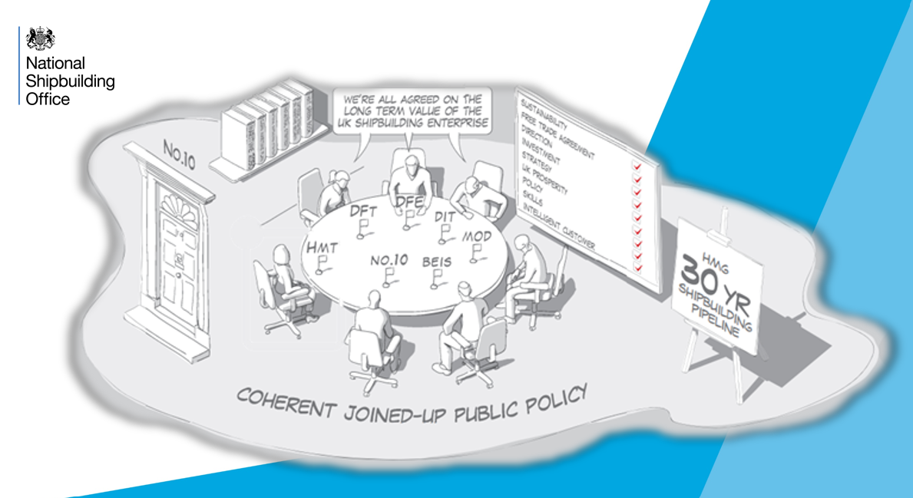

Objectives 2022-2025

The NSO objectives encompass not only direct deliverable objectives but also wider corporate and enabling objectives

The NSO's 6 high level objectives for the period 2022-2025
1. Ensure that the UK shipbuilding sector is provided with a clear cross-Government shipbuilding demand signal and that Government shipbuilding programmes support the policy objectives of the NSbS Refresh.
2. Work with industry and across Government to improve the productivity and competitiveness of the UK shipbuilding sector, including meeting the sector’s skills needs
3. Support investment in R&D and technology, particularly clean maritime technology, autonomy and advanced manufacturing technology
4. Improve access to competitive finance packages and ensure coherent export support for the UK shipbuilding sector
5. Creating an empowered and diverse workforce of high performing individuals
6. Providing value for money by delivering excellence, making best use of resources, ensuring appropriate governance and demonstrating the principals of "Managing Public Funds"

Strategy Objectives

Demand Signal and Policy
Objective 1 – Ensure that the UK shipbuilding sector is provided with a clear cross-Government shipbuilding demand signal and that Government shipbuilding programmes support the policy objectives of the NSbS Refresh. | Sub-objective 1a – Oversee the 30 Year Cross-Government Shipbuilding Pipeline and update it at each multi-year spending review.  Sub-objective 1b – Work with shipbuilding project teams across Government to ensure programmes support the NSbS policy objectives wherever possible.  Sub-objective 1c – Work with the MOD and industry to develop bespoke strategies for each sub-sector of the naval shipbuilding sector.  Sub-objective 1d – Work with Government and Industry to identify and cohere the opportunities for the UK shipbuilding enterprise in off-shore energy.
Cross-Government /Civil Service Priorities | Levelling Up  Net Zero  Strengthening the Union
Some of the key activities we will undertake to meet this objective include:

30 Year Cross-Government Shipbuilding Pipeline
The NSbS Refresh sets out the Government demand signal through the 30-Year Cross Government Shipbuilding Pipeline, one of the most significant mechanisms available to Government to shape the shipbuilding sector. The Pipeline includes over 150 new vessels from across the UK Government, with contributing Departments including the MOD, BEIS, the Home Office, DfT, Defra and the Devolved Administrations. The vessels range from large warships to research vessels, ferries, auxiliaries , and tugs. Through the Government Pipeline, there is an opportunity to encourage industry investment in facilities, infrastructure, innovation and skills. The NSO will oversee this pipeline, working with Departments across Government to maximise the opportunities for industry against UK industrial capacity, within our international and legal obligations. As the Pipeline spans a 30-year period, it is subject to change and will be agreed through future Spending Reviews. The NSO will update this pipeline at each multi-year Spending Review

Bespoke strategies for each sub-sector of the naval shipbuilding sector
The NSbS Refresh highlighted that as the Royal Navy moves from a platform-based approach to a more systems-based one, the MOD's approach to the shipbuilding sector must adapt too. The NSO will therefore work with the MOD to develop bespoke strategies for the main segments of the naval shipbuilding enterprise, including design and engineering, fabrication and manufacturing, and integration and commissioning. The Type 32 frigate programme will be used as path-finder for this activity.

Off-shore energy opportunities for the UK shipbuilding enterprise
The Government’s Ten Point Plan for a Green Industrial Revolution sets out the intent to quadruple the UK’s offshore wind capacity by 2030 so that we are producing 40GW of offshore wind energy, including 1GW from floating offshore wind. With the global offshore renewable energy market growing, there is a significant requirement for crew transfer vessels and service operation vessels to support these offshore installations. The NSO, working with BEIS and industry stakeholders, will explore how the UK shipbuilding sector can capitalise on this opportunity.

Shipbuilding Productivity and Skills
Objective 2 – Work with industry and across Government to improve the productivity and competitiveness of the UK shipbuilding sector, including meeting the sector’s skills needs. | Sub-objective 2a – Support the Shipbuilding Enterprise for Growth (SEG) and its Task and Finish Groups to identify and act upon opportunities to improve productivity and competitiveness.  Sub-objective 2b – Work with the Department for Education to ensure the activity of the UK Shipbuilding Skills Taskforce is aligned with the SEG and support the Taskforce to identify solutions to address the sector’s skills needs.  Sub-objective 2c – Develop a vibrant supply chain ecosystem for the entire shipbuilding enterprise.
Cross Government /Civil Service Priorities | Levelling Up  Net Zero  Strengthening the Union  Education Jobs and Skills

Some of the key activities we will undertake to meet this objective include:

Shipyard of the Future
Working with the SEG T&FG support the development of the model for the Shipyard of the Future. This will be a modern, efficient shipyard which draws on advanced manufacturing technologies, like robotics and automation, and is digitally integrated with the broader supply chain. providing a benchmark for UK shipyards to understand where investment should be prioritised. Once the model is complete, the NSO will work with shipyards and potential investors to understand how Government procurement programmes can support the realisation of the Shipyard of the Future.

Centres of Excellence
One of the initial priorities for the SEG is to identify priority areas of the shipbuilding enterprise where the development of Centres of Excellence could deliver benefits. These should focus on areas where the UK shipbuilding enterprise already has particular strengths, as well as areas where consolidation would help to improve overall competitiveness. The SEG has established a Task and Finish Group to lead this activity.

Strengthen the Supply Chain
Develop a vibrant supply chain ecosystem for the entire shipbuilding enterprise. As part of the core delivery programme, working closely with HM Government procurement teams to understand how their programmes can create opportunities for the UK shipbuilding supply chain and encourage investment in R&D at all levels. The NSO will work with industry to identify where specific interventions for systems and sub-systems, such as Centres of Excellence, could strengthen the UK shipbuilding enterprise further.

UK Shipbuilding Skills Taskforce
One of the most critical enablers of a thriving UK shipbuilding enterprise will be a highly skilled and motivated workforce who will support our industry to become more innovative, productive and ultimately more competitive. Led by DfE and working closely with the NSO, a UK Shipbuilding Skills Taskforce has been established to work collaboratively across Government, the Devolved Administrations, industry and training providers to develop and implement a future-focussed skills strategy. The Taskforce will build a picture of industry’s skills needs and provide solutions to skills shortages, particularly those related to new and emerging technologies.

Research & Development (R&D) and Technology
Objective 3 – Support investment in R&D and technology, particularly clean maritime technology, autonomy and advanced manufacturing technology | Sub-objective 3a – Supporting the Department for Transport (DfT) to develop and deliver the £206m investment in the UK Shipping Office for Reducing Emissions to address the barriers to investment in clean maritime technologies.  Sub-objective 3b – Work with shipbuilding programme teams, particularly the Royal Navy, to ensure technology priorities for future platforms can be met by the UK shipbuilding sector.  Sub-objective 3c – Work with UK Research and Innovation to promote existing opportunities to the UK shipbuilding sector and to develop new ones to ensure the shipbuilding sector can achieve maximum benefit.
Cross-Government /Civil Service Priorities | Levelling Up  Net Zero  Strengthening the Union  Education Jobs and Skills

Some of the key activities we will undertake to meet this objective include:

Green Maritime
As set out in the NSbS, the NSO will establish a dedicated Green Maritime Technology Forum that will help to identify, analyse, plan and execute the steps required to reach maritime decarbonisation targets. We will ensure alignment of Government shipbuilding programmes to the UK Shipping Office for Reducing Emission’s Clean Maritime Demonstration Competitions so that they benefit the shipbuilding enterprise and encourage join up within the enterprise. Working with DfT the NSO will help develop a suite of interventions such as the Office for Zero Emission Vehicles and the Future Fuels for Flight and Freight Competition, transforming the UK into a global leader in the design, manufacture, and operation of clean maritime technology.

Innovation and Technology
Innovation and Technology will be supported, through the NSO, by Government as a customer. We will work to ensure alignment of the 30-Year Cross-Government Pipeline with our technology and innovation priorities, such as advanced manufacturing, green and autonomy. The NSO will develop a future SR bid for a shipbuilding manufacturing innovation fund informed by the Shipyard of the Future T&FG. The NSO will work across the shipbuilding enterprise to ensure the innovation and technology ambitions of the strategy are realised, including greater coherence and collaboration within the shipbuilding enterprise.

Promoting existing opportunities
The NSO will work with BEIS, Innovate UK, UKRI and DfT to encourage the uptake of the existing innovation support measures by the shipbuilding enterprise and better utilisation of place-based programmes and the catapult network. The NSO will also work with stakeholders to ensure accessibility for shipbuilding is considered and that these support the vision of the Refresh.

Export and Finance
Objective 4 – Improve access to competitive finance packages and ensure coherent export support for the UK shipbuilding sector | Sub-objective 4a – Work with the Department for International Trade’s Maritime Capability Campaign Office (MCCO) to ensure coherent and targeted Government support for maritime export and inward investment opportunities.  Sub-objective 4b – Work with the MCCO, UK Exports and Finance (UKEF) and Shipbuilding Enterprise for Growth (SEG) to ensure UK Export Finance offers meet the needs of the UK shipbuilding sector.  Sub-objective 4c – Work with the Department for Business Energy and Industrial Strategy to promote the Home Shipbuilding Credit Guarantee Scheme and ensure it meets the needs of UK shipbuilding customers and industry.
Cross-Government /Civil Service Priorities | Levelling Up  Net Zero  Strengthening the Union  Education Jobs and Skills  Global Britain

Some of the key activities we will undertake to meet this objective include:

Establish the Maritime Capability Campaign Office
DIT have recently launched the MCCO. The MCCO acts as the export arm of our organisation, helping to ensure the coherent pursuit of export opportunities. One of the key success criteria for the MCCO will be to ensure that Industry & UK Government work together to build and share understanding of the market, identifying long-term opportunities to strategically position the UK for improved success and matching shorter-term opportunities for requirements to UK.

Home Shipbuilding Credit Guarantee Scheme
The Home Shipbuilding Credit Guarantee Scheme is a new government-backed credit guarantee scheme, which will help stimulate the UK’s shipbuilding industry by helping UK shipowners and operators access finance to place orders to buy new vessels and refit, retrofit and repair existing ones at UK shipyards. It will guarantee a portion of the value of loans used to purchase new vessels or refit, retrofit or repair existing ones, sharing the risk with lenders to encourage offers of finance to UK vessel owners and operators. The scheme is led by BEIS and will be delivered by UKEF. The NSO is supporting the development and launch of the scheme, as well as engaging with UK shipyards and customers who may be beneficiaries.

Establishing our Organisation
Objective 5 – Creating an empowered and diverse workforce of high performing individuals | Sub-objective 5a – Expand and develop the knowledge and skills base of the NSO team ensuring ongoing development.  Sub-objective 5b – Ensure that all members of the NSO support the NSO Ways of Working.  Sub-objective 5c – Creating an NSO Edinburgh office ensuring our presence is spread across the UK, and in a location to support the Maritime Enterprise in Scotland.
Cross-Government /Civil Service Priorities | Strengthening the Union  Education Jobs and Skills  Levelling Up

Some of the key activities we will undertake to meet this objective include:

Establishing our Footprint
The NSO will establish a footprint across government and industry. Our team will use their knowledge and experience of working across government and industry to establish and build relationships with our stakeholders. This will be one of the first steps to enable us to drive our mandate for transformative change across the shipbuilding enterprise.

Learning and Development Group
The NSO team support the learning and development of team members through line management support and the Learning and Development Group, who ensure access to diverse and bespoke training is highlighted and available to team members.

Edinburgh Office
The NSO will utilise office space in Queen Elizabeth House (QEH) in Edinburgh allowing us to be engage with the wide range of Scottish shipyards and supply chain companies and with their pipeline activity as well as with the Devolved Administration.

Delivering Value for Money
Objective 6 – Providing value for money by delivering excellence, making best use of resources, ensuring appropriate internal governance and demonstrating the principals of “Managing Public Money” | Sub-objective 6a – Ensure that the NSO is fully resourced and that resources are utilised to maximum effect.  Sub-objective 6b – Manage effective and positive relationships with the MOD sponsor.  Sub-objective 6c – Implement the Memorandum of Understanding (MOU) delivering effective partnership working arrangements between the NSO, other relevant Whitehall Departments and Government shipbuilding structures.  Sub-objective 6d – Establishing robust governance and reporting frameworks.
Cross-Government /Civil Service Priority | Value for public money – principles of managing public money  Strengthening the Union  Education Jobs and Skills

Some of the key activities we will undertake to meet this objective include:

Portfolio Management
The Portfolio Management team provide valuable Management Information tracking the delivery of the NSbS Refresh, identifying dependencies, risks and issues and providing trend analysis across the remit of the strategy.

Internal Governance
The NSO is an independent team who are hosted by the MOD and as such we are bound by wider MOD policies and procedures. Our MOU details our partnership with our Sponsor, and as such we feed into the wider departmental reporting arrangements.

Resource Management
As a new department the NSO are closely monitoring and reviewing resource allocation to ensure we deliver value for money feeding into the MOD for Budget management reporting and strategic workforce planning, making sure succession plans are in place for post rotations, and recruitment is on time and processes are followed.

Achievements

From the creation of the NSO in September 2021 (end Quarter 2 2021/2022), the NSO has worked with partners and stakeholders to make the following notable achievements, which are the first strides towards delivery of the strategy and achieving our goals.

Quarter 3 2021/2022 | The NSO was launched by the Shipbuilding Tsar on board HMS Albion.
Quarter 3 2021/2022 | The NSO has developed and published a comprehensive 30-Year Cross Government Shipbuilding Pipeline as part of the development of the NSbS Refresh. This expanded Pipeline sets out the Government demand signal and includes over 150 new vessels from across the UK Government and the Devolved Administrations. The vessels range from large warships to research vessels, auxiliaries and tugs.
Quarter 3 2021/2022 | NSO MOU agreed and endorsed at the Inter-Ministerial Group.
Quarter 3 2021/2022 | NSO performing at full operating capability.
Quarter 3 2021/2022 | The Prime Minister commissioned a refresh of the NSbS, focusing on commercial opportunities, particularly green shipping, and all parts of the shipbuilding enterprise.
Quarter 3 2021/2022 | The NSbS Board was formed, with the inaugural board held. This was attended by representatives across government.
Quarter 4 2021/2022 | The NSbS Refresh was published and set out the conditions for the transformative change required to meet our bold ambition for the shipbuilding industry. ​
Quarter 4 2021/2022 | The SEG was formed, and the inaugural meeting held. Co-chaired by the CEO of the NSO and a senior industry executive, with membership from across the shipbuilding sector, supply chain and Government.
Quarter 4 2021/2022 | First Cross-Government Shipbuilding Pipeline Contact Group held, to ensure the shipbuilding pipeline is considered in the context of the wider cross government shipbuilding portfolio.
Quarter 4 2021/2022 | We have collaborated with BEIS on the development of the Home Shipbuilding Credit Guarantee Scheme which is due to be introduced in by the end of 2022 This will help to level the playing field for domestic shipbuilding orders, which will complement the working capital and buyer credits provided by UKEF.
Quarter 4 2021/2022 | The UK Shipbuilding Skills Taskforce was launched by the DfE. This taskforce will work collaboratively across Government, the Devolved Administrations, industry and training providers to develop and implement a future-focussed skills strategy.

