Committee on Standards in Public Life

Room G07
1 Horse Guards Road
London
SW1A 2HQ

William Shawcross CVO
Commissioner for Public Appointments

By email

29 November 2022
Dear William,

Many thanks for talking to the Committee last week. We greatly appreciate you giving us your perspective on your first year as Commissioner.

You kindly said that you would come back to us on the question of whether any particular categories of appointments are more subject to delays than others.

There were a few areas that we didn’t have the chance to discuss at the meeting and the Committee would be grateful for your views.

- The importance of maintaining an independent element on advisory assessment panels - how have you found this is working in practice?

- In our 2021 Upholding Standards in Public Life report, we recognised that in certain circumstances it may be appropriate for appointments to be unregulated e.g. heads of short-term policy reviews or some tsars or envoys. But we found there is a lack of transparency about the number and nature of unregulated appointments which makes it difficult to judge the influence unregulated appointees have over public policy. We therefore recommended that government departments should publish a list of all unregulated and regulated appointments? We would be interested to know your views.

- In the same report, while we said that we believe ministers should not appoint candidates that panels deemed unappointable, we believed the final decision on all public appointments must ultimately remain with ministers. However, we recommended that, if ministers went ahead and appointed a candidate deemed unappointable by an assessment panel, the minister must appear in front of the relevant select committee to justify their decision. Do you have any concerns about Ministers appointing candidates found unappointable by the panel?

I look forward to hearing from you.

With best wishes.

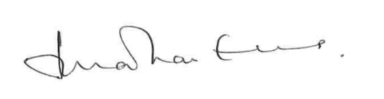
Lord Evans of Weardale KCB DL
Chair, Committee on Standards in Public Life

