NOTICE OF ORDER
Town & Country Planning Act 1990 - S257
Leeds City Council
(Horsforth Public Footpath No. 50) Diversion Order 2021

Notice is hereby given that the above referenced Order has been submitted to the Secretary of State for Environment, Food and Rural Affairs for determination. An Inspector will be appointed by the Secretary of State to determine the Order.

The start date for the above Order is 08 November 2022

Consideration of the Order will take the form of exchanges of statements of case and comments on statements of case.

The effect of the Order, if confirmed without modifications, will be to divert the public footpath commencing from a point, 2360 3836, behind 125 Hall Park Avenue and proceeding for a distance of 141 metres in a north easternly, then an east north easterly, then a south south easterly and finally in a south easterly direction to a point, SE 2370 3835, behind 14 to 22 Church Lane to a new line running between the same points for a distance of 141 metres in an east south easterly, then a south easterly, then a southerly, then a south easterly, and finally a north easterly direction as shown on the Order Map

Any queries relating to this Order should be referred to Clive Richards at The Planning Inspectorate, Rights of Way Section, Room 3/A Eagle Wing, Temple Quay House, 2 The Square, Temple Quay, Bristol, BS1 6PN. Telephone: 0303 4445502. Email: Rightsofway2@planninginspectorate.gov.uk Please quote reference number ROW/3297184 on all correspondence.

Any person wishing to view the statements of case and other documents relating to this Order may do so by appointment at the offices of the Parks and Countryside, Leeds City Council, Farnley Hall, Hall Lane, Farnley, Monday to Friday between 9 am and 4 pm. Contact at Leeds City Council: Tiegan Patrick, Tel: 0345 050 3291, Email: Tiegan.Patrick@freeths.co.uk

Timetable for sending in statements of case and comments

Within 2 weeks of the start date [by 22 November 2022]
The Order Making Authority must ensure their statement of case is received by the Secretary of State. As soon as possible after the deadline, the Secretary of State will send a copy (excluding copies of any supporting documents - these will be available to view at the Authority’s offices) to everyone who has made an objection or representation, the applicant and any other person who has written to us in respect of the Order.

Within 9 weeks of the start date [by 10 January 2023] - (N.B: usually 8 weeks but an extra 7 days have been given due to the Christmas holidays)
Everyone who has made an objection or representation or any other written representation or any other person wishing to make representations in writing must ensure their statement of case is received by the Secretary of State. As soon as possible after the deadline, the Secretary of State will send full copies to the Authority. Copies (excluding copies of any supporting documents - these will be available to view at the Authority’s offices) will also be sent to the applicant, every person who has made an objection or representation and any other person who has written to us in respect of the Order.

Within the same period the applicant (if applicable) must ensure their statement of case is received by the Secretary of State. As soon as possible after the deadline, Secretary of State will send a full copy to the Authority. Copies will also be sent to everyone who has made an objection or representation and any other person who has written to us in respect of the Order (excluding copies of any supporting documents - these will be available to view at the Authority’s offices).

Within 15 weeks of the start date [by 14 February 2023] (N.B: usually 14 weeks)
Everyone who has made an objection or representation, the Authority, the applicant (if applicable) and anyone who has written to us in respect of the Order must ensure that their comments on any or every other statement of case is received by the Secretary of State. As soon as possible after the deadline, the Secretary of State will send copies of these comments to everyone else.

In fairness to the other parties everyone should keep to the timetable to ensure that statements of case and comments are received on time. Late documents will be returned.

We cannot accept any inflammatory, discriminatory or abusive comments. Any documents containing such comments will be returned.

Notice of order for w/r

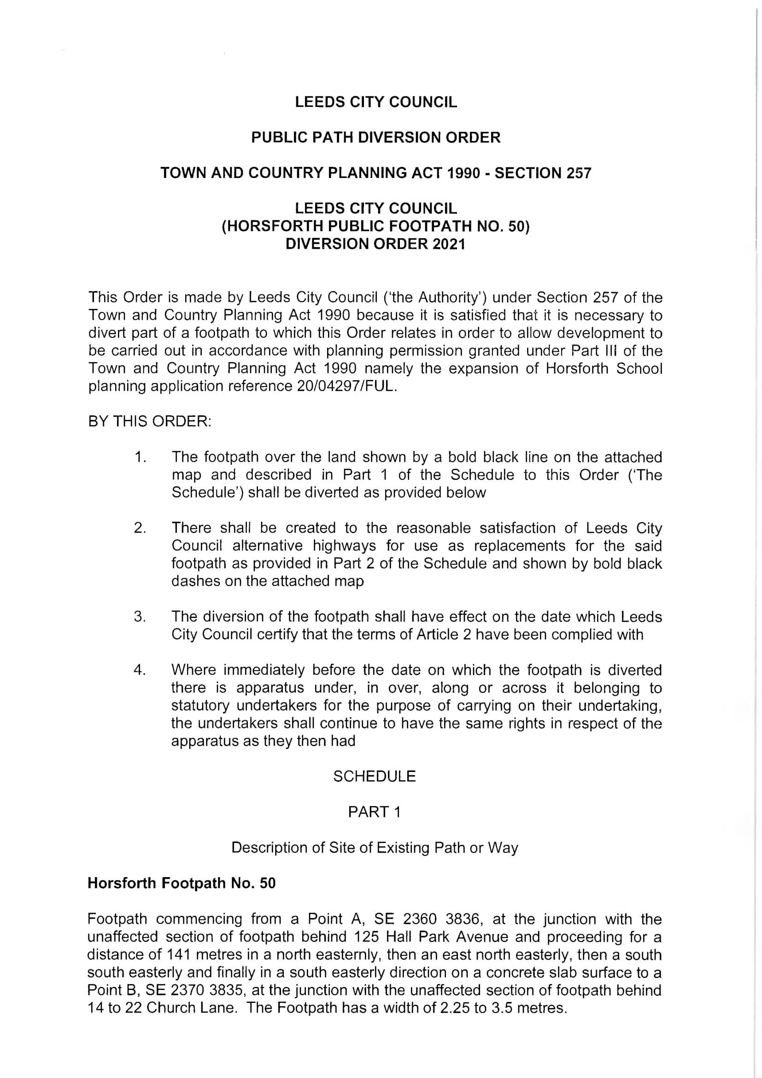

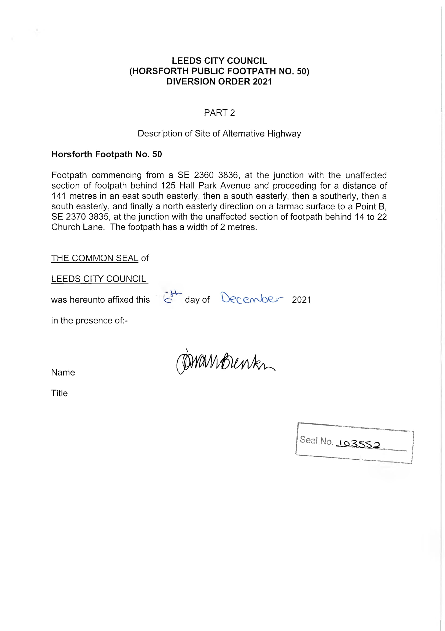

ORDER MAP – COPY NOT TO ORIGINAL SCALE

