NOTICE OF ORDER
Highways Act 1980

North Yorkshire County Council
Public Bridleway No. 20.46/24, Brook House Farm, Middleton Tyas Diversion Order 2021

Notice is hereby given that the above referenced Order has been submitted to the Secretary of State for Environment, Food and Rural Affairs for determination. An Inspector will be appointed by the Secretary of State to determine the Order.

The start date for the above Order is 22 November 2022.

Consideration of the Order will take the form of exchanges of statements of case and comments on statements of case.

The effect of the Order, if confirmed without modifications, will be to divert the Public bridleway described below

Public Bridleway 20.46/24 from the end of the unclassified road at NZ 2394 0657 and running in a generally south-easterly direction for approximately 172 metres to NZ 2405 0645, will be diverted onto a new route running from the unclassified road at NZ 2388 0677 in a northeasterly direction for approximately 150 metres to a bridle gate at NZ 2403 0680, then running in a south-easterly direction for approximately 46 metres to an access track at NZ 2406 0678, then running along the access track in a south-south-east direction for approximately 100 metres to NZ 2408 0667 and continuing for approximately 53 metres into the field at NZ 2408 0662, then running in a south-westerly direction for approximately 125 metres, then turning and running in a south-south-easterly direction for approximately 74 metres to a gap at NZ 2405 0646 and then continuing for approximately 12 metres to its junction with the original route of bridleway 20.46/24 at NZ 2405 0645. Bridle gates will be provided at NZ 2388 0677 and NZ 2403 0680 and bridle gaps at NZ 2406 0678 and NZ 2405 0646. Fencing will be provided to separate the new route from adjoining fields and the surfaces will be a mixture of grass and Type 1 aggregate over a stone base and geotextile membrane.

Any queries relating to this Order should be referred to Clive Richards at The Planning Inspectorate, Rights of Way Section, Room 3/A Eagle Wing, Temple Quay House, 2 The Square, Temple Quay, Bristol, BS1 6PN.
Telephone: 0303 44465502 Email: clive.richards@planninginspectorate.gov.uk or Rightsofway2@planninginspectorate.gov.uk Please quote reference number ROW/3293520 on all correspondence.

Any person wishing to view the statements of case and other documents relating to this Order may do so by appointment at o Richmond Library, Queens Road, Richmond, DL10 4AE between the hours of 10:00am to 17:00pm (Monday to Friday) & 10:00am to 13:00 (Saturday). Council Contact: Mr Steve Metcalfe, Telephone 01609 532244 & Email: steve.metcalfe@northyorks.gov.uk

Timetable for sending in statements of case and comments

Within 2 weeks of the start date [by 06 December 2022]
The Order Making Authority must ensure their statement of case is received by the Secretary of State. As soon as possible after the deadline, the Secretary of State will send a copy (excluding copies of any supporting documents - these will be available to view at the Authority’s offices) to everyone who has made an objection or representation, the applicant and any other person who has written to us in respect of the Order.

Within 8 weeks of the start date [by 17 January 2023]
Everyone who has made an objection or representation or any other written representation or any other person wishing to make representations in writing must ensure their statement of case is received by the Secretary of State. As soon as possible after the deadline, the Secretary of State will send full copies to the Authority. Copies (excluding copies of any supporting documents - these will be available to view at the Authority’s offices) will also be sent to the applicant, every person who has made an objection or representation and any other person who has written to us in respect of the Order.

Within the same period the applicant (if applicable) must ensure their statement of case is received by the Secretary of State. As soon as possible after the deadline, Secretary of State will send a full copy to the Authority. Copies will also be sent to everyone who has made an objection or representation and any other person who has written to us in respect of the Order (excluding copies of any supporting documents - these will be available to view at the Authority’s offices).

Within 14 weeks of the start date [by 28 February 2023]
Everyone who has made an objection or representation, the Authority, the applicant (if applicable) and anyone who has written to us in respect of the Order must ensure that their comments on any or every other statement of case is received by the Secretary of State. As soon as possible after the deadline, the Secretary of State will send copies of these comments to everyone else.

In fairness to the other parties everyone should keep to the timetable to ensure that statements of case and comments are received on time. Late documents will be returned.

We cannot accept any inflammatory, discriminatory or abusive comments. Any documents containing such comments will be returned.

Notice of order for w/r

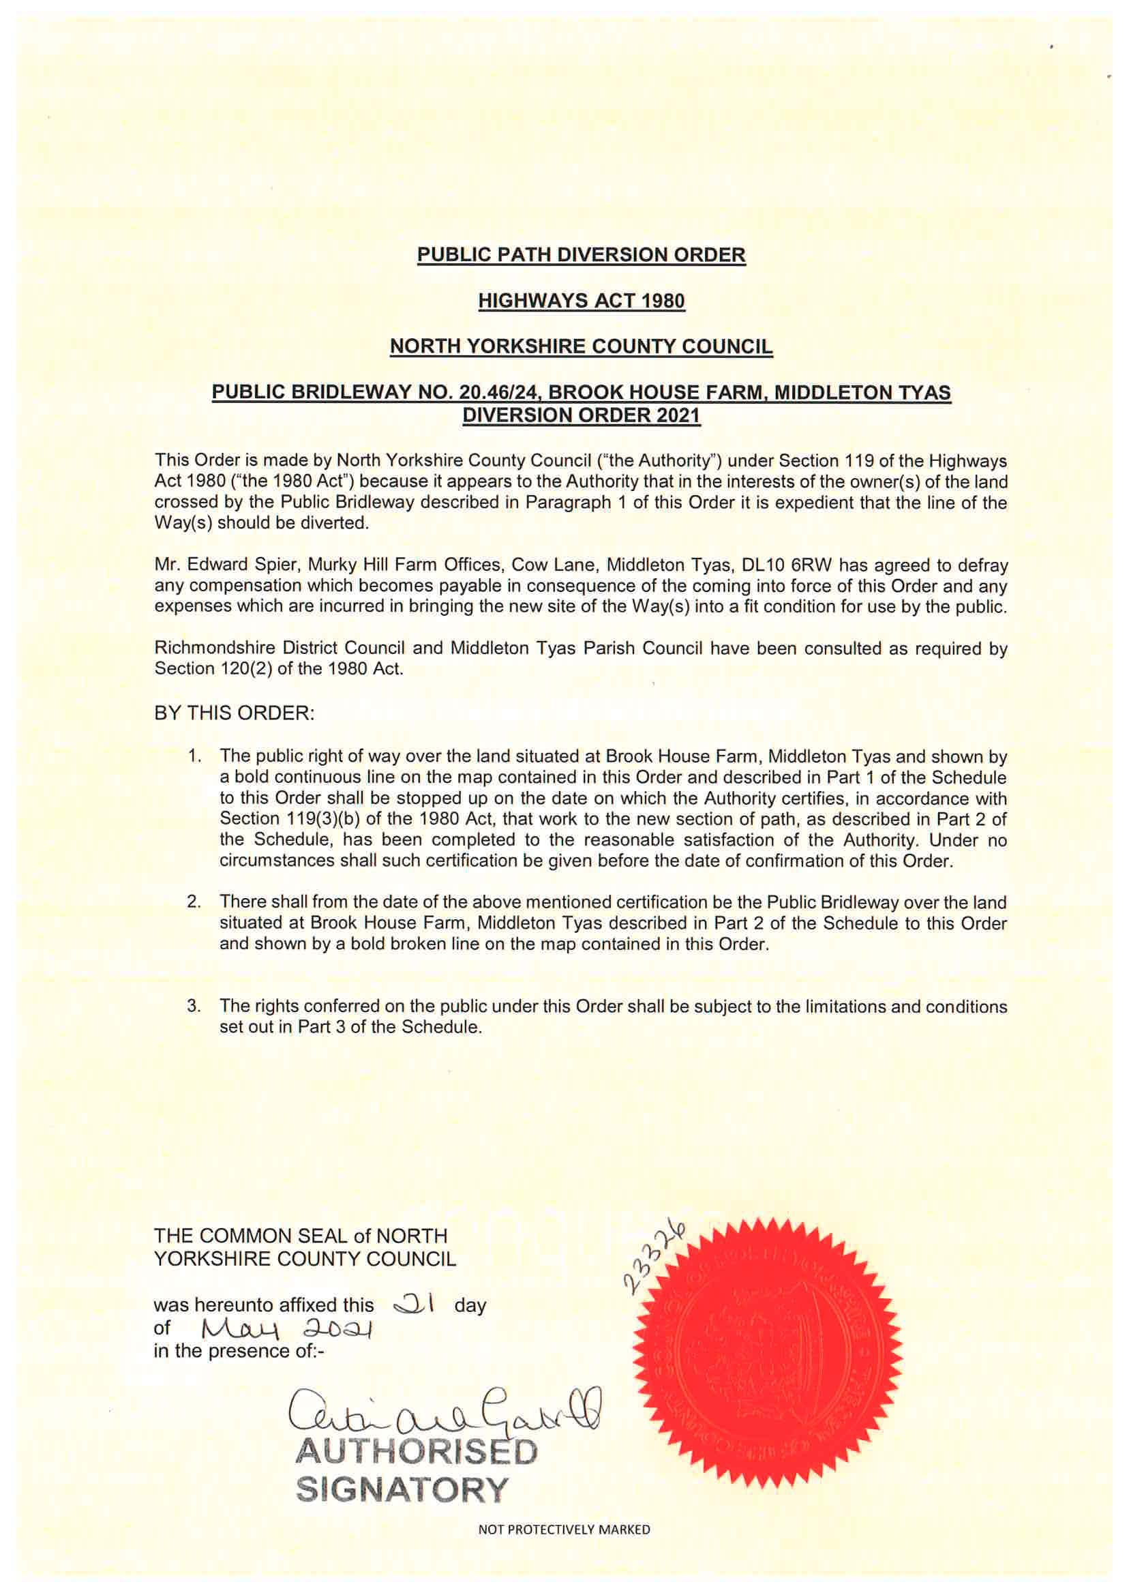
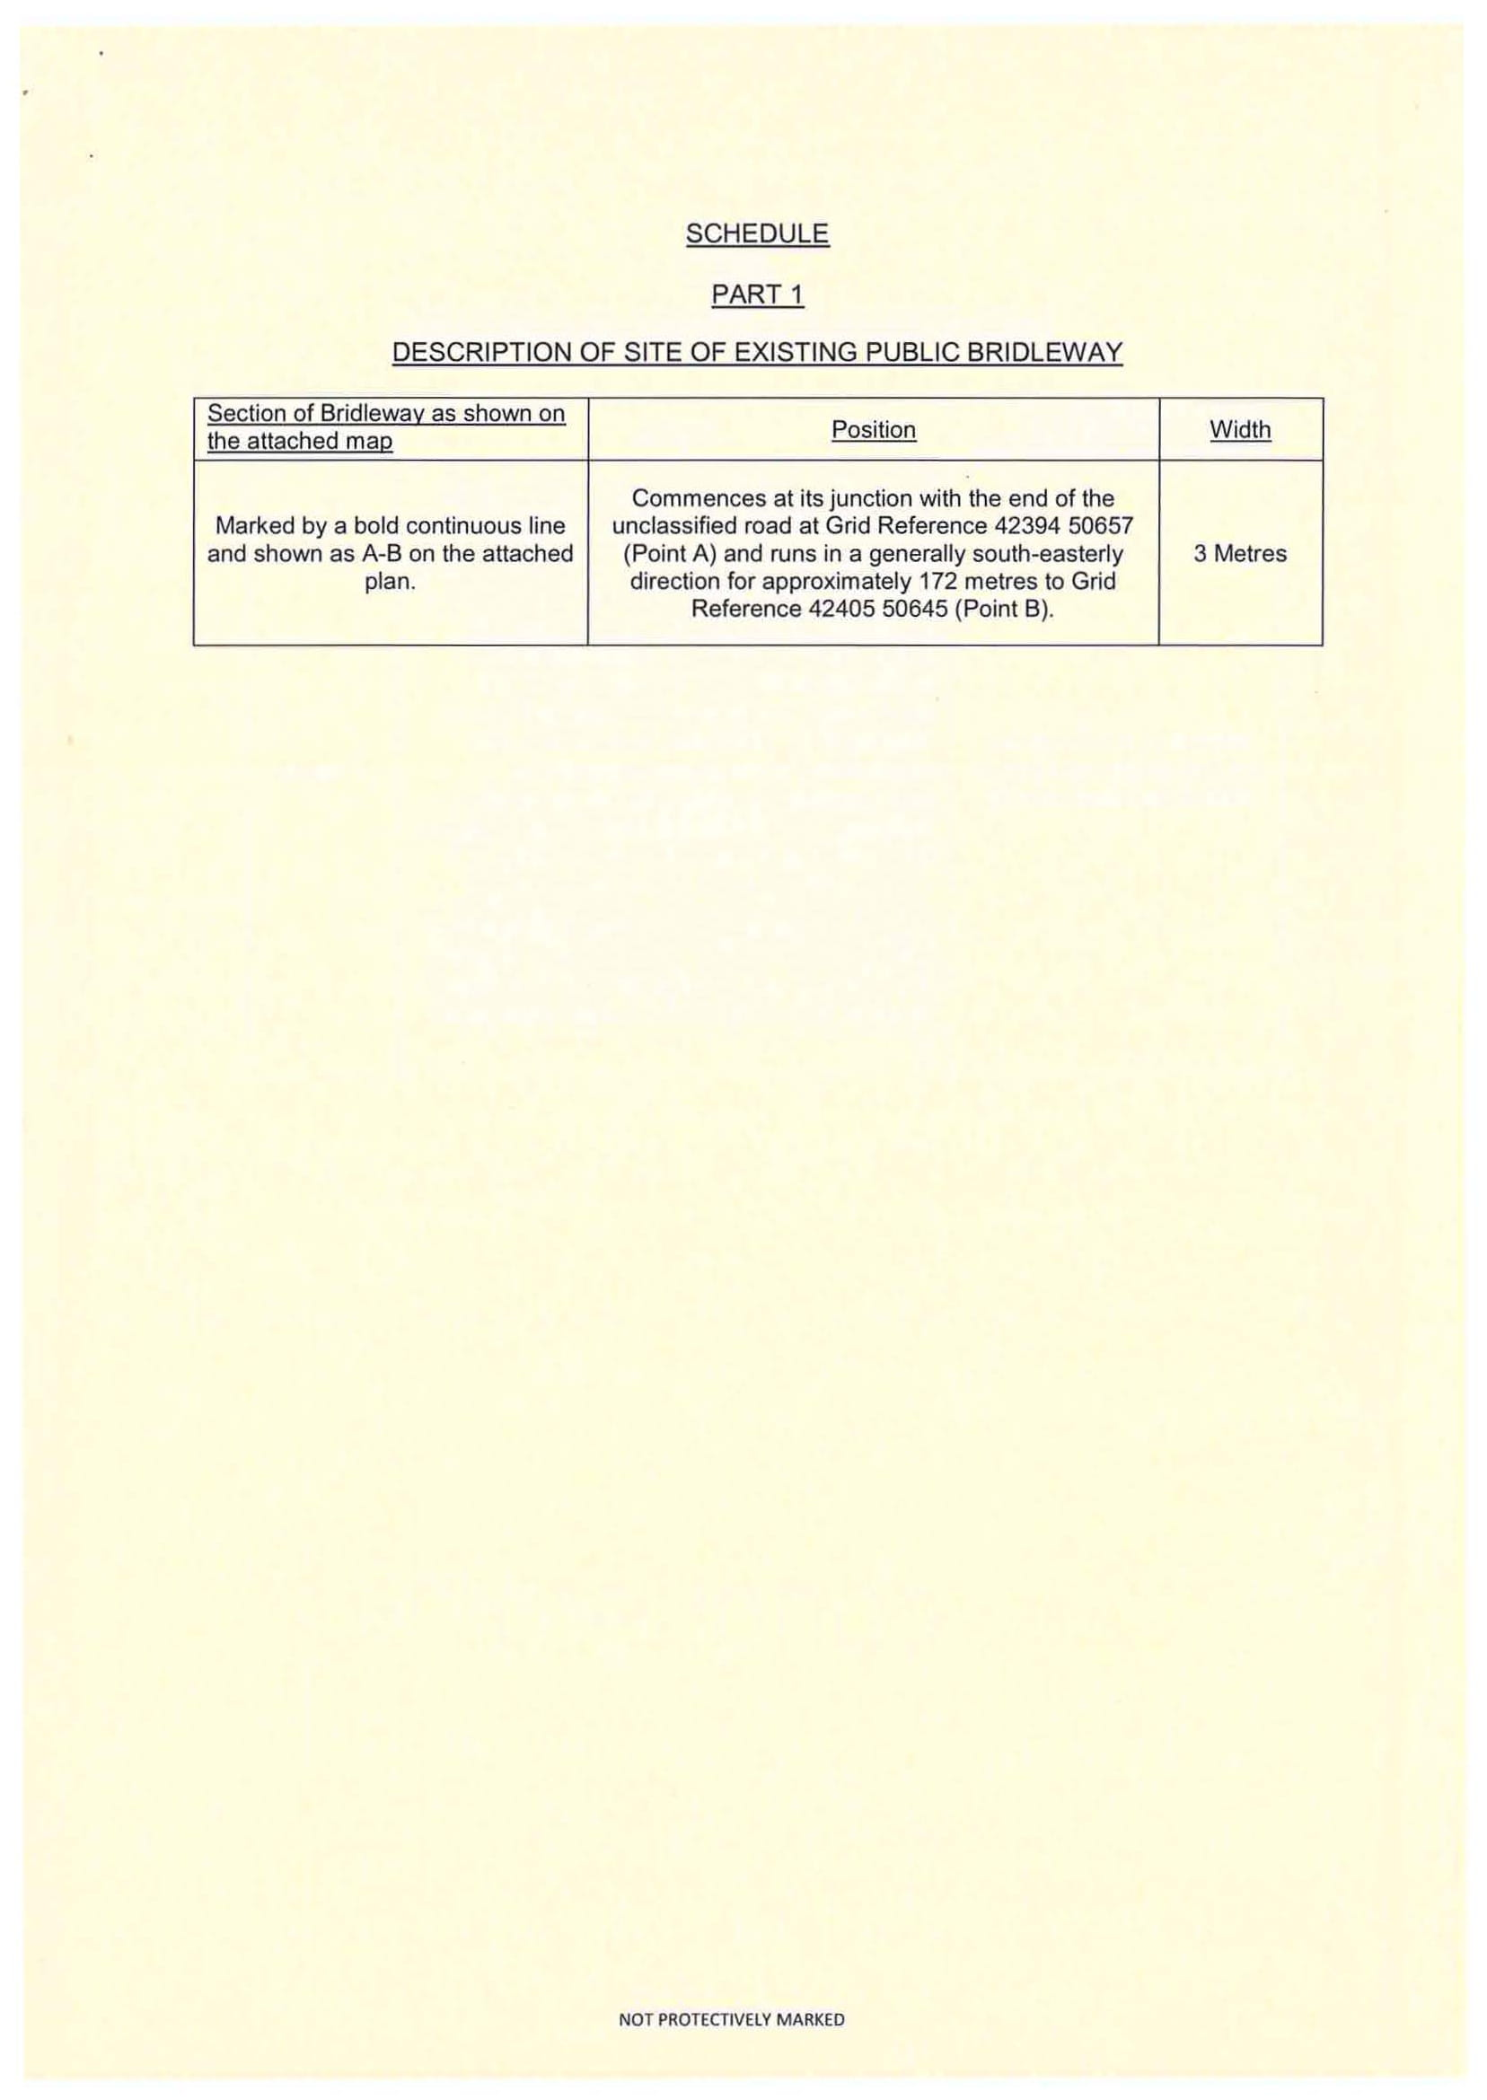
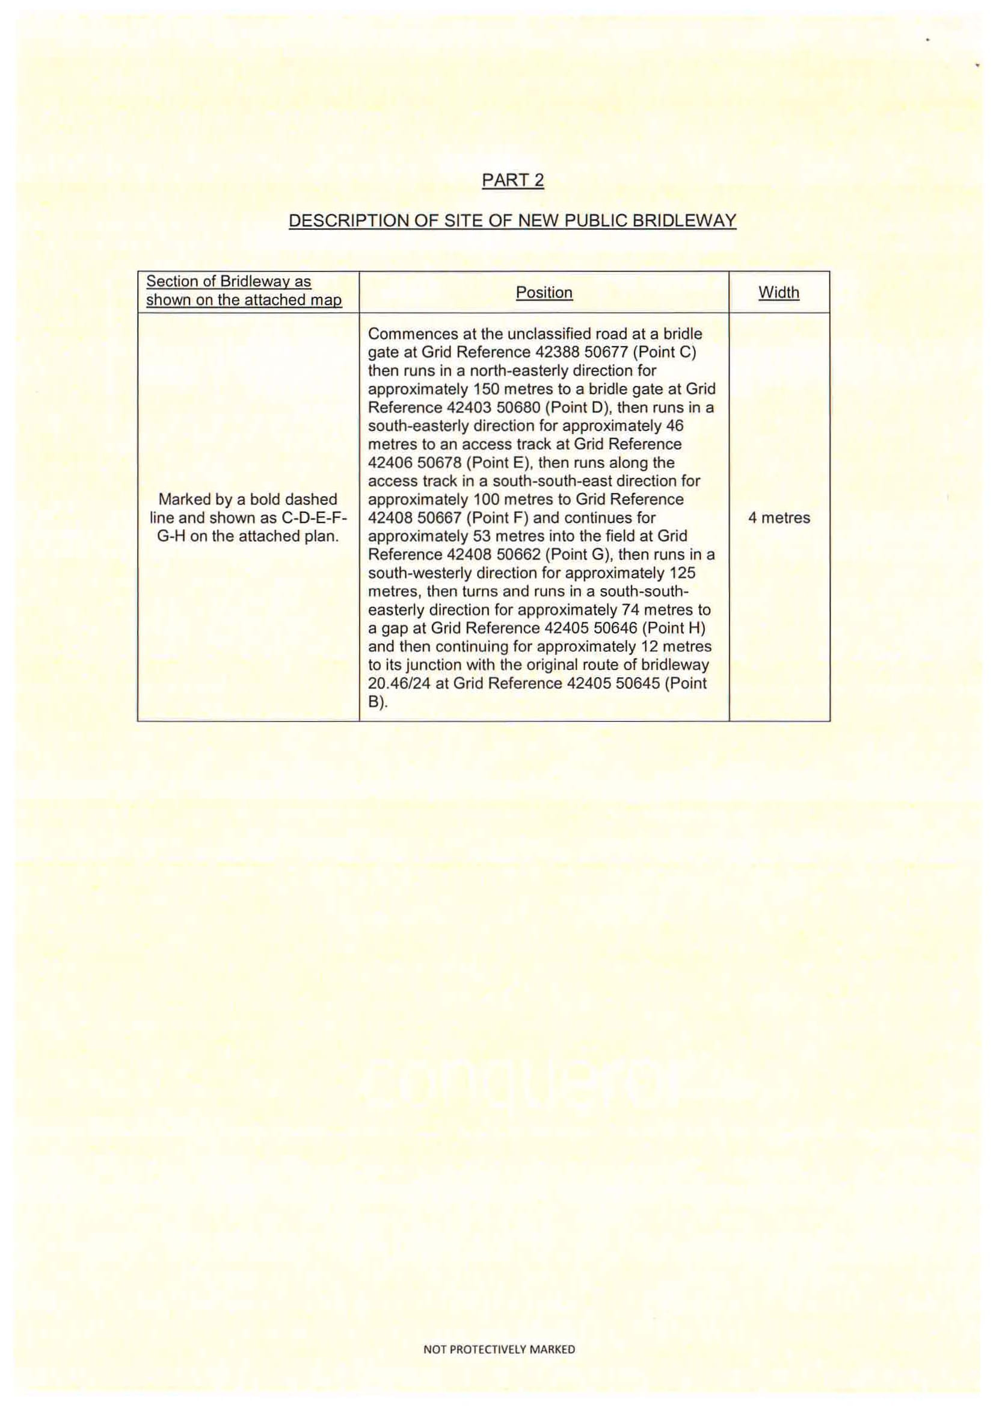
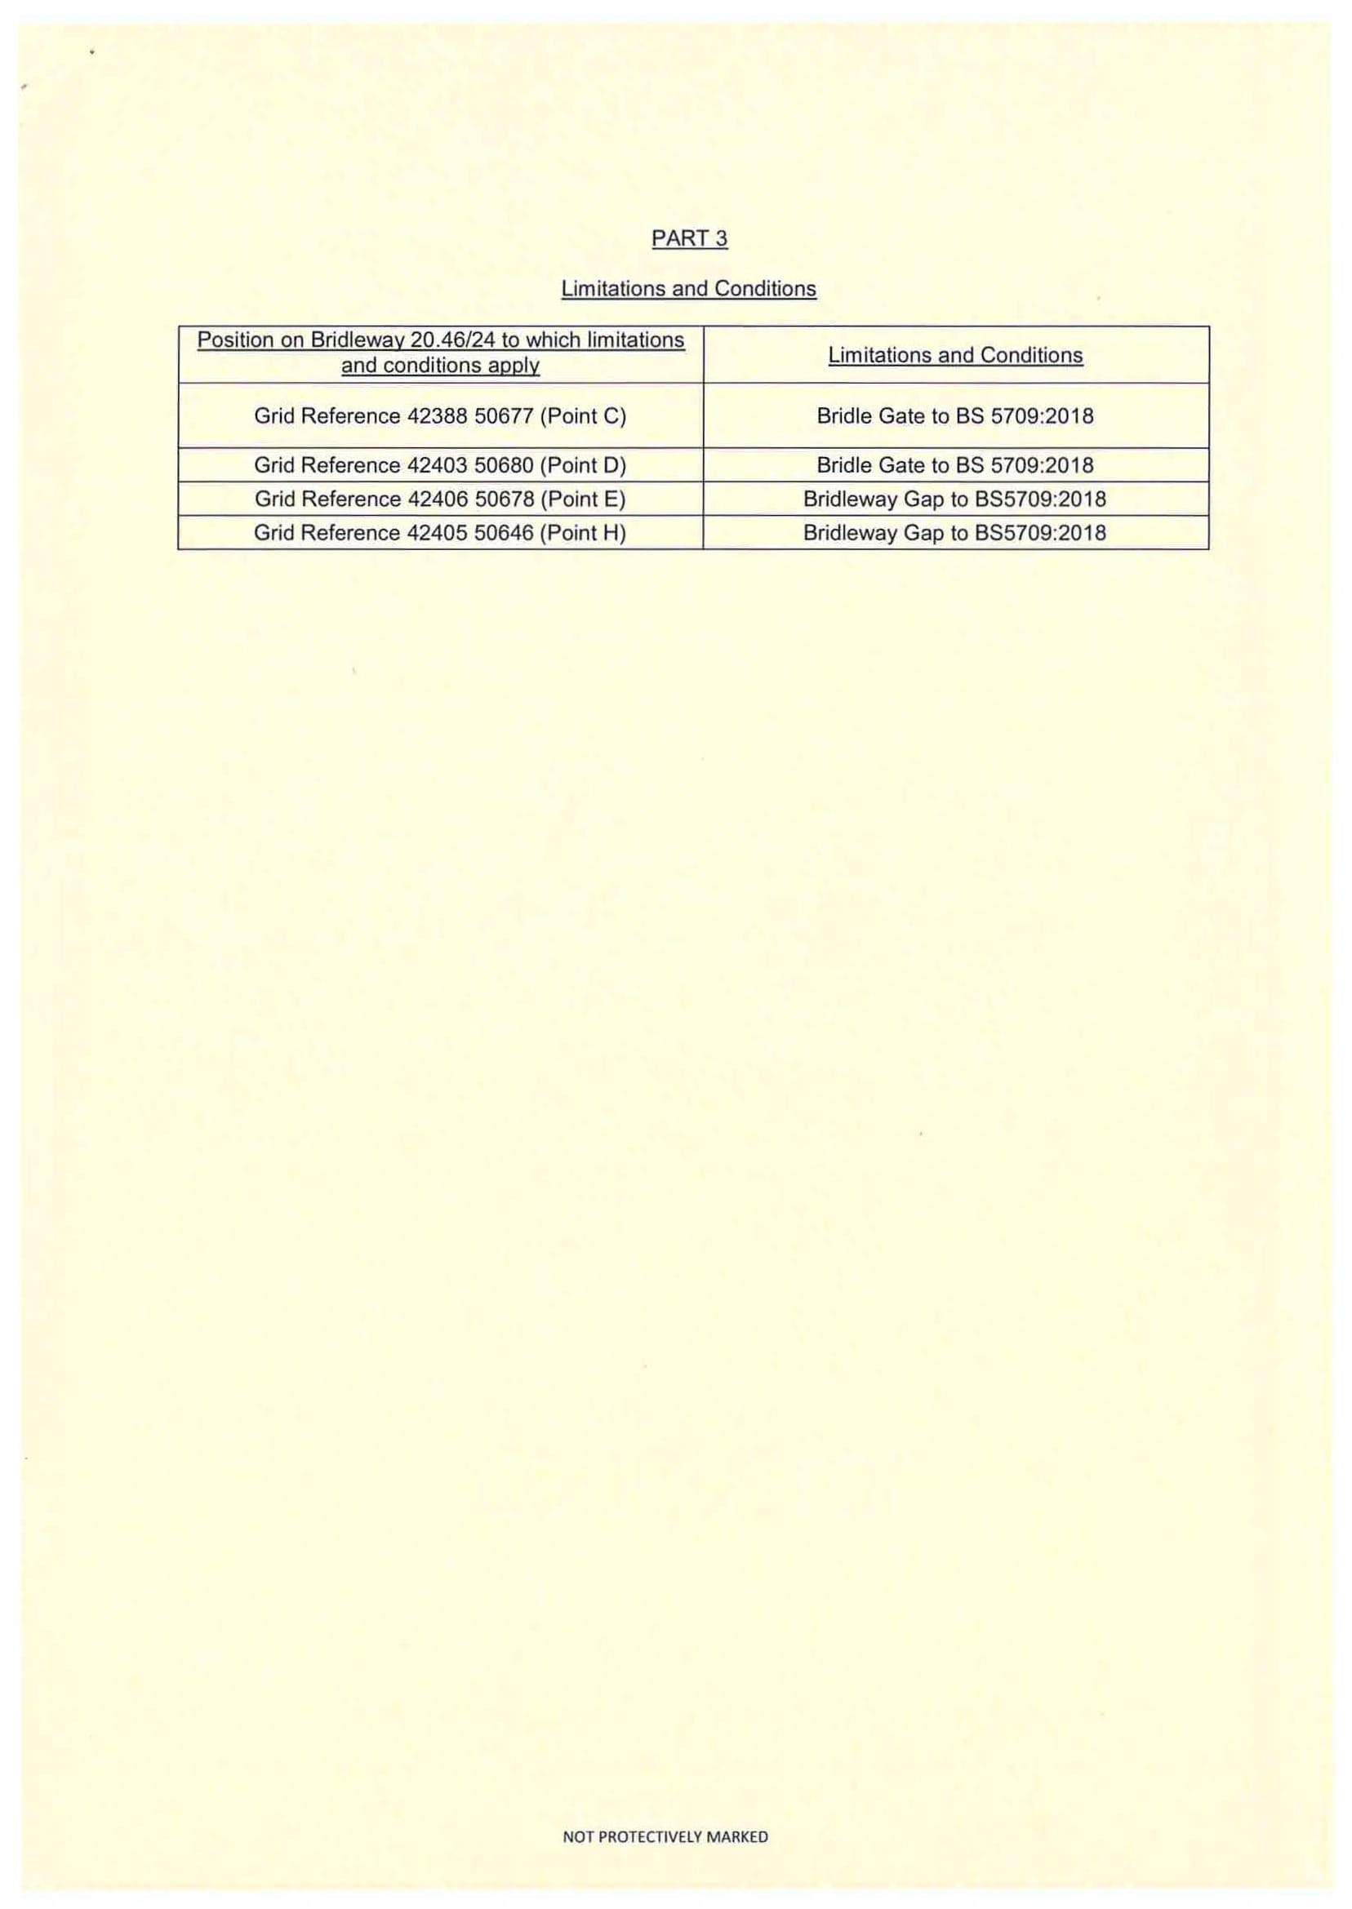
COPY – MAP NOT TO ORIGINAL SCALE
