School
Output Specification:

School-specific Annex SS6:
Sustainable Estate Strategy
[Insert full name of school]
[DfE School URN: AAxxxx]
[Project number]

November 2022
Document Control
Revision | Status | Date | Author | Amendment
P01 | S2 | 2021-04-19 | AWI | First Issue.
P02 | S2 | 2021-10-27 | AWI | MMC / CF21 Consultation Markup – Minor non-material changes made. Corrections and errors addressed
P03 | S2 | 2022-09-02 | AWI | Amendment to drafting note at Section 4
P04 | S2 | 2022-11-25 | AWI | Gov.uk publication

Revision History – Project Specific
Revision | Status | Date | Author | Amendment
P0n | Sn | YYYY-MM-DD | ABC | Employer's Representative to add amendments made to document here and rename file to make project specific.

Summary
This document is one of a number of Annexes to the School-specific Brief (SSB).
Review Date
Review dates for this document will be at 6-month intervals.
Who is this publication for?
This document is for technical professionals involved in the design and construction of school premises, as part of the Employer’s Requirements of the DfE Construction Framework. It may also be used as the basis of similar documentation for other procurement routes using the Output Specification.
Uniclass Codes
This document captures Uniclass codes for the management of exchange of information. To access all codes and associated titles reference should be made to Uniclass 2015 | NBS (thenbs.com)

School-Specific Sustainable Estate Strategy – [Insert Property Name]
[Drafting note: The Supplier will work with the Responsible Body (RB) to produce a School-specific, Sustainable Estate Strategy. This should be developed in line with the requirements of the Output Specification, with particular reference to Technical Annex 2J. This is a direct output of the Strategic Brief.]
The School-Specific Sustainable Estate Strategy is a direct output of the Strategic Brief as detailed in paragraph 2.8 in the School Specific Brief.
The School Sustainable Estate Strategy will be used to:
- communicate the Strategic approach for the development of the whole site up to 2050
- capture information gathered during the development of the Project Brief to
- inform the future development of the site to meet the ambition of climate resilience and net zero carbon up to 2050 to initially inform the project brief as well as define a longer-term development plan for the Responsible Body
- support Good Estate Management in Schools (GEMs) and future plans for funding applications for condition and energy efficiency improvements.

This document has four components:

Timeline of Condition Led Projects (up to at least 2050)
Using the Sustainable Estates Data Summary Tool a timeline for future condition led projects has been developed. See below:
[Drafting Note] The Supplier shall work with the Responsible Body and gather all project information available to them to develop a condition led timeline of projects up to 2050.
For Existing Buildings on site, the Sustainable Estate Data Summary Tool shall be used to collect site wide information to inform the understanding and analysis of school developments. The drawing, on next page, which has been included as an example has been made using this Tool. This shall be replaced with a Project specific drawing.
An example of what the Excel template looks like can be seen below.
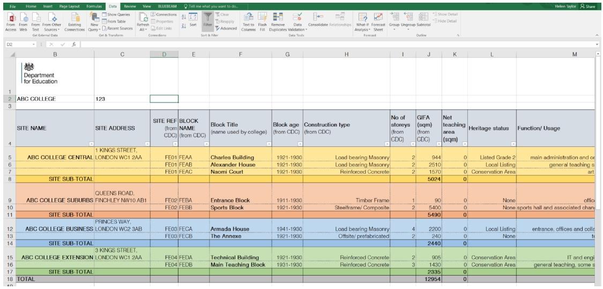
The Employer shall release the Tool to be used by the Contractor to take ownership and update throughout the project lifecycle.
Where a site is being 100% rebuilt, this element may be less applicable, but the information should still be displayed to enable the project School to inform decisions made about the project development. The carbon strategy on the following page will help to articulate the need to adapt new builds by 2050, if any.
The Technical Advisor shall also include a description of:
- Available routes for DfE funding for condition led upgrades
- SALIX, CIF, Public Sector Decarbonisation etc. where applicable to the school
- Other funding sources which may be available or relevant to the institution type.

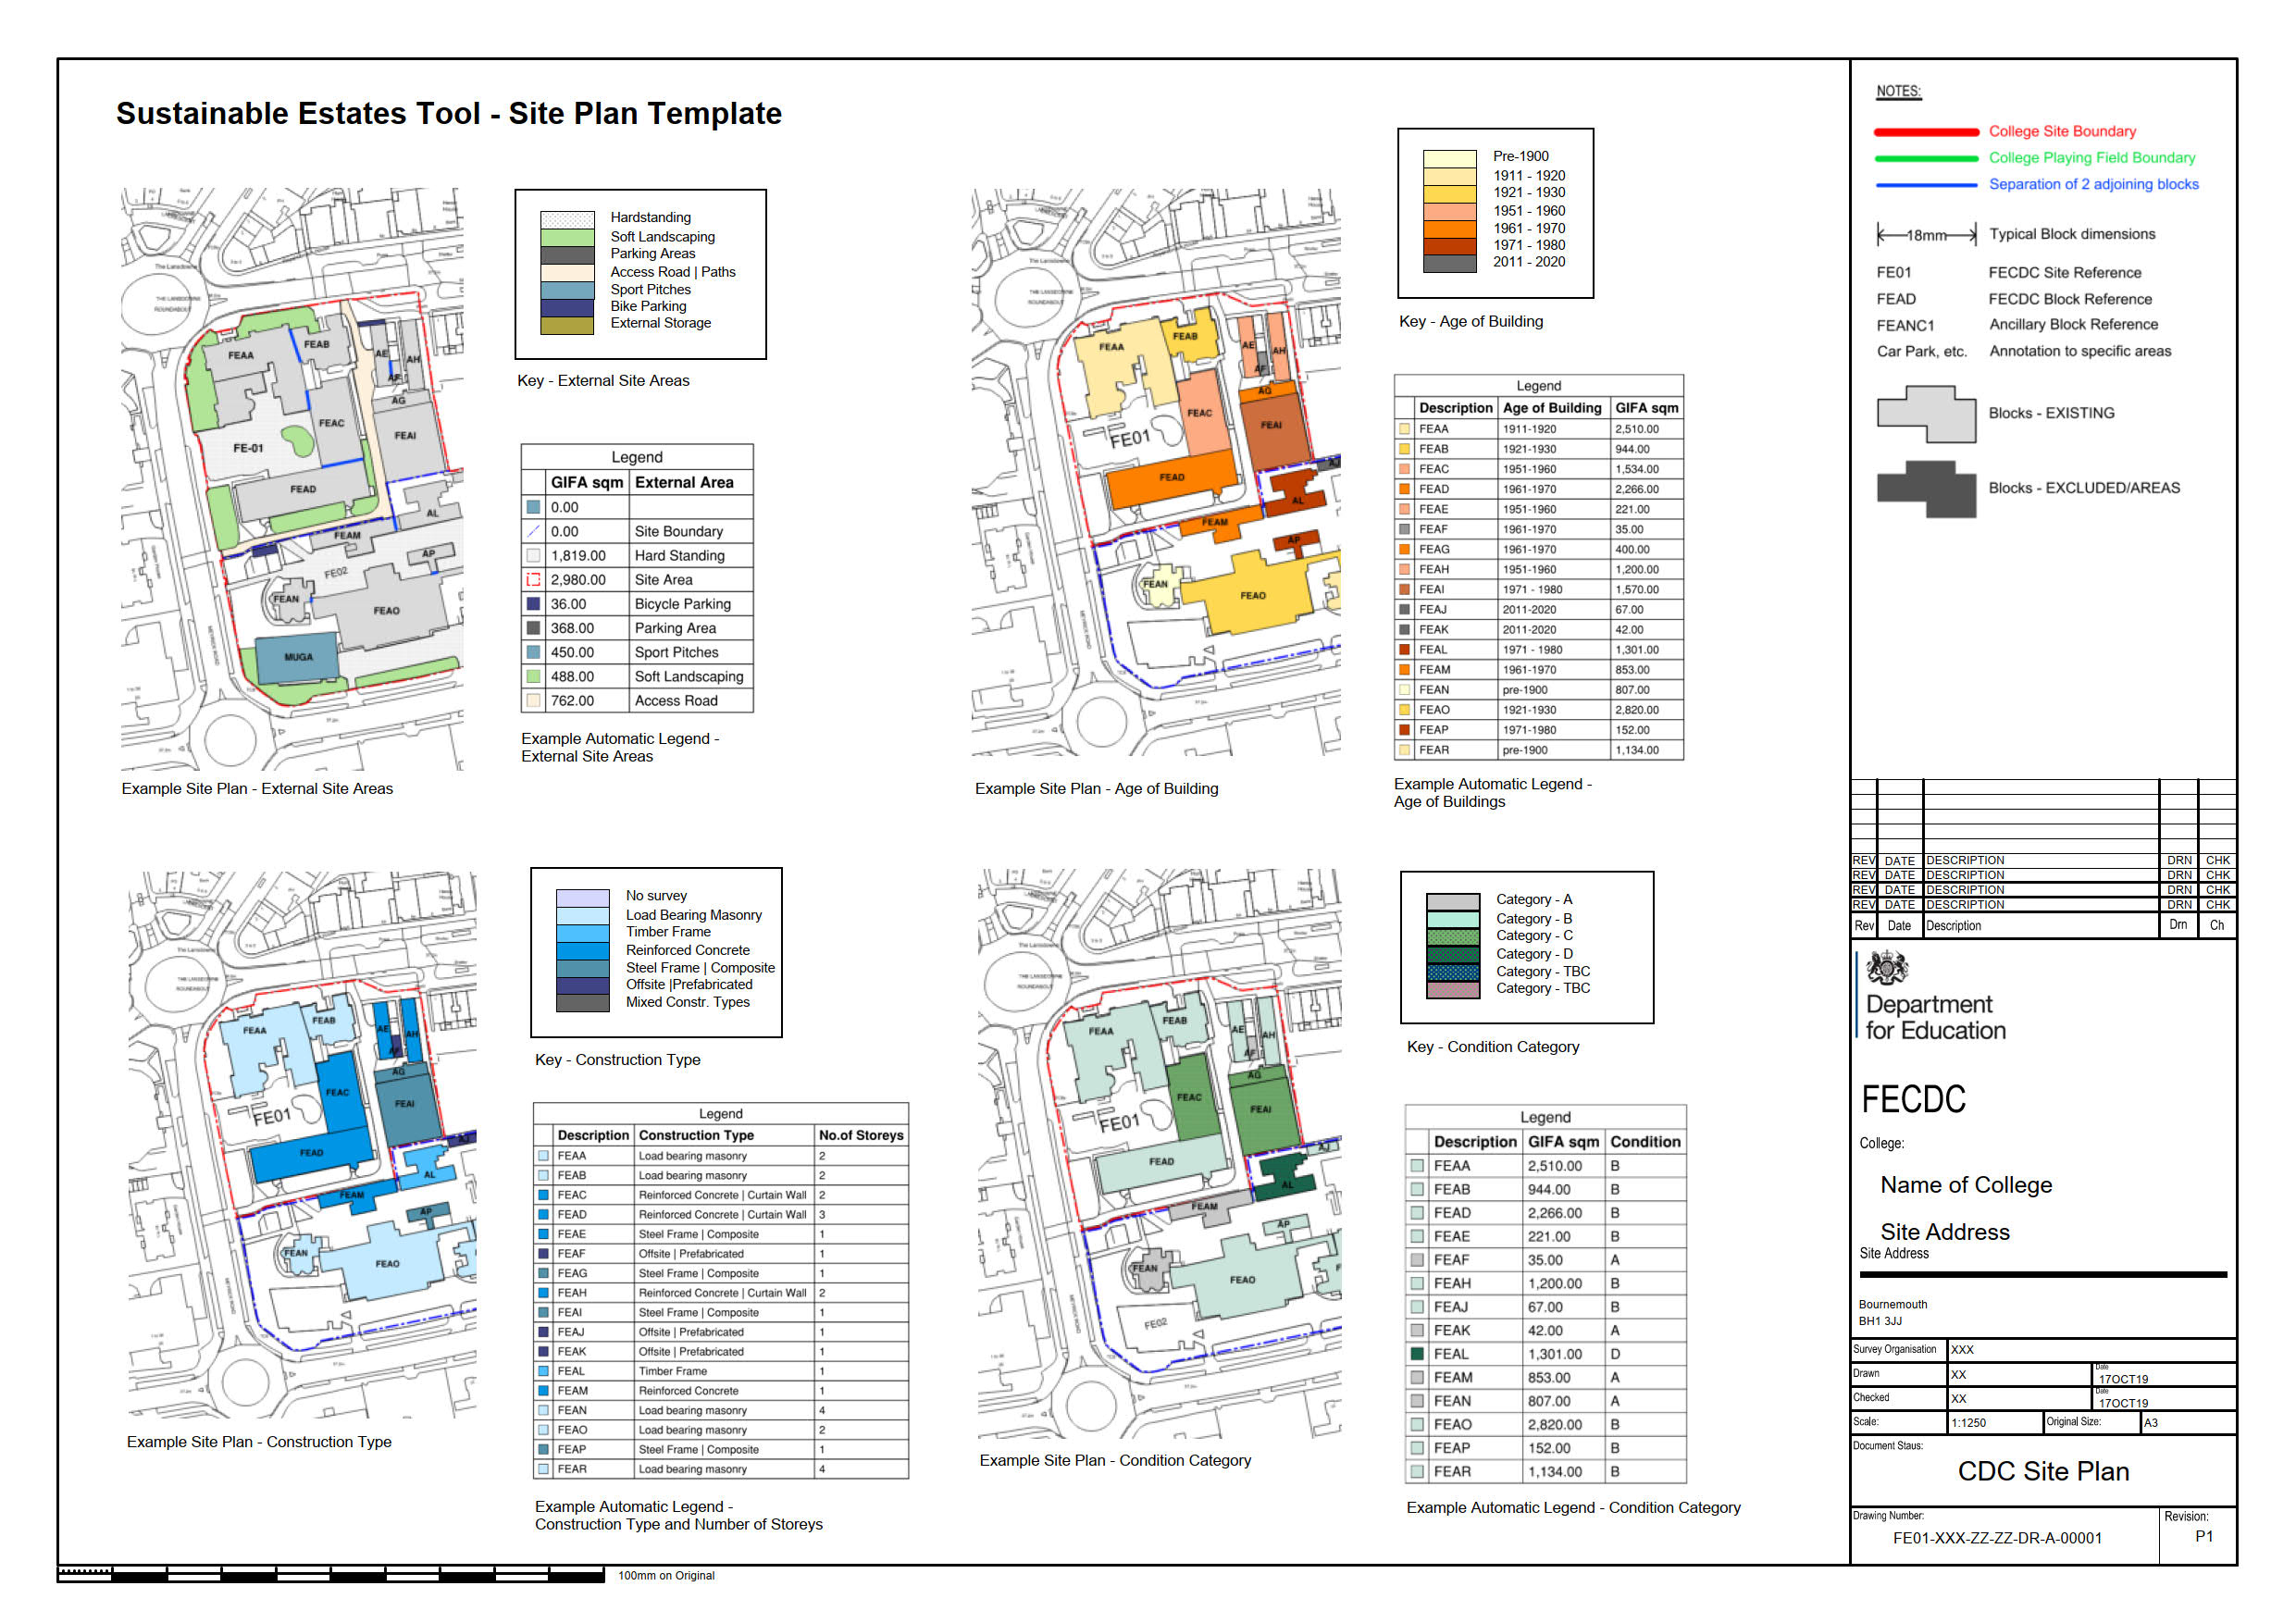

Climate Resilient Roadmap
The following sets out the road map to achieve net zero carbon in operation.
[Drafting Note] Climate Resilient Roadmap
The Supplier shall work with the Responsible Body and gather all project information available to them to develop a roadmap of the climate resilient strategy up to 2050, including the requirement for net zero carbon in operation across the entire estate as stipulated.
This section should be used to set out a Climate Resilient Strategy between now and 2050 supported by available information at this time. The development of this section should include:
- High-level roadmap to visually represent and dictate in a graphic format, the level of planned or foreseen/proposed interventions over a timeline between now and 2050 (using the intelligence from previous section on condition need and other supporting information as appropriate)
- Information gathered from survey data developed to form the Project Brief and a picture of the works that need considering up until 2050 which are outside the current Project Brief.
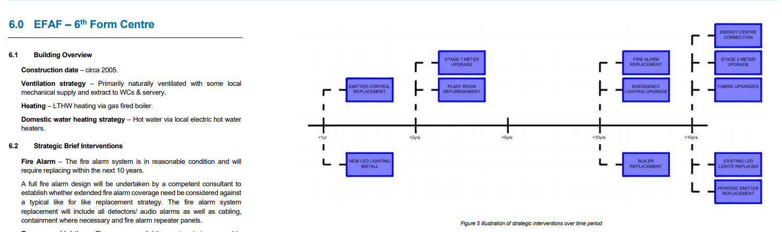
The document should give a high-level picture of the interventions required between now and 2050 and be coupled with a brief description. An example of how this information could be displayed can be seen above.
- Highlight the key opportunities within the existing estate to address the wider climate resilience measures within the Technical Annex 2J, which includes the adaptation to overheating (4°C for new builds, 2°C for existing), biodiversity net gain and flood resilience measures. These should also be highlighted within the Constraints and Opportunities Plan.
- If the Project Brief does not achieve net zero carbon in operation from handover, this section shall clearly also provide the Responsible Body/School with the ‘how’, for when the funding is available.

This page is intentionally left blank

<Space for Drawing/Report>

Constraints and Opportunities
The constraints and opportunities plan shall be based on constraints and opportunities assuming the control option is built and is illustrated below, in support of a future development plan.
[Drafting Note] The Constraints and Opportunities Plan will be based on the Control Option drawing and not the blank site. The Supplier should illustrate elements for the Responsible Body to be aware of, to the best of The Supplier’s knowledge at the time, to enable the RB and Contractor to consider and formulate any future development at the site. These site-specific elements could include, but are not limited to:
Constraints:
  - Key Highways considerations
  - Topographical and geographical (ground conditions)
  - Statutory access across the site, for example, Public Right of Ways or on-site substation access
  - Existing easements on the site for buried cables or underground sewers
  - Local Planning constraints including known Sport England restrictions
  - Adjacent area designations (e.g. sites of special interest (SSSI), nature reserves, sites of importance for nature conservation (SINC), ancient woodland and wetland) and strategic links to wider green infrastructure networks
  - Greenbelt or any protected land
  - Heritage or Listed Building elements
  - Any future housing or commercial developments
  - Any survey data which informed the Project Brief and may still be relevant for any future development
  - Tree preservation orders
  - Tree root protection areas on and adjacent to site
  - Existing semi-natural vegetation (e.g. trees, woodland, species-rich grassland)
  - Pluvial and fluvial flood risks
Opportunities:
  - Any future opportunities to develop external spaces for curricular or non-curricular functions
  - Using topographical levels to maximise nature-based Sustainability Urban Drainage systems (SuDS)
  - Future Development or Expansion zone
  - Views across site that can be exploited
  - Future re-greening of the site
  - Future greening as per the Urban Greening Surface types, if applicable, or as per biodiversity net gain (if greenfield site) being met on site.

The Technical Advisor will replace sample drawing below with Project specific drawing.

[Drafting Note]
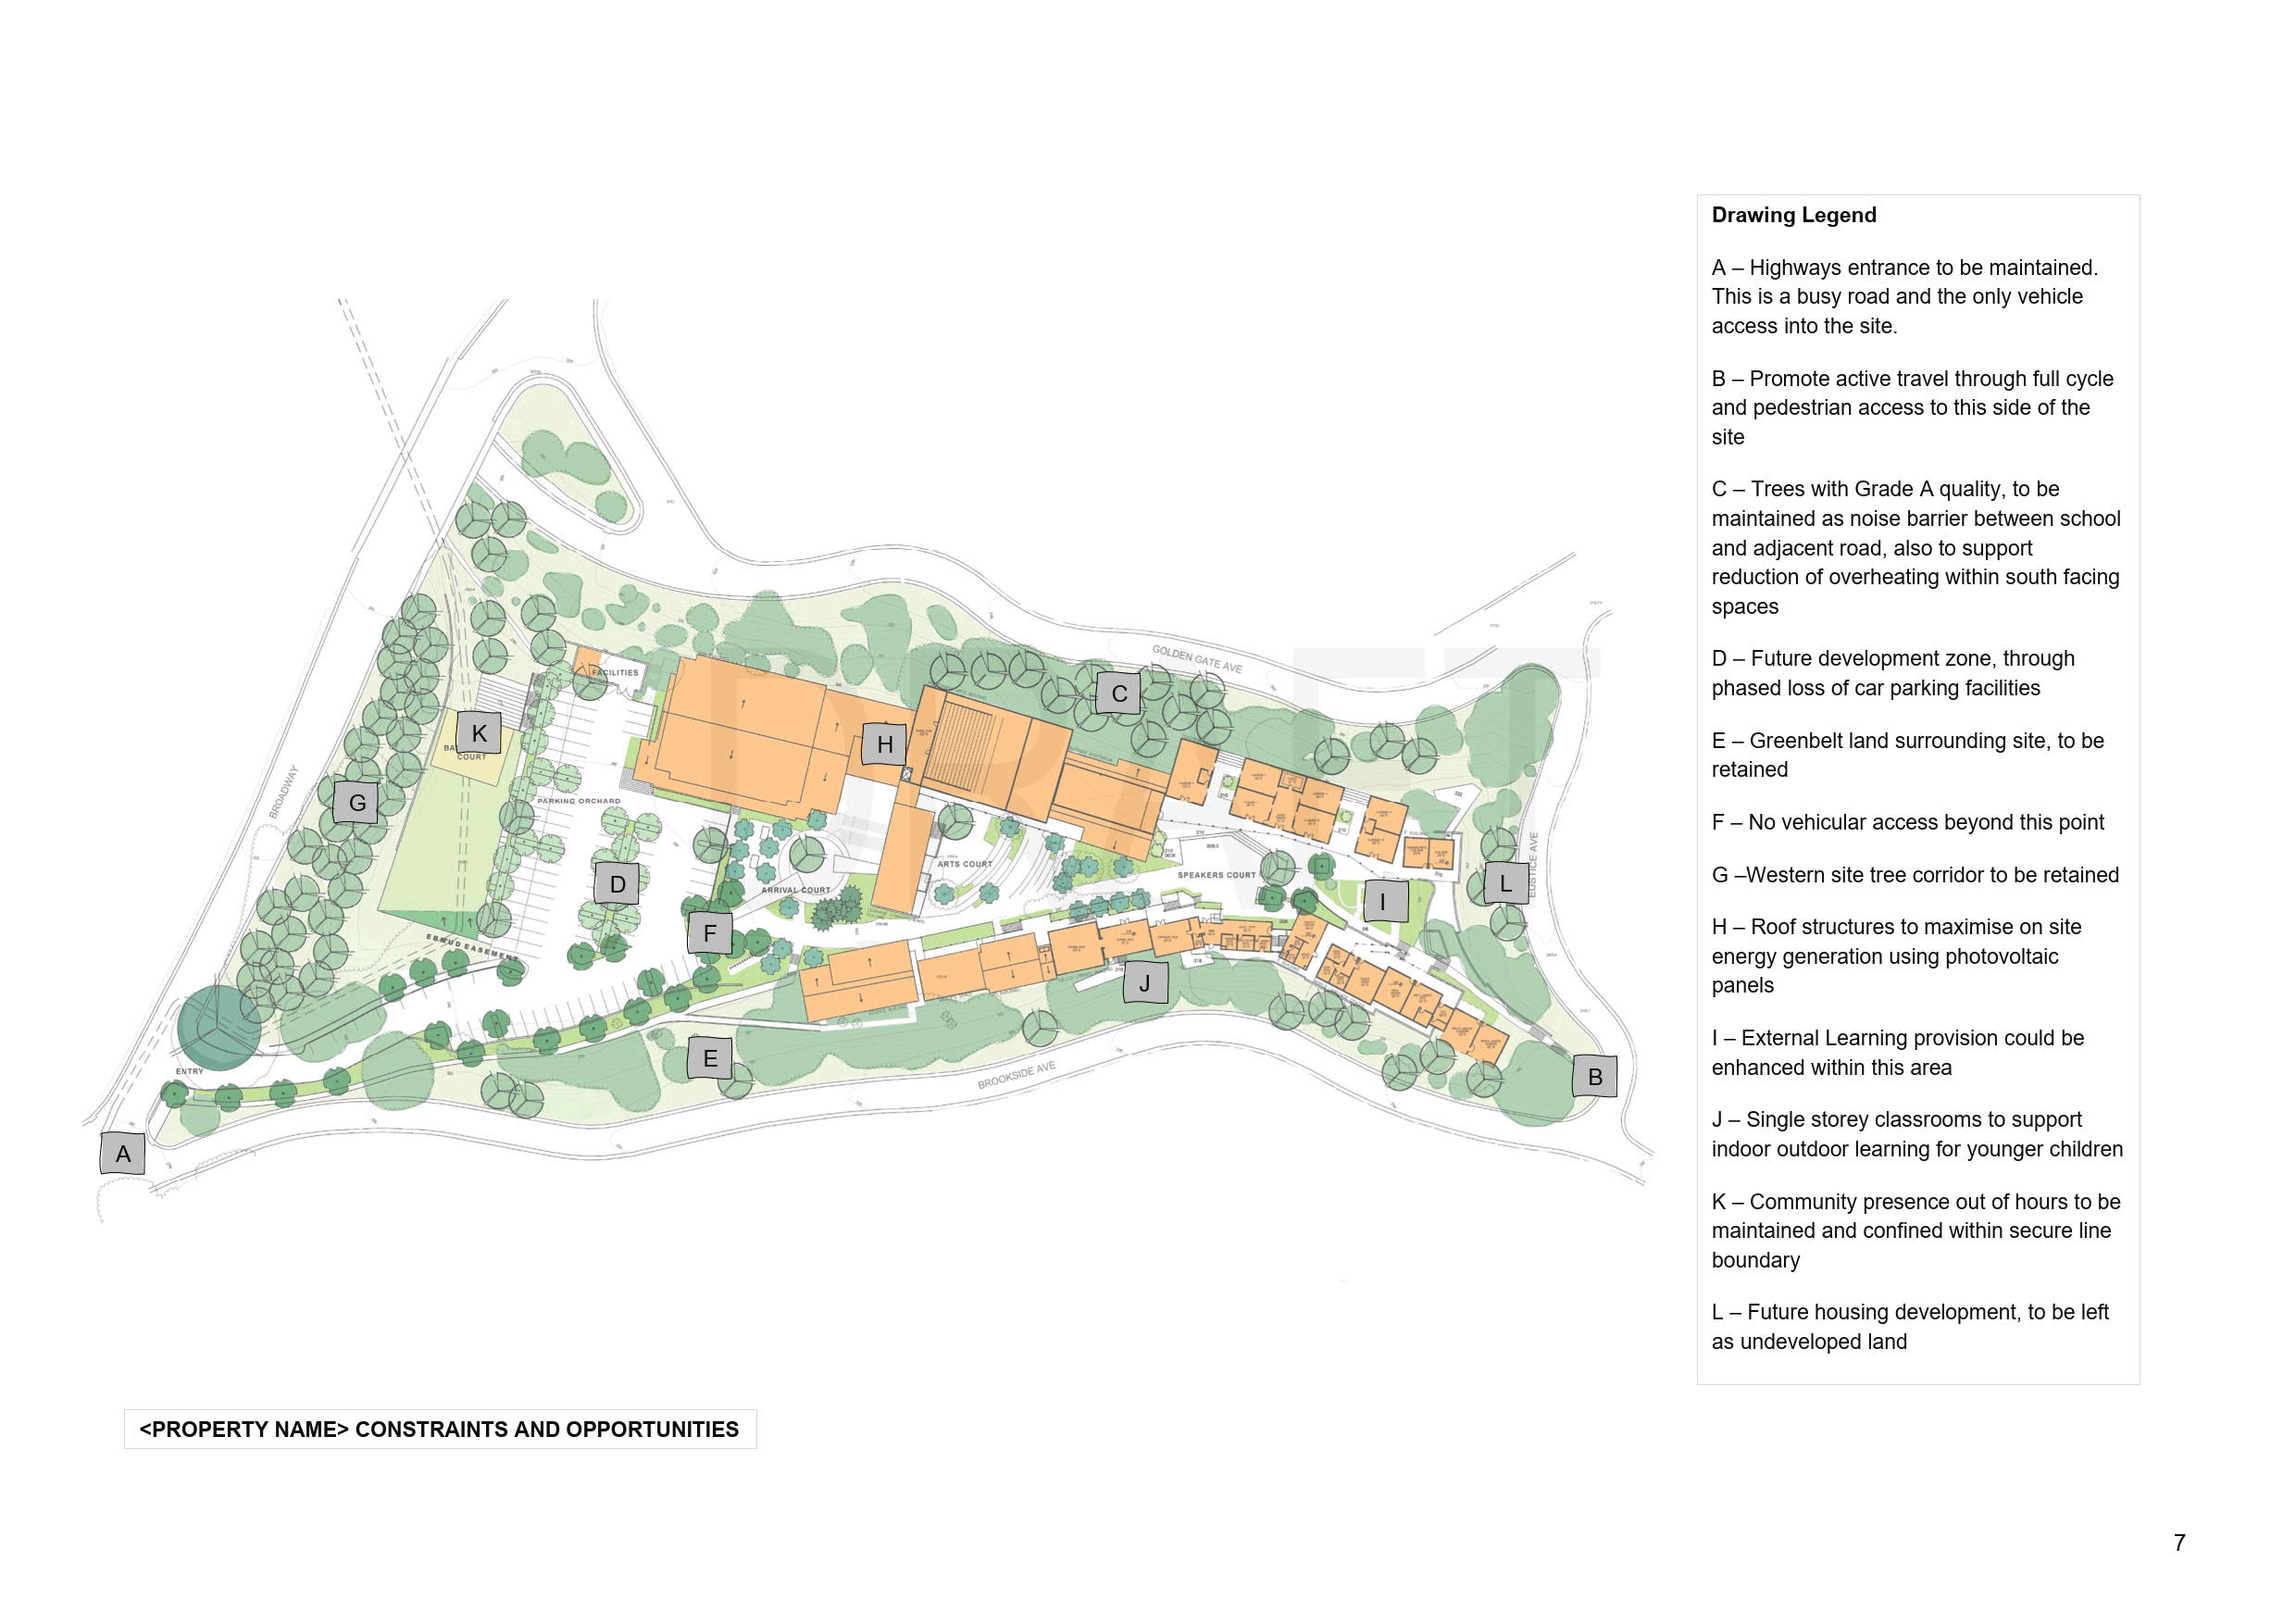

Site Masterplan
The Site master plan, below, depicts the preferred approach to the long-term development of the school estate to meet any Condition Led Project identified, as well as indicating any future expansion plans which have been considered. It considers how the Estate can allow for future change (rationalisation or expansion) whilst maintaining compliance with the External Site Area requirements of Building Bulletin (BB)103/104 guidance as applicable. It also depicts outline Phasing requirements considering planned or potential capital works (where applicable).
[Drafting Note] The Site Masterplan will be based on the Control Option drawing and not the blank site. The Supplier shall illustrate to the Responsible Body to be aware of, to the best of The Supplier’s knowledge at the time, the Site Masterplan based on the ‘Strategic Brief’ and direction for the site up to 2050.
In addition to the drawing, a brief written narrative should be added to this section providing further detail and explanation where necessary.

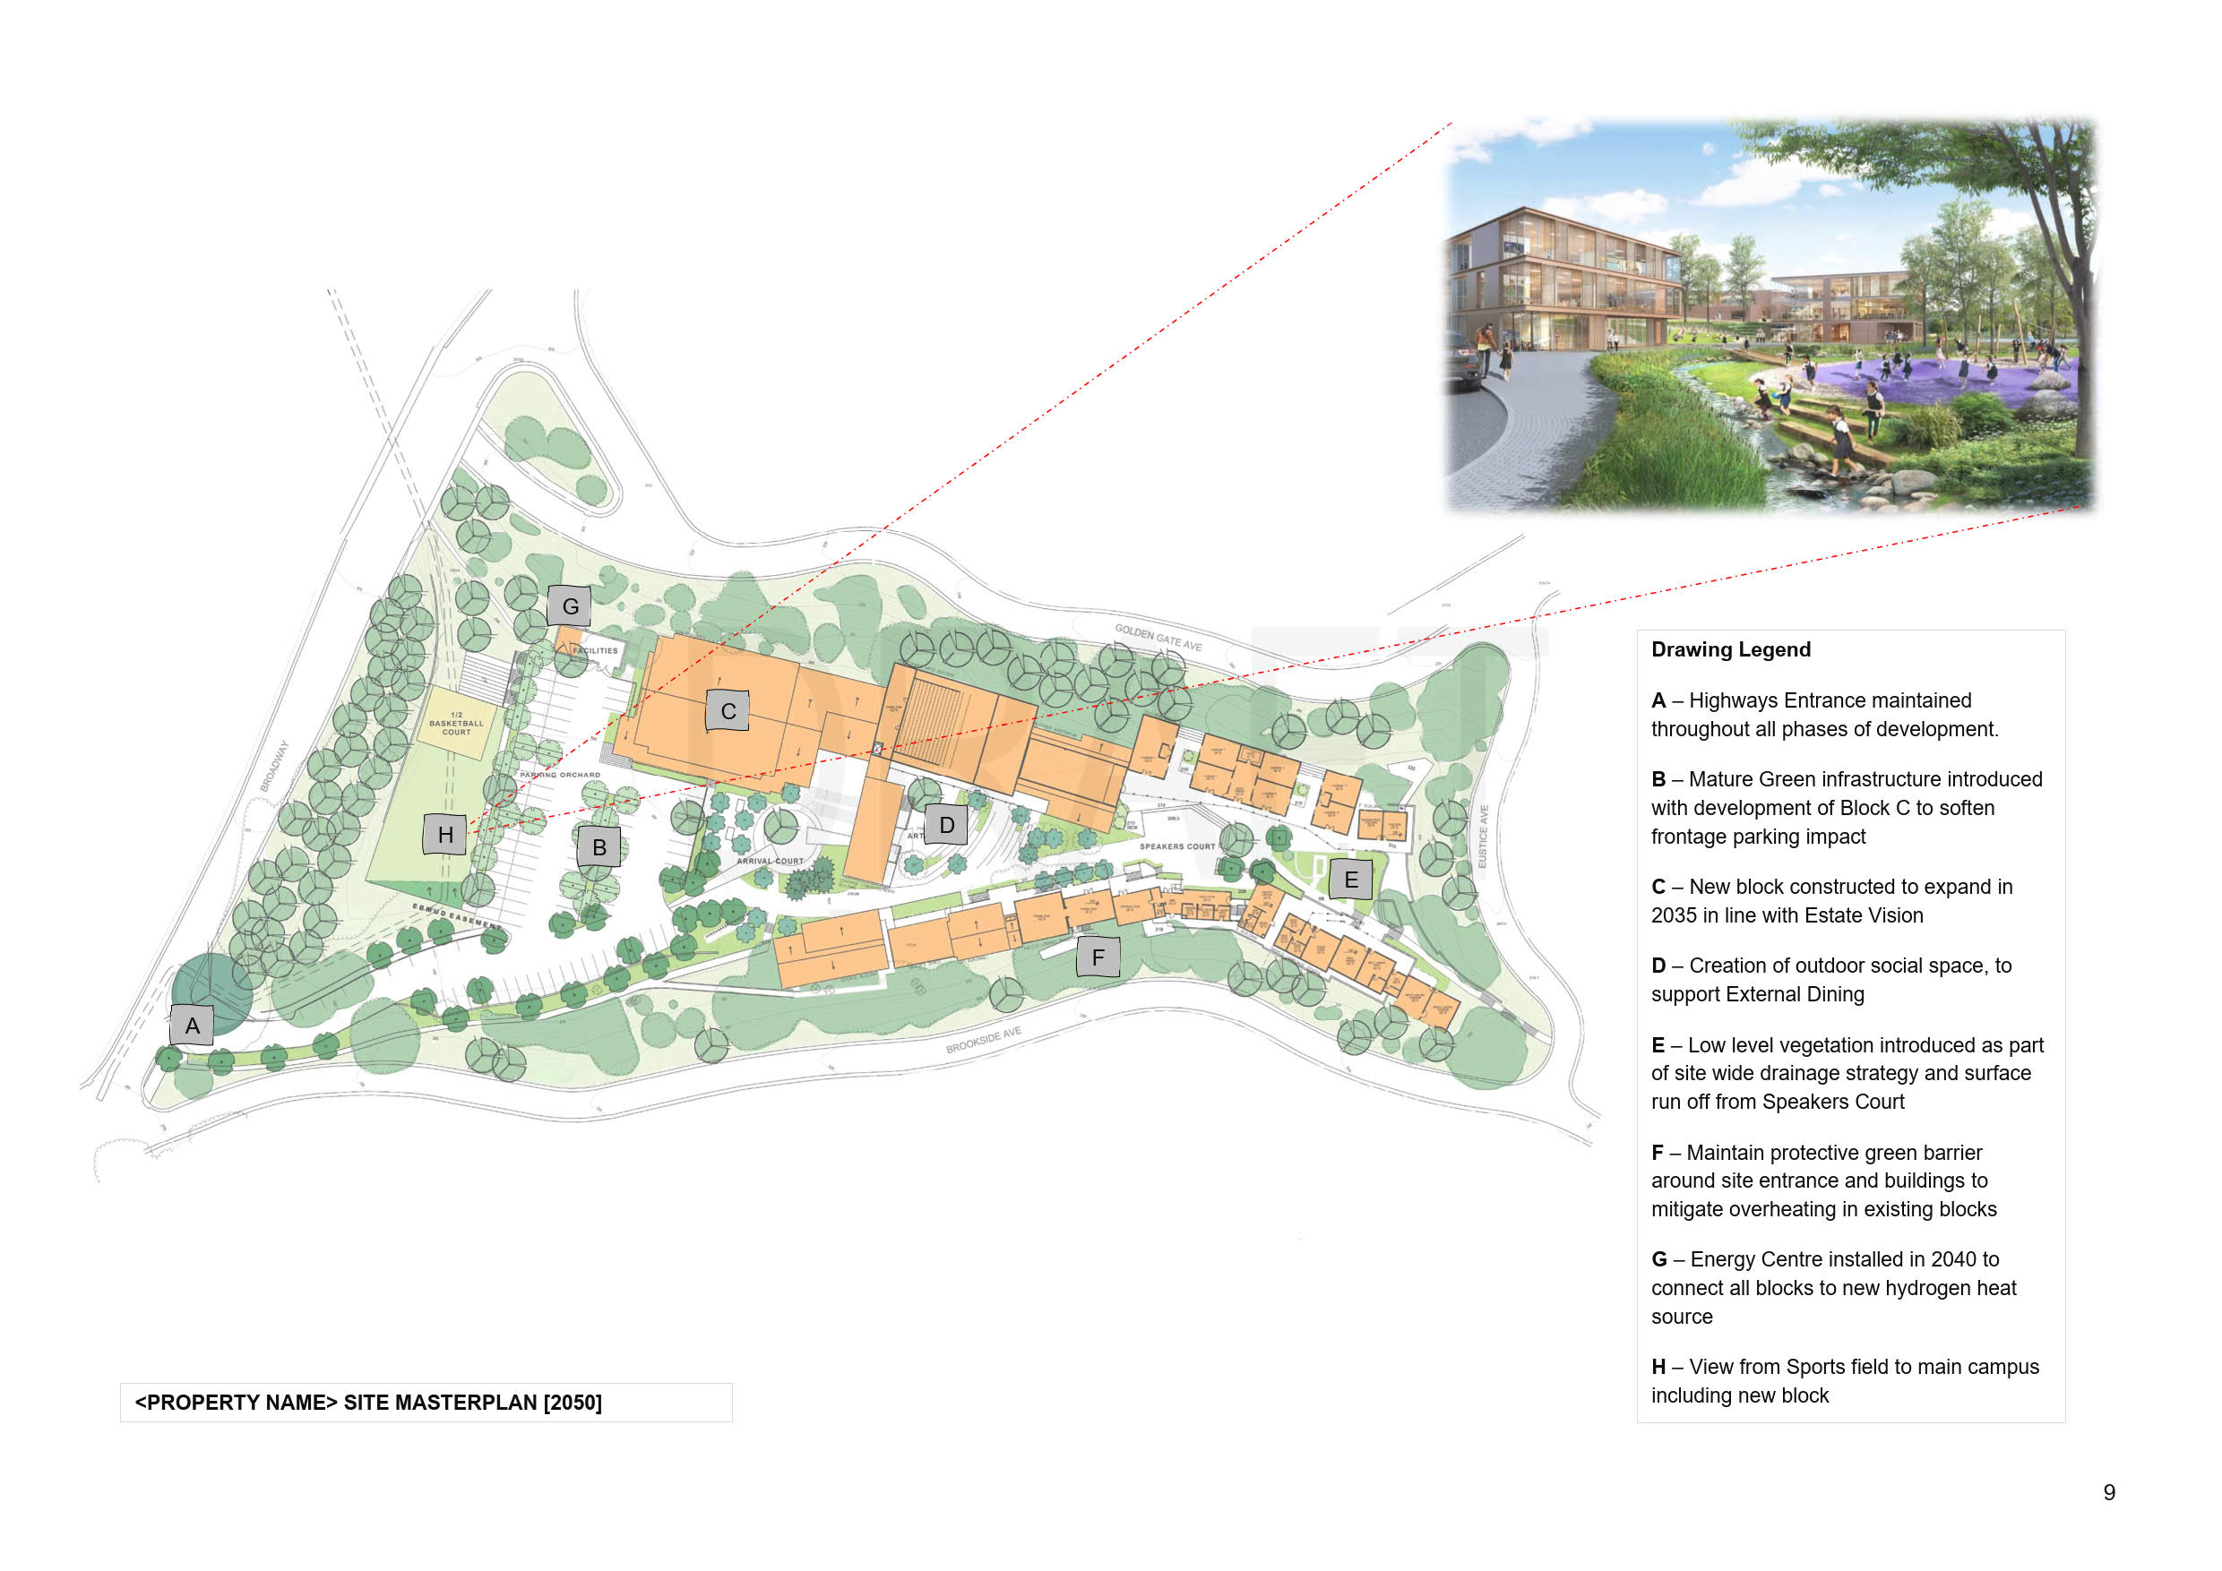

The Technical Advisor will develop drawings as per examples given.

© Crown copyright 2022
This publication (not including logos) is licensed under the terms of the Open Government Licence v3.0 except where otherwise stated. Where we have identified any third-party copyright information you will need to obtain permission from the copyright holders concerned.
To view this licence:
visit www.nationalarchives.gov.uk/doc/open-government-licence/version/3
email psi@nationalarchives.gsi.gov.uk
write to Information Policy Team, The National Archives, Kew, London, TW9 4DU
About this publication:
enquiries www.education.gov.uk/contactus
download www.gov.uk/government/publications

 | Follow us on Twitter: @educationgovuk |  | Like us on Facebook:  facebook.com/educationgovuk

