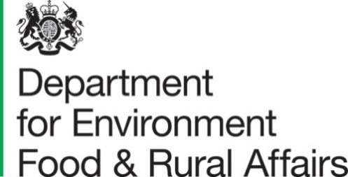

10 February 2022
Total Income from Farming for the Regions of England, second estimates for 2020
This release presents the second estimates of Total Income from Farming (TIFF) for the regions of England for 2020, replacing first estimates published on 17 November 2021. Total Income from Farming is the total profit from all farming businesses on a calendar year basis. It measures the return to all entrepreneurs for their management, labour and capital invested.
These regional statistics are a disaggregation of the Total Income from Farming in England account. The England 2020 second estimates were published on 3 February 2022 and contained sizable revisions compared to first estimates. These revisions feed through directly to this release. An explanation of these revisions can be found with the England account. We would like to encourage all users to complete this feedback form to tell us how you use this statistical notice.

Key Messages
- Total Income from Farming (TIFF) for England was £3,552 million in 2020. This was a decrease of £188 million (-5.0%) compared with 2019. When adjusted for inflation, this becomes a £404 million decrease (-10%).
- TIFF was lower in 2020 than in 2019 for six of the eight regions of England. The biggest proportional decrease was a 18% reduction (-£70 million) in Yorkshire & the Humber, whilst the biggest proportional increase was a rise of 4.6% (+£20 million) in the West Midlands.
- The South West made the biggest contribution to England TIFF in 2020 at £682 million (19.2%), followed by the East of England at £671 million (18.9%). The North East made the smallest contribution at £128 million (3.6%).
- When expressed on a ‘per hectare of farmed land’ basis, the West Midlands had the highest TIFF in 2020 at £488 per hectare. The region with the lowest TIFF per hectare was the North East, at £212. The England average was £389 per hectare.
- For every year from 2010-20, either the East of England or the South West was the region with the highest TIFF and the North East was the lowest. Regional shares of TIFF have remained fairly stable over time.
Contents
What you need to know about this release 3
Key terms and user information for this publication 4
Section 1 - How did the regions contribute to Total Income from Farming (TIFF) in England in 2020? 5
1.1 Regional income levels and income shares 5
1.2 Income per hectare 6
Section 2 - How has TIFF changed over time in the regions of England? 9
Section 3 - How did different outputs vary between regions in 2020? 12
3.1 Definition of output groups 12
3.2 Output groups by NUTS1 region 14
3.3 Regional variations at a finer spatial scale 15
Section 4 - Regional Profiles 19
4.1 Regional profile introduction and user guide 19
4.2 North East regional profile 21
4.3 North West regional profile 22
4.4 Yorkshire & The Humber regional profile 23
4.5 East Midlands regional profile 24
4.6 West Midlands regional profile 25
4.7 East of England regional profile 26
4.8 South East including London regional profile 27
4.9 South West regional profile 28
Section 5 - About these statistics 29
5.1 Methodology for regional production and income accounts 29
5.2 Revisions due to new methodology 30
5.3 Quality Assurance 31
5.4 Summary quality report 31
5.5 Main users and uses of the aggregate agricultural accounts 31
5.6 User engagement and feedback 31

What you need to know about this release

Contact details
Responsible statistician: Robin Karfoot, Room 202 Foss House, Kings Pool, 1-2 Peasholme Green, York, YO1 7PX.
Telephone enquiries: 0208 026 6449.
Email: farmaccounts@defra.gov.uk
Media enquiries: 0345 051 8486
Public enquiries: 02080 266449

National Statistics and Official Statistics
Publications with National Statistics status meet the highest standards of trustworthiness, quality and public value, and it is our responsibility to maintain compliance with these standards. The aggregate agricultural accounts for England and the UK are designated as National Statistics. These regional estimates are based on a method to apportion the England totals between the different English regions. Whilst this methodology is in accordance with the Code of Practice for Official Statistics, it introduces additional inherent uncertainty such that these estimates are designated as Official Statistics, rather than National Statistics.

Key terms and user information for this publication

Basic price replicates what the farmer receives. It is the market price plus directly paid subsidies that are linked to the production of specific products. In England, this type of subsidy last existed in 2011, so for recent years basic price and market price are the same.
Current price is the value based on prices observed during the reference year (i.e. values not adjusted for inflation). The alternative to Current price is ‘Real terms’ (see below). The datasets that accompany this notice contain both Current price and Real terms time series to best suit the varied preferences of users.
Gross output is the total value of output produced by farm businesses.
Gross Value Added (GVA) is computed as Gross output minus Intermediate consumption and represents that contribution of a business, sector or industry to Gross Domestic Product (GDP).
Inseparable non-agricultural activities are non-agricultural enterprises that are included within the business level accounts of farms, e.g. tourism and recreation facilities. Otherwise known as ‘diversification’.
Intermediate consumption is the goods and services used as inputs in the productive process, e.g. feed, energy and veterinary expenses.
Market price is what is paid by the consumer. See basic price above.
NUTS (Nomenclature of Units for Territorial Statistics) is the geographical classification used throughout this Statistics Notice. This publication uses the latest version, NUTS 2016, throughout and London has been combined with the South East of England due to the very low levels of agricultural production in London. Further information on NUTS.
The full agricultural accounts for each region can be found in the dataset that accompanies this notice, together with more aggregated versions of the accounts for individual counties and unitary authorities (NUTS2/NUTS3 level).
Real terms is where values from previous years have been adjusted for inflation. The alternative to Real terms is ‘Current price’ (see above). All the time series in this statistics notice are expressed in real terms in 2020 prices.
Total Income from Farming (TIFF) is the total profit from all farming businesses in England on a calendar year basis. More specifically, TIFF is income generated by production within the agriculture industry, including subsidies, and represents business profits and remuneration for work done by owners and other unpaid workers. TIFF excludes changes in the values of assets, including stocks, due to price changes but includes non-agricultural activities such as further processing or tourist activities where these cannot be separated from the agricultural business. TIFF is the preferred measure of aggregate income for the agricultural industry, conforming to internationally-agreed national accounting principles required by the UK National Accounts.

Section 1 - How did the regions contribute to Total Income from Farming (TIFF) in England in 2020?

1.1 Regional income levels and income shares
Total Income from Farming for England was £3,552 million in 2020. Figures 1.1.1 and 1.1.2 show the extent of the variation in TIFF between the regions. The South West made the biggest contribution to England TIFF with £682 million (19.2%), followed by the East of England at £671 million (18.9%). The region with the lowest TIFF was the North East, at £128 million (3.6%).

Figure 1.1.1: Total Income from Farming for England in 2020, by NUTS1 region (£ million)

Figure 1.1.2: NUTS1 Regional Share of England Total Income from Farming, 2020
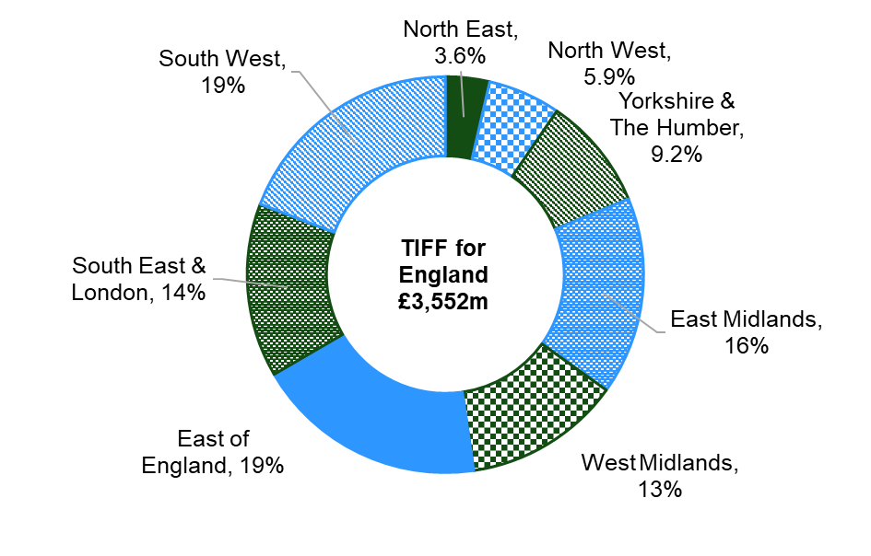
The key drivers of agricultural income include the volume of production, commodity prices and the cost of inputs. These are themselves driven by a range of factors such as the weather, exchange rates, oil price and global supply and stocks of commodities. As a result, agricultural incomes tend to be volatile and fluctuate from year to year.
A range of external factors contribute to regional variations in farming, including climate, soils, topography and altitude. These in turn influence what commodities are produced and how efficiently, and hence the value of production and incomes achieved. The regions of England also vary considerably in size and as a result, total incomes are strongly linked to the total agricultural area in each.
Area is considered in Section 1.2 and type of farming is explored in Section 3.

1.2 Income per hectare
The NUTS1 regions are not identical in size. Naturally, the value of TIFF is closely linked to the size of the area being farmed. Therefore, expressing TIFF per hectare of farmed land gives a fairer metric to use for comparisons across regions. The areas used are from 2016 because these are the latest results from a year when the June Survey of Agriculture and Horticulture was run with an enhanced sample size. It is only such years in which NUTS3 farmed areas are considered robust enough to publish. Therefore, all per hectare statistics in this release use 2016 areas as the divisor for all account years.
Table 1.2.1: Farmed area of NUTS1 regions, 2016
 |  |  |  |  |  |  | Hectares
North East | North West | Yorkshire and The Humber | East Midlands | West Midlands | East of England | South East including London | South West
603,341 | 939,559 | 1,114,936 | 1,203,411 | 932,382 | 1,397,545 | 1,138,670 | 1,790,781

Figure 1.2.1 expresses TIFF per hectare of agricultural land. The overall pattern remains similar to that seen for absolute values (Figure 1.1.1), but the extent of the variation between regions is reduced.
Figure 1.2.1: Total Income from Farming per hectare of farmed land in 2020, by region (£/ha)
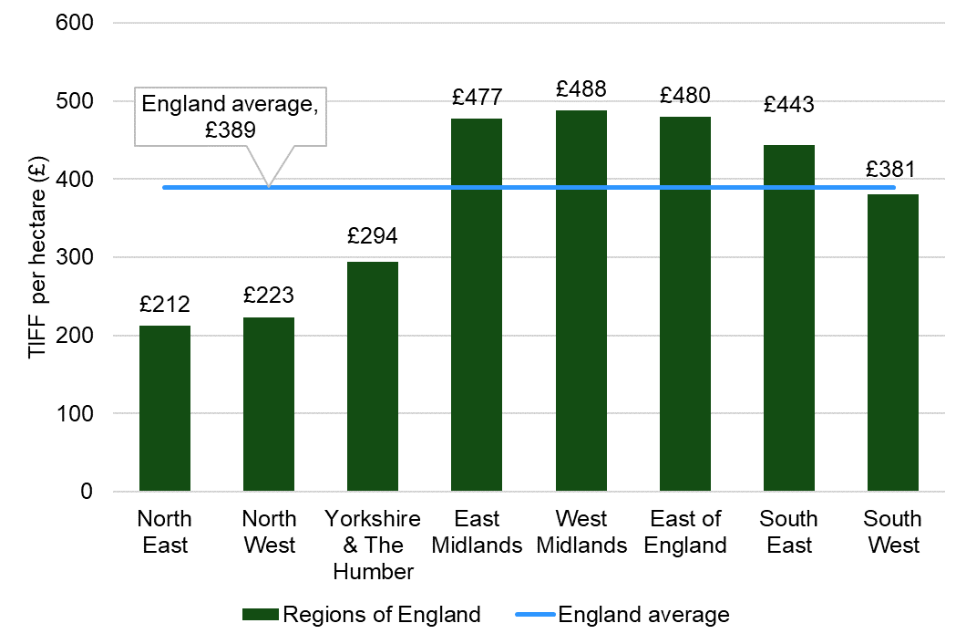

The West Midlands had the highest Total Income from Farming at £488 per hectare, narrowly ahead of the East of England (£480 per hectare) and East Midlands (£477 per hectare). The North East was still lowest at £212 per hectare, only slightly behind the North West (£223 per hectare). Even after adjusting for the area of farmed land, the three most northerly regions (North East, North West and Yorkshire & The Humber) are well below the England average TIFF of £389 per hectare.
The regions with the greatest TIFF per hectare in 2020 were largely lowland areas with relatively warm and dry climates, making them more suitable for growing crops and higher value horticulture. They also tended to generate relatively more output from pigs and poultry (generally more intensive) than beef and sheep (generally more extensive).

Section 2 - How has TIFF changed over time in the regions of England?

Total Income from Farming has followed broadly the same trend since 2010 in all regions.
Figure 2.1: Total Income from Farming by region in real terms, 2010 to 2020 (£ million)
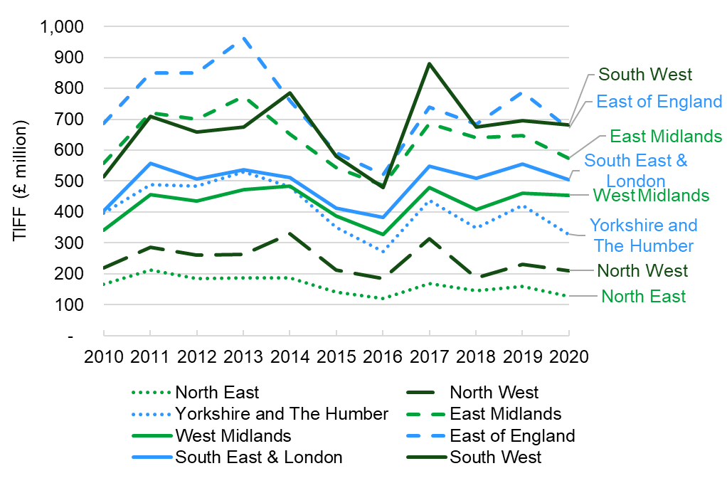
Figure 2.1 shows how TIFF has changed over time in each region. The values are in real terms, which means they have been adjusted for inflation. The trend is very similar in all eight regions. In almost every year, either the incomes in all regions went up, or they all went down. A rare exception to this was in 2014 which saw contrasting fortunes for crops and dairy. As a result, the dairy reliant North West and South West saw an increase in TIFF whereas TIFF fell in the East of England and the East Midlands. More analysis of the trends in TIFF for England as a whole can be found in the ‘Total income from farming in England’ statistical release.
To simplify and characterise the results, the regions can be considered to be clustered into three groups with TIFF broadly around £200 million (North East, North West), £400 million (Yorkshire and The Humber, West Midlands, South East) and £700 million (East of England, East Midlands, South West). These clusters have remained fairly distinct over time. Aside from this, the trends over 2010-20 have been very consistent between regions and the order of the regions when ranked by TIFF has remained almost constant.
Depending on external drivers (particularly commodity prices), some farm types can have a profitable year whilst other types have a difficult year. A typical example is when cereal prices are high, arable farms benefit whereas livestock farms can suffer as a result of higher feed prices. Whilst the fortunes of each farm type can vary drastically from year to year, the regional distribution of these farm types varies very little over time, even over a whole decade. There are widely recognised regional variations in the prevalence of farm types, with more dairy and grazing livestock production in the West and more cropping in the East. However, the data suggests that most of the time, regional fortunes are aligned.
One feature of Figure 2.1 which stands out is the sharp rise in TIFF for the South West between 2016 and 2017. TIFF rose for all regions between 2016 and 2017 and one reason for this was a considerable increase in milk prices, to which the South West has a large exposure. In addition to this, the region saw a big increase in its share of the plants and flowers sector in the same year.

Figure 2.2: The share of Total Income from Farming accounted for by Direct Payments, for the regions of England, 2010-20
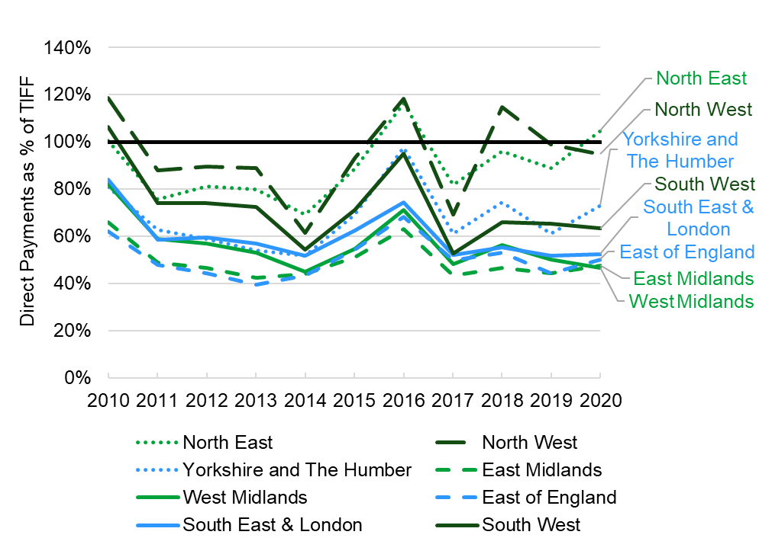
As presented in Figure 2.1, TIFF is volatile and has large fluctuations year to year. Direct Payments (referred to as ‘Other subsidies (less taxes) not linked to production’ in the datasets) have been much more stable, particularly since 2014, following a real terms drop in total Direct Payments for England of 22% between 2010 and 2014. When Direct Payments are considered on a per hectare of farmed land (in 2016) basis, there are slight differences between regions, with slightly higher rates in the East of England and South West and lower rates in the North East, North West and Yorkshire & The Humber. The regions with the highest rate of Direct Payments per hectare of farmed land receive roughly 10-15% more per hectare than the lowest. This is likely to be due to slightly lower rates of Basic Payment per hectare on upland areas, which are concentrated in the northern regions and eligibility for different agri-environment schemes. These NUTS1 regional shares of Direct Payments barely changed between 2016 and 2020, although users should be aware that in the absence of earlier data, Direct Payments in the 2010-15 accounts have been given the same regional split as was observed in 2016.
Figure 2.2 shows that all regions were reliant on Direct Payments for a large proportion of Total Income from Farming (TIFF), in all years. Direct Payments accounted for at least 47% of TIFF in all regions in 2020. The North East is the only region for which Direct Payments were greater than TIFF in 2020, though North West was at 95%. This means that without Direct Payments, TIFF for the North East would have been negative in 2020.
The East Midlands, East of England and West Midlands have generally been least reliant on Direct Payments, although were still regularly around the 50% mark between 2010-20. In every year 2011-20, the North East and North West were the regions most reliant on Direct Payments and both regions have at times been reliant on Direct Payments to keep TIFF positive.

Section 3 - How did different outputs vary between regions in 2020?

3.1 Definition of output groups
The agricultural accounts capture all farm production and thus cover a large and diverse range of outputs. In the agricultural accounts, these outputs are combined into sub-categories and categories in a hierarchy, for example wheat falls into the sub-total for “cereals” and cereals into the category “crops”. As a result, making comparisons for all output items across eight regions is complex and difficult to present clearly. To simplify this presentation and aid analysis and interpretation, outputs have been grouped into six clear and logical groups (see Table 4.1.1).

Table 3.1.1 Output group names and their component account items
Group name | Component account items
Combinables & Sugar Beet | Cereals  Industrial crops  Forage Plants  Other crop products (straw)
Veg, Hort & Potatoes | Vegetables and Horticultural Products  Potatoes  Fruit
Pigs & Poultry (1) | Pigs  Poultry-meat  Eggs
Beef & Sheep (1) | Cattle  Sheep and goats  Other (minor) livestock and livestock products
Dairy | Milk (excluding goats milk)
Diversification | Other non-separable secondary activities  Equines
- All animal production excludes Gross Fixed Capital Formation.

The account items shown in Table 3.1.1. all contribute to ‘Gross Output at basic prices’. However, there are some additional account items, which also contribute to ‘Gross Output at basic prices’, that have been excluded from this analysis of output groups. They are as follows:
Table 3.1.2 Account items excluded from the Output Groups
Account item | Reason for Exclusion
Gross Fixed Capital Formation (GFCF) in livestock | This is an accounting tool and is counterbalanced by ‘Consumption of Fixed Capital’ (CFC) on the other side of the account.
Agricultural Services | This represents contracting and is exactly netted off on the other side of the account as the agricultural industry is both the provider and consumer of these services.
Total subsidies on product. (These are subsidies linked directly to production.) | These have been zero for England since 2012 and were very small in 2010 and 2011.

3.2 Output groups by NUTS1 region
This section looks at variation of outputs between regions at NUTS1 level (Government Office Region).
Figure 3.2.1 Value of output groups by region, 2020 (£ million)

Figure 3.2.1 shows that whilst there are clear regional differences in the scale of output values, all regions had some level of production for all six groups.
Key points for output groups in 2020 include:
- The largest contributions in an individual region were made by Dairy in the South West (£1.1 billion) and ‘Combinables & Sugar Beet’ in the East of England (£1.0 billion).
- The West Midlands had the most balanced outputs, with all five agricultural categories contributing between £301 million and £534 million each.
- The East of England and the East Midlands both had similar output patterns, with a prevalence of ‘Combinables & Sugar Beet’, ‘Veg, Hort & Potatoes’ and ‘Pigs and Poultry’. The contributions of grazing livestock (Dairy and ‘Beef & Sheep’) were much lower.
- In spite of a small overall contribution to TIFF (3.6%), the North East made a more significant contribution to England ‘Beef and Sheep’ output, at around 8.7%. Similarly, whilst the North West contributes 5.9% to England’s TIFF, it had a 25% share of England Dairy output.
- The value of ‘Beef & Sheep’ output was similar (around £200 million) in both the North East and the East Midlands. However, Beef & Sheep represented the largest output in the North East, whereas three outputs in the East Midlands (‘Combinables & Sugar Beet’, ‘Veg, Hort & Potatoes’ and ‘Pigs & Poultry’) were worth at least three times as much.
- ‘Diversification’ made the smallest contribution to output in every region apart from North East, East of England and South East.

3.3 Regional variations at a finer spatial scale
This section looks at variation between regions at NUTS 3 level (County and Unitary Authority).
This is a more detailed geographical level than covered in the rest of this statistical notice. A subset of the agricultural accounts at NUTS3 level is available in a dataset that accompanies this notice. Mapping using NUTS3 conveys far more information than at NUTS1 level, however, NUTS3 estimates are derived using data from fewer observations and so are more uncertain. NUTS3 territories with very low levels of farming have been amalgamated with neighbouring NUTS3 territories to avoid any risk of disclosing confidential data. Therefore, the information displayed for some of the smaller territories marked on the map represents estimates for larger, amalgamated territories. The accompanying dataset provides the details of these amalgamations.

Figure 3.3.1: Total Income from Farming per hectare of farmed land in 2020, by NUTS3 territory

Figure 3.3.1 shows Total Income from Farming per hectare of farmed land at NUTS3 level. The thicker lines denote NUTS1 regions whereas the finer lines separate NUTS3 territories. Around 60% of farmed land is in NUTS3s that had a TIFF per hectare of farmed land of between £200 and £400, with a few areas having much higher returns. Users should note that the map depicts TIFF per hectare of farmed land and the concentration of farmed land as a proportion of all land will vary between NUTS3 territories. The differences observed are largely related to the types of farming present. The areas with the lowest TIFF per hectare of farmed land are predominantly grazing livestock areas in the north of England and south west. Most of these NUTS3 territories include upland areas where geographical and climatic challenges restrict farming options and lead to an extensive approach that will lower returns per hectare used.
The darker areas with higher TIFF per hectare of farmed land all have significant concentrations of intensive livestock (pigs and poultry) or intensive horticulture. Wakefield and North Hampshire have significant output from pigs and poultry. Kent, Cornwall and South West Lancashire are hotspots for horticulture (production of fruit, vegetable or ornamentals), whilst some areas such as Norfolk, Lincolnshire, Herefordshire and Telford have concentrations of both intensive horticulture and intensive livestock. Users should be aware that making accurate estimates for intensive sectors such as pigs, poultry and horticulture is difficult due to the structure of those industries and therefore extra caution should be observed when considering these figures.
Figure 3.3.2 depicts the output group (see Section 3.1 for definitions) with the highest monetary output within each NUTS3 territory. The thicker lines denote NUTS1 regions whereas the finer lines separate NUTS3 territories. There are clear geographical concentrations of the output groups with Dairy dominant in many western areas and Combinables & Sugar Beet or Pigs & Poultry dominant in many eastern areas. However, within each NUTS1 region, there are at least three different dominant output groups in the individual NUTS3 territories. Areas dominated by Veg, Hort & Potatoes are scattered around, though there is a cluster in the far south east of England. Beef & Sheep dominates only in the upland areas of the North East and the Pennines. Users should note that ‘dominant’ output groups have different output shares in each NUTS3 territory, though this information is not displayed by the map.

Figure 3.3.2: Output Group with highest value in 2020, by NUTS3 territory

Section 4 - Regional Profiles

4.1 Regional profile introduction and user guide

4.1.1 Regional profile introduction
Each of the eight NUTS1 regions (London is included with the South East) have a one-page profile presented in this section. The profiles are designed to provide an overview of the dominant types of agriculture in each region and their financial importance in 2020 and earlier years. A user guide based on a fictitious ‘Region X’ is presented in 4.1.2 to help explain the content and details of the profile sheets.
4.1.2 Regional profile user guide
Table 4.X: Key statistics for Region X in 2020
 |  | 2020 (£m) | % of England | 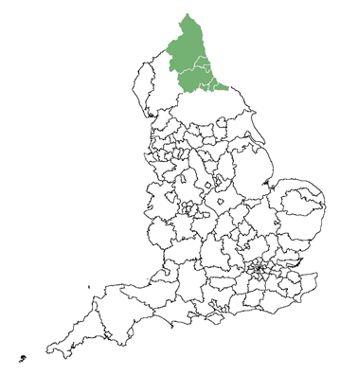  Region is highlighted on map of England.
Gross output at basic prices  Gross output also includes GFCF and Agricultural Services. |  | 759 | 4%
of which: | Combinables & Sugar Beet | 195 | 4%
 | Veg, Hort & Potatoes | 28 | 1%  The full account for each region is in the accompanying dataset.
 | Pigs & Poultry | 72 | 2%
 | Dairy | 33 | 1%
 | Beef & Sheep | 234 | 11%
 | Diversification | 86 | 7%
Total intermediate consumption |  | 557 | 5%
Gross value added at basic prices |  | 202 | 3%
Direct payments |  | 144 | 7%
Total Income from Farming |  | 64 | 2%

Figure 4.X.1: Value of output groups in Region X, 2020 (£ million)
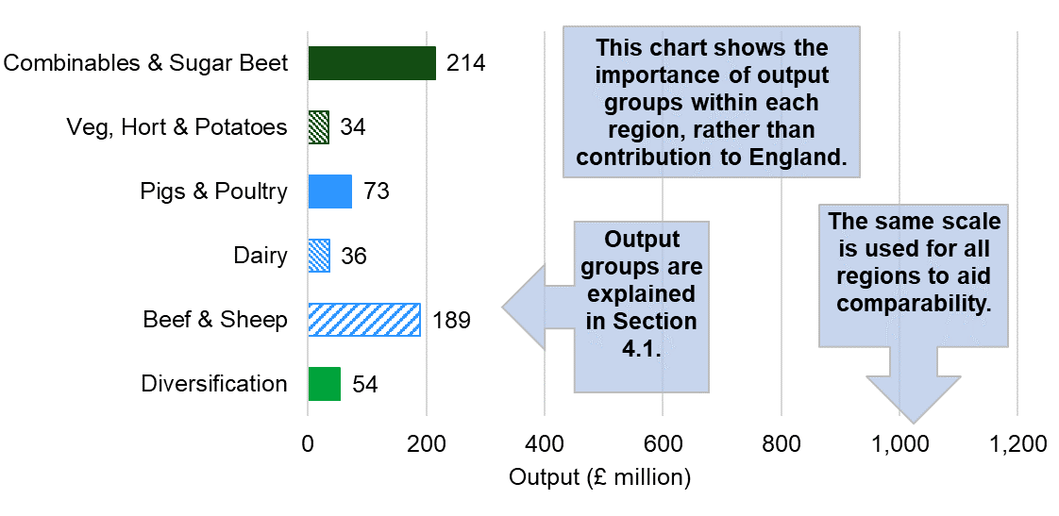
Figure 4.X.2 Share of 'total' output value for Region X, 2010-20, real terms
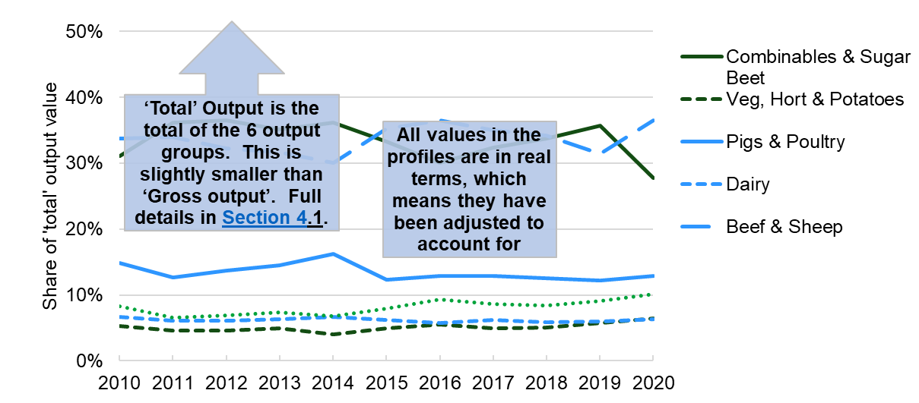
Key points give an overview of the region and how it compares to others.

Key Points for the Region X region: Key points text for Region X. Key points text for Region X. Key points text for Region X. Key points text for Region X. Key points text for Region X. Key points text for Region X. Key points text for Region X. Key points text for Region X. Key points text for Region X. Key points text for Region X. Key points text for Region X. Key points text for Region X.

4.2 North East regional profile
Table 4.2.1: Key statistics for the North East region in 2020
 |  | 2020 (£m) | % of England
Gross output at basic prices |  | 611 | 3%
of which: | Combinables & Sugar Beet | 147 | 4%
 | Veg, Hort & Potatoes | 34 | 1%
 | Pigs & Poultry | 68 | 2%
 | Dairy | 33 | 1%
 | Beef & Sheep | 192 | 9%
 | Diversification | 53 | 5%
Total intermediate consumption |  | 391 | 3%
Gross value added at basic prices |  | 220 | 3%
Direct payments |  | 134 | 6%
Total Income from Farming |  | 128 | 4%

Figure 4.2.1: Value of output groups in the North East, 2020 (£ million)

Figure 4.2.2 Share of 'total' output value for the North East, 2010-20, real terms
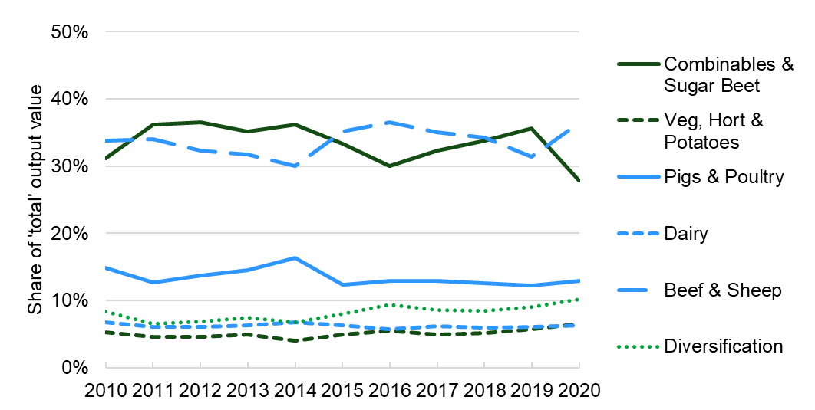

Key Points for the North East region: From 2010-20, the North East had the lowest TIFF of all regions. When its relatively small farmed area is taken into account by using a ‘per hectare’ measure, it has consistently had a similar TIFF per ha to the North West, but lower than all the other regions. The NE is heavily reliant on output from ‘Combinables & Sugar Beet’ and ‘Beef & Sheep’ and has very little output from ‘Veg, Hort & Potatoes’ and Dairy. Direct Payments are included in TIFF and without their contribution, TIFF for the North East would have been negative in some years, including 2020.

4.3 North West regional profile
Table 4.3.1: Key statistics for the North West region in 2020
 |  | 2020 (£m) | % of England | 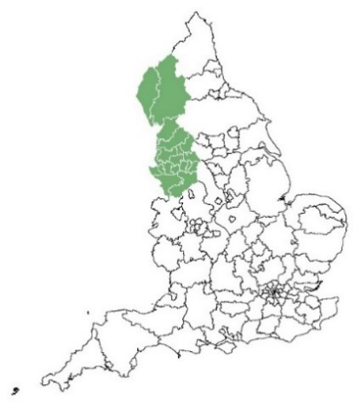
Gross output at basic prices |  | 1,893 | 10%
of which: | Combinables & Sugar Beet | 96 | 3%
 | Veg, Hort & Potatoes | 166 | 4%
 | Pigs & Poultry | 241 | 6%
 | Dairy | 733 | 25%
 | Beef & Sheep | 345 | 16%
 | Diversification | 70 | 6%
Total intermediate consumption |  | 1,240 | 10%
Gross value added at basic prices |  | 653 | 9%
Direct payments |  | 199 | 10%
Total Income from Farming |  | 210 | 6%

Figure 4.3.1: Value of output groups in the North West, 2020 (£ million)

Figure 4.3.2 Share of 'total' output value for the North West, 2010-20, real terms
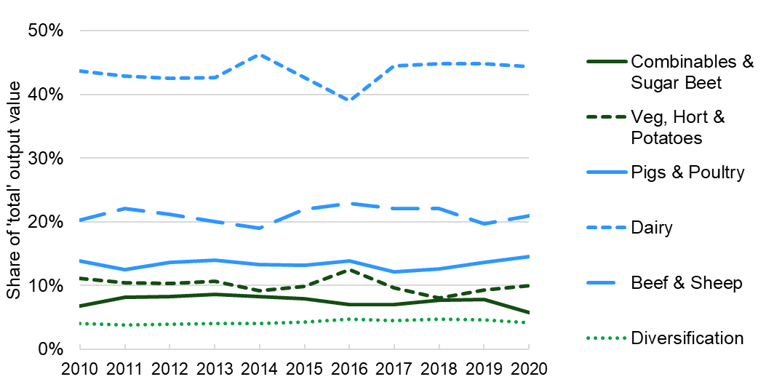
Key Points for the North West region: From 2010, the North West has had the second lowest TIFF of all regions. When farmed area is taken into account by using a ‘per hectare’ measure, it has consistently had a similar TIFF per ha to the North East, but lower than all the other regions. Dairy dominates output in the North West, contributing about 45% of total output in most years. The region was responsible for 25% of England Dairy output in 2020 and 16% of Beef and Sheep output. The North West has consistently accounted for the second highest output from sheep, behind South West. Cropping of all kinds is very limited due to the relatively cold and wet climate and significant upland areas in the north of the region. Direct Payments are included in TIFF and without their contribution, TIFF for the North West would have been negative in some years, but not 2020.

4.4 Yorkshire & The Humber regional profile
Table 4.4.1: Key statistics for the Yorkshire & The Humber region in 2020
 |  | 2020 (£m) | % of England | 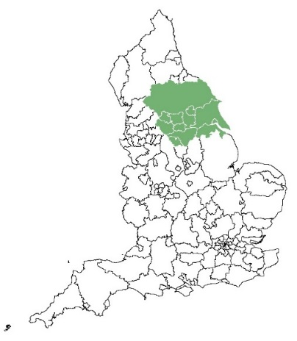
Gross output at basic prices |  | 2,402 | 12%
of which: | Combinables & Sugar Beet | 476 | 13%
 | Veg, Hort & Potatoes | 357 | 9%
 | Pigs & Poultry | 747 | 19%
 | Dairy | 208 | 7%
 | Beef & Sheep | 277 | 13%
 | Diversification | 126 | 11%
Total intermediate consumption |  | 1,567 | 13%
Gross value added at basic prices |  | 835 | 11%
Direct payments |  | 240 | 11%
Total Income from Farming |  | 328 | 9%

Figure 4.4.1: Value of output groups in Yorkshire & The Humber, 2020 (£ million)

Figure 4.4.2 Share of 'total' output value for Yorkshire & The Humber, 2010-20, real terms
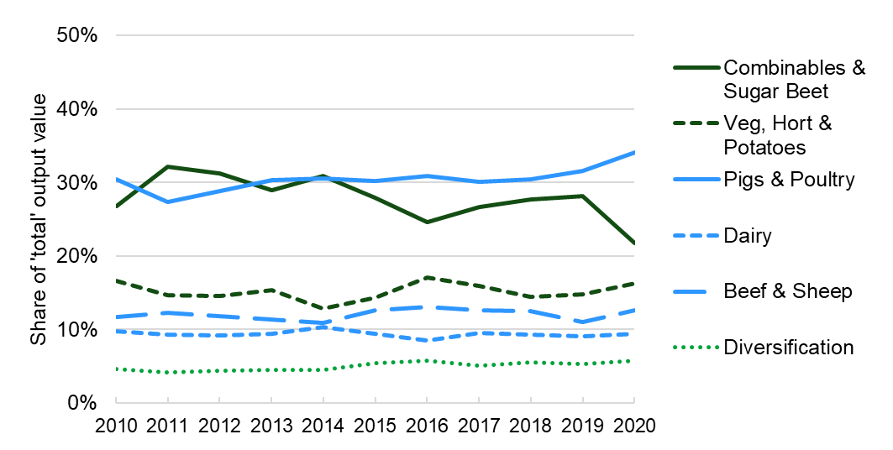

Key Points for the Yorkshire & The Humber region: From 2015-20, the Yorkshire & The Humber region has had both the third lowest TIFF and third lowest TIFF per hectare of agricultural land. ‘Combinables & Sugar Beet’ and ‘Pigs & Poultry’ are the main contributors to output in the region, with each accounting for roughly 30% between 2010 and 2019 before diverging in 2020 in favour of ‘Pigs & Poultry’. Yorkshire & the Humber consistently has the highest absolute output of any region from Pigs and by a considerable margin. The region is quite varied with upland areas in the north and west most suitable for Dairy and Beef & Sheep and areas more suitable for arable in the south and east.

4.5 East Midlands regional profile
Table 4.5.1: Key statistics for the East Midlands region in 2020
 |  | 2020 (£m) | % of England | 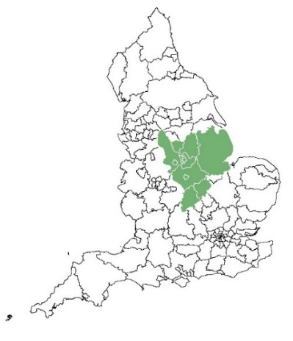
Gross output at basic prices |  | 2,830 | 14%
of which: | Combinables & Sugar Beet | 665 | 18%
 | Veg, Hort & Potatoes | 719 | 18%
 | Pigs & Poultry | 654 | 17%
 | Dairy | 191 | 7%
 | Beef & Sheep | 211 | 10%
 | Diversification | 161 | 15%
Total intermediate consumption |  | 1,689 | 14%
Gross value added at basic prices |  | 1,141 | 15%
Direct payments |  | 274 | 13%
Total Income from Farming |  | 574 | 16%

Figure 4.5.1: Value of output groups in the East Midlands, 2020 (£ million)

Figure 4.5.2 Share of 'total' output value for the East Midlands, 2010-20, real terms
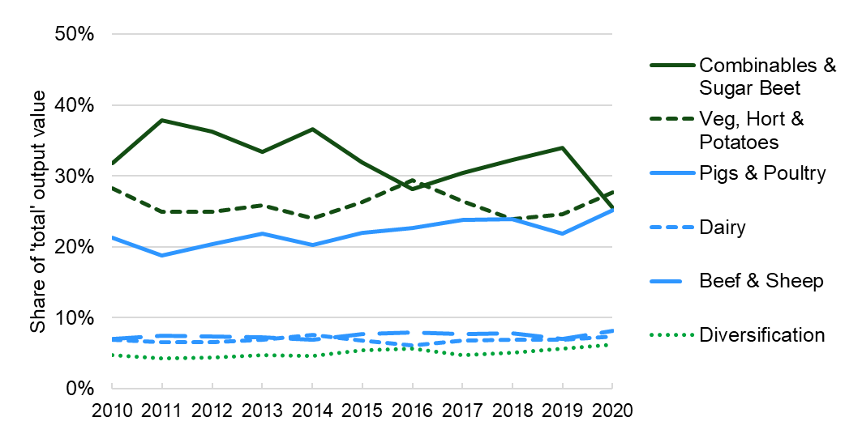

Key Points for the East Midlands region: TIFF and TIFF per hectare have been consistently high in the East Midlands, driven by output from cropping and poultry. Lincolnshire is a particularly high output area with a TIFF comparable to several entire NUTS1 regions. Dairy and ‘Beef & Sheep’ have contributed only 5-10% to regional output over the period 2010-20, but in absolute terms these were still each worth around £200 million in 2020. Derbyshire accounts for approximately half of the dairy output in the region and is more similar to counties to its west than the rest of the East Midlands region.

4.6 West Midlands regional profile
Table 4.6.1: Key statistics for the West Midlands region in 2020
 |  | 2020 (£m) | % of England | 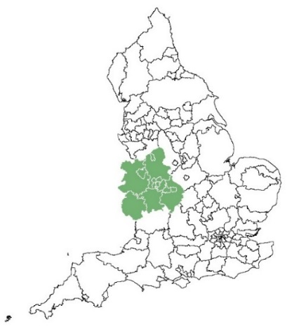
Gross output at basic prices |  | 2,445 | 13%
of which: | Combinables & Sugar Beet | 324 | 9%
 | Veg, Hort & Potatoes | 508 | 13%
 | Pigs & Poultry | 534 | 14%
 | Dairy | 412 | 14%
 | Beef & Sheep | 301 | 14%
 | Diversification | 124 | 11%
Total intermediate consumption |  | 1,456 | 12%
Gross value added at basic prices |  | 989 | 13%
Direct payments |  | 213 | 10%
Total Income from Farming |  | 455 | 13%

Figure 4.6.1: Value of output groups in the West Midlands, 2020 (£ million)

Figure 4.6.2 Share of 'total' output value for the West Midlands, 2010-20, real terms
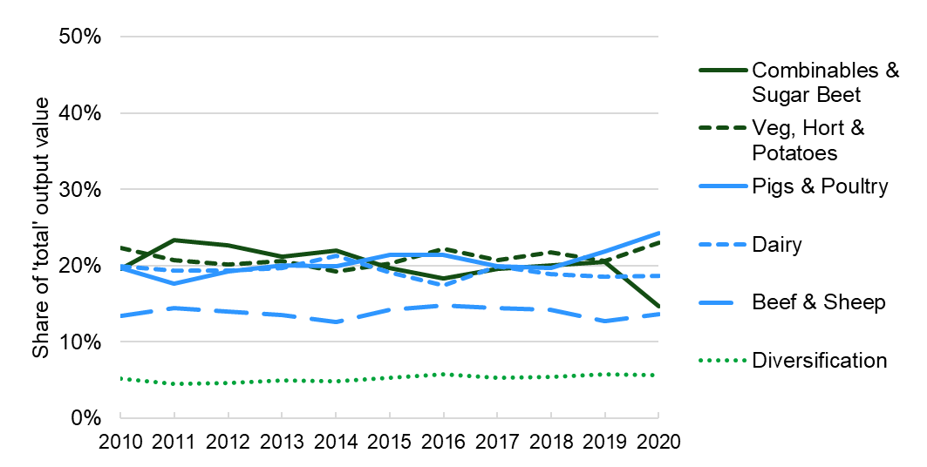
Key Points for the West Midlands region: The West Midlands had the highest TIFF per ha of all regions in 2020, but was always behind the East Midlands and the East of England for 2010-19. The West Midlands is the region with the most balanced range of outputs which has helped it maintain a consistent TIFF of around £400m in real terms. ‘Combinables & Sugar Beet’, ‘Veg, Hort & Potatoes’, ‘Pigs & Poultry’ and Dairy have all consistently made roughly a 20% contribution to output, though the contribution of ‘Combinables & Sugar Beet’ dropped in 2020. The south west of the region is one of the main fruit producing areas in England and the north of the region has a high concentration of dairy activity.

4.7 East of England regional profile
Table 4.7.1: Key statistics for the East of England region in 2020
 |  | 2020 (£m) | % of England | 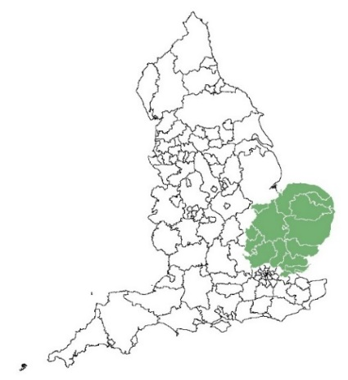
Gross output at basic prices |  | 3,364 | 17%
of which: | Combinables & Sugar Beet | 997 | 28%
 | Veg, Hort & Potatoes | 866 | 22%
 | Pigs & Poultry | 932 | 24%
 | Dairy | 39 | 1%
 | Beef & Sheep | 87 | 4%
 | Diversification | 200 | 18%
Total intermediate consumption |  | 2,039 | 17%
Gross value added at basic prices |  | 1,325 | 17%
Direct payments |  | 337 | 16%
Total Income from Farming |  | 671 | 19%

Figure 4.7.1: Value of output groups in the East of England, 2020 (£ million)

Figure 4.7.2 Share of 'total' output value for the East of England, 2010-20, real terms
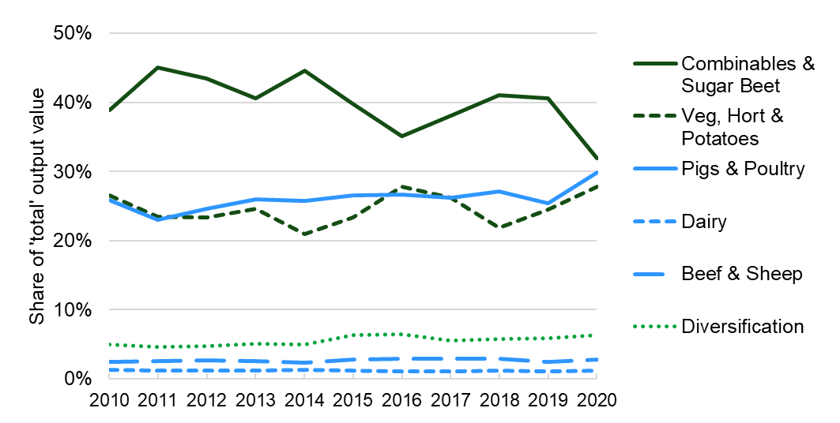

Key Points for the East of England region: This region has had either the highest or second highest TIFF of any region in every year from 2010-20, contributing 19% of England TIFF in 2020. In 2020, the East of England made the biggest regional contribution to total England output for ‘Combinables & Sugar Beet’ (28%), ‘Pigs & Poultry’ (24%) and ‘Veg, Hort & Potatoes’ (22%). Conversely there is very little in the way of output from Beef & Sheep and almost no Dairy with the dry climate, fertile soils and absence of uplands being much better suited to arable farming. The region is the primary sugar beet producing area of England.

4.8 South East including London regional profile
Table 4.8.1: Key statistics for the South East region in 2020
 |  | 2020 (£m) | % of England | 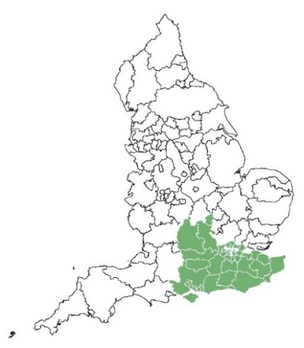
Gross output at basic prices |  | 1,996 | 10%
of which: | Combinables & Sugar Beet | 479 | 13%
 | Veg, Hort & Potatoes | 619 | 15%
 | Pigs & Poultry | 218 | 6%
 | Dairy | 155 | 5%
 | Beef & Sheep | 189 | 9%
 | Diversification | 169 | 15%
Total intermediate consumption |  | 1,135 | 9%
Gross value added at basic prices |  | 861 | 11%
Direct payments |  | 265 | 13%
Total Income from Farming |  | 504 | 14%

Figure 4.8.1: Value of output groups in the South East, 2020 (£ million)

Figure 4.8.2 Share of 'total' output value for the South East, 2010-20, real terms
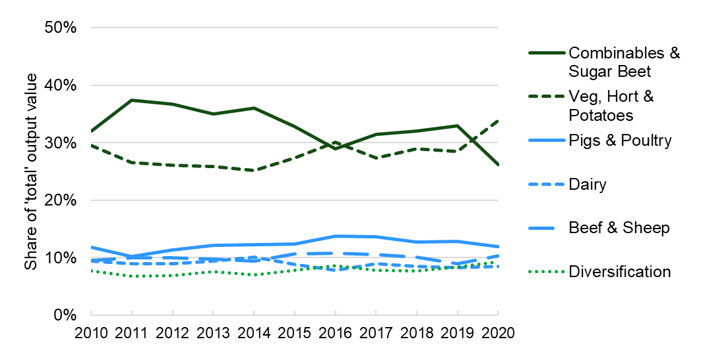
Key Points for the South East region: The majority of agricultural output in the South East region is from cropping, with ‘Veg, Hort & Potatoes’ responsible for a bigger share of regional output (34%) than in any other region in 2020. In common with the East Midlands and the East of England which also generate the majority of their output from cropping, the South East & London has little in the way of Dairy or Beef & Sheep, but also lacks significant output from Pigs & Poultry. In 2020, Pigs & Poultry accounted for just 12% of output for the region, less than in any other region.

4.9 South West regional profile
Table 4.9.1: Key statistics for the South West region in 2020
 |  | 2020 (£m) | % of England | 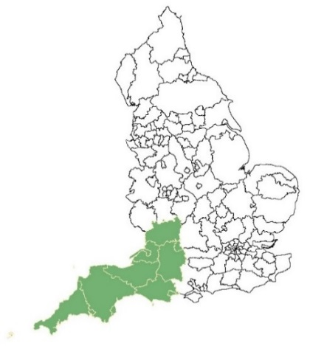
Gross output at basic prices |  | 4,004 | 20%
of which: | Combinables & Sugar Beet | 425 | 12%
 | Veg, Hort & Potatoes | 746 | 19%
 | Pigs & Poultry | 465 | 12%
 | Dairy | 1,123 | 39%
 | Beef & Sheep | 598 | 27%
 | Diversification | 208 | 19%
Total intermediate consumption |  | 2,453 | 20%
Gross value added at basic prices |  | 1,550 | 20%
Direct payments |  | 432 | 21%
Total Income from Farming |  | 682 | 19%

Figure 4.9.1: Value of output groups in the South West, 2020 (£ million)

Figure 4.9.2 Share of 'total' output value for the South West, 2010-20, real terms
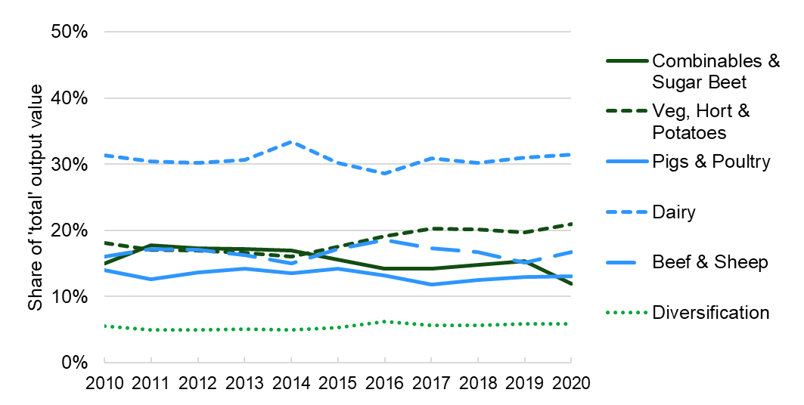

Key Points for the South West region: The South West has been in the top three regions for TIFF every year throughout 2010-20 and top in some years, including 2020. However, it has the largest farmed area and TIFF per hectare was lower than the England average in every year except for 2017, partly due to the limitations of upland areas in Devon, Cornwall and Somerset. Output from Dairy was £1.1 billion in 2020, equating to 31% of the region’s total output and 39% of England Dairy output. The South West also had a higher output from ‘Plants and Flowers’ (a contributor to ‘Veg, Hort & Potatoes’) than any other region during 2010-20, most of which is found in Cornwall.

Section 5 - About these statistics

5.1 Methodology for regional production and income accounts
This release contains regional breakdowns of the England agricultural account, which is published in a separate release and contains information about the methodology used. Please consult the most recent England release for details of revisions to the England agricultural account between the 1st and 2nd estimates.
The regional accounts for England are constructed by apportioning each account item value (£) for England to the 133 NUTS3 territories (County/unitary authorities) using coefficients derived mostly from Farm Business Survey (FBS) and June Survey of Agriculture and Horticulture (‘June Survey’) data. The FBS records detailed annual account data from a relatively small panel of farms whereas the June Survey records a snapshot of crop areas and livestock numbers as at June 1st each year. NUTS1 (regional) and NUTS2 estimates are then derived through aggregation of NUTS3 account values.
Apportionment of England output account items to NUTS3 level
For almost all output items, June Survey data has been used for the geographical location of crop areas and livestock counts. The most appropriate June Survey item has been matched with each account item, which can be done well for almost all account items of significant value. See ‘Apportionment of other account items to NUTS3 level’ below for exceptions.
Apportionment of England cost account items to NUTS3 level
The best source of cost data is the FBS. Due to its small sample size, FBS data becomes less reliable when split down to NUTS3 level. Therefore, for almost all account items relating to cost, farm typology has been used to provide a link between FBS cost data and output account items for which we have relevant NUTS3 data. This allocation has been weighted by the values of outputs relevant to each cost, to account for differences in the scale and composition of farms of the same farm type in different geographical areas.
Apportionment of other account items to NUTS3 level
A few significant account items required different approaches. Output from ‘Inseparable non-agricultural activities’ (diversification) is apportioned between the regions using FBS data as there is no suitable item on the June Survey.
Both output values and costs for ‘Agricultural Services’ are apportioned using contracting expenses from the FBS. The same value for Agricultural Services appears as both an output and a cost in the account, so whilst the split is relevant when just considering outputs (or costs), overall, this item has no impact on TIFF. Gross Fixed Capital Formation (GFCF) and Consumption of Fixed Capital (CFC) in animals have been apportioned using June Survey items relating to breeding animals.
‘Direct payments’ (farm subsidies) are apportioned using detailed NUTS3 payments data from the Rural Payments Agency (RPA) which is thought to be highly accurate.
Limitations of data sources
The Farm Business Survey (FBS) is based on an accounting year from March to February rather than calendar years. Testing with calendar year estimates constructed from two FBS years suggested negligible impact and therefore the FBS year with a 10 month overlap is used as a proxy for calendar years. For example, FBS year 2020-21 (March 2020 to February 2021) is used as a proxy for 2020.
When first estimates are produced, FBS data for the most recent year of agricultural accounts is not available. Therefore all cost items and the output from diversification item have to be allocated using data from the previous FBS year as a proxy.
Some enterprises are recognised as being particularly difficult to collect accurate regional data for. In particular, intensive pigs, intensive poultry and horticulture (ornamentals, fruit and vegetables). These sectors are highly concentrated and often part of large countrywide businesses making them difficult to capture and represent accurately in both the June Survey and FBS, particularly with respect to location. Furthermore, stock numbers may fluctuate greatly in intensive livestock systems, so numbers recorded on 1 June (in the June Survey) may not accurately reflect the annual picture. Therefore users should exercise extra caution when considering regional estimates for these sectors.
Some data from the June Survey was collected in a different format prior to 2013. Therefore June Survey data for 2013 has been used to apportion the accounts for 2010-12. Similarly, detailed Direct Payments data is not available prior to 2016, therefore the 2016 split has been used for 2010-15.
The methodology for the regional agricultural accounts is complex and users wishing to deepen their understanding should contact the Defra Farm Accounts mailbox.
Limitations to reliability of the estimates
Assumptions have had to be made about the level of variation within account items between geographical regions. In several cases, the account items that are being apportioned between regions are quite broad. Examples are ‘Fresh vegetables’, ‘Fresh fruit’, ‘Cattle’, ‘Pigs’, ‘Sheep and goats’ and ‘Poultry’ (meat). These will each cover several different types of crops/livestock, which are likely to have different values and costs per hectare/head and concentrations that vary by location. Even where account items represent a single crop (e.g. wheat), there will, in reality be different yields and prices per hectare depending on factors such as climate, soil, use, local demand etc. A perfect model would include all of these variables, however, in most cases there is insufficient data to construct such a model.
Testing of the methodology has explored the impact of making additional assumptions about the values of different groups within single account items (for example poultry, where higher value turkeys, ducks and geese are concentrated in the East of England). This testing concluded that the impact on regional (NUTS1) TIFF was not sufficient to justify the extra complexity. Therefore, for the purpose of the regional accounts, the units used to apportion account items are assumed to be identical across regions. For example a sheep in Cumbria is considered to be identical to a sheep in Devon and a hectare of wheat in Northumberland is considered to be identical to a hectare of wheat in Hampshire.
The simplifications made under this methodology may reduce accuracy and the level of uncertainty will increase at finer spatial resolutions. Users should give consideration to these limitations when using these results and drawing conclusions, particularly at NUTS3.
Level of detail of items within the accounts
Steps have been taken to prevent the publication of results with a very high level of uncertainty and also to avoid disclosure of data for individual farmers. Whilst the full account is published at NUTS1 level, some of the more minor items are not shown at NUTS2 level and at NUTS3 level and only headline figures are shown. For the same reasons, geographical areas have been aggregated with neighbours to ensure that they contain at least 100 farms and 10,000ha of farmland. (This is based on the 2016 June Survey, which is the last time the survey was conducted with an enhanced sample size and therefore is considered to be more accurate than more recent surveys). At NUTS2 level this impacts only on London, however at NUTS3 level, 133 territories have been reduced to 80, creating a bespoke set of geographical territories. Despite this, users should be aware that the level of uncertainty will increase in smaller NUTS territories and that the physical area of NUTS territories varies enormously at both NUTS2 and NUTS3 levels.

5.2 Revisions due to new methodology
The 2020 1st estimates edition of this publication (17 November 2021) saw the introduction of a series of refinements to the methodology for apportioning items in the England accounts down to NUTS3 level. The same methodology has been used for the 2020 2nd estimates. The main improvements were the introduction of Rural Payments Agency (RPA) data for apportioning Direct Payments (subsidies) and the linking of costs only to outputs from enterprises likely to have consumed those inputs. The main impact is that costs have become more concentrated in more productive areas. As a result, areas with lower output per hectare of farmed land, such as upland areas attract a much smaller proportion of costs. In particular this benefits the North East and North West which receive a big boost to their Total Income from Farming (TIFF). Highly productive areas such as the East of England and East Midlands are hit by higher costs. Overall, this reduces the disparity between regions, compared to the previous methodology.

5.3 Quality Assurance
Defra has in place quality assurance processes to check the accuracy and reliability of the underlying aggregate agricultural accounts that include:
- Ongoing review of methods employed in the calculation of the accounts.
- Assessment of the quality of the estimates of components of the accounts with experts within Defra.
- Discussion of components of the accounts with external experts.
In April 2019, Defra carried out an internal formal quality assurance of the new methodology used to apportion the England agricultural accounts to regional level. This involved inspection of the mechanics used to calculate the coefficients as well as the suitability of the data sources used. The quality assurance process was conducted by two experienced Defra economic advisors who were not involved in the production of the agricultural accounts or the regional estimates, but had a solid understanding of the available data sources and potential uses of regional accounts. Although the methodology has been enhanced since the quality assurance was performed, most of the general principles and data sources are the same.

5.4 Summary quality report
A summary quality report for the underlying data on the Aggregate Agricultural Accounts and its statistical releases can be found on the GOV.UK website.
This is an overview note which is not release specific and was last updated in March 2019. It pulls together key qualitative information on the various dimensions of quality as well as providing a summary of methods used to compile the output. It relates to estimates of Total Income from Farming and aims to provide users with information on usability and fitness for purpose of these estimates.

5.5 Main users and uses of the aggregate agricultural accounts
The aggregate agricultural accounts are used both within government and by the wider agricultural industry in conjunction with other economic information to:
- Monitor the productivity and competitiveness of the farming industry.
- Inform policy decisions and to help monitor and evaluate current policies relating to agriculture in the UK by Government.
- Inform stakeholders of the performance of the agricultural industry.
- Inform research into the economic performance of the agricultural industry.

5.6 User engagement and feedback
As part of our ongoing commitment to compliance with the Code of Practice for Official Statistics, we wish to strengthen our engagement with users of these statistics and better understand the use made of them and the types of decisions that they inform. Consequently, we invite users to make themselves known, to advise us of the use they do, or might, make of these statistics, and what their wishes are in terms of engagement. Feedback on this notice and enquiries about these statistics are also welcome. Please complete this feedback form to tell us how you use this statistical notice. If you have any other feedback you wish to provide, please get in contact using the details provided in the ‘What you need to know about his release’ section of this publication.

