Economic Research into the Circumvention of Trade Remedies

Prepared by Frontier Economics for the UK Trade Remedies Authority

November 2022

Table of Contents
1 Executive summary 1
2 Introduction 10
2.1 Context and approach 10
2.2 Focus and structure of this research 15
3 A comparative international analysis of anti-circumvention 17
3.1 Circumvention in the broader context of trade remedies and international disciplines on trade remedies 17
3.1.1 Discussions on multilateral rules 17
3.1.2 Differences in perspective on what constitutes circumvention, and responses to it 18
3.2 Comparative assessment of the deep-dive countries 20
3.2.1 Circumventors and modes of circumvention 20
3.2.2 Other points of comparison 25
3.3 Conclusions on comparative analysis of anti-circumvention frameworks and cases 29
4 Data resources and methodologies for assessing circumvention 32
4.1 Introduction 32
4.2 Review of trade data sources 33
4.2.1 Context 33
4.2.2 International sources of trade data 34
4.2.3 National sources of trade data 35
4.3 Review of production data sources 36
4.3.1 Context 36
4.3.2 International sources of production data 36
4.3.3 National sources of production data 38
4.3.4 Dealing with limitations to official production data 41
5 Proof of concept and toolkit for circumvention investigations 43
5.1 Example 1: Application of UN Comtrade data to a past EU transhipment case 44
5.2 Example 2: Potential extension of trade remedy duties to continuous filament glass fibre products from PRC 54
5.2.1 Changes in the pattern of trade 54
5.2.2 Data and information on industrial organisation 62
5.2.3 Conclusions 63
5.3 Example 3: Potential extension of trade remedy duties to biodiesel from the United States and Canada 63
5.3.1 Changes in the pattern of trade 63
5.3.2 Data and information on industrial organisation 73
5.3.3 Conclusions 76
5.4 A toolkit for handling anti-circumvention cases 78
5.4.1 General framework 78
5.4.2 Implementing the framework through data sources and methodologies 79
5.5 Steps to implement the toolkit 84
5.6 Summing up 88
Annex 1 – Further information on deep dive jurisdictions 89
Deep-dive study of the European Union 89
Legal framework and processes 89
Examples of cases highlighting data and information gathered to meet the tests of the legal framework 94
Key descriptive statistics concerning EU anti-circumvention cases 97
Geographic patterns of circumvention cases in the EU 103
Summary observations relating to the EU 104
Deep-dive study of the United States 105
Legal framework and processes 105
Examples of cases which highlight data and information gathered to meet the tests of the legal framework 110
Key descriptive statistics concerning United States anti-circumvention cases 112
Geographic patterns of circumvention cases 118
Summary observations relating to the United States 119
Deep-dive study of Australia 120
Legal framework and processes 120
Examples of cases highlighting data and information gathered to meet the tests of the legal framework 121
Key descriptive statistics concerning Australian anti-circumvention cases 124
Summary observations regarding Australian anti-circumvention cases 127
Deep-dive study of Canada 128
Legal framework and processes 128
Further observations based on past scope reviews 130
Annex 2 – Data on anti-circumvention actions in other jurisdictions 132
Annex 3 – Quantity analysis from Example 1: The application of UN Comtrade data to a past EU transhipment case 140
Annex 4 – Supplementary charts from Example 2: Potential extension of trade remedy duties to continuous glass fibre from PRC 143
Annex 5 – Supplementary charts and discussion from Example 3: Potential extension of trade remedy duties to biodiesel from the United States and Canada 147

Disclaimer: This report has been prepared by Frontier Economics. All views and analysis are the sole responsibility of Frontier Economics and should not necessarily be attributed to the UK Trade Remedies Authority (TRA) or to any of the authorities in the countries reviewed.

1 Executive summary
What do we mean by the circumvention of trade remedies?
Global trade rules permit, but do not require, countries to undertake trade remedy measures. These include the imposition of temporary duties through anti-dumping or countervailing action. Because such duties are product- and firm-specific, they create incentives for businesses to exploit the “wedge” between world and protected prices by circumventing the duties.
There is no internationally settled definition of circumvention in the context of trade remedies. The United Kingdom (UK) follows the approach of the European Union (EU) and defines circumvention as arising when there is a change in the pattern of trade that results from specific activities undertaken by businesses for the specific purpose of avoiding the payment of duties resulting from the imposition of duties. Most other jurisdictions that recognise the concept of circumvention in their legislation follow a similar approach, i.e. they attempt to link a change in the pattern of trade to certain identified activities. Jurisdictions vary in terms of the activities that are considered, the methodologies for assessing that these activities are taking place and evidentiary requirements. Various attempts at developing multilateral rules on anti-circumvention action have thus far failed because of divergences in views regarding the definition and indeed materiality of circumvention.
Why do we need an economic analysis of approaches to circumvention?
Most jurisdictions require an analysis of changes to trade patterns as a starting point of circumvention investigations. This is a legal stipulation that requires empirical analysis. The analysis will need to take into account the fact that a range of economic factors can drive changes in trade patterns. In particular, duties, including trade remedy duties, can lead businesses to relocate investment and production for reasons that are consistent with economic efficiency. Indeed, empirical analysis shows that trade remedy duties are associated with trade diversion and trade deflection in a manner analogous to the effects of tariff preferences.
Such changes are not a form of circumvention. Mistakenly extending trade remedy duties on the imports of new products and/or countries could lead jurisdictions to violate their World Trade Organization commitments and is likely to amplify the economic harms generally attributed to trade remedies and other forms of contingent protection. It is therefore in the UK’s interest to develop a methodological toolkit that allows it to ascertain when genuine circumstances of circumvention arise. Moreover, this concern dovetails with the rationale underpinning the economic interest test that the Trade Remedies Authority is required to follow. A flawed decision on circumvention may undermine the calculus of interests underpinning the original duty.
What we know about products that are subject to anti-circumvention duties
We considered anti-circumvention action in a range of jurisdictions, with a particular focus on the EU, the United States, Canada and Australia. Each of these jurisdictions has specific frameworks for circumvention. One common feature that emerges is the relative degree of concentration of product categories that fare subject to anti-circumvention duties. Figure 1 below uses the data for the period from 2009 to 2021 to report the number of products within product chapters at the Harmonised System (HS) 2-digit level that have been the object of circumvention duties.
Figure 1: Number of times product groups have been subject to duties, 2009-2021
Source: Frontier Economic analysis based on information retrieved from the jurisdictions, Global Trade Alert and secondary research. Product groupings based on HS chapters as follows: Food and foodstuffs (HS chapters 15,17,21); Minerals and chemicals (27,28,29,38); Plastics (39); Paper (48); Textiles (63); Glassware (70); Iron and steel (72); Articles of Iron and Steel (73); Other base metals and articles thereof (76,81); Nuclear and electrical machinery (84, 85); Vehicles (87); Furniture (94); Miscellaneous Manufactured Articles (95,96)
The distribution can already help to identify risks in relation to particular products. The experience of the EU is particularly relevant for the UK given commonalities in trade structure and routes with the EU, and that it has adopted a similar trade remedy regime. This experience also suggests that the most common form of circumvention the UK will likely encounter is through third-party assembly operations and transhipment.
What countries are involved in circumvention?
The country most frequently engaged in circumvention in the United States, EU, and Australia is the People’s Republic of China (hereafter, “PRC”). In the EU, PRC was involved in 29 of the 32 cases in the period 2009-2021 in which the EU imposed duties, while for the United States the figure is 22 out of 32 and Australia it is 5 out of 8. The result is unsurprising since PRC is also the most frequent target of circumvention inquiries. Its non-market economy status also means that it is usually exposed to higher anti-dumping duties. Empirical evidence based on existing cases suggests that circumvention is positively related to duties.
A number of cases in which PRC was the circumventor involved third countries as points of assembly operations, or (in the case of the EU) transhipment. For such cases in the United States and the EU, countries from the ASEAN region were the preferred location for third party assembly operations or transhipment. In cases in the United States, Vietnam featured in around a third of the cases. In EU cases, Malaysia featured in a third of the cases and other ASEAN countries (notably Cambodia and Vietnam) were involved in around 40%. These trends point to the existence of a regional circumvention “hub” for cases involving PRC as the circumventor.
How can findings regarding circumvention be made more robust?
Authorities in the jurisdictions studied in this report typically base their decisions on a range of evidence. This includes trade data, data retrieved from written question-response processes and site visits, and different types of qualitative information, e.g. on market demand and end-use patterns or the organisation of production. The types of information and methodologies are dependent on the specifics of the case. This points to the value of a toolkit approach.
The key challenge is to ensure that the implementation of such an approach is robust. The use of trade data is a necessary starting point, given legal requirements to attribute changes in the pattern of trade to circumvention activities. Several steps can be taken to increase the robustness of analyses based on trade data. These include the analysis of trade between countries that are the object of investigations as well as trade with other countries that might serve as comparators. This enables us to establish whether there are broader trends associated with observed changes which are supposedly attributable to trade remedies, and it may provide alternative sources of explanation for observed changes to the pattern of trade.
Widening the use of trade data in the manner suggested above increases the robustness of the analysis. That in turn can provide a richer context for subsequent stages of the inquiry, notably the question- response process. For example, in a third-party assembly or transhipment case, if trade patterns between the country under investigation and a range of countries are considered, producers in the country under investigation can be asked to describe the export pathway to these markets and how these relate to production and investment decisions. These responses can then be assessed against wider trade trends to see if normal commercial drivers explain observed trade patterns.
Given constraints surrounding the availability of official data on these matters, the bulk of evidence on industrial organisation and production is derived from commercial information, specifically financial accounts of the businesses under investigation. This information is retrieved through requests for information, typically accompanied by site visits.
The analysis of financial information requires significant capacity, notably in forensic accounting and auditing. For the UK and EU, there are also specific requirements in relation to assembly operations, namely the requirement to establish that the value of parts from the circumventing jurisdiction exceeds 60% of the total value of parts, and that the cost of parts is not greater than 25% of manufacturing costs. Increasing the robustness of findings is partly a question of capacity building, and partly a question of access to external data sources that can help to verify the reliability of data, particularly cost data, that are presented to the authorities.
There are substantial challenges that need to be met, most notably in making judgements on cost-allocation practices in multi-product operations; a challenge not unique to trade remedies and that has indeed been widely documented in the context of regulated industries.

Possible elements of a toolkit for circumvention cases
The two steps that are specific to a circumvention inquiry and that place the heaviest demands on analytical capacity are, respectively, ascertaining that there has been a change in the pattern of trade as a result of trade remedies, and to attribute these to particular circumvention activities.
We propose a toolkit describing the evidence needed to generate robust conclusions under each of these steps, and assess the overall strength of evidence through a “traffic light” (Red, Amber, Green, or RAG). Green in this case means that the evidence is sufficiently robust to make a determination, either negative or positive, regarding a change in the pattern of trade.

An illustrative way in which this could work for the first step – changes in the pattern of trade - is outlined in Table 1.
Table 1: RAG rating of strength of evidence in a circumvention case – step 1
Step 1: Change in the pattern of trade (regulation 73(2)(a) )
Quantitative evidence | Qualitative evidence | RAG rating
Cases involving third countries:  (i) Data on UK imports from third country  (ii) Data on exports of products between the target country and third country  (iii) Data on exports between target country/third country and comparator countries | Reports by market participants e.g. based on observations of imports into the UK or trade trends overseas | Green if all three quantitative elements present, or (i) and (ii) plus verifiable qualitative evidence; Amber if only (i) and (ii);  Red if only (i)
Channelling: As above but target country and third country with target firms and third party | As above. Field visits. | As above
Slight modification cases:  (i) Imports into the UK of modified products  (ii) Imports into the UK of like products from other countries  (iii) Exports from target country to other jurisdictions of product and comparators | As above | As above
Table 2 provides an overview of the different types of quantitative and qualitative information that could support analysis under step 2 – establishing the circumvention activity in question and its role in producing the change in the pattern of trade.
Table 2: RAG rating of strength of evidence in a circumvention case – step 2
Step 2: Circumvention activity responsible for the change in pattern of trade (regulation 73(2)(b))
Quantitative evidence | Qualitative evidence | RAG rating
Cases involving third countries:  Production and cost data retrieved from written requests and site visits | Investment plans for businesses under investigation;  Industry studies and reports documenting investment and production patterns;  Interviews with businesses and experts | Green if production and cost data of reliable quality;  Amber if data deficiencies can be remedied by on-site interviews;  Red if no production or cost data
Channelling: Production and cost data from written requests and site visits | As above | Green if production and cost data, or if reliable evidence from field visit interviews and information on business plans;  Amber if relying on only interviews;  Red if no field visits or production and cost data
Slight modification cases:  (i) Data on market demand (e.g. quantities by end-users)  (ii) Cost and production data from written requests and site visits | Industry analysis of end-use and substitutability;  Expert inputs;  Field visit interviews | Green if both types of quantitative data, or one type and full range of qualitative inputs;  Amber if only qualitative inputs;  Red if only limited types of qualitative inputs and no field visits.
We note that for third-party assembly cases, production and cost data is non-optional given the threshold set by the legislation. Information retrieved from written requests or site visits is clearly of fundamental importance in these cases and cannot be substituted for by qualitative evidence. Written responses and site visits are likely to be important in channelling cases as it is difficult to see how findings under this category can be established in the absence of firm-level data.
Considerations for the UK TRA
A review of practices and approaches to anti-circumvention suggests that decision-making requires considerable judgement in weighing multiple types of evidence. The capacity to do this develops over time through experience. The main challenge for a newly established institution such as the TRA is therefore to rapidly put in place a process that ensures judgements are made on a robust basis. Several steps can be taken to supplement what the TRA may be already doing in this space:
- Actively monitor trade patterns in products and jurisdictions that are known areas of risk. The distribution in Figure 1 provides some guidance as to the products that feature frequently in circumvention cases. An analysis of the three deep dive countries suggests PRC dominates anti-circumvention cases that lead to the imposition of measures. PRC is the also the most frequent target of trade remedies, in these countries and globally (it accounted for a third of all anti-dumping measures imposed globally in the period 2009-21, according to the WTO’s anti-dumping database). That in part explains why it features prominently in anti-circumvention cases. But the numbers suggest that PRC’s share of circumvention cases is higher than its share of anti-dumping cases in all of the three deep dive jurisdictions, suggesting that businesses in PRC targeted by trade remedies have a greater propensity to engaged in circumvention. The analysis of EU anti-circumvention cases involving PRC highlights the role played by South and South-East Asia as a “hub” for circumvention. Recognising products and jurisdictions that present a more material risk of circumvention can help to increase preparedness and can inform engagement with industry.
- Recognise that building expertise in circumvention processes is a complex task. It is necessary to invest in developing in-house expertise regarding products and jurisdictions or to identify ways of accessing such expertise, but capacity building also involves learning-by-doing. In addition to reviewing relevant cases involving the products and jurisdictions, it is useful to complete ex-post reviews of cases (as had been done in this report) to consider the robustness of conclusions reached as further data, notably on trade patterns, emerge.
- Ensure that there is sufficient and substantial expertise in the forensic analysis of company accounts, and processes for making judgements on matters such as cost allocation, that can be deployed in the context of a circumvention inquiry.
- Liaise with authorities in other jurisdictions to understand approaches, share “best practice” and build capacity. Authorities interviewed in the four jurisdictions of interest – Australia, Canada, the EU and the United States – all expressed a willingness to collaborate with other authorities on circumvention matters. Specifically explore collaboration with the European Commission given overlaps in trade remedy concerns and commonalities in legislation.

2 Introduction

2.1 Context and approach
The Trade Remedies Authority (TRA) commissioned Frontier Economics to undertake research into the circumvention of trade remedies and, specifically, methods that are used to determine the existence, form and extent of circumvention. Circumvention refers to actions taken to avoid duties imposed as a consequence of anti-dumping or countervailing measures. There is no common international definition of what actions count as circumvention. Indeed, many jurisdictions do not identify circumvention specifically within their legal frameworks for trade remedies. Those that do tend to identify circumvention in terms of activities by parties to modify product, producer or origin characteristics in a bid to avoid duties.
The approach of the United Kingdom (UK) to circumvention is established through part 7 of The Trade Remedies (Dumping and Subsidisation) (EU Exit) Regulations 2019, specifically Regulation 73, and 96E-96. This essentially reproduces the legal framework for anti-circumvention implemented by the European Union (EU) in Article 13 of the EU Basic Antidumping Regulations and Article 23 of the Basic Anti-Subsidy Regulation. Regulation 73(2) sets out a series of steps to define when circumvention exists. All of the requirements in these steps must be met for a finding of circumvention to be made.
The starting point, Regulation 73(2)(a), is that there must be an observed change in the pattern of trade between the UK and a country not part of the original trade remedy investigation, or a change in the pattern of trade between the UK and companies not covered by the original investigation. However, a mere observation of a change in the pattern of trade is not enough. The change must be in accordance with Regulation 73(2)(b), which states that the change must result from “a practice, process or work which has insufficient economic justification other than the avoidance of the anti-dumping amount or countervailing amount”.
What counts as a “practice, process or work” is defined separately under Regulation 73(3), which sets out a non-exhaustive list including the following:
(a) The minor modification of the dumped goods or subsidised imports to make them subject to a different customs code and so not subject to the anti-dumping amount or countervailing amount, provided that the modification does not alter the essential characteristics of the good;
(b) Channelling the consignment of dumped goods or subsidised imports via third countries;
(c) The reorganisation by overseas exporters of their patterns and channels of sales in the relevant exporting country or territory in order to export dumped goods or subsidised imports to the UK through exporters of goods which are subject to a lower anti-dumping amount or countervailing amount; and
(d) The assembly of parts by an assembly operation in the UK or a third country.
In relation to Regulation 73(3)(d), which deals with the assembly of parts, Regulation 73(4) stipulates other conditions that need to be met. In particular, Regulation 73(4)(c) requires that at least 60% of the value of the parts of the assembled goods comes from the jurisdiction under investigation AND that the said parts account for 25% or less of manufacturing costs. The two conditions need to be satisfied jointly for circumvention via third-party assembly to be found.
Regulation 73(2)(b) contains an “insufficient economic justification” requirement. This states that, in addition to ascertaining the existence of a change in the pattern of trade and the existence of one or more of the practices identified in Regulation 73(3), the TRA needs to be satisfied that the principal reason for that activity is the avoidance of duties. In essence, as discussed below, this amounts to a causal test: the change in the pattern of trade would not have occurred but for one or more of the identified practices undertaken for the purposes of duty avoidance.
Regulation 73(2) sets out two further conditions for a determination of circumvention: there is injury or an observed undermining of the remedial effects of the initial duties (73(2)(c)) and there is dumping, or the countervailed subsidy still confers a benefit. The injury test does not require a de novo (new) causal analysis: it can be satisfied by comparing weighted export prices of the circumvented product with those observed in the original inquiry. If the prices are comparable, then the fact that the original inquiry established injury is sufficient to establish that the prices of the circumventing exports also cause injury.
The focus of this research is on the first two limbs of the circumvention test, i.e. changes in the pattern of trade and its attribution to a particular circumvention activity. That is because these are the questions that, in practice, require the greatest investment in resources from investigating authorities, as they pose more significant analytical challenges. In relation to the original investigation, they are also the focus of de novo analysis, whereas the other two limbs, relating to injury and to the existence of dumping or the continued benefit delivered by a countervailed subsidy, can draw on the original investigation.
As observed above, the first threshold test for circumvention is that there should be a change in the pattern of trade as a result of these activities. From an economic point of view, a change in the pattern of trade could reflect circumvention because the imposition of trade remedies creates incentives for businesses to attempt to avoid duties by investing in circumvention actions of the sort described above. In theory at least, it would be profitable for businesses to invest resources in circumvention until the marginal benefits of circumvention just offset the marginal resource costs of circumvention. There is some evidence to suggest that the larger the price “wedge” created by the duties, the stronger the incentives for circumvention. In sum, circumvention can be the result of self-interested profit-maximising behaviour by firms.
At the same time, changes in the pattern of trade could be the result of legitimate economic responses, i.e. profit-maximising behaviour that leads to changes in the choices regarding the location of investment and production. As duties make commercial activity less profitable in a location targeted by duties, businesses may shift their activities (or parts thereof) elsewhere through foreign direct investment (FDI). They may cease operations, while businesses in other locations start operations.
Indeed, empirical research confirms that a common consequence of the imposition of trade remedies is a “diversion” of trade from jurisdictions targeted by the trade remedies in question to ones that are not. In a sense, this effect is the mirror image of trade diversion that results from the granting of preferential tariff treatment. More broadly, changes in the pattern of trade may reflect other policy factors (such as the effects of free trade agreements (FTAs)) or exogenous factors (e.g. changes in costs due to technological innovation or improved ease of doing business) that may be contemporaneous with trade remedies but not necessarily a consequence of these. The possibility of these intervening factors is reflected in the language of Regulation 73(2)(b) which in essence requires that these other factors are not the determinative factors behind the change in patterns of trade. Moreover, just as firms subject to duties have incentives to circumvent, import-competing firms have incentives to lobby for trade remedies to be imposed and to be extended.
Based on the above, we see that the analysis which needs to be undertaken is a counterfactual one: (i) what would the patterns of trade have been but for the imposition of duties, and how does that differ from what we observe?; and (ii) how much of this difference would be observable but for the specific types of circumvention activities identified in the legislation. The counterfactual analysis is needed to distinguish cases of circumvention which justify the extension of trade remedies from cases in which observed changes to trade patterns stem from other economic forces. From a purely legal point of view, establishing this distinction in a robust manner is important to ensure that measures are insulated from legal challenge, including judicial review. In particular, it helps to meet the standard for positive evidence required to take action under trade remedy legislation. That is to say, the counterfactual analysis helps to demonstrate that circumvention is the most plausible explanation for a change in the pattern of trade observed.
But there is a more fundamental economic objective: establishing this distinction in a robust manner is important as an unjustified extension of trade remedies can cause economic harm, potentially adding to any damages caused by the initial trade remedies themselves. This is because the economic costs of contingent protection, and anti-dumping specifically, are considered to be greater than those of comparable traditional tariff protection. This is particularly true in a world of interconnected value chains, and in which trade remedies primarily fall on inputs and intermediates. Hence, increasing the scope of duties on erroneous grounds could considerably augment damages. How to meet this challenge of correctly identifying circumvention is thus the key overarching theme of this research.
From a UK perspective, several factors make economic research into circumvention and anti-circumvention practices particularly relevant. Firstly, the UK’s trade remedy mechanisms and anti-circumvention practices are at an early stage of implementation, with a number of demands placed on institutional capacity. Developing an understanding of when circumvention is a material concern can help with anticipating circumstances in which the TRA might be called to respond, either by monitoring trends on its own initiative or in response to industry demands, and thus with allocating internal capacity appropriately. Secondly, key aspects of the UK’s trade policy are changing rapidly, notably through the negotiation of FTAs, and these may create changes to the pattern of trade. The status of border arrangements between Northern Ireland and the Republic of Ireland could also create issues around circumvention. Thirdly, the UK has an interest in promoting stability in global trade, given its ambition of being a hub for global value chains. It therefore has an interest in avoiding cascading protection. It has already demonstrated a revealed preference in mitigating the costs traditionally associated with trade remedies by enshrining an EIT in its legislation. Finally, the UK has a more general interest in promoting transparency in global trade. Given a fraught international political economy context, with concerns about level playing fields and concerns about distortions stemming from a myriad of factors, it is in the UK’s interest to promote a disciplined approach to anti-circumvention and trade remedies generally.

2.2 Focus and structure of this research
The research is structured as follows:
- We take stock of anti-circumvention cases internationally. In particular, we present:
  - An overview of discussions internationally on circumvention to establish the broader context for the analysis;
  - A panorama of anti-circumvention actions undertaken since 2009 in the following jurisdictions: Argentina, Australia, Brazil, Canada, the EU, India, Mexico, Turkey and the United States; and
  - “Deep-dive” analyses of the United States, Canada, EU and Australia. This includes more detailed analysis of the policy and legal context, the methodologies and approaches used, and consultations with the representatives of authorities responsible for the administration of trade remedies in these countries.
- Drawing on step 1, we review data sources and methodologies that could be used in anti-circumvention cases in order to robustly differentiate between cases of circumvention and other factors driving changes in the pattern of trade. We examine the use of data from statistical sources; the role played by data obtained through industry, including through written requests by authorities and site visits; and the role of qualitative information.
- We examine how the different sorts of information identified in step 2 can be synthesised. We do this on the basis of three previous cases that collectively act as a proof of concept, in the sense that they show how making fuller use of existing trade data can help us to identify the types of other information needed. On the basis of this analysis, we develop a methodological toolkit which the TRA could utilise in the context of its anti-circumvention investigations, in a manner that represents an investment in resources that is proportionate to the risk of circumvention.

3 A comparative international analysis of anti-circumvention

3.1 Circumvention in the broader context of trade remedies and international disciplines on trade remedies

3.1.1 Discussions on multilateral rules
In the late 1980s, the then European Economic Community (EEC) enacted legislation targeting “assembly circumvention”, which is the practice of avoiding anti-dumping or countervailing duties through the importation of “knock-down” kits that were then assembled within the EEC’s customs territory. Meanwhile, the United States Omnibus Trade and Competitiveness Act 1988 developed an expansive, four-fold definition of circumvention that has carried over into its current approach and has also influenced the approaches taken by major users of anti-circumvention (see subsequent sections on the deep-dive analysis). These developments reflected the increased use of trade remedies targeting, notably, Japanese and South Korean imports and perceived attempts by businesses in these jurisdictions to evade the scope of duties.
Concerns around the proliferation of trade remedies led to the conclusion of new disciplines on anti-dumping through the Agreement on Implementation of Article VI of the General Agreement on Tariffs and Trade 1994 (the Anti-Dumping Agreement or ADA), and on subsidies through the Agreement on Subsidies and Countervailing Measures (SCM Agreement). These agreements were the result of the Uruguay Round of trade negotiations (1986-1994) that also led to the creation of the World Trade Organisation (WTO). Circumvention was addressed under the Uruguay Round of negotiations on anti-dumping, but countries that were party to the negotiation could not reach agreement. Pursuant to the Decision on Anti-Circumvention, which is part of the legal texts establishing the WTO, WTO Members agreed to refer the matter to the committee on Anti-Dumping Practices. This in turn established an Informal Working Group on Anti-Circumvention to, inter alia, define the scope of what constituted circumvention and agree on responses.
Views on circumvention largely reflect the “bargain” that led to disciplines on trade remedies under the Uruguay Round. Japan, Korea, and member states of the Association of Southeast Asian Nations (ASEAN) (“demandeurs”, i.e. those asking for rules) were concerned about unilateral trade measures taken by the United States (primarily) and the EU. The United States accepted disciplines on countervailing measures and anti-dumping but insisted on a different standard of review for anti-dumping measures. The United States’ main aim has been to preserve discretion in applying trade remedies.
The demandeurs accepted this outcome but remained sensitive to the possibility that discretion can undermine their gains and upset the balance or rights and obligations negotiated under the Uruguay Round Agreements. These differences have largely played out in discussions on circumvention at the WTO. These have remained at the level of exchanges of views and position papers in informal group meetings (meaning that no written minutes are produced).
Circumvention was also considered through the Doha Round of negotiations. The Chairman’s draft text identified three types of circumvention: (i) slight modifications; (ii) imports of parts for assembly; and (iii) and third-country assembly. The draft proposed relatively strict criteria that needed to be met and suggested that WTO members should develop threshold values for matters such as processing. The proposals did not find consensus.

3.1.2 Differences in perspective on what constitutes circumvention, and responses to it
The lack of consensus reflects entrenched differences between groups of countries as to what constitutes circumvention and its policy implications. The EU, United States, Australia and Canada, notably, favour an approach to circumvention which considers a broad range of activities that could constitute circumvention and that there should be no ex-ante limitation of what activities a jurisdiction might consider within the scope of a circumvention investigation. They favour allowing investigating authorities to have discretion in choosing those methodologies that are appropriate for establishing whether there has been circumvention based on the type of circumvention activity under consideration. Based on these methodologies, a finding of circumvention leads to an extension of the original duties.
By contrast, Japan, South Korea, Hong Kong and the ASEAN nations favour a narrow scope. Hong Kong, as a major re-exporting hub, has been particularly active in the proceedings. They think the approaches taken by major users of anti-circumvention duties will likely capture genuine economic responses and will further expand discretion in the administration of trade remedies. They believe circumvention should be restricted to identifying cases of fraud, e.g. product relabelling to hide true nature or false customs declarations. They also emphasise the handling of cases through existing rules and administrative procedures. These include rules of origin to determine originating content and relying on product classifications under the Harmonised Commodity Description and Coding System (often known more simply as the “Harmonised System” and simplified to HS) and its interpretative principles.
In particular, they favour the application of the General Rule 2(a) of the Harmonised System (HS) as a basis for determining when a customs heading for an article refers also to the unassembled parts of the article.
Where there are allegations of minor alterations, transhipment or assembly operations, these should be considered under new anti-dumping actions, with the administrative process implications this carries regarding burden of proof in relation to the margin of dumping and adverse effects.
These discussions highlight the fact that, internationally, there is no settled definition of circumvention nor any consensus on the basis for enacting anti-circumvention measures. This reinforces the importance of distinguishing between circumvention – however defined – and other sources of changes to trade patterns, a point recognised by jurisdictions that favour more expansive approaches to anti-circumvention.
In light of these observations, we now turn to a closer examination of trends in circumvention cases in specific jurisdictions: the EU, the United States, Australia and Canada.

3.2 Comparative assessment of the deep-dive countries

3.2.1 Circumventors and modes of circumvention
Figure 2 and Figure 3 present a comparison between the United States, the EU and Australia (the deep-dive countries in which circumvention cases have taken place) in terms, respectively, of countries that are the circumventors (i.e. the countries subject to the original duties) and in terms of the mode of circumvention.
Figure 2: Circumventors by deep-dive jurisdiction
Source: Frontier Economics calculations based on data from the Australian Anti-Dumping Commission, EU annual trade defence reports, Department of Commerce, Global Trade Alert, Research by Aksel Erbahar.
PRC’s position is not surprising given the frequency with which it is the target of trade remedies. Both the United States and the EU targeted PRC in around 70% of their anti-dumping cases over the period under study, and PRC’s status as a non-market economy (NME) may be a further factor. NME status tends to be associated with higher dumping margins. As already observed, the incidence of circumvention increases in line with duties imposed.
In cases in the United States involving PRC as circumventor and a third party as either a location for trans-shipment or assembly operations, a little over a third involve Vietnam as the third party, while another quarter are accounted for by other ASEAN countries. India and the UAE are also other third parties to have featured in more than 1 case. In similar cases for the EU, Malaysia is involved in over a third of the cases, and a combination of other ASEAN countries (Vietnam and Cambodia notably) are involved in 40%. India and South Korea are involved in around 10% of cases each.
Figure 3: Modes of circumvention by deep dive jurisdiction
Source: Frontier Economics calculations based on data from the Australian Anti-Dumping Commission, EU annual trade defence reports, Department of Commerce, Global Trade Alert, Research by Aksel Erbahar. Note: numbers between charts 2 and 3 may not match, as for a limited number of cases several countries may be cited as circumventors in a case, with only one mode of circumvention found.
Do differences in institutional arrangements and approaches explain some of the differences between countries in modes of circumvention?
The data summarises the main points already discussed in the sections on the countries in question, namely that PRC is the most common circumventor but that there are also differences between jurisdictions (specifically, between the EU and the United States) in the distribution of circumvention by mode. In the EU’s case, circumvention involving third countries, notably transhipment and assembly operations, dominate modification. In the United States, no cases of trans-shipment have been recorded. Assembly processes, in third parties or the United States, is the dominant mode, while modifications also account for a more substantial proportion of cases that they do in the EU.
The importance of modification as a mode of circumvention may in part reflect the target of original duties. In the United States, these heavily target iron and steel, and products in these sectors are particularly amenable to modification (with industry having experience of this practice in response to broader commercial drivers). However, actions in the EU are also skewed towards these sectors, although less heavily, and so this factor alone may not explain the differences.
Unlike the EU, there are no reported circumvention cases involving trans-shipment for the United States (as distinct from third party assembly operations). This may reflect in part the approach taken by the United States to trade remedies more generally.
The United States, for example, tends to initiate new anti-dumping investigations (instead of circumvention investigations) when imports increase from new sources (regardless of questions around transhipment or trade diversion). The United States also tends to target multiple countries at once, which can obviate the need for circumvention cases brought against these countries, at least as far as circumvention involving transhipment is concerned.
Data for the period 2009 to 2019 from the Temporary Trade Barriers Database provides some corroboration for these points. Over this period, the United States initiated 142 unique anti-dumping investigations, and the average number of countries named in an investigation was 2.2 (ranging from 1 to 12). In the same period, the EU initiated 85 unique anti-dumping investigations, and the average number of named countries was 1.5 (ranging from 1 to 5). This indicates that the United States covers more source countries in original anti-dumping investigations, potentially curtailing the need for future circumvention cases that involve transhipment.
There is also more evidence that the United States has engaged in sequential imposition of de novo anti-dumping measures targeting the same product but a different country. Notable examples include:
- Measures on Certain Steel Nails from the UAE in 2012, followed by a de novo investigation initiated in 2014 targeting the same products from seven other countries;
- Measures on Utility Scale Wind Towers from PRC and Vietnam in 2012, followed by a de novo investigation initiated in 2019 targeting the same products from Canada, Indonesia and Korea;
- Measures on Large Residential Washers from Korea and Mexico in 2013, followed by a de novo investigation initiated in 2015 targeting the same products from PRC. (In 2017, the United States initiated a safeguard investigation to cover all the remaining countries.);
- Measures on Welded Stainless Steel Pressure Pipe from Malaysia, Thailand and Vietnam in 2014, followed by a de novo investigation initiated in 2015 targeting the same products from India;
- Measures on Carbon and Certain Alloy Steel Wire Rod from PRC in 2015, followed by a de novo anti-dumping investigation initiated in 2017 targeting the same products from 10 other countries; and
- Measures on Quartz Surface Products from PRC in 2019 (preliminary measures already imposed in 2018), followed by a de novo investigation initiated in 2019 targeting the same products from India and Turkey.
In principle, the evidentiary requirements in the United States for circumvention cases are lower than for dumping, as is the case in the EU. Specifically, there is no requirement to demonstrate causality in relation to injury under the former (the causality analysis from the original injury analysis is carried over). While this could favour recourse to circumvention over anti-dumping, other factors intervene.
Notwithstanding this, certain specificities in the United States framework could encourage recourse to de novo investigations over the circumvention “route”.
Firstly, anti-dumping investigations present the option of imposing higher duties. In the United States, duties extended to third parties in a circumvention case are the quantity-weighted average of existing duties, whereas, in the EU, it is the highest rate. Secondly, the United States also has a procedure known as scope rulings under which the DOC determines whether a product comes within the scope of an existing duty. In recent years, in transhipment cases with no third-party processing, scope rulings have been enforced by Customs and Border Protection under fraud provisions. That could also explain why transhipment per se is not reported as circumvention.
The interaction between United States producers of biodiesel and the EU authorities is revealing in this respect. The case involved the alleged circumvention of EU duties on United States exports via transhipment through Canada. The United States exporters argued that duties could only be imposed as part of a de novo investigation as the product in the circumvention case (biodiesel blends with less than 20% biodiesel) was not a “like product” in relation to those within the scope of the original duty. The EC did not enter into an analysis of likeness, but instead used its findings that imports of the particular blend from Canada had increased because of the imposition of duties on United States producers and that trade data suggested these were in fact imports consigned from the United States.
In conclusion, there is reason to believe that institutional arrangements play a role in determining the type of circumvention that is more likely to feature in an anti-circumvention case. That in turn has implications for data and methodological approaches. Cases involving third countries will rely more on international trade data to assess changes in patterns of trade in the products of interest across a range of countries, while controlling for other factors. They also require analysis of the factors affecting the organisation of production in the countries of interest.

3.2.2 Other points of comparison
All deep-dive countries follow a structured approach to considering circumvention cases. They use a wide mix of information and methodologies.
- Trade data is the standard starting point, and such data can come from a mix of sources including official trade statistics, bespoke databases maintained for the purposes of trade remedies (EU 14(6) database), subscription sources (such as Global Trade Atlas) and submissions made by industry. The United States tends to define its actions at the 10-digit level, while the EU’s product definition is generally at a higher level of aggregation, mirroring their respective approaches to trade remedies generally;
- Production data. This can be obtained from national or international sources, or through questionnaires. Production data usually lags trade data;
- Cost information and investment data, used to determine the extent of processing, can come from industry sources and submissions, and official studies (e.g. OECD in the case of steel cases in the United States);
- Patent and trademark filing data to verify the timing of product development and the extent of “inventive steps” taken; and
- Qualitative information and market studies on trends in end-use, commercial expectations and technological progress.
Most of the quantitative analysis of time series data is rudimentary and tends to be limited to a visual inspection of data. It does not appear that formal controls are introduced for structural breaks, nor for the influence of other factors (for example, preferential market access). As documented in the section on data methodologies, there appears to be no real attempt to assess whether observed variations in trade between countries investigated are part of a broader pattern of variation, e.g. by checking for, if not formally estimating, differences-in-differences vis-à-vis comparators.
On-ground verification activities play an important part. For example, in EU investigations on third-party assembly operations, these on-ground activities enabled verification of the extent to which capacity usage of facilities was commensurate with claims made about the extent of investment and production. Investigative activities also extend to internet searches, which can help to verify the extent of circumvention services provided by third parties.
Authorities retain a significant extent of discretion in weighing evidence and in deciding which evidence is determinative. This fact is consistently affirmed, notably by the United States DOC. The EC is more constrained in that there are, for example, numerical thresholds concerning processing value (60%) and share of costs (25%). But even within this framework, the EC has considerable scope to consider what is admissible or not in terms of evidence (e.g. whether claims about costs are admissible or not).
Circumvention cases involving third parties typically require an analysis of cost data from financial accounts. As observed, this involves forming a view on cost-allocation practices, an exercise whose challenges are widely understood. In particular, a range of allocations could be consistent with commercial practice. This will inevitably require judgements on the part of the authority, which, in line with the regulations governing its actions, has considerable discretion in making determinations.
Issues raised by the scope for discretion in relation to how authorities assess commercial operations extend to matters beyond cost allocation. For example, while the EC recognised the possibility of preferential market access playing a role in changing trade patterns, it dismissed the proposal that these could be an explanation on the basis of measured processing value. However, these determinations were based on thresholds set for circumvention cases, not specifically those set in association with rules of origin for the products concerned. As observed, the 60% and 25% thresholds are more rules of thumb than rigorously derived estimates, and they may reflect an inherent preference in favour of permitting duties and accepting the risk that this might in fact capture legitimate activities, rather than erring on the side of permissiveness.
Similarly, Australia’s approach relating to the avoidance of intended effects seems to reflect a prior view on how businesses should pass on the effects of tax to consumers. Forming an ex-ante view of pass-through in imperfectly competitive markets is a complicated exercise, and forming the view that limited pass-through is not reflective of commercial behaviour seems largely speculative. Moreover, effectively imposing pricing principles on firms, as noted by the Australian Productivity Commission, is largely at odds with the National Competition Policy principles that have formed a central plank of Australia’s reform agenda over the last three decades. Indeed, this practice dovetails with concerns expressed by the Australia Competition and Consumer Commission that trade remedies have a chilling effect on competition.
The broader critiques of trade remedies developed by the Productivity Commission are not specific to Australia. These critiques, along with the observations derived from the deep dives, suggest that the administration of anti-circumvention cases is essentially an art which involves judgement and the sifting of various types of evidence rather than a mechanical process involving quantitative inputs that yield a particular conclusion, as might be the case for example in a controlled experiment. This does not obviate the need for quantitative inputs. Rather, it underscores the case for developing a robust framework for considering circumvention cases and, specifically, ways in which data and information can be used systematically to ensure that the scope for anti-circumvention actions captures genuine cases of circumvention.

3.3 Conclusions on comparative analysis of anti-circumvention frameworks and cases
The concept of circumvention of trade remedies and the appropriate ways to respond to it remain unsettled areas in international trade policy and law, and indeed to some extent at the level of national jurisdictions. Approaches to the issue of circumvention vary across countries. In addition, approaches have evolved over time within countries in response to developments in trade and jurisprudence specific to the jurisdictions in question. International differences over the question of circumvention largely reflect broader differences in relation to trade remedies.
Jurisdictions such as the EU and the United States, which have a longer history than others of anti-circumvention action, have historically used trade remedies as a form of contingent protection for industries declining in competitiveness. In the 1980s and 1990s, the focus was on Japan and what were then known as the “newly industrialised countries” in East Asia. More recently, the focus has been on PRC, possibly reflecting the expansion of PRC’s trade following WTO accession. The implementation of circumvention measures has largely reflected this focus.
This broader context needs to be taken into account as it conditions the focus of attention on the part of authorities and inevitably shapes their determinations given the role played by qualitative judgements in making determinations. Moreover, as demonstrated by the comparative analysis of the United States and the EU, the types of detected circumvention are significantly influenced by the institutional context. The legal adage that process determines outcome holds in the context of circumvention investigations (and trade remedies more broadly).
The main question, from the perspective of this report, is what this means for the UK, which finds itself in a unique situation. It is a newcomer to circumvention insofar as it has only recently acquired formal competences in relation to trade remedies, but it has also adopted a similar approach to the EU’s on trade remedies and circumvention, in particular. Moreover, it has some experience of trade remedies via its prior dealings with the EC. There are several points already made in this analysis that are worth reiterating.
Firstly, the key challenge is to distinguish between circumvention and legitimate causes of change to trade patterns. That objective is reflected in the UK’s legal framework (and in the EU’s) specifically through a series of steps: observed changes to the pattern of trade; threshold tests in the case of third-country operations; and the notion of legitimate due cause. From an economic perspective, correctly discerning circumvention is challenging in an informationally constrained environment and in a world with complex, fragmented and internationalised supply chains. Moreover, the main tests proposed by the legal framework may be biased, in the sense that they reflect a greater tolerance of the risk of finding false positives than of finding false negatives. This is despite the fact that the economic costs of the former are likely higher than the latter, given that the broader economic costs of trade remedies are at best similar to those of standard tariff protection.
Secondly, authorities use multiple sources of evidence in reaching a determination in circumvention cases. Such mixed-methods approaches are common in legal proceedings and more broadly in certain empirical research settings that cannot rely on controlled experiments. As observed earlier, anti-circumvention cases are an art. Given the broad objectives of predictability and transparency that have traditionally been at the core of trade governance over the last seven decades, the key challenge is to ensure that the synthesis of the evidence is done in a way that is empirically robust.
Key steps for the TRA to consider include: (i) ensuring the rigour of analysis using trade data, especially the extent to which factors other than trade remedies are controlled for; (ii) developing an understanding of patterns of industrial organisation through a combination of official data, data from inquiries and on-site inspections, and from expert sources; and (iii) developing a framework for weighing evidence. An EU-type framework facilitates this because of its stepped approach and thresholds. At the same time, at the “insufficient due cause” step, authorities will be typically called to weigh evidence presented to them by respondents and their own evidence, which will be a mix of quantitative and qualitative evidence. These points will be the objective of the next section of this analysis.
Thirdly, a key issue is the optimal allocation of limited resources to support the sort of empirical framework outlined above. One of the advantages for the UK is its similarities with the EU, both in trade and in legal frameworks for circumvention, meaning it can draw on the EU’s experience as a guide. For example, the UK can refer to the broad product classes that are typically the focus of EU anti-circumvention actions, modes of circumvention and geographic channels, notably the “circumvention hub” that is observable in South and South-East Asia. Our research on that front suggests the possibility of developing a risk-based approach which could take account of both trade and non-trade factors, including indicators of governance and administrative capacity and linguistic and cultural proximity. That would help to prioritise cases in which circumvention risk is more material.
The next section of the report presents a methodological toolkit, with the objective of strengthening the robustness of the economic analysis which underpins circumvention investigations, taking account of the specific characteristics of the UK.

4 Data resources and methodologies for assessing circumvention

4.1 Introduction
The second major phase of work draws on the findings of the country reviews to develop a toolkit for addressing circumvention cases in the UK’s specific context. Key questions include:
- In light of trends in circumvention, what are the major data and information sources that can be used to understand the extent of different types of circumvention? Authorities typically use a mix of sources to form an overall understanding of circumvention cases. We specifically consider their usability in the context of circumvention investigations, taking account of the legal and institutional frameworks for investigations.
- What methodologies can be applied to these sources? The country reviews suggests that authorities have significant discretion in their treatment of this evidence. A key question is therefore to what extent can the robustness of decisions made via the weighting of different sources of evidence be increased? In particular, what is the proportionate gain in robustness relative to resource costs in using more formal analytical methods, particularly in relation to time series data?
The section is structured as follows. We begin with an analysis of two main types of data sources, trade data and production data. Trade data is required in order to assess whether there has been a change in the pattern of trade as a result of the imposition of trade remedies. Production data, as observed in preceding sections, has an important role to play in determining whether any change is attributable to circumvention activities. Production data, in the sense used here, includes data on output value and volumes. It also includes financial information on the costs of production. Following our consideration of these data sources, we then set out the toolkit for assessing circumvention, supported by a proof of concept. The proof of concept draws on products that have been the subject of circumvention inquiries. The role of the proof of concept is to examine how different data sources can be used to reinforce the evidence base, their limitations and how quantitative and qualitative evidence can be considered.

4.2 Review of trade data sources

4.2.1 Context
A threshold condition for initiating investigations is to establish whether there has been a change in the pattern of trade following the imposition of trade remedies (or the initiation of investigations). The first source of data for this is national trade data. The EU relies on Eurostat trade data, complemented where possible by questionnaires to respondent firms.
We focus specifically on the use of trade data in the context of transhipment cases or third-party assembly cases. These account for the majority of the cases dealt with by the EU. For this reason, and considering the fact that the UK has largely inherited the EU’s trade defence mechanisms, these cases are likely to be relevant to the UK.
In EU transhipment and third-party assembly cases, the authorities typically rely on comparisons of import trends from the country originally subject to duties and the third country through which circumvention is thought to be happening. A decrease in imports from the original country following the imposition of trade remedy duties and an observed increase in imports at the same 8-digit commodity code from the third-party country is often taken as evidence of a significant change in the pattern of trade.
As Puccio and Erbahar (2016) point out, the main weakness of that approach is that it does not in and of itself rule out trade diversion in response to the duties. As observed in the discussion on the EU’s anti-circumvention framework, other tests, notably in relation to production and processing activities, are required. We consider these subsequently.
The key question here though is whether the trade analysis could itself be strengthened. Possibilities include evidence of:
- Substitutability in imports between countries preceding the imposition of duties;
- Trade between the country originally targeted by the duties and the third party(parties) supposedly involved in circumvention;
- Broader changes to trade patterns that may explain observed changes to trade between the countries in question.

4.2.2 International sources of trade data
Data on international trade could be gathered either from international or national sources. For points (ii) and (iii) above, this requires the use of international trade data sources that cover trade between sets of third countries. The main source of such data is UN Comtrade.
UN Comtrade is a central repository which stores official international trade statistics by country, relating to both goods and services. A breakdown into imports, re-imports, exports and re-exports is presented. Goods data is available according to the HS, Standard International Trade Classification and Broad Economic Categories classification. For the HS classification, data is available at the 6-digit level of disaggregation. UN Comtrade includes annual and monthly goods trade data ranging from 1963 to 2021. The most recent published monthly data, as of writing, is for February 2022. Annually, the most recent is for 2021.
Where monthly or annual data is available at the 6-digit HS level before, during and after e.g. a transhipment case, it is possible to do ex-post analysis. We test the applicability of UN Comtrade by re-running a past case in Section 5.
As discussed in more detail in Section 5, although before-and-after analysis can be performed using UN Comtrade data, there may be three potential problems when applying this to a live anti-circumvention investigation:
- Given the time lag for countries submitting data to UN Comtrade, the required level of detailed trade data (e.g. monthly data) for the specific case may not be available in a timely fashion.
- Remedies in other anti-circumvention cases have been imposed at the 8- and 10-digit levels. For these cases, UN Comtrade may not provide the required level of disaggregation to assess potential impacts.
- Country-level trade data is unlikely to be helpful in relation to cases of circumvention through channelling via exporters in the same country, e.g. in cases where some firms are exempted from initial duties or benefit from a lower duty, and where exporters who are subject to higher duties channel exports through the exempt or lower-duty firms. Trade data typically does not pick out firm-level activity.

4.2.3 National sources of trade data
For point (i) above (subsection 4.2.1), relating to evidence of substitutability in imports between countries preceding the imposition of duties, national datasets can provide more detailed information on import trends than international data sets such as UN Comtrade. However, this is at the expense of being unable to answer point (iii) above. Using a mix of international and national trade data sources is likely to be beneficial.
Eurostat provides detailed import data by partner at the more detailed 8-digit (CN) level, which is the level at which inquiries are typically conducted in the EU. Eurostat data is also available for the UK, both in relation to the EU-27 and the rest of the world. This is a potentially useful data source in the event of circumvention into the UK involving an EU member state as well as non-EU member states. HMRC data for the UK is also gathered following the EU’s Combined Nomenclature and is also available at the 8-digit (CN) level.
A novel approach to monitoring is taken by the Australian Anti-Dumping Commission, which produces what it calls the Trade Remedy Index (TRINDEX). This index tracks monthly volume and price movements of certain goods subject to anti-dumping measures (such as A4 copy paper, steel and glass products). The Australian Anti-Dumping Commission publishes this index on its website with interactive graphs, although unlike Eurostat and HMRC, the specific custom tariff codes are not specified. The aim of TRINDEX is to facilitate monitoring of import volumes and data by industry.

4.3 Review of production data sources

4.3.1 Context
As observed in the previous section and in the deep-dive analysis, observations about industrial organisation (investment, structure of production activities, industry structure and so forth) play an important, and usually decisive role, in the authorities’ determinations regarding circumvention. That is particularly true in the context of cases involving third countries (transhipment and third-party assembly), but it is also true of cases relating to modification, as demonstrated in cases in the United States. In the EU, an analysis of production data is directly relevant to meeting the quantitative threshold tests. Moreover, qualitative analyses of production and investment patterns have been used to gauge what evidence submitted by respondents is plausible. Finally, an analysis of industrial organisation is an important part of the analysis surrounding insufficient due cause.

4.3.2 International sources of production data
Data on production could be gathered either from international or national sources. The United Nations Industrial Development Organisation’s INDSTAT4 database is a central repository containing manufacturing data for 110 countries. It includes, inter alia, annual statistics on the number of establishments, number of employees, wages and salaries, output, value added, gross fixed capital formation. It provides this at the 4-digit International Standard Industrial Classification (ISIC) level (Revision 3), for more than 150 manufacturing sectors and subsectors. The most recent set of data covers the period 1990 to 2018.
Several factors limit the use of this resource in live circumvention investigations:
- The data is published with a significant time lag, so is unlikely to be suitable for a live investigation, which requires timely data.
- The data is presented at a high level of aggregation. Given that cases are usually very specific in scope, changes in production may not be visible using this data. For example, iron and steel products, which feature heavily in trade remedy cases, are captured under two product codes (2410 – basic iron and steel; 2431 – casting of iron and steel). These broad categories contrast with the specificity of product definition in trade remedy cases.
- The data is presented annually. As demonstrated in the trade analysis in the proof of concept section (Section 5), significant changes can happen within years. Not having access to intra-year figures means any changes may be difficult to detect.
- For some countries, the database does not cover all years or sectors. For example, data for PRC on casting of iron and steel is not available after 2015.
Eurostat Prodcom is a data source that covers all EU countries, the UK, Norway, Iceland, Turkey, Bosnia and Herzegovina, North Macedonia, Montenegro and Serbia. The data covers 1995-2020 with some time/country gaps, and there is some delay (2021 is not currently available). The products are classified according to 8-digit Prodcom codes, which are highly disaggregated and can be matched with CN codes. The Prodcom user manual states that “Most 8-digit PRODCOM codes have a complete reference to the Combined Nomenclature (CN). A complete reference means full comparability between data from PRODCOM and data from foreign trade classified by the Combined Nomenclature”. Prodcom records production, imports and exports, which can be particularly useful in recording discrepancies between domestic production and exports. Searches need to be made by Prodcom code or by product label.
Prodcom could potentially be useful to the UK in cases involving the EU, European Free Trade Association and the other countries listed with which the EU has preferential trade arrangements. Data on Ireland, in particular, may be useful if uncertainty about border arrangements on the island of Ireland raise concerns about circumvention.

4.3.3 National sources of production data
National data sources of countries involved in circumvention investigations are also a potential source of data. In this case, we focus on countries that are part of the third-party circumvention hub identified in relation to Chinese exports (see Example 1 in the next section).
Malaysia
The Department of Statistics Malaysia’s Monthly Manufacturing Statistics is a dataset based on a monthly survey covering 155 out of 259 industries in the manufacturing sector. It records a number of data points, including sales value, number of paid employees, and salaries and wages paid. The results of the survey are published with a two-month lag, with the latest figures at time of writing covering November 2021. The results are presented at the division (2-digit) level, using the Malaysia Standard Industrial Classification 2008 (which conforms closely to the ISIC Revision 4).
While it is valuable that the data is presented monthly, with a short time lag for publication, its highly aggregated nature means it is unlikely that changes in production would be detectable using this data.
Taiwan
The Department of Statistics, Ministry of Economic Affairs’ monthly industrial production, shipment and inventory survey in Taiwan is published monthly and covers five industrial sectors: mining and quarrying, manufacturing, electricity and gas supply, water supply and building construction. It covers a range of data, including production volume, inventory volume, production value, and inventory value amongst others. The data is provided at both the 4-digit ISIC level and at a more detailed 7-digit level. The latest available data is for October 2021.
The regular frequency of publication, relatively high degree of granularity and monthly breakdown together suggest this data set could be a useful tool for assessing production levels. The key challenge, however, is mapping the specific product codes from circumvention cases to the Taiwanese industrial classification system.
Singapore
The Singapore Economic Development Board publishes two relevant data sets: manufacturing output by industry and the index of industrial production. The former is published on an annual basis and reports the value of manufacturing output in Singapore for 21 industrial classifications (according to Singapore Standard Industrial Classification (SSIC) 2020). The latest data is for 2020. For the latter, this is published on a monthly basis (with a one-month lag) and reports in index form the percentage change in manufacturing output for the same 21 industrial classifications. The latest data is for November 2021.
While it is an advantage that the index of industrial production data is presented monthly with a short time lag for publication, its highly aggregated nature means it is unlikely that changes in production would be detectable using this data. Similar considerations apply for the output in manufacturing by industry data set, which is also highly aggregated, but with the added disadvantage of only being presented annually. This means intra-year changes may be difficult to detect.
Indonesia
Statistics Indonesia splits its manufacturing datasets into the two data series: “large and medium industry” and “small and micro industry”. The large and medium manufacturing series includes monthly and quarterly production index data disaggregated into 33 subsectors (identified via a 2-digit ISIC code). These include “coal, petroleum refining and natural gas processing, refined products from petroleum, and nuclear materials” and “non-metal excavated goods”. For the same subsectors, there is also annual data on value added (market price). The small and micro industry data series contains the same data but with slightly different subsectors and only available on a quarterly basis. Both series also contain datasets on the number of workers employed and value of gross output by the same subsectors. However, both are only available annually. The latest time period available for all these datasets is December/Q4 2019, apart from total workers in large and medium manufacturing, which is available up to 2018.
The most useful dataset available in terms of level of aggregation and the time periods available is the large and medium manufacturing index dataset, which is available quarterly. However the 33 subsectors are still quite broad.
Vietnam
Vietnam’s General Statistics Office offers two relevant datasets. The first, an index of industrial production by industrial activity, disaggregates industrial production into 35 subsectors including “manufacture of paper and paper products” and “manufacture of leather and related products”. The second, the production value of industrial products, disaggregates into 83 products including “sodium glutamate” and “toothpastes”. Both are available in annual time periods only. The latest time period for both is 2019 and a “preliminary 2020”.
The main industrial products dataset offers a fairly detailed level of disaggregation. However, both are limited by their availability in annual time periods only.
Sri Lanka
The Sri Lanka Department of Census and Statistics’ dataset “Index of Industrial Production (IIP)” contains data in index form (percentage change) by month (although a month per quarter appears to be excluded from the data). The data is disaggregated into 20 categories (2-digit ISIC codes), including “manufacture of leather and related products”, and “manufacture of paper and paper products”. The latest time period available is Q3 2021. Although the dataset is in a monthly form, it is at a fairly high level of product aggregation.

4.3.4 Dealing with limitations to official production data
In principle, the use of production data from statistical sources could offer a means for substantiating findings relating to changes to patterns of trade and, specifically, seeing whether these are connected to underlying drivers of industrial organisation. In practice, various limitations constrain the use of official sources and there appears to be no case in which these sources have played an influential part. Moreover, they are not equipped to deal with the types of calculations required for the threshold values set in EU and UK legislation.
This in turn reinforces the role played by primary data gathering through site inspections and information retrieved through question-and-answer processes with respondents, notably about production facilities and investment. The quality of information received depends on the willingness of parties to cooperate. In the EU biodiesel case, the level of cooperation received was high and the data was deemed reliable, while in the EU wire mesh and bicycles cases, for example, this was not deemed to be the case.
Information received via questionnaires and visits will inevitably need to be assessed. In the EU, reported costs associated with production activities and data on imported products are evaluated against the thresholds set by legislation. The process for determining what constitutes reliable data is as yet unclear and could be elucidated via discussions with the authorities.
In that context, the role of expert advice could be considered. Some cases, notably in the United States involving assembly operations, underscore the need for expert evidence as to what constitutes feasible or optimal ways of organising production (e.g. the extent of vertical integration). In the case of biodiesel imports into the EU, the EC determined that Canadian biodiesel production was at an infant industry stage and, therefore, was unlikely to support the increase in volumes witnessed. The basis for this determination is not clear, although expert analysis could be used to substantiate claims about production volumes. In practice, as documented in the deep-dive analysis, investigating authorities tend to rely on in-house or “within-government” expertise in carrying out such assessments.
An analysis of trade and production data sources can help to frame the questions put to experts or personnel involved in site visits. For example, consider cases where there are surges in recorded imports from a particular destination and production data from the official sources described in this section are missing or cannot provide corroboration. The task of industry experts or site visits would be to assess the plausibility that observed surges reflect investment and production decisions in the country under investigation.

5 Proof of concept and toolkit for circumvention investigations
The preceding sections analysed the approaches taken by different jurisdictions conducting circumvention investigations. They highlighted the challenges stemming from the counterfactual nature of the analysis required to make a determination concerning circumvention cases, that is, comparing observed patterns of trade to one that might have arisen in the absence of duties and attributing this difference to specific categories of activities. The inherent challenges of such an analysis, coupled with time and data constraints, mean that authorities rely on a range of quantitative and qualitative information in making a determination. That in turn underscores the importance of a mixed-methods approach.
The key issue lies in ensuring that such an approach is implemented as rigorously as possible, given constraints on time and data. In this section, we explore how to develop a toolkit that would help enhance the rigour of investigations.
To begin with, we consider three cases involving trade remedy duties and their circumvention. These cases act as a proof of concept in the sense that they help to highlight:
- How data can be used to enhance the analysis;
- How far data limitations highlight the need for field research and data collection, as well as qualitative analysis;
- How exploiting existing data sources can help with identifying the questions considered through field research and qualitative analysis.
On this basis, we develop a toolkit and principles for putting this toolkit into practice.
Note that the case study examples included in this section represent independent analysis undertaken by Frontier Economics based on the information available to undertake this research and they do not reflect the views of relevant investigating authorities. Nor do they reflect any findings or conclusions on any of the TRA’s current or future cases.

5.1 Example 1: Application of UN Comtrade data to a past EU transhipment case
We replicate below the analysis for an EU transhipment case in 2011 relating to glass fibres (certain open mesh fabrics). The original anti-dumping investigation was against PRC, and the anti-circumvention investigation was against Malaysia. In the course of its investigation, the EC observed that “Imports of the product concerned from the PRC to the Union dropped dramatically subsequent to the imposition of the provisional measures in February 2011 and of the definitive measures imposed” and that “exports of the product under investigation from Malaysia to the Union increased significantly in 2011” (emphases added).
The EC placed particular weight on the finding that there had been no production in Malaysia before 2011, and that the companies responsible for production had been established in 2010 and 2011. This was treated as evidence that recorded production and exports from Malaysia were instances of circumvention. Based on these facts alone, the finding of circumvention appears not to be secure. In particular, it cannot rule out the possibility that businesses, anticipating duties and a more restrictive stance vis-à-vis PRC generally, sought to relocate operations to Malaysia, at least in part.
To test this hypothesis, we use UN Comtrade data to analyse patterns in the value of trade over the period from 2010 to 2013. Monthly data prior to 2010 does not exist. Starting with Figure 4, we see a marked increase in imports from PRC to the EU at the start of 2010, followed closely by the initial anti-dumping investigation in May 2010 (the first vertical line). Following the imposition of the first anti-dumping (“AD” in the figures below) measures in February 2011 (the second vertical line), we see a large decrease in imports from PRC, a lag and then a large increase in imports from Malaysia. The third vertical line shows that when the anti-circumvention (“AC” in the figures below) investigation against Malaysia was initiated (in November 2011), there was a concurrent fall in imports (which occurred before the definitive measures were imposed in July 2012). This matches the EC’s description of the pattern of trade but, as outlined above, does not rule out the business relocation hypothesis.
Figure 4: Value of monthly imports into the EU from the PRC and Malaysia for glass fibres (certain open mesh fabrics) for 2010 to 2013
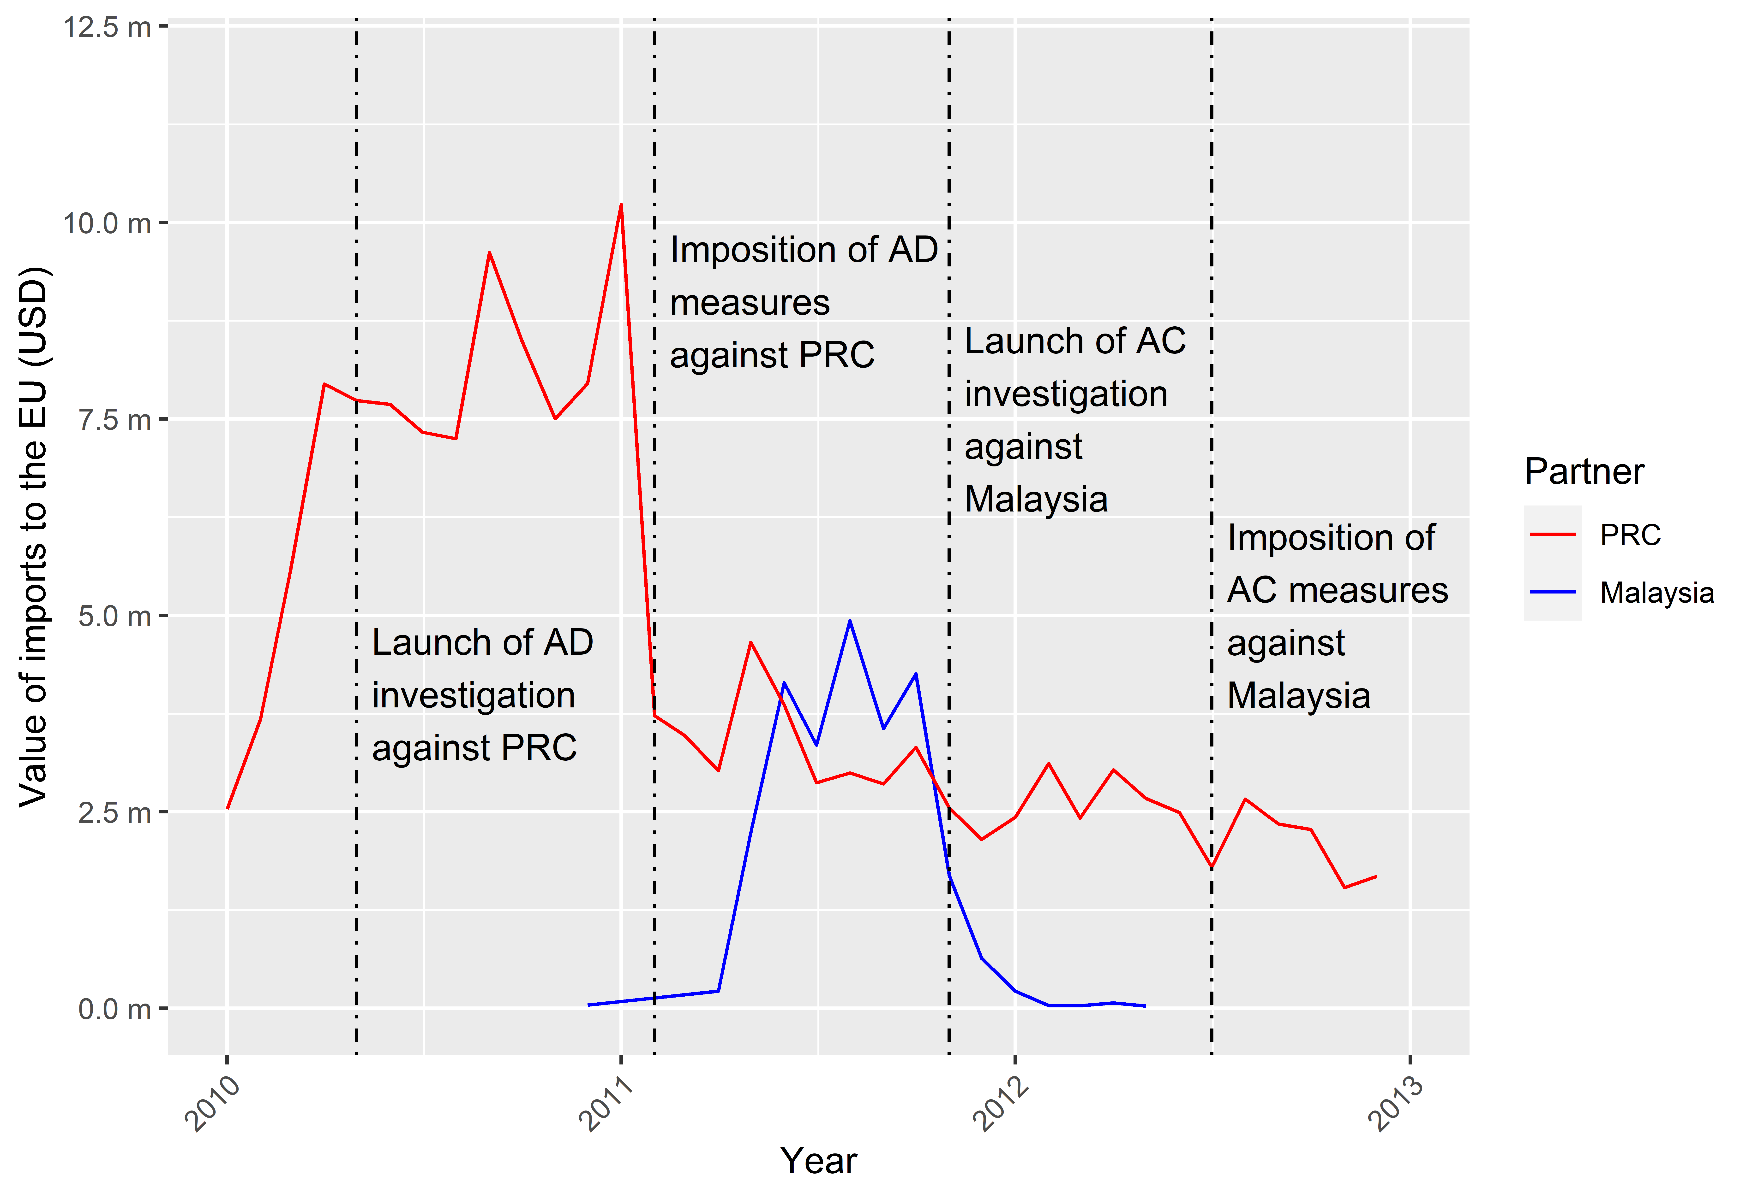
Source: Frontier Economics analysis of UN Comtrade data.
Investigating this hypothesis further, Figure 5 presents the value of monthly exports from PRC to Malaysia for 2010 to 2013. This shows a small uptick in exports following the imposition of the anti-dumping measures and then a fall when the anti-circumvention investigation was launched. While this change is indicative of a response to the investigation, the timing of these exports from PRC to Malaysia (towards the end of 2011) does not align with the timing of EU imports from Malaysia (which begins in the first half of the year). The value of exports from PRC (c. US$2 million) is also much smaller than EU imports from Malaysia (c. US$5 million). The evidence is therefore not convincing.

Figure 5: Value of monthly exports from the PRC to Malaysia for glass fibres (certain open mesh fabrics) for 2010 to 2013
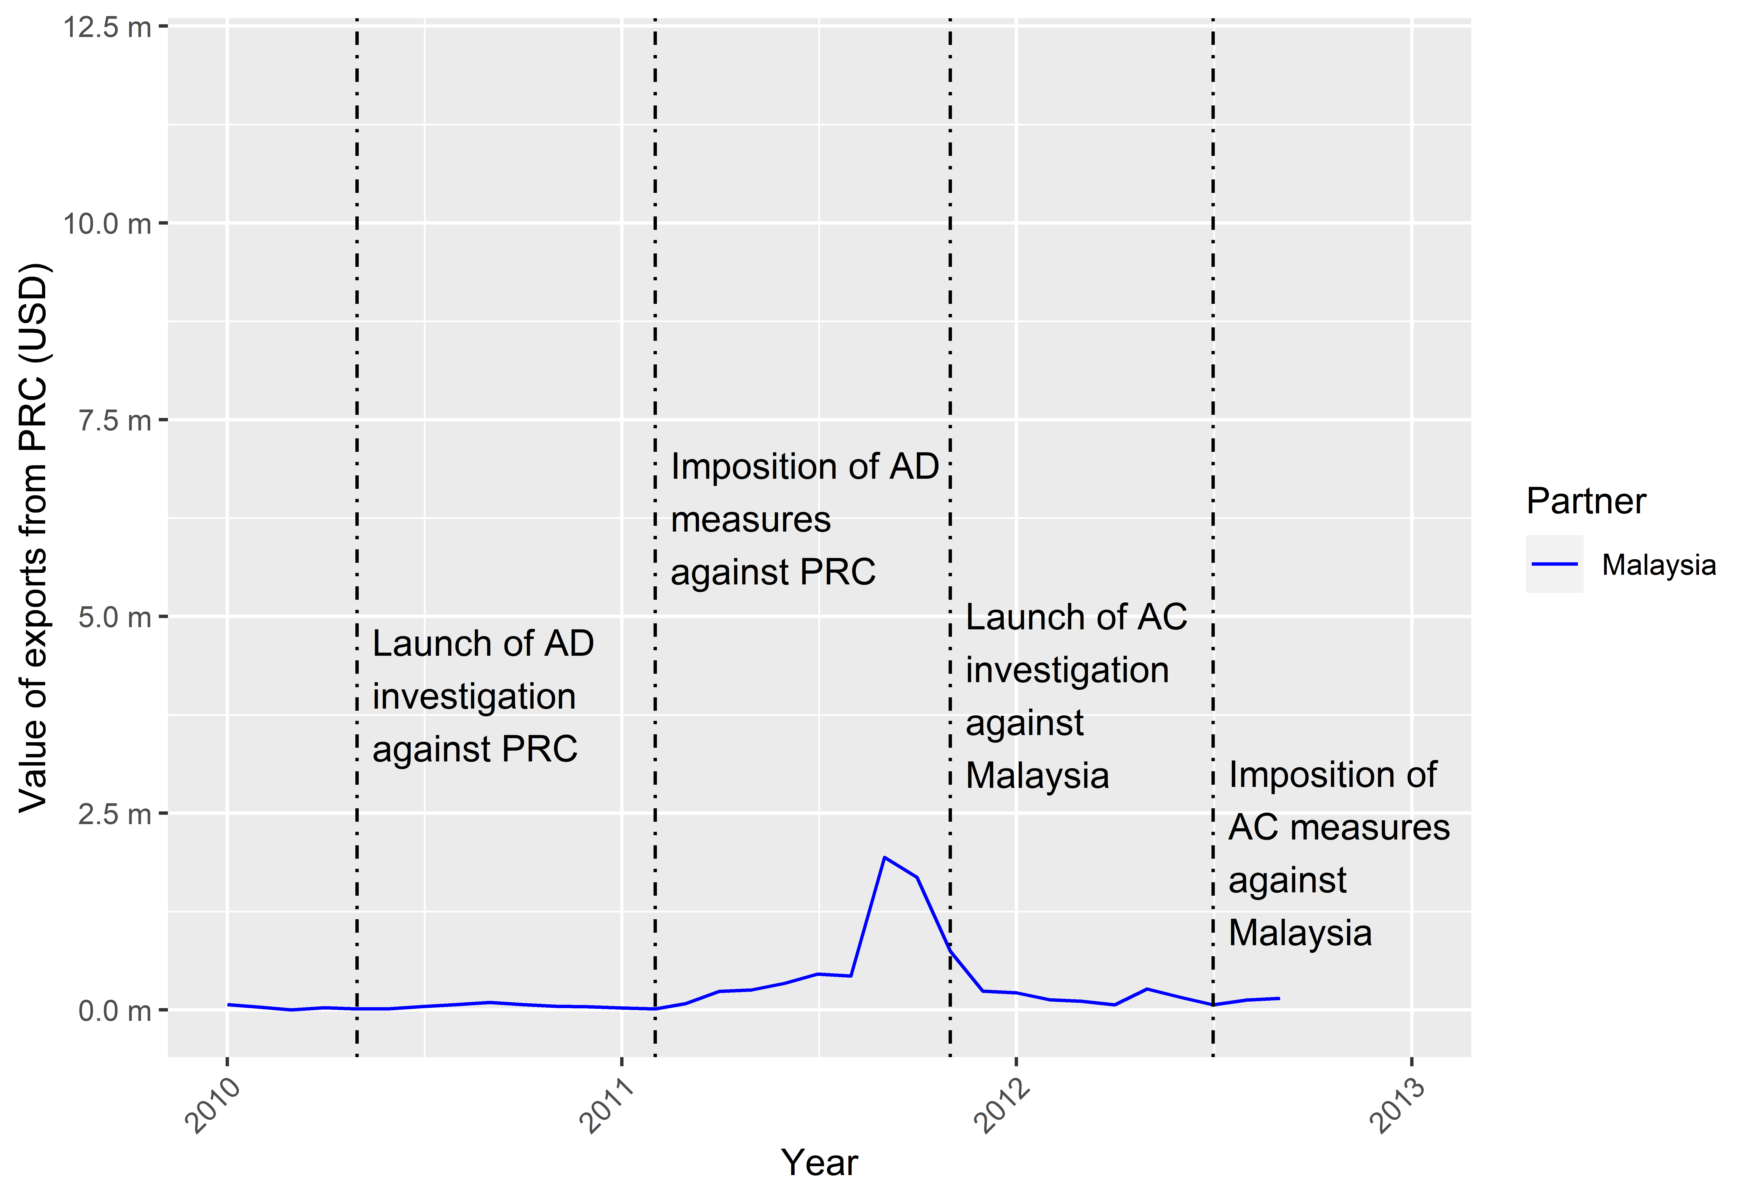
Source: Frontier Economics analysis of UN Comtrade data.
To understand what is driving these differences, Figure 6 presents the value of imports into Malaysia from PRC i.e. the “mirror” of Figure 7. Here the timing (and to an extent the trade values) match more clearly with EU imports from Malaysia. This evidence suggest that the imposition of duties may have led to a re-routing of Chinese exports to Malaysia. What this also highlights is an inconsistency between the reporting of what should be the same trade flow: namely, that Chinese reporting of exports to Malaysia does not seem to match the Malaysian reporting of Chinese imports for the same good.

Figure 6: Value of monthly imports into Malaysia from the PRC for glass fibres (certain open mesh fabrics) for 2010 to 2013
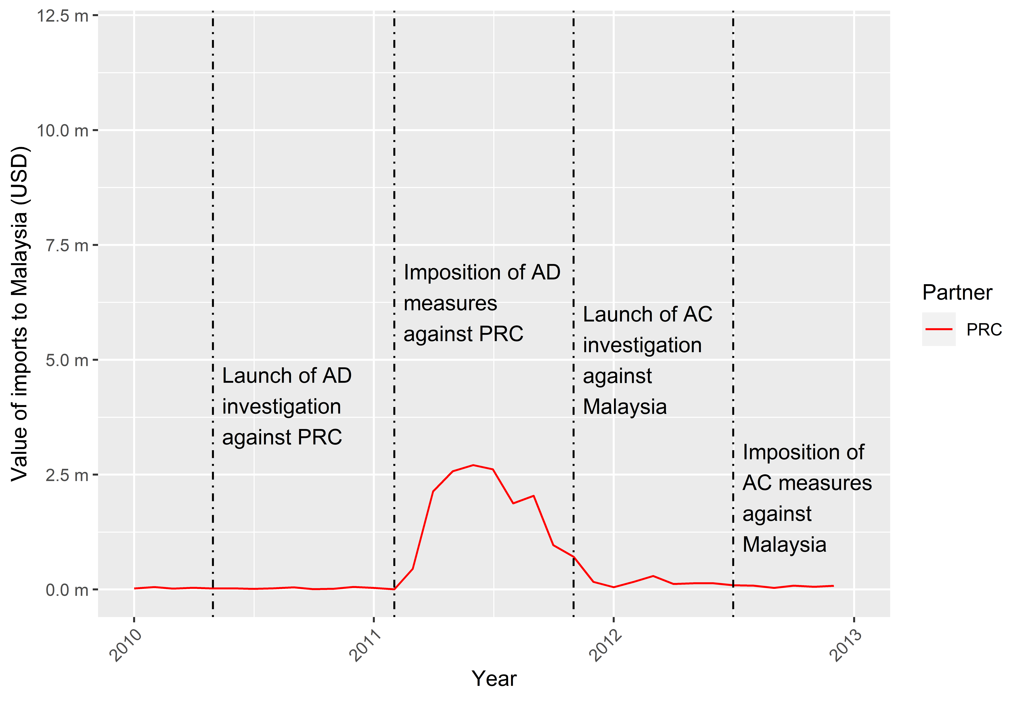
Source: Frontier Economics analysis of UN Comtrade data.
The evidence presented so far augments the evidence base compared to what was presented by the EC in its findings. However, it is not conclusive, as other factors could explain these trends. To rule out these other factors, we first expand the time period to cover 2000 to 2020 (albeit that this is only possible for annual trade values). Figure 7 shows that, when put into a wider context, the peak in exports from PRC to Malaysia which is seen when anti-dumping measures are imposed on PRC is unprecedented prior to this point, and falls back sharply when the anti-circumvention investigation is launched and measures are imposed on Malaysia (albeit to a higher level). This suggests that the exports from PRC to Malaysia around this period were not a fluctuation around a historical average: there was a specific spike associated with the duties imposed on PRC.
Figure 7: Value of annual exports from the PRC to Malaysia for glass fibres (certain open mesh fabrics) for 2000 to 2020
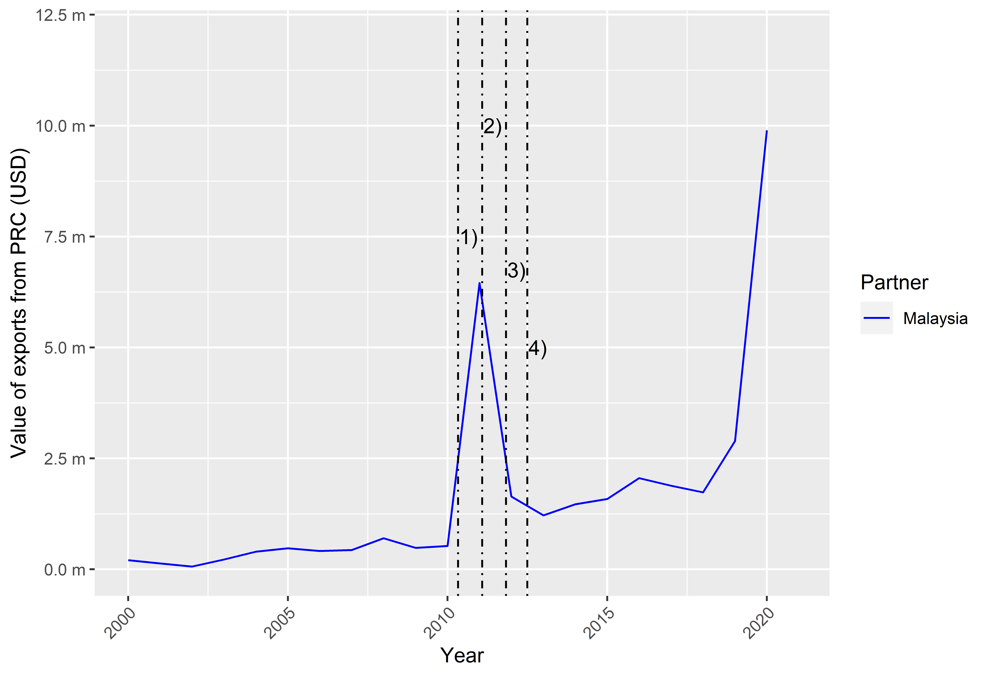
Note: 1) Launch of AD investigation against PRC (May 2010), 2) Imposition of AD measures against PRC (February 2011), 3) Launch of AC investigation against Malaysia (November 2011), 4) Imposition of AC measures against Malaysia (July 2012).
Source: Frontier Economics analysis of UN Comtrade data.
This does not, however, rule out the possibility that PRC’s exports to Malaysia are simply a diversion of exports to that country from the EU to Malaysia, reflecting that this and other markets are more profitable once EU duties have been imposed. In particular, it could be that exports to Malaysia are intended to meet Malaysian domestic consumption. The possibility arises because the observed increase in exports from Malaysia to the EU is substantially greater than the increase in imports into Malaysia from PRC. If the increase in Malaysia-EU exports is a result of Malaysian producers exploiting opportunities in the EU following the imposition of duties on PRC, this may have left a shortfall in domestic supply which Chinese producers are now meeting.
Figure 8 reports EU imports from Malaysia and Malaysian exports to the world. We observe that outside of its trade with the EU, Malaysia exports very little of this product and that exports to the EU are largely in the period following the imposition of duties on PRC and prior to the imposition of circumvention duties on Malaysia. It is important to note, however, that the value of the peak in exports from PRC to Malaysia is much smaller (c. US$6.5 million) than the peak of EU imports from Malaysia (c. US$25 million). It is therefore unlikely that all of the imports from Malaysia are attempted circumvention from PRC.
Figure 8: Value of annual exports from Malaysia to the world and value of annual EU imports from Malaysia for glass fibres (certain open mesh fabrics) for 2000 to 2020
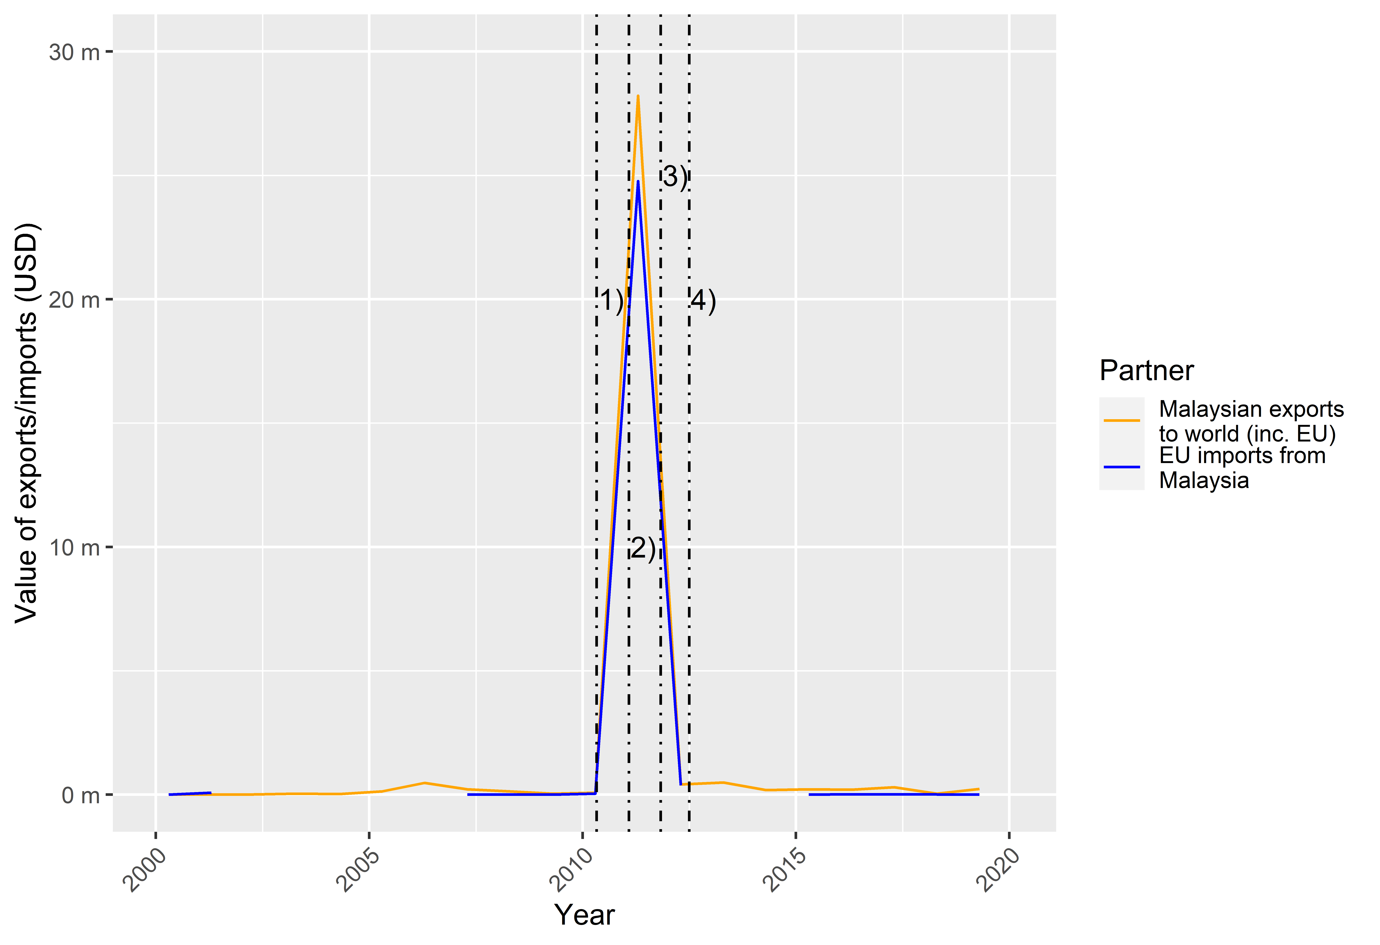
Note: 1) Launch of AD investigation against PRC (May 2010), 2) Imposition of AD measures against PRC (February 2011), 3) Launch of AC investigation against Malaysia (November 2011), 4) Imposition of AC measures against Malaysia (July 2012).
Source: Frontier Economics analysis of UN Comtrade data.
To complete the analysis, we examine how PRC’s exports to South-East Asia behaved, and what this reveals about the role of duties. This is reported in Figure 9 for seven ASEAN countries, covering 2010 to 2013. Generally, we observe that exports remained constant. Exports to Thailand started increasing after the imposition of anti-dumping duties on PRC, before increasing markedly after the launch of the anti-circumvention investigation against Malaysia. Imports into the EU from Thailand also increased (Figure 10) and Thailand was then subjected to an anti-circumvention investigation (May 2012) and then duties (January 2013).
Figure 9: Value of monthly exports from the PRC to South-East Asia (excl. Malaysia) for glass fibres (certain open mesh fabrics) for 2010 to 2013
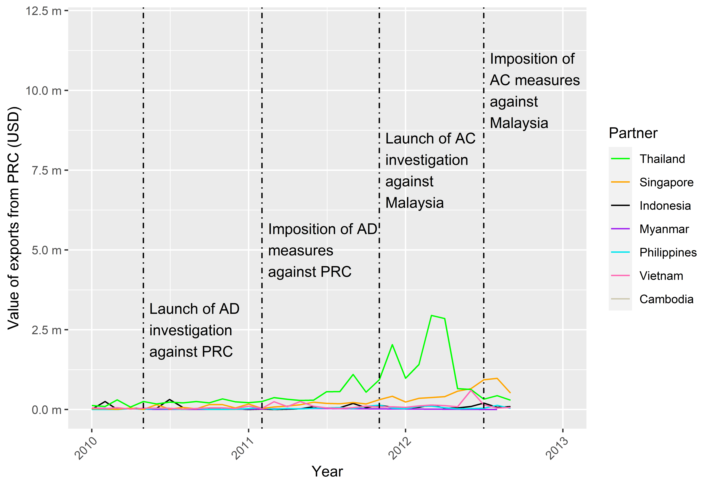

Note: Data for Laos, Brunei and East Timor were not available.
Source: Frontier Economics analysis of UN Comtrade data.

Figure 10: Value of monthly imports to the EU from Thailand for glass fibres (certain open mesh fabrics) for 2010 to 2014
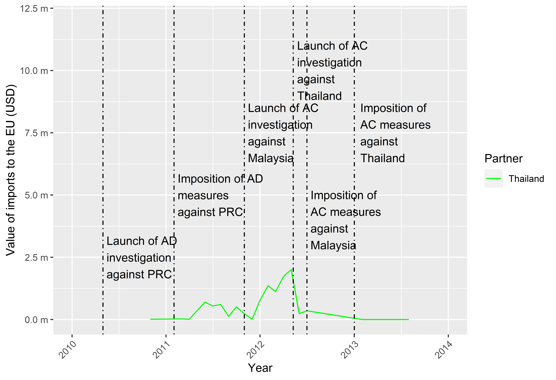
Source: Frontier Economics analysis of UN Comtrade data.
The analysis presented here substantially increases the evidence base relative to that initially provided by the EC. In particular, it introduces a range of comparators, including trade patterns between PRC and Malaysia, and between PRC and other countries in the region. The latter examination suggests that South-East Asia is not usually a significant market for glass fibres for PRC, nor is the EU a significant market for these South-East Asian countries. This makes the combination of surges in exports to South-East Asia and surges from the region to the EU following the imposition of duties consistent with the view that at least a portion of that surge was due to attempted circumvention. This is not, however, definitive, given that the values and timing of trade flows do not always align or are inconsistent.
The evidence based on trade data is therefore not fully determinative: it is conceptually possible that, in both the Malaysian and Thai cases, Chinese exporters found exports to those countries more profitable and exploited gaps in demand, and that Malaysian and Thai exporters were seizing the opportunities created by the wedge between EU and world prices.
This appears questionable given the patterns of trade observed above. We would need to believe that Malaysia (and Thai businesses) were largely focused on the domestic market and were not interested in exporting to the EU or to overseas markets, and that it was only following duties being imposed on PRC that they decided to export to the EU. The reason why this may be questionable is because firms typically cannot transition seamlessly into exporting: there are fixed costs to entering overseas markets, notably the acquisition of customers and the conclusion of purchasing contracts with distributors or end-users.
Overall, the analysis of trade data presents a mixed score-card. Discrepancies between PRC-Malaysia trade flows and Malaysia-EU trade flows raise questions as to whether at least part of the latter reflects genuine substitution/diversion effects. The analysis of regional trade patterns raises questions about the export capability of Malaysian businesses, which in turn raises questions about whether the one-off spike in Malaysia-EU trade is consistent with bona fide Malaysian exports.
While the trade data analysis is inconclusive, this does not detract from its value. Firstly, analysing PRC-Malaysia export patterns provides some additional context for understanding Malaysia-EU export patterns and increased scrutiny of the finding of circumvention based solely on analysis of bilateral trade between the EU and, respectively, PRC and Malaysia. Secondly, the analysis of regional trade patterns raises a particular question for further investigation: do Malaysian exporters have the capacity to ramp up production for the purposes of exports to the EU and switch exports apparently seamlessly between domestic and foreign markets? Finally, the analysis also underscores the points made in relation to a South-East Asia circumvention hub in the context of EU anti-dumping duties.
Regarding the use of UN Comtrade data specifically, as part of these more sophisticated before-after analyses, it is worth noting (as outlined in section 4.2) that:
- Given the time lag for countries submitting data to UN Comtrade, the required level of detailed trade data (e.g. monthly data) for the specific case may not be available in a timely fashion;
- Remedies in other anti-circumvention cases have been imposed at the 8- and 10-digit levels. For these cases, UN Comtrade may not provide the required level of disaggregation to assess potential impacts.
As observed above, the trade data is useful as it provides a specific justification, as well as contextual elements, for the further investigation of production patterns and capacity in Malaysian businesses. As it happens, this was a key focus of the site visit conducted by EC officials.
The site visit found evidence that Malaysian businesses had manipulated commercial and financial documents and, moreover, that they did not have the capacity to produce the quantities imported into the EU which were designated as originating in Malaysia. This finding proved to be determinative. Viewed from the prism of the trade data analysis presented above in this report, the EC’s findings provide a negative response to our question as to whether Malaysian producers had the capacity to rapidly ramp up production and shift seamlessly from a domestic focus to a foreign one. This shows that, while collecting additional trade data (and information on industrial organisation) can provide helpful insights and flag potential cases of circumvention, site visits are necessary to provide determinative evidence and confirm whether this is indeed the case.
Finally, these findings could be further supported by other evidence that circumvention of trade remedies has emerged as a business in its own right. For example, Liu and Shi (2019) report businesses advertising “circumvention services” in relation to PRC and Malaysia, which in turn lends credence to the idea that sudden changes in trade patterns between PRC and Malaysia (of the sort observed in this example) reflect circumvention.

5.2 Example 2: Potential extension of trade remedy duties to continuous filament glass fibre products from PRC

5.2.1 Changes in the pattern of trade
This case relates to continuous filament glass fibre products from PRC. Provisional anti-dumping measures were imposed in September 2010, with definitive measures imposed in March 2011 and amended in December 2014. In April 2017, an expiry review maintained the anti-dumping duties. The 10-digit TARIC codes of the commodities concerned are outlined in the first column of Table 3. Given the history of circumvention related to glass fibre products from PRC (see Example 1), we explore trade patterns following the imposition of anti-dumping duties. We compare these trends to those observed in the previous analysis for this case to establish the materiality of the circumvention risk.
We first look at imports into the EU-28 (including the UK) and to the UK from PRC. We also include imports into the EU-28 and UK from countries in South-East Asia plus Taiwan, Hong Kong and India. These are countries that PRC has either used to circumvent anti-dumping measures in the past or that are geographically close to those countries and so could act as alternative routes for circumvention.

Table 3: TARIC codes for the review of the anti-dumping case (Commission Implementing Regulation (EU) 2017/724), and those available in Eurostat and UN Comtrade
Anti-dumping case TARIC codes | Eurostat CN codes | UN Comtrade HS codes
7019 11 00 00 | 7019 11 00 | 7019 11
7019 12 00 22 | 7019 12 00 | 7019 12
7019 12 00 25
7019 12 00 26
7019 12 00 39
7019 31 00 00 | 7019 31 00 | 7019 31
Source: Notice of Initiation, Transition Review No. TD0008, Department for International Trade. Available from: https://www.trade-remedies.service.gov.uk/public/case/TD0008/
For imports, we use data from Eurostat. As the second column in Table 3 shows, Eurostat only provides data at the 8-digit (CN) level. For this reason, we group some TARIC codes together under their higher-level CN grouping. For Chinese exports, we use data from UN Comtrade. As the third column in Table 3 shows, UN Comtrade only provides data at the 6-digit HS code level.
Figure 11 presents monthly imports into the EU-28 for CN code 7019 11 00 and Figure 12 presents the same information for imports into the UK. Here we see little change in the pattern of trade when the EU anti-dumping measures against PRC were extended in 2017, apart from a potential uptick in imports from Malaysia (in particular for the UK). As imports from Malaysia appear to move cyclically over the period, this may just represent a temporary movement from the wider trend. We do not see a clear change in imports into the EU-28 or UK from any other country in South-East Asia, nor from Taiwan, Hong Kong or India. This tentatively suggests that, for the countries covered, there are no clear signs of circumvention activity.

Figure 11: Value of monthly imports into the EU-28 from the PRC, South-East Asia, Taiwan, Hong Kong and India for CN code: 7019 11 00 for 2015 to 2020
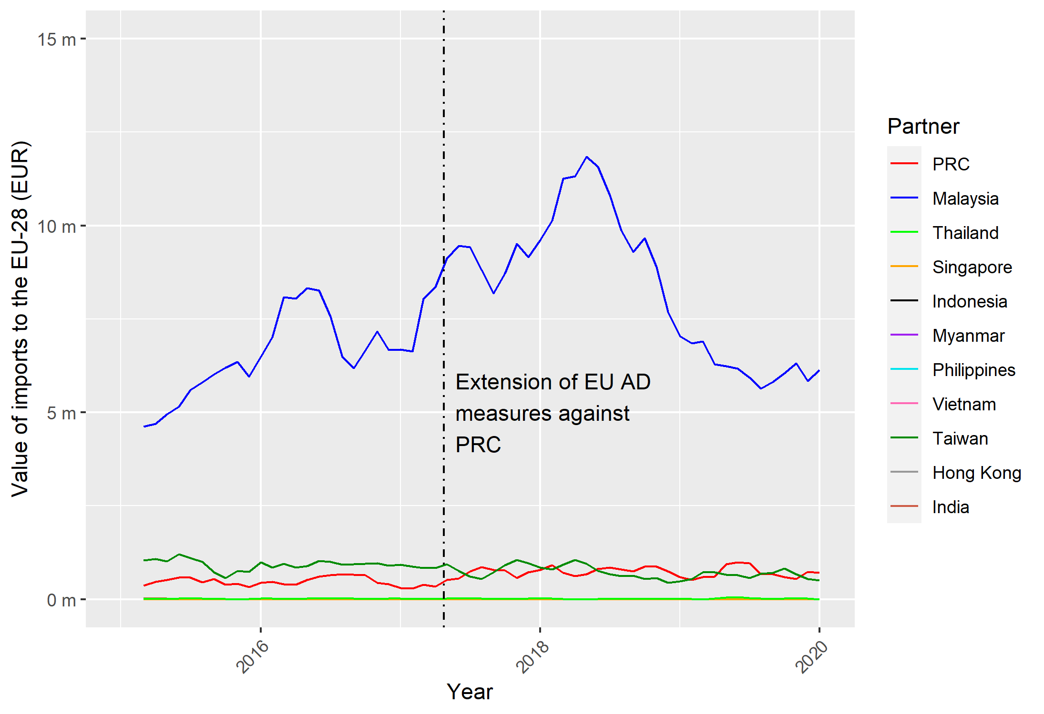
Note: Data presented is a three-month moving average. Not all South-East Asian countries are included, as data was not available.
Source: Frontier Economics analysis of Eurostat data.

Figure 12: Value of monthly imports into the UK from the PRC, South-East Asia, Taiwan, Hong Kong and India for CN code: 7019 11 00 for 2015 to 2020
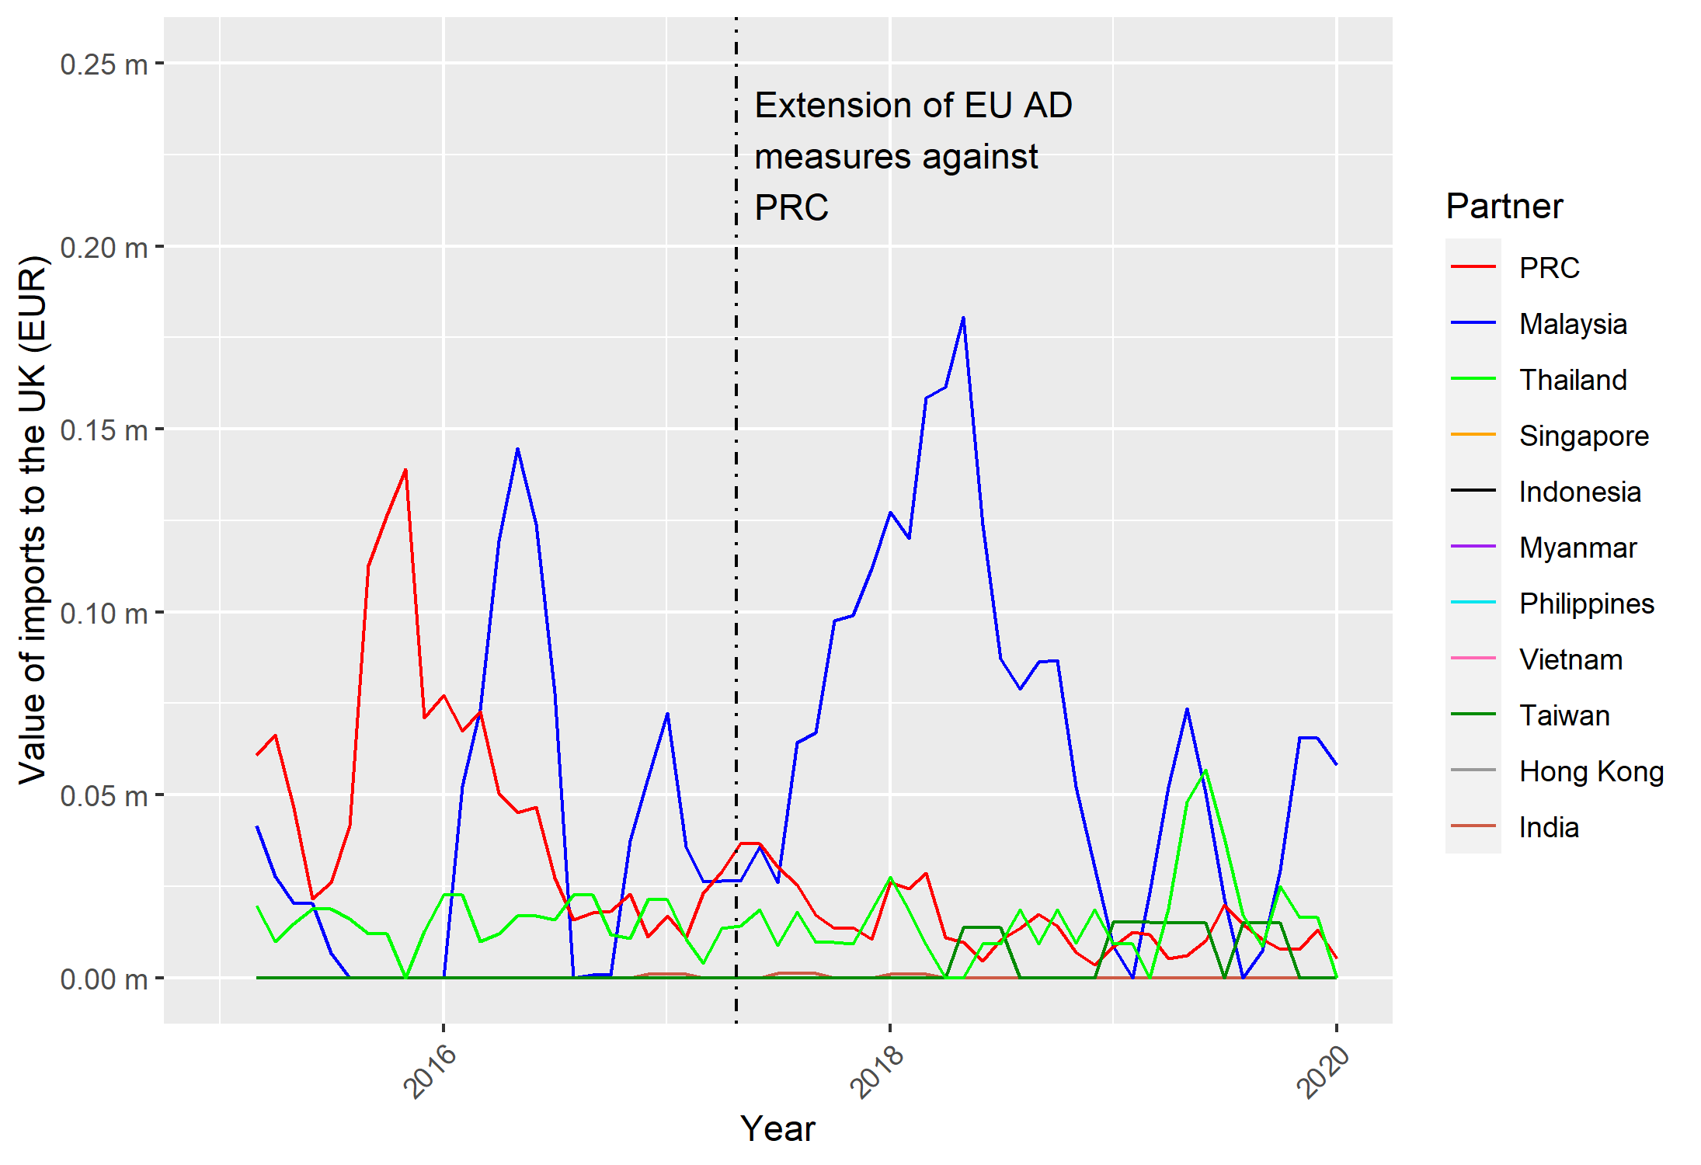
Note: Not all South-East Asian countries are included, as data was not available.
Source: Frontier Economics analysis of Eurostat data. Data presented is a three-month moving average.

Despite this apparent lack of evidence of circumvention for CN code 7019 11 00, there is value in analysing the pattern of trade in Chinese exports to the countries included in the import analysis (i.e. PRC’s regional trading partners). This is to identify two things. Firstly, whether there is evidence of the cascading circumvention seen in the earlier analysis of the glass fibres (certain open mesh fabrics) case. This is where we saw PRC attempting to circumvent an anti-dumping measure via a second country (Thailand). The timing of the changes in trade suggests that this could have been in anticipation of an anti-circumvention measure against the first (Malaysia). Secondly, perhaps because the EU-28 was a less attractive export destination, whether Chinese exports to these countries increased because of trade deflection (rather than circumvention). This could provide useful context for future analysis as it might show that producers in PRC are adapting to persistent duties in the EU-28 (now EU-27 plus the UK) by seeking new commercial opportunities elsewhere, rather than attempting to circumvent the anti-dumping duties.
Figure 13 presents annual exports from PRC to South-East Asia, Hong Kong and India for HS code 7019 11 (i.e. at a higher level of aggregation than the Eurostat analysis). The figure shows that there is a large increase in exports to India until 2018, exports to Thailand also slightly increase, but exports are relatively flat to other countries. After this point, exports to India decline. This could reflect both:
- Rapidly increasing demand in India because of particular end-uses for continuous filament glass fibre;
- That PRC is seeking new opportunities in response to anti-dumping duties in Europe and lagging growth there in the wake of the eurozone crisis.
Even allowing for differences in data aggregation, this suggests that there is little evidence from the trade data that transhipment occurred (as there is no corresponding increase in EU-28 or UK imports from India following this peak in exports from PRC to India).

Figure 13: Value of annual exports from the PRC to South-East Asia, Hong Kong and India for HS code: 7019 11 for 2015 to 2020
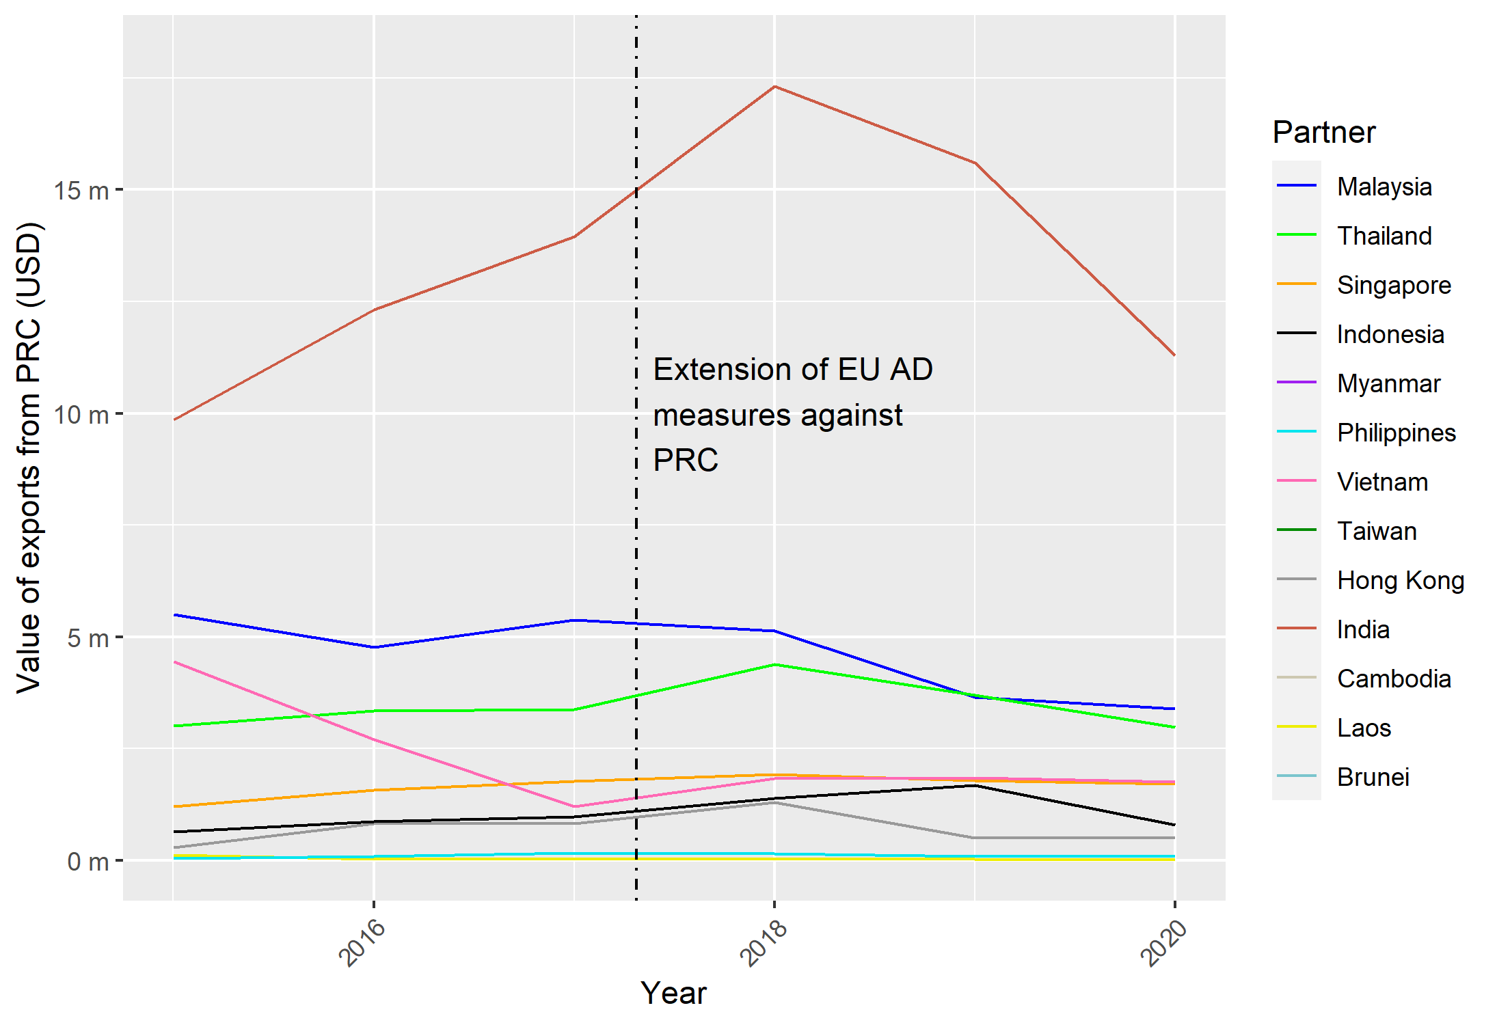
Note: Not all South-East Asian countries (or Taiwan) are included, as data was not available.
Source: Frontier Economics analysis of UN Comtrade data.
No changes in the pattern of EU-28 and UK imports over the period are found for CN code 7019 12 00 (see Figure 29 and Figure 30 in Annex 4) or for CN code 7019 31 00 (see Figure 31 and Figure 32 in Annex 4). The only discernible trend is that imports from PRC appear to decline over the period (apart from a seemingly temporary uptick in the UK for 7019 12 00 in 2019). This is not surprising given the continued application of anti-dumping duties.
Turning to the analysis of Chinese exports for these two CN codes, a similar pattern is seen. Figure 14 presents this for HS code 7019 12. Here, exports to India and Thailand increase until 2018. A similar pattern is seen for Malaysia albeit with a lag. The increased exports to India occurred notwithstanding anti-dumping duties imposed by India on these types of products in 2011, and then extended in 2016 following a sunset review. India also initiated, in 2018, an anti-circumvention investigation on transhipment of these types of products via Thailand and imposed duties. It is only from that time that Chinese exports to both India and Thailand fall. Interestingly, following these declines there appears to be an increase in exports to Vietnam. This could signify Chinese exporters seeking new markets or possible circumvention. A similar trend in Chinese exports is seen in Figure 15 for HS code 7019 31, where exports to India increase rapidly over the period, but decline from 2019 onwards.
Figure 14: Value of annual exports from the PRC to South-East Asia, Hong Kong and India for HS code: 7019 12 for 2015 to 2020
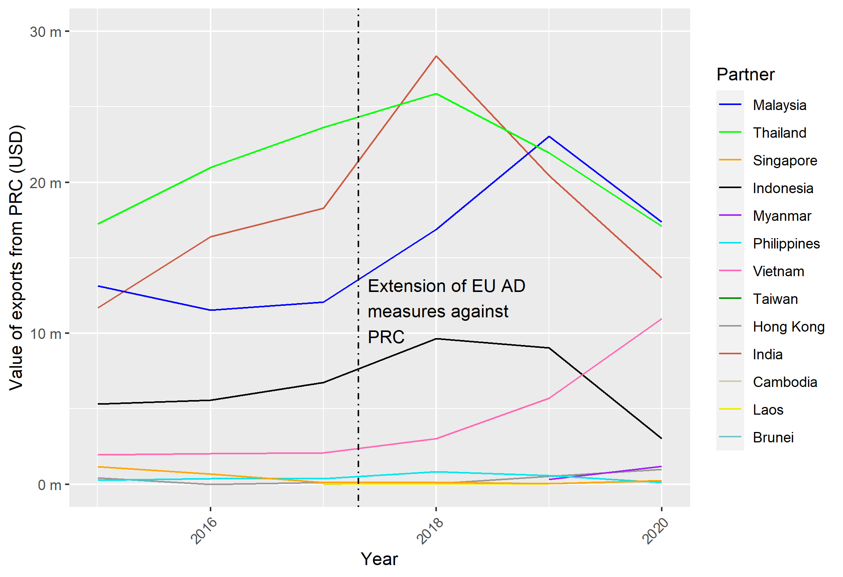
Note: Not all South-East Asian countries (or Taiwan) are included, as data was not available.
Source: Frontier Economics analysis of UN Comtrade data.

Figure 15: Value of annual exports from the PRC to South-East Asia, Hong Kong and India for HS code: 7019 31 for 2015 to 2020
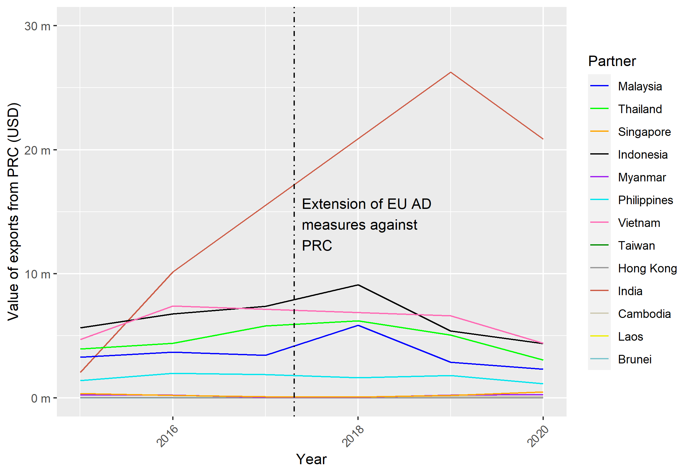
Note: Not all South-East Asian countries (or Taiwan) are included, as data was not available.
Source: Frontier Economics analysis of UN Comtrade data.
Taken together, the patterns of trade in this case suggest that PRC is an aggressive exporter of these products. In particular, export trends to India in the face of EU anti-dumping duties suggest that market opportunities existed in India that could be exploited notwithstanding the duties, and possibly compensated for lost opportunities in the EU.
By using a broad set of comparators, in terms of countries that trade with PRC and both the EU-28 and the UK, we are able to augment the power of the basic before-after framework used in anti-circumvention actions. The preliminary conclusions suggest that there is a mix of both commercial drivers and attempts at circumvention which drive trade patterns relating to PRC, although the evidence of circumvention is stronger in relation to non-EU markets.

5.2.2 Data and information on industrial organisation
The global market for glass fibre has grown rapidly over the last decade. It was valued at around US$11.5 billion in 2020 and is expected to reach just over US$14 billion by 2025. Growth is the result of derived demand associated with the growth of a range of end-use industries, including construction, automotives and renewable energy. PRC became the leading producer and exporter of glass fibres over the last decade and, depending on estimates, accounts for between 50% and 60% of global production. Growth in PRC’s production has been fuelled by demand in key areas, notably in construction, both in PRC and the rest of Asia. Rates of construction growth correlate with higher growth rates in that region, particularly compared to Europe in the wake of the global financial crisis.
In terms of industrial organisation, Chinese businesses have established affiliates across Asia as well as in Europe, the United States, North Africa and South Africa. Some of these have been cited in circumvention investigations. For example, the Indian authorities focused on Thai affiliates of Chinese producers. The establishment of affiliates may be driven by a number of factors. From a Chinese perspective, the Belt and Road Initiative may have been a contributing factor insofar as it helps to reduce the costs associated with transnational linkages.
Setting this aside, the avoidance of import tariffs, including anti-dumping duties, is sometimes cited as one of the factors that motivate decisions about the location of investment. This is not tantamount to saying that Chinese producers are engaged in circumvention. In the presence of duties, markets seeking FDI is an efficient response (indeed, one of the long-standing rationales for tariff protection has been to stimulate FDI as an alternative to imports). However, an expansive web of affiliates can provide opportunities for circumvention of duties, as appears to have been the case in Thailand in respect of exports of glass fibre from PRC to India. These aspects of industrial organisation illustrate the challenges of detecting circumvention.
Detailed data on glass fibre production, end-use patterns and investment is not available from official sources for PRC or jurisdictions in Asia. Various industry sources can be accessed on a subscription basis. These could supplement data obtained through written requests for information.

5.2.3 Conclusions
This analysis shows how a richer set of comparator countries can enhance the analysis of trade patterns. Given the history of circumvention in glass fibre products, trade and production patterns warrant monitoring. As outlined in Example 1 above, however, while collecting additional trade data (and information on industrial organisation) can provide helpful insights and flag potential cases of circumvention, site visits are sometimes necessary to confirm whether circumvention really is occurring.

5.3 Example 3: Potential extension of trade remedy duties to biodiesel from the United States and Canada

5.3.1 Changes in the pattern of trade
The EU imposed anti-dumping duties and countervailing measures on biodiesel imported from the United States in July 2009 (provisional measures were imposed in March 2009). In August 2010, the EU initiated an investigation into the possible circumvention of these measures through transhipment via Canada and Singapore, and separately via product modification in the United States. In May 2011, the EU imposed anti-circumvention duties on biodiesel imports from Canada.
The TRA is undertaking a transition review of the anti-dumping duties and circumvention duties applying to biodiesel consigned through Canada. The 24 TARIC codes that the TRA considered in its investigation are outlined in the first column of Table 4. It is worth noting that some of the product codes have featured in other high-profile trade remedy cases, notably biodiesel imports from Argentina and Indonesia.

Table 4: TARIC codes from the UK transition review of the original anti-dumping case (Council Regulation (EC) No.599/2009), and those available in Eurostat and UN Comtrade
Anti-dumping case TARIC codes | Eurostat CN codes | UN Comtrade HS codes
1516 20 98 21 | 1516 20 98 | 1516 20
1516 20 98 29
1516 20 98 30
1518 00 91 21 | 1518 00 91 | 1518 00
1518 00 91 29
1518 00 91 30
1518 00 99 21 | 1518 00 99
1518 00 99 29
1518 00 99 30
2710 20 11 21 | 2710 20 11 | 2710 20
2710 20 11 29
2710 20 11 30
2710 20 16 21 | 2710 20 16
2710 20 16 29
2710 20 16 30
3824 99 92 10 | 3824 99 92 | 3824 99
3824 99 92 12
3824 99 92 20
3826 00 10 20 | 3826 00 10 | 3826 00
3826 00 10 29
3826 00 10 50
3826 00 10 59
3826 00 10 89
3826 00 10 99
3826 00 90 11 | 3826 00 90
3826 00 90 19
3826 00 90 30

Source: Statement of Essential Facts, Case TD0004, Department for International Trade. Available from: https://www.trade-remedies.service.gov.uk/public/case/TD0004/submission/a8fa1a1e-4ba7-433e-b358-edcbf0d17450/
To understand the rationale for the original anti-dumping and anti-circumvention measures, we revisit the Commission’s analysis. Figure 16 presents the value of annual imports from the United States and Canada into the EU-28 (including the UK) using data from UN Comtrade. This is for HS code 3824 90. From 2006 onwards, we see a large increase in imports from the United States (and the rest of the world – RoW in the figures below), reaching a peak of nearly US$3 billion in 2008. Anti-dumping duties are then imposed in 2009, leading to a substantial decline in United States imports. This decline in imports happens while imports from the rest of the world (driven primarily by Argentina and Indonesia, which were then subject to a separate EU anti-dumping investigation) continue to grow. While Canadian imports also rise in the same year as the imposition of EU anti-dumping measures on the United States (and then fall in the same year as the imposition of anti-circumvention measures), Canada plays a very small role in total EU imports of this product. Relative to the large decline in United States imports, the increase from Canada is also minimal.
Figure 16: Value of annual imports from the United States and Canada into the EU-28 for HS code: 3824 90 for 2005 to 2016
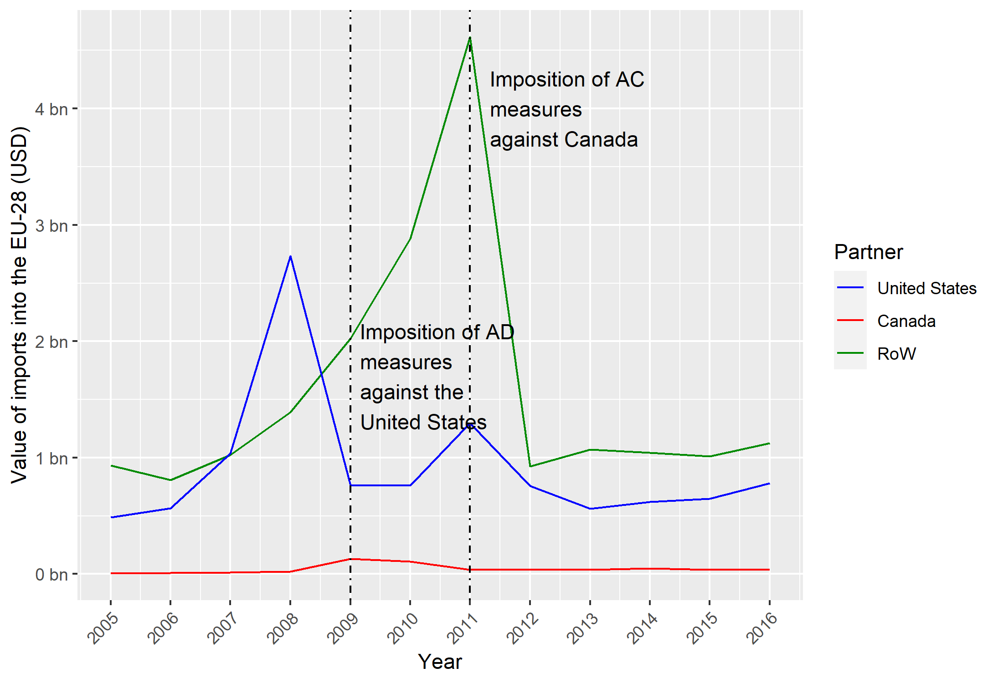
Source: Frontier Economics analysis of UN Comtrade data.
To understand whether the increase in Canadian imports into the EU represents potential transhipment (and not Canada responding to the change in competitive dynamics), we analyse Canadian imports of the same product from the United States and the rest of the world. In Figure 17, we see that after the imposition of the anti-dumping measures against the United States, there is a large uptick in imports from the United States into Canada. The timing of this uptick (2010 and 2011) does not, however, align with the uptick in Canadian exports seen in Figure 20 in 2009.
Similarly, following the anti-circumvention measures imposed on Canada in 2011, we see a large fall in exports from the United States to Canada in 2012. However, again, the timing appears to be out by one year; the fall in Canadian exports to the EU takes place in 2011, but the fall in United States exports to Canada is in 2012. This could suggest that the United States shifted to supplying Canadian domestic demand, while Canada legitimately expanded its exports to the EU (following the imposition of the anti-dumping duties on the United States). When the circumvention action was taken against Canada, Canadian exports may have then progressively been redirected to its local market, squeezing out United States exports to Canada. It is not possible, however, to determine from the trade data whether that was the case. In addition, even if we were to assume that the timings happened concurrently, the fall in United States exports into Canada is larger than the fall in exports from Canada to the EU-28 following the anti-circumvention duties. This suggests that at least some of this was being consumed domestically, with the fall potentially reflecting a reduction in Canadian demand.
This potential one-year lag may reflect (as was the case in Example 1 above) an inconsistency between the reporting of trade flows between trading partners. Equally, it could also show that circumvention was not taking place. Irrespective of the true cause of these trends, this highlights some of the pitfalls that might be associated with a superficial monitoring of patterns of trade based solely on the behaviour of imports.
Figure 17: Value of annual exports from the United States and RoW into Canada for HS code: 3824 90 for 2005 to 2016
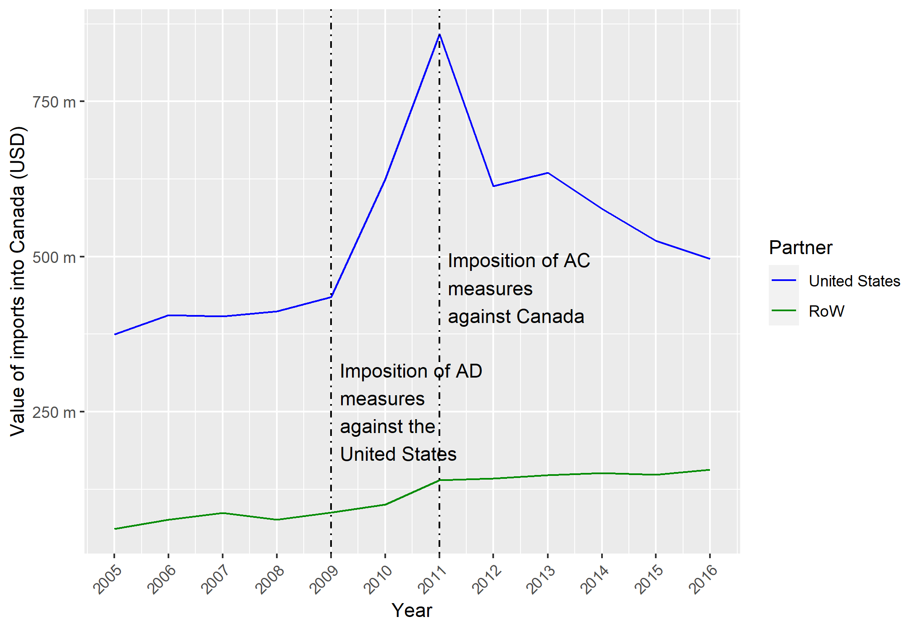
Source: Frontier Economics analysis of UN Comtrade data.
We now explore more recent patterns of trade to understand the materiality of the circumvention risk for the categories of goods included in Table 4.
We begin by identifying the five largest exporters into the EU-28 and UK for those CN codes with the most material trade values between 2015 to 2020. We do this using Eurostat data. Figure 18 presents the results for CN code 3826 00 10, which has the largest value of trade of these CN codes. For the EU-28, we see that imports remain relatively constant from Malaysia and other nations. From 2017 onwards, however, there is a large increase in imports from Argentina and Indonesia (following the expiry of duties), with this later followed by Malaysia and PRC in 2019. However, this trend is not seen for the UK in Figure 19 where total imports decline over the period and involve relatively immaterial values of trade.
Figure 18: Value of monthly imports into the EU-28 from the top five exporters into the EU-28 for CN code: 3826 00 10 for 2015 to 2020
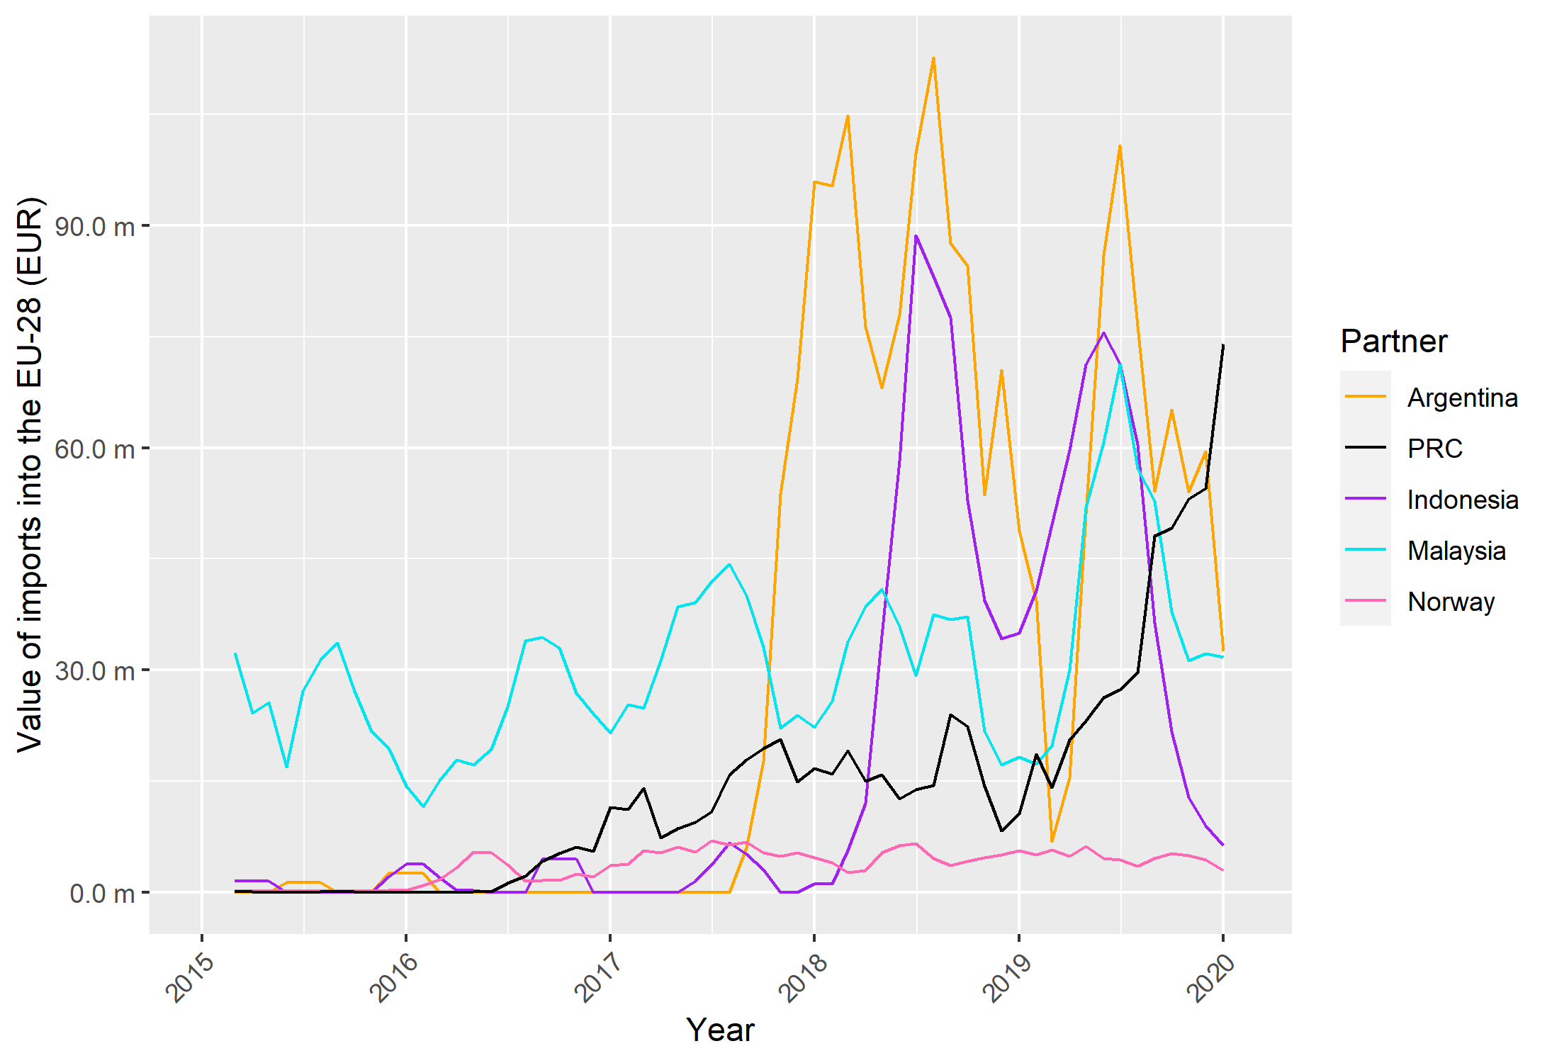
Source: Frontier Economics analysis of Eurostat data. Data presented is a three-month moving average. Not all South-East Asian countries are included, as data was not available.

Figure 19: Value of monthly imports into the UK from the top five exporters into the UK for CN code: 3826 00 10 for 2015 to 2020
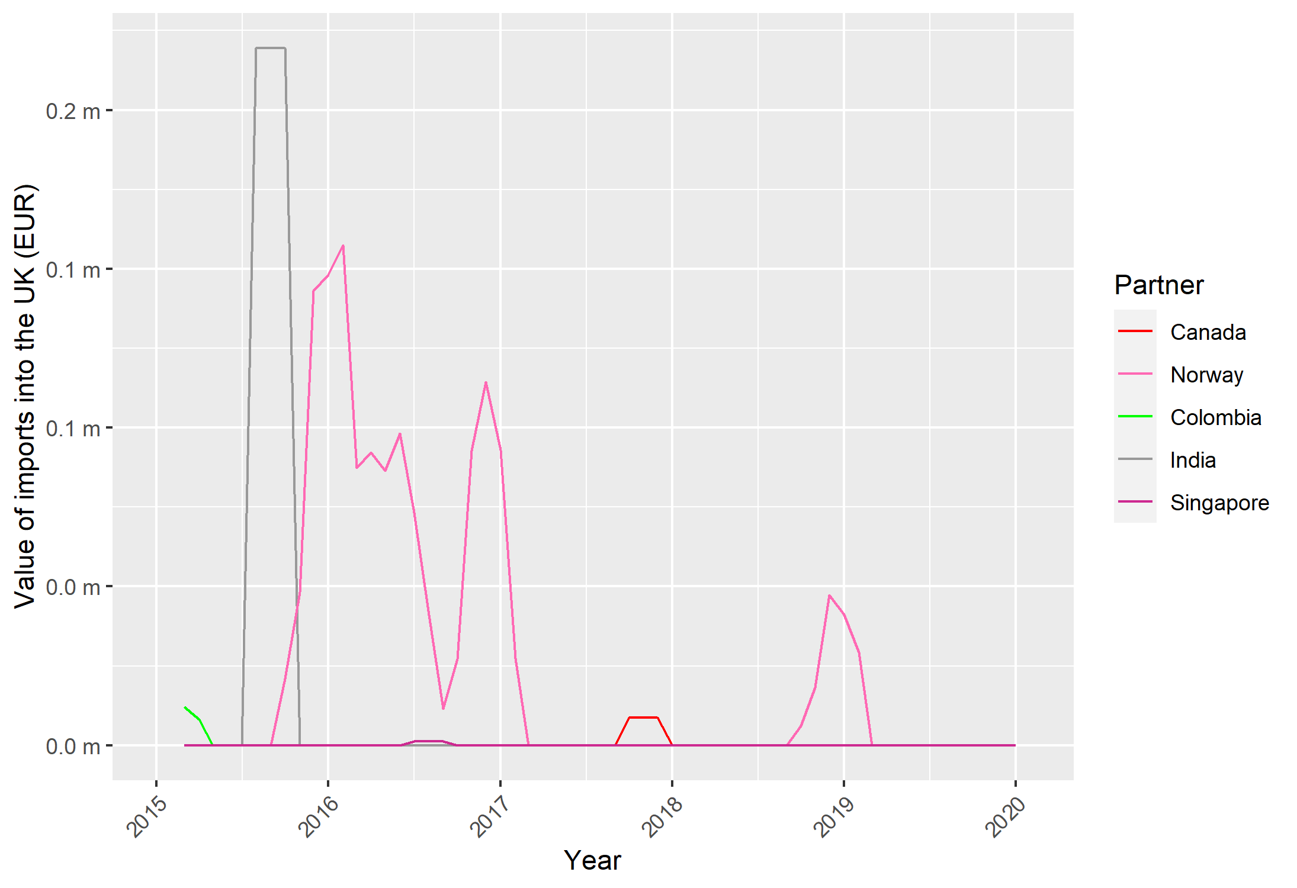
Note: Not all South-East Asian countries are included, as data was not available.
Source: Frontier Economics analysis of Eurostat data. Data presented is a three-month moving average.
For both the EU-28 and UK, neither the United States nor Canada makes it into the top five exporters. This is reflected in Figure 20 and Figure 21, which show the top five export destinations for HS code 3826 00 from the United States and Canada respectively. This shows that Canada and the United States are each other’s largest trading partner by a considerable distance for this product, with (in the case of Canada) minimal trade with Germany and the UK by comparison (which are the only EU-28 countries to make it into the top five export destinations for Canada).

Figure 20: Top five export destinations by value of annual exports from the United States for HS code: 3826 00 for 2015 to 2021
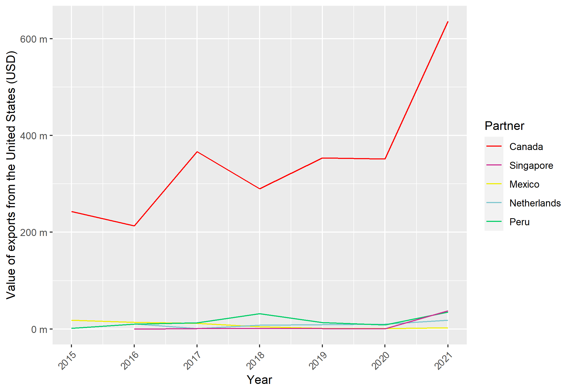
Source: Frontier Economics Analysis of Comtrade Data

Figure 21: Top five export destinations by value of annual exports from Canada for HS code: 3826 00 for 2015 to 2021
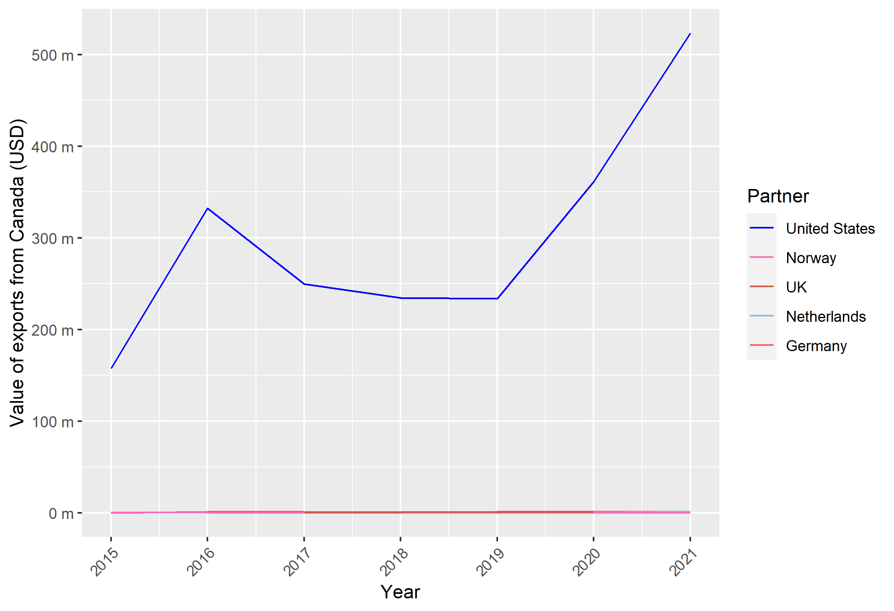
Source: Frontier Economics analysis of UN Comtrade data.
For brevity, we include the charts and analysis for the remaining three CN codes in Annex 5. Based on the EU-28 and UK import analysis set out above and in Annex 3, the key trends are:
- Although the import data is relatively noisy, demand appears to be generally trending upwards for these products. This is unsurprising given the increasing focus on climate change and the role products like biodiesel play in meeting emissions targets (by substituting for conventional fuels).
- The mix of imports reflects to a large extent the rankings of world producers.
- Canada is not a major exporter to the EU and the UK.
- There are similarities between recorded imports into the UK and the EU. However, comparisons are complicated by the principle of free circulation between the UK and the EU that held until the end of 2020 (i.e. reported imports into the UK may have been consumed in the EU, and vice versa).
- For certain codes, the effects of anti-dumping duties can be detected. For example, following the expiry of duties in 2018, EU-28 imports of code 3826 00 10 from Argentina increased sharply.
While it is important to examine import trends into the EU-28 and the UK, understanding the export trends of the countries subject to the anti-dumping (United States) and anti-circumvention (Canada) duties helps to inform the risk of further circumvention by these countries. The key trends from the analysis above are:
- The United States and Canada have developed an important bilateral relationship in biodiesel trade. In retrospect, this suggests that the increase in exports from the United States to Canada observed in 2010 and 2011 may have been part of a broader industry dynamic. While this may or may not have been partly connected to duties imposed by the EU (and therefore attempted circumvention), it might also reflect trade deflection and, more broadly, efforts to diversify markets to take advantage of trends in demand and end-use.
- The material expansion of exports to Singapore (a country previously subject to an EU anti-circumvention investigation) from the United States and Canada was not accompanied by an equally material increase in exports from Singapore to the EU-28 or the UK (see Annex 5). If it had been, then this might have suggested attempted circumvention.
Taken together, the retrospective analysis above suggests various ways in which investigations into the existence of circumvention could be strengthened, in order to make more robust decisions as to whether or not the imposition of duties is warranted.

5.3.2 Data and information on industrial organisation
The market for biofuels (made up of ethanol and biodiesel) expanded rapidly between 2010 and 2020, with demand for major biofuels doubling over that period. The United States is the largest producer of biofuels by virtue of its dominance of ethanol. The EU dominates biodiesel production. The United States, Indonesia, Brazil and Argentina are the other “top five” producers. Canada is ranked eighth for biodiesel. The rankings are relevant as close competitors are likely to attract trade remedy duties. In recent years, the EU has levied duties on biodiesel on all of its top five competitors, with the exclusion of Brazil.
Data on national production and national consumption is available from the OECD for biodiesel and for ethanol (at an aggregate level). While this data lacks the granularity associated with a trade remedy case, it is useful in considering high-level trends. Figure 22 reports production trends for the world, OECD, the United States, the EU27, Canada and Argentina.
Figure 22: Biodiesel production data for 2012 to 2021
Note: regional and country totals are not additive (e.g. OECD includes United States, EU-27 and Canada).
Source: OECD.
Figure 23 reports data on production and consumption for Canada and the United States. The data records Canada’s increase in production relative to consumption. Recorded consumption is still in excess of production, which on the face of it is difficult to square with Canadian exports, particularly to the United States. The explanation could reside in the level of aggregation of the data. Different grades of biodiesel have different end-uses, and it is possible that the balance between domestic consumption and production varies by grade.
Data for the United States shows parallel trends for production and consumption, with the former higher than the latter. This explains United States exports, although it is difficult to square with the reported fluctuations. Again, this could be an issue of aggregation.
It is difficult to draw firm conclusions from the data, although the low level of Canadian production in 2012 (the data series does not extend prior to this) is consistent with the EU findings that domestic production in Canada may not have been sufficient.

Figure 23: Biofuel consumption and production data for Canada and the United States for biodiesel for 2012 to 2021l
Canada

United States

Source: OECD.

5.3.3 Conclusions
The proof of concept work highlights the challenges of investigating circumvention in the context of industries that are expanding due to demand factors, and through the consequent investment decisions of the main producers. There is some evidence, notably in the glass fibre sector that, as well as being motivated by cost efficiencies, FDI decisions may have been motivated by a desire to minimise exposure to duties, including trade remedies. This, in and of itself, is not circumvention: it may simply be the sort of commercial response we would also observe in response to other trade policy changes, such as preferential market access.
Given that our overall challenge is to differentiate between circumvention and these broader commercial responses, the proof of concept work highlights the value of monitoring patterns of trade using a wide range of comparator countries in order to ascertain trends (including in response to trade remedy action taken in other jurisdictions). This analysis suggests that anti-circumvention action taken in the past on glass fibres was likely warranted and that the risk of circumvention in the future warrants active monitoring of trade data. By contrast, the analysis also suggests various ways in which the analysis of the biodiesel case could be strengthened.
The analysis also reinforces the importance of considering patterns of production and industrial organisation. Data from official sources tends to be at a high level, is reported with lags, has gaps and tends to be reported annually rather than monthly. It can help with developing a broader narrative and understanding, but it sheds limited light on the specifics of a case. It is unlikely to meet the positive evidence requirements required for a determination that circumvention has occurred. Industry sources, which are available through subscription, may provide more detailed evidence. But, on balance, the analysis brings out a point underscored in the deep dives, i.e. the importance of detailed information gleaned from the financial accounts of the producers under investigation. That in turn reinforces the importance of ensuring that the TRA has sufficient internal capacity to analyse such information within the framework of a circumvention case.

5.4 A toolkit for handling anti-circumvention cases

5.4.1 General framework
Given the legal and institutional context within which the TRA is called to undertake research into circumvention, a toolkit should consist of the following elements:
- Identification of data sources;
- Specific methodologies;
- An assessment of how the insights gained from deploying the toolkit compare with the resource costs involved.
As the analysis in this report has revealed, addressing circumvention cases requires a mixed-methods approach based on a combination of quantitative and qualitative information. Moreover, it is opportune at this juncture to recall the counterfactual nature of key aspects of the analysis. This is particularly evident in relation to the threshold question of a change in the pattern of trade.
To begin with, we wish to establish whether changes in patterns of trade would have happened had the trade remedy duties not been imposed. This is a necessary but not sufficient condition because duties themselves may lead to a reorganisation of trade and production on commercial grounds. Therefore, we wish to establish whether changes would have occurred but for reasons of circumvention. This added layer of complexity is the main reason, along with issues related to the timeliness and coverage of data, why a mixed-methods approach is needed.
As far as the quantitative aspects of the analysis is concerned, we can represent the range of possibilities using the Maryland Scientific Methods Scale. This was developed in the area of criminology and is a five-point scale that gauges the strength of evidence based on underlying methods. It is used by the National Audit Office and also finds support in international organisations such as the OECD. The scale is presented in Table 5 below.
Table 5: Overview of the Maryland Methods Scientific Scale
Level | Description
1 | Before versus after analysis
2 | Before versus after with control variables e.g. use of comparator groups versus “treatment group” to provide cross-sectional comparisons
3 | Comparison of treatment group with comparator group that provides counterfactual. Use of econometric methods such as difference- in-difference, synthetic comparators or propensity score matching
4 | Quasi-randomness in treatment and controls is exploited e.g. through the use of regression discontinuity treatment
5 | Fully randomised control trials, with limited or no possibility of contamination between treatment and control groups

The purpose of the scale is to assess how robustly a particular methodology can answer the question: “Did a particular intervention cause a particular impact?”. In the case of the present research, a necessary question is: “Did the imposition of duties cause a change in observed patterns of trade?”.
Robustness increases with the level in the scale: level 5 provides the most robust methodologies for estimating the impact of an intervention, while level 1 is the weakest.

5.4.2 Implementing the framework through data sources and methodologies
Trade data
A review of actual cases suggests that current quantitative approaches are largely at level 1. Levels 4 and 5 seem unfeasible in the trade remedy context. Level 3, which introduces the use of econometric methodologies in order to strengthen the robustness of analysis, also seems particularly ambitious in the constraints of a live circumvention case, although such approaches have been adopted in retrospective analysis of several cases. A suitable level of ambition would therefore be to see if the robustness of analysis could be shifted to at least level 2, and preferably to a point between levels 2 and 3.
Indeed, the analysis of trade data presented in this report and the three case studies demonstrates a way of doing this by expanding the range of data that is considered. In the cases under review, this includes:
- Using trade flow data between the country targeted by the original trade remedy investigation and the third country/countries involved in cases of transhipment or third-party assembly;
- Expanding the time horizon of the analysis;
- Including comparator countries or products and examining variations to the pattern of trade involving these countries (e.g. in the glass fibres/ open mesh case, we examined data on trade between PRC and South-East Asia).
A formal econometric approach – based on quasi-experimental methods such as differences-in-differences or synthetic comparators – could build on the use of comparator countries or products. The main challenge would be to do this within the timeframe of an investigation and under situations of constrained data availability. In particular, data for the comparators may not be available at the time of the investigation.
Absent the possibility of a formal approach, the use of descriptive data of the sort considered in the three proof of concept cases can help to identify the particular questions that need answering if the counterfactual (“what would we have observed but for the imposition of duties?”) is to be established. For example, in the open mesh case, having established that there has been a change in the pattern of trade a crucial question was whether it was plausible that observed trends for Malaysian exports to the world and the EU could be explained by Malaysian firms opportunistically switching production from domestic supply to exports. That is not a question answerable via the trade data, but it helps with identifying the information that could be obtained through expert insights or field visits.
Information and data on industrial organisation
As observed in the three cases analysed, and more generally in the comparative country analysis, an examination of industrial organisation is usually central to forming a view on circumvention.
The review of official data sources suggests that it would be challenging to draw on these, even for analyses at levels 1 and 2 on the scale presented above. That leaves the possibility of using data obtained through industry sources – whether commercial sources or through questionnaires. Questionnaire data could potentially provide useful cross-sectional information over time at the firm level. If questionnaires covered firms within the industry but that were not subject to the initial duty, or covered firms subjected to different levels of duty, they could potentially provide the basis for considering comparators, as envisioned in level 2 of the scale presented above-
One specific type of data that the UK would need to obtain is production cost data-. This is a requirement for determining whether threshold tests for third-party assembly operations is met or not. But more generally, it will help to understand business decisions and how these might have evolved since the imposition of duties. Such data will need to be retrieved through written requests, and typically in association with site visits.
A key issue here is the verification of the data. That is partly a matter for auditing and will need to rely on personnel with experience in this area. As documented in the EU deep-dive analysis, this can be a challenging task given investigation timeframes and lack of capacity or preparedness on the part of investigated businesses. Beyond that, another question is the reliability of the data provided, e.g. whether the costs reported are plausible, and whether there may be evidence of cost-allocation practices that are designed to ensure the investigated businesses and products meet the threshold values specified by the legislation.
Trade remedy authorities have some experience of using benchmark costs when costs reported by investigated firms are unreliable or distorted, in the context of normal value calculations. Sources include specialist industry reports (e.g. for the steel sector) and international data sources such as the International Labour Organization’s database on wages.
Evidence on consumer and end-user preferences play an important, if not determinative role, in deciding cases relating to minor modifications. The key issue is to ascertain the extent of substitutability. A quantitative way of doing this is through estimates of cross-price elasticities of demand. But this could be a challenging exercise as it requires high-quality data that can be processed in a short period of time. It is also worth noting that econometric estimates of substitution have not generally found favour in WTO dispute settlement proceedings, mainly because of concerns around robustness but also because of a tendency on the part of WTO panels and the Appellate Body to analyse “likeness” in legal terms. To the extent that this attitude reflects a broader approach by trade lawyers to econometrics, it may limit the extent to which econometrics can be used in this particular context. On that basis, the primary form of evidence on preferences is likely to come from expert evidence.
An analysis of industrial organisation may need to draw on expert evidence. Expert evidence is routinely used in competition policy cases and in WTO dispute proceedings. But as the deep-dive studies indicated, trade remedy authorities tend not to rely on external experts in circumvention cases, relying instead on accumulated in-house experience. In the United States specifically, expert witnesses have played a role in hearings and the authorities can draw on the adversarial nature of the hearings in forming a view.
As the TRA is a new institution, there may be more of a role for external experts in the UK context. The use of expert evidence is not unproblematic. Expert witnesses may not necessarily be unbiased witnesses, and there are challenges when they are called to provide evidence on matters on which there may be no professional consensus. Moreover, the timelines for the inquiry may make it challenging to commission independent experts in time. These issues can be mitigated by:
- Drawing on lessons of experience from past cases in understanding what the broad areas of research are likely to be (e.g. patterns of substitution and end-use in alteration cases);
- Ensuring that the quantitative analysis drawing on trade data is as thorough as possible so that the remaining questions are precisely identified;
- Focusing the questions on specific points of industrial organisation, e.g. the likelihood that, in imperfectly competitive markets, the observed behaviour on pricing and output is commercially justifiable. This will also ensure that the costs associated with expert evidence are contained;
- Emphasising transparency regarding the underlying assumptions based on which inferences are drawn e.g. models of imperfect competition.
Other qualitative assessments
On-site visits to the allegedly circumventing third-country exporters have often played a critical role. And, clearly, field research that reveals businesses openly advertising “circumvention services” may considerably reduce, or eliminate, the need for other forms of analysis.
In the standard cases, field visits include verification of evidence provided by businesses. As observed in the EU deep-dive study, the EC has used assessments of production capacity in investigated countries to examine whether observed capacity and production rates tally with reports that the country has become a genuine location for production. Field research also helps with one key aspect of circumvention cases: as with anti-dumping more generally, duties are firm-specific, and there is latitude within the UK circumvention framework to exempt specific businesses from duties. While official data and other sources can help with determining the existence of circumvention, they may not be sufficient for identifying specific firms.
Finally, a range of factors could be considered to assess the likelihood of circumvention based on past cases. As observed in the context of the EU analysis, and the identification of a South/South-East Asian circumvention hub, factors include ethnic/linguistic commonalities and measures of governance and administrative capacity.
Various measures for these indicators exist and have been used in applied trade modelling. Measures of linguistic distance have been developed for measuring the determinants of bilateral trade flows. Measures of governance and administrative capacity can be captured by indices such as the World Bank Logistics Performance Index or the Customs Capabilities Index developed by the Global Express Association.

5.5 Steps to implement the toolkit
The analysis of the three cases undertaken in this report, and the discussion of the types of evidence available, highlight that anti-circumvention cases are typically undertaken in data-constrained environments. This is partly because statutory timelines may require the conduct of an investigation prior to the availability of data and partly because data often does not exist at the level of granularity required for the authorities to make findings on specific questions of interest.
Within the scope of these limitations, it is nevertheless still possible to develop a framework to assess how best to implement the different evidentiary elements of the toolkit in a manner that is more likely to lead to robust conclusions. One way of doing this is through a “traffic light” (Red, Amber, Green, or RAG) system to rate the overall strength of evidence.
In doing this, we need to consider the specific legal framework for circumvention cases handled by the TRA. As observed in the introduction, the UK’s legal framework sets out four specific steps. The main challenges, in terms of counterfactual analysis, arise in relation to step 1 (change in the pattern of trade) and its attribution to the circumvention categories identified in step 2. Hence the focus of this RAG analysis is on these steps.
An illustrative way in which this could work is outlined in Table 6.
Table 6: RAG rating of strength of evidence in a circumvention case – step 1
Step 1: Change in the pattern of trade (regulation 73(2)(a) )
Quantitative evidence | Qualitative evidence | RAG rating
Cases involving third countries:  (i) Data on UK imports from third country  (ii) Data on exports of products between the target country and third country  (iii) Data on exports between target country/third country and comparator countries | Reports by market participants e.g. based on observations of imports into the UK or trade trends overseas | Green if all three quantitative elements present, or (i) and (ii) plus verifiable qualitative evidence; Amber if only (i) and (ii);  Red if only (i)
Channelling: As above but target country and third country with target firms and third party | As above. Field visits. | As above
Slight modification cases:  (i) Imports into the UK of modified products  (ii) Imports into the UK of like products from other countries  (iii) Exports from target country to other jurisdictions of product and comparators | As above | As above
Green in this case means that the evidence is sufficiently robust to make a determination, either negative or positive, regarding a change in the pattern of trade. The robustness here depends on the availability of the data rather than the methodologies used to analyse it.
In relation to qualitative evidence, as observed in the deep-dive analysis, industry typically initiates investigations. This means that some evidence based on market observations is likely to be presented. Of the different types of cases considered, channelling is likely to be the most difficult to address through formal trade data. This is because channelling activities are firm-specific. Trade data may not be available at that level of granularity, although specific requests could be made to customs authorities. Field visits may prove to be a more fruitful channel.
The findings regarding changes to the pattern of trade help to identify the specific questions that need answering in relation to the second step of the analysis: the attribution of the change in pattern of trade to a category of circumvention activity. This is true from a strictly legal perspective – for example, if third-party assembly is suspected on the basis of changes to the pattern of trade, then investigations require the acquisition of cost and production data. But beyond that, as observed through the three examples in the proof of concept section, the particularities of trade patterns observed help to identify specific questions for this stage of the analysis.
Table 7 provides an overview of the different types of quantitative and qualitative information and the impact of their availability or otherwise on the robustness of analysis. For third-party assembly cases, production and cost data is non-optional given the threshold set by the legislation. Information retrieved from written requests or site visits is clearly of fundamental importance in these cases and cannot be substituted for by qualitative evidence. Written responses and site visits are likely to be important in channelling cases as it is difficult to see how findings under this category can be established in the absence of firm-level data.

Table 7: RAG rating of strength of evidence in a circumvention case – step 2
Step 2: Circumvention activity responsible for the change in pattern of trade (regulation 73(2)(b))
Quantitative evidence | Qualitative evidence | RAG rating
Cases involving third countries:  Production and cost data retrieved from written requests and site visits | Investment plans for businesses under investigation;  Industry studies and reports documenting investment and production patterns;  Interviews with businesses and experts | Green if production and cost data of reliable quality;  Amber if data deficiencies can be remedied by on-site interviews;  Red if no production or cost data
Channelling: Production and cost data from written requests and site visits | As above | Green if production and cost data, or if reliable evidence from field visit interviews and information on business plans;  Amber if relying on only interviews;  Red if no field visits or production and cost data
Slight modification cases:  (i) Data on market demand (e.g. quantities by end-users)  (ii) Cost and production data from written requests and site visits | Industry analysis of end-use and substitutability;  Expert inputs;  Field visit interviews | Green if both types of quantitative data, or one type and full range of qualitative inputs;  Amber if only qualitative inputs;  Red if only limited types of qualitative inputs and no field visits.
There is, in principle, more scope to make up for shortcomings in quantitative data via qualitative findings in the case of slight modification cases. For all three categories, the range of qualitative evidence that can be considered is broad, as demonstrated through the deep-dive studies. The types of information listed are those that, as a matter of practice, authorities tend to rely on in making determinations.
In addition to assessments made against the specific steps described above, the TRA can also draw on other types of information discussed in this report to form a view of the materiality of circumvention risks associated with trade remedy duties that are imposed. Information includes notably:
- Product types and the regularity with which they featured in past circumvention cases, notably in the EU;
- The targeted country and its connection to known circumvention routes.
This information could help the TRA to ensure internal readiness, including its own monitoring of trade trends, and thus to mobilise internal resources in a timely manner should circumvention become an issue.

5.6 Summing up
As documented throughout this report, the key challenge for authorities lies in addressing the counterfactual nature of the analysis that lies at the heart of a circumvention case. Counterfactual analysis is challenging in most circumstances, but it is particularly challenging in the time- and data-constrained contexts of circumvention investigations.
Nevertheless, undertaking such analysis with as much rigour as possible is important for ensuring that harms associated with the application of duties are minimised. It is also important to ensure that decisions withstand legal scrutiny, including judicial review.
The toolkit we developed is intended to help the TRA form an ex-ante view on how it is positioned to handle a circumvention case in connection with a particular trade remedy case. In particular, it can form a view based on past experience of the possible circumvention activity that may arise, depending on the product and country targeted by the remedy. It can form an assessment of what data it has at its disposal and the data and information it needs to obtain in order to align with a green rating for the key steps of the investigation.
Moreover, the toolkit provides a basis for ex-post reviews of cases. As illustrated through the case studies, ex-post reviews can identify fragilities in past decisions, which in turn can provide a basis for strengthening future decisions.

Annex 1 – Further information on deep dive jurisdictions

Deep-dive study of the European Union

Legal framework and processes
The EU’s approach to circumvention cases is governed by Article 13 of the EU Basic Antidumping Regulations and Article 23 of the Basic Anti-Subsidy Regulation. The approach has also largely been transposed into UK legislation and, consequently, observations on processes followed pursuant to the EU regulations are also relevant to the UK.
Article 13(3) stipulates that the investigation will be conducted by the European Commission (EC) and that it will be concluded within nine months. The EU’s approach is based on the steps depicted in the schematic below (Figure 24).
Figure 24 Schematic representation of the EU’s approach to anti- circumvention
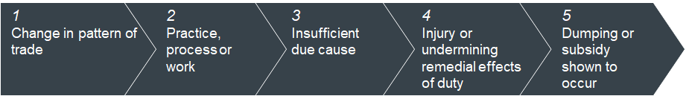
Step 1 is the basic threshold question: has there been a change in the pattern of trade? The change could be between the EU, the country targeted by the original remedy and third country or countries. It could also be between exports from a set of firms in the targeted country and another set of firms in that country. The regulations stipulate that the focus is on trade in like products, without defining the term.
The second step is that the change in the pattern or trade is attributable to a “practice, process or work”. The regulations provide a non-exhaustive list of what these could consist of, in particular:
- Slight modification or alteration of product (e.g. adding silica to zinc oxide);
- Consignment of products through third countries;
- Reorganisation by exporters or producers of their patterns and channels of sales;
- Assembly operation in the EU or a third country.
The third step is insufficient due cause or economic justification for this practice, process or work other than circumvention of duties. A finding of insufficient due cause by the EC is rebuttable by respondents to a case. This step is closely connected to the preceding steps both in terms of its formulation and because data or information used to gauge the extent of assembly operations or the extent of modifications is also pertinent to the consideration of “due cause”. As highlighted in the introduction to this report, this aspect of the legal framework underlines the essentially counterfactual nature of the analysis underpinning circumvention cases.
The fourth step is to demonstrate that circumvention gives rise to adverse effects by undermining the remedial effects of the original duty. This test is not as complex as the test for injury in anti-dumping or countervailing cases, as there is no requirement to demonstrate causation of injury. Rather, the EC verifies the existence of price undercutting or underselling.
The final step is to verify that there is evidence of dumping in relation to the normal values already established in the original case.
Investigations can be initiated by the EC (self-initiated cases) or by industry. Historically, around 80% of cases have been initiated by industry. The EC has observed that industry participants usually have well-developed monitoring capabilities that allow them to ascertain when circumvention is a possibility. For self-initiated cases, the EC relies on import data from TARIC to monitor changes in the pattern of trade.
The processes for initiation of investigations and for final determinations as to the imposition of duties both need to follow these steps. The main difference lies in the evidentiary standards. For initiations, the evidentiary standard is one of “sufficient evidence,” i.e. that there is adequate evidence that circumvention has taken place. For the final determination, the threshold is one of positive evidence i.e. that there is substantial evidence relating to the relevant factors that have to be satisfied, that circumvention has taken place. Whether the standard of positive evidence has been met is one of the key issues that would be addressed by the European Court of Justice (ECJ) in any review of determinations.

Specific procedures for assembly operations
The EU has established specific procedures in relation to alleged cases of circumvention involving assembly operations, whether these are undertaken in the EU or in a third country. These procedures involve the following steps which must all hold for a finding of circumvention via assembly operations to be made.
Firstly, the operation must have started or increased substantially when or just before imposition of duties and parts must be from countries subject to measures.
Secondly, parts must constitute 60% or more of the total value of parts of the assembled product AND the cost of assembly in the EU or third party must account for 25% or less of the production cost.
According to the authorities, the second leg of the test is the more challenging of the two and requires a forensic analysis of financial accounts, based on requests for information and site visits.
The additional tests relating to the value of parts and costs of assembly reflect, in part, the jurisprudence of the ECJ. The ECJ has had the opportunity in various cases dealing with customs administration to determine the scope of the application of General Rule 2(a) of the Harmonised System (HS). This rule states that any reference in a heading to an article shall be taken to include a reference to that article incomplete or unfinished. The ECJ has determined that this rule only applies to consignments of parts presented to customs at the same time. This has raised the issue that a good could be shipped in consignments of various parts, staggered over various points in time, and thus could enter under different customs classifications to the ones covered by the trade remedy action, and could then be assembled. Moreover, the ECJ has also ruled that complex assembly processes (essentially those that involve more than simple manipulations of tools) confer origin. This aspect of the ECJ’s jurisprudence has led to concerns being raised by EC and EU member states that standard knock-down or partial knock-down kits, used extensively in value chains such as electronics, vehicles and automotive components and light transport equipment such as bicycles, would provide opportunities for circumvention. That is because these kits could be imported in different consignments and the processes of assembly could be characterised as involving complex operations. Moreover, in this and other rulings, the ECJ has stated that assembly operations need to result in an “appreciable” increase in the value of the finished product, but it has declined to set a threshold. This in turn leaves open the question as to what threshold would be suitable to insulate origin findings from legal challenge.

Threshold tests versus rules of origin
One question put to the EU at the WTO by members such as Hong Kong is why concerns regarding assembly, and thresholds specifically, cannot be handled under normal arrangements for rules of origin. Indeed, the thresholds specified in the additional tests have some similarity to thresholds for determining originating content under the EU preferential rules of origin that apply in the EU’s FTAs.
Given the range of product-specific rules, a formal comparison is outside the scope of this research. But, as a broad generalisation, the thresholds for the circumvention tests are on the more restrictive end of thresholds found in the EU’s preferential rules of origin, which is to say that the rules of origin, reflecting their product specificity, often allow for less than 60% of the value of parts to originate outside the country in question and more than 25% of the cost of production to arise from sources outside the country. Moreover, the threshold tests under circumvention rules do not explicitly refer to the concept of last substantial transformation, which is one of the key underpinnings of rules of origin.
The more restrictive application of threshold tests, including their lack of product specificity, likely reflects a number of factors. Firstly, from an institutional perspective, trade remedy authorities operate within an informationally constrained environment and with limitations to capacity. Moreover, their concern is primarily with limiting injury to industry rather than promoting preferential trade liberalisation.
Secondly, as documented in relation to the discussion on knock-down kits, there are opportunities for circumventors to rely on the fragmented nature of modern value chains to characterise their operations as genuine assembly operations. Indeed, in a context of highly fragmented value chains, the substantial transformation criterion could be met with limited value added in the country in question. That in turn could favour the use of more restrictive thresholds if the focus is on limiting injury to domestic industry rather than encouraging processing across preferential FTAs.
One of the implications of this analysis is that the threshold approach may reflect an approach to risk that attaches more weight to the containment of circumvention than the risk of mistakenly capturing a product that is not the result of circumvention activity, i.e. a toleration of false positives if this can limit the risk of false negatives. To the extent that the former type of occurrence generates broader costs, and may indeed undermine some of the objectives sought by broader trade liberalisation efforts, this reinforces the importance of sharpening the analytical toolkit in a way that differentiates between circumvention on one hand and genuine changes to trade on the other.

Examples of cases highlighting data and information gathered to meet the tests of the legal framework
In view of the challenges associated with the detection of circumvention, and more specifically of discriminating between circumvention and other factors affecting trade in the products concerned, it is opportune to consider in more detail the data and information gathered by the authorities in the context of specific cases. We present some observations below based on a range of cases.

Changes in the pattern of trade
Peroxosulphates imports from PRC (2020), Case Number R707. The EC observed a change in the pattern of trade: imports from a company that had been the subject of a lower anti-dumping duty rate in the original measures had increased substantially, suggesting channelling from other producers subject to higher rates. This was based on customs declarations by member states which were recorded in the EU’s TARIC database and on information in the EC’s possession that the company in question had in fact ceased production as at 31 December 2017.
Certain aluminium foil imports from PRC (2020), Case Number R 646 – a third-party assembly case. Exports of foil from PRC ceased following the imposition of anti-dumping duties, while Chinese exports of stock for processing to Thailand and exports from Thailand to the EU Member States of the subsidiary of the targeted Chinese company increased. The data sources were EU internal 14(6) database on company information, Eurostat and Global Trade Atlas.
Molybdenum wire imports from PRC (2015 – third extension of circumvention), Case Number R525 – a case involving the slight modification of products. The initial duties imposed on wire containing at least 99.5% molybdenum, with a diameter of between 1.35mm and 4.0mm, were extended to wires with 97.5% molybdenum and a diameter of between 4mm and 11mm. The decision was on the basis of the EU’s internal 14(6) database which showed the disappearance of imports of the targeted product from the time of imposition and an increase in variants containing lesser amounts of molybdenum.
Stainless steel fasteners from PRC (2013), Case Number R535. Production data obtained by site visits was sufficient to show that Malaysian firms were not engaged in transhipment. However, a lack of such evidence for the Philippines motivated the EC to find that it was engaged in circumvention.
The cases above highlight that changes in patterns of trade can arise in different forms: changes in the direction of trade (i.e. countries involved); changes in the nature of the product (e.g. the composition of alloys); and changes in channels of imports (i.e. from different producers). That in turn places particular demands on both industries and authorities in terms of information gathering.
Where third countries are involved, a key plank of the EC’s analysis is to examine how respective trade patterns between the EU and the country originally targeted by duties, and between the EU and third countries, evolve from the point of imposition of the original duties. As discussed in the more detailed sections on trade data analysis and the methodological toolkits, there are several ways in which this analysis could be strengthened.

Evidence of substantial processing and differentiating between simple and complex operations
Certain aluminium foil imports from PRC (2020), Case Number R 646 – with third-party assembly in Thailand. The EC made a qualitative assessment that the processing carried out was simple relative to operations required to prepare inputs. As all parts inputs were sourced from PRC, the 60% threshold for the parts test was considered to be met. For the production costs/value-added test, the EC estimated the labour costs and factory overheads associated with the processing of inputs and found that these were substantially below the 25% threshold. The EC also studied the investment plan submitted by the Thai subsidiary, which highlighted plans for scaling up production and reducing reliance on PRC inputs. But the plan was produced after the period of alleged circumvention had begun and was therefore not deemed to be reflective of investment decisions that were made independently of the anti-dumping action.
Imports of tungsten electrodes from PRC (2020), Case Number R710 – Transhipment via Laos and Thailand. For Laos, the EC found that 100% of inputs were sourced from PRC. The EC rejected claims from the Laotian business that its operations accounted for 30% of production costs on the basis that their evidence was unreliable and determined that the proportion fell under the 25% threshold. For Thailand, there was no explicit measurement of processing, and the EC relied solely on its finding, from a site visit, that there was no production taking place at the facility where it was claimed that processing was taking place and which was advanced as the explanation for the change in the observed pattern of trade. Unlike the aluminium foil case, there was no examination of investment plans.
Imports of bicycles from PRC (2015), Case Number R608 – transhipment/third-party assembly via Cambodia, Pakistan and the Philippines. The EC found that all businesses involved in Cambodia and Pakistan failed the value of parts and share of production cost tests. The EC rejected a cost allocation proposed by a Cambodian business as the EC’s own investigation found that the allocation of labour costs was overstated and that significant parts of the facilities in question were unused. This latter finding was also used as a basis for considering that production was not reflective of preferential market access to the EU accorded to Cambodia. For Pakistan, invoices which claimed to show sourcing of parts from Sri Lanka were dismissed as unreliable. For the Philippines, one business was considered to have demonstrated that inputs from PRC accounted for less than 60% of value, but the other failed that test and the production cost test.
As indicated in the preceding cases relating to questions of processing and differentiating between simple and complex operations, the analysis of financial information is a central step in understanding production processes and organisation. The EC’s anti-circumvention unit has in-house accountants and auditors who review accounts provided. They scrutinise the following key issues:
- Inconsistencies between financial information and claims about production, e.g. depreciation rates associated with production machinery versus claims of productive capacity;
- Costs attributed to sales, management and other administrative items that could increase the share of firm costs relative to input costs.
There are several challenges associated with the analysis of financial information:
- The financial year and auditing details may not correspond with the investigation period. There will be some need for imputation based on partial accounts. This is undertaken by the EC’s anti-circumvention unit.
- Cost-allocation practices, particularly in multi-product firms, can be exploited to allocate costs to the investigated product (as, by doing this, producers can meet or exceed the 25% threshold for cost of production). The unit can draw on external expertise to verify this.
This last point on cost allocation highlights the scope left to judgement in the context of anti-circumvention inquiries. This is because in a multi-product firm, there are incremental costs (those that would have been avoided by not choosing to produce a specific product) and common costs (those that are common across all products). Common costs are usually allocated to a greater extent to products that are less price sensitive but, within this framework, there are any number of cost allocations that may be efficient. Narrowing this down to a defensible allocation is a demanding task for an authority to undertake – indeed it is often the key task in regulated industries.

Key descriptive statistics concerning EU anti-circumvention cases
Table 8 gives an overview of anti-circumvention cases since 2009 in which the EC imposed duties. We provide information on the type of product and the country (“circumventor”) covered by the original trade remedies investigation, the mode of circumvention, the countries targeted by circumvention duties, and the HS codes of products covered by the circumvention case and on which duties were levied.
We observe that, in relation to products covered by the circumvention cases, major product chapters which stand out (HS 2-digits) are those that come under:
- HS section VI (products of chemicals and allied industries), particularly chapters 28, 29 and 38;
- HS section XII (articles of stone, plaster, cement, asbestos, mica or similar materials, ceramic products, glass and glassware), particularly chapters 68 and 70;
- HS section XV (base metals and articles of base metals), particularly chapters 72 and 73, and to a lesser extent chapter 81.
Machinery and mechanical parts (HS 84) and vehicles (HS 87) also feature (and were part of prominent cases – see below).

Table 8: Overview of anti-circumvention cases in which duties were imposed (2009 to 2021), EU
Type of product (circum-ventor) | EU case number | Total number of cases | Mode of circumvention |  |  |  | Targeted country | Combined Nomenclature (CN) Commodity code(s)
 |  |  | Third-party assembly | Tranship-ment | Modifi-cation | Company channelling
Biodiesel (USA) | Case R752 | 2 |  | 1 | 1 |  | Canada, Singapore, USA | 15162098,15180091, 15180099, 27101941, 38249091, 38249097
Monosodium glutamate (MSG) (PRC) | Case R757 | 1 |  |  | 1 |  | PRC | 21039090, 21041000, 21042000, 38249993, 38249993
Peroxo-sulphates (PRC) | Case R707 | 1 |  |  |  | 1 | PRC | 28334000
Citric acid (PRC) | Case R614 | 2 |  | 2 |  |  | Cambodia, Malaysia | 29181400, 29181500
Silicon (PRC, South Korea) | Case R556 | 1 |  | 1 |  |  | Taiwan | 28046900
Ceramics (PRC) | Case R700 | 1 |  |  |  | 1 | PRC | 681110
Glass fibre fabrics (PRC, Egypt) | Case R739 | 1 |  | 1 |  |  | Morocco | 70193900, 70194000, 70195900, 70199000
Certain open mesh fabrics of glass fibres (PRC) | Case R594 | 5 |  | 4 | 1 |  | India, Indonesia, Malaysia, Thailand, Taiwan | 70194000, 70195100, 70195900
Certain corrosion resistant steels (PRC) | Case R607 | 1 |  |  | 1 |  | PRC | 72104100, 72104900, 72106100, 7210 6900, 72123000, 72125061, 72125069, 72259200, 72259900, 72269930, 72269970
Certain seamless pipes and tubes of stainless steel (PRC) | Case R309 | 1 |  | 1 |  |  | India | 73041100, 73042200, 73042400, 73044100, 73044910, 73044993, 73044995, 73044999, 73049000
Steel ropes and cables (PRC) | Case AD489 | 1 |  | 1 |  |  | South Korea, Malaysia | 73121081, 73121083, 73121085, 73121089, 73121098
Certain iron or steel fasteners (PRC) | Case R515 | 1 |  | 1 |  |  | Malaysia, Philippines, Thailand | 73181210, 73181410, 73181530, 73181551, 73181561, 73181570
Certain stainless steel fasteners and parts thereof (PRC) | Case R535 | 1 |  | 1 |  |  | Malaysia, Thailand | 73181210, 73181410, 73181530, 73181551, 73181561, 73181570
Certain aluminium foil (PRC) | Case R565 | 3 | 1 |  | 2 |  | Thailand, PRC | 76071119, 76071190
Tungsten electrodes (PRC) | Case R710 | 1 |  | 1 |  |  | PRC, India, Laos | 8101991010,8515908010
Molybdenum wires (PRC) | Case R525 | 3 |  | 1 | 2 |  | PRC, Malaysia | 81029600, 8102960090, 8102960099
Hand pallet trucks and their essential parts (PRC) | Case R458 | 2 |  | 1 |  | 1 | PRC | 84279000, 84312000
Crystalline silicon photovoltaic modules and key components (PRC) | Case R620 | 1 |  | 1 |  |  | Malaysia, Taiwan | 85013100, 85013200, 85013300, 85013400, 85016120, 85016180, 85016200, 85016300, 85016400, 854140901
Bicycles (PRC) | Case R565 | 2 | 1 | 1 |  |  | Indonesia, Malaysia, Sri Lanka, Tunisia,  Pakistan, Philippines, Cambodia | 87120030, 87120070
Gas-fuelled/non-refillable pocket flint lighters (PRC) | Case R555 | 1 | 1 |  |  |  | Vietnam | 96131000
Total |  | 32 | 3 | 18 | 8 | 3
Source: European Commission, Trade Defence Report (2009-2017); European Commission Trade Defence Investigations database, Global Trade Alert database,

Geographic patterns of circumvention cases in the EU
As observed in the preceding section, circumvention cases involving third parties (transhipment and third-party assembly) form the majority of cases in the EU which lead to the imposition of duties.
The data in Table 8 captured the role played by PRC as the main circumventor and the role played by geographically proximate countries. Trade linkages, and the fact that PRC plays an important role as an assembly hub in regional value chains, may explain this pattern, notably in the case of Thailand, Malaysia, India and Indonesia. At the same time, PRC’s largest export destinations (Japan and South Korea), which also have well-developed port facilities, are conspicuous by their near- absence (South Korea being actioned in one case). The same comment applies to Hong Kong, which has long been a re-export hub.
Several factors could explain this, although none are determinative and should not be treated as predictive of whether a particular country will be a circumvention hub:
- Lower labour costs in parts of South and South-East Asia, which facilitate assembly operations. In turn, however, this invites the question as to whether changes in patterns of trade reflect attempts to exploit such cost advantages.
- The presence of diaspora networks, although this is clearly more relevant to Indonesia, Malaysia and Taiwan for example, than it is for India or Thailand.
Preferential trade arrangements between the EU and third countries do not appear to be a major factor. The EU has unilateral or reciprocal arrangements with all the countries in the region, whether or not they are involved in circumvention routes.
It is possible that initiatives such as PRC’s Belt and Road Initiative could facilitate circumvention. While the extent of the initiative’s effects on circumvention would need to be the subject of a specific research project, intuitively, lowering trade costs should (for any given price wedge created by duties) reduce the costs of circumvention to parties undertaking such actions. But by the same token, lowering trade costs could also facilitate outward investment from PRC to exploit cost advantages. This in turn brings us back to the challenge of differentiating circumvention from genuine changes to the pattern of trade at a time when factors could stimulate both these trends.

Summary observations relating to the EU
The development of the EU’s anti-circumvention framework reflects a combination of factors: developments in underlying trends in international trade, including the challenges posed by fragmented production processes (reflected notably in the development of numerical threshold tests for cases involving assembly operations); international policy debates relating to circumvention; and case law relating to circumvention and customs administration.
The modal circumvention case in the EU is likely to involve transhipment or third-party assembly with PRC as the circumventor and products in HS Chapters 68, 70, 72 or 73, with actual cases prosecuted at the 8- or 10-digit Combined Nomenclature (CN) level. Third countries involved are likely to be in South or South-East Asia; typically those have lower levels of administrative capacity and/or important cultural and linguistic linkages to PRC in addition to commercial and investment links.
A review of cases suggests that simple trade diagnostics are used to consider the “gateway” issue of a change in the pattern of trade. The bulk of the evidentiary weight in circumvention cases, specifically in relation to the two numerical thresholds relating to the value of parts (60%) and share of production costs (25%), appears to come from information retrieved through either formal inquiries or information gathered from site visits. The application of numerical thresholds may impose some level of discipline on the conduct of investigations, although at the same time the authorities retain a relatively high degree of discretion as to what constitutes admissible information.
The last point highlights the informationally constrained environment in which the authorities operate. While cooperation received from targeted countries and businesses is satisfactory on the whole, in terms of responsiveness and willingness to engage with the EC, the quality of information received is variable. Analysing this information requires considerable in-house expertise, notably in auditing and understanding cost-allocation practices, which tend to be industry-specific. The EC relies on experienced staff and the accumulated expertise from handling many cases over time. As already observed, addressing the issue of cost allocation in the presence of informational asymmetries is one of the major challenges facing authorities involved in economic regulation.
The EU’s experience is relevant to the UK given that they have the same legal framework for circumvention cases and similarities in trade and trade routes. We would expect similar countries and product types to raise circumvention questions in the UK. The main challenge for the UK will be that there is a considerable amount of learning-by-doing in the handling of circumvention inquiries. The EC can draw on a considerable amount of past experience. The UK can learn from this experience, including through bilateral contacts, given the EC’s willingness to engage with the TRA on these matters.
The role of third countries in circumvention, coupled with our observations about the role played by weaknesses in administrative capacity in facilitating third-country circumvention, highlight the challenges that issues surrounding border arrangements between the EU and the UK via the Irish border could pose. These challenges are more likely to arise if EU and UK trade remedies were to differ. As the EC noted in our interviews, circumvention tends to be a more material risk when customs arrangements are uncertain or experimental.

Deep-dive study of the United States

Legal framework and processes
Anti-circumvention action in the United States is governed by 19 U.S. Code § 1677j and its implementing regulations are found in 19 CFR § 351.226 – Circumvention Inquiries.. The key question is whether products which purportedly circumvent duties should be included within the scope of an existing duty, or whether they should be considered under a de novo investigation. Anti-circumvention cases are administered by the Department of Commerce (DOC), though the International Trade Administration (ITA).
The current framework builds on past approaches, notably the United States Omnibus Trade and Competitiveness Act of 1988, which, as documented before, identified four modes of circumvention. A similar approach is followed today, with four broad scenarios envisioned. Each scenario sets out a non-exhaustive range of types of evidence that can be used to determine the existence of circumvention. These are summarised in Table 9 below.
Table 9: Circumvention scenarios in the United States
Scenario (1) – Merchandise completed or assembled in the United States from parts or components produced in the foreign country subject to order, and where: (i) the process of assembly or completion is minor or insignificant and (ii) the value of imported parts or components is a significant portion of total value. (NB: no specific thresholds are set for either test.)
Evidence sought (illustrative list) | Examples of data and methodologies used in practice
In relation to “minor”/“insignificant”:  - Level of investment or R&D in the United States.  - Nature of production processes and extent of production facilities in the United States.  - Share of processing in United States in sales value of product in United States.  Determination of whether product falls under scope of existing duty:  - Patterns of trade and sourcing by customers, including indications of increase in imports of parts post anti-dumping or countervailing duty.  - Affiliation/relationship between exporter of parts and assembler(s). | - Data on imports of parts versus imports of finished products and timing of changes in relation to imposition of duty.  - Were customers of the parts the same as of the finished product?  - Evidence of commercial relationship between assembler and exporter.  - Qualitative assessment of processing – simple or requiring expert knowledge?  - Quantitative assessment of value of processing based on a constructed value approach: observed resale price minus the CIF value of imported parts, an adjustment for general, selling and administrative expenses.  - Comparisons of level of investment or R&D in the United States to levels of investment or R&D by the exporter in the country of origin.  - Evidence of intellectual property and patenting.
Scenario (2) – Merchandise completed or assembled in other countries from parts or components of foreign country subject to order.
Evidence sought (illustrative list) | Examples of data and methodologies used in practice
As above, but with references to the United States replaced with references to foreign country. | As above, but with references to the United States replaced with ones to foreign country. In computing share of value accounted for by processing, authorities will deduct share of inputs originating from country subject to initial duty. Higher shares of inputs from other countries and evidence of investment in processing are more likely to lead to a negative determination.
Scenario (3) – Minor alterations i.e. of form or appearance in minor respects (including raw agricultural products that have undergone minor processing), whether or not included in the same tariff classification.
Evidence sought (illustrative list) | Examples of data and methodologies used in practice
- The overall physical characteristics of the product.  - The expectations of the ultimate user.  - End-uses.  - Channels of trade and advertising.  - Cost of any modification relative to the total value of the products at issue.  - Changes in patterns of trade (e.g. if variant with minor alteration was imported prior to duty). | Expert analysis of physical characteristics (e.g. for steel, based on metallurgical analysis) and how this determines performance against end-use. In addition to being product specific, this can also depend on the requirements of customers, so similar products can be treated differently. United States submissions to the WTO Informal Working Group point to the case of boron steel which, in the case of Canada, was considered to circumvent duties but not in the case of Japan given different customer expectations and requirements.
Scenario (4) – Later-developed merchandise – one not previously available but which has the same general characteristics as the product covered by the initial duty.
Evidence sought | Examples of data and methodologies used in practice
As above. In addition, whether the later development involved significant technological developments and whether these entail commercially significant changes. | As above. In addition, expert/qualitative assessments of whether technological and commercial changes are significant.  Evidence of investment in technology.

Cases are typically initiated by industry, but a significant number – close to a quarter in the last five years – have been initiated by the DOC. Of those cases, all but one have focused on the circumvention of duties originally imposed on PRC. The DOC actively monitors trade trends for evidence of circumvention, particularly in relation to geographies and products for which circumvention has been an issue in the past.
The DOC also works closely with industry to explain the requirements of a circumvention case, in particular the evidentiary standards that are required. In the initiation phase The DOC must determine that a circumvention inquiry request satisfies the requirements for circumvention relating to initiation that are set out in the Regulations. In the determination phase, the standard is more stringent.
The description of the scenarios suggests that a wide range of evidence can be considered in circumvention cases, and this is borne out by the description of cases below. The regulations do not stipulate any hierarchy to the types of evidence nor do they provide any guidelines as to how different types of evidence are to be weighed against each other. The authorities consider evidence as a whole in the context of the particularities of the case in question, and the DOC repeatedly emphasises the discretion left to its judgement in considering different types of evidence.
The DOC will consider quantitative data on trade flows and on matters such as investment, production and R&D. These last three metrics are usually based on firm-level data. In assembly cases, the DOC will normally calculate value added in operations involving the investigated entities to ascertain whether this is consistent with circumvention. Unlike the EU’s framework, the United States’ framework does not include numerical threshold tests that need to be satisfied. Rather, the calculations are considered in light of all the other sources of evidence presented.
The DOC also considers evidence and industry information on matters relating to industrial organisation, such as the expected extent of vertical integration and/or patterns of substitutability based on preferences of consumers and end-users. The DOC reportedly does not typically consult outside experts, although it may consult other branches of the administration. It relies primarily on in-house expertise accumulated over cases. It does not formally designate internal sector experts.
Matters of industrial organisation are relevant to questions relating to technical change and whether assembly operations follow patterns that plausibly reflect economic factors rather than a desire to circumvent. Preferences regarding end-use can be significant in determining substitutability and, thus, issues of likeness that play a role both in scope inquiries and in determining the extent to which modifications are substantial or otherwise. The approach, in conjunction with an analysis of industrial organisation, is consistent both with the jurisprudence on “likeness” in the WTO context and approaches to market definition followed in competition policy cases.
All evidence on which the DOC makes its determinations are placed on the record, which is publicly accessible (with commercial-in-confidence information redacted). Parties to a case are expected to interact with the information placed on record. The DOC records highlight an adversarial process between respondents and petitioners in relation to various items of evidence, with parties offered the opportunity to rebut both the arguments and data presented by each other and the DOC forming a view based on this and its own research.

Examples of cases which highlight data and information gathered to meet the tests of the legal framework

Cases in relation to scenarios 1 and 2 (third-party assembly in the United States or another country)
In Brazil – Uncoated Paper (2021), the DOC relied, inter alia, on an analysis of the costs of conversion of inputs sourced from Brazil into uncoated paper sold in the United States and found these to be a small proportion of the sales value. The DOC also compared the levels of investment required in the United States to investment required in Brazil to produce the inputs and deemed the former to be insignificant. On that basis, the DOC concluded that the processing was minor or insignificant.
In PRC – Welded Oil Country Tubular Goods (OCTG) (2021), the issue was possible circumvention via Brunei and the Philippines. The DOC compared investment in OCTG in Brunei and the Philippines with integrated steel operations in PRC (as opposed to OCGT in PRC). The DOC used OECD data to calculate benchmark costs for integrated steel. Because the costs of integrated operations far outweigh OCGT production, the processing was deemed to be insignificant. The DOC recognised that OCGT producers did not need to have integrated hot-rolled steel operations, but argued that, in the context of circumvention inquiries, this was relevant to whether a producer would move operations across borders to avoid duties. This is because they believed that moving only a fraction of operations across borders was more consistent with circumvention. PRC-Certain Corrosion Resistant Steel (2019) used a similar methodology to determine circumvention via the UAE.
In PRC-Small Graphic Electrodes (2012), the DOC considered the qualitative nature of the process in the third country, the level of investment, research and development, and the production facilities. It calculated the value added in the third country by adding the cost of processing and amounts for general, selling and administrative expenses, interest expenses and profit.
In UAE – Pet Film (2015), the DOC compared the investment level in the third country with the investment levels in the United Arab Emirates (UAE). In determining value added, the DOC deducted all inputs from the UAE or countries other than the country of assembly.

Cases in relation to scenarios 3 and 4 (minor alterations and later-developed merchandise)
In Mexico – Steel Concrete Reinforcing Bar (2020), an assessment of expectations of users and of actual end-use supported the DOC view that alterations were minor. The DOC found that there were significant differences in production costs. But, as the Omnibus Trade and Competitiveness Act gave the DOC flexibility in how to consider minor alterations, this was seen as insufficient to overturn the findings based on an assessment of demand-side factors, i.e. that the alterations were not significant from an end-use perspective. On this basis, the DOC concluded that switching production between types of steel concrete reinforcing bar and incurring the associated costs was not in response to specific consumer expectations but rather for the purposes of evading duties.
In Mexico – Carbon and Certain Alloy Steel Wire Rod (2013), initial duties applied to wire rod of greater than 5mm in diameter. The DOC investigation found that there were no commercial differences between wire rod in the range of 4.75mm to 5mm, the imports of which increased following the imposition of duties.
No finding under the later-developed merchandise scenario has been made since 2009. In PRC-Petroleum Wax Candles (2006), the DOC found that vegetable wax candles were a later development, in the sense that commercialisation took place after the imposition of duties, and that expectations and end-use were substantially the same as for petroleum wax candles, leading the DOC to impose duties.

Key descriptive statistics concerning United States anti-circumvention cases
Table 10 provides an overview of anti-circumvention cases since 2009 in which the United State imposed duties. We provide information on the type of product and the country (“circumventor”) covered by the original trade remedy investigation, the mode of circumvention, the countries targeted by circumvention duties, and the HS codes of products covered by the circumvention case and on which countries duties were levied.

Table 10: Overview of anti-circumvention cases in which duties were imposed (2009 to 2021), United States
Type of product (circumventor) | Total | Mode of circumvention |  |  |  |  | Targeted country | Commodity code(s)
 |  | Third-party assem-bly | Assem-bly in the US | Trans-ship-ment | Modifi-cation | Later- develop-ed merchan-dise
Honey (PRC) | 1 |  |  |  | 1 |  | PRC | 04090000, 17029090, 21069099, 0409000005, 0409000010, 0409000035, 0409000045, 0409000056, 0409000065
Glycine (PRC) | 1 | 1 |  |  |  |  | India | 2922494020
Hydrofluorocarbon (HFC) Blends (PRC) | 1 |  | 1 |  |  |  | PRC | 2903.39.2035 2903.39.2045  3824.78.0020 3824.78.0050.
Small diameter graphite electrodes (PRC) | 2 | 1 |  |  | 1 |  | UK, PRC | 380110, 8545110000, 8545110010
Polyethylene terephthalate film, sheet and strip (UAE) | 1 | 1 |  |  |  |  | Bahrain | 3920620090
Polyethylene retail carrier bags (PRC, Taiwan) | 2 |  |  |  | 2 |  | PRC, Taiwan | 3923210085
Hardwood plywood (PRC) | 1 | 1 |  |  |  |  | Vietnam | 44123300
Certain tissue paper products (PRC) | 1 | 1 |  |  |  |  | Vietnam, India | 480230, 480254, 480261, 480262, 480269, 480439, 480640, 480830, 480890, 481190, 48029000, 48059190, 48205000, 95059040, 4804311000, 4804312000, 4804314020, 4804314040, 4804316000, 4805911090, 4805915000, 4805917000
Uncoated paper (PRC, Australia, Brazil, Indonesia, Portugal) | 3 |  | 3 |  |  |  | PRC | 48025590
Certain corrosion resistant steel products (PRC, Costa Rica, Malaysia, South Africa) | 3 | 3 |  |  |  |  | UAE, Vietnam, PRC, Taiwan, USA, India | 7210.30.0030, 7210.30.0060, 7210.41.0000,  7210.49.0030, 7210.49.0091, 7210.49.0095, 7210.61.0000, 7210.69.0000, 7210.70.6030,  7210.70.6060, 7210.70.6090, 7210.90.6000, 7210.90.9000, 7212.20.0000, 7212.30.1030,  7212.30.1090, 7212.30.3000, 7212.30.5000, 7212.40.1000, 7212.40.5000, 7212.50.0000, and  7212.60.0000.
Carbon and certain alloy steel wire rod (Mexico) | 1 |  |  |  | 1 |  | Mexico | 7213913093
Steel concrete reinforcing bar (Mexico) | 2 |  |  |  | 2 |  | Mexico | 7213.10.0000 7214.20.0000, and 7228.30.8010.
Cut to length carbon steel plate (PRC) | 1 |  |  |  | 1 |  | PRC | 7225403050, 7225990090, 7226915000, 7226990180
Diamond sawblades (PRC) | 2 | 2 |  |  |  |  | Canada  Thailand | 7304.29.20.30,7304.29.20.40, 7304.29.20.50,7304.29.20.60, 7304.29.20.80,  7304.29.31.10,7304.29.31.20, 7304.29.31.30, 7304.29.31.40,7304.29.31.50, 7304.29.31.60, 7304.29.31.80,7304.29.41.10, 7304.29.41.20, 7304.29.41.30,7304.29.41.40, 7304.29.41.50, 7304.29.41.60,7304.29.41.80, 7304.29.50.15, 7304.29.50.30,7304.29.50.45, 7304.29.50.60, 7304.29.50.75,7304.29.61.15, 7304.29.61.30, 7304.29.61.45,7304.29.61.60, 7304.29.61.75, 7305.20.20.00,7305.20.40.00, 7305.20.60.00, 7305.20.80.00,7306.29.10.30, 7306.29.10.90, 7306.29.20.00,  7306.29.31.00, 7306.29.41.00, 7306.29.60.10,  7306.29.60.50,
Certain steel threaded rod (PRC) | 1 |  |  |  | 1 |  | PRC | 7318.15.5051,  7318.15.5056, 7318.15.5090, and 7318.15.2095
Steel wire garment hangers (PRC) | 1 | 1 |  |  |  |  | Vietnam | 7323999060, 7323999080, 7326200020
Aluminium extrusions (PRC) | 2 | 1 |  |  | 1 |  | PRC, Vietnam | A large range from 6603.90.81.00 to 9603.90.80.50
Certain cold-rolled steel flat products (PRC, Korea) | 2 | 2 |  |  |  |  | Vietnam | A large range from 7209.15.00.00 to 7229.90.10.00
Uncovered innerspring units (PRC) | 1 | 1 |  |  |  |  | Macau | 7320.20.50.10, 7320.90.50.10, 7326.20.00.70, 7326.20.00.71, 7326.20.00.90, 9404.10.00.00, 9404.29.90.05, 9404.29.90.10, 9404.29.90.11, 9404.29.90.13, 9404.29.90.50
Carbon steel butt-weld pipe fittings (PRC) | 1 | 1 |  |  |  |  | Malaysia | 7307.93.30
Uncoated paper products (Australia, United States, Brazil, PRC, Indonesia, Portugal) | 1 | 1 |  |  |  |  | PRC, United States, India | A large range from 4802.55 to 4811.90.90.80
Total | 31 | 17 | 4 | 0 | 10
Source: United States Trade.gov, Department of Commerce, Federal Register.
Note: numbers report anti-circumvention action taken in response to a specific finding of circumvention e.g. modification or third party assembly. Where a particular case involves more than one type of circumvention activity, each action against will be reported separately. Duties imposed on multiple partners involving the same type of circumvention activity for a particular case are treated as one action.

We observe that, in relation to products covered by the circumvention cases, there is a significant degree of concentration in relation to HS section XV (base metals and articles of base metal), specifically chapters 72 and 73, which cover iron and steel. This is consistent with the large share of anti-dumping actions historically accounted for by this sector in the United States (over 50% between 1995 and 2021, according to data reported by the WTO based on notifications by members – a share that is higher than other WTO members).
Other cases can be found, notably, under section VII (plastics and articles thereof), specifically chapter 39; Section IX (woods and articles of wood), specifically chapter 74; and Section X (pulp of wood etc.), specifically chapter 48.
The majority of circumvention cases are accounted for by assembly operations, particularly in 3rd party jurisdictions. The majority of these include intermediate goods or commoditised consumer products which undergo minor additional processing either in 3rd party jurisdictions or the United States. circumvention via minor modification accounts for a substantial share of cases. One possibility is that iron and steel products, which dominate trade remedies and circumvention cases, are susceptible to modification through the addition of other elements to form alloys and through operations such as painting.

Geographic patterns of circumvention cases
As with the EU, PRC accounts for the largest share of cases that have led to the imposition of circumvention duties. (As with the EU, it also is the leading target of anti-dumping duties, but its share of circumvention cases leading to duties is substantially higher). However, as the data in Table 10 demonstrates, the circumvention routes involving third countries differ to some extent to those seen vis-à-vis the EU, while South and South-East Asia seem to offer circumvention possibilities, as do the Middle East, Mexico and Canada.
Again, as with the EU, existing trade linkages may play a role, but they are not necessarily determinative. Factors mentioned in relation to the EU, including capacity constraints affecting governance and administration, may influence the choice of circumventor.

Summary observations relating to the United States
The United States case presents similarities and points of difference to that of the EU. A comparative analysis of the differences is undertaken in more detail in the concluding part of this section. Commonalities include the differentiation between different modes of circumvention and identification of the specific types of information required to make a determination in relation to these. Observations regarding changed patterns of trade are, as with the EU, a gateway issue in determining whether circumvention inquiries are pursued. Trade trends are actively monitored by the DOC, as they are with the EC.
Findings regarding end-use and expectations thereof appear to play a determinative role in several cases, specifically those dealing with minor alteration or later development claims. Findings regarding end-use appear largely to be based on qualitative assessments rather than quantitative techniques (such as estimations of cross-price elasticities of demand), possibly because of data and resource constraints. The DOC relies mainly on in-house expertise, including familiarity with sectors gained over time, in formulating its judgements.
A typical United States circumvention case would involve PRC and iron and steel products and could involve either minor modification or third-party assembly. While the country focus is similar to the EU cases, the range of products is smaller.

Deep-dive study of Australia

Legal framework and processes
The current legal framework for anti-circumvention in Australia is based on two instruments: the Customs Act 1901 and the Customs (International Obligations) Regulation 2015, the latter being the implementing regulations for the former.
The Anti-Dumping Commission (ADC), which is under the authority of the minister responsible for industry, administers trade remedy and anti-circumvention cases. Such activities are a relatively new phenomenon and mark a change in Australia’s posture on these matters internationally. Australia’s Productivity Commission, tasked with reviewing economic policy, identified the change as a protectionist shift in Australian policy in response to weak demand and over-capacity in capital-intensive industries which produce intermediates.
There are currently six types of circumvention identified (Table 11 below). The first four are in common with other countries (some jurisdictions treat improper arrangements as a variant of transhipment). The “slight modification of products” category was introduced in 2015 through a modification of the Regulation. (The other five categories are identified in the Act). The introduction of this form of circumvention reflected the concerns of industry that the existing scope of activities defined as circumvention was insufficient. Specifically, steel-makers, who are major users of the anti-dumping system, had concerns about the circumvention of duties related to a range of steel products through the addition of elements such as boron.
The avoidance of intended effect is a particular feature of Australia’s anti-circumvention system. The application of duties in one case (aluminium extrusions from PRC) relied on a view that post-duty prices were loss-making, based on the ADC’s own calculations. In principle, the methodology used would enable a finding of avoidance to also be made even when production is profitable.
Table 11: Modes of circumvention identified by Australia
Type | Comments
Assembly of parts in Australia  Australia | Examine import trends and ascertain proportion of value added attributable to processing in Australia. No cases to date.
Assembly of parts in third countries | As above but substituting third countries for Australia. No cases to date.
Export of goods through one third country or more | Observe changes to patterns in trade.
Slight modification of products | Cases where, but for the modification, goods would attract duty. Consider whether the purposes of the goods after modification are the same as before. Cases are mainly basic industrial goods.
Improper arrangements between exporters | Exporting via another exporter not subject to duty or to a lower duty. No cases to date.
Avoidance of intended effects | Businesses targeted by duty continue to sell good at prices that have not changed in manner commensurate with duty because exporter has lowered price or is selling at a loss, or the importer has absorbed the loss.

Examples of cases highlighting data and information gathered to meet the tests of the legal framework
Australia’s experience with circumvention is relatively limited compared to other jurisdictions. All cases to date have been initiated by industry.
The ADC has taken steps to facilitate the monitoring of trade data on the part of industry in order to identify possible changes in trade that may in turn be indicative of circumvention. In particular, the ADC has prepared a resource, the Trade Remedy Index (TRINDEX), which reports monthly volume and price data on products that are subject to anti-dumping duties. TRINDEX uses raw data provided by the Australian Border Force (ABF) import data base. The data is then cleansed: the ADC website explains that this is necessary because the raw ABF data may cover a broader range of products than relevant to a particular case, and this data needs to be stripped out.
The TRINDEX website explains that the data is converted into indices which report for each product subject to duties their weighted average unit price and volume. The website explains that the data is not comparable to data supplied by the Australian Bureau of Statistics. TRINDEX data is reported in the form of interactive graphs, and stakeholders can call up data on a particular product. The product labels reflect the product description in the trade remedy case (e.g. “A4 copy paper”) – customs tariff codes are not specified.
In PRC – Zinc Coated Galvanised Steel (2015), the authorities found slight modifications on galvanised steel through the addition of certain substances to change the composition of alloys. Whether particular firms were found to engage in circumvention turned on whether evidence could be found that the end commercial use of the alloyed steel was different. For some firms’ sales, that proved to be the case, and consequently circumvention was not found to occur.
For slight modifications, which have accounted for the bulk of circumvention cases leading to duties, section 48(3) of the Regulation sets out a non-exhaustive list of criteria that the ADC must consider in making a determination. There is no ranking or weighting attached to the criteria, and the ADC makes a determination on the basis of the facts relevant to a particular case. In most cases to date, end-use and patterns of substitutability have played an important role in determining whether circumvention has occurred.
Investigations follow an adversarial process between petitioners and respondents, and the ADC relies on submissions and rebuttals to form a view on whether or not the criteria set out in the Act (or, where relevant, the Regulation) are met. For example, in the case of a circumvention investigation relating to A4 copy paper, the question arose as to whether copy paper weighing 68 grams was substitutable for paper weighing 70-100 grams (and which was the subject of anti-dumping duties). The ADC heard a range of views before coming to a view on the matter.
Cost data and production data from financial accounts of investigated businesses play a key role in the investigations. In the context of avoidance of intended effect of duties cases, the ADC uses this data to determine whether the imported goods subject to duties are being sold in the Australian market at a price commensurate with the imposition of those duties.
Relative to the rest of the world, Australia has a well-developed policy review process, which falls under the responsibility of the Productivity Commission. A Productivity Commission’s report offers some insights into the challenges associated with the implementation of anti-circumvention measures. In particular, the report pointed to the risk of non-circumvention action being captured by the current framework. For instance, it noted that:
“Circumvention likewise implies misconduct, even though it may sometimes involve no more than an overseas supplier making a commercial decision to absorb all, or part of, the additional cost of an import duty”.
and that
“(…), [T]he shifting patterns of global production, technological advancements and global value chains (where different stages of the production process are located across different countries) provide an environment where the sorts of changes to supply arrangements targeted by the new circumvention regime can occur for a whole range of other reasons”.
While some of the Productivity Commission’s criticism is a response to the avoidance of intended effect provisions that are particular to Australia, the criticism has broader application. In particular, it resonates with the overarching challenge identified by this report, which consists both in identifying possible circumvention and, more specifically, differentiating it from other drivers of trade. In a previous inquiry report, the Productivity Commission argued that the main rationale for trade remedies in general was a political economy one: it acted as a safety valve for localised protectionist pressures and in doing so allowed a broader political consensus on trade liberalisation to be maintained. But if that is the case, it could suggest that methodologies are not sufficiently calibrated to exclude cases of legitimate economic activity from the scope of trade remedies (anti-circumvention in this case) simply because authorities are less concerned by this risk.

Key descriptive statistics concerning Australian anti-circumvention cases
Table 12 provides an overview of anti-circumvention cases since 2013 when the anti-circumvention provisions in the Act came into force, and as a consequence of which Australia imposed duties. We provide information on the type of product and the country (“circumventor”) covered by the original trade remedy investigation, the mode of circumvention, the countries targeted by circumvention duties and the HS codes of products covered by the circumvention case and on which duties were levied.
In one case, A4 Copy paper, the decision to impose circumvention duties was overturned following a merits review by the Anti-Dumping Review Panel.

Table 12: Overview of anti-circumvention cases in which duties were imposed (2009 to 2021), Australia
Type of product (circumventor) | Total | Mode of circumvention |  |  |  | Targeted country | Commodity code(s)
 |  | Third-party assembly | Tranship-ment | Modification | Avoidance of intended effects
A4 copy paper (PRC) | 1 |  |  | 1 |  | PRC | 4802.56.10
Clear float glass (Thailand) | 1 |  |  | 1 |  | Thailand | 7006.00.00
Zinc coated (galvanised) steel (South Korea, Taiwan, PRC) | 2 |  |  | 2 |  | South Korea, Taiwan, PRC | 7210.49.00, 7212.30.00, 7225.92.00, 7226.99.00
Hollow structural sections (PRC and Malaysia) | 1 |  |  | 1 |  | PRC | 7306.30.00, 7306.61.00, 7306.69.00
Wire ropes (South Africa) | 1 |  |  | 1 |  | South Africa | 7312.10.00
Aluminium extrusions (PRC) | 2 |  | 1 |  | 1 | PRC, Malaysia, Taiwan, Thailand | 7604.10.00, 7604.21.00, 7604.29.00, 7608.10.00, 7608.20.00. 7610.10.00, 7610.90.00
Total | 8 |  | 1 | 6 | 1
Source: Australian Anti-Dumping Commission.

We find that cases are essentially concentrated in section XV (base metals and articles of base metals), and more specifically iron and steel products and aluminium. Both sectors are affected by issues of global oversupply and, in Australia, they have faced declining levels of competitiveness, notably on account of rising energy costs.
Most cases involve modification. This tallies with the finding made in relation to the United States, namely that base metals lend themselves to forms of modification through notably through the addition substances to alter the chemical composition of steel products, which indeed can significantly alter the performance characteristics of the product, depending on the intended end-use.

Summary observations regarding Australian anti-circumvention cases
Australia’s anti-circumvention framework is still in the relatively early stages of development. Its implementation reflects a change in the broader context of Australian trade policy, notably a shift away from the unilateral and multilateral liberalisation pursued in the period from 1980 to the early 2000s. The legislative changes which implemented the circumvention framework also implemented changes to the way in which normal value was calculated for the purposes of establishing the margin of dumping, specifically by allowing the authorities a greater degree of flexibility to use constructed values. To the extent that this increases both the likelihood of finding dumping and the margin of dumping (and hence of remedial duties), this can increase the price wedge that creates incentives for circumvention.
Changes to the anti-circumvention framework, and trade remedy arrangements more generally, have been welcomed, as might be expected, from industries that are major users of trade remedies. At the same time, these changes have come under scrutiny by the Productivity Commission. The “avoidance of intended effects” provisions have been singled out by the Productivity Commission as being inconsistent with the National Competition Policy principles, and indeed they dovetail with broader concerns that trade remedies are used as a means of encouraging anti-competitive practices. Overall, these criticisms have broader applications beyond Australia and reinforce the need to strengthen the methodological toolkit required to address circumvention in an economically defensible manner.

Deep-dive study of Canada

Legal framework and processes
Canada’s anti-circumvention regime came into effect in 2018, through the Special Import Measures Act, or “SIMA” (Sections 71 – 75) and the Special Import Measures Regulations (Sections 57.11 to 57.21). Prior to 2018, it did not have a formal mechanism for extending the scope of duties levied via anti-dumping or countervailing measures. The framework sets out the conditions, depicted in Figure 25 below, that must all be met for circumvention to be deemed to exist. The framework reflects changes made to the anti-circumvention provisions of SIMA in Bill C-19, following consultations undertaken by the government, that received royal assent in late June, 2022.

Figure 25: Schematic representation of Canada’s approach to circumvention
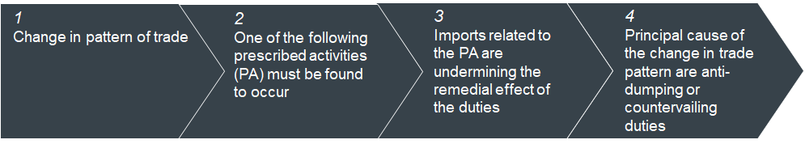
The prescribed activities are: the assembly or completion of like goods in Canada or a third country using parts from the country subject to duties; or the slight modification of goods.
Condition 4 (change in the pattern of trade) is the one that has changed following the revisions enacted in June 2022. Prior to the amendment, condition 4 required that the principal cause of the change in pattern of trade be the trade remedies duties. The amendment to replace that expression with “cause” was a response to industry opinion that viewed the evidentiary standard under the “principal cause” provision to be too high. In line with these views expressed by industry, a separate change was made to section 72.1 introducing a “reasonable indication standard” for the initiation of inquiries.
Table 13 below explains the evidence that may be supplied in relation to the conditions set out above. To date, no circumvention cases have been brought under this framework.
Table 13: Summary of legal framework for anti-circumvention in Canada
Type | Evidence sought
1) Change in pattern of trade | Consider import trends in terms of changes in import volumes with respect to relevant goods in a particular investigation.
2)(i) Assembly or completion of like goods | Evidence includes:  - the nature of the processes and the facilities;  - the level of investment into the processes or facilities;  - the level of research and development related to the processes;  - the costs of the processes in Canada or a third country as a proportion of the total cost of production of the assembled or completed like good; and  - any other factor that is relevant in the circumstances.
2)(ii) Slight modification | Indicative list of evidence includes:  - the technical specification of the like goods and the modified goods; and  - the HS classification numbers attributed to the like goods and the modified goods substitutability;  - end-uses;  - consumer preferences;  - the manner in which the goods are packaged and advertised;  - the differences in production processes, costs and facilities;  - the cost of the modification and, if it is possible to reverse the modification, the cost of reversing it; and  - any other factor that is relevant in the circumstances
3) Undermining of remedial effects | Indicative list of evidence includes:  - the price and volume of like subject goods that are assembled or completed in Canada and sold in Canada; whether the subject goods and like goods serve the same markets;  - whether the goods have the same end-uses.  - the price and import volume of like goods that are assembled or completed in a third country or of slightly modified like goods; and  - any other factor that is relevant in the circumstances
4) Change in pattern of trade is caused by the imposition of anti-dumping or countervailing duties | Factors to be taken into account are:  - differences in costs between the goods that are subject to the applicable order or finding and the completed/assembled like goods or the slightly modified like goods;  - any sales, in a country other than Canada, of the like goods that have been completed or assembled in the third country, parts or components that are being sold to Canada or the third county for assembly/completion, or; slightly modified goods;  - any other factor that is relevant in the circumstances

Further observations based on past scope reviews
Prior to 2018, matters related to circumvention were primarily addressed by the Canada Border Services Agency (CBSA) in scope advance rulings or anti-dumping or countervailing duty expiry reviews or by the Canadian International Trade Tribunal (CITT), also in expiry reviews. Although circumvention was rarely relied on in these cases, the approach of both the CBSA and CITT bore similarities to those used elsewhere, with a focus on the timing of trade flows and whether admitting or not admitting a product within the scope of an inquiry would undermine the remedy.
Rulings made by the CBSA and the CITT point to factors that need to be demonstrated to show circumvention:
- In its Scope Ruling on Oil Country Tubular Goods originating in or exported from PRC (2019), the CBSA responded to concerns about slight modification of goods or their assembly or completion in Canada by directing interested parties to the circumvention process under SIMA.
- In Certain Aluminium Extrusions from PRC (2019), the CBSA relied on evidence of circumvention/ transhipment and circumvention findings in the United States and Australia, in support of findings that dumping was likely to resume.
- In Certain Waterproof Footwear from PRC (2005), the CITT relied on evidence of circumvention through slight modification (modifications that made the footwear not waterproof) in support of its finding that dumping was likely to resume.
- In Mattress Innerspring Units originating in PRC (2014), the CITT set aside circumvention concerns relating to Malaysia on the grounds that trade data showed only a limited role of Malaysian imports in the Chinese market.
- In Bicycles and Frames originating in Taiwan and PRC (2007), the CITT decided not to continue the finding against certain cheaper frames which could be used in assembling bikes in Canada on the basis of evidence that showed it was unlikely that the finding would be circumvented in this manner.
- In Paint Brushes and Heads imported from PRC (1999), the CITT rejected the submission that new products, such as brushes based on a blend of synthetic and natural filaments, should be included in the order as these innovations could be construed to be a natural part of product evolution.
In line with comments made by the DOC and the EC, the CBSA stated that it would expect to consult a range of evidence in circumvention cases, with the nature of that evidence depending on the specifics of the case. The CBSA would be open to consulting outside experts on particular matters.

Annex 2 – Data on anti-circumvention actions in other jurisdictions
Table 14 to Table 18 present information on anti-circumvention actions that have led to the imposition of duties in Turkey, Mexico, Brazil, India and Argentina since 2009.
Of these countries, Turkey is by far the biggest user of anti-circumvention duties. Its cases are overwhelmingly related to transhipment, with PRC as the main circumventor, mainly via South-East Asia and, to a lesser extent, via EU member states. Turkey’s anti-circumvention framework essentially replicates that of the EU, with which it shares a customs union.
As observed, some of Turkey’s circumvention cases target transhipment via countries in the EU such as Bulgaria, Greece, Italy, Poland and Spain. The customs union may incentivise exporters who face anti-dumping duties in Turkey to tranship their goods via the EU, as the probability of detecting circumvention is lower due to customs unions’ laxer border checks. Specifically, within the customs union, once goods entering from outside the customs union have cleared customs, they are deemed to be in free circulation. Free circulation principles do not apply under FTAs such as the EU-UK Trade and Cooperation Agreement. However, Turkey’s experience could shed some light on the potential issues created by the special arrangements between the Republic of Ireland and Northern Ireland, and on-going uncertainty as to the implementation of these and of controls specifically.
Products which feature cases show a relatively wide range of dispersion. Compared to the EU, textiles and clothing appears to be a particular sector of focus for Turkey, which could be related to the intensity of competition between Turkey and PRC in trade in these products.
Iron and steel products feature regularly in the countries concerned, notably Brazil and Mexico. Products of light manufacturing feature slightly more prominently than they do in deep-dive countries, perhaps reflecting differences in trade structure relative to these countries.
Apart from Mexico, which implemented anti-circumvention actions in the 1990s, the countries covered in this subsection developed their anti-circumvention frameworks in the first decade of the 2000s. This may reflect an increasing focus on PRC – the main target of anti-circumvention actions across countries – since its accession to the WTO in late 2001, and the subsequent rapid growth in its share of world trade.
Table 14: Overview of anti-circumvention cases in which duties were imposed (2009 to 2021), Turkey
Type of product (circumventor) | Total | Mode of circumvention |  |  |  | Targeted country | Commodity code(s)
 |  | Third-party assembly | Tranship-ment | Modifi-cation | Later developed merchandise
Aluminium offset printing plates (PRC) | 1 |  | 1 |  |  | Malaysia | 370130000029
Certain plywood (PRC) | 1 |  | 1 |  |  | Bulgaria, Vietnam | 441210, 441231, 441232, 441239
Polyester partially oriented yarn (PRC, Taiwan, Indonesia, India, Malaysia, Thailand, Vietnam) | 1 |  |  | 1 |  | PRC, Taiwan, Indonesia, India, Malaysia, Thailand, and Vietnam | 540246
Certain woven fabrics (PRC) | 1 |  | 1 |  |  | Greece | 5513, 5514, 5515, 5516
Woven fabrics of synthetic filament yarn (PRC) | 1 |  | 1 |  |  | Bulgaria | 5407
Yarn of man-made or synthetic or artificial staple fibres (PRC) | 2 |  | 2 |  |  | Bangladesh | 5508, 5509, 5510, 5511
Granites (PRC) | 2 |  | 2 |  |  | Iran | 680223, 680293
Welded stainless steel tubes and pipes and profiles (PRC, Taiwan) | 1 |  | 1 |  |  | Malaysia, Vietnam | 730640209000, 730640809000, 730661100000
Fittings (Brazil, Bulgaria, PRC, India, Indonesia, Thailand) | 1 |  | 1 |  |  | Taiwan | 730719
Articulated link chain and parts (PRC) | 2 |  | 2 |  |  | Malaysia, Taiwan, South Korea | 731511900011, 731511900019, 731512000011, 731512000019, 731519000000
Certain furniture accessories of metal (PRC) | 1 |  | 1 |  |  | Spain, Italy, Greece, Thailand
Wall type split air conditioners (PRC) | 1 |  | 1 |  |  | Vietnam, Indonesia, Philippines, Pakistan, Egypt | 84151090, 841581, 841582
Slide fasteners (PRC) | 1 |  | 1 |  |  | Indonesia | 960711, 960719
Total | 16 |  | 15 | 1
Source: Research by Aksel Erbahar.
Table 15: Overview of anti-circumvention cases in which duties were imposed (2009 to 2021), Mexico
Type of product | Total | Mode of circumvention |  |  |  | Targeted country | Commodity code(s)
 |  | Third-party assembly | Tranship-ment | Modifi-cation | Later developed merchandise
Ammonium sulfate (PRC) | 1 |  |  | 1 |  | PRC | 3105.90.99
Bond paper (Brazil) | 1 |  |  | 1 |  | Brazil | 4802.55.01
Carbon steel Plates (Russia) | 1 |  |  | 1 |  | Russia | 7225.4001, 7225.4002
Hot-rolled steel (Russia) | 1 |  |  | 1 |  | Russia | 7208.1099, 7208.2601, 7208.2701, 7208.3801, 7208.3901
Cold-rolled steel (PRC) | 1 |  |  | 1 |  | PRC | 7209.1601, 7209.1701
Graphite electrodes for electric arc ovens (PRC) | 1 |  | 1 |  |  | PRC | 8545.1101
Iron and steel valves (PRC) | 1 | 1
Three-layer cement paper sacks (USA) | 1 |  |  | 1
Total | 8 | 1 | 1 | 6
Source: Global Trade Alert, Uruchurt, G. (2016), “Anti-Circumvention of Anti-Dumping Measures: Mexico”, Global Trade and Customs Journal, 11(11/12): 515-520.
Table 16: Overview of anti-circumvention cases in which duties were imposed (2009 to 2021), Brazil
Type of product | Total | Mode of circumvention |  |  |  | Targeted country | Commodity code(s)
 |  | Third-party assembly | Tranship-ment | Modifi-cation | Later developed merchandise
Synthetic fibre blankets (PRC) | 1 | 1 |  |  |  | PRC | 6301.4, 6001.102
Hot-rolled steel (PRC) | 1 |  |  | 1 |  | PRC | 720851  720852
Heavy plates (PRC) | 2 |  |  | 1 | 1 | PRC | 7208.361, 7208.369, 7208.37, 7225.3
Heavy plates (PRC and Ukraine) | 1 |  |  | 1 |  | PRC, Ukraine | 7208.361, 7208.369, 7208.37, 7225.3
Graphite electrodes (PRC) | 1 |  | 1 |  |  | UK, UAE | 8545.11, 3801.1
Footwear (PRC) | 1 | 1
Footwear (PRC) | 1 |  |  |  | 1
Terry fabric rolls (PRC) | 1 |  |  |  | 1
Total | 9 | 2 | 1 | 3 | 3
Source: Global Trade Alert Database.
Table 17: Overview of anti-circumvention cases in which duties were imposed (2009 to 2021), India
Type of product | Total | Mode of circumvention |  |  |  | Targeted country | Commodity code(s)
 |  | Third-party assembly | Tranship-ment | Modifi-cation | Later-developed merchandise
Cold-rolled flat products of stainless steel (PRC, South Korea, EU, South Africa, Taiwan, Thailand, USA) | 1 |  |  | 1 |  | PRC, South Korea, EU, South Africa, Taiwan, Thailand, USA
Diclofenac sodium (PRC) | 1 |  |  |  | 1 |  | 29420090
Polytetrafluoroethylene (Russia) | 1 |  | 1 |  |  |  | 3904.61.00
Total | 3 |  | 1 | 1 | 1
Source: Global Trade Alert, Sud, Juhi Dion (2016), “Circumvention of Anti-Dumping Measures: Law and Practice of India”, Global Trade and Customs Journal, Volume 11, Issue 11/12 (2016), p. 508-514.

Table 18: Overview of anti-circumvention cases in which duties were imposed (2009 to 2021), Argentina
Type of product | Total | Mode of circumvention |  |  |  |  | Targeted country | Commodity code(s)
 |  | Third-party assembly | Trans-shipment | Modifi-cation | Assembly operations in Argentina | False declaration of origin
Certain types of coated paper and paperboard (Finland and PRC) | 1 |  |  |  |  | 1 | Finland, PRC | 4810.29.10
Parts of bicycles (PRC and Taiwan) | 1 |  |  |  | 1 |  | PRC, Taiwan | 4810.29.10
Footwear (PRC) | 1 |  |  |  |  | 1 | Malaysia | 6404.19.00, 6404.99.90
Certain types of electric fans (PRC) | 1 |  |  |  |  | 1 | Vietnam | 8414.511, 8414.519, 8414.599
Steel butt-welded pipe fittings (PRC) | 1 |  |  |  |  | 1 | Cambodia | 7307.93.00
Certain types of eyewear (PRC) | 1 |  |  |  |  | 1 | Japan | 9003.11.00, 9003.19.10, 9003.19.90, 9004.10.00
Total | 6 |  |  |  | 1 | 5
Source: Global Trade Alert Database, Arnolt, P. (2016), “Anti-Circumvention of Anti-Dumping Measures: Law and Practice of Argentina”, Global Trade and Customs Journal, 11(11/12): 473-478.

Annex 3 – Quantity analysis from Example 1: The application of UN Comtrade data to a past EU transhipment case

Figure 26: Quantity of monthly imports into the EU from the PRC and Malaysia for glass fibres (certain open mesh fabrics) for 2010 to 2013
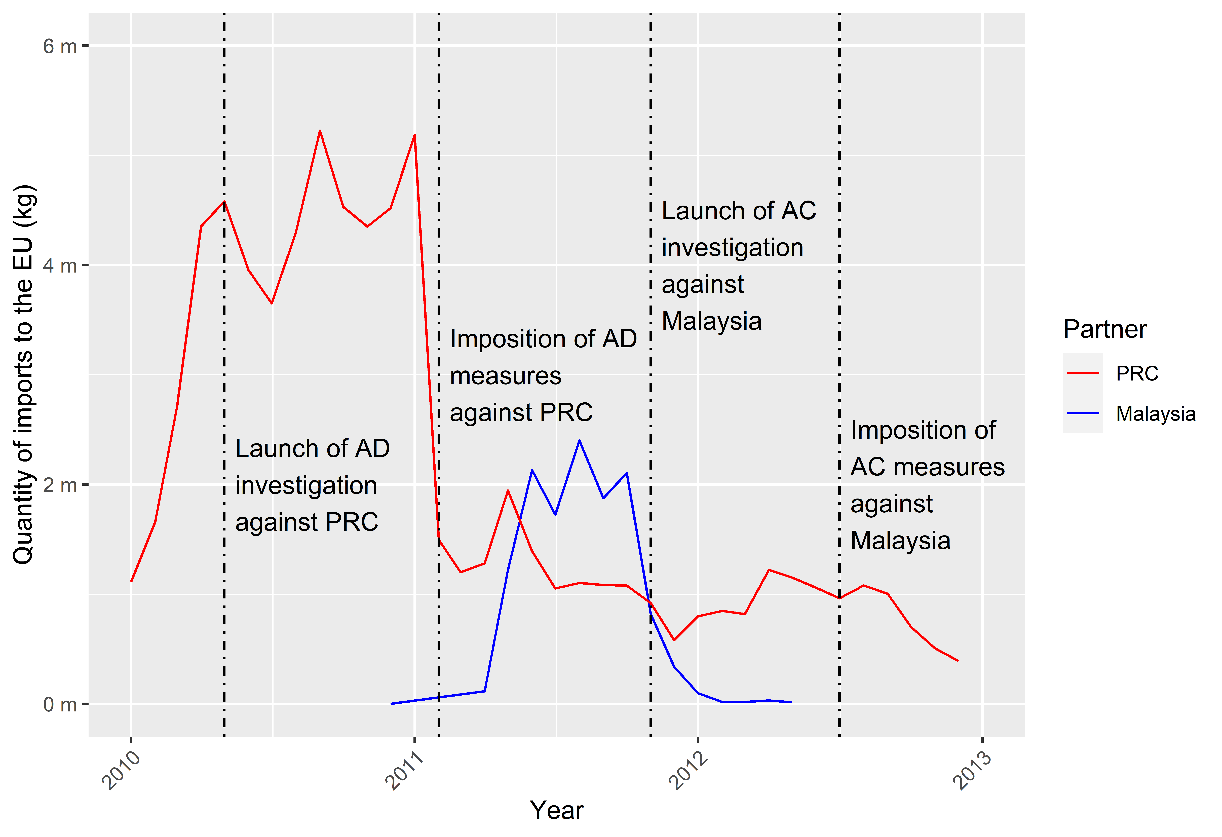
Source: Frontier Economics analysis of UN Comtrade data.

Figure 27: Quantity of monthly exports from the PRC to Malaysia for glass fibres (certain open mesh fabrics) for 2010 to 2013
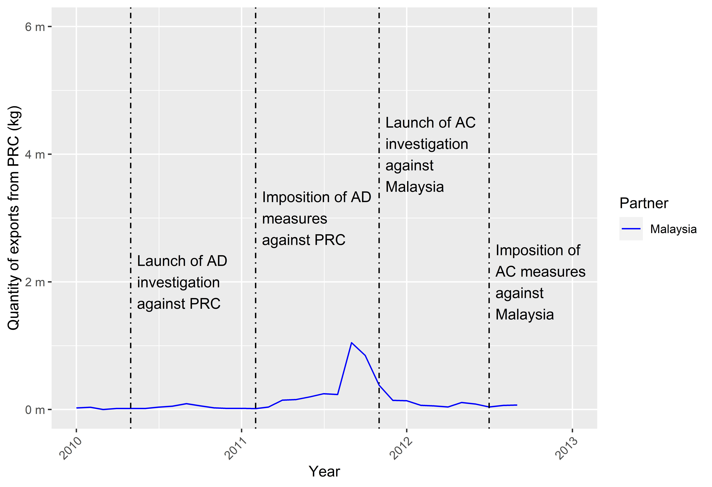
Source: Frontier Economics analysis of UN Comtrade data.

Figure 28: Quantity of monthly imports into Malaysia from the PRC for glass fibres (certain open mesh fabrics) for 2010 to 2013
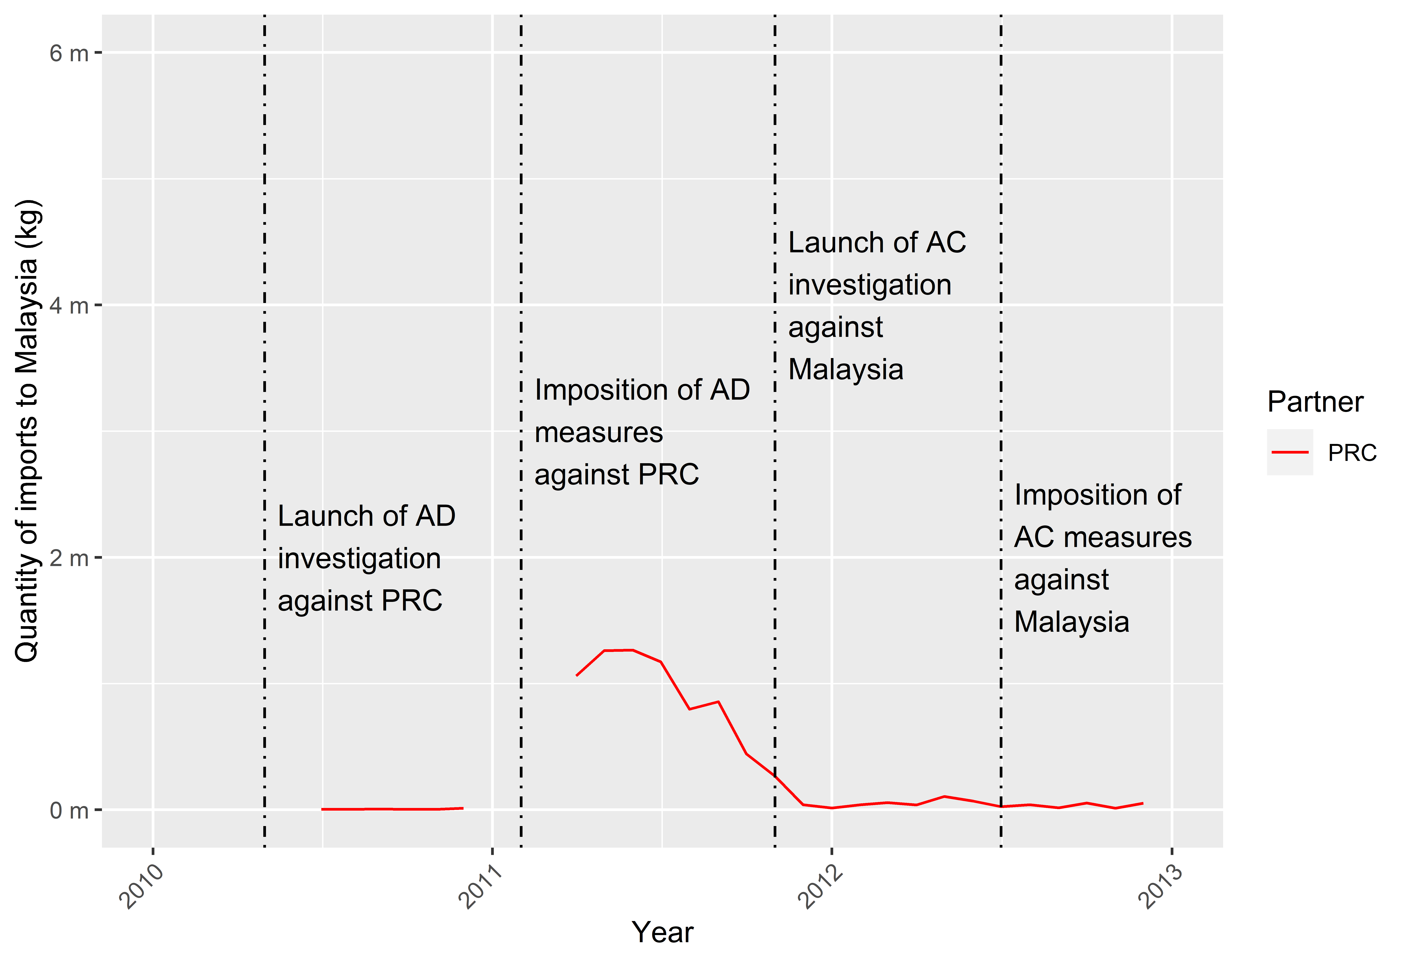
Source: Frontier Economics analysis of UN Comtrade data.

Annex 4 – Supplementary charts from Example 2: Potential extension of trade remedy duties to continuous glass fibre from PRC
Figure 29: Value of monthly imports into the EU-28 from the PRC, South-East Asia, Taiwan, Hong Kong and India for CN code: 7019 12 00 for 2015 to 2020
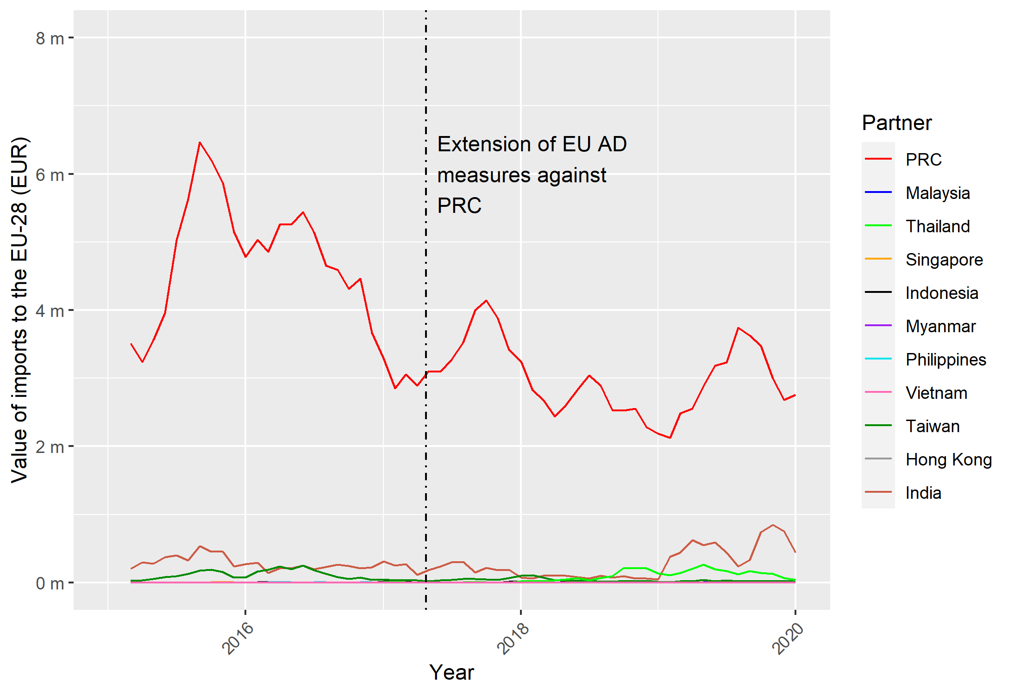
Note: Data presented is a three-month moving average. Not all South-East Asian countries are included, as data was not available.
Source: Frontier Economics analysis of Eurostat data.

Figure 30: Value of monthly imports into the UK from the PRC, South-East Asia, Taiwan, Hong Kong and India for CN code: 7019 12 00 for 2015 to 2020
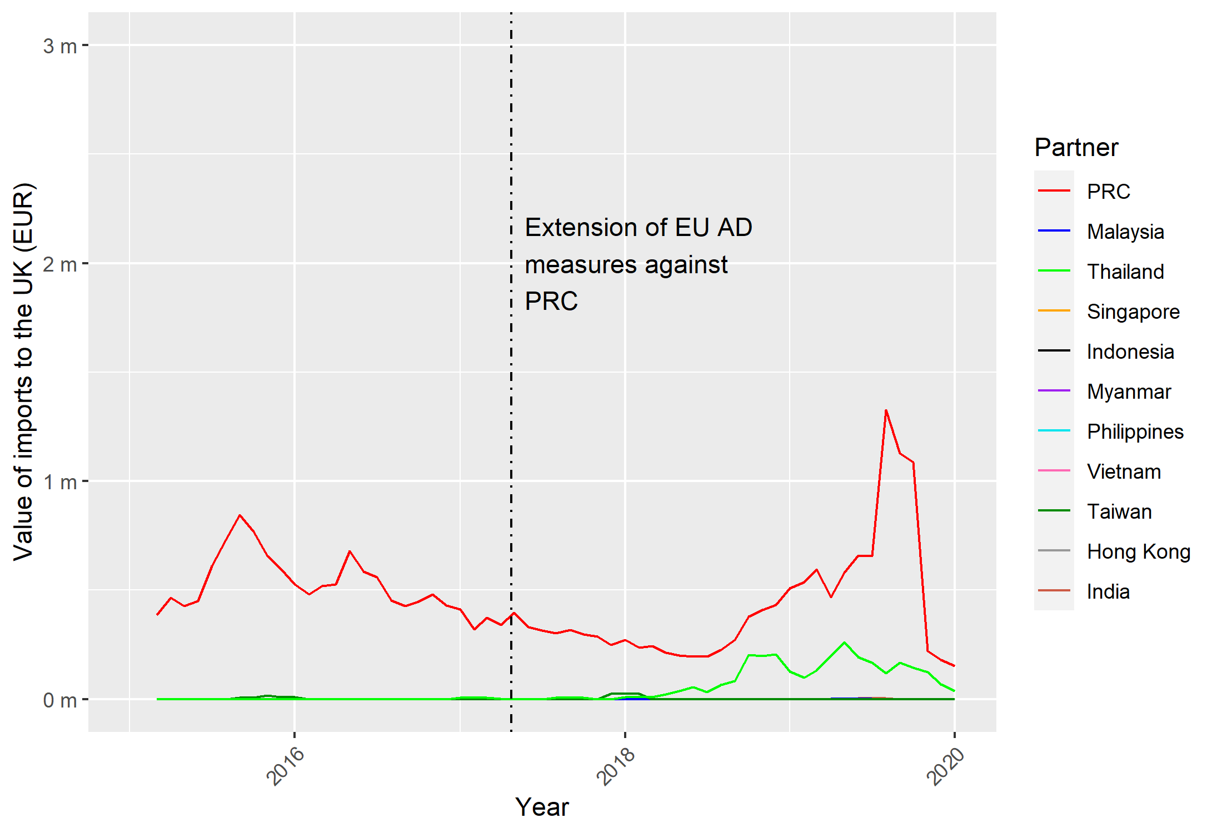
Note: Data presented is a three-month moving average. Not all South-East Asian countries are included, as data was not available.
Source: Frontier Economics analysis of Eurostat data.

Figure 31: Value of monthly imports into the EU-28 from the PRC, South-East Asia, Taiwan, Hong Kong and India for CN code: 7019 31 00 for 2015 to 2020
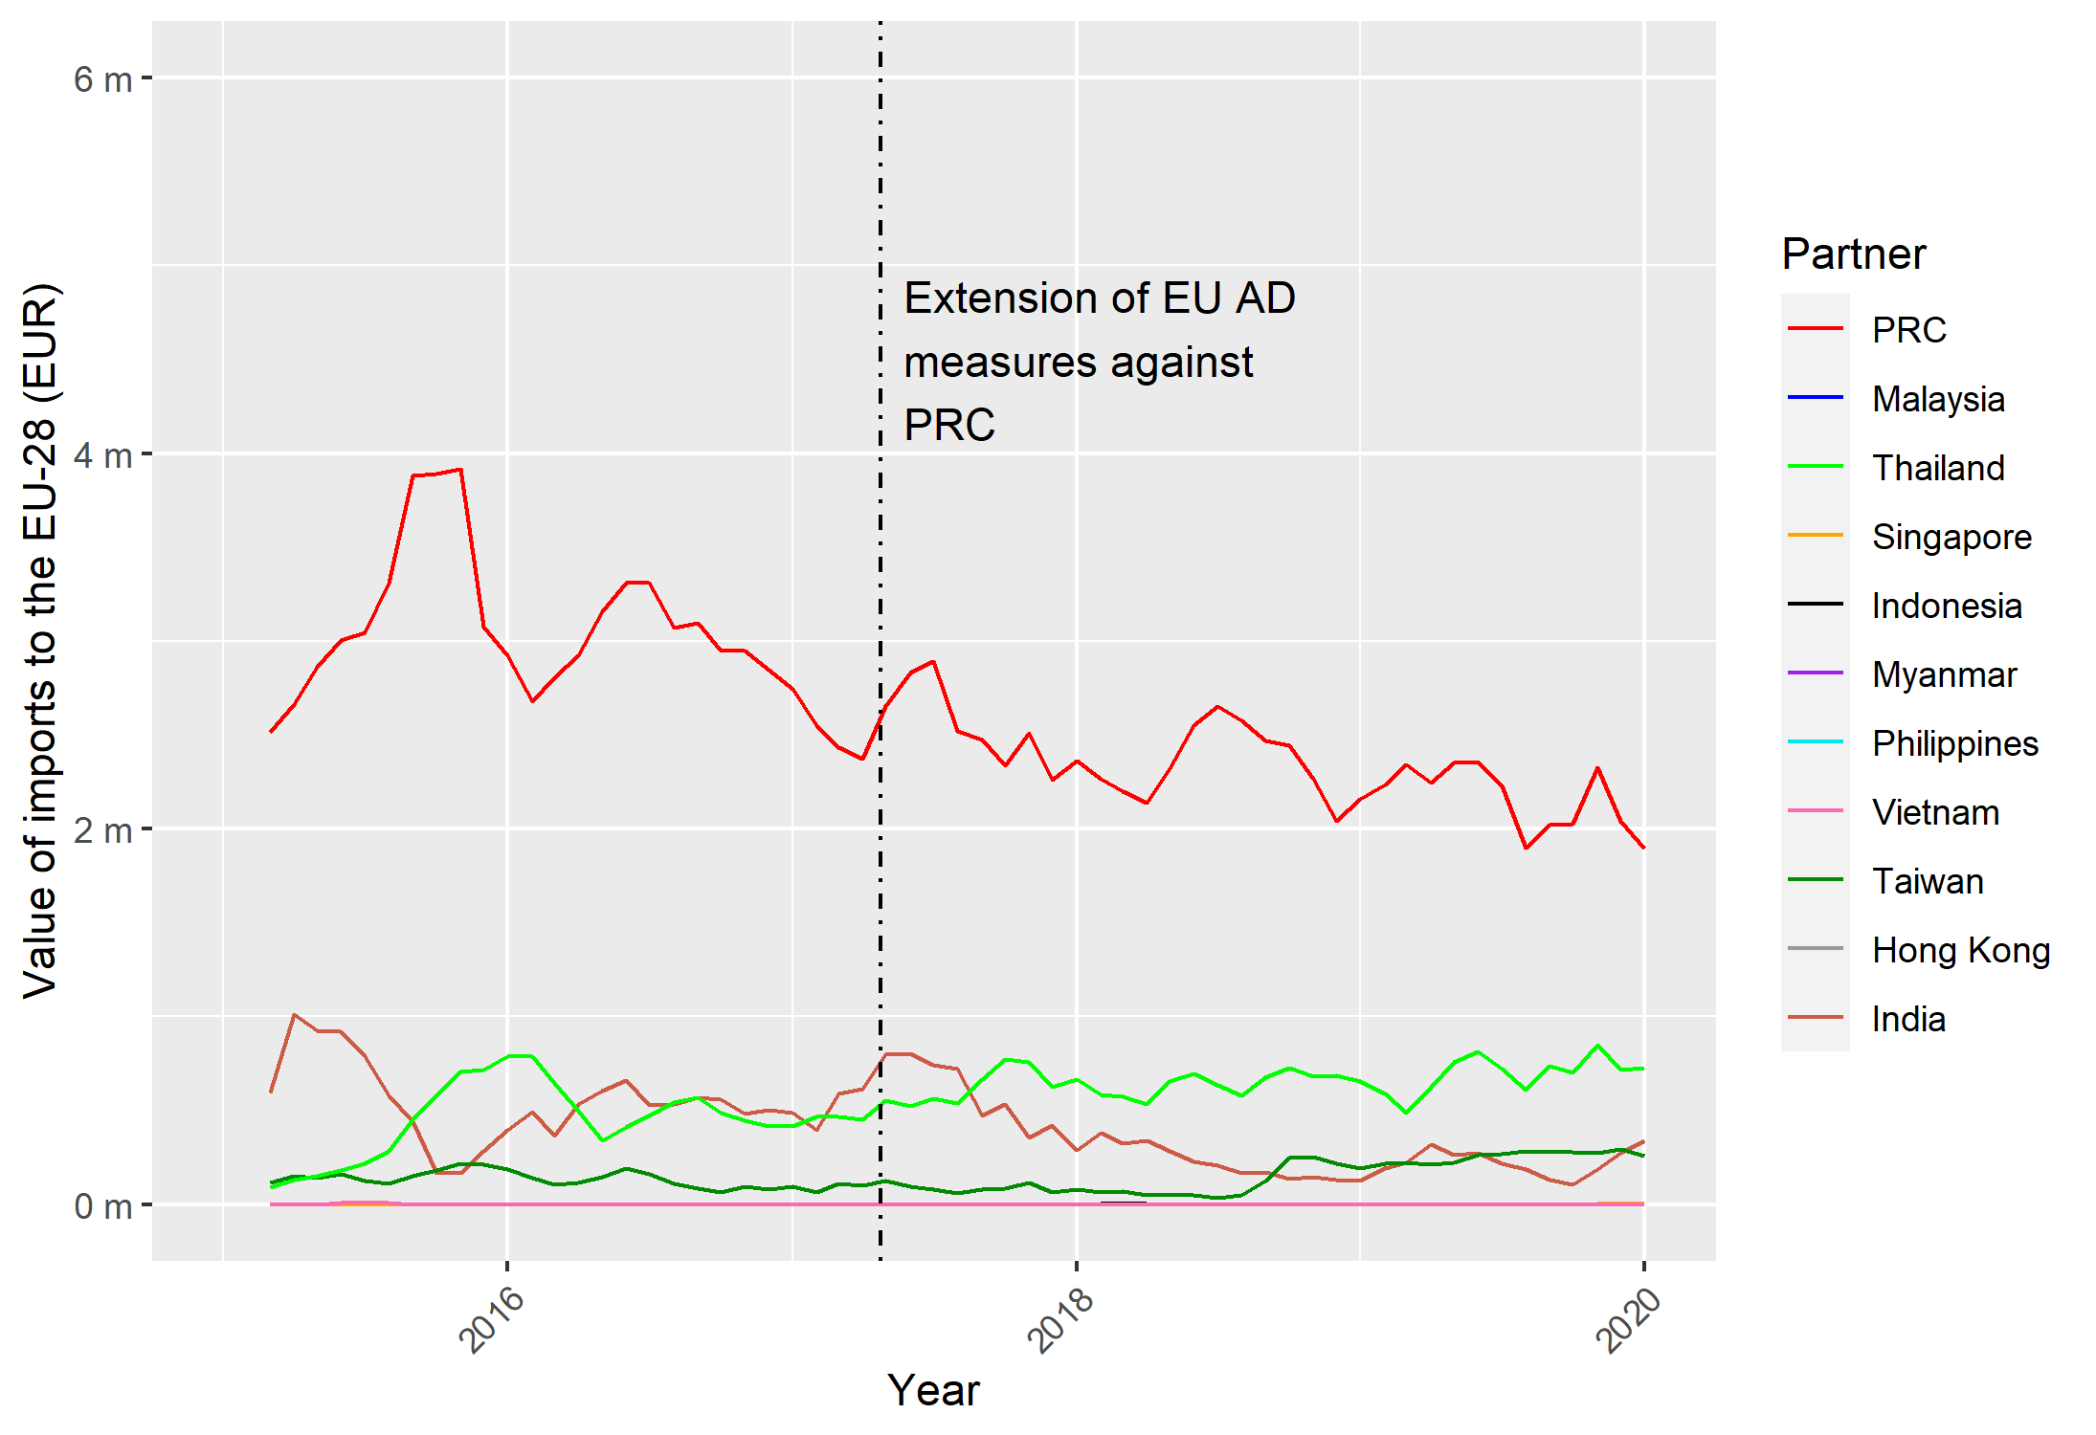
Note: Data presented is a three-month moving average. Not all South-East Asian countries are included, as data was not available.
Source: Frontier Economics analysis of Eurostat data.

Figure 32: Value of monthly imports into the UK from the PRC, South-East Asia, Taiwan, Hong Kong and India for CN code: 7019 31 00 for 2015 to 2020
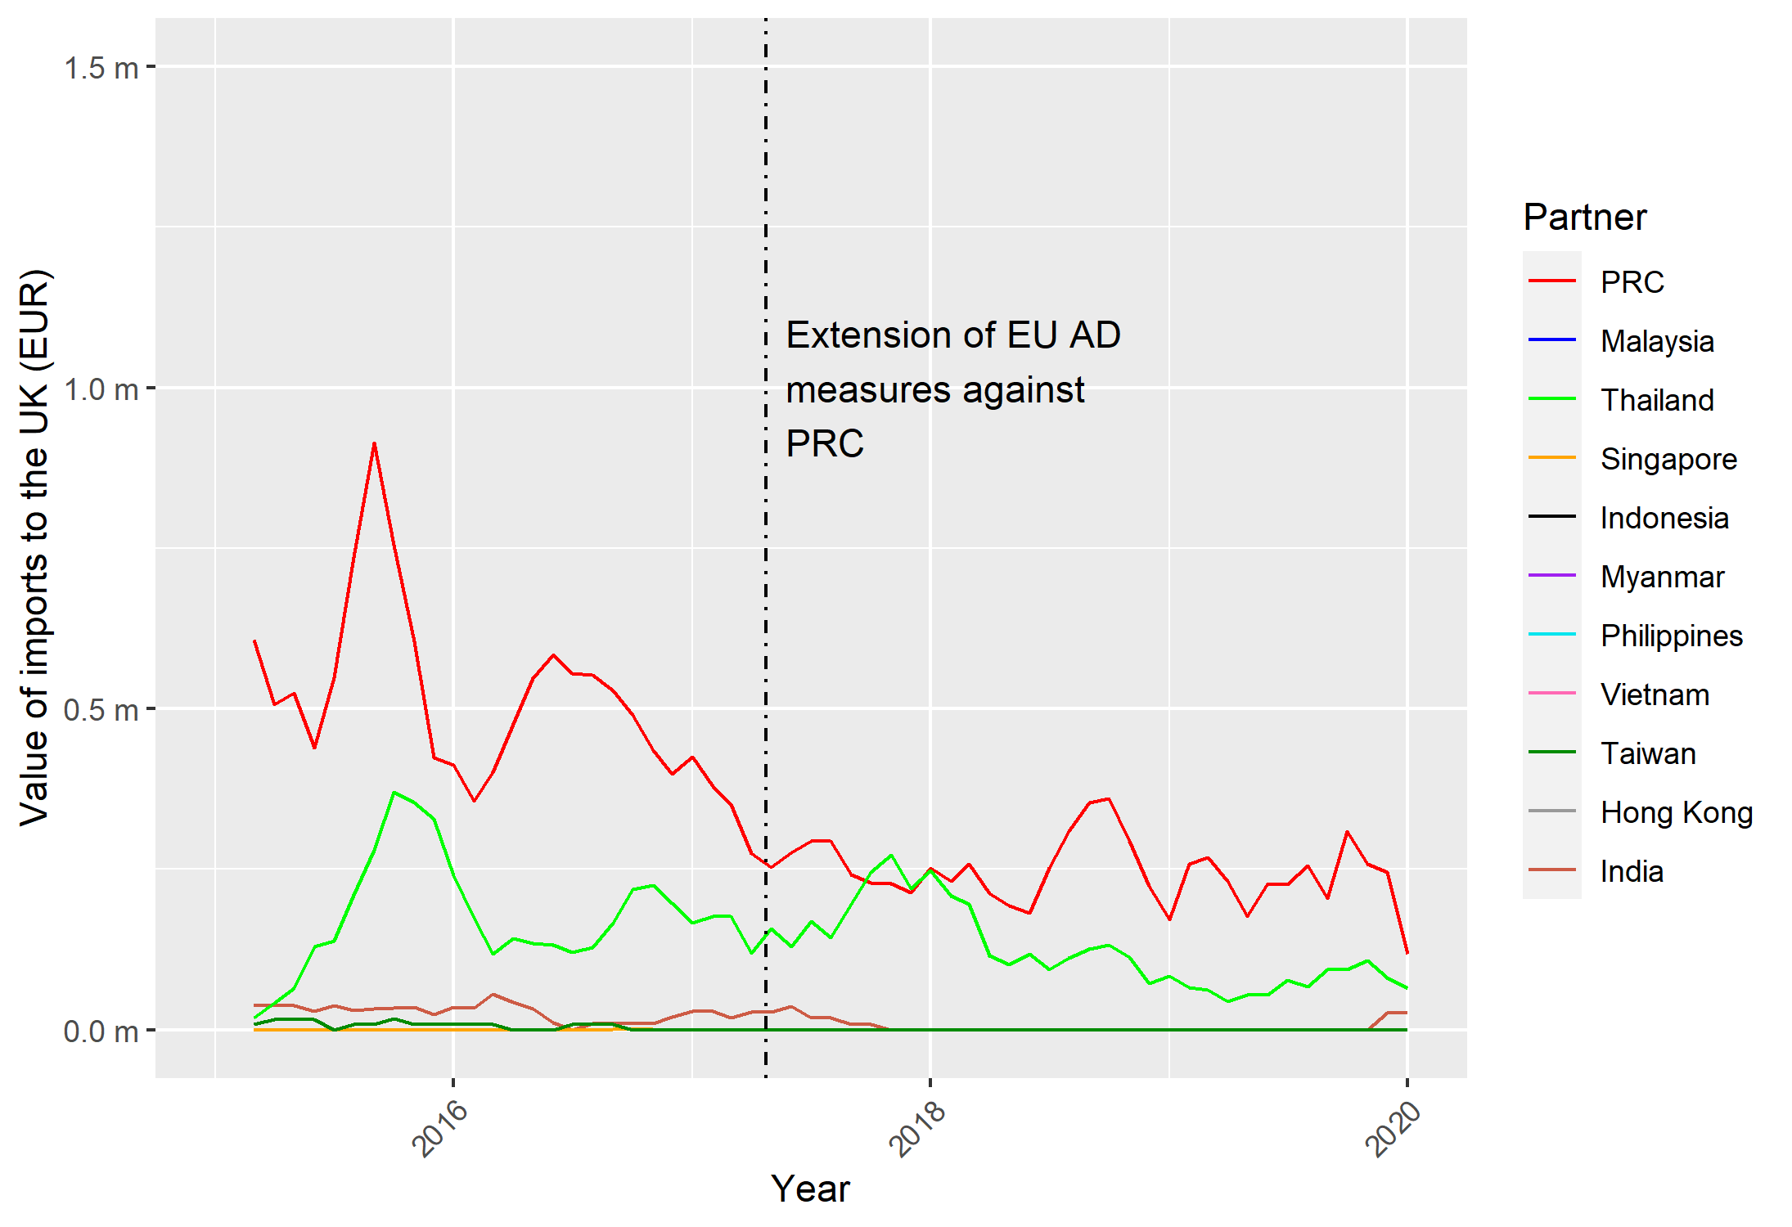
Note: Data presented is a three-month moving average. Not all South-East Asian countries are included, as data was not available.
Source: Frontier Economics analysis of Eurostat data.

Annex 5 – Supplementary charts and discussion from Example 3: Potential extension of trade remedy duties to biodiesel from the United States and Canada
Figure 33 presents a similar analysis (to that included in the main body of the text) for CN code 3824 99 92. This is a new code that was introduced in 2017, which is why trade values are presented from 2017 onwards. In contrast to code 3826 00 10, the United States is the top exporter into the EU-28. Along with PRC, which is the second largest exporter into the EU-28, total imports trend upwards over the period. Imports from other countries in the top five remain relatively flat over the period. For the UK, in Figure 3444, we see a similar trend, although Chinese imports play a proportionately bigger role than the United States, supplanting those from the United States in 2019.
Figure 33: Value of monthly imports into the EU-28 from the top five exporters into the EU-28 for CN code: 3824 99 92 for 2015 to 2020
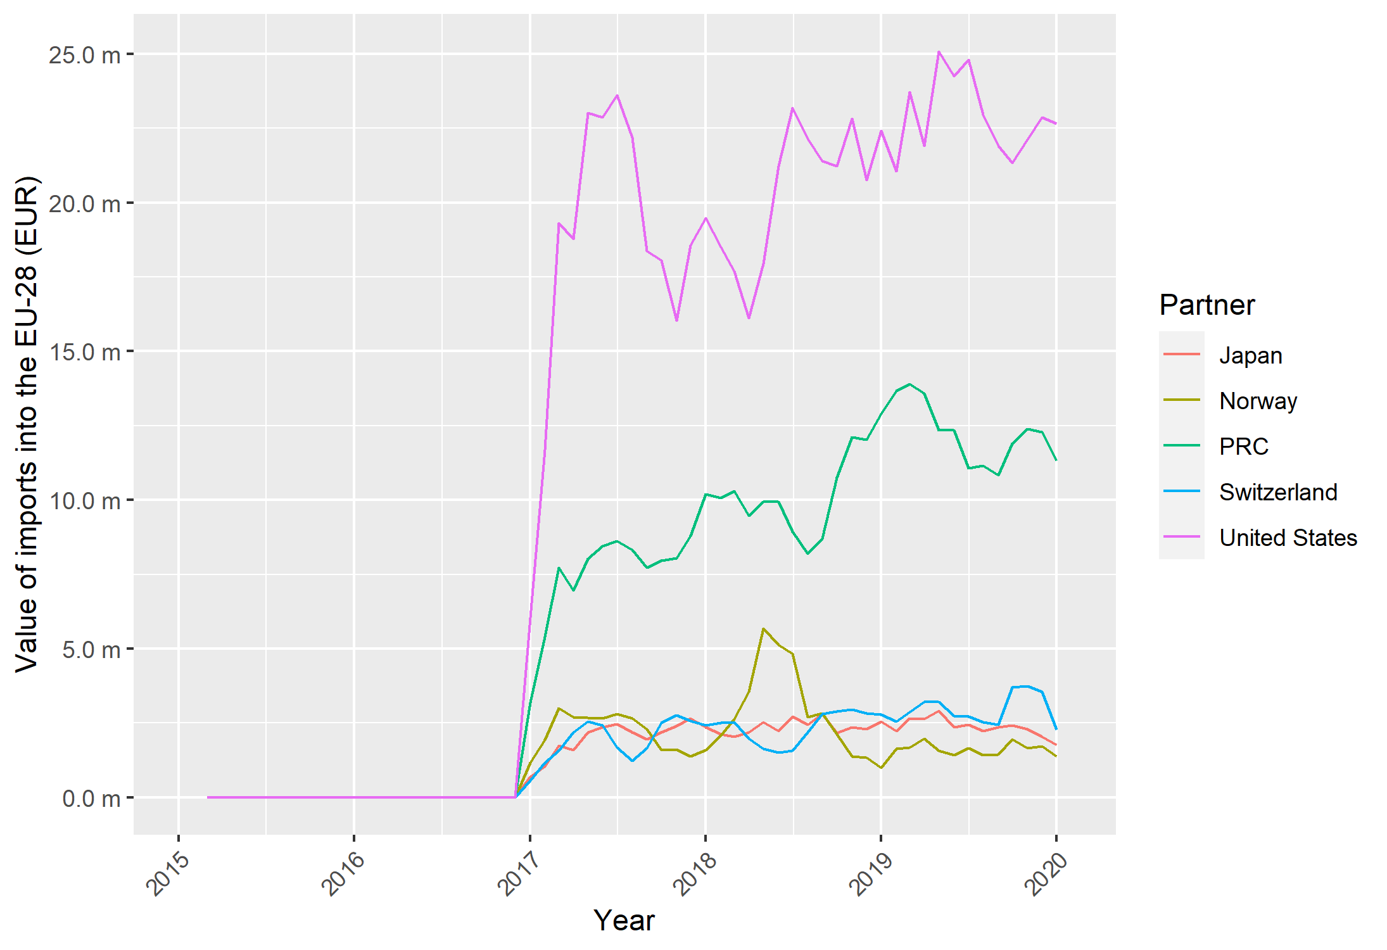
Note: Data presented is a three-month moving average.
Source: Frontier Economics analysis of Eurostat data.

Figure 34: Value of monthly imports into the UK from the top five exporters into the UK for CN code: 3824 99 92 for 2015 to 2020
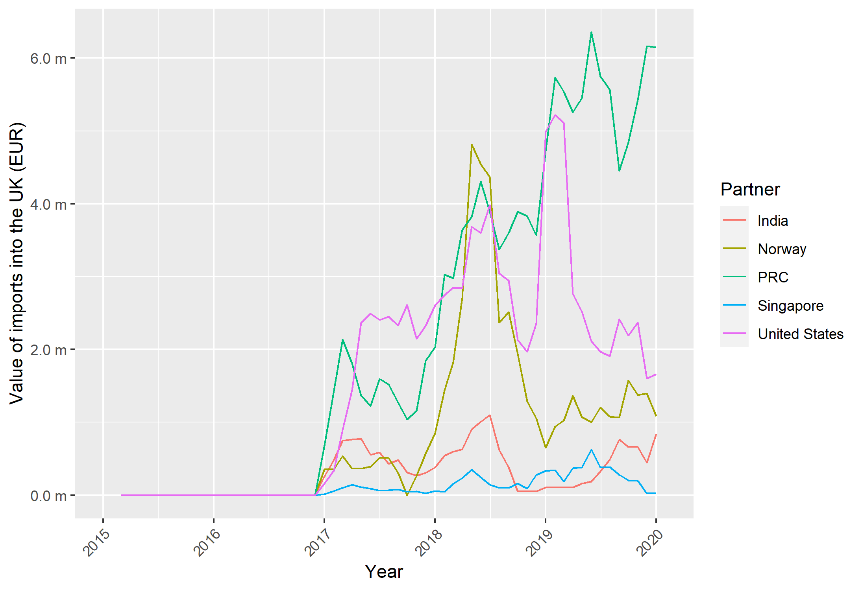
Note: Data presented is a three-month moving average.
Source: Frontier Economics analysis of Eurostat data.
Figure 35 and Figure 36 show the top five export destinations for HS code 3824 99 from the United States and Canada respectively. For the United States, we see a much more varied set of export destinations, ranging from Canada and Mexico to PRC and Germany. Of particular note is the fact that exports trend upwards for all countries over the period (particularly so for Germany). It is worth noting, however, that the less granular product definition available in the UN Comtrade data in Figure 35 and Figure 36 (the Eurostat import data is at the 8-digit (CN) level) means that the very large trade values with Germany (c. US$400 million in 2021) are not reflected in EU-28 imports in Figure 33. Looking at Canadian exports, we see much less diversification, with the vast majority of exports to the United States (although Germany does appear in the top five export destinations).

Figure 35: Top five export destinations by value of annual exports from the United States for HS code: 3824 99 for 2015 to 2021
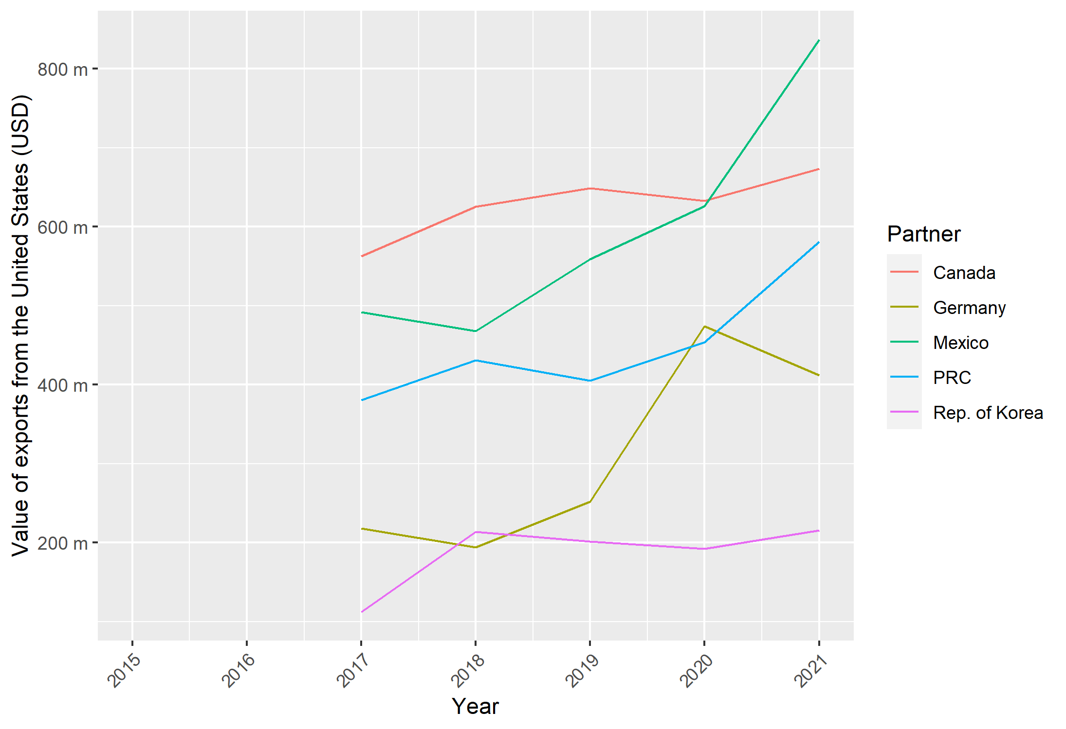
Source: Frontier Economics analysis of UN Comtrade data.

Figure 36: Top five export destinations by value of annual exports from Canada for HS code: 3824 99 for 2015 to 2021
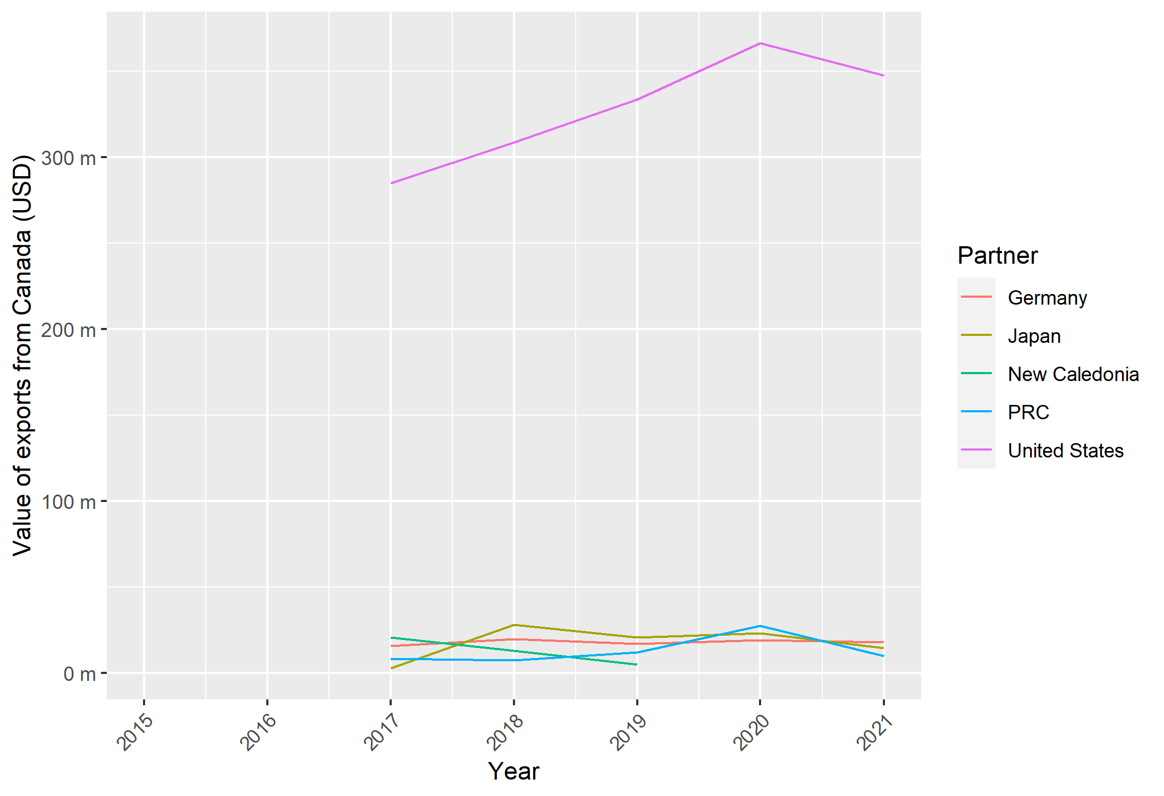
Source: Frontier Economics analysis of UN Comtrade data.
Looking now at EU-28 and UK imports for CN code 1518 00 91 in, respectively, Figure 37 and Figure 38, a different picture emerges. For the EU-28, almost all imports of this product are from Indonesia, with highly volatile trade flows seen from 2017 onwards (following the expiry of duties). For the UK, while most imports are from the United States, the value of the trade flows are relatively immaterial (below €100,000 annually).

Figure 37: Value of monthly imports into the EU-28 from the top five exporters into the EU-28 for CN code: 1518 00 91 for 2015 to 2020
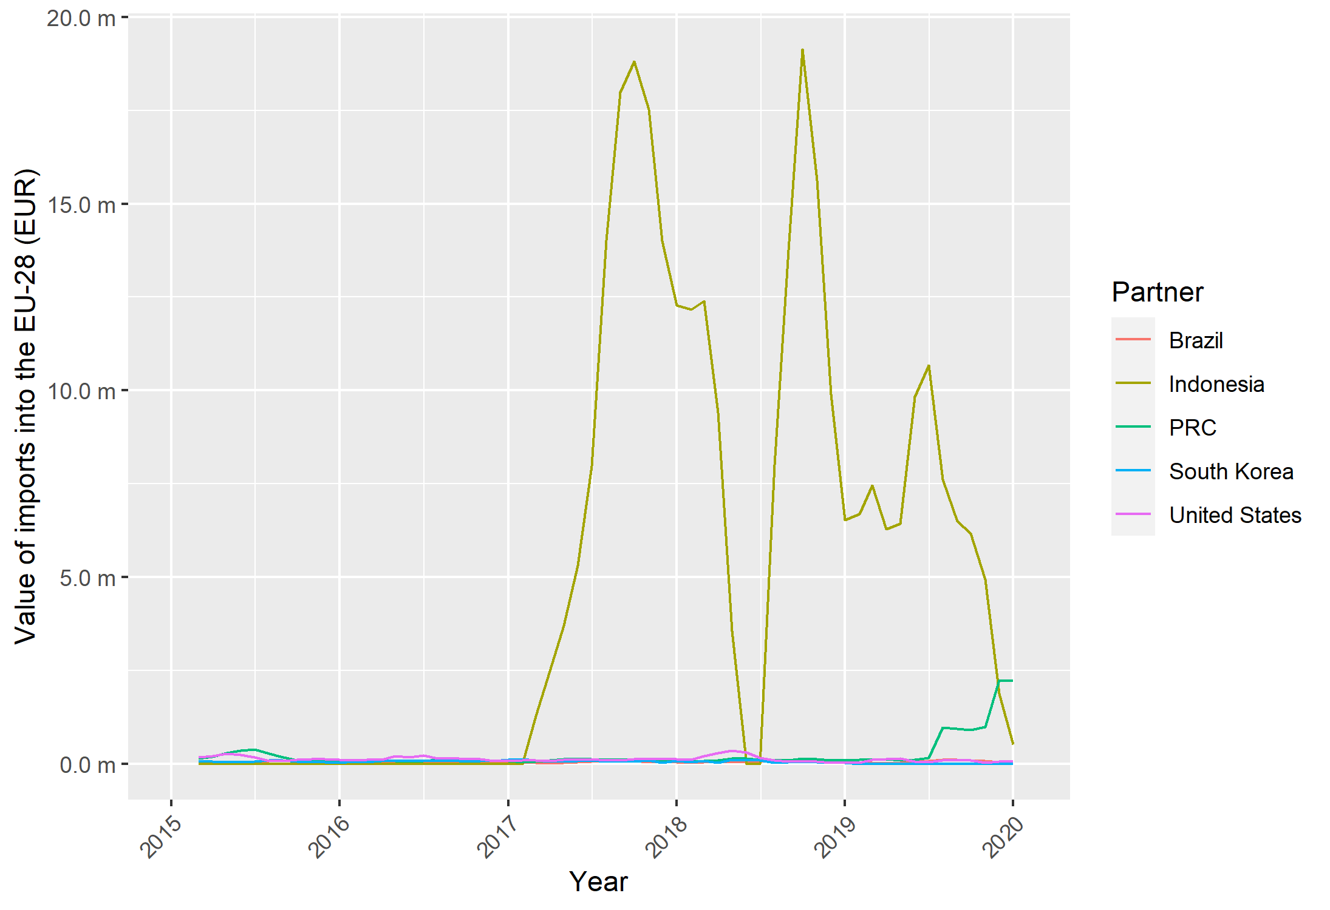
Note: Data presented is a three-month moving average.
Source: Frontier Economics analysis of Eurostat data.

Figure 38: Value of monthly imports into the UK from the top five exporters into the UK for CN code: 1518 00 91 for 2015 to 2020
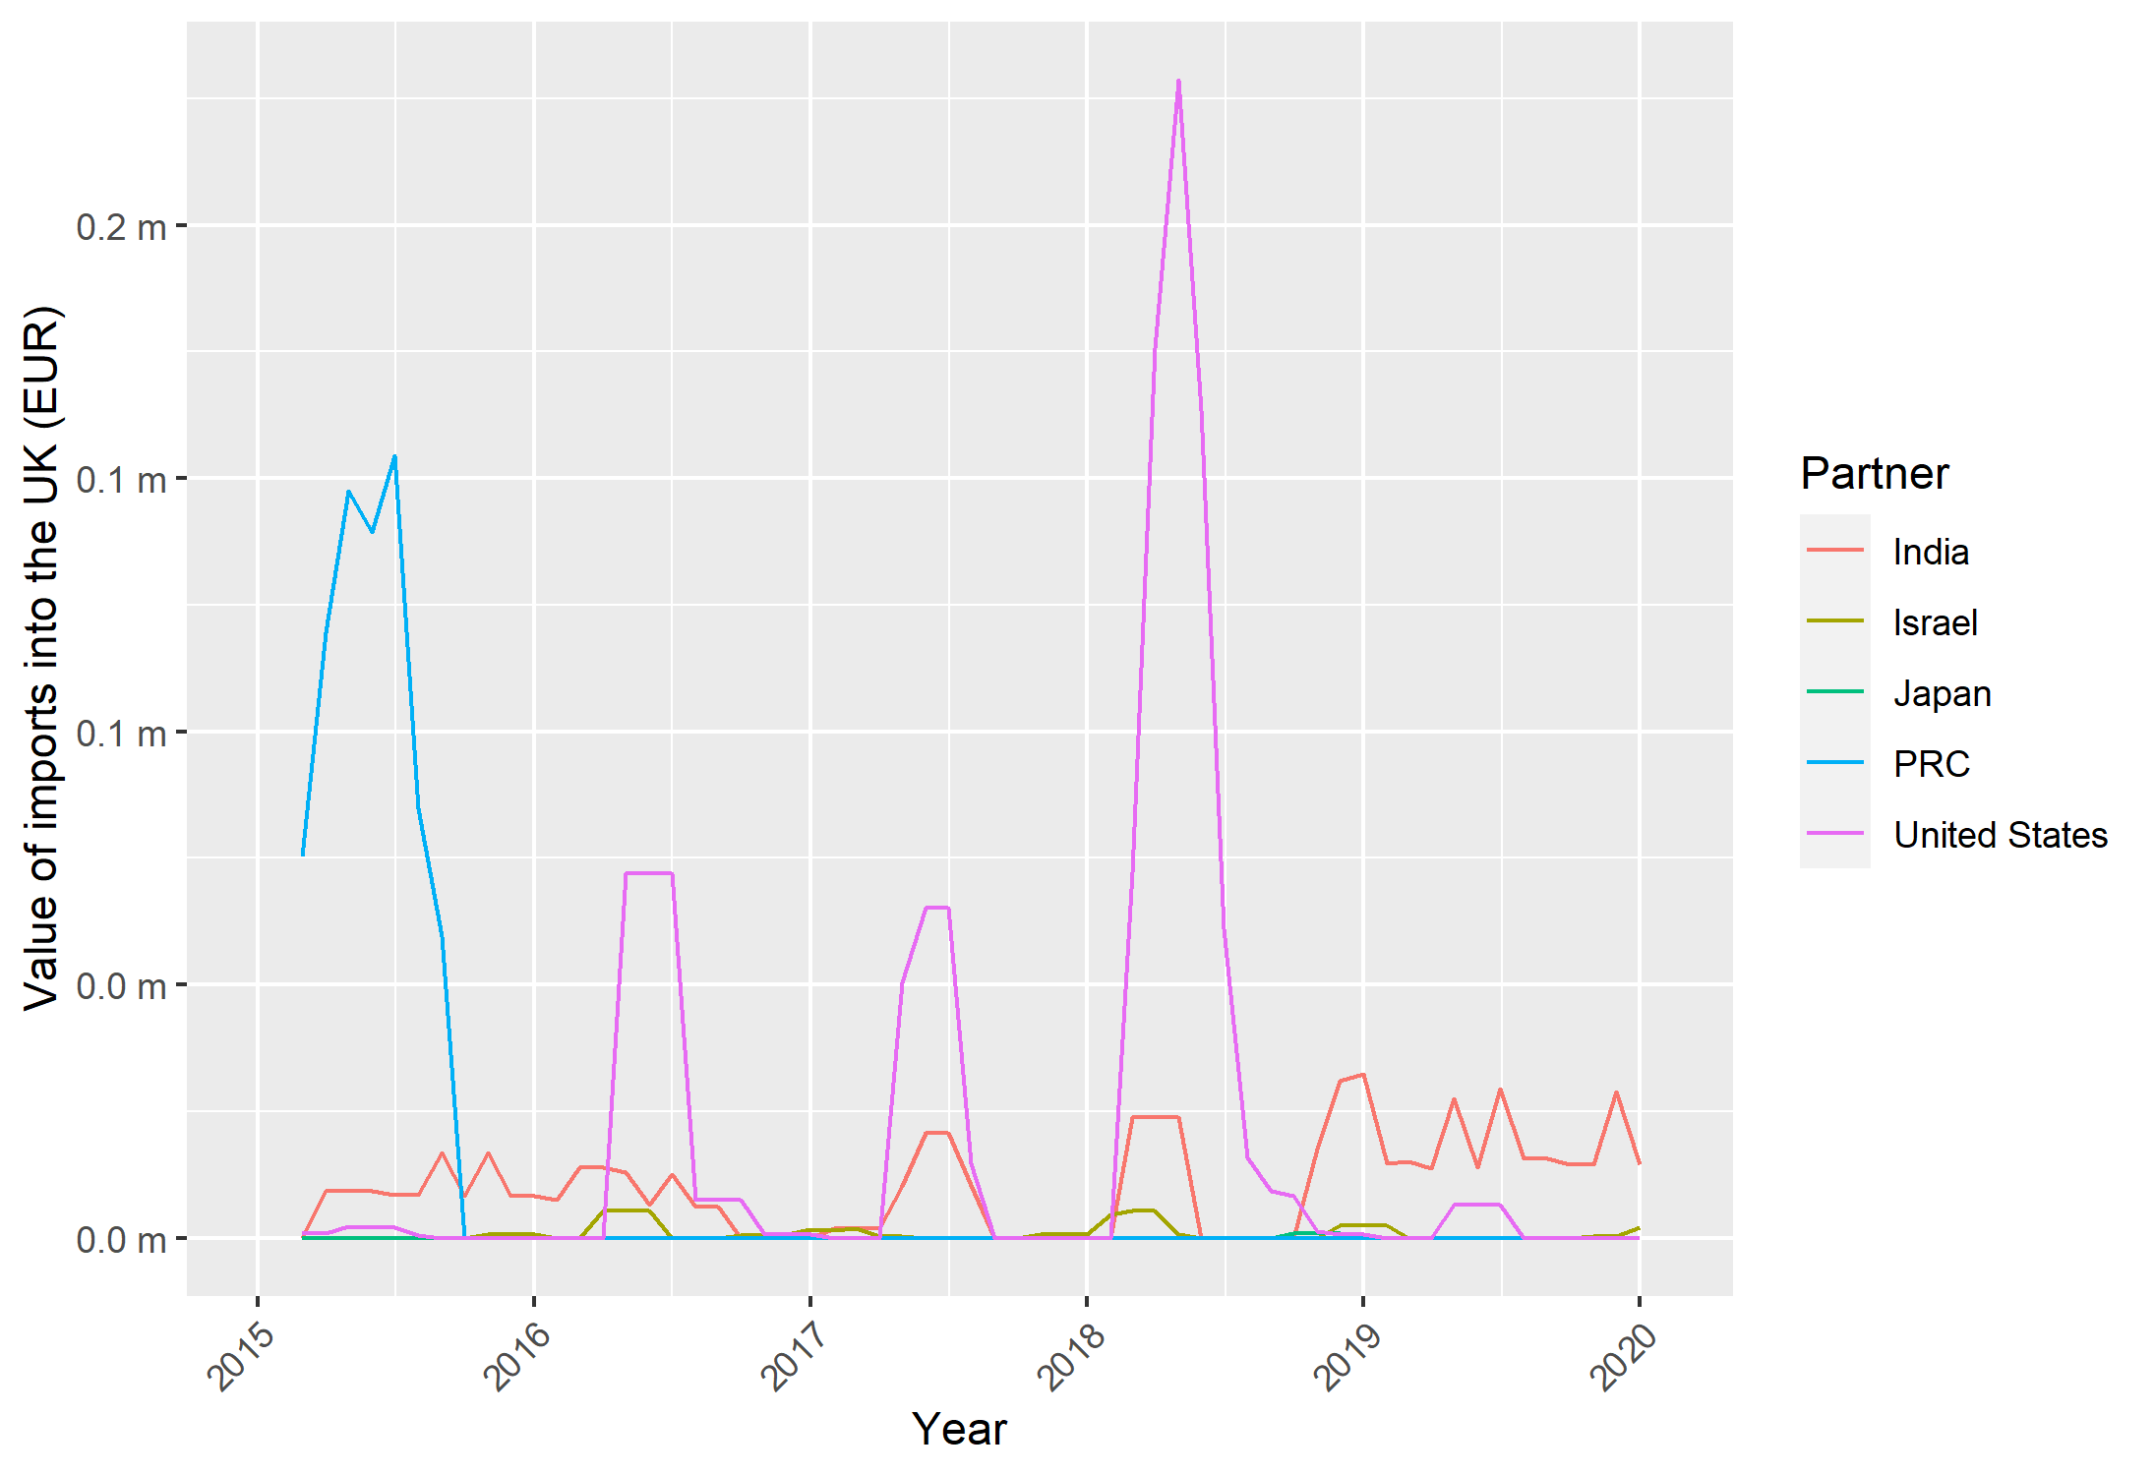
Note: Data presented is a three-month moving average.
Source: Frontier Economics analysis of Eurostat data.
Looking at the export destinations for the United States and Canada in Figure 39 and Figure 40, for both countries we see a significant increase in exports to Singapore over the period. Given that Singapore was originally part of the anti-circumvention investigation (but was later exonerated), this is potentially significant. As imports from Singapore do not increase in the EU-28 or the UK, this suggests that circumvention is unlikely to be present. For Canada, there is also a significant increase in exports to the United States. For the United States, we also see an increase over the period in exports to the UK. For the same reason outlined in the previous paragraph, the expansion in exports from the United States to the UK does not appear in Figure 38.

Figure 39: Top five export destinations by value of annual exports from the United States for HS code: 1518 00 for 2015 to 2021
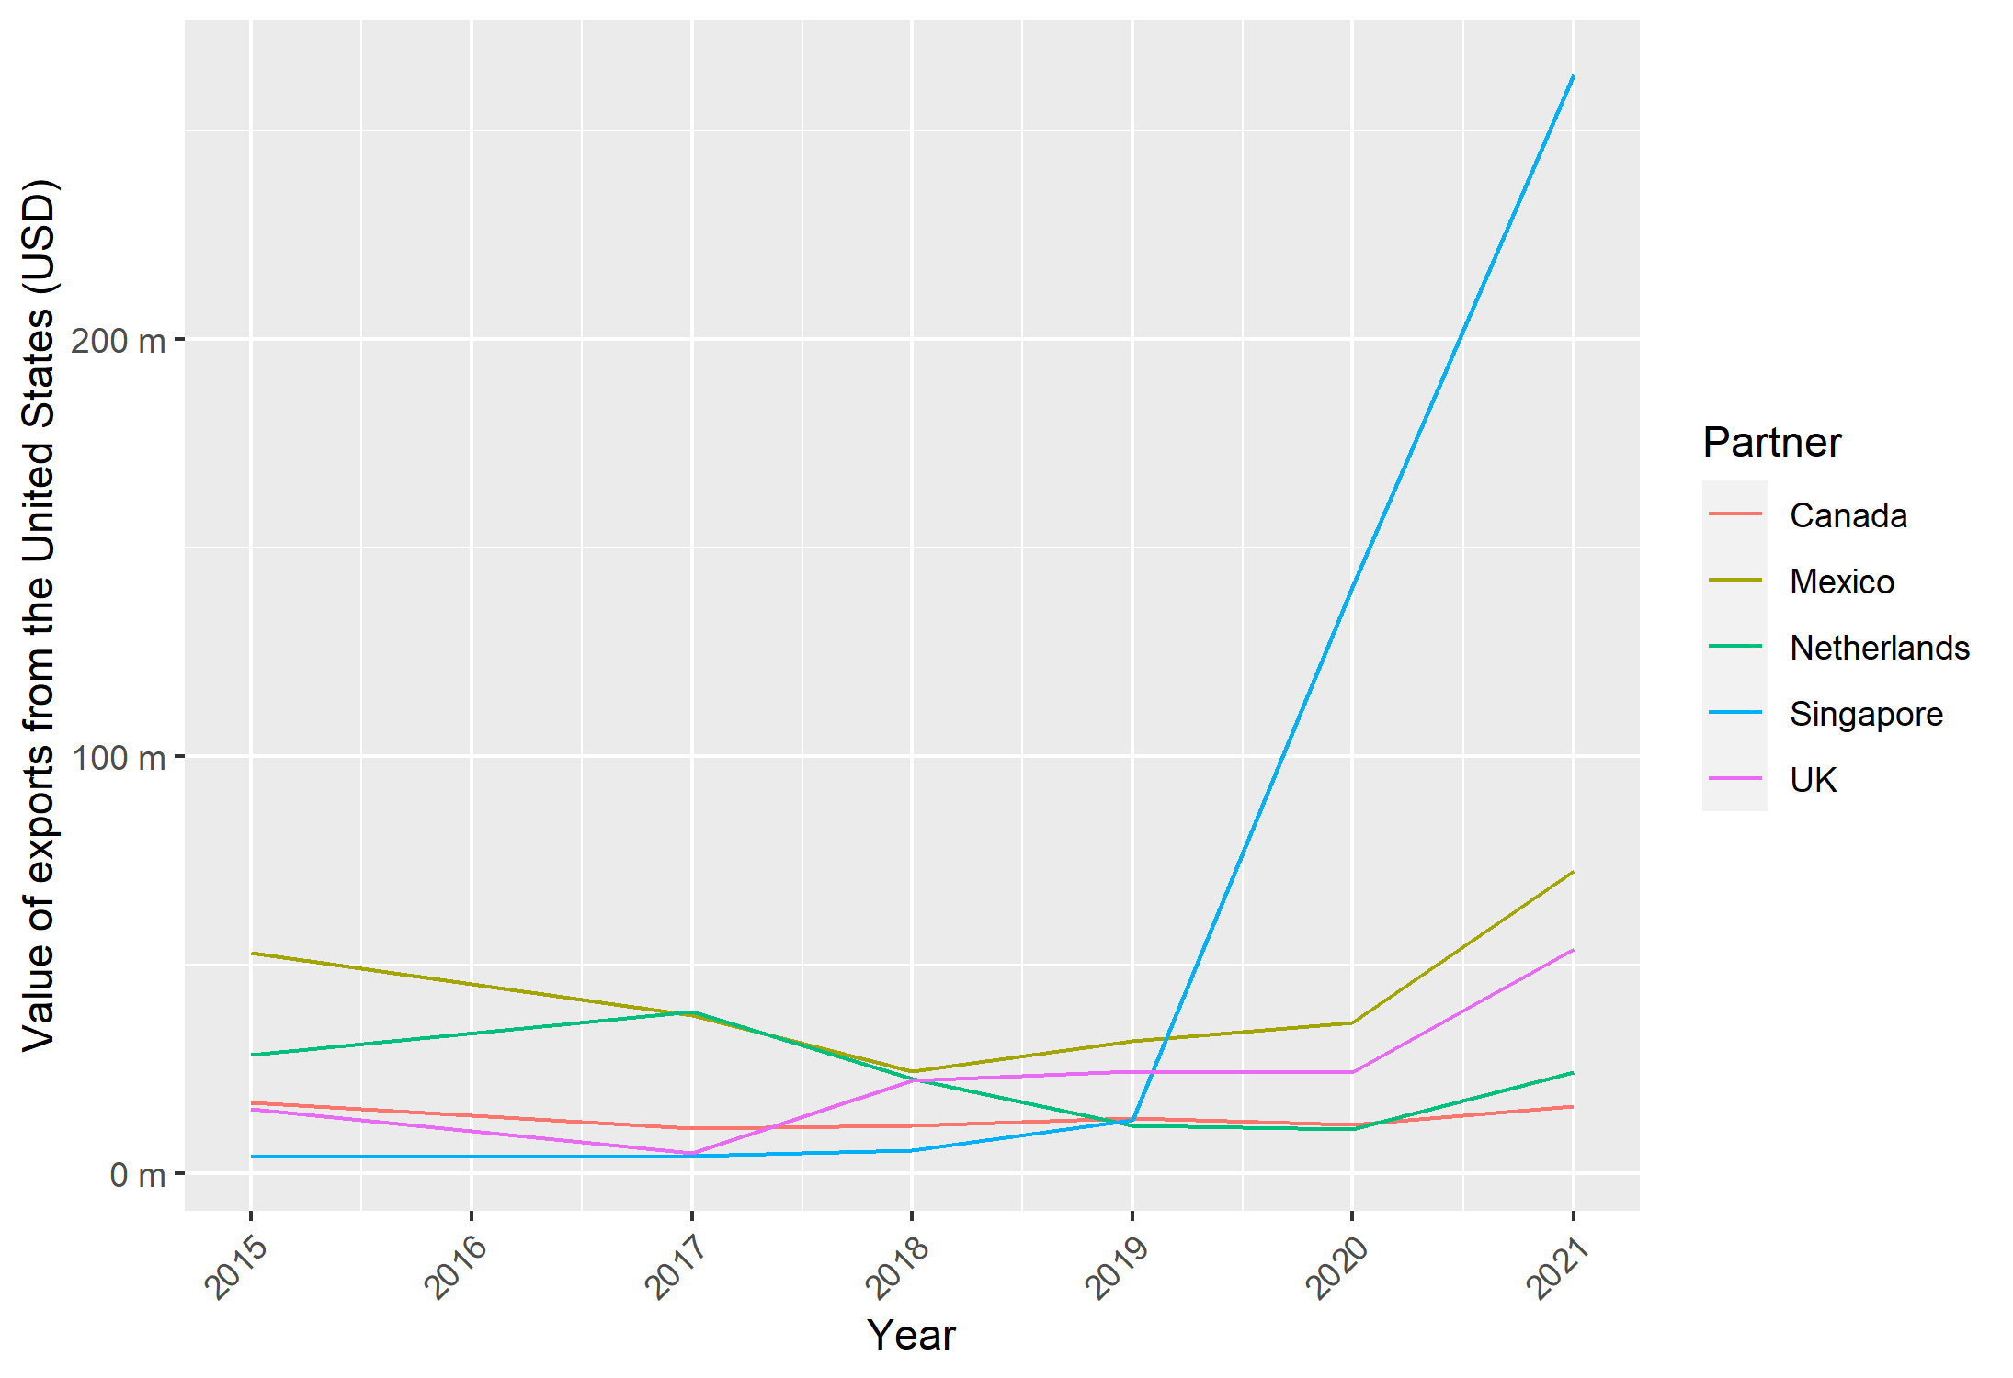
Source: Frontier Economics analysis of UN Comtrade data.

Figure 40: Top five export destinations by value of annual exports from Canada for HS code: 1518 00 for 2015 to 2021
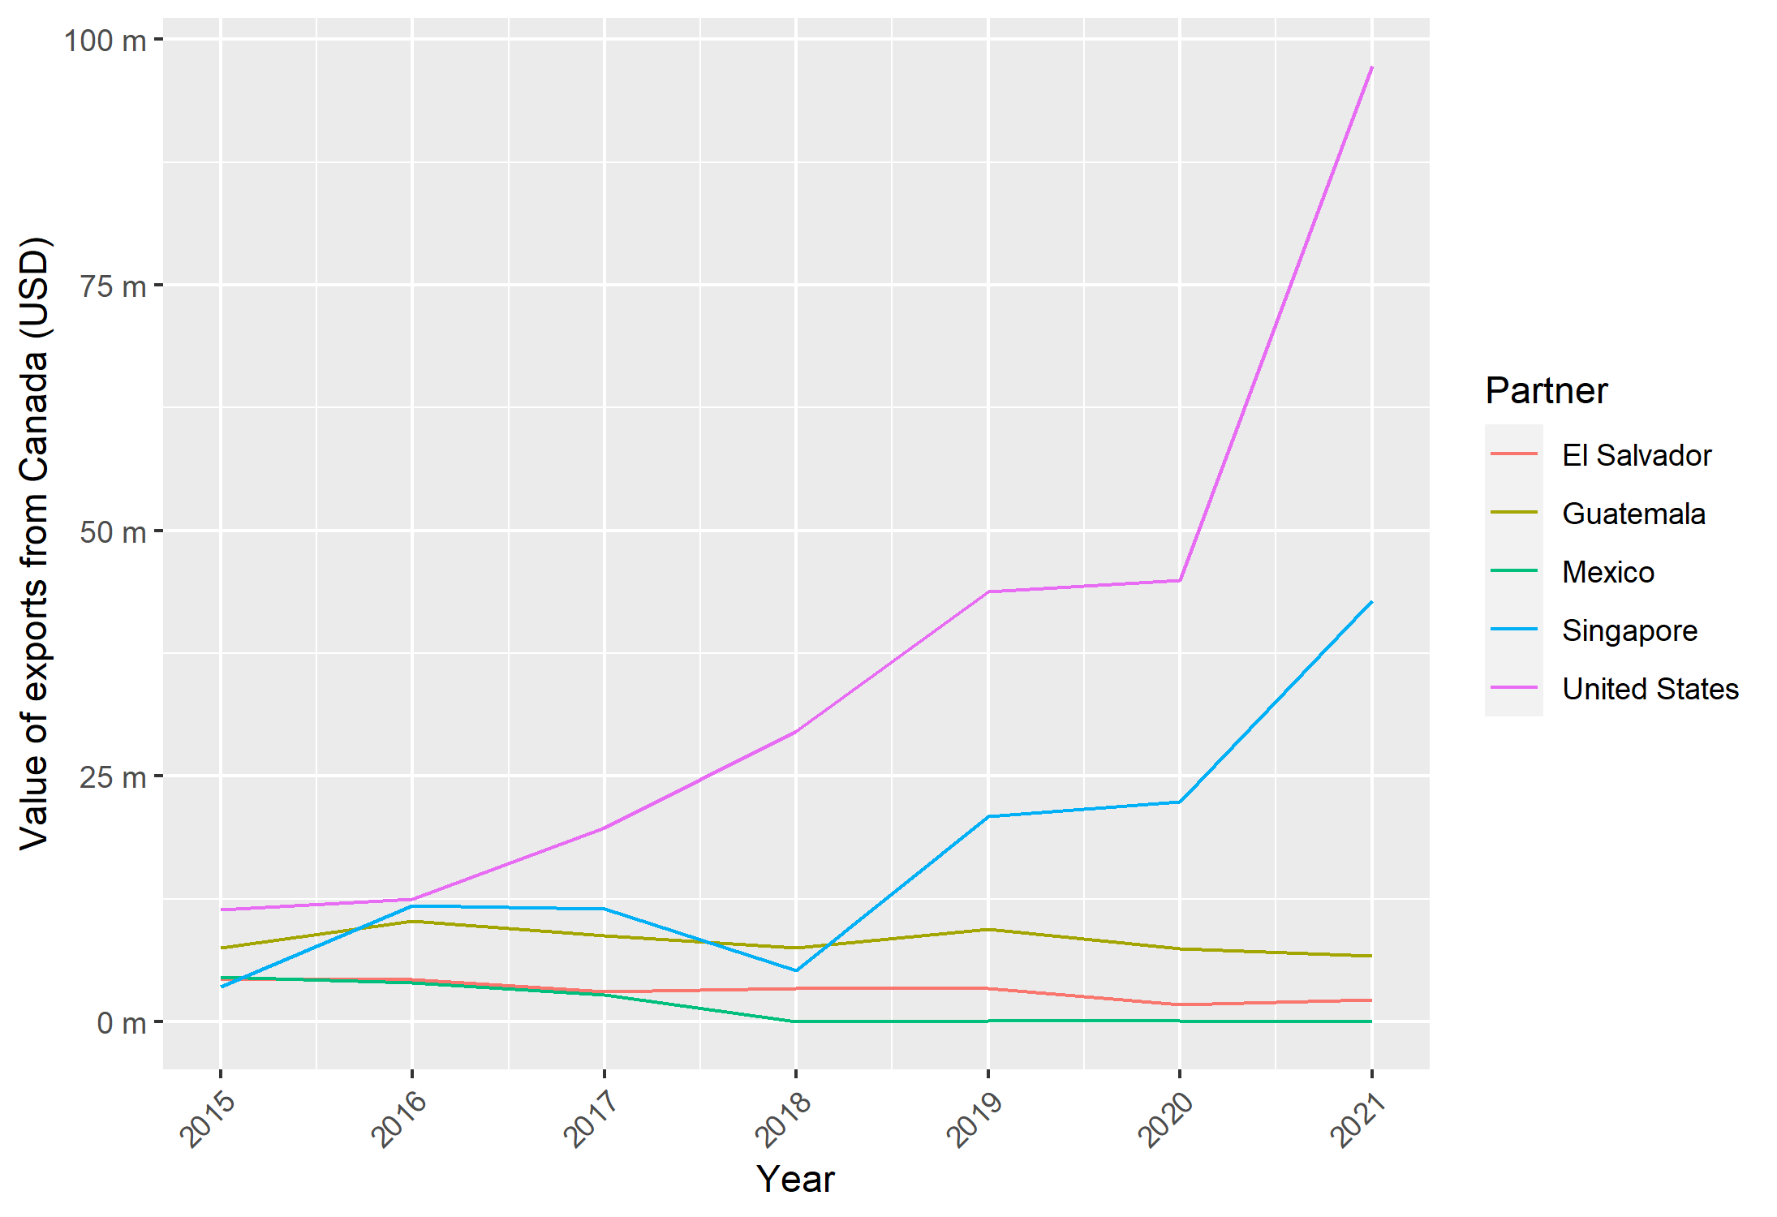
Source: Frontier Economics analysis of UN Comtrade data.
Turning now to the final CN code, Figure 41 and Figure 42 present the top five exporters into the EU-28 and UK respectively for code 1516 20 98. Here we see trade dominated by Indonesia, Malaysia and the United States, with trade relatively stable until 2019. After 2019, imports from the United States decline and those from Malaysia more than double. For the UK, imports are mainly sourced from Malaysia until 2018 when a large increase in imports from Indonesia takes place (again, following the expiry of duties).

Figure 41: Value of monthly imports into the EU-28 from the top five exporters into the EU-28 for CN code: 1516 20 98 for 2015 to 2020
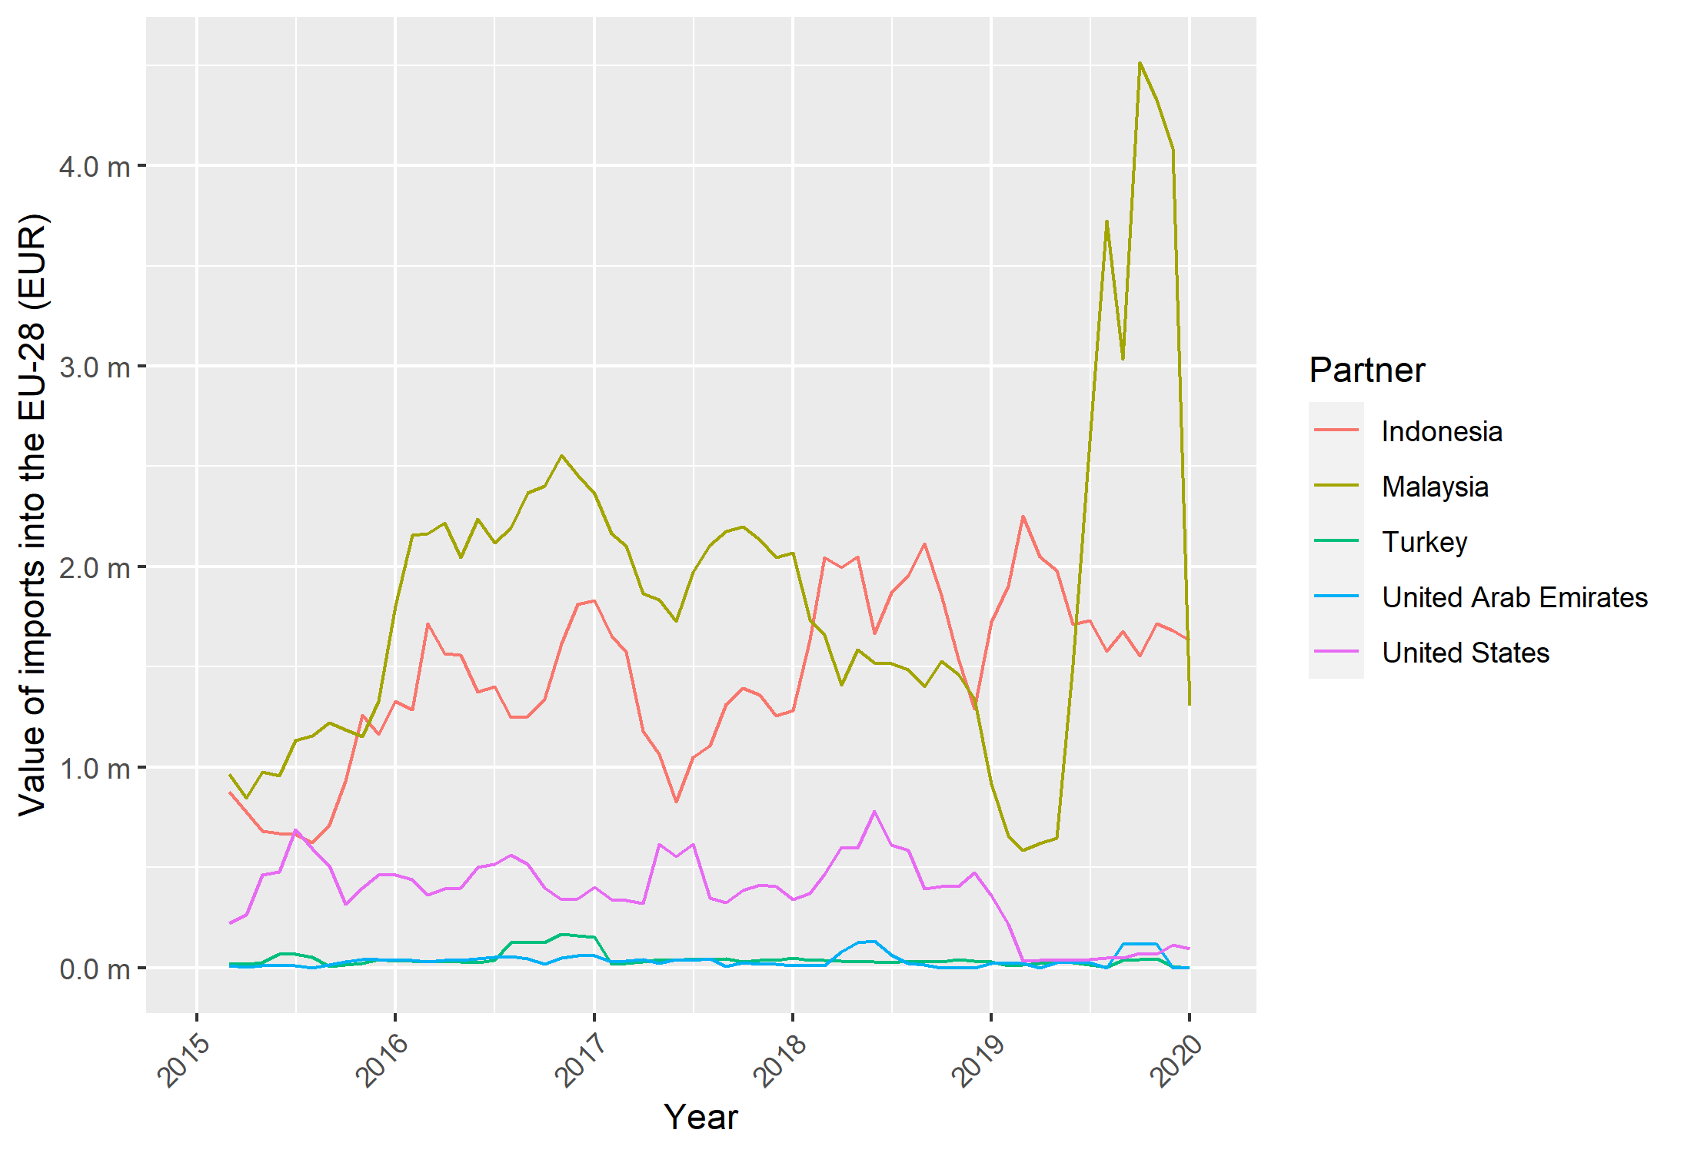
Note: Data presented is a three-month moving average.
Source: Frontier Economics analysis of Eurostat data.

Figure 42: Value of monthly imports into the UK from the top five exporters into the UK for CN code: 1516 20 98 for 2015 to 2020
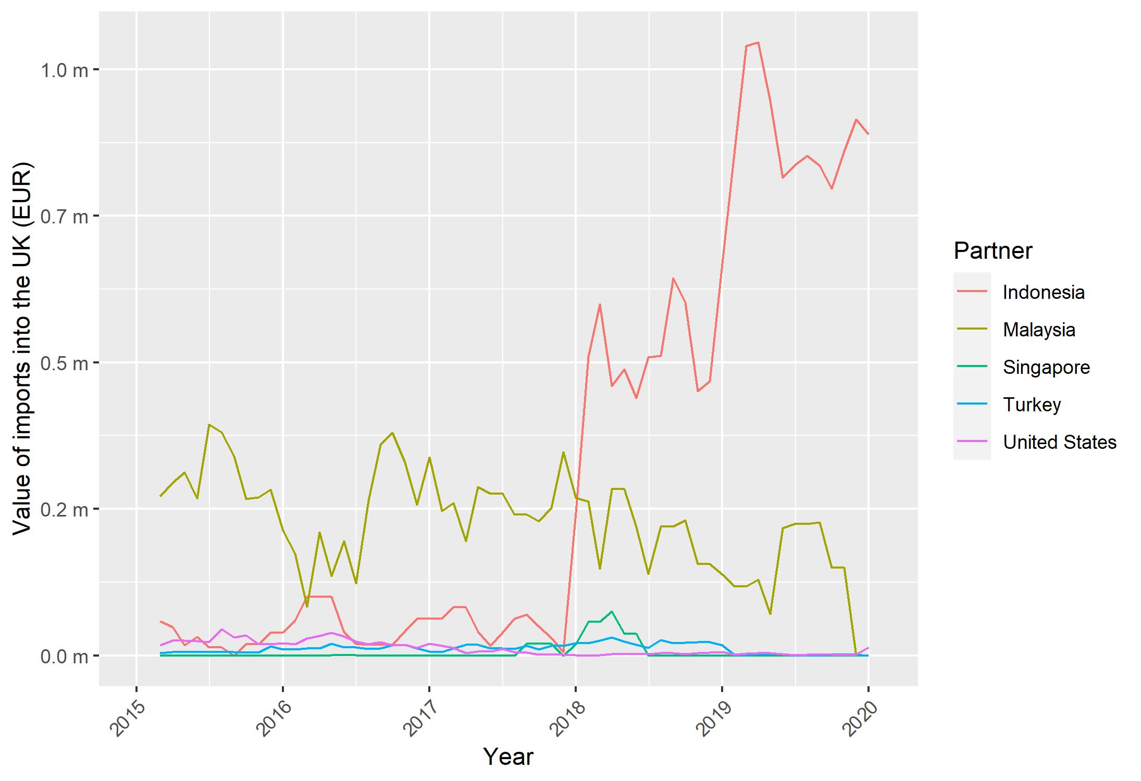
Note: Data presented is a three-month moving average.
Source: Frontier Economics analysis of Eurostat data.
Figure 43 and Figure 44 present the top five export destinations for the United States and Canada. For the United States, there is a variety of different trade partners, with the largest being Canada and Mexico – the former suffering a year-on-year decline until 2019. The only EU-28 member in the top five export destinations is the Netherlands, where trade drops sharply in 2016, and then remains at a low level until 2021. For Canada, again, we see that the United States is by far its largest export market, although a large drop in exports is seen between 2019 and 2021, with no corresponding increase seen for other countries.

Figure 43: Top five export destinations by value of annual exports from the United States for HS code: 1516 20 for 2015 to 2021
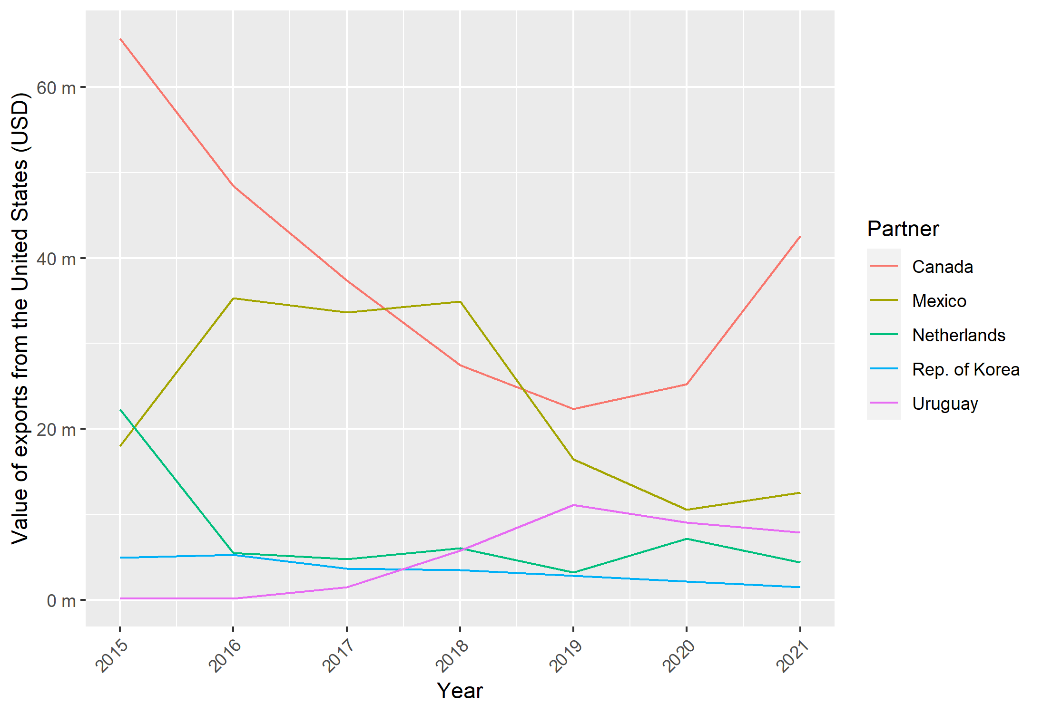
Source: Frontier Economics analysis of UN Comtrade data.

Figure 44: Top five export destinations by value of annual exports from Canada for HS code: 1516 20 for 2015 to 2021
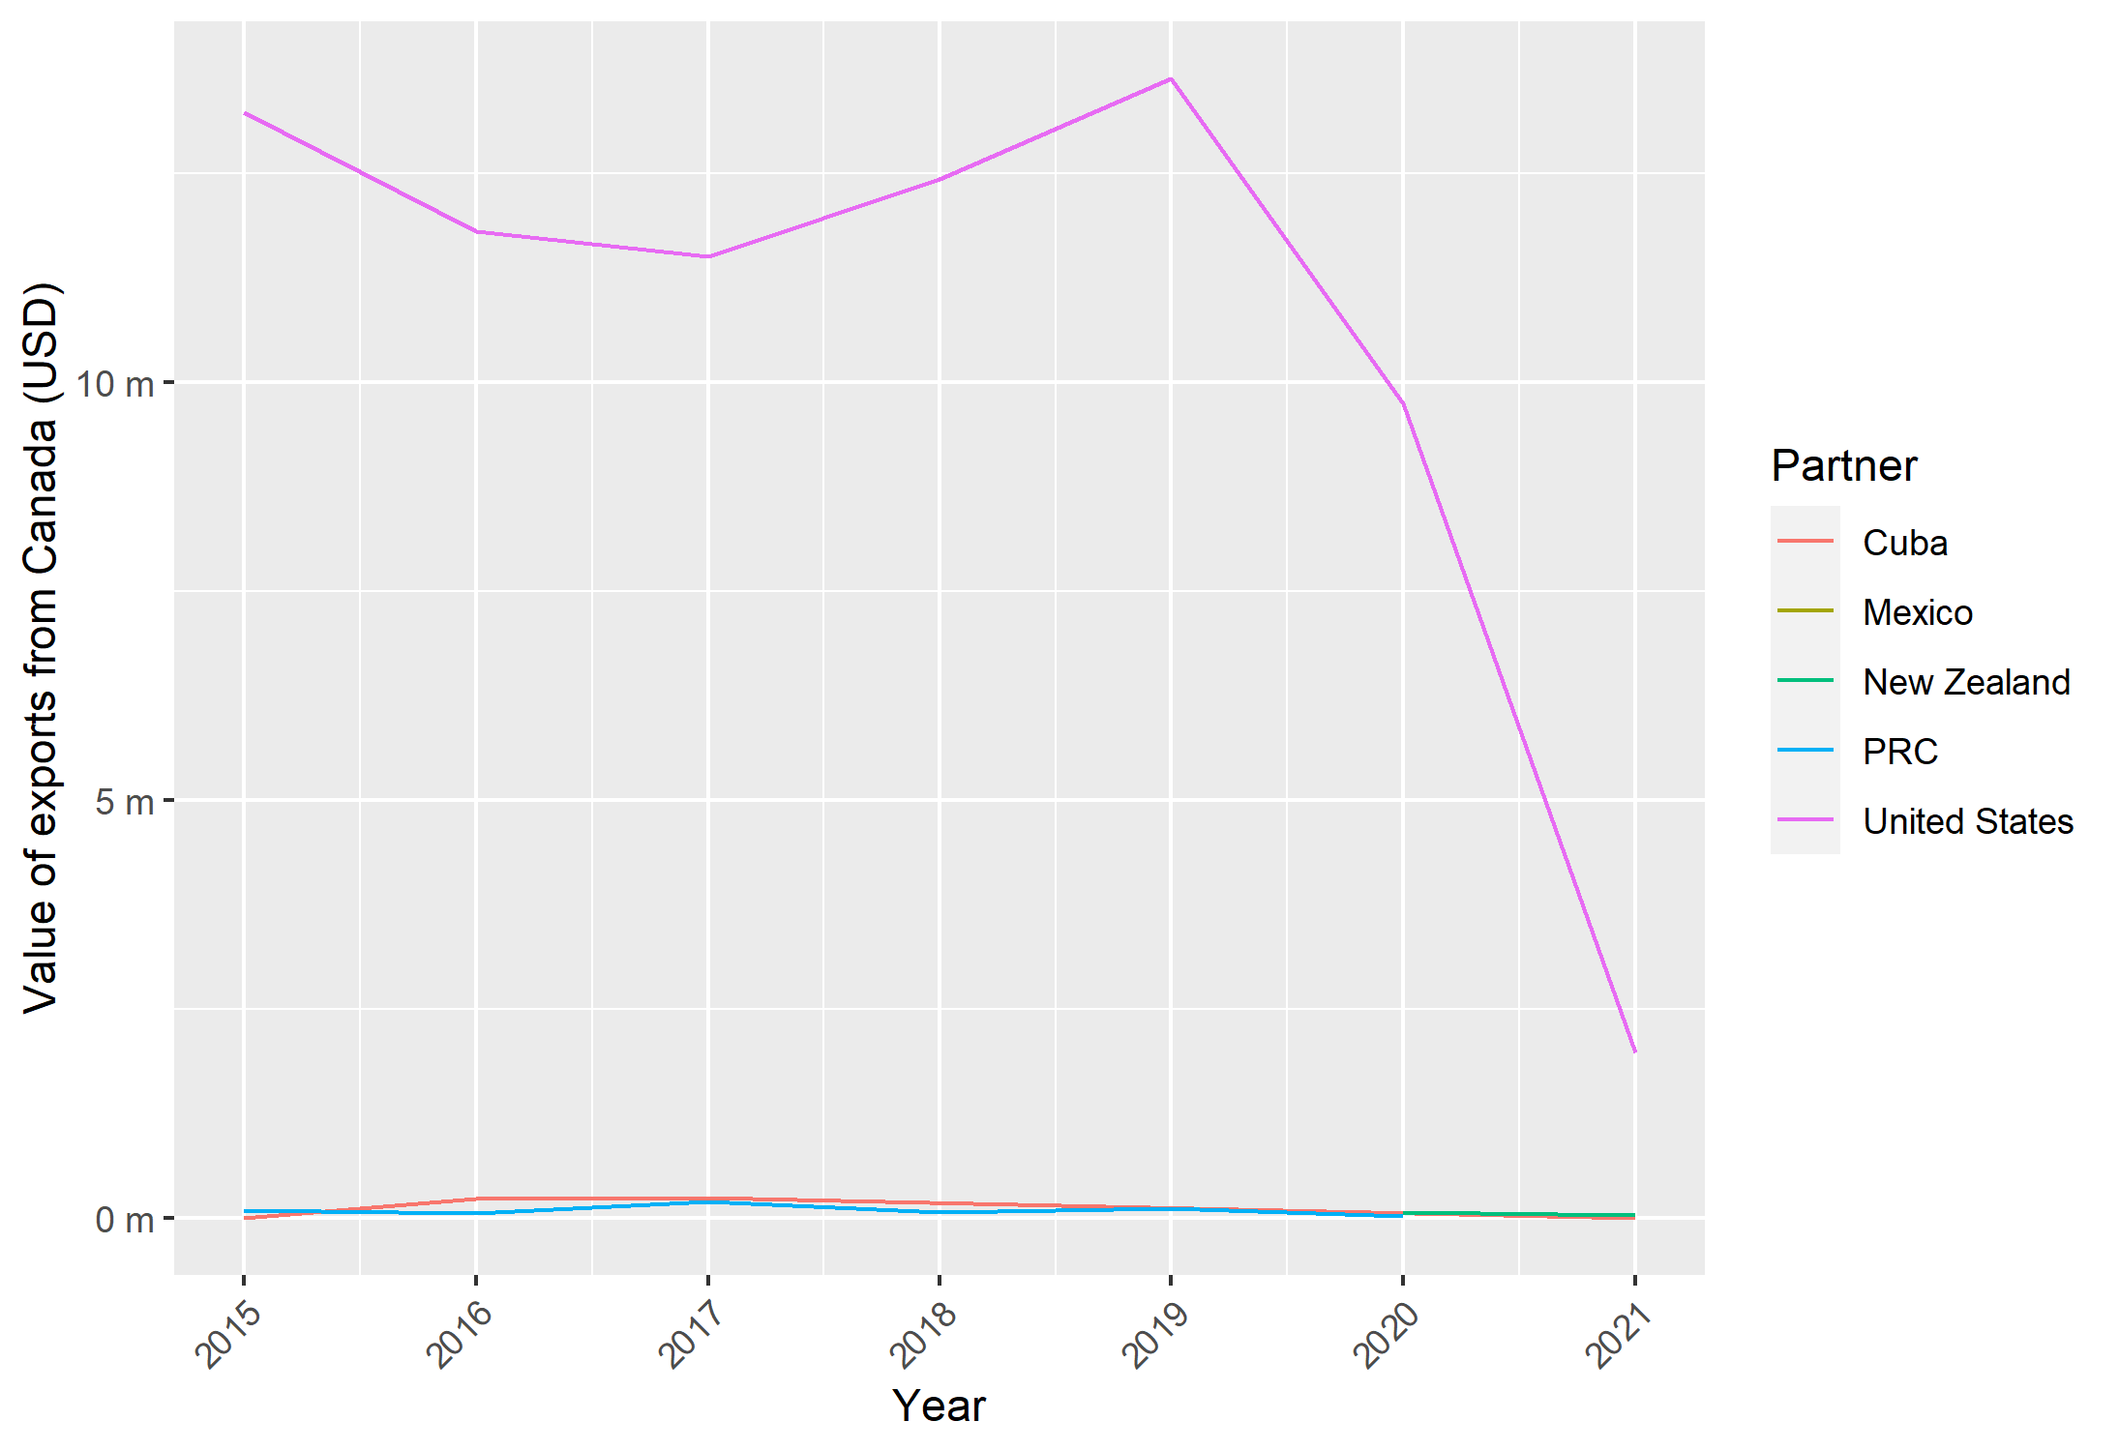
Source: Frontier Economics analysis of UN Comtrade data.

That is the country subject to the original duties.
Puccio, L. and Erbahar, A. (2016), “Circumvention of Anti-dumping: A Law and Economics Analysis of Proportionality in EU Rules”, Journal of World Trade, 50(3): 391-416.
Bown, C.P, and Crowley, M.A. (2006), “Policy Externalities: How U.S. Antidumping Affects Japanese Exports to the EU”, European Journal of Political Economy, 22: 696-714; Bown, C.P., and Crowley, M.A. (2007), “Trade Deflection and Trade Depression”, Journal of International Economics, 72: 176-201 ; Kommerscollegium (2009), Do EU Producers and the EU Economy Really Benefit from Anti-Dumping Policy; Paul Brenton (2014), “Anti-dumping policies in the EU and trade diversion”, in Paul Brenton (ed), International Trade, Distribution and Development, Empirical Studies of Trade Policies,l
The economic interest test (EIT) as provided for in UK trade remedy legislation could mitigate some of these costs by requiring that authorities consider a broader set of interests than import-competing producers. But the EIT is not a full net-benefits test. Some export behaviours caught by anti-dumping rules could still be commercially rational behaviour (notably price discrimination by multi-market, multi-product firms). Moreover, some of the “costs” captured by the EIT could, rather, be a displacement by imports of activity in which the UK does not have a comparative advantage. If that is the case, duties, and their extension via unwarranted anti-circumvention action, would prevent resource reallocation from less productive activities to more productive ones.
Productivity Commission (2016), “Developments in Anti-Dumping Arrangements”, Commission Research Paper, Canberra, p 25; Blonigen, B. and Prusa, T. (2003) “The Cost of Antidumping: The Devil is in the Details’, Journal of Economic Policy Reform, 6(4): 233-245; and Barattieri, A. and Cacciatore, M. (2020), “Self-Harming Trade Policy? Protectionism and Production Networks”, NBER Working Paper 27630.
Erbahar, A. and Zi, Y. (2017), "Cascading Trade Protection: Evidence from the United States", Journal of International Economics, 108(C): 274-299; Bown, C.P., Conconi, P., Erbahar, A. and Trimarchi, L. (2021), “Trade Protection Along Supply Chains”, CEPR Discussion Paper 15648.
See TRA (2022), “How We Apply the Economic Interest Test”, available from: https://www.gov.uk/government/publications/the-uk-trade-remedies-investigations-process/how-we-apply-the-economic-interest-test
See notably https://eur-lex.europa.eu/legal-content/EN/TXT/HTML/?uri=CELEX:31987R1761&from=DE
https://home.treasury.gov/system/files/206/authorizing-statute.pdf
Coskun, S., Kreier, J. and Hiromi ,Y. (2016), “Anti-Circumvention in the Multilateral System: Plus ça Change“,Global Trade and Customs Journal, 11(11/12): 461-472.
Coskun et al., op.cit.
See, for example: Canada (1997), “An Approach to the Definition of Circumvention”, Communication to the Committee on Anti-Dumping Practices, Informal Group on Anti-Circumvention, G/ADP/IG/W/3; European Community (1997), “What Constitutes Circumvention”, Communication to the Committee on Anti-Dumping Practices, Informal Group on Anti-Circumvention, G/ADP/IG/W/1; United States (1997), “What Constitutes Circumvention”, Communication to the Committee on Anti-Dumping Practices, Informal Group on Anti-Circumvention, G/ADP/IG/W/2.
At the WTO, since 1997 Hong Kong has been referred to as “Hong Kong, PRC” to denote both its status as a special administrative region of PRC and its status as a separate customs territory and therefore separate WTO membership. For clarity of exposition we refer simply to “Hong Kong” in this report.
See, for example: Republic of Korea (1999), “What Constitutes Circumvention”, Communication to the Committee on Anti-Dumping Practices, Informal Group on Anti-Circumvention, G/ADP/IG/W/17; Hong Kong, PRC (1998), “What Constitutes Circumvention”, Communication to the Committee on Anti-Dumping Practices, Informal Group on Anti-Circumvention, G/ADP/IG/W/8.
This rule states that: “Any reference in a heading to an article shall be taken to include a reference to that article incomplete or unfinished, provided that, as presented, the incomplete or unfinished article has the essential character of the complete or finished article. It shall also be taken to include a reference to that article complete or finished (or falling to be classified as complete or finished by virtue of this rule), presented unassembled or disassembled”.
See for example, United States (2002), “Topic 3. To What Extent Can Circumvention Be Dealt with under Relevant WTO Rules? To What Extent Can It Not? What Other Options May Be Deemed Necessary?” G/ADP/IG/W/44.
https://www.worldbank.org/en/data/interactive/2021/03/02/temporary-trade-barriers-database
It is calculated by taking a weighted average unit price and volume of imported goods (taken from the Australian Border Force), with 2017 set as the base year for most goods.
https://stat.unido.org/content/dataset_description/indstat-4-2021%252c-isic-revision-4
https://ec.europa.eu/eurostat/web/prodcom/data/database. Prodcom stands for “Production Communautaire”*.
Eurostat (2021), European Business Statistics User Manual for PRODCOM, p 10.
https://www.dosm.gov.my/v1/index.php?r=column/cthemeByCat&cat=90&bul_id=cnE4U01Qc0xjb0JCdWtKQU5LZGdtdz09&menu_id=SjgwNXdiM0JlT3Q2TDBlWXdKdUVldz09#:~:text=Total%20employees%20engaged%20in%20the,3.5%20per%20cent%20or%20RM247
https://www.moea.gov.tw/MNS/english/content/ContentMenu.aspx?menu_id=32928
https://tablebuilder.singstat.gov.sg/table/TS/M354851#!
https://tablebuilder.singstat.gov.sg/table/TS/M355272
https://www.bps.go.id/subject/9/industri-besar-dan-sedang.html#subjekViewTab3
https://www.bps.go.id/subject/170/industri-mikro-dan-kecil.html#subjekViewTab3
https://www.bps.go.id/indicator/9/2077/1/monthly-production-index-of-large-and-medium-manufacturing-by-subsector-kbli-2009-2010-100-.html
https://www.bps.go.id/indicator/9/2084/1/quarterly-production-index-of-large-and-medium-manufacturing-by-subsector-kbli-2009-2010-100-.html
https://www.gso.gov.vn/en/px-web/?pxid=E0701&theme=Industry
https://www.gso.gov.vn/en/px-web/?pxid=E0705&theme=Industry
http://www.statistics.gov.lk/Industry/StaticalInformation/IndexIndustrialProduction
The analysis using volume data is included in Annex 3 (covering Figure 26 to Figure 28). It does not lead to material changes to the inferences drawn.
While annual data does exist, the values of imports from Malaysia were extremely small – US$5,645 in 2009 and US$44 in 2008.
We extended the series to 2014 to include the impact of the anti-circumvention measures imposed on Thailand.
If we assume that the imposition of duties in the EU raised EU prices above world prices, and that producers in Malaysia faced world prices normally, then they would have incentives to sell to the EU at prices above world prices but below the duty-marked-up price in the EU. In a situation of imperfect competition in Malaysia, a reduction in quantity supplied at home (because of a re-routing of production) would increase prices at home as well (the opportunity cost for Malaysian producers of selling at home is now the higher EU price). Residual demand could then be met by PRC.
Liu and Shi (2019), op. cit.
See Official Journal of the European Union, Commission Implementing Regulation EU 812/2010 of 15 September 2010.
See Official Journal of the European Union, Commission Implementing Regulation EU 248/2011 of 9 March 2011.
See Official Journal of the European Union, Commission Implementing Regulation EU 1379/2014 of 16 December 2014.
See Official Journal of the European Union, Commission Implementing Regulation EU 2017/724 of 24 April 2017.
For these instances, it may not be possible to detect changes in the underlying categories, as the higher-level grouping may include many additional categories not subject to the anti-dumping duties.
There is no guarantee that goods recorded as entering the UK are used there. This is because there is freedom of movement of goods within the EU. It does, however, provide a useful proxy.
Sunset review investigation relating to anti-dumping duties imposed on imports of “certain glass fibre and articles thereof” originating in or exported from PRC PR (2016), Ministry of Commerce & Industry. Available from: https://www.dgtr.gov.in/sites/default/files/MOC636034220573714323_adfin_SSR_glass_fibre_articles_ChinaPR.pdf
Anti- circumvention investigation concerning the alleged circumvention of antidumping duty imposed on the imports of “glass fibre”, originating and exported from PRC PR vide Customs Notification No. 48/2016-Customs dated 1 September 2016, 2018, Ministry of Commerce & Industry. Available from: https://www.dgtr.gov.in/sites/default/files/Final_Finding%204.pdf
https://www.marketsandmarkets.com/Market-Reports/fiberglass-market-6124844.html#:~:text=The%20global%20fiberglass%20market%20is%20estimated%20to%20be%20USD%2011.5,at%20a%20CAGR%20of%204.5%25
Ibid.
https://www.prnewswire.com/news-releases/global-and-china-glass-fiber-industry-report-2012-2015-185273212.html
See for example https://www.researchandmarkets.com/reports/5414921/glass-fiber-market-report-trends-forecast-and#relc0-5314014
See Official Journal of the European Union, Commission Implementing Regulation EU 599/2009 of 7 July 2009.
See Official Journal of the European Union, Commission Implementing Regulation EU 194/2009 of 11 March 2009.
See Official Journal of the European Union, Commission Implementing Regulation EU 721/2010 of 11 August 2010.
See Official Journal of the European Union, Commission Implementing Regulation EU 443/2011 of 5 May 2011.
Council Implementing Regulation (EU) No 1194/2013, 2013, Official Journal of the European Union. Available from: https://trade.ec.europa.eu/tdi/case_history.cfm?init=1893.
This HS code is not included in Table 4 as it was superseded in 2017 by a set of seven new HS codes. Some of the new HS codes are included in Table 4but not all. Further, it is worth noting that the EC’s analysis in the anti-circumvention investigation was performed for CN code 3824 90 91, but UN Comtrade data is only available at the 6-digit level. We use UN Comtrade data as the Eurostat data had relatively poor coverage of this CN code.
https://www.iea.org/reports/renewables-2021/biofuels?mode=transport&region=World&publication=2021&flow=Consumption&product=Renewable+Diesel
OECD- FAO Agricultural Outlook, available from: https://stats.oecd.org/Index.aspx?QueryId=36348
In addition to the examples mentioned in the context of the case studies, other sources include the World Steel Association (https://worldsteel.org/steel-by-topic/statistics/about-our-statistics/) and the International Aluminium Institute (https://international-aluminium.org/statistics/primary-aluminium-production/).
Farrington, D., Gottfredson, D.C., Sherman, L.W. and Welsh, B.C. (2002), “The Maryland Scientiﬁc Methods Scale” in Farrington, D., Gottfredson, D.C., Sherman, L.W. and Welsh, B.C. (eds), Evidence-Based Crime Prevention.
National Audit Office (2013), “Evaluation in Government, Part Two”, p 21.
OECD (2020), Mobilising Evidence for Good Governance: Taking Stock of Principles and Standards for Policy Design, Implementation and Evaluation, p.89
Liu, X. and Shi, H (2019), “Anti-dumping Circumventing through Trade Re-routing: Evidence from Chinese Exporters”, World Economy, 42(5): 1427-1466.
https://ilostat.ilo.org/topics/wages/
This can be attempted in markets where high frequency can be accessed. For example, in the telecoms or retail sector. See for example, Werden, G. and Froeb, L. (1995), “The Effects of Mergers in Differentiated Products Injuries: Logit Demand and Merger Policy”, Journal of Law, Economics and Organisation, 10(2); Nevo, A. (2000), “Mergers with Differentiated Products: The Case of the Ready-to-eat Cereal Industry”, 31(3): 395-421.
See, notably, Lacovides, M. and Jansen, M. (2017), “Lost in Translation: Communication and Interpretation Challenges Related to Economic Evidence in Trade Disputes”, in Jansen, M., Pauwellyn J. and Carpenter, T. (eds), The Use of Economics in International Trade and Investment Disputes, pp 164-191.
Posner, R.A. (1999), “The Law and Economics of the Economic Expert Witness”, Journal of Economic Perspectives, 13(2): pp 91-99.
See, notably, Lohmann, J. (2011), “Do Language Barriers Affect Trade?”. Economics Letters, 110(2): 159-162; Mélitz, J. and Toubal, F. (2012), “Native Language, Spoken Language, Translation and Trade”, CEPR Discussion Paper No. 8994.
https://lpi.worldbank.org/ and https://global-express.org/index.php?id=904
https://global-express.org/index.php?id=271
That is, respectively 73(2)(a) and 73(2)(b).
That is the country subject to the original duties.
Regulation (EU) 2016/1036 of the European Parliament and of the Council, of 8 June 2016, on Protection Against Dumped Imports from Countries Not Members of the European Union, available from: https://eur-lex.europa.eu/legal-content/EN/TXT/HTML/?uri=CELEX:32016R1036&from=EN; Regulation (EU) 2016/1037 of the European Parliament and of the Council of 8 June 2016 on Protection Against Subsidised Imports from Countries Not Members of the European Union, available from: https://eur-lex.europa.eu/legal-content/EN/TXT/?uri=celex%3A32016R1037.
See Vermulst, E. (2016), “Circumvention of Anti-dumping Measures: Law and Practice of the European Union”, Global Trade and Customs Journal, 11(11/12): 499-507.
TARIC stands for TARif Intégré Communautaire; or Integrated Tariff of the European Communities.
See, notably, Case 26/88, Brother International GmbH v. Hauptzollamt Giessen, [1989] ECR 4253, cited in Vermulst, E. (2015), “EU Anti-circumvention Rules: Do They Beat the Alternative”, EUI Working Paper RSCAS 2015/57, pp 13-14.
Vermulst, E. (2016), op.cit. pp 507-509.
Vermulst, E. (2015), op.cit, p14.
Rules of origin are criteria set by a jurisdiction in the context of customs administration to determine whether an imported good can be classified as originating in a particular country. It arises because goods often contain embodied inputs sourced from different countries. Preferential rules of origin are used to determine whether an import is eligible for preferential tariff treatment, e.g. in the context of FTAs or under unilateral preference schemes. Criteria can vary by product and typically involve the notion of substantial transformation, often defined as the minimum amount of value added that needs to originate in countries covered by the preferential arrangement.
See Puccio and Erbahar (2016), op.cit.
See https://trade.ec.europa.eu/tdi/case_history.cfm?init=388 for case history.
See https://trade.ec.europa.eu/tdi/case_history.cfm?init=647 for case history.
See https://trade.ec.europa.eu/tdi/case_history.cfm?init=1060 for case history.
See https://trade.ec.europa.eu/tdi/case_history.cfm?init=293 for case history.
See https://trade.ec.europa.eu/tdi/case_history.cfm?init=647 for case history.
See https://trade.ec.europa.eu/tdi/case_history.cfm?init=355 for case history.
See https://trade.ec.europa.eu/tdi/case_history.cfm?id=2429&init=1532 for case history.
Inorganic chemicals; organic or inorganic compounds of precious metals, of rare-earth metals, of radioactive elements or of isotopes.
Organic chemicals.
Miscellaneous chemical products.
Articles of stone, plaster, cement, asbestos, mica or similar materials.
Glass and glassware.
Iron and steel.
Articles of iron and steel.
Other base metals; cermets; articles thereof.
Hyperlinks link to Global Trade Alert, apart from cases where more relevant information can be found on the EC website (i.e. where information for the exact case cannot be found on Global Trade Alert).
Anti-circumvention case is not listed on the EC website but appears on Global Trade Alert.
These effects may also stimulate demand for trade remedies in other jurisdictions as lower trade costs increase the exposure of local industries to competition from PRC.
CIF – cost, insurance and freight is the price of the good delivered at the frontier of the importing country.
See 19 CFR 351.226 (d)(1)(ii) referencing 19 CFR 351.226 (c) which requires each circumvention inquiry request to provide evidence of the elements necessary for a circumvention determination that is reasonably available to the interested party making the request.
See, notably, Japan – Taxes on Alcoholic Beverages, and Canada — Certain Measures Concerning Periodicals. The jurisprudence states that likeness should be assessed narrowly, on a case-by-case basis, taking account of relevant factors including: (i) the product's end-uses in a given market; (ii) consumers' tastes and habits; and (iii) the product's properties, nature and quality.
Access is via the International Trade Administration’s ACCESS database, https://access.trade.gov/login.aspx
Department of Commerce, International Trade Administration (2021), “Certain Uncoated Paper from Brazil, the People’s Republic of PRC, and Indonesia: Affirmative Final Determinations of Circumvention of the Antidumping Duty Orders and Countervailing Duty Orders for Certain Uncoated Paper Rolls”.
Department of Commerce, International Trade Administration (2021), “Oil Country Tubular Goods from the People’s Republic of PRC: Issues and Decision Memorandum for Final Affirmative Determinations of Circumvention”.
Department of Commerce, International Trade Administration (2012), “Small Diameter Graphite Electrodes from the People’s Republic of PRC: Affirmative Final Determination of Circumvention of the Antidumping Duty Order”, cited in Spicer, M., Clarke, P. and Horlick, G. (2016), “Anti-circumvention of Anti-dumping Measures: Law and Practice of the United States”, Global Trade and Customs Law, 11(11-12): 537.
Department of Commerce, International Trade Administration (2011), “Polyethylene Terephthalate Film, Sheet, and Strip from the United Arab Emirates: Negative Final Determination of Circumvention of the Antidumping Duty Order”, cited in Spicer et al. 2016, op.cit.
Department of Commerce, International Trade Administration (2020), “Steel Concrete Reinforcing Bar From Mexico: Final Affirmative Determination of Circumvention of the Antidumping Duty Order”.
Department of Commerce, International Trade Administration (2013), “Carbon and Certain Alloy Steel Wire Rod from Mexico: Affirmative Final Determination of Circumvention of the Antidumping Duty Order”, cited in Spicer et al. (2016), op.cit, p 538.
Department of Commerce, International Trade Administration (2006), “Later-Developed Merchandise Anti-Circumvention Inquiry of the Anti-dumping Order on Petroleum Wax Candles from the People’s Republic of PRC: Affirmative Final Determination of Circumvention of the Anti-dumping Duty Order”, cited in Spicer et al. 2016, op.cit, p 538.
This column is the total of the columns to the right.
There are two separate cases for PRC, one modification, and one third-party assembly.
Two separate cases.
https://www.wto.org/english/tratop_e/adp_e/AD_Sectoral_MeasuresByRepMem.xlsx accessed on 3 December 2021.
The relevant amendments to the Customs Act 1901 were made by the Customs Amendment (Anti-dumping Improvements) Act (No. 3) 2012.
Productivity Commission (2016), “Developments in Anti-Dumping Arrangements”, Commission Research Paper, Canberra, p 25.
BlueScope Steel Limited (2015), “Application for an Anti-Circumvention Inquiry – Zinc Coated (Galvanised) Steel”, pp 5-7 and Austube Mills Pty Ltd (2015), “Application for an Anti-Circumvention Inquiry – Hollow Structural Sections”, pp 5-8.
Moulis, D. (2016), “Anti-circumvention of Anti-dumping measures: Law and Practice of Ten World Trade Organization Members – Australia”, Global Trade and Customs Journal, 11(11/12): 482.
https://www.industry.gov.au/data-and-publications/trade-remedy-index
Moulis, D. (2016), op.cit., p 482.
Productivity Commission (2016), op.cit., p 53.
Productivity Commission (2016), op.cit., p 72.
Productivity Commission (2009), “Australia’s Anti-dumping and Countervailing System”, Report no. 48, Canberra.
This column is the total of the columns to the right.
The investigation also involved South Korea but circumvention was not found in its case.
Grattan Institute (2014), “Less Cost, Less Coal: Why Global Rivals Are Killing Australian Aluminium”, available from: https://grattan.edu.au/news/less-cost-less-coal-why-global-rivals-are-killing-australian-aluminium/
The criticisms have been echoed by the Australian Competition and Consumer Commission, which in 2019 initiated action in the Federal Court against Bluescope Steel and its then chairman, on the grounds that it was engaged in price fixing and anti-competitive behaviour. Part of the statement of claims pointed to threats made by Bluescope to foreign competitors that it would undertake anti-dumping action if the competitors did not raise prices to acceptable levels. (See Federal Court of Australia (2019), “Notice of filing, AUSTRALIAN COMPETITION AND CONSUMER COMMISSION v BLUESCOPE STEEL LIMITED & ANOR”, p 4.
https://laws-lois.justice.gc.ca/eng/acts/s-15/
https://laws-lois.justice.gc.ca/eng/regulations/sor-84-927/
This column is the total of the columns to the right.
This column is the total of the columns to the right.
This column is the total of the columns to the right. There is one case where the mode of circumvention is unknown.
This column is the total of the columns to the right.
This column is the total of the columns to the right.
https://unstats.un.org/unsd/classifications/Econ/Structure/Detail/EN/2089/382499

