Google Keep Guidance: LGBT Veterans Review Call for Evidence

This is guidance on how to provide oral testimony to the LGBT Veterans Review.
You do not need to send us your testimony in multiple formats - if you have already submitted testimony you do not also need to submit the same answers via voice, but you can if you wish. If your verbal testimony is supplementary to testimony you have already submitted, and you want it attached to your previous testimony, you will need to either provide us with your email or service number that you input previously.
You do not have to give any personal details. However, by sending this oral testimony we will receive your email. All personal details, such as email address, will be deleted at the end of the Review.

Download Google Keep
Download Google Keep from the Android Play Store or Apple App Store. This can be done on any mobile device, including tablets. You will need a Google account to use this app

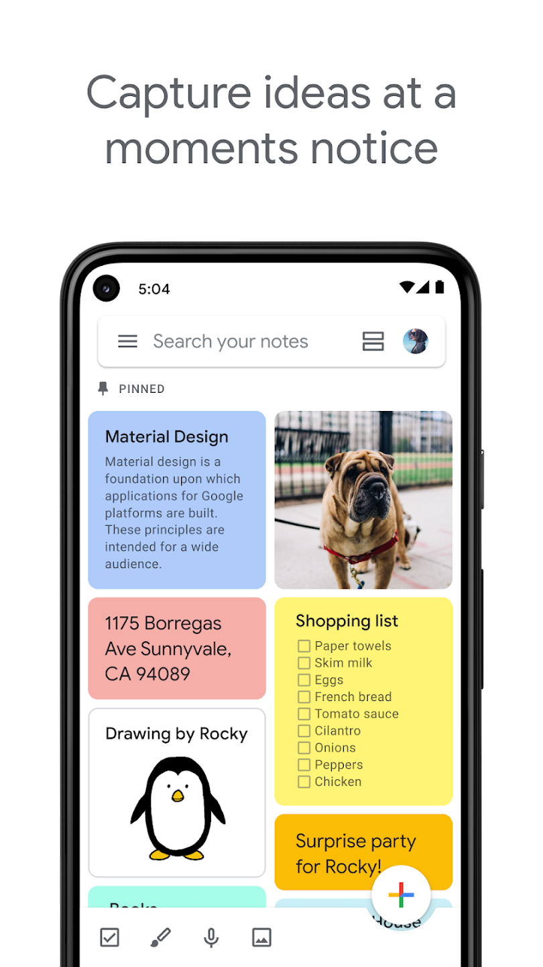
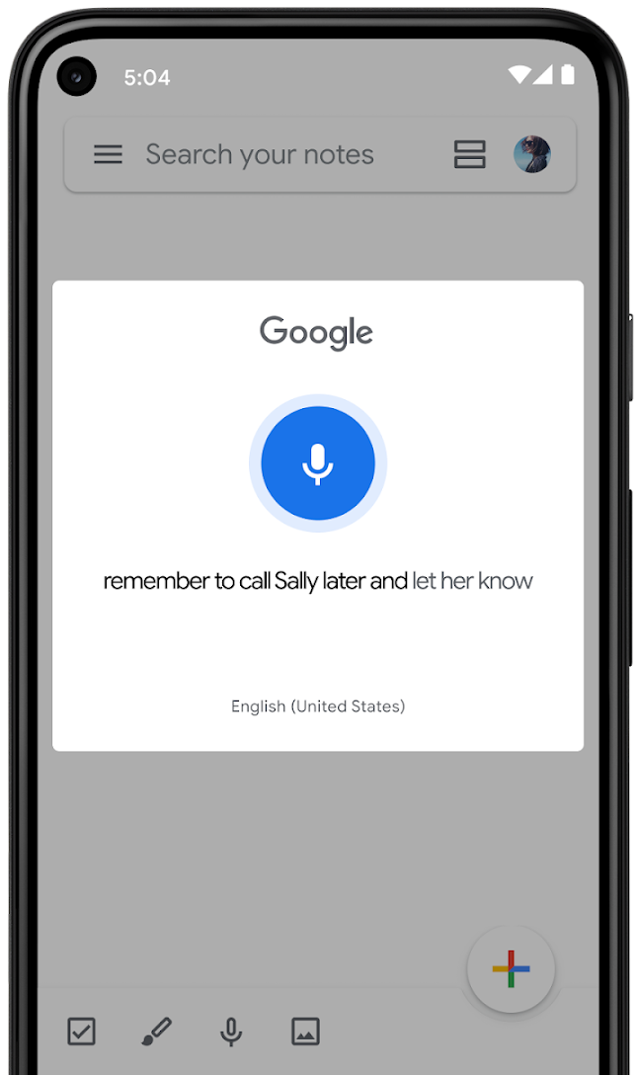
Test the app transcription is working correctly
Click the little microphone icon to start recording and transcribing audio. Speak a test sentence to check it is working correctly, e.g. ‘The quick brown fox jumps over the lazy dog.’
Your device will listen and record the audio, transcribing at the same time.
Once you’ve finished your sentence, an audio recording and transcript should appear on the screen. Check the text is correct and that it transcribed your voice accurately.

Head to our govuk page and download the questions
If you want to, you can respond to the questions we have set out in our Call for Evidence.
Head to our govuk page and download the question set for your group: LGBT Veterans, other service personnel or family, friends and/or representatives. These questions may be useful when recording your testimony.
You do not need to respond to all the questions. The important thing is that we hear your story.

Record your testimony
Head to your keep app, click the microphone button and start speaking.
When you have finished your recording, you will see a transcription of what you said alongside an audio recording. Please do read over this to check it is correct.
Note: if you take a pause for a moment, Google Keep may think you have finished talking and will end the recording and transcription. If this happens you can go back to the main Google Keep page, click the microphone button again and continue from where you left off.

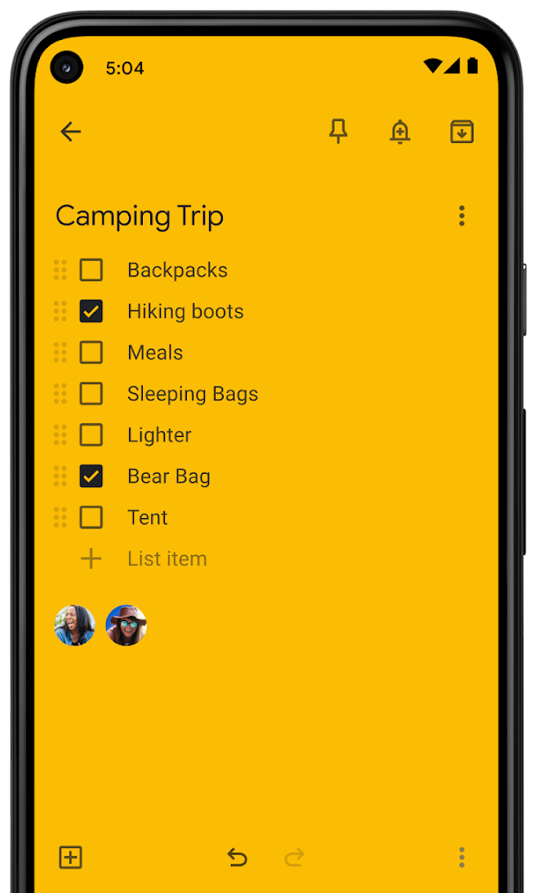
Send us your testimony
Tap the three dots in the bottom right, tap ‘Collaborator’. Enter lgbtveterans-audio-noreply@cabinetoffice.gov.uk
At the top right, tap Save.
Please let us know you have submitted audio testimony via the above process in an email to contact@lgbtveterans.independent-review.uk. If this is supplementary to testimony that you have already submitted where you provided either email or service number, please also provide email or service number if you want the audio linked to your response.
If you used multiple notes to record your testimony, ensure you share all of these to us.

Thank you
Please note that any information you pass to us will be confidential.
We thank you for your time and willingness to share your story.
We provide a list of support organisations if you need help: https://www.gov.uk/guidance/national-services-that-offer-support-to-veterans
You can read our Privacy Notice.
If the above method does not work for you or you wish to provide evidence in a different format, contact us at contact@lgbtveterans.independent-review.uk.

