Order Decision
Site visit made on 27 June 2022
by D M Young JP BSc (Hons) MPlan MRTPI MIHE
an Inspector appointed by the Secretary of State for Environment, Food and Rural Affairs
Decision date: 23 August 2022

Order Ref: ROW/3276397
- This Order is made under Section 119 of the Highways Act 1980 (the 1980 Act) and is known as the Buckinghamshire Council (Public Footpath No.30 Parish of Westcott) Public Path Diversion Order 2020.
- The Order is dated 22 July 2020 and proposes to divert the public right of way shown on the Order plan and described in the Order Schedule.
- There were two objections outstanding when Buckinghamshire Council submitted the Order to the Secretary of State for Environment, Food and Rural Affairs for confirmation.
Summary of Decision: The Order is Confirmed

Procedural Matters
- This case concerns the proposed diversion of part of Public Footpath 30 (FP30) which traverses land to the south of properties on Lower Green, Westcott.
- No-one requested an accompanied site visit, so my inspection was carried out unaccompanied.

The Main Issues
- The Order is made in the interests of the owner of the land crossed by the Footpath. Section 119 of the Act requires that, before confirming the Order, I should be satisfied that:
  - it is expedient, in the interests of the owner, that the footpath in question should be diverted;
  - the new footpath will not be substantially less convenient to the public;
  - it is expedient to confirm the Order having regard to its effect;
    - on the public enjoyment of the path as a whole; and
    - the effect the coming into operation of the order would have with respect to the land served by the existing path and the land over which the new path is created together with any land held with it, having regard to the provisions as to compensation.
- In addition, in determining whether or not to confirm the Order, I am required to have regard to the provisions of any rights of way improvement plan (“ROWIP”) prepared by any local highway authority whose area includes land over which the Order would create or extinguish a public right of way.

Reasons

Whether it is expedient, in the interests of the owner of the land, that the footpath in question should be diverted
- The current legal alignment of FP30 runs along the access drive to 10/12 Lower Green. At point A, the path enters private land owned by the applicants. At point B, the route turns northwards across the driveway/parking area to point C where it crosses a field to point D which is immediately to the rear of 14 Lower Green.
- The reason given for the proposed diversion on the application form is “to move the footpath away from the house and to make the garden private and useable”.
- Over section A-B-C users of the footpath are able to view both the house and garden at close quarters. Accordingly, it is not unreasonable for the applicants to want to divert the footpath to increase privacy, security and general enjoyment of their property.
- Having regard to the above and given that there is no evidence to the contrary, I am satisfied that it is expedient in the interests of the landowners that the footpath should be diverted.

Whether the new route will be substantially less convenient to the public
- According to the Council, the existing alignment of the footpath is 89m in length whereas the Order route is 61m. In my view, a 28m decrease would not be substantially less convenient to the public.
- The alignment of FP30 away from the applicant’s house and garden would provide a more coherent route than the current legal alignment and would remove any uneasiness users might have about intruding into what is clearly a private space, regardless of their legal rights.
- Accordingly, I am satisfied the Order route would not be substantially less convenient to the public.

The effect of the diversion on public enjoyment of the route as a whole
- One of the objectors argues that the section A-E-D would be enclosed on one side by fences. Whilst that is true, it is important to note that significant sections of FP30 are already enclosed by residential boundary treatments of one form or another. The proposed route would retain pleasant open views to the south. It is also worth pointing out that if I were not to confirm the Order the applicants could decide to fence section A-B-C.
- Overall, I am therefore satisfied that the Order route would not diminish the public’s enjoyment of the route as a whole.

The effect the coming into operation of the Order would have with respect to the land served by the existing route and the land over which the new route is created together with any land held with it, account being taken of the provisions as to compensation
- The land crossed by the existing route would remain within the ownership of the applicants. I have carefully considered the objection from the adjoining landowner who feels that moving FP30 closer to the rear boundary of neighbouring residents would negatively impact on their quality of life.
- In response, I note there would be ample separation between the path and those houses which would back onto it. As I have already noted FP30 for the large part, already runs very close to a number of residential properties and there is no evidence before me to suggest these occupiers have had their living conditions undermined as a result. I also have no reason to believe that future users of the Order route would not continue to be respectful and considerate of neighbouring residents.
- I therefore conclude that the Order route would not have any negative effect on land served by the existing or proposed routes.

Other Matters
- From the information provided I am satisfied that the Council fulfilled their statutory responsibilities in terms of advertising the Order.
- No compensation issues have been raised.

Conclusions
- I have concluded above that the Order is expedient in the interests of the landowner. The proposed route would not be substantially less convenient, and I am satisfied that it is expedient to confirm the Order having regard to its effect both on public enjoyment and land served by the existing route and proposed route. There is nothing in the submissions referred to above or from my site visit that would lead me to conclude that it would not be expedient to confirm the Order.

Formal Decision
- The Order is confirmed.

D. M. Young

Inspector

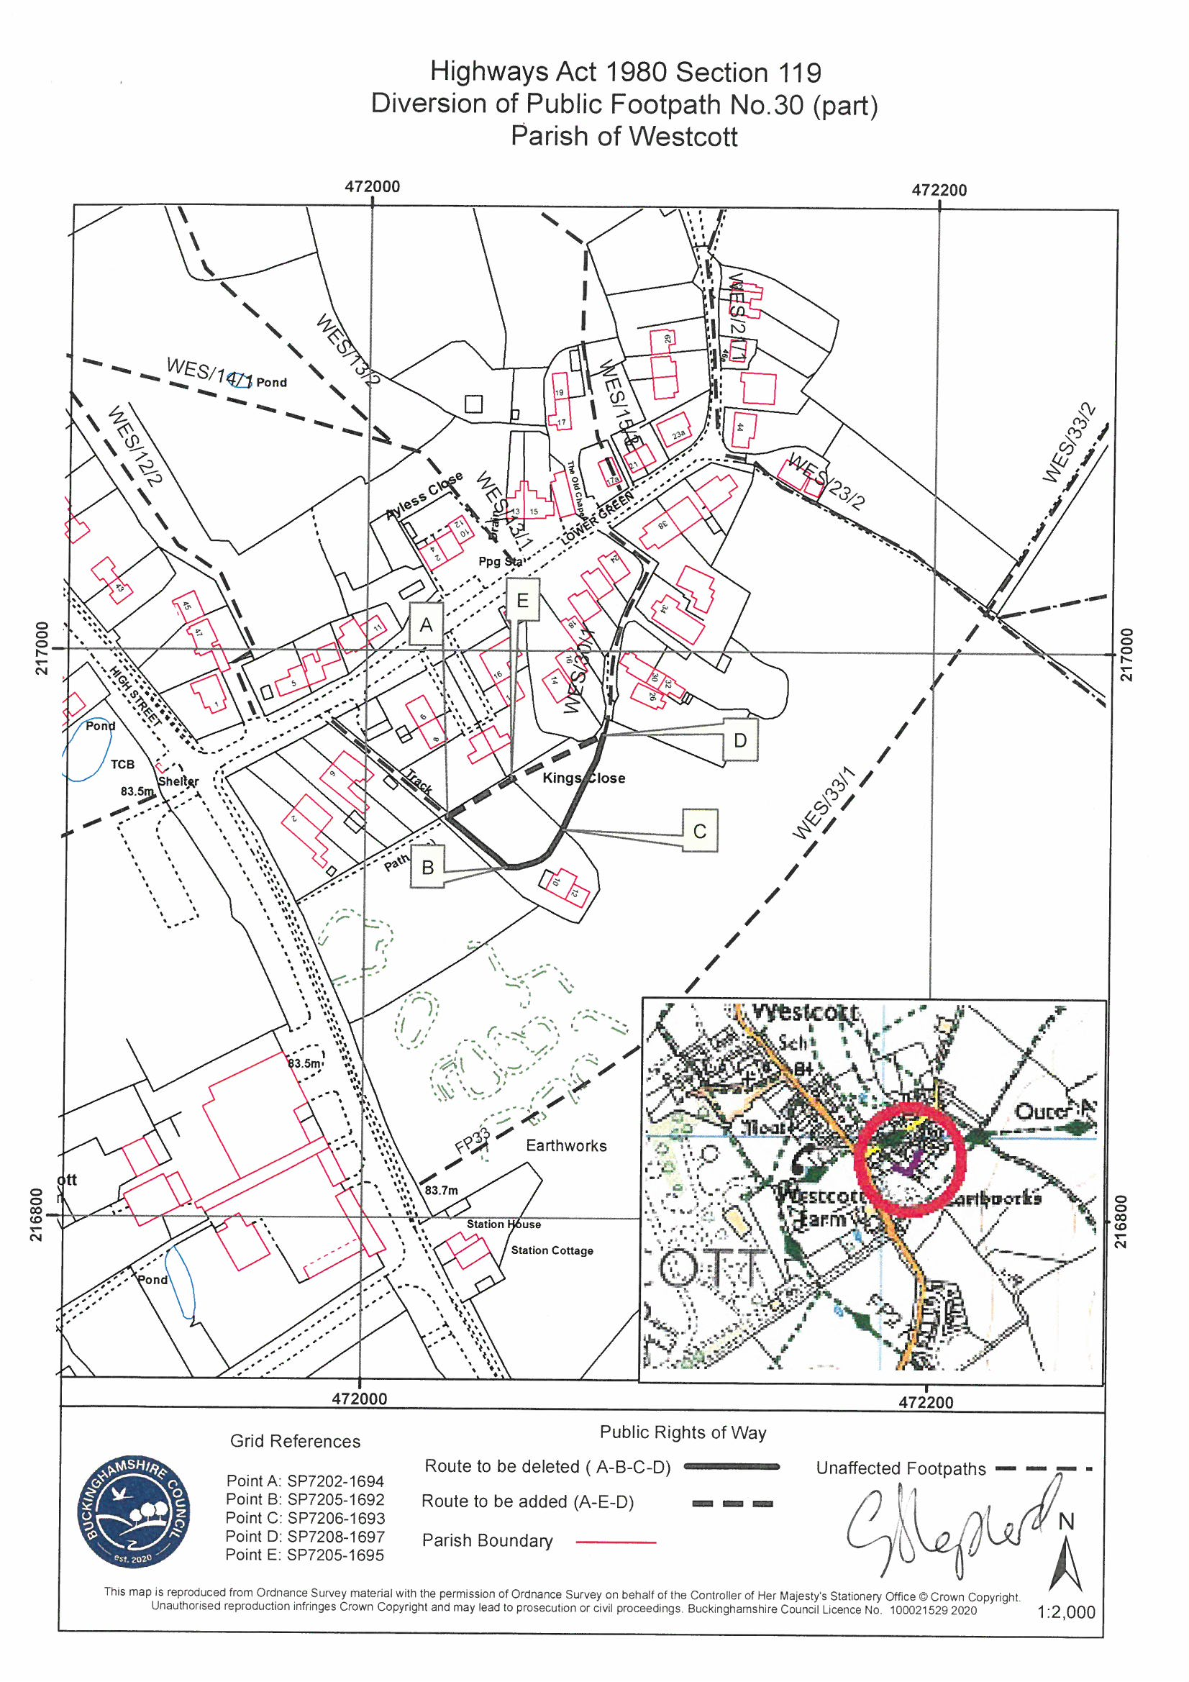

Michael & Vanessa Ort

