Order Decision
Site visit made on 22 August 2022
by D M Young JP BSc (Hons) MPlan MRTPI MIHE
an Inspector appointed by the Secretary of State for Environment, Food and Rural Affairs
Decision date: 23 September 2022

Order Ref: ROW/3255940
- This Order is made under Section 53 (2) (b) of the Wildlife and Countryside Act 1981 (the 1981 Act) and is known as the Mixbury Footpath Nos. 30, 31 and 32 Modification Order.
- The Order is dated 27 March 2019 and proposes to modify the Definitive Map and Statement for the area by adding the footpaths shown in the Order plan and described in the Order Schedule.
- There were three objections outstanding when Oxfordshire County Council submitted the Order to the Secretary of State for Environment, Food and Rural Affairs for confirmation.
Summary of Decision: The Order is confirmed.

Procedural Matters
- Applications to add two routes to the Definitive Map and Statement (DMS) for the area were made by Westbury Parish Council (WPC) in December 2010.
- As objections to the Order were received, it was submitted to the Secretary of State for Environment, Food and Rural Affairs for confirmation.
- Oxfordshire County Council (the Order Making Authority (“OMA”)) supports the confirmation of the Order on the basis that the evidence of use meets the criteria for statutory presumption of dedication under Section 31 of the Highways Act 1980 (the 1980 Act).
- The first route (Footpaths 31 & 36) is shown between points T–U–V–W on the Order Plan (see Appendix 1) and continues into Westbury in Buckinghamshire. The second route (Footpaths 32 & 36)) is shown between points T-U- Y on the Order Plan. The land north of the river is owned by Beachborough School. The land to the south of the river is owned by Mr David Owen.
- It was originally intended to hold a Public Inquiry on 24 August 2022. However, the objectors who originally requested to be heard indicated that they would not be attending. I therefore cancelled the Inquiry and have made my decision on the written submissions.
- I carried out an unaccompanied site visit on 22 August 2022.

The Main Issues
- The Order is made under Section 53(2)(b) of the 1981 Act, relying on the occurrence of an event specified in Section 53(3)(c)(i) of the same. This section requires me to consider whether the evidence discovered by the OMA, when considered with all other relevant evidence, is sufficient to show, on the balance of probabilities, that the right of ways described in the Order subsists and that the DMS therefore requires modification.
- The Council rely on statutory dedication of the Order routes under Section 31 of the 1980 Act. This provides that where a way, other than a way of such a character that use of it could not give rise at common law to any presumption of dedication, has been actually enjoyed by the public, as of right and without interruption, for a period of twenty years, the way is deemed to have been dedicated as a highway unless there is sufficient evidence that the landowner demonstrated a lack of any intention during this period to dedicate the route.
- ‘As of right’ is set out in R v Oxfordshire County Council, ex parte Sunningwell Parish Council (1999) as being without force, secrecy or permission. The 20-year period applies retrospectively from the date on which the right of the public to use the way was brought into question.
- The case for confirmation of the Order relies mainly upon user evidence. As there is considerable conflict between this and the landowners’ evidence, I intend to base my findings on inferences that can be drawn from the documentary evidence and known or probable facts.

Background
- Based on information from WPC, Buckinghamshire County Council (BCC) recorded public Footpaths (FP) 12 and 14 on their DMS in the early 1950s. However, given the location of the County/Parish boundary these stopped at the River Great Ouse rather than continuing into Oxfordshire.
- The OMA did not record the continuation of the routes in Oxfordshire. The most cogent explanation for this is that the routes were used mainly by the residents of Westbury in Buckinghamshire, whereas responsibility for recording the routes lay with Mixbury Parish Council in Oxfordshire. The omission of the routes from Oxfordshire’s DMS created a number of cul-de-sac footpaths.

Reasons

When the right to use the routes was first brought into question
- One of the few areas of agreement between the landowners’ and user evidence is that there was a sea change to the issue of access over the school grounds in 2005 when Mr Whybrow became headmaster of Beachborough School. Before Mr Whybrow’s tenure there is some evidence to suggest members of public were challenged. However, the user evidence suggests this was at best sporadic and not at a level to bring home to the public at large that their use of the route was being challenged.
- From 2005 onwards the school took the issue more seriously as evidenced through the proposed extinguishment of FP14 and FP12 in 2009. Before that, from about mid-2006 onwards, members of public found on the school grounds were challenged by staff. However, the evidence from ex-staff and local residents suggests these challenges tended to be directed at those exercising dogs on the playing fields rather than those walking between the ends of FP14 and FP12/11a. In short while some were challenged, many were not.
- In 2006/7 notices stating “COUNTY BOUNDARY AND END OF PUBLIC FOOTPATH THERE IS NO OTHER RIGHT OF WAY THROUGH THE SCHOOL GROUNDS” were erected at point T. The user evidence tends to favour 2007 as the date when the notices were first erected. The only exception is WPC’s letter dated 10 June 2009 which states that the school erected the notices “three years ago” which would have been June 2006. On the balance of probabilities, I am satisfied that the notices were erected by 2007 at the very latest. This is therefore the date on which the public’s right to use the Order routes was ‘called into question’ unless an earlier challenge can be identified.
- Another possible and earlier ‘calling into question’ arises from the locked gate at point U. Karin Owen states in her evidence that a padlock was put on the gate in 2003. However, she goes on to say that this was later removed and not replaced until 2005/6. After that, she concedes that it was possible to push the gate open for a time until the chain and lock were rearranged. David Owens states “permanent gate at U from 2002-3 kept locked”.
- Jim and Karen Calvert who used the route between 1990-2010 recalled the gate on the Owens’ side of the footbridge but state it was either unlocked or they used a stile or small gap rather than opening it. Edward Rainbow who used the route between 1980-2000 states that there was a “gate at U, we never used to open it – climbed over it (may have been a small gap to the side) Don’t know if it was locked”. Vicky and Clint Webb state that the gate at point U was “always unlocked” until 2010. While climbing over the gates would not have constituted a peaceable use of the route, the consensus of user evidence is that prior to 2010 there was either a stile, gap or the gate was simply unlocked.
- WPC provided a photograph of the bridge at point U purportedly taken in 2010. Unlike the photos provided by the Owens, it does not show any signage (other than a circular waymarker) nor indeed any gate on the school side of the bridge. I disagree with the OMA that the photographs provided by the Owens show the gate padlocked. I cannot see any clear evidence of that in any of the photographs provided. Even if I am wrong about that, the photographs are undated and therefore even clear evidence of a chain/padlock would not necessarily support an earlier ‘calling into question’. While notices are evident, these are not shown on the 2010 photograph provided by WPC. The only logical conclusion is that the removal of the circular waymarker sign and the erection of the “No public Footpath” notice at point U did not occur until 2010 at the earliest. That would be a year or two later than the 2008/9 date given by the Owens.
- Interruption means the actual and physical stopping of the enjoyment of the public’s use of the way – it is generally held that this is distinct from periods of non‐use or sparse use and therefore means some actual action of the landowner, or someone acting with his authority. A common example is the locked gate or bar across a route, often on a certain, specified day in the year. Even then, this is not absolute proof of interruption. In R v Secretary of State for the Environment ex parte Cowell, a locked gate on Christmas Day only and in a blizzard may not actually and physically stop enjoyment. In this case, the user evidence does not support the locking of the gate until 2010. Therefore, if the gate was initially locked in 2003 as claimed by Karin Owen, this was likely to have been for a short period only and insufficient to constitute an ‘interruption’.
- Timothy Smith, a former teacher at Beachborough, recalls that there were locked gates on the school side of the footbridge at point U and another at point W from 1995 onwards. However, that account is not corroborated by other witnesses. For example, Terence Sadler’s states that in 2018 that the [school] gate had only recently been locked. The 1995 date also conflicts with a significant body of local user evidence as well as WPC’s 2010 photograph which shows there was no gate on the school side of the footbridge at that time.
- In terms of Route 2, David Owen claims that “private no access” signs were erected at point Y in 2003/4 but were subsequently ignored, torn down or defaced. Many years later “No public footpath” and “private land no access without permission” notices were erected at points U and V in 2008/9. In addition to notices, David Owen also states that gates at points Y and U were locked from 2002/3 onwards. Mr Owen’s evidence is supported by most of the landowners’ witnesses.
- While photographs have been submitted by the landowners’ showing notices at point Y, these are again undated and therefore of little evidential value in terms of demonstrating an earlier ‘calling into question’. Fencing invoices have also been supplied. However, these only show that the fence “along the old railway” was replaced at some point before 8 May 2010.
- The landowner evidence has to be weighed against that of local people, a significant number of which (over 50) have no recollection of any notices prior to 2009. In December of that year, WPC reported that “private land, no access” signs have been erected at point Y as well as the removal of a circular waymarker and stile.
- Given the inconsistency between the landowner and user evidence, it is not unreasonable to ask why the landowners did not erect signage at point U at the same time they claim to have done so at point Y. If the landowner was genuinely wanting to stop local people from using the routes, then one might reasonably have expected notices to have appeared at both points at the same time. This is particularly so here as users of the routes generally lived in Westbury and would have naturally accessed the Owens’ land from the footbridge at point U. Given that notices were not erected at point U until at least 2010, this weakens the landowners’ argument that they were erected at point Y in 2003.
- Given that inconsistency and the weight of the user evidence, I do not consider there is sufficient evidence to support an earlier ‘calling into question’ of the routes at point U or Y. I therefore find that the relevant 20-year period for both routes is 1987-2007.

Whether there has been use by the public for the required period of 20 years

Documentary Evidence
- The documentary evidence for both routes is comprehensively set out in the OMA’s Statement of Reasons. Rather than repeat all of that information again here, I have instead summarised the salient points.
- A route on a broadly similar alignment is first shown on Byrant’s Map of 1832 as a double pecked line track labelled “Bridle Road”. Route 1 is not shown. The 1845 Buckinghamshire Proposed Railway shows the line of the proposed railway traversing the southern section of the Bridle Road shown on Byrant’s Map. It is possible to see a path heading northwards from the approximate location of point Y. The relevant plots are described in the accompanying book of reference as having a “footpath”. A route on a similar alignment to Route 2 was stopped up by the 1855 Quarter Sessions Stopping Up Order.
- The first Ordnance Survey (OS) Map for the area dates back to 1885. Similar to Byrant’s Map this shows a route on a similar alignment as Route 2 as a double pecked line. Route 1 is not shown. However, there is a double pecked track running from the end of Westbury 12 in a southerly direction crossing a footbridge before skirting the Oxfordshire Cowshed before terminating at the railway line. There is no material change to the routes in subsequent OS Maps.
- The Westbury Parish Claim Map shows FP14 running between Mill Lane and point T. To the south of point T (within Oxfordshire) the map is annotated “14” over a double pecked line which corresponds with Route 1. There is a fainter “FP” with a line to point U. This provides strong evidence that Westbury 14 was reputed at that time to continue south of point T.
- The Claim Map also shows Westbury FP12 as a spur off FP11 but terminating at the county boundary. The map is also marked “FP” to the south of FP12 on what is now the FP11a spur. Interestingly, the surveyor has marked “12” on the south side of the river in Oxfordshire but its positioning is ambiguous. However, the map is also annotated with a “C.B.” (cart bridge) and in faint pencil “FP” pointing to a position that roughly corresponds with point V on the Order map. There is accordingly some support from the Parish Claim map for the continuation of both routes into Oxfordshire. The evidence in respect of Route 2 is stronger than Route 1. Neither route was shown on the Mixbury Claim Map although others in the area were for example, FP4 and FP5.
- There was an exchange of correspondence between the Oxfordshire County Surveyor and Mixbury Parish Council in 1953 which essentially queried why the Order routes had been omitted from the Mixbury Parish Claim. In response, Mr Thornitt (Mixbury PC’s surveyor) replied that the routes were not included because there was no evidence on the plan of a track beyond the railway. From his own observations and enquiries, it was concluded that the routes were not rights of way, but merely tracks made by farm workers and animals. In light of the above the routes were not recorded on the first DMS for Oxfordshire dated 1953 nor any subsequent editions.
- That appears to be how matters were left until 1991 when BCC’s Rights of Way Officer wrote to the OMA regarding footbridges on both routes. One of the footbridges shown on the accompanying plan is at point U, the other is approximately 40m south-east of point V. The OMA’s reply stated that FP14 did not continue into Oxfordshire, and they did not own the footbridges.
- In 2006 the Property Manager and Bursar at Beachborough School met BCC’s Right of Way Officer to discuss the extinguishment of FP14 and FP12. The Officer recorded:

“It is known by the school that local people have been walking across and around the playing field areas for many years, including walking between the two ends of the public footpaths in Westbury. Therefore, there may already exist a number of public footpaths across the playing fields, that have never been claimed or recorded.”
- In 2008 BCC’s Rights of Way officer inspected the routes and found that Route 1 was non-existent on the ground and therefore it was not believed there was a footpath linking FP12 and FP14. While 2008 falls outside the relevant 20-year period, given that a number of users have given evidence that they used the route up until 2010, one would have expected some evidence of a walked path between the ends of FP12 and FP14.

Conclusions on Documentary Evidence
- The relevant 20-year period for the routes is 1987-2007. In the main, the documentary evidence provided by the OMA does not relate to this period.
- Historical maps show the long-standing existence of a physical route to between Points U and Y. The documents connected to the Westbury Parish Claim support the OMA’s contention that FPs 12 and 14 continued into Oxfordshire and were reputed to be public footpaths in the early 1950s. As previously stated, the evidence is stronger in respect of Route 2 than Route 1.
- The above has to weighed against the evidence of Mr Thornitt on behalf of MPC who evidently investigated the matter in 1953 and concluded that the routes were not public rights of way but farm tracks for workers. Notwithstanding that response, I find it improbable that one, let alone two routes, would have simply terminated at the river given the presence of footbridges and the recent repairs that were carried out at point T by the County Council.
- The fact that the routes were not considered to be public rights of way in 1953 does not preclude the possibility that public rights have been established since through section 31 of the 1980 Act. Documents pertaining to the proposed extinguishment of the routes dating from 2006 suggest that the school was well aware that Route 1 had been well used by local people for a number of years. This is supported by evidence of former school staff which collectively covers the period 1985-2007. Given the above one would have expected there to be some evidence of a walked path along Route 1 in 2008 when BCC’s Rights of Way officer investigated the matter. This evidence suggests the route was not well used in the period immediately after the relevant 20-year period had ended.

User Evidence
- 56 User Evidence Forms (UEFs) were submitted for Route 1 in 2010 with 15 of the respondents being subsequently interviewed by the Council witnesses. For Route 2, 54 UEFs were submitted with 14 of the respondents being subsequently interviewed by the Council.
- While the ratio of interviews versus UEFs appears to be low, in my experience, it is within the range that one might ordinarily expect in the context of a DMMO application. In this case, the response rate was almost certainly influenced by the letter dated 16 December 2014 sent to a number of respondents by the owners of the land crossed by Westbury 11/11a. In essence this letter sought to discourage members of the public from giving evidence at an upcoming Public Inquiry by highlighting the ‘ordeal of cross examination’. Given the tone of that letter, it is almost inevitable that it put some witnesses off from giving interviews in connection with these Order routes.
- Although a number of the UEFs were discounted this still leaves a significant body of evidence which supports the public’s use of both routes ‘as of right’ over the relevant 20-year period. The OMA’s Statement of Reasons shows that there are at least 47 witnesses who claim to have used Route 1 over part of the 20-year period and 11 who claim use over the whole period either on a monthly or weekly basis. The corresponding figures for Route 2 are 48 and 12. Many of the witnesses refer to widespread use of the route by other villagers. Overwhelmingly, users believed that the landowners were aware that the public at large were using the routes.
- The above is consistent with accounts given by former staff members nearly all of which reported daily levels of use by the public. Pat Hearn states that the school was aware that the routes were being used, but nothing was ever said. The high level of public use was also noted in 2006 in relation to the proposed extinguishments (see paragraph 38 of this decision). The level of claimed use of Route 1 is also markedly similar to that already accepted by BCC in respect of the DMMO application for FP11a, which is effectively the section of Route 1 that falls within Buckinghamshire.
- Based on the foregoing, I consider that the level of use during the relevant 20-year period would have been sufficient to “bring home to the landowner that a right is being asserted against him”. While a small number of users received permission to walk the routes, most did not. There is no substantive evidence to suggest that any use of the Order routes was secretive or by force nor that the use was interrupted during the 20-year period.

Conclusions on User Evidence
- Overall, the user evidence demonstrates use of the Order routes during the 20-year period and weigh in favour of confirmation of the Order. There is no evidence that the use was interrupted or that it was not ‘as of right’. Although the level of use varies between the witnesses, overall, it has been demonstrated that it was on a regular basis varying from daily, weekly and monthly depending on the time of year.
- The objectors have queried the sincerity and accuracy of the user evidence but chose not to test it at a Public Inquiry. As a result, I have no reason to believe the user evidence is inaccurate or dishonest. In view of my conclusions above it is necessary to consider whether any landowner demonstrated a lack of intention to dedicate the way as a public footpath.

Lack of intention to dedicate
- The user evidence gives rise to a presumption of dedication and therefore the burden shifts to the landowner to demonstrate a lack of intention to dedicate. For there to be sufficient evidence of this there must be evidence of some overt acts on the part of the landowner, during the relevant period, to show the public at large, the public who used the path, that they had no intention to dedicate. The test is whether a reasonable user would have understood that the landowner, that is the owner of the land over which the route passes, was intending to disabuse the user of the notion that the way was public.
- Between them the landowners have raised three possible actions which potentially could constitute a lack of intention to dedicate: locked gates, notices and verbal challenges. Given the overlap between ‘bringing into question’ and ‘lack of intention to dedicate’, I have already addressed these matters and found that the first calling into question was in 2007 when the school first erected notices on its land.
- I have carefully considered whether locked gates, verbal challenges and notices on land to the south of the river could have demonstrated an earlier ‘calling into question’ but for the reasons given have found this not to be the case. The same conclusions apply to ‘lack of intention to dedicate’ i.e. that actions taken by the landowners were not sufficient to demonstrate to the public at large that they had no intention to dedicate the routes during the period 1987-2007.

Other Matters
- Various objectors have raised child safety and security concerns. However, these are not matters that can be taken into consideration under section 53 of the 1981 Act.

Conclusions
- I have found that there is sufficient user evidence to demonstrate use of the Order routes between 1987 and 2007. There is no evidence that use was interrupted or that it was not ‘as of right’. I have not identified any evidence to show a lack of intention to dedicate a public right of way over the Order route within the 20-year period. Therefore, on the balance of probabilities, and considering the evidence as a whole, I am satisfied, that the Order routes should be recorded as public footpaths. Having regard to these and all other matters raised I conclude that the Order should be confirmed.’

Formal Decision

- The Order is confirmed.

D. M. Young

Inspector

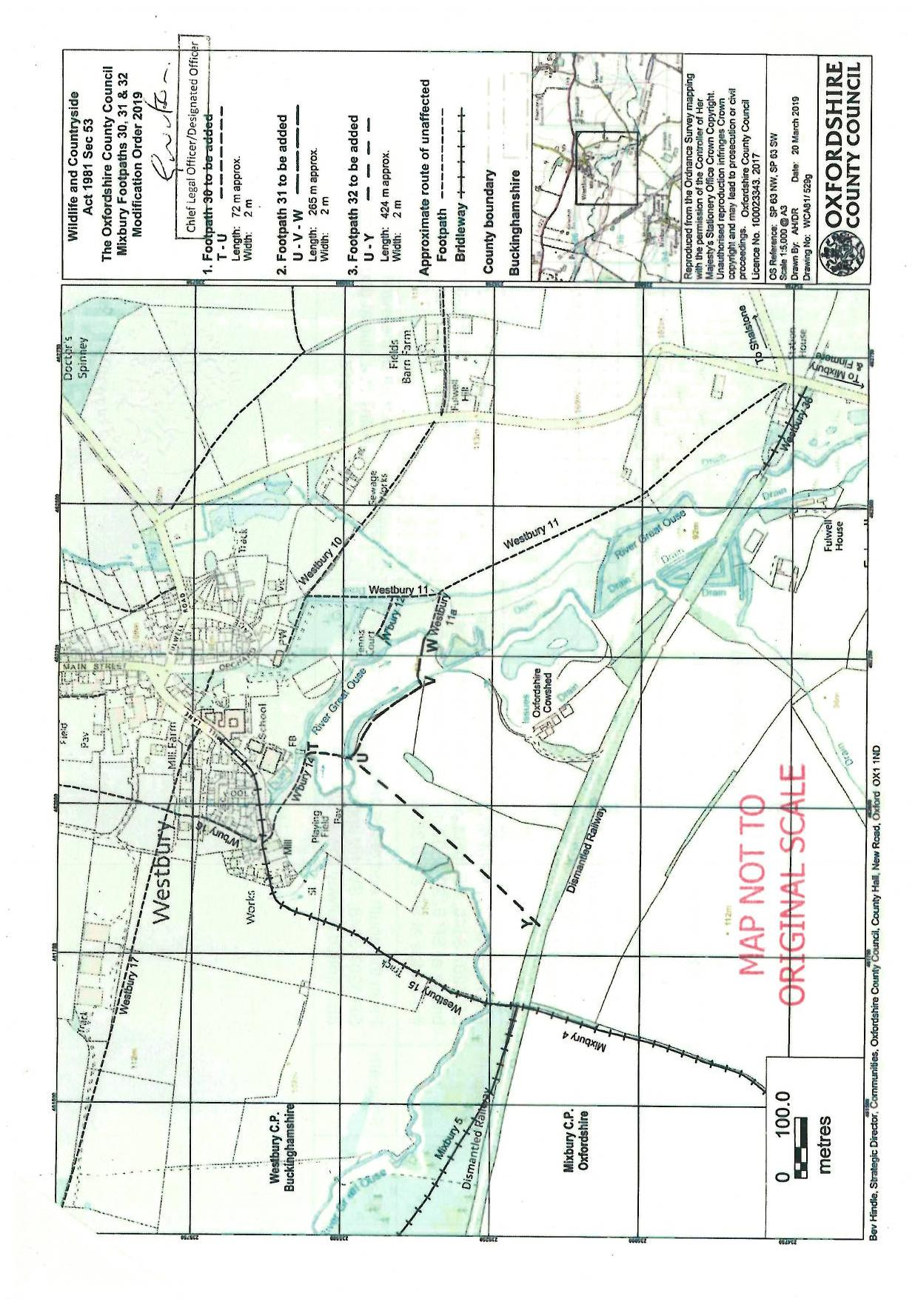

The River Great Ouse defines the administrative boundary between Oxfordshire and Buckinghamshire
See UEFs from Timothy & Julie Smith and Michael Sanders
See Appendix 256
Statements from Karin Owen, Mr & Mrs Read as well as user evidence forms
Through periods of sparse or non-use are relevant to the question of ‘full period of twenty years’
[1993] JPL 851
Rachel Thompson, Ian & Julia Read, Michael Bezant, C Pullin, Simon Bennett & Karin Owen
There is a noticeable curve between Points U-Y as opposed to the straight line on the Order Map
Since 1888 OS maps have carried the disclaimer: “The representation on this map of a road track or footpath is no evidence of a public right of way.”
This is the location of the original footbridge which according to the OS maps was removed prior to 1977. The replacement bridge a point V is shown on OS maps from 1977 onwards.
A further UEF was submitted in 2018
Ian & Julia Read
See paragraphs 171 & 172 of the OMA’s Statement of Reasons
Appendices 162 and 163
R (Lewis) v Redcar and Cleveland Borough Council UKSC 11 (03 March 2010)
Mann v Brodie (1885)

