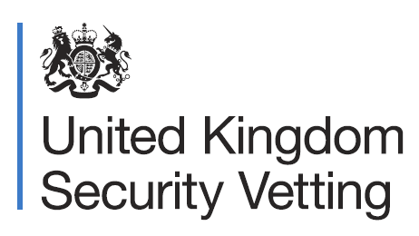
The Civil Service values diversity in its workforce,and welcomes applications for roles that require national security clearance from everyone.

The Vetting experience will ask you questions about your nationality and any related travel so we can better understand your relationship with each country and your loyalty to the UK.

Do I need to be a British national?

Many people with different nationalities hold UK security clearance, as do colleagues with dual nationality.

All applications are assessed on a case-by-case basis, so we may ask questions about the countries you’re connected to, and whether you travel to them.

How long must I have been a UK resident?

The length of residency required varies depending on the level of clearance you are applying for.

For a job that requires a higher level of clearance, in most cases you need to have been a UK resident for ten years.

This is assessed on a case-by-case basis.

What should I do if I feel uncomfortable?

If you feel uncomfortable at any point when discussing your nationality, let your Vetting officer know so they can address this.

We work to the values of respect, trust and collaboration, and all staff undergo continuous learning and development to enhance their cultural awareness.

Remember that the aim of Vetting is to make an objective risk assessment through a safe and professional process.

For more information search”UKSV” on Gov.uk

