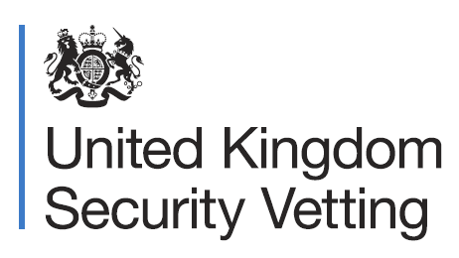
There are many ideas of what the Vetting process is and what the experience may feel like.

And when it comes to sexuality and gender identity, there are many misconceptions.

We want to take away any uncertainty and ensure nobody is dissuaded from applying for roles that require you to go through the Vetting process, however you identify.

Is my gender identity or sexuality a factor when considering my application for security clearance?

We want people from all walks of life to apply to security cleared roles, regardless of their sex, sexuality or gender identity.

Vetting is non-judgemental, it does not discriminate on any of these grounds.

Is the LGBTQ+ community welcomed?

People within the LGBTQ+ community have been welcome and able to obtain security clearance for several decades.

We work closely with staff networks to improve the experiences of LGBTQ+ people applying for roles that require clearance?

Why will I be asked about my gender identity or sexuality?

As the Vetting process is a whole life assessment, you may be asked questions about these areas.

We understand that this can feel intrusive or could involve sensitive subjects.

But it is important that you share your story with us so we can build up a picture of what makes you, you. We understand that everyone has a unique journey when it comes to who we are.

What happens if I don’t like some terminology being used?

Our Vetting officers and case assessors undergo training and development to enhance their awareness and understanding of these personal topics.

However, we encourage applicants to speak up if they are feeling uncomfortable and to correct their Vetting officer’s terminology if they get it wrong.

The Vetting experience is a safe, non-judgmental, and professional process, where we do our best to make everyone feel as comfortable as possible.

There are no right or wrong answers, we simply ask that you are honest throughout.

For more information search”UKSV” on Gov.uk

