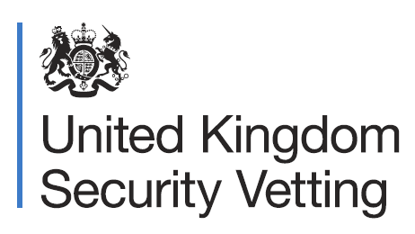
During your application for national security clearance, we will ask you questions regarding all areas of your life.

We do this to form an accurate picture of who you are and to understand your behaviours in particular scenarios.

What will I be asked about my online behaviour?

The questions we ask will focus on things like your social media usage, which websites you frequently visit,
and your associated views and attitudes towards your online activity.

We appreciate that these questions cover topics that could be embarrassing or difficult to discuss, such as dating apps, gambling, or pornography.

But please be assured everything remains confidential, and our team will treat anything you share with sensitivity.

It is vital to be open and honest throughout, as anything later discovered that you did not initially share could negatively impact your security clearance application and even jeopardise your offer of employment.

We make no moral judgements of you based on answers you provide at any time, we will always look at the information you give us with a professional and respectful approach.

For more information search”UKSV” on Gov.uk

