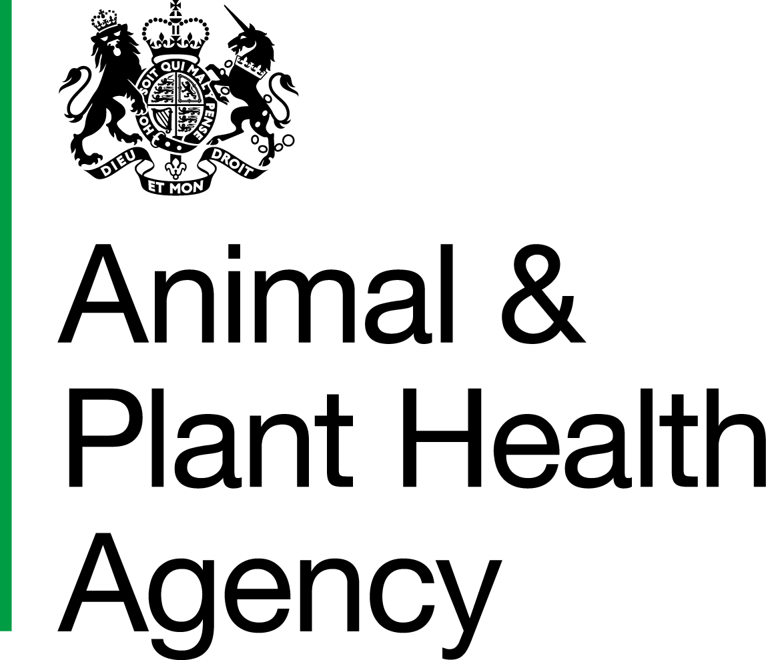Department for Environment, Food and Rural Affairs
Scottish Government
Welsh Government

The Rabies (Importation of Dogs, Cats and Other Mammals) Order 1974 (as amended)

This application is for Authorisation / Re-authorisation for a Carrying Agent / Portal Carrying Agent
(select as appropriate)
For re-authorisations, provide the expiry date of current approval:
Important - To satisfy ‘nose-and-paw’ proof requirements the following sizes and strengths of wire-mesh are recommended for cats and dogs:
- for cats: not larger than 2.54cm x 2.54cm (1” x 1”) and no thinner than 1.6mm (16 SWG)
- for dogs: not larger than 2.54cm wide x up to 7.6cm (1” wide x up to 3”) and no thinner than 2mm (14 SWG)
- for small rodents under 250g: not larger than 1cm² constructed of wire no thinner than 16swg (1.65mm)
- for Carnivora over 50kg: no larger than 2.54cm wide x up to 7.62cm or 5.08cm² and no thinner than 2.65mm (12 SWG)
For completion by applicant (use block letters)
1. (a) Full name, business address and postcode:
Telephone number:
Email:
Trade name (if applicable):
(b) Address and postcode where vehicle(s) are usually kept (if different from above):
2. (a) Name of business partners, associates and employees directly concerned with the movement of the quarantine animals:
(b) Details of any other allied business of relevance to this application:
3. Specify the classes of animals you wish to carry e.g. dogs, cats and other mammals:
- for other mammals state order(s) (see Schedule 1 - Animals to which the order applies (RM25))
- for larger animals state upper weight limit:
Note: Portable crates must be supplied for the animals concerned and the range of crates must meet all the requirements of condition 15 of Schedule of Conditions (Form RM11A/ID52A) in relation to the animals you carry. Refer to the Important note at the top of this page.
4. Are you authorised to carry any other animals under other Statutory Orders? Yes No
5. Do you transport vertebrate animals on journeys over 65km as part of an economic activity?
Yes No
If Yes, provide your Transporter Authorisation Number:
This covers all vertebrate animals including zoo animals. The journey of an animal includes the entire transport operation from the place of departure to the place of destination, including any unloading, accommodation and loading occurring at intermediate points in the journey. Any animals collected from port/airport in the UK are likely to have already travelled at least 65km.

6. If any of the animals being transported are not delivered to the quarantine premises on the day of importation, where and in what conditions, are they kept overnight?:
7. Do you wish to be included in the list of carrying agents available to the public? Yes No
8. What areas are you prepared to cover with your vehicle(s)? (you require transporter authorisation to carry veterbrate animals on journeys over 65km as part of an economic activity - referred to in Question 5 above):
9. Do you maintain a record book to record all collections and deliveries as stated in paragraph 52 of the Schedule of Conditions? Yes No
 |  |  |  |  | For Animal Health Officer, APHA Veterinarian Use Only
10. Give details of all vehicles to be used for carrying quarantine animals. For this purpose ‘vehicles’ includes private cars (e.g. estate cars or saloon cars for certain types of animals), detachable horse-box type trailers and box vans) |  |  | Is vehicle equipped to operate under systems  A or B of paragraph 17 of the Schedule of Conditions? |  | Is vehicle so constructed that it can be cleansed and disinfected after each movement of quarantine animals? |  | Does vehicle meet the requirements of paragraph 15 or 16 (PCA) of the Schedule of Conditions? |  | Is vehicle fully satisfactory for the carriage of classes of animals specified at question 3 on page 1?
Make | Model | Registration Number | A | B | Yes | No | Yes | No | Yes | No
- I, the undersigned, apply for the *authorisation/re-authorisation as a carrying agent for the movement of *dogs/cats/and certain other categories of other mammals under the provisions of the Rabies (Importation of Dogs, Cats and Other Mammals) Order 1974 (as amended).
*delete as appropriate
- I realise that any authorisation will only cover the animals listed at question 3 and I declare I will comply with the regulations and that to the best of my knowledge all the information given above is true.
- I am fully aware of the obligations and risks involved in the work and this applies to all my staff concerned.
- I have read and understand the duty place upon me under the relevant legislation below regarding the welfare of animals during transit:
  - *The Welfare of Animals (Transport) (WATO) (England) Order 2006

  - *The Welfare of Animals (Transport) (Scotland) Regulations 2006/

  - *The Welfare of Animals (Transport) (Wales) Order 2007
*delete as appropriate
Carrying agents signature

Name in block letters Date

Data Protection
For information on how we handle personal data please go to www.gov.uk and search Animal and Plant Health Agency Personal Information Charter.
Reference:
APHA Veterinarian or Animal Health Officer’s report
For Official Use Only
1. If primates are to be carried is each driver equipped with:
- a pair of protective gloves? Yes No N/A
- a catching net? Yes No N/A
2. Do all containers or crates fully meet the standards listed at paragraph 15 of the Schedule of Conditions? Yes No N/A
- for all new applications please include photos of containers and crates
3. If this is a re-authorisation have there been any changes since the last APHA visit?
Yes No N/A
If Yes, detail changes:

4. Vehicle details - give details of vehicle or trailer below, and on continuation sheet if necessary:
- REG. No - IDENT No.:
- Method of Ventilation:
- For approval under System 17A (i.e. Double crating system):
- Description of outer crate:
- Identification number:
- Size and materials from which made (including mesh size and gauge):
- For approval under System 17B:
- Security system materials from which made (including mesh size and gauge)
- Partition:
- Rear door:
- Side door:

For Official Use Only
5. Do the vehicle(s) covered by this application meet all requirements for approval?
Yes No

6. Do you recommend *authorisation/re-authorisation of this applicant as a carrying agent under the terms of the Conditions? Yes No
*delete as applicable
7. If ‘No’, is the applicant aware that he or she will not be authorised until deficiencies are rectified? Yes No
8. If you are unable to recommend authorisation or re-authorisation state in what respect are the facilities and or proposal inadequate:

Take a moment to check through the form to ensure all information is included and all questions answered. Checklist for Application for Authorisation/Reauthorisation as a Carrying Agent/Portal Carrying Agent (ID52B) (ID105) is available to download from the Operations Manual.
Date of visit or inspection
Signature *APHA Veterinarian/Animal Health Officer (*delete as appropriate)
Name in block letters Date
If the inspection was carried out by an Animal Health Officer, the report must be countersigned by an APHA Veterinarian.
Countersignature

Name in block letters Date
Send completed form to:
Animal and Plant Health Agency
Centre for International Trade Carlisle
Eden Bridge House
Lowther Street
Carlisle, CA3 8DX
Tel: 03000 200 301
Email: imports@apha.gov.uk

For Official Use Only
REG. No - IDENT No.:
Method of ventilation:
- For approval under System 17A (i.e. Double crating system)
- Details of outer crate:
- Identification:
- Size and materials from which made (including mesh size):
- For approval under System 17B
- Partition present: Yes No Materials from which made (including mesh size):

- Rear door security present: Yes No Materials from which made (including mesh size):
- Side door security present: Yes No Materials from which made (including mesh size):
REG. No - IDENT No.:
Method of ventilation:
- For approval under System 17A (i.e. Double crating system):
- Description of outer crate:
- Identification:
- Size and materials from which made (including mesh size and gauge):
- For approval under System 17B:
- Security system materials from which made (including mesh size and gauge)
- Partition:
- Rear door:
- Side door:

For Official Use Only
REG. No - IDENT No.:
Method of ventilation:
- For approval under System 17A (i.e. Double crating system)
- Details of outer crate:
- Identification:
- Size and materials from which made (including mesh size):
- For approval under System 17B
- Partition present: Yes No Materials from which made (including mesh size):

- Rear door security present: Yes No Materials from which made (including mesh size):
- Side door security present: Yes No Materials from which made (including mesh size):
REG. No - IDENT No.:
Method of ventilation:
- For approval under System 17A (i.e. Double crating system):
- Description of outer crate:
- Identification number:
- Size and materials from which made (including mesh size and gauge):
- For approval under System 17B:
- Security system materials from which made (including mesh size and gauge)
- Partition:
- Rear door:
- Side door:

APHA is an Executive Agency of the Department for Environment, Food and Rural Affairs and also works on behalf of the Scottish Government, Welsh Government and Food Standards Agency to safeguard animal and plant health for the benefit of people, the environment and the economy.

HM3 Stamp | Name: |  | Date Received: |  | WS ID:

