NOTICE OF ORDER
Highways Act 1980 – Section 119
North Yorkshire County Council
Footpath No. 30.31/096 (Part), Botton Grove, Danby Head
Diversion Order 2020

Notice is hereby given that the above referenced Order has been submitted to the Secretary of State for Environment, Food and Rural Affairs for determination. An Inspector will be appointed by the Secretary of State to determine the Order.

The start date for the above Order is 13 September 2022.

Consideration of the Order will take the form of exchanges of statements of case and comments on statements of case.

The effect of the Order, if confirmed without modifications, will be to divert the public footpath described below:
Footpath No. 30.31/096 running generally north for approximately 431 metres from GR NZ 6975 0514 to GR NZ 6986 0555 will be diverted onto a new route commencing from GR NZ 6975 0514, running generally north-east for approximately 92 metres to an existing field gate in the field boundary at GR NZ 6983 0519, then continues generally north for approximately 149 metres to an existing field gate in the field boundary at GR NZ 6987 0534, then runs generally north-north-east for approximately 93 metres to an existing field gate in the field boundary at GR NZ 6991 0542, then continues generally north for approximately 44 metres to a pedestrian gate at GR NZ 6992 0546, then continues northwest for approximately 103 metres to GR NZ 6986 0555. The new route will be 2 metres wide throughout on a surface of grass.

Any queries relating to this Order should be referred to Clive Richards at The Planning Inspectorate, Rights of Way Section, Room 3/A Eagle Wing, Temple Quay House, 2 The Square, Temple Quay, Bristol, BS1 6PN. Telephone: 0303 4445502. Email: clive.richards@planninginspectorate.gov.uk or Rightsofway2@planninginspectorate.gov.uk Please quote reference number ROW/3284297 on all correspondence.

Any person wishing to view the statements of case and other documents relating to this Order may do so at Stokesley Library, Town Close, North Road, Stokesley, TS9 5DH during normal opening hours. Contact at NYCC: Ron Allan, Tel: 01609 532558, Email: ron.allan@northyorks.gov.uk

Timetable for sending in statements of case and comments

Within 2 weeks of the start date [by 27 September 2022]
The Order Making Authority must ensure their statement of case is received by the Secretary of State. As soon as possible after the deadline, the Secretary of State will send a copy (excluding copies of any supporting documents - these will be available to view at the Authority’s offices) to everyone who has made an objection or representation, the applicant and any other person who has written to us in respect of the Order.

Within 8 weeks of the start date [by 08 November 2022]
Everyone who has made an objection or representation or any other written representation or any other person wishing to make representations in writing must ensure their statement of case is received by the Secretary of State. As soon as possible after the deadline, the Secretary of State will send full copies to the Authority. Copies (excluding copies of any supporting documents - these will be available to view at the Authority’s offices) will also be sent to the applicant, every person who has made an objection or representation and any other person who has written to us in respect of the Order.

Within the same period the applicant (if applicable) must ensure their statement of case is received by the Secretary of State. As soon as possible after the deadline, Secretary of State will send a full copy to the Authority. Copies will also be sent to everyone who has made an objection or representation and any other person who has written to us in respect of the Order (excluding copies of any supporting documents - these will be available to view at the Authority’s offices).

Within 14 weeks of the start date [by 20 December 2022]
Everyone who has made an objection or representation, the Authority, the applicant (if applicable) and anyone who has written to us in respect of the Order must ensure that their comments on any or every other statement of case is received by the Secretary of State. As soon as possible after the deadline, the Secretary of State will send copies of these comments to everyone else.

In fairness to the other parties everyone should keep to the timetable to ensure that statements of case and comments are received on time. Late documents will be returned.

We cannot accept any inflammatory, discriminatory or abusive comments. Any documents containing such comments will be returned.

Notice of order for w/r
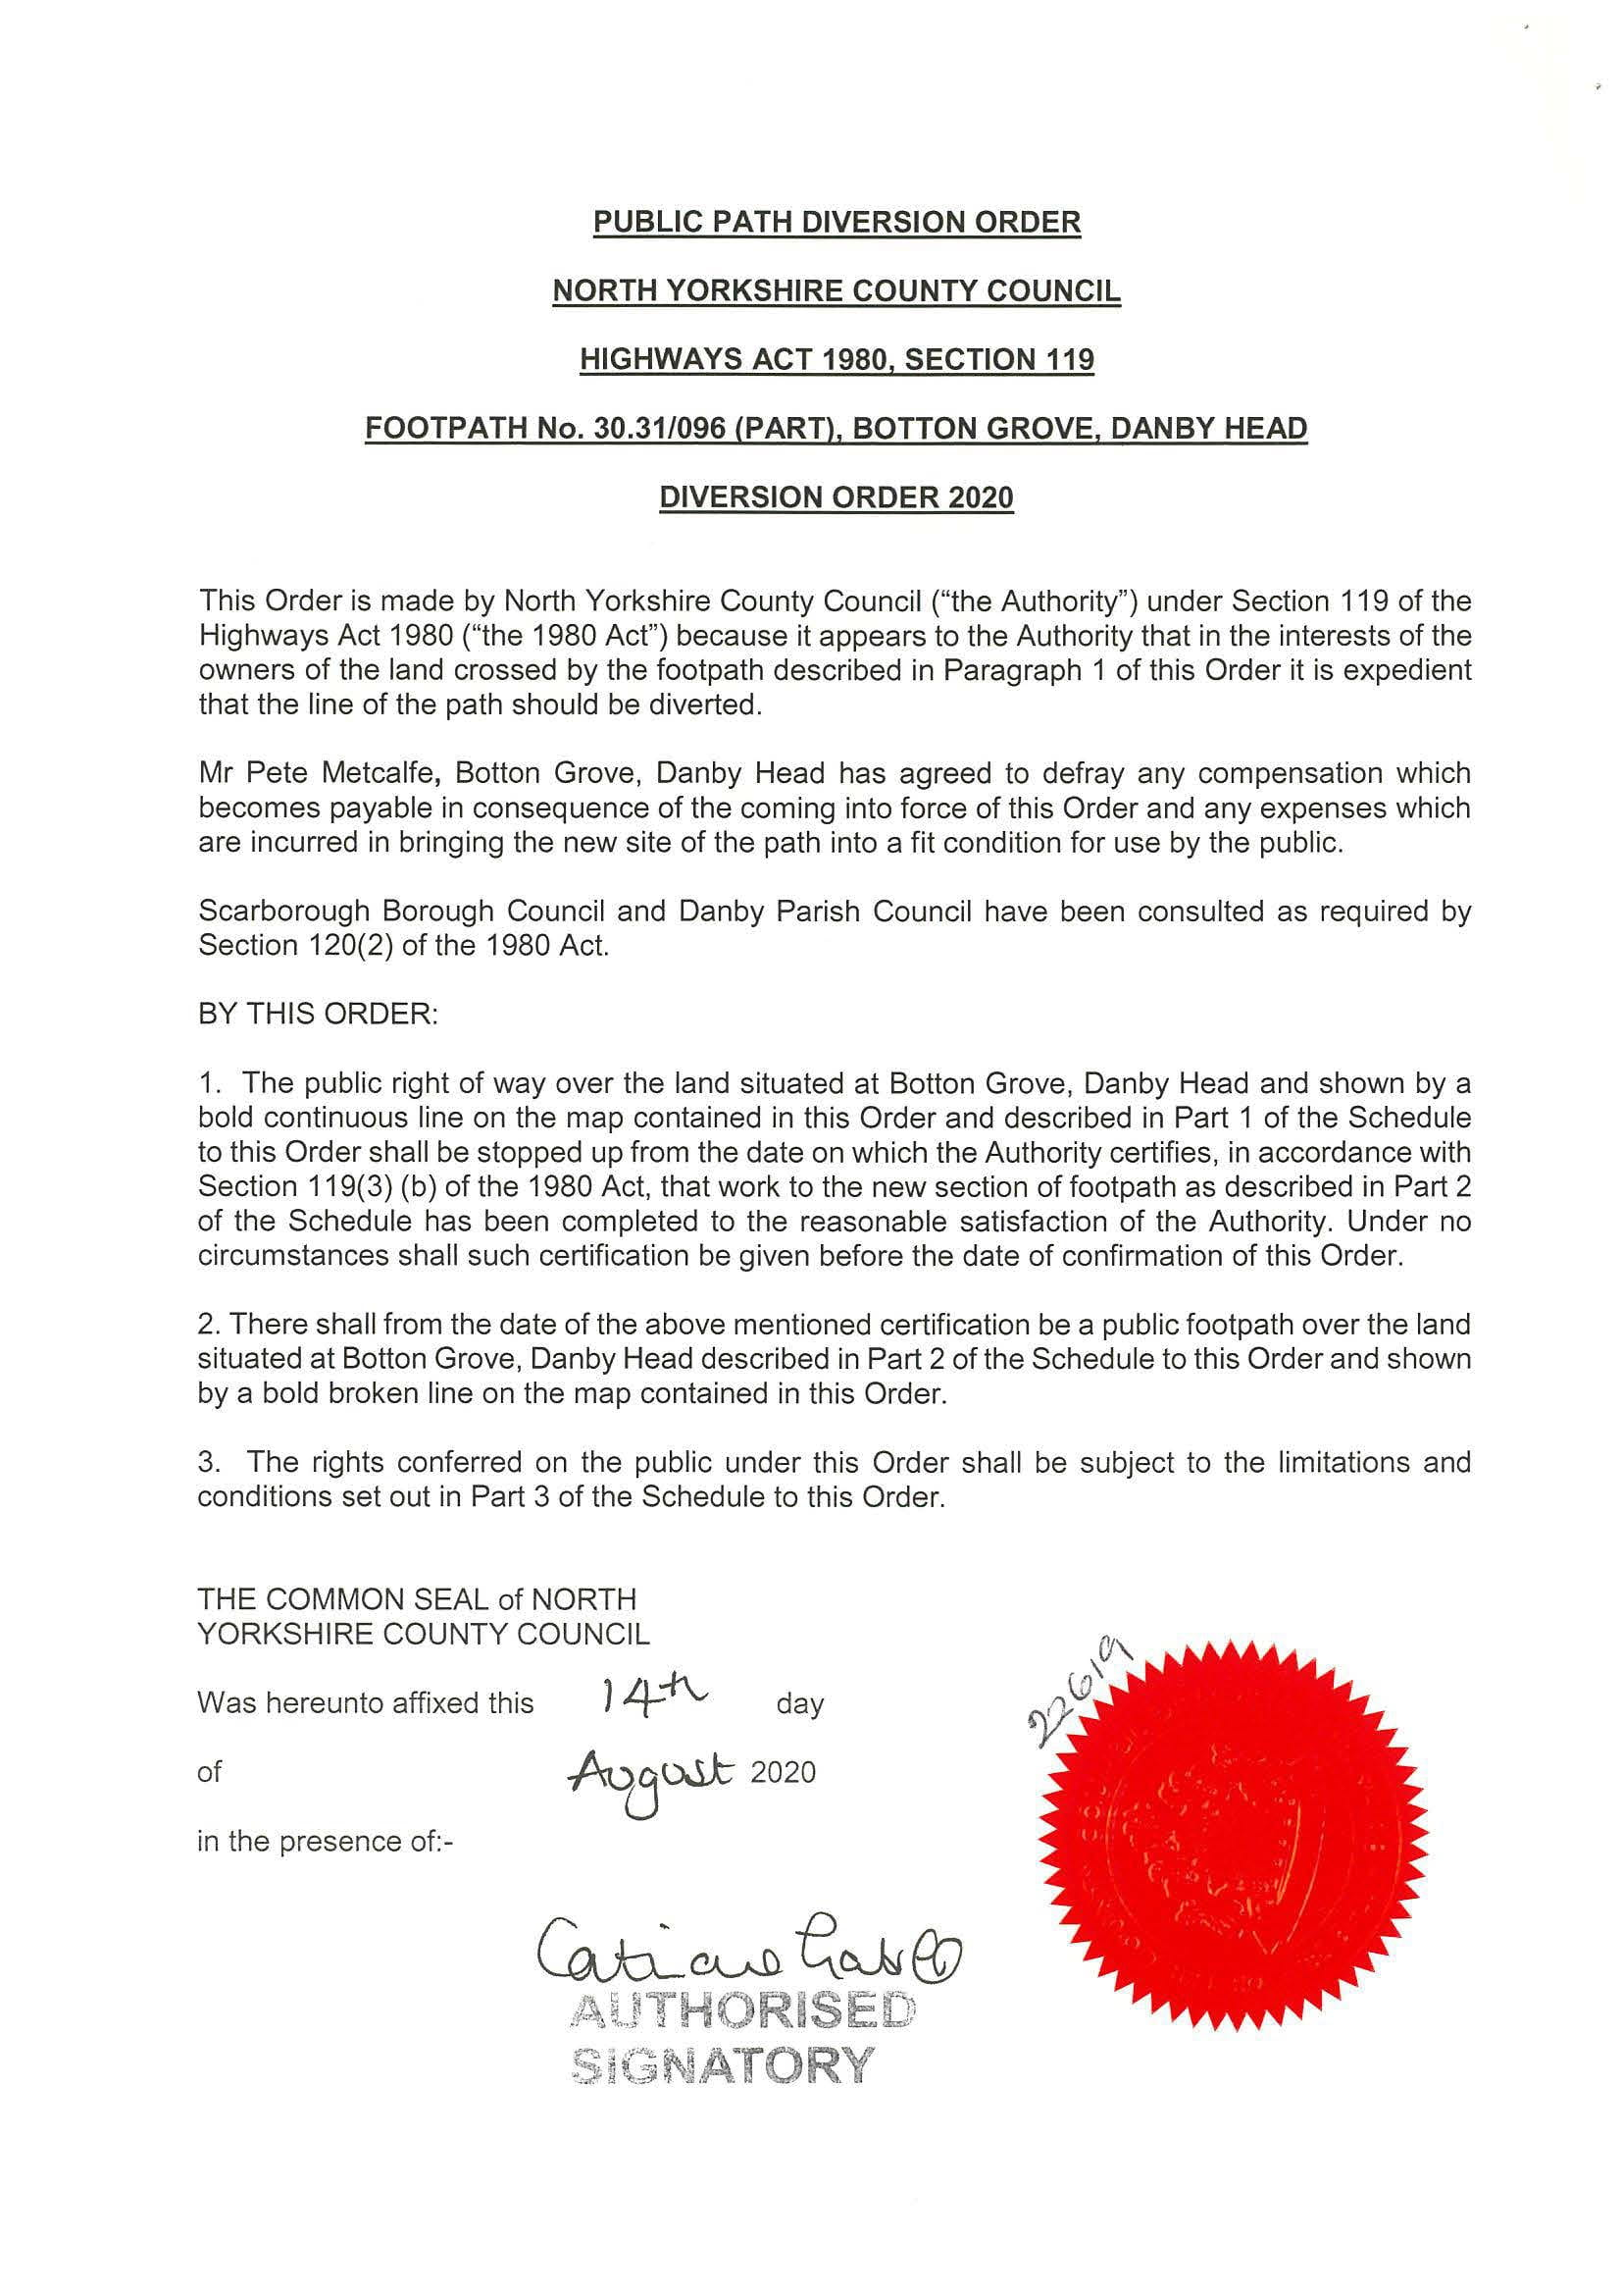

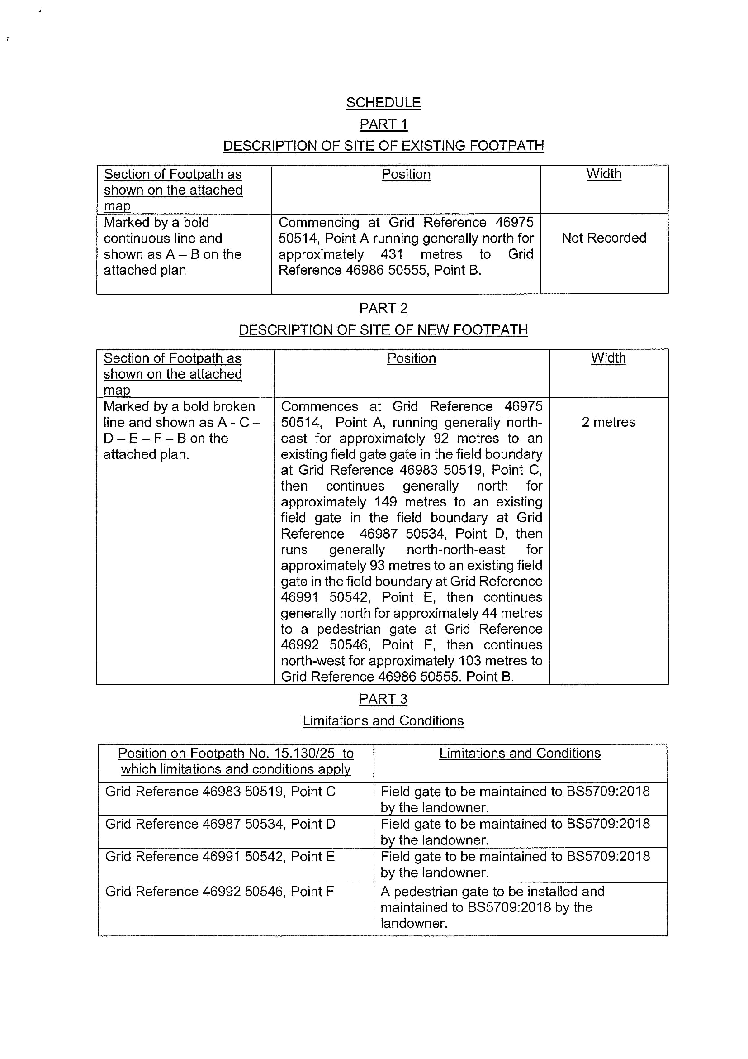
ORDER MAP – NOT TO SCALE


