Guidance on completion of the DCO fastrak claim form (DCO1)
Use this form for dismissed defendant in magistrates’ court where the total claim is for £2000 or less. The £2000 limit includes counsel fees but excludes disbursements and VAT. All claims should be e-mailed to dcofastrak@justice.gov.uk
You should download the most up to date version of the DCO fastrak (DCO1) claim form from the gov.uk website:
https://www.gov.uk/government/publications/dco-magistrates-court-fastrak-claims-form-dco1
Top tip
Always download a fresh form for each claim. Using an out of date form or overtyping may cause an error and result in your claim being rejected

Once downloaded, it is recommended that you name the file as using the following format:
- Defendant’s name followed by the case number
Please do not remove lines of information on the claim form. If work claimed has not been entered in date order then this can be rectified once the claim is received. If you do enter a row in error please highlight the relevant cells and use the ‘clear contents’ function to remove the data if you are copying and pasting into the form, please use the ‘paste values’ function.
This ensures that any values entered do not affect anything in the background of the forms.
Your claim and papers must be submitted via email as separate attachments as follows:
- DCO1 claim form
- Defendant’s Costs Order
- Client care letter / evidence of private retainer
- Invoices/receipts for any disbursements over £20
Top tip
Please ensure that you provide both pages of the Defendant’s Cost Order including details of any offences to which it relates

If the total attachments exceed 10mb then please send via a separate email, entering 1 of 2 etc in the subject heading.
Documents submitted electronically will not be returned.

CLAIM DETAILS
Step 1
Enter you details of the instructed solicitor along with the case and defendant information

Step 2
You must ‘sign’ the declaration by selecting yes. Unsigned claims will be rejected and returned
Step 3
You must declare the total costs that the defendant is liable to pay under the terms of the retainer.
Step 4
Where a defendant has been convicted/pleaded guilty to any part of the charges the Criminal Cases Unit cannot determine any claim unless the court has indicated the percentage of costs to be allowed (partial acquittal). If the Court has ordered costs to be apportioned you must confirm the percentage of costs to be allowed.

Top tip
Where the DCO does not confirm the percentage of costs to be allowed your claim will be returned and you will need to seek a further order from the Magistrates Court.

Step 5
Complete the Fee Earners information including the full name, initials and grade of fee earner using the drop-down list.
Top tip
If you are claiming a grade of fee earner based on previous experience you should provide supporting information.

LITIGATOR WORK CLAIMED
Enter the details of the work claimed using the drop-down box
NB: A decimal time converter can be found at the final tab on the claim form
Top tip
Time must be entered as a digital, e.g.: 1hour 18m = 1.3. Entering time in the wrong format may result in your claim being underpaid.

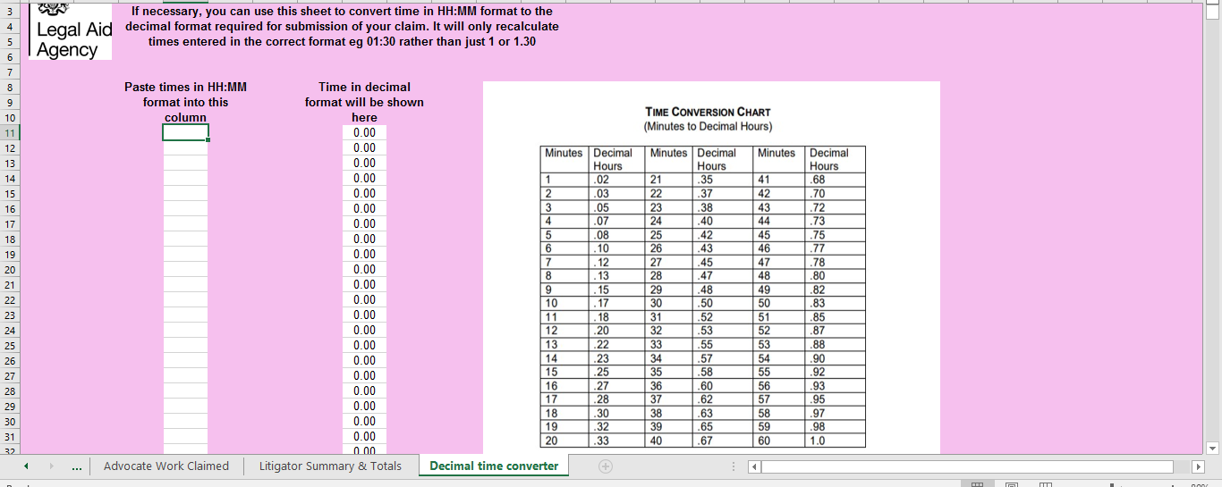
If the form does not contain sufficient lines for your claim, please contact the CCU and we will send you an appropriate form. In order for us to add additional lines please enclose your partially completed claim form with any request.
Routine correspondence:
Enter the number of routine items of correspondence claimed. This should include telephone calls made and received, emails and letters sent. Routine emails and letters received are not remunerated separately.
Disbursements:
Disbursements for travel expenses must be claimed as part of travel in “work claimed”.
Any disbursement in excess of £20 must be accompanied by an invoice or receipt.

Advocate fees:
If you have instructed an advocate who is not an employee of your firm you must claim their fees separately. You must include a copy of their fee note/invoice and work log.
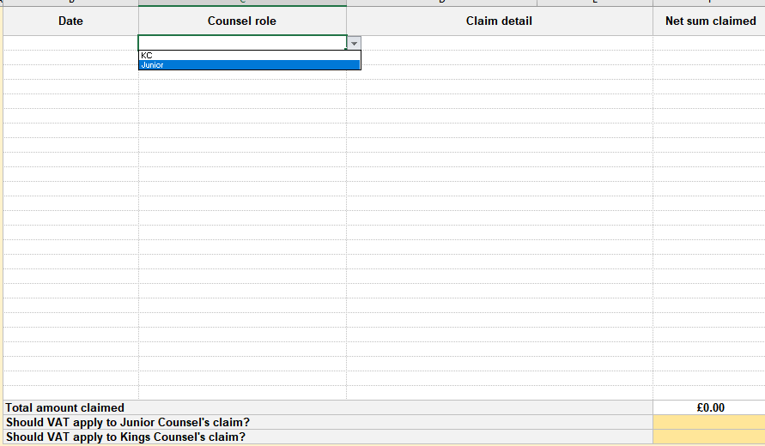
Top tip
If you are claiming for costs of more than one advocate of the same status but they are not all VAT registered you should claim the non-VAT registered advocate under disbursements.

Enhanced rates:
The prescribed rate may be exceeded in cases where:
- the work was done with exceptional competence, skill or expertise; or
- the work was done with exceptional dispatch; or
- the case involved exceptional circumstances or complexity.

Supporting information
Under the Regulations a determining officer may request information or documentation that will assist them in assessing the costs to be allowed. This includes requesting your attendance notes and correspondence file, even if your claim has been submitted under the fastrak scheme.
Top tip
If it is necessary to request additional information it may delay the determination and payment of your claim

Claim Summary
The ‘summary of claim’ does not populate until you have entered all of the claim details.
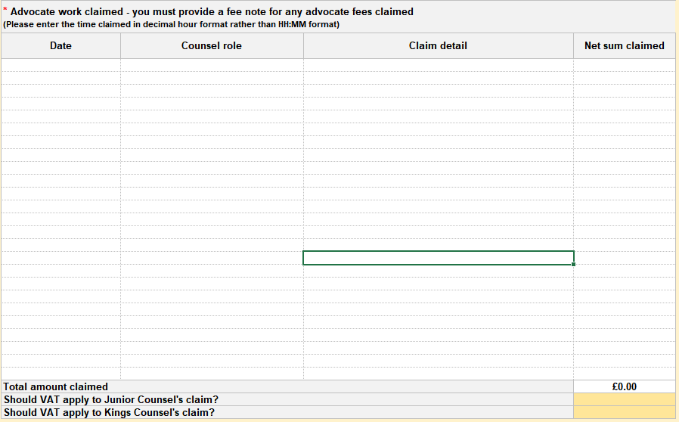

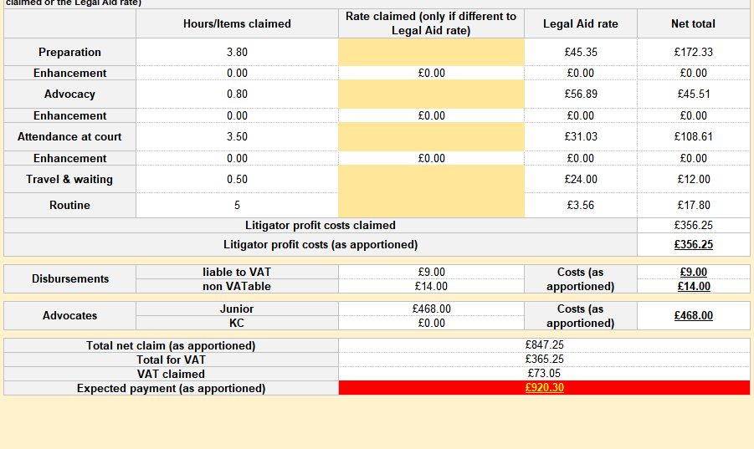
Once you have completed your claim you must ensure that the declaration has been completed.

Your claim and accompanying documents should be emailed to
dcofastrak@justice.gov.uk
If you are submitting your claim and documents in more than one email, please mark as such in the subject heading, i.e.:DCO claim John Smith 1 of 2
On receipt your claim will be allocated a unique reference number which should be quoted whenever you contact us.
Top tip
If your claim summary does not populate check that you have entered
- The date of the DCO
- The date of the warrant/requisition/summons
- Whether Vat applies to counsels’ fees

We aim to determine all claims within 20 days of receipt.
Once your claim has been determined, unless your costs have been allowed in full, a copy of your DCO1 will be sent to the email address provided on the claim form. 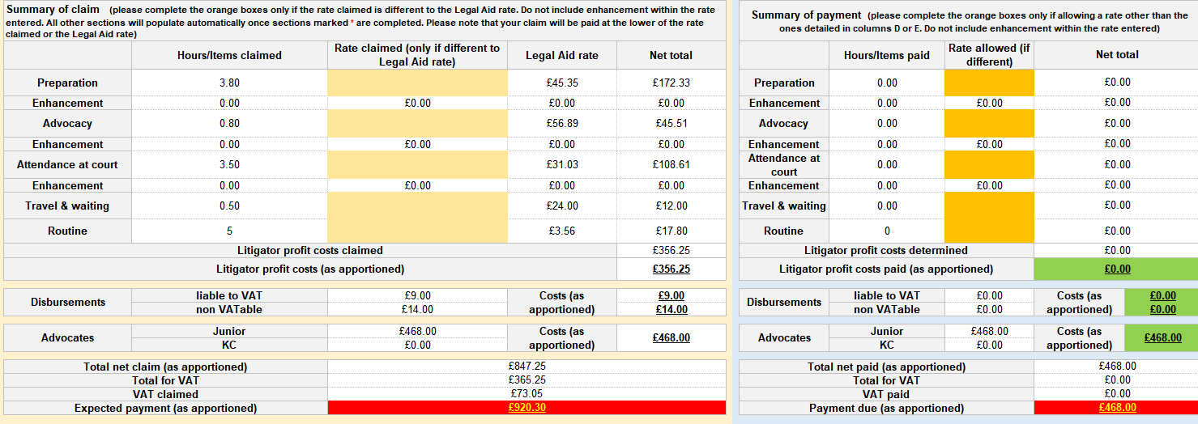

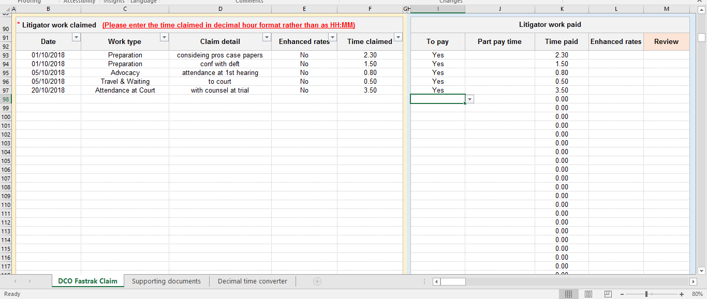
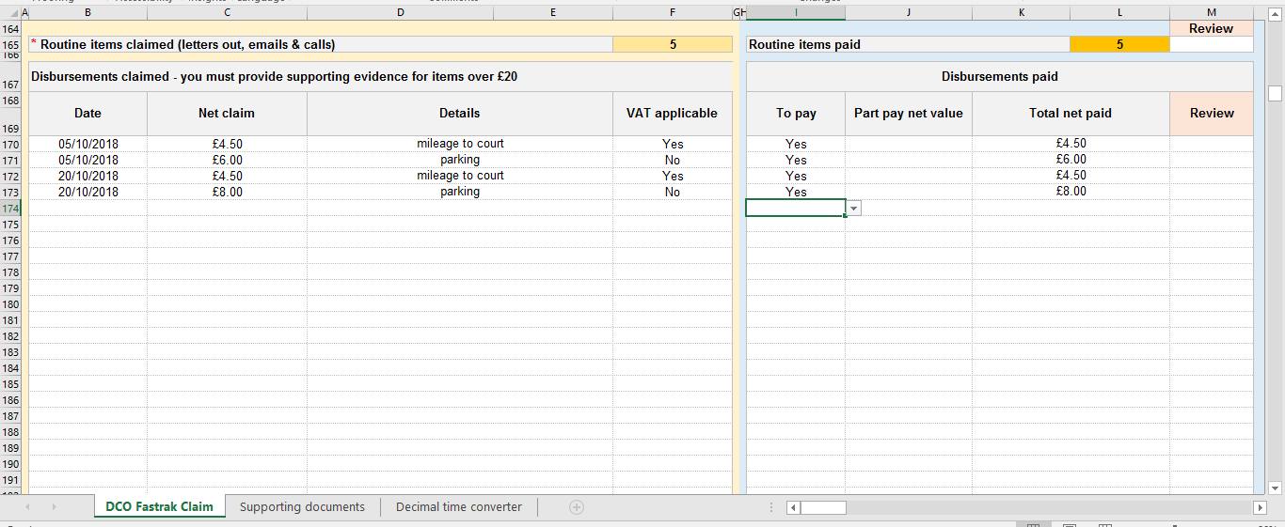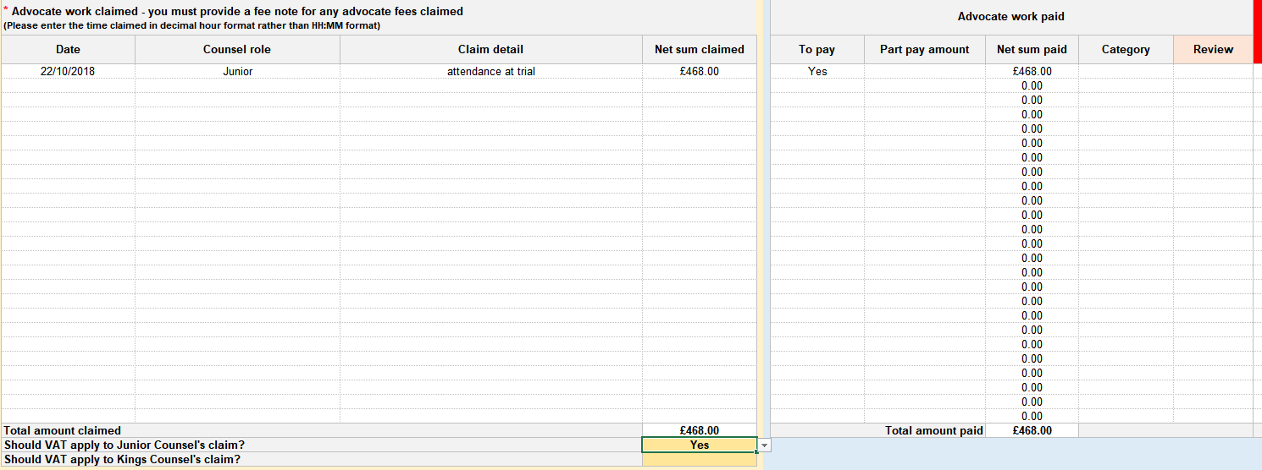

If you are dissatisfied with the determination you may request a review within 21 days of receipt of the notification of determination.
If you are dissatisfied with the costs allowed:
Whilst the Costs in Criminal Cases (General) Regulations 1986 do not make provision for the redetermination of costs from central funds incurred in the Magistrates Court the Criminal Cases Unit have agreed to continue with the previous practise of the Magistrates Court and carry out an informal review of the costs allowed on request.
Requests for review should be sent to dcofastrak@justice.gov.uk quoting the unique reference number.
Any request for review must be made within 21 days of determination.
A request for review may be made using your original claim form or via email alone. You must set out on which items a review is requested, include any information you wish the case manager to consider and attach any relevant attendance notes or copies of correspondence.
Requesting a review using DCO1:
Using the drop-down list, indicate in column ‘M’ which items you wish to be reviewed.
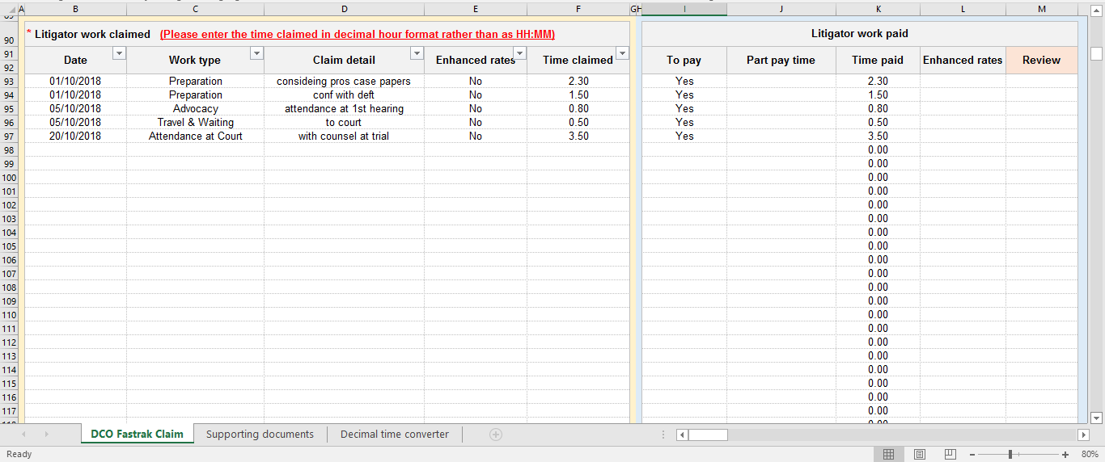
You should provide detailed submissions on each item you wish to be reviewed in your accompanying letter/email.
Once your claim has been reviewed a copy of your claim form will be returned detailing any additional amount to be paid. Further clarification setting out the reasons behind any decision will be sent either via letter/email or, if an additional payment is made via the payment notification.
A copy of your redetermined claim will be returned.
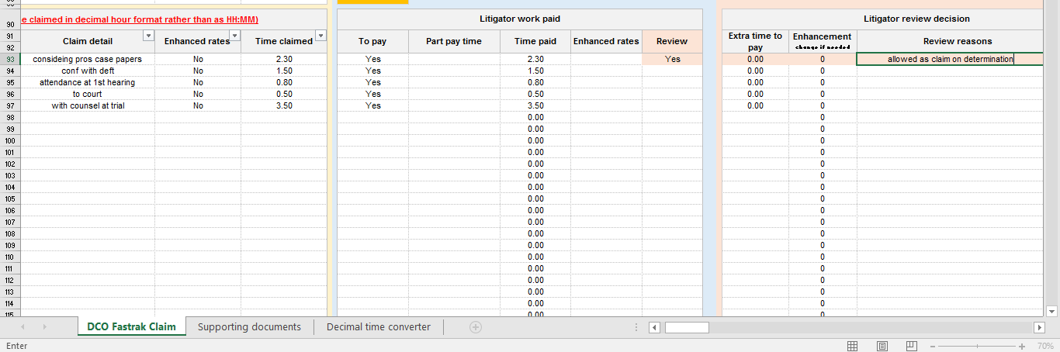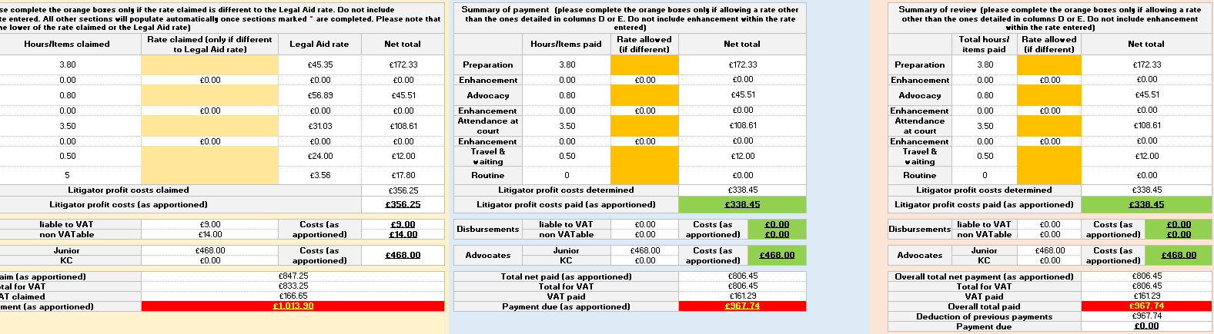

We aim to deal with requests for review within 20 working days of receipt
If you remain dissatisfied following review you can apply for Judicial review. Guidance on this process can be found at
https://www.justice.gov.uk/courts/rcj-rollsbuilding/administrative-court/applying-for-judicial-review

