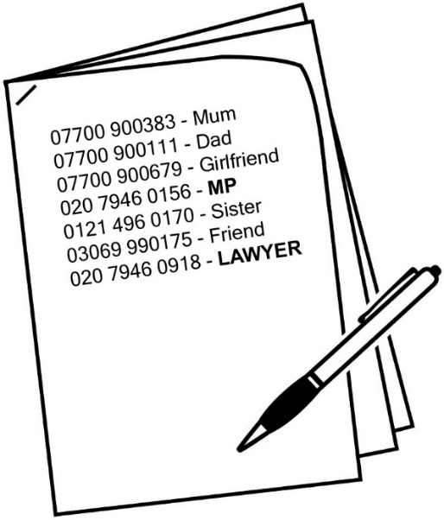 | You must give the prison a list of the people you wish to call/video call during your time in prison, including their contact numbers and their relationship to you. You will be told if you cannot contact any of the numbers on your list.  You should clearly mark the phone numbers of your legal and confidential numbers in the correct section (e.g, lawyer and MP).
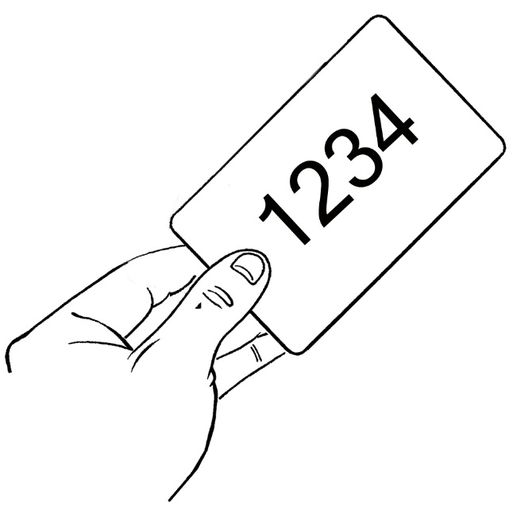 | You will be given a PIN number to use the telephone. You must keep this safe. You must not allow anyone else to use your PIN number.
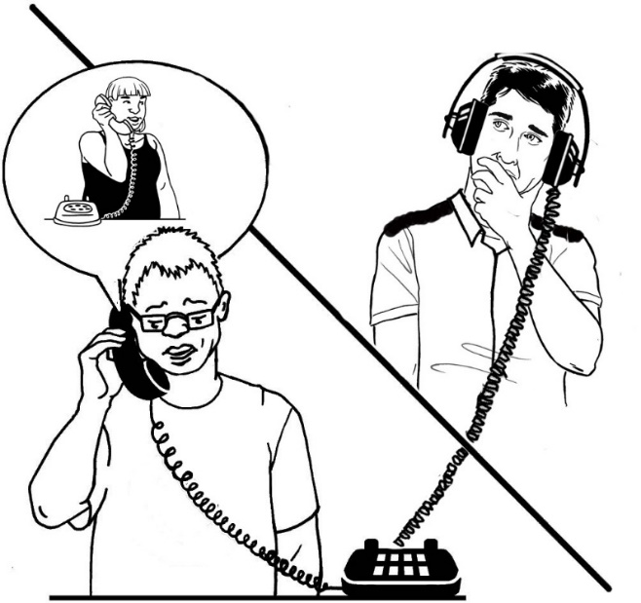 | Your phone calls to friends and family are recorded and may be monitored. The person you are calling will be notified of this before the call connects.
If you want to call/video call any legal or confidential access representatives or (from the confidential access list) you must wait until your numbers have been officially processed.
Calls to legal or confidential numbers will only be granted in exceptional circumstances before this process has taken place and you must make staff aware that it is a legal or confidential call.
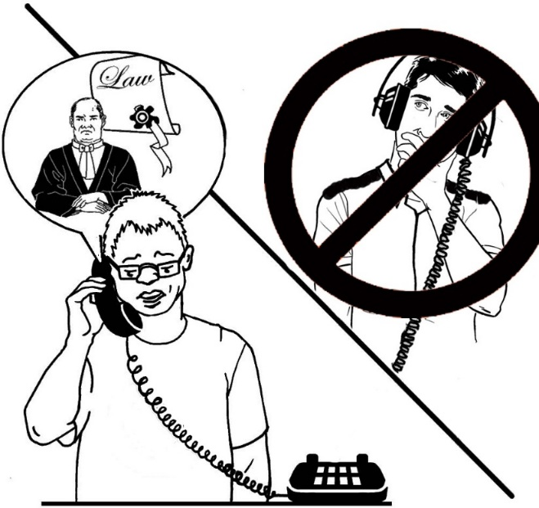 | Legal and confidential access calls WILL NOT be monitored routinely.
I confirm that the information above has been explained to me and that further detail regarding communications is contained within the Communications Compact. I understand that this Compact will be retained on my personal file.

Prisoner Name:
Prisoner Number:
Signature:
Date Signed:

