Appeal Decision
by A Spencer-Peet BSc(Hons) PGDip.LP Solicitor (Non Practicing)
an Inspector appointed by the Secretary of State for Environment, Food and Rural Affairs
Decision date: 23 August 2022

Order Ref: FPS/X2600/14A/6
- This Appeal is made under Section 53(5) and Paragraph 4(1) of Schedule 14 of the Wildlife and Countryside Act 1981 (the 1981 Act) against the decision of Norfolk County Council (the Council) not to make an Order under section 53(2) of the Act.
- The Application dated 4 November 2020 was refused by the Council on
20 September 2021.
- The Appellants claim that the definitive map and statement (the DMS) of public
rights of way should be modified by deleting part of Newton by Castle Acre Restricted Byway No 3 (RB3) (shown Points A – B on the Application Plan appended to this decision).
Summary of Decision: The Appeal is dismissed.

Preliminary Matters
- I have been directed by the Secretary of State for Environment, Food and Rural Affairs to determine an appeal under Section 53(5) and Paragraph 4(1) of Schedule 14 of the 1981 Act.
- The appeal is made against the Council’s decision not to make an order in respect of the Application to delete part of a restricted byway from the DMS. Whilst I acknowledge and have considered the parties’ submissions with regards to a separate application to extend the route from Point B on the plan appended to this decision, to the Mill Common Road located to the southwest, that matter is the subject of a separate appeal. As such, this appeal solely concerns the matters raised in the Application dated 4 November 2020 which seeks to delete part of a restricted byway as identified in the banner heading above.
- I have not visited the site. However, I am satisfied I can make my decision without the need to visit the site. The appeal has been determined on the papers submitted.
- It is acknowledged that the Council have provided a copy of a plan which, it is maintained, was produced to clarify the application map. However, it is noted that the Appellants have requested that the original map they have provided in support of the Application, be used for the purposes of this appeal. As such, in the banner heading above and throughout this appeal decision, I have used the term “the Application Plan” to refer to the Appellants’ “Map B” submitted in support of the application. A copy of the Application Plan is appended to this decision.

Background and Main Issue
- The parties’ submissions confirm that RB3 was originally recorded as a Road Used as a Public Path (RUPP) and was known as CRB3 (County Road
Bridleway 3). The Council, in 1996, commenced a review in respect of reclassifying all RUPPs in Newton by Castle Acre. In 2000, all RUPPs except
for CRB3 were reclassified. Under the statutory requirements contained within Section 47 of the Countryside and Rights of Way Act 2000, CRB3 was reclassified as RB3 on 2 May 2006.
- The Application Plan shows RB3 as terminating at a point to the south of the dwelling referred to as “Byeways”. The submissions in this appeal from all parties identify that dwelling as ‘Byways’, and I shall continue to use that name in this appeal to identify the relevant dwelling. Byways was previously formed of two dwellings which comprised the properties known as Newton Heath Cottages.
- The Application was made under Section 53(2) of the 1981 Act which requires the surveying authority to keep the DMS under continuous review, and to modify them upon the occurrence of specific events cited in Section 53(3) of the 1981 Act.
- Section 53(3)(c)(iii) of the 1981 Act provides that a modification order should be made on the discovery of evidence which, when considered with all other relevant evidence available, shows that there is no public right of way over land shown in the map and statement as a highway of any description.
- In the case of Trevelyan, the Court of Appeal held that “Where the Secretary of State or an inspector appointed by him has to consider whether a right of way that is marked on a definitive map in fact exists, he must start with an initial presumption that it does. If there were no evidence which made it reasonably arguable that such a right of way existed, it should not have been marked on the map. In the absence of evidence to the contrary, it should be assumed that the proper procedures were followed and thus that such evidence existed. At the end of the day, when all the evidence has been considered, the standard of proof required to justify a finding that no right of way exists is no more than the balance of probabilities. But evidence of some substance must be put in the balance, if it is to outweigh the initial presumption that the right of way exists. Proof of a negative is seldom easy, and the more time that elapses, the more difficult will be the task of adducing the positive evidence that is necessary to establish that a right of way that has been marked on a definitive map has been marked there by mistake.”
- The case of Norfolk County Council, R (on the application of) v Secretary of State for Environment, Food & Rural Affairs (the Norfolk Case) establishes that for the purposes of Section 56 of the 1981 Act, the definitive map is the primary source document. If the definitive statement cannot be reconciled to it, the position shown on the map prevails and a degree of tolerance is permissible. However, at review stage neither the map nor statement is conclusive evidence of its content. If there is a conflict between the map and statement, there is no evidential presumption in favour of the map. A conflict would indicate an error in their preparation. The map and statement should then be accorded weight as appropriate, analysing the documents and circumstances at the relevant date.
- The Department of the Environment, Food and Rural Affairs, Rights of Way Circular (01/09) confirms that once prepared, and until subsequently revised, the DMS is conclusive evidence in rights of way disputes, and that Authorities are under a duty to make an order modifying the DMS where they have evidence that a public right of way should be deleted. It is for those who contend that there is no right of way, to prove that the map requires amendment due to the discovery of evidence.
- Circular (01/09) further provides that “The evidence needed to remove what is shown as a public right from such an authoritative record as the definitive map and statement – and this would equally apply to the downgrading of a way with “higher” rights to a way with “lower” rights, as well as complete deletion – will need to fulfil certain stringent requirements. These are that:
- the evidence must be new – an order to remove a right of way cannot be founded simply on the re-examination of evidence known at the time the definitive map was surveyed and made.
- the evidence must be of sufficient substance to displace the presumption that the definitive map is correct;
- the evidence must be cogent.”
- The main issue is whether the available evidence shows that, on the balance of probabilities, the DMS requires modification.

Reasons
- I have been provided with a copy of the DMS for this area. The evidence before me indicates that the definitive map is based on 1950s Ordnance Survey (OS) mapping, with the draft map being compiled in 1957, the provisional map
in 1960, with the definitive map being published in 1966. The statement element of the DMS describes RB3 (formerly CRB3 as noted above) “starts from junction of Fakenham Road with East and West Lexham Roads and runs south westwards to Newton Heath Cottages”.
- The Appellants have put it to me that the termination point of RB3 at Newton Heath Cottages included on the definitive map differs to that which is recorded in the statement element of the DMS. The Appellants maintain that the definitive map shows RB3 terminating where a well in the garden to the property at Byways is located, with the statement element of the DMS describing a different termination point.
- As noted above, the property at Byways was previously formed of two cottages which comprised ‘Newton Heath Cottages’. The definitive map shows RB3 extending beyond the eastern most dwelling at Newton Heath Cottages to a point to the south and alongside the western most dwelling at Newton Heath Cottages. The termination point shown on the definitive map corresponds with Point B on the Application Plan.
- In the Norfolk case described above, it was decided that the correct approach to interpretation of the DMS must be a practical one, examining them together to see if they are truly in conflict or the statement can properly be read as describing the position of the right of way. Only if they are in conflict must the map “take precedence since the discretionary particulars depend for their existence upon the conclusiveness of the obligatory map. Unless the statement can properly be interpreted as describing the same footpath as that shown on the map, then the statement cannot be regarded as conclusive evidence of the position of the footpath shown on the map”.
- The Application was supported by a number of documents and plans. Upon review of the documentary evidence, the Council has refused to make an order, maintaining that there was no new evidence which was not considered when the definitive map was compiled, and that the evidence did not displace the presumption that the DMS is correct.
- In Section 53(3)(c) of the 1981 Act, "evidence'' is not to be restricted to new evidence or evidence not previously considered, but to be given its ordinary meaning. Whilst this cannot simply be a re-examination of the same evidence considered when the definitive map was drawn up, the “new” evidence has to be considered in the context of the evidence previously given.
- A map (referred to as “Map A” within the Appellants’ submissions) shows that to the south and east of Newton Heath Cottages, the route is bounded by solid lines. To the west of those cottages, a route is shown on that map being bounded by dashed lines. The Council identify that Map A is an extract from the 1905 OS map, and agrees that that map, which also appears to have been used in conjunction with a conveyance of land from 1951, includes a clear point of access for the eastern most of Newton Heath Cottages onto RB3, which corresponds with Point A on the Application Plan. A later OS map from 1958 similarly depicts the route in a similar fashion, with solid lines giving way to dashed lines at a point to the south of the western most dwelling at Newton Heath Cottages.
- In addition to the above, the Application provides a copy of the first page from a letter, dated June 1996, between the Newton Parish Council and the Council and which refers to the former CRB3 being terminated “at the Newton Heath Cottages”. A Deed of Grant of Easements, dated August 2001, is also provided in support of the Application, and which confirms that occupants of Byways are authorised to pass and repass, with or without vehicles, over a track located to the southwest of that property.
- The Appellants have put it to me that access from RB3 to the western most of Newton Heath Cottages and to the dwellings to the north of those properties, was over land which previously formed the eastern most of the cottages, and that was the only access to water from a well which is now located within the garden at Byways. Furthermore, the Appellants maintain there is evidence to support the contention that residents of the western most dwelling at Newton Heath Cottages used to cross the land at the eastern most cottage in order to access RB3, and that a statement could be obtained from “the son of the owner of the land in 1951”.
- As such, the Appellants contend that the statement element of the DMS which includes the term “to Newton Heath Cottages” refers to the point where access from the eastern most dwelling at Newton Heath Cottages onto RB3 existed, and that that conflicts with the definitive map which shows the termination point to the south of the western most dwelling at Newton Heath Cottages.

Conclusions
- The burden of proof in this appeal lies with the Appellants to demonstrate that, on the balance of probabilities, a mistake was made with regards to the extent or length of the route when RB3 was first recorded in the DMS.
- The Deed of Grant of Easement concerns authorisation for occupants to use a track which is located away from the disputed part of RB3 and, therefore, offers little or no support for the contention that the disputed part of RB3 should be deleted.
- Whilst it is accepted that OS maps provide good evidence of the features that were present on the ground at that time, they do not, as is the case here, indicate or confirm the status of the routes shown thereon. Whilst I acknowledge the Appellants’ submissions, no statement from “the son of the owner of the land in 1951” has been provided and no other evidence is offered which supports the contention that occupants of the nearby and neighbouring cottages described above, accessed RB3 by crossing land which formerly comprised part of the eastern most of Newton Heath Cottages. Furthermore, both the 1905 map (Map A) and the plan attached to the 1951 conveyance show an additional well as being located within the group of dwellings to the north of Newton Heath Cottages, suggesting that access to the well at Newton Heath Cottages would not have been necessary.
- Both the Parish Council letter and the statement element of the DMS indicates that the route terminated at Newton Heath Cottages. Whilst the OS maps and subsequent conveyance plan, described above, indicate that there was access from the eastern most dwelling at Newton Heath Cottages to RB3, there is no substantive evidence before me which supports the contention that both of those cottages used that point of access onto RB3.
- The statement element of the DMS includes the wording “to Newton Heath Cottages”, referring to those properties in the plural. Whilst I acknowledge that wording of that statement could be interpreted as being ‘to the first of the cottages encountered when travelling east to west along RB3’, it could equally be reasonably be interpreted as being to a point where the western most cottage is located.
- For the above reasons, I do not find that the evidence reaches the standard of proof required to show that, on the balance of probability, a mistake was made with regards to the extent or length of the route when RB3 was first recorded in the DMS, or that the disputed part of the route should be deleted from the DMS. As such, I conclude that the matters raised by the Appellants is insufficient to displace the presumption that the DMS is correct. I, therefore, do not find that there is conflict between what is shown on the definitive map to that route that is described within the statement element of the DMS.

Formal Decision
- The appeal is dismissed.

Mr A Spencer-Peet

INSPECTOR

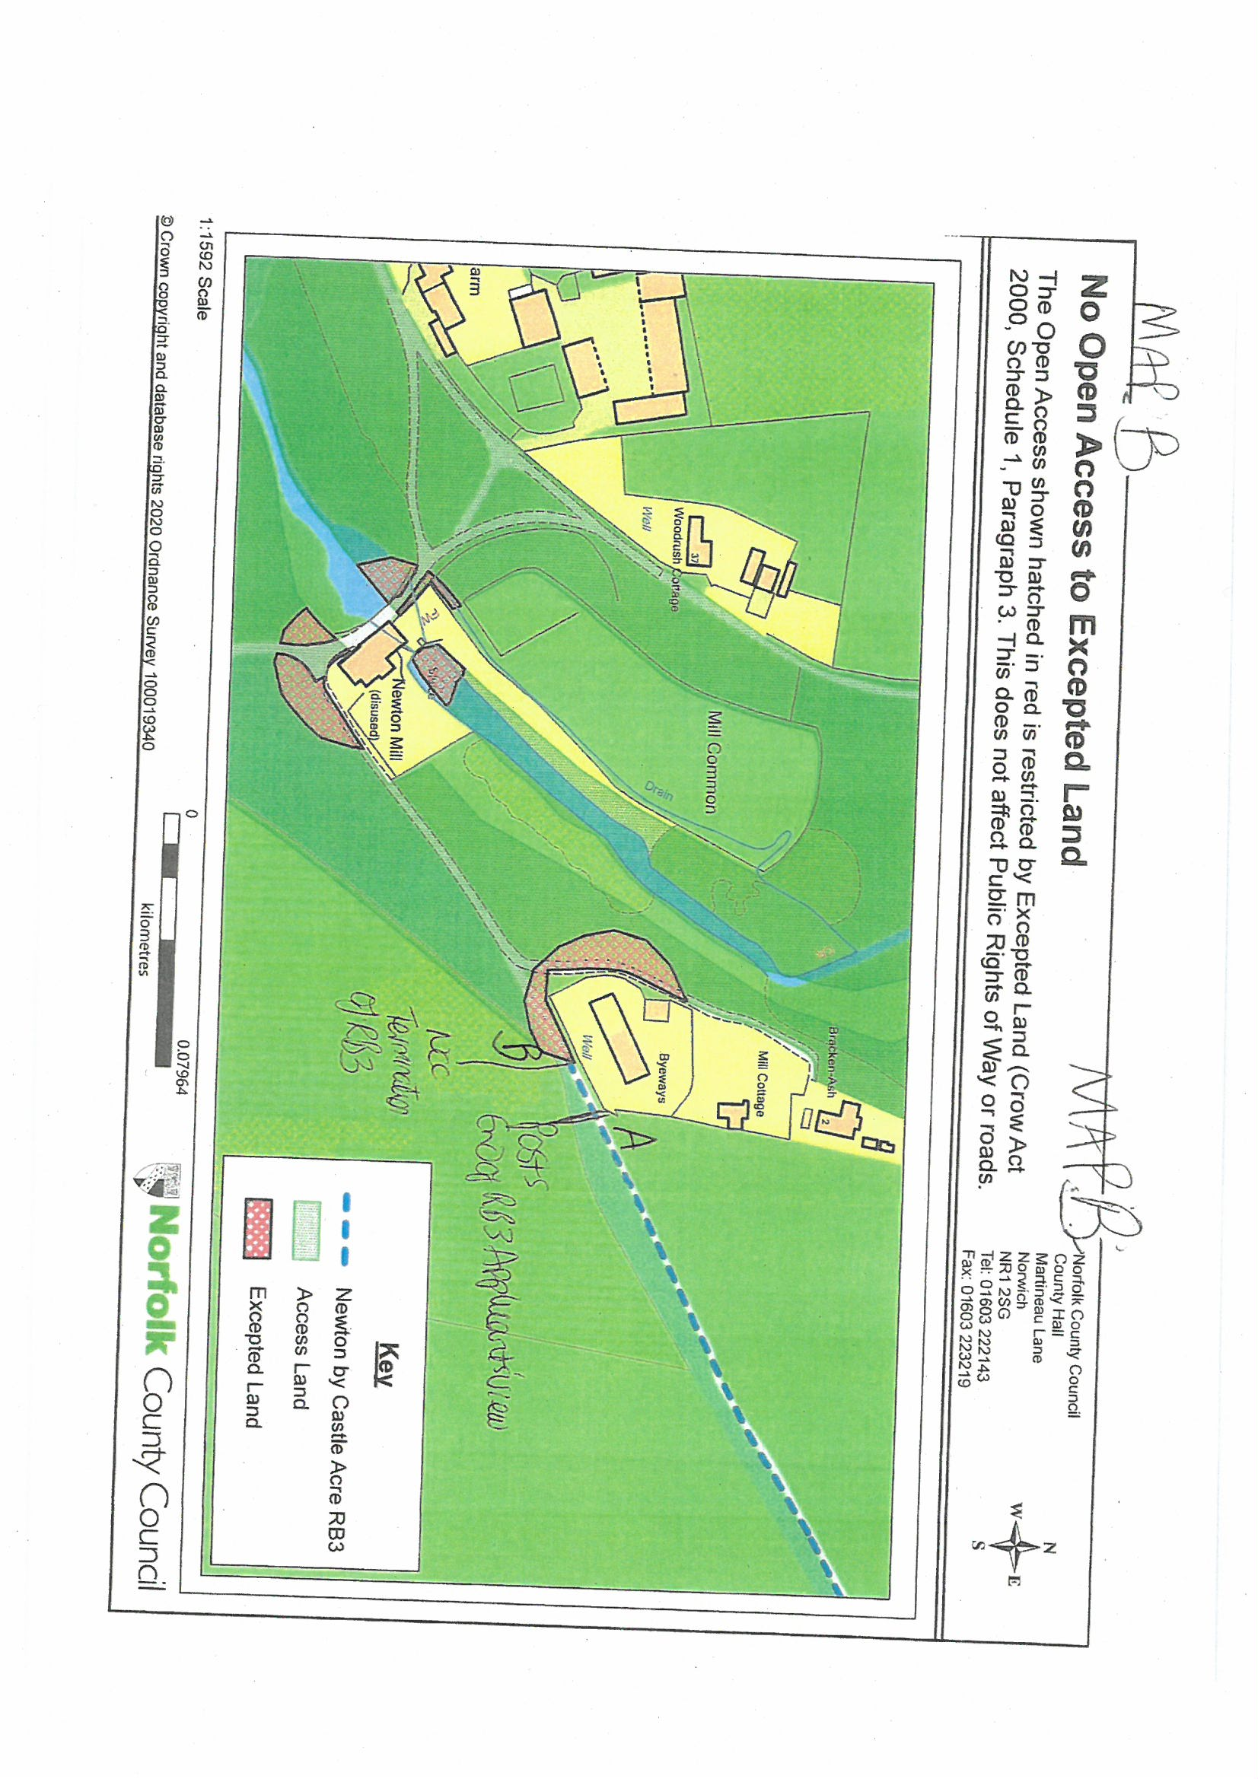

Trevelyan v Secretary of State for Environment, Transport and the Regions [2001] EWCA Civ 266
[2005] EWHC 119 (Admin)

