Application Decision
by Mr W Johnson BA(Hons) DipTP DipUDR MRTPI
an Inspector appointed by the Secretary of State for Environment, Food and Rural Affairs
Decision date: 18 August 2022

Application Ref: COM/3274101
Wellow Common, Wellow, NG22 0EJ
Register Unit No: CL29
Commons Registration Authority (CRA): Nottingham County Council
- The application, dated 29 April 2021, is made under Section 38 of the Commons Act 2006 (the 2006 Act) for consent to carry out restricted works on common land
- The application is made by Ms Gair Kettles
- The works comprise the installation of a sealed and bound material to entrance track (Tarmac)

Decision
- Consent is granted for the proposed works in accordance with the application dated 29 April 2021, subject to the following conditions:

1) The works shall begin no later than 3 years from the date of this decision.

2) The development hereby permitted shall be carried out in strict accordance with the following approved plans: DWG no. 01, dated May 2022 and DWG no. 02, dated May 2022.
- For identification purposes, a copy of the plan for the proposed works is attached to this decision.

Preliminary Matters
- I have had regard to Defra’s Common Land Consents Policy dated November 2015 in determining this application under Section 38, which has been published for the guidance of both the Planning Inspectorate and applicants. However, every application will be considered on its merits and a determination will depart from the policy if it appears appropriate to do so. In such cases, the decision will explain why it has departed from the policy.
- This application has been determined solely on the basis of written evidence and an unaccompanied site visit undertaken on 29 March 2022.
- I have taken account of the representations made by the CRA; Natural England (NE); the Open Spaces Society (OSS); Wellow Toftholders and Owner’s Association (WTOA) and Challenge Ltd. I have considered all submissions in reaching my decision on this application.
- I am required by section 39 of the 2006 Act to have regard to the following in determining this application:-

a. the interests of persons having rights in relation to, or occupying, the land (and in particular persons exercising rights of common over it);

b. the interests of the neighbourhood;

c. the public interest. (Section 39(2) of the 2006 Act provides that the public interest includes the public interest in; nature conservation; the conservation of the landscape; the protection of public rights of access to any area of land; and the protection of archaeological remains and features of historic interest); and

d. any other matter considered to be relevant.
- In general terms Section 38 of the 2006 Act prohibits the carrying out of certain restricted works on common land without the appropriate consent. Restricted works are defined as including the re-surfacing of land which may consist of “the laying of concrete, tarmacadam, coated roadstone or similar material on the land”.
- Any ownership issues are a private matter between the relevant parties and not within my jurisdiction on this application. However, the dispute between the applicant and the WTOA and Challenge Ltd is noted. Additionally, reference to a different scheme being developed by interested parties that includes a cattle grid is acknowledged, but the merits of such a proposal are not before me in this application.
- Revised plans by IBA Planning regarding the existing (DWG no. 01, dated May 2022) and proposed junction (DWG no. 02, dated May 2022) were received from the applicant on 30 May 2022, which give greater clarity to the proposal. Interested parties were given the opportunity to comment on the revised plans and any comments received, including those from additional interested parties were taken into consideration. Therefore, I will not prejudice any party by taking the revised plans into account in reaching my decision.

Reasons

The interests of those occupying or having rights over the land
- There are a number of registered rights recorded over the land as outlined on the Register, which include grazing. The application has been submitted following the grant of 2no. planning permissions for holiday accommodation and facilities (APP/B3030/W/20/3265677 and APP/B3030/W/20/3184203) dated 15 April 2021 and 26 June 2018 respectively (the appeal decisions). Whilst the works are required to satisfy conditions imposed on both planning permissions, I am satisfied that the works would also be in the interests of persons exercising rights of common over the land. Furthermore, I am satisfied that the development would not harm the interests of those occupying or having rights over the land.

The interests of the neighbourhood
- The interests of the neighbourhood test relate to whether the works will impact on the way the Common is used by local people. In general terms works should only be permitted if they maintain or improve the condition of the Common or where they confer some wider public benefit and are either temporary in duration or have no significant or lasting impact. The application area extends to some 35m² and comprises an existing access track off Newark Road (the A616) and a section of adjacent grassland.
- There is no definition within the 2006 Act of the term ‘neighbourhood’. The applicant submits that the principal aspect of the proposal affecting the neighbourhood would be the visual effect of the replacement of a limited area of grass with a paved surface but that this would be outweighed by the benefits accruing from the proposal.
- Whilst noting the objections to the development from the CRA, OSS and WTOA, in general terms any negative effects on the neighbourhood will have been taken into account when the planning applications were determined. Although, I accept that the projected visitor numbers estimated by the applicant may not have been before the respective Inspectors on the appeal decisions, I do not consider that this factor would be to the detriment of the Common.
- Additionally, there is little evidence to suggest that vehicular parking, including larger vehicles, with no legitimate right of access would be attracted to the Common through the approval of this application. Nonetheless, it appears to me that the benefits that will be derived by local people (and those living within the neighbourhood in particular) from the improvements to highway safety are a factor to be weighed in the balance when determining this application.

The public interest
- Section 39(2) of the 2006 Act provides that the public interest includes the public interest in; nature conservation; the conservation of the landscape; the protection of public rights of access to any area of land; and the protection of archaeological remains and features of historic interest.

Nature Conservation
- There is no evidence before me to indicate that the development harms nature conservation interests.

Landscape
- The works are situated in part of the Common has a very different character to the main area, and that, in essence, it constitutes an existing access and roadside verge in visual terms. The proposed road junction would be seen from within the Common, but the works for which consent is sought, especially the change of surface to tarmac, is unlikely to form a strident feature.
- The proposal already has planning permission through the approval of the appeal decisions. Nonetheless, the actual works for which consent is sought under Section 38 of the 2006 Act will have an impact on the landscape on this section of the Common, but widening the existing access and covering it with tarmac would not create a wholly incongruous feature. Additionally, being adjacent to an existing public road and no other ancillary works are to take place, such as street furniture, the overall effect would be limited.
- On balance, I accept there would be a change in the character of the Common at the point of the site as a consequence of the works proposed. However, I do not believe this would significantly affect the main area of the Common.

Public access
- Concern has been raised about an increased use of the track through the

implementation of the proposed works. I accept that there will be traffic generated by the appeal schemes, but find that there is little evidence to substantiate the view that significant unrelated traffic movements would occur. Overall, I consider that the development would not unacceptably restrict public rights of access or harm the interests of people from the neighbourhood wishing to use the Common.

Archaeological Remains and Features of Historic Interest
- There is no evidence to suggest that the development has an adverse effect on any archaeological remains or features of historic interest.

Conclusion
- I accept that the Defra Common Land Consents Policy implies that Section 38 of the 2006 Act is not the appropriate mechanism to grant consent for works of this nature. Although, the legislation itself does not preclude the granting of consent for the works proposed here under the provisions of Section 38. Furthermore, as noted in paragraph 3 above, every application is considered on its individual merits and a determination may depart from the policy if it is appropriate to do so.
- In other circumstances the policy arguments for rejecting this application may apply, However, I consider the factors listed above favour a departure from the published policy. I conclude that the proposed works will not seriously harm the interests set out in paragraph 6 above and will bring wider public benefits through improving highway safety and significantly lowering the risk of material being deposited on Newark Road. Thus, in this particular case I have concluded that an exception should be made and that the application should be granted.
- Consent is therefore granted for the works subject to the conditions set out in paragraph 1.

W Johnson

INSPECTOR

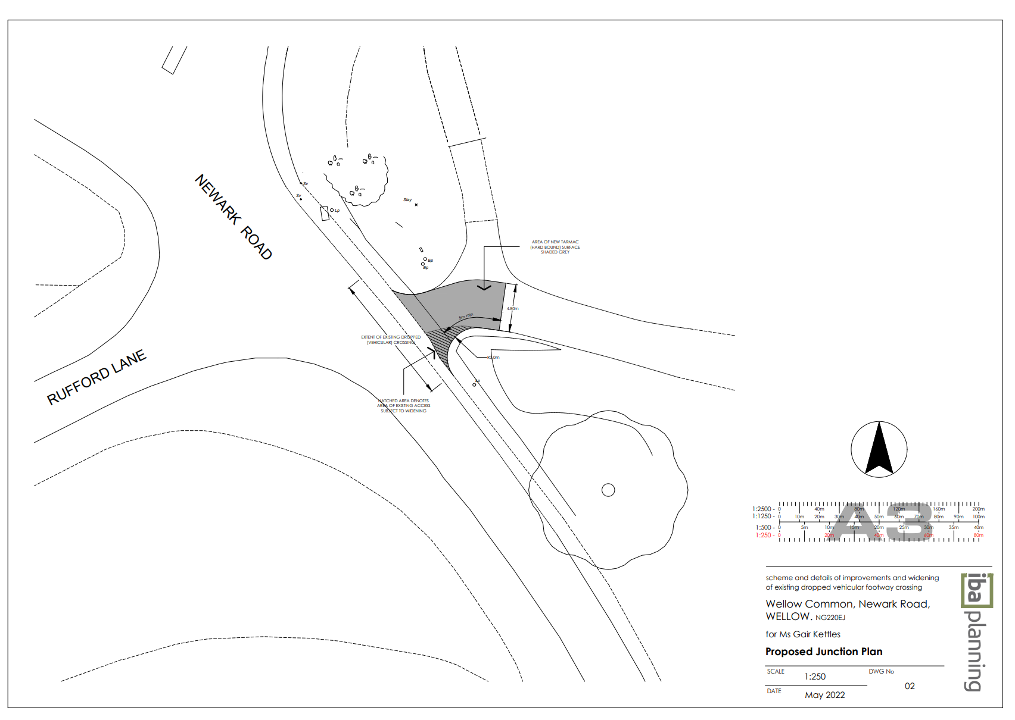
PLAN NOT TO ORIGINAL SCALE

