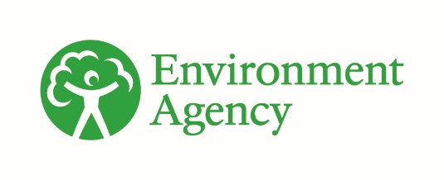


Drinking Water Protected Areas: challenges for the water environment
Date: June 2022

Contents

1. Background 3
2. The problem 3
3. Future challenges to meeting DrWPA objectives 18
4. Choices 22
5. References 27

1. Background

1.1 Relevance and accuracy of data
This document has been produced by bringing together the readily available information on the topic. Quality assurance of the information included so far is not complete. As a result the document may contain some errors or inaccuracies. Please let us know of any other relevant evidence or if you are aware of any issues with the information. This will help us to build a comprehensive and robust evidence base to underpin decision-making in river basin management planning.
All groundwater data are taken as correct on 7 October 2021. All surface water data are taken as correct on 28 June 2022.

2. The problem
We must protect our drinking supplies so they are not polluted, making them more resilient to future pressures and climate change. The rivers, lakes and groundwater that currently (or will in the future) supply more than 10m3 per day of water for human consumption, or serve more than 50 people, are identified as Drinking Water Protected Areas (DrWPAs). This includes public drinking water supplied by water companies to their customers and private water supplies for domestic dwellings or the food and drink industry.
The objectives for Drinking Water Protected Areas are:
- to ensure that, under the water treatment regime applied, the drinking water produced meets the requirements of the Water Supply (Water Quality) Regulations 2016
- to ensure the necessary protection of the supply by avoiding deterioration in water quality to reduce the level of purification treatment required in producing drinking water
- for groundwater, to meet good chemical status and reverse upward trends in pollution
Meeting the requirements of the Water Supply (Water Quality) Regulations 2016 is regulated by the Drinking Water Inspectorate (DWI). In England in 2019, the DWI reported that the quality of public water supplies was very high, with only 0.04% of tests failing to meet standards. However, the quality of private water supplies remains a concern, with 3.4% of tests failing to standards in 2019.
Significant investment has been made by water companies through their customers' bills to remove pollutants and meet the standards. The DWI Chief Inspector’s letter to Ministers in July 2020 set out that clean drinking water is “ever more important in the face of significant challenges to drinking water supplies, from the impacts of climate change, and on the quality and availability of water resources, as well as more recently infectious disease such as CoViD-19”. Risks considered tolerable now may not be so in years to come as environmental challenges and resource pressure increase.
Protecting supplies by avoiding deterioration in water quality and, for groundwater, reversing upward trends in pollution requires pollution to be prevented from entering the environment. This, in turn reduces the need for expensive and unsustainable treatment. Understanding the risks posed to drinking water sources in a catchment is a central part of the World Health Organisation’s water safety planning approach. Investing in collaborative catchment management reducing pollution at source is a more cost-effective approach than removing the pollutants or blending with clean water.

2.1 England's drinking water sources
In England around 30% of drinking water sources are from groundwater and 70% from surface water. However, in the south-east, nearly 100% of drinking water supplies are from groundwater. Figure 1 shows that the north-east, north-west, Wales, Cornwall and Devon had 0% of its deployable output made up of groundwater in 2015. Other parts of the south-west and south-east had 100%. The east and midlands had between 25 and 75% (see Figure 1).

Figure 1: Groundwater as a percentage of water companies' deployable output, 2015 (BGS, 2019). Contains British Geological Survey materials, UKRI 2021
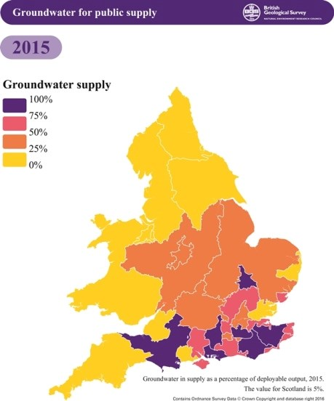
All groundwater in England contain boreholes, wells or springs cumulatively abstracting more than 10 m3/day. As a result all 271 groundwater bodies in England are identified as DrWPAs covering 86% of England.
There are 450 (10%) surface waters (lakes, rivers and canals) identified as DrWPAs.

2.2 Pressures on drinking water sources
Many drinking water sources are deteriorating because of pollution from nutrients, chemicals or micro-organisms. This can be exacerbated by pressure from future development, population growth and climate change. Nitrate is a continuing concern in many groundwater bodies and will continue to be for decades. Chemicals in groundwater such as pesticides, solvents, plasticisers and industrial chemicals are emerging issues.
DrWPAs are ‘at risk’ when the quality of water abstracted does not, or is unlikely to meet, one or more of the objectives set out above. Across England 240 of the 450 (53%) surface water DrWPAs at ‘at risk’. A DrWPA can be ‘at risk’ for one or more reasons.
Figure 2 shows the broad categories why surface water DrWPAs are ‘at risk’ in each river basin district:
- pesticides
- nutrients – nitrogen compounds
- nutrients – algae related
- sediment and colour – including turbidity, dissolved organic carbon (DOC), total organic carbon (TOC) and colour
- ‘other’ – including cryptosporidium and manganese
The Dee RBD has no surface water DrWPAs and is therefore not included.
Humber has the highest number of DrWPAs at risk at just under 70, followed by the north-west at 60. Anglian and the south-west are both around 30, with the south-east, Thames and Severn regions between 10 and 20. Northumbria and Solway Tweed both have below 10.
Regionally, sediment and colour are responsible for the highest numbers of at risk DrWPAs in the north-west and Humber regions (47 and 32 areas, respectively). Overall, amongst all the causes of surface water DrWPA risks, pesticides are most frequently listed, with the most areas at risk being recorded in the Anglian region (31).
Of the 271 groundwater DrWPAs 175 (65%) contain safeguard zones. Over a quarter of groundwater bodies (71 of the 271, 26%) are not meeting good chemical status because the water quality in DrWPAs is deteriorating, and almost all of these have an upward trend in pollution. There is no equivalent status requirement for surface water bodies.
Figure 3 shows the broad categories why groundwater DrWPAs are not meeting good status in each river basin district:
- nutrients – nitrogen compounds
- nutrients – phosphate
- pesticides
- solvents
- metals/metaloid
- ‘other’
South-west and Thames had the greatest number of groundwater DrWPAs at poor chemical status at just over 30 and 40 respectively. Metals/metalloids and nutrients – nitrogen compounds were identified as responsible in both regions. Nutrients – nitrogen was also responsible for most poor chemical status areas in the south-east.

Figure 2: Reason for surface water DrWPAs being ‘at risk’ grouped by substance type and river basin district.

Figure 3: Reasons groundwater DrWPAs are classed at poor chemical status grouped by substance type and river basin district
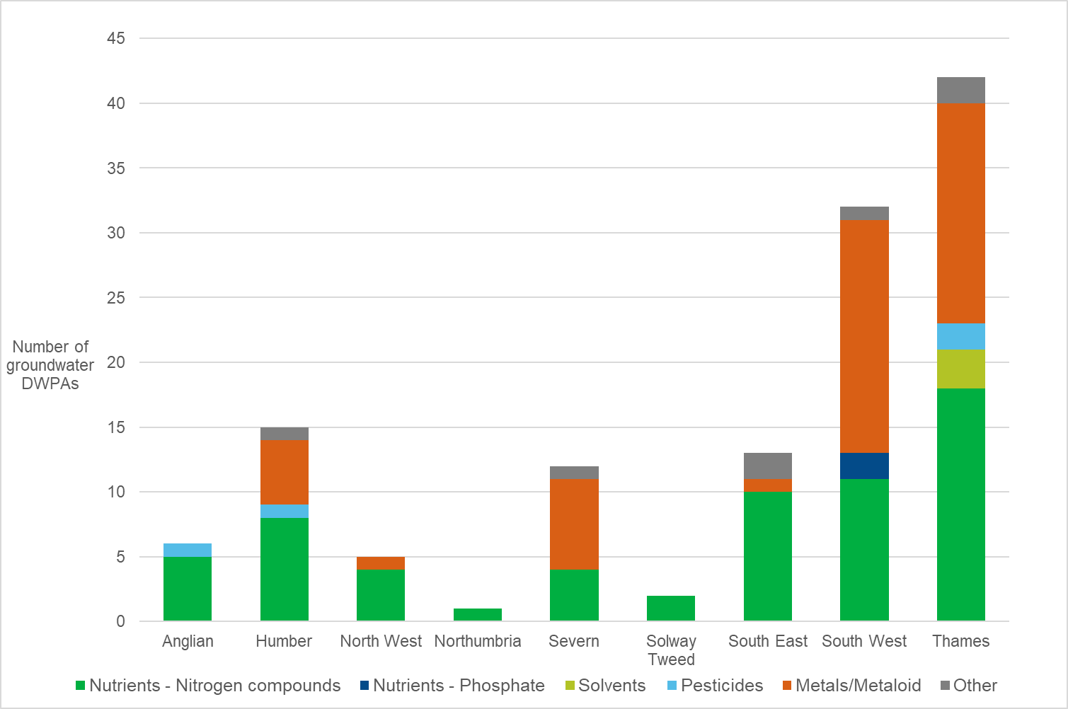
Where a DrWPA is at risk, a non-statutory safeguard zone (SgZ) is established identifying the catchment area where land use practices are most likely to be causing, or have caused, water quality in the DrWPA to deteriorate. Safeguard zones focus pollution prevention and regulatory actions where they are most needed.
There are 148 surface water SgZs and 251 groundwater SgZs in England. A SgZ can be identified for one or more reasons. Figure 4 shows the main reasons for identifying a SgZ. Pesticides, algal related issues and sediment or colour dominate for surface waters, whilst nutrients in the form of nitrogen compounds dominate for groundwaters.

Figure 4: Reasons for safeguard zone implementation

An interactive map showing groundwater and surface water SgZs is also available.

2.3 Nitrate
High levels of nitrate are a concern in drinking water resources and supplies. The World Health Organisation standard for nitrate is below 50 mg/l. This is equivalent to 11.3 mg/l as nitrogen at the tap.
In England there are 11 surface water DrWPAs where water quality is deteriorating due to the presence of high nitrate or ammoniacal nitrogen. There are 63 groundwater DrWPAs at poor chemical status for nitrogen compounds – 60 DrWPAs as a result of nitrate and 3 for ammoniacal nitrogen. There are 223 SgZs established to reduce nitrate concentrations in groundwater (see figure 5).
Removing nitrate from drinking water is expensive. "The installation cost of a nitrate removal plant at a groundwater source can be around £8 million, and £250,000 to run annually”.
Nitrate in groundwater comes from a variety of sources. Modelling shows in rural areas in the UK, more than 80% of nitrate in groundwater may come from agricultural practices. Data from ADAS, based on farming activities in 2010, shows that the nitrate concentrations in water that leaches from soils, contributing to aquifer recharge and river base flow, is close to or above the safe drinking water nitrate concentration in many parts of England. However, there can be significant additional input from aerial deposition and industry.

Figure 5: Nitrogen issues in groundwater bodies

Historic overuse of artificial fertiliser has led to nitrate pollution in many of our groundwater sources9. Some of that nitrate is trapped between tiny pores in the rock and slowly works its way through the unsaturated rock to groundwater. It can take up to 60 years for peak concentrations to be detected at the water table. Concentrations now reflect current and historic practices. The lag time for peak concentration to reach groundwater is often referred to as the ‘nitrate time bomb’.
The historic nitrate cannot be practically removed from groundwater. However, we can stop further deterioration from our current activities by limiting the nitrate lost to the environment so it does not breach 50 mg/l (as NO3). Fertiliser applications to land have reduced slightly since the 1990s, however the nitrate concentrations leaching to groundwater are often still in excess of the drinking water standard. Fertiliser application rates recommended within Nitrate Vulnerable Zones (NVZs) are the optimal for the crop rather than meeting the environmental or drinking water standard, so there is a choice to make, or challenge to be met, if we are to achieve optimal crop yield and drinking water standards.
Local work to apportion sources of nitrate confirms that agriculture is the dominant source of nitrate in groundwater. For example, studies in 3 public water supply catchments in East Anglia demonstrated that agriculture was responsible for 74%, 94% and 95% of the nitrate in the water9.
Recent modelling work indicates a mixed picture for peak nitrate concentrations across UK aquifers (that is, rocks which are good at storing water). The modelling has shown that the year peak nitrate concentrations are expected to occur varies greatly between different aquifers. For example, the Jurassic limestone in the Cotswolds peaked in 1994, whereas the chalk in Yorkshire will not peak until 2078. Any delay in peak nitrate concentrations needs to be considered in our response to managing these aquifers.
The modelling study also showed there were slightly more aquifers with increasing trends rather than decreasing trends. As fertiliser inputs have reduced since around 1990 it is hoped that there will be more aquifers with decreasing trends in the future. Our most recent borehole monitoring also shows a mixed picture with respect to nitrate concentrations over much of England, with slightly more increasing trends compared to decreasing. Against this mixed picture a significant number of boreholes still show exceedances of nitrate standards (50 mg/l) in groundwater.
Nitrate Vulnerable Zones are designated under the Nitrates Pollution Prevention Regulations (2015) to prevent nitrate pollution arising from agriculture. The NVZ action programme contains measures to reduce nitrogen losses from farmland, including controls on fertiliser application to reduce leaching from soils.
Johnson and Lord (2011) found that since NVZs were introduced, within them there was a very gradual reduction in the total nitrogen applied by farming overall. However, the reduction was judged to be mostly influenced by reductions in managed grasslands due to the greater restrictions on fertiliser inputs introduced as part of the NVZ expansion in 2002 and reduced livestock densities. In the arable sector there was no significant reduction in net nitrogen balance where fertiliser nitrogen inputs and yields per hectare of individual crops were noted to have changed little since NVZ inception. As a result, between 1990 and 2009 nitrogen balance remained largely stable for all harvest crops including grassland.
A small gradual reduction in manufactured fertiliser has been identified in the livestock sector which has been offset by increased manure use, and there appears to have no substantial change in the arable sector. Estimates of the effectiveness of NVZs (based on the 2002 programme), put the overall national reduction of nitrate lost to the water environment in NVZs as between 2 and 7%. Additional measures to meet DrWPA objectives often need to go beyond NVZ requirements to protect drinking water quality from further deterioration.
Whilst public supplies have robust systems in place to ensure that the nitrate standard is not exceeded at consumers’ taps, this may not be the case for private supplies. Of 7,229 private supply samples analysed for nitrate at consumers’ taps in England in 2019, 7.5% exceeded the limit2. Many of these supplies are in rural areas away from public mains supplies. Whilst there is a downward trend in nitrate failures it is suspected that this is due to a combination of improved treatment and enforcement rather than local improvements in water quality, which goes against the aim to reduce treatment.
Nitrate concentrations in groundwater can be affected by leakage from public mains water supplies. Although the nitrate concentration in public main water leakage is always below the drinking water limit, it contributes significantly to the nitrogen loading, particularly in urban areas. The amount of nitrogen released to groundwater through this route is expected to increase in coming years as a result of greater use of treated water transfers. Nitrates, which are frequently present due to sewage contamination or agricultural runoff, are best managed by protecting the source water from contamination.
Nitrate concentrations in groundwater are expected to continue to deteriorate between now and 2050 unless interventions are taken. Climate change and population growth will also need to be mitigated.
Further information on nitrates can be found in the nitrate challenge report which includes details of the standards, obligations and measures relevant to nitrates.

2.4 Algae
Algae naturally grow in slow moving or standing water such as lakes and reservoirs. Algal growth depends on the supply of available nutrients, sunlight, water movement, retention time (or flushing rate), and temperature. Phosphorus entering the environment through sewage effluent or agricultural runoff is the main nutrient causing algae and plants to grow excessively in freshwaters (eutrophication). In some lakes and reservoirs nitrogen can also be important.
Excess plant and algal growth affects the quality of the raw water. It can have physical impacts on treatment through clogging of filters as well as causing taste and odour problems. Some algae are toxic to people and animals.
Excess nutrients that contribute to algal growth or eutrophication can impact the ecological status of waterbodies. Measures to address algal problems aim to reduce nutrient loading and manage water movement within the water body or reservoir.
Algae impact 42 lake and reservoir DrWPAs and 17 river DrWPAs. Algae are not a concern in groundwater DrWPAs. There are 40 surface water Safeguard Zones targeting measures to address algal impacts.
Algal impacts can be through elevated counts of total algae, green algae (chlorophyll) or blue green algae. The formation of the organic compounds – geosmin or 2-methylisoborneol – as a result of algal growth can result in taste and odour issues (Figure 6).

Figure 6: Number of 'at risk' surface water DrWPAs due to algal impacts

Further information can be found in the phosphorus and nitrate challenge reports.

2.5 Colour
Dissolved organic carbon (DOC) released from organic soils and vegetation increases colour in water supplies from upland catchment areas particularly in catchments dominated by peat soils. Water draining from upland catchments is often peaty (brownish) in colour. It feeds into streams, rivers and many upland reservoirs used to supply drinking water. Damaged peat landscapes are more readily washed away increasing the problem and cost of removing colour from water supplies.
This deteriorating trend is causing 89 surface water DrWPAs to be 'at risk' of not meeting DrWPA objectives. Deterioration in colour is not evident in groundwater.
Elevated levels of DOC can interfere with the effectiveness of disinfection processes at water treatment works and cause disinfection by-products, such as trihalomethanes (THM) to occur. The presence of DOC in the final treated water can increase the potential for bacterial growth in the water distribution system.
Chlorine is an essential part of the water treatment process. To limit the potential for THM production there are limits for the level of colour that can be present in the water before chlorine is added in the treatment process.
A range of factors are thought to contribute to DOC levels. When the surface layer of peat bogs dry out, conditions change from anaerobic to aerobic allowing aerobic bacteria to breakdown peat, resulting in an increase in colour generation. Areas of deeper peat appear to generate higher colour levels.
Land management activities altering the natural hydrological balance of peatlands producing drier conditions in the peat, will potentially lead to increased colour levels from peat erosion. Drainage, heather burning to promote sheep and grouse production, overgrazing, wildfires and recreational access are all factors to consider.
Aerial pollution from road traffic and power stations can also cause significant damage to peatlands. Sulphur deposition, which increases the acidity of peatlands, is thought to increase colour by allowing bacteria to grow that generate DOC. Aerial deposition of nitrogen is also a potential issue. Climate change and variation in weather conditions are also becoming increasingly important.
Peatland restoration can help improve ecosystem services, such as biodiversity, carbon storage, and water quality and quantity. Reducing the rate of surface runoff may, in localised areas, lead to a reduction in flood risk, as well as reducing soil erosion and any resulting build-up of sediment downstream.

2.6 Turbidity
Turbidity is the amount of suspended sediment, or particulate, in water. Low levels of turbidity are important to avoid particulate in drinking water and to prevent micro-organisms attaching to these particulates and shielding from disinfection treatment. Land uses such as mining, quarrying and agriculture, that disturb the ground, can cause fine particles to mix with water. Sediment is transported to rivers and into groundwater from land uses that disturb sediment and increase the speed of water movement in the catchment. Heavy rainfall can accelerate this process increasing surface water run-off and increasing the amount of sediment and other pollutants the run-off carries. Land uses that slow water, encourage infiltration, reduce soil compaction and prevent gully formation are less likely to cause turbidity problems for drinking water sources.
More information can be found in the fine sediment challenge report.

2.7 Chemicals
Chemicals enter the water environment through our day-to-day activities including what we put down the drain, spray in our gardens, apply to agricultural land, as well as from historic pollution and industrial land uses.
Chemicals including pesticides, herbicides, solvents and fungicides impact the quality of drinking water sources. Increased levels of expensive purification treatment, using raw materials and energy, are often needed before the water reaches our taps.
Figure 7 shows that 96 groundwater bodies, equating to 35%, were classified as poor chemical status in the 2019 classifications.

Figure 7: Groundwater DrWPA chemical status results (2019 classification)

There are a number of emerging chemicals in groundwater which have potential to affect long term quality and lead to an increased need to treat our drinking water sources. These include bentazone, butanedioic acid, caffeine, diethylhexyl phthalate (DEHP) and perfluorooctanesulfonic acid (PFOS).
The Chemicals Investigation Programme (CIP) is the UK water industry’s response to current and emerging legislation on chemicals in the water environment. It brings together the water and wastewater companies in England and Wales with the various regulators in a collaborative programme.
The current phase (2015 to 2020), known as CIP2, is a substantial project to prioritise substances of potential concern and to determine the concentrations of these substances in wastewater. Over 600 sewage treatment plants have been sampled covering 74 substances including metals, industrial chemicals such as fire retardants and biocides, hydrocarbons, pharmaceuticals, hormones and personal care products. Investigations of treatment processes and river catchment-wide assessments are also included. This work will help to safeguard drinking water supplies from emerging chemicals. More information can be found in the chemicals in the water environment report.
Solvents, including trichloroethene and tetrachloroethene, have been identified in 16 groundwater SgZs. Solvents are often associated with historic pollution incidents or previously contaminative land uses such as metal degreasing and dry cleaning. Plumes can travel long distances in groundwater affecting abstractions many miles away. There are also a number of historic land contamination issues which affect drinking water sources. Remediation by land owners, polluters or local authorities will be key to preventing further deterioration from substances such as solvents.
The Water Supply (Water Quality) Regulations 2016 requires that no individual pesticide is present in tap water above 0.1 µg/l, and that total pesticide concentrations are not above 0.5 µg/l. In surface water DrWPAs impacted by pesticides, the largest concern is metaldehyde (used in slug pellets), and a small group of herbicides predominantly used on oil seed rape, cereals and grassland. Concentrations of these pesticides peak in surface waters at times of the year coinciding with their use and increased rainfall encouraging runoff. Higher risk catchments include those where land drainage is required (for example catchments with heavier clay soils), catchments with thin, sandy or stony soils overlying chalk, limestone or sandstone, and where there is predominance of certain crops which require the use of 'hard to treat' pesticides.
Pesticides are the largest reason for surface water DrWPAs being 'at risk' of not meeting DrWPA objectives in England, with 125 surface water DrWPAs ‘at risk’ for one or more pesticides in 2022. Figure 8 shows the frequency certain pesticides at assessed as ‘at risk’ in surface water DrWPAs: metaldehyde (110), propyzamide (39), MCPA (35), carbetamide (34), total pestcides (26), mecoprop (24), clopyralid (17) and quinmerac (12) are the key pesticides of concern.
Pesticides are found to a lesser extent in groundwater though their presence is an indication of long-term pollution and they are unlikely to degrade. Of the 79 groundwater DrWPA water bodies, 2 are classified as poor chemical status due to the presence of pesticides.

Figure 8: Surface water DrWPAs ‘at risk’ from individual pesticides
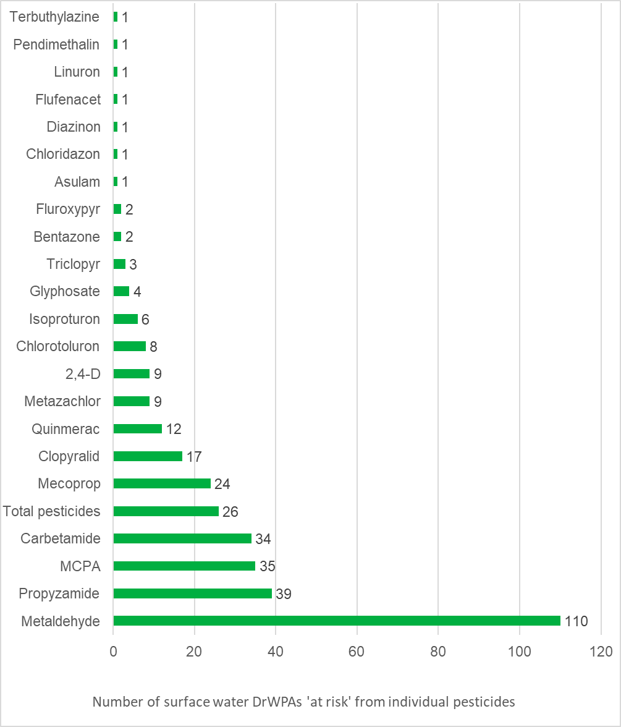

Figure 9: Number of groundwater DrWPAs and associated Safeguard Zones established for individual pesticides
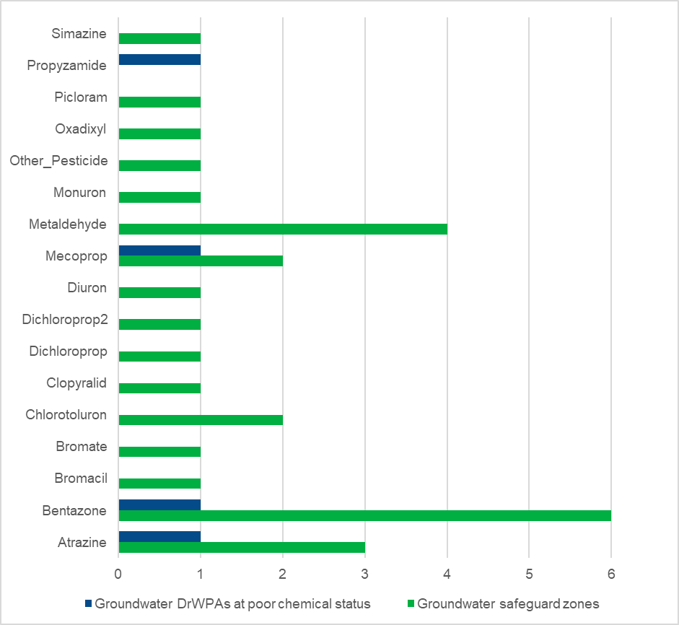
The Voluntary Initiative (VI) promotes best practice regarding the use of most oilseed rape herbicides, with the exception of propyzamide, which continues to be problematic due to application timing and the requirement to apply at the correct growth stage of the target weed (usually mid-winter). The VI is looking at other product groups associated with specific crops to enable better stewardship opportunities. Further information can be found in the chemicals in the water environment report.

2.8 Microbiology
Cryptosporidium is a protozoan parasite found in water contaminated by both human and animal wastes. Catchment sources include sewage works, farms, soil run-off, drainage and livestock using or crossing watercourses. There is no DWD standard for cryptosporidium at the tap as the safe limit is regarded as zero.
There are 6 surface water DrWPAs 'at risk' for cryptosporidium and 3 groundwater Safeguard zones. Cryptosporidium is managed through catchment management measures and investigations to remove the pathway of contaminated water within the catchments.
Microbiological contaminants can also impact groundwater abstractions and are potentially very serious as there is potential to impact public health. There are 3 groundwater safeguard zones for coliforms, however, as these microbes are not substances, it is not possible to issue an environmental permit to control them directly. Defra are working towards changing the legislation so that this activity can be controlled under an environmental permit. In the meantime, other limited controls are available such as using an anti-pollution works notice and the precautionary principle which restricts risky activities in Source Protection Zones around drinking water abstractions.
Private water supplies may be contaminated with harmful pathogens if the borehole headworks are not sealed properly, there is ingress of surface water or access to spring sources allowing water sources to be contaminated by faecal matter. A key source of faecal contamination for private supplies is from nearby septic tanks. If a septic tank is within 50m of the private supply an environmental permit is required and good practice followed to avoid microbiological contamination of groundwater.
In 2019, of the 12,890 samples for Escherichia coli (E. coli) taken, 5.4 % failed the standard, and of the 7,201 samples for enterococci 6.6% failed the standard2. The DWI note the 2019 testing shows that despite an overall improvement over previous years private supplies continue to be of unsafe microbiological quality.

2.9 Manganese
Four surface water DrWPAs and 16 groundwater DrWPAs are affected by manganese. Sources of manganese tend to be from natural sources in surrounding catchments and mobilisation can depend on the (acidic) pH of upland soils. Water company investigations are looking into the sources and pathways of manganese and whether catchment management is appropriate.

3. Future challenges to meeting DrWPA objectives
A Green Future: Our 25 Year Plan to Improve the Environment, sets out under ‘clean and plentiful water’ an aim of ‘reaching or exceeding objectives for rivers, lakes, coastal and ground waters, that are specially protected, whether for biodiversity or drinking water as per our River Basin Management Plans’.
Solving the problems affecting our drinking water sources and moving towards cleaner, more sustainable sources, challenges us to reduce our impact on the environment. In some cases, such as land contamination, remediation to reverse the damage done by previous generations may be needed.
Reducing our impact on the environment can be challenging but we can make choices about how we live and have a positive impact on the quality of our drinking water sources. We need them to support life.

3.1 Education
Improving our knowledge and understanding of the water cycle, the source-pathway-receptor approach of pollutants, effective pollution prevention measures will protect water sources.
Relying on expensive but effective water supply treatment often means wholesome drinking water is taken for granted or is the responsibility of someone else. Protecting drinking water sources is not always considered a key priority for planners, businesses or the public. This needs to change

3.2 Competing priorities
Competing priorities and goals can make reaching a common understanding of catchment issues and improving drinking water sources challenging. Safeguard zone action plans set out catchment actions and schemes, agreed with partners, required to protect drinking water supplies. There are challenges in completing catchment actions. For example, short term or differing funding mechanisms may hinder long term progress and success of catchment schemes, particularly for groundwater where a sustained effort is needed over many decades to reduce nitrate and pesticide concentrations. We want to make sure funding for long-term solutions is maintained.

3.3 Evidence
We need to be able to separate short-term pollution incidents from longer term activities causing deteriorating trends as well as from historic activities. There is a monitoring network in place using both our data as well as that provided to the DWI to identify where raw water quality concerns arise and evidence gaps are identified.
Third party data is often collected for different purposes or legislative drivers and there be restrictions on sharing due to commercial or other sensitivities. This can make comparisons between datasets, coming to a common understanding of the catchment, agreeing a common goal and sharing data between parties difficult, hindering progress in improving drinking water sources. Maximising the use of all evidence available would improve decision making and strengthen investment decisions. The current approach for sharing data could be improved by greater openness and improved working across organisations to agree common goals.

3.4 Private drinking water supplies
Whilst the majority of environmental information available in DrWPAs is from public water supplies, our understanding of smaller private water supplies is improving. Local councils are the lead authorities for private water supplies, with the DWI providing technical advice and support. We work with these authorities to identify environmental risks that could affect private supplies, to raise awareness of what to do should a pollution incident occur at or near a private water supply, and to clarify environmental permitting and licensing requirements for activities affecting private water supplies. This supports the local councils risk assessments and decision making as regulators for private supplies.
The British Geological Survey must be notified of boreholes drilled to a depth of 15 m or more for water supply purposes. Abstractions greater than 20m3 per day need an abstraction licence from the Environment Agency. We recommend the local authority are notified if an abstraction is used for a private water supply.
Surface water bodies from which private water supplies are abstracted at more than 10 m3 per day, or serving more than 50 people, should be identified as a DrWPA. As all groundwater bodies are DrWPAs, and the majority of private supplies are from groundwater, we do not expect a significant number of additional new DrWPAs to be identified.
Measures to improve DrWPAs form part of the ‘programme of measures’ in the river basin management plans. Measures can cover large areas of land benefitting multiple private and public supplies and could be used to support local authorities when assessing environmental risks to private water supplies.
See the:
- Groundwater Safeguard Zone Action Plans
- Surface water Safeguard Zone Action Plans
Whilst the Environment Agency is the competent authority for meeting the DrWPA objectives we hold limited information on the location and quality of private water supplies. This is partially due to the way legislation is written to protect personal data of private supply owners. This can result in decisions being made with limited evidence, a lack of environmental protection around those supplies, and potentially expensive increases in treatment for supply owners.
Work needs to be done in partnership with Defra, the DWI, well drillers, supply owners and local authorities towards improving water quality for private supplies. However, without data on their quality or location a common goal of improving raw water quality becomes harder to achieve. Over the coming years we want to improve the way we share appropriate data, identify any further DrWPAs and SgZs, and improve environmental protection for private drinking water supplies.

3.5 Continued change and lag times
The range of substances posing risks to drinking water will change over time as the environment, society and the economy change. Risk assessment and implementing pollution prevention measures will remain an ongoing process. The environmental response time for measures to improve raw water quality can take years or even decades. Safeguard zone action plans will remain a key mechanism to improve raw water quality as we develop our understanding of the success of the measures for different pollutants.
The European Drinking Water Directive has been published in the European Official Journals. Decisions on how this text may influence how drinking water is managed in the UK are not yet known.
Nitrate already within the ground will continue to drain to the water table for many decades. It will therefore not be possible to predict with accuracy, when peak concentrations of nitrate will occur in groundwater and poses difficulties in ensuring current activities don't cause deterioration.

3.6 Population growth
Over the next 25 years the population will have grown by 10 million. More people will live in urban areas. A growing population and smaller family units will mean that the number of households is forecast to increase by 23%. This scale of growth has significant implications for protecting the quality of drinking water sources especially when combined with the challenges of climate change.

3.7 Climate change
The Climate Change Impacts and Adaptation (2018) report highlights that the climate is changing and will continue to do so. UK Climate Change projections (UKCP18) suggest that hotter drier summers, milder wetter winters, rising sea levels and more extreme weather events are expected. As atmospheric temperatures rise so will river temperatures. Rainfall patterns are likely to change – winter rainfall is likely to occur in heavy events whilst summer rainfall is likely to decrease. The trend of more intense rainfall events is expected to continue.
The water environment is already under considerable pressure from a range of human activities and a growing population. Climate change adds to this pressure through changes to river flow, groundwater recharge and water temperatures. The impact of climate change on groundwater quality is highly uncertain. A study by Stuart et al 2011 found that the implications for nitrate leaching to groundwater as a result of climate changes are not yet well enough understood to be able to make useful predictions without more site-specific data. The few studies which address the whole cycle show likely changes in nitrate leaching ranging from limited increases to a possible doubling of aquifer concentrations by 2100. These changes may be masked by nitrate reductions from improved agricultural practices, but a range of adaption measures need to be identified. Future impact may also be driven by economic responses to climate change.
Decreasing summer river flows will increase the variation in river and reservoir water quality and bring about an increased use of additional treatment at water treatment works for algae related nutrient issues, concentrated levels of chemicals in rivers, and will inevitably impact on the river's ability to support healthy aquatic ecosystems. The frequency of heavier rainfall events will increase pollutant runoff from land to water and increase storm discharges from sewage outfalls.
Adaptation is important to protect the quality of water bodies against climate change impact. For example, water companies will have to work closely with the Environment Agency, land managers and other catchment partners to identify what measures are needed to adapt to climate change building resilience in the quality and quantity of natural drinking water sources.
More information can be found in the climate change challenge report.

4. Choices
A range of organisations are involved in designing, promoting, supporting and delivering measures to improve raw water quality, including water companies, the crop protection sector, farmers, agronomists, trade bodies, manufacturers, voluntary organisations and government bodies.
There are choices in how we meet DrWPA objectives. A range of voluntary measures with targeted enforcement are the chosen way to meet the objectives. There is scope, however, for altering the measures and mechanisms used to prevent or limit the amount of pollution. Greater industry and societal ownership of drinking water sources may be crucial to make change happen.

4.1 Current measures
This section describes the current measures available to improve raw quality and the choices we have to secure a sustainable future for our drinking water supplies.
During the third river basin management cycle, further evidence will be gathered improving our understanding of pollutant sources and pathways impacting raw water quality. We work with the water industry, manufacturers and the agricultural sector to deliver various pollution prevention approaches. They are encouraged to understand the fate, transport and impact of their products on the environment, develop best practice guidelines to protect the environment, and undertake voluntary and catchment-based initiatives to protect drinking water resources.

4.2 Statutory water industry measures
Water companies deliver a significant proportion of measures for both surface and groundwater SgZ action plans. Their commitment to preventing deterioration and improving the quality of raw water is vital.
The Water Industry's National Environment Programme sets a legal obligation on water companies to complete catchment measures to prevent further deterioration and improve raw water quality within SgZs. Between 2020 and 2025, water companies will complete:
- 29 measures to improve the quality of water abstracted from the environment – all of these will improve nitrate in groundwater and 7 will also to improve microbial quality – these measures are estimated to improve of a licensed abstraction volume of 49,636 Ml/day
- 236 measures to prevent deterioration of abstracted potable water quality – these measures are estimated to prevent deterioration of a licensed abstraction volume of 3,894,736 Ml/day
- 77 investigations into why raw water quality is deteriorating resulting in recommendations for measures
Indicative costs for these measures and investigations are £95 million to £115 million. This equates to 1.9 to 2.3% of the indicative capital costs (£4.9 billion) that companies will spend between 2020 and 25. Between 2015 and 2020 approximately £69 million was allocated to water companies to implement 170 DrWPA measures identified in safeguard zones.
More information can be found in the water industry challenge report.

4.3 Private water supply measures
Local authorities are the lead regulator for private supplies.
Individual, and proliferation of, non-mains sewerage systems can lead to pollution, particularly for private water supplies. Where a septic tank is within 50m of a private supply or in a source protection zone 1, it must have an environmental permit to ensure the system will not pollute a private supply. Small package treatment plants and septic tank owners are responsible for ensuring they meet general binding rules, and if not apply for a permit. There’s guidance on permits you need for septic tanks.
Spills from domestic heating oil tanks can also impact private supplies.
Good practice pollution prevention measures should be implemented by owners and their neighbours. If a pollution incident occurs and affects a private water supply we encourage to contact the Environment Agency through the national incident hotline on 0800 807060. We will record the incident and may require further investigation and remedial works to protect private water supplies.
Relatively little information is held by the Environment Agency on private water supplies. We have a choice whether we want to better protect, and define safeguard zones for, private supplies.
Individuals can apply to water companies for first time rural sewerage in areas on non-mains drainage. Local communities could invest in upgrading existing private sewerage facilities where they impact drinking water.

4.4 Nitrate vulnerable zone action programme
In places where DrWPAs overlap with areas designated as Nitrate Vulnerable Zones (NVZs), the measures set out in the statutory NVZ action programme may contribute to progress towards DrWPA objectives. The measures which farmers must follow includes nutrient management practices to prevent water pollution. NVZs and the action programme are reviewed every 4 years. The government is reviewing the success of the current regime for nitrates. It will consider the findings as part of its wider regulatory review for agriculture and the environment post EU exit.

4.5 Other measures
A range of other voluntary and statutory measures are in place to protect and improve raw water sources. We have a choice to look for wider benefits of environmental measures looking at the water cycle holistically in terms of how pollution is created and transferred through the environment to a receptor such as a drinking water supply. These include:
- Countryside Stewardship: providing financial incentives for farmers, woodland owners, foresters and land managers to look after and improve the environment
- Catchment Sensitive Farming (CSF): a partnership between Defra, the Environment Agency and Natural England working with farmers, and a range of other partners, to improve water and air quality in high priority areas. CSF offers farmers free training, advice and support for grant applications
- Campaign for the Farmed Environment (CFE): encouraging farmers and land managers across England to protect and enhance the environmental value of farmland, through measures that sit alongside productive agriculture
- Protecting our Water, Soil and Air: a Code of Good Agricultural Practice for farmers, growers and land managers (the ‘CoGAP’) offers practical interpretation of legislation and provides good advice on best practice
- Groundwater protection guides covering requirements, permissions, risk assessments and controls (previously covered in GP3)
- Voluntary Initiative: an industry led programme promoting the responsible use of pesticides through an IPM-based approach to sustainable agriculture through schemes, tools and messages
- initiatives by the River Trusts and the Catchment Based Approach
- BASF's bentazone stewardship programme
- local initiatives

4.6 Meeting current and future standards
DrWPAs can change over time as abstraction patterns change. The DrWPA requirement also protects water sources that could be used for drinking water in future.
The Environment Audit Committee on Nitrate noted "We are particularly concerned that existing standards are not weakened and there appears a danger that this will happen to the EU goal of all water bodies reaching a good status by 2027. The government have said that they will replace the current Common Agricultural Policy with a new regime based on payments for the delivery of public goods. However, it is important that the polluter pays principle is not undermined and use of public money is effectively scrutinised”9
Groundwater body status and the measures needed to meet good status, as well the ‘at risk’ status of surface water DrWPAs are kept under review. The SgZ catchment areas, and action plans measures, are also frequently reviewed.
New deterioration risks are identified as early as possible to enable catchment actions to have effect well before treatment levels could be impacted. Once identified as 'at risk' the waters are likely to remain 'at risk' for a number of years, potentially decades for groundwater, before it is clear whether the deterioration risks are being adequately managed. Where measures are effective this knowledge is shared.
Defra’s proposed environmental land management (ELM) scheme will enable us to influence farming practices to reduce pollutants impacting raw water quality.
In September 2020 restrictions on the outdoor use of metaldehyde were announced taking effect from March 2022 to address the risks posed to birds and mammals. The restrictions should result in metaldehyde levels significantly declining in raw water sources over time.
We have a choice around how we manage pests and weeds in future. The cumulative effect of individuals and businesses making a conscious choice to use less-polluting alternatives can have a significant positive affect on drinking water sources. Alternatives to pesticides are available, such as the use of wool or ferric phosphate instead of metaldehyde, the use of nematodes instead of some pesticides, and manual weeding, all of which can cumulatively reduce pollution as long as they do not result in a 'pollutant swap'. There are opportunities to develop more environmentally friendly products, and to improve product labelling and application advice to better prevent pollution.

4.7 The 25 Year Environment Plan
Despite current efforts, we are some way from meeting DrWPA objectives. The 25 Year Environment Plan emphasises meeting current standards but also proposes tightening some, where the evidence is justified, to do more for the environment.
Whilst the ambition and goals in the plan are high level, it sets the framework for long-term targets that operate over a longer time span and will provide interim targets to work towards. This includes setting deadlines for achieving pollutant reductions.
Affordability for these environmental measures will ultimately depend on the government spending review and planning.
Aligning different policy areas to deliver benefits that are cross cutting across sectors, for example water quality, agriculture, soil health, climate and productivity.

4.8 Regulatory review
A more efficient way to communicate and achieve environmental objectives is to align legislative requirements.
Defra and the Environment Agency are undertaking reviews of a number of water and agricultural obligations and regulations to make delivery more integrated.

4.9 Catchment management
There is a lot to understand in terms of maximising the wider benefits that the ecosystem services can provide. Working closely with farmers and land managers, water companies and local authorities in particular, as well as a range of other partners in developing that understanding and putting in place measures that will secure long term improvements is key.
There is a long way to go in terms of land use planning in order to have sustainable and unpolluted water supplies. In the event of current mechanisms and measures not improving the water quality, the Secretary of State for the Environment can designate a water protection zone if shown to be appropriate.
Further work is being undertaken by UK Water Industry Research to develop tools to determine the effectiveness of catchment management for a range of substances.

4.10 Cultural change
Perceptions of the environment are changing especially following the COVID-19 pandemic during 2020. There is an increased awareness of the benefits a clean and healthy environment can bring to businesses and people's health, as well as building natural capital for industry and the public. However, societal awareness of environmental problems that are out of sight, or not obviously visible, are often out of mind.
For example, for water quality issues that cannot be easily seen our awareness and social attitudes are less developed and more difficult to change. Because the impacts on the environment are not seen, we assume that following the manufacturer's guidance is sufficient to protect our drinking water supplies.
Increased education, such as work by the voluntary initiative, are a step in the right direction but much more could be done by working with non-governmental organisations, education providers, improved product labelling and guidance to improve our social understanding of the choices we make and impacts they have on the environment.
We can improve visibility of environmental problems in the media and other routes, encouraging greater public interest. Companies and manufacturers can increase their diligence and responsibility for the effects of their products in the environment.

5. References

Drinking water 2019: Summary of the Chief Inspector’s report for drinking water in England (2019) http://www.dwi.gov.uk/about/annual-report/2019/CIR-2019-England.pdf
Drinking water 2019: Private water supplies in England (2019) http://www.dwi.gov.uk/about/annual-report/2019/PWS-2019-England.pdf [online]
Drinking Water Chief Inspector Letter to Ministers in England http://www.dwi.gov.uk/about/annual-report/2019/Letter-England.pdf [online]
World Health Organisation (WHO) 2019 https://www.who.int/water_sanitation_health/water-quality/safety-planning/en/
British Geological Survey https://www2.bgs.ac.uk/groundwater/waterResources/GroundwaterInUK/facts.html
BGS Micro-organic contaminants in groundwater in England: summary results from the Environment Agency LC/MS and GC/MS screening data [Report]. Keyworth, Nottinghamshire: BGS, 2019
https://www.southwestfarmer.co.uk/news/17698941.rising-nitrates-working-farmers-protect-drinking-water/
Environment Agency, 2010 Cumulative impacts on groundwater from phosphorus and nitrogen loadings, Entec
Environment Agency, 2014. Progressing towards WFD objectives – the role of agriculture. Progressing-towards-WFD-objectives-the-role-of-agriculture.pdf (waterlife.org.uk)
L. Wang, M.E. Stuart, M.A. Lewis, R.S. Ward, D. Skirvin, P.S. Naden, A.L. Collins and M.J. Ascott. 2016. The changing trend in nitrate concentrations in major aquifers due to historical nitrate loading from agricultural land across England and Wales from 1925 to 2150. Science of the Total Environment Volume 542, Part A Pages 694-704.
House of Commons Environmental Audit Committee, 2018. 11th Report - UK Progress on Reducing Nitrate Pollution HC656
D. Johnson and E. Lord, 2011. Assessment of Trends in N and P Balance in Agriculture, by Sector, with Likely Causes. Environment Agency: EPCRS Framework Project 14627
Ascott and others, 2018. Public water supply is responsible for significant fluxes of inorganic nitrogen in the environment. Environmental Science and Technology, 52, 14050-14060
Drinking Water Inspectorate Website (2019) Drinking Water Inspectorate Website (2019) http://dwi.defra.gov.uk/consumers/adviceleaflets/crypto.pdf [online]
A Green Future: Our 25 Year Plan to Improve the Environment, https://assets.publishing.service.gov.uk/government/uploads/system/uploads/attachment_data/file/693158/25-year-environment-plan.pdf
https://www.bgs.ac.uk/services/NGDC/records/notification/home.html
Environment Agency (2018) Climate change impacts and adaptation.
M.E. Stuart, D.C. Goody, J.P. Bloomfield and A.T. Williams 2011. A review of the impact of climate change on future nitrate concentrations in groundwater of the UK. Science of the Total Environment. Volume 409, Issue 15, 1 July 2011, Pages 2859-2873

