The Town and Country Planning (Section 62A
Applications) (Hearings) Rules 2013

ISSUES REPORT

Application Reference No: S62A/22/0000004
Applicant: Stanstead Airport Limited (SAL)
Description of proposal: The erection of a 14.3mw solar photovoltaic farm with associated access tracks, landscaping, supplementary battery storage, and associated infrastructure.
Site address: Land east of Parsonage Road and south of Hall Road, Stanstead,
Essex CM22 6PL

Report prepared by: Mike Robins MSc BSc(Hons) MRTPI
Hearing to be held on: 9 August 2022
_________________________________________________________

Introduction/background
- The application seeks permission for a 14.3MW solar farm with associated infrastructure, including battery storage, to supply renewable energy to Stanstead Airport. The application site is located on agricultural land to the southeast of Stanstead Airport and comprises 22.5 Hectares(ha) currently in arable use, leased from SAL.
- Although the period of the permission is not explicitly stated, the applicant has referred, in a number of their supporting documents, to a period of approximately 25 years. I have taken this figure, subject to discussion at the Hearing, as the period for any temporary permission were the application to be successful.
- The site lies within the Countryside Protection Zone (CPZ) set out in the Uttlesford Local Plan (2005) (the Local Plan) under Policy S8, which seeks to maintain a ‘..local belt of countryside around the airport that will not be eroded by coalescing developments.’ Further Local Plan Policies, amongst others, seek to protect the countryside for its own sake (Policy S7), protect agricultural land (Policy ENV5), address farm diversification (Policy E4), highway safety (Policy GEN1), nature conservation (GEN7) and support the development of renewable energy schemes (Policy ENV15).
- National policy and guidance is contained within the National Planning Policy Framework (the Framework) and associated national Planning Practice Guidance (nPPG) as well as the National Policy Statements, EN-1 and EN-3.

Proposal
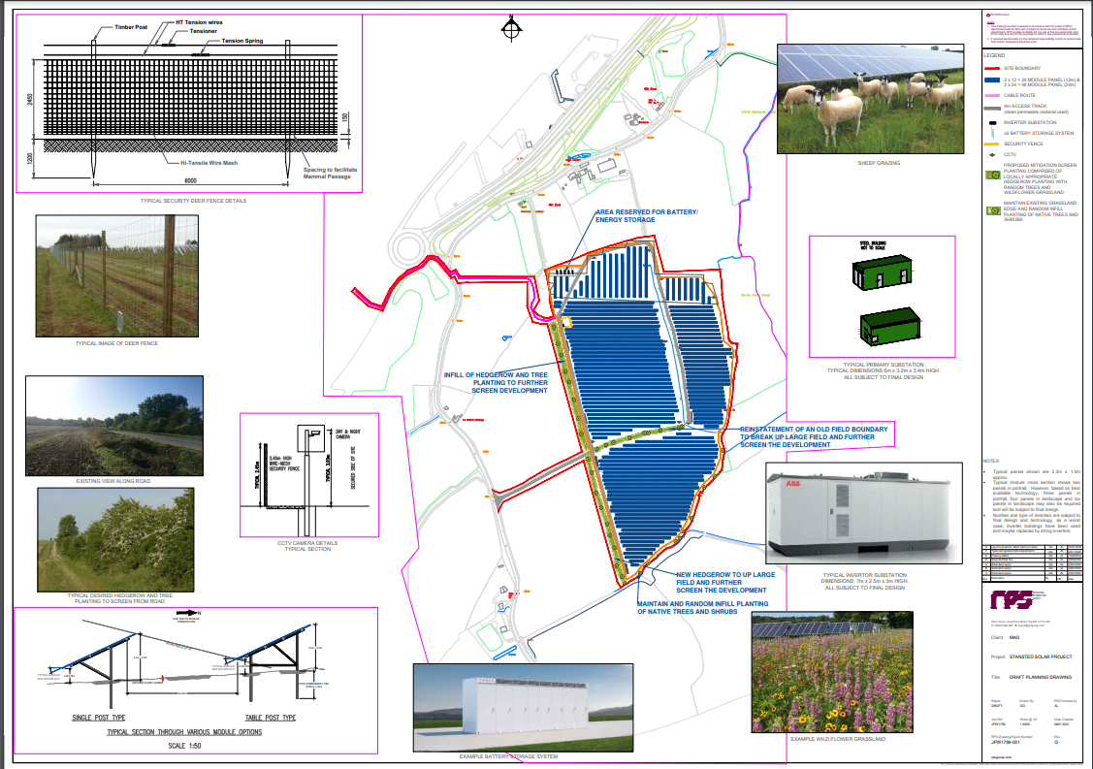
- The scheme would comprise rows of photovoltaic (PV) panels set 4 metres(m) apart with a maximum height of 3.2m and predominantly orientated due south, other than where alternative alignment is necessary to address glint or glare effects, notably for the airport. In addition, there would be inverter substations, electricity substations and battery storage units, as well as a connection to a substation, which lies within the boundary of the airport to the west of the site. The main part of the application site would be surrounded by a wire fence, 2.4m high, with some security lighting and CCTV. All existing trees and hedgerows are proposed to be retained with new planting on the western boundary of the site and reinstatement of a former field boundary within the site. Some strengthening of the hedge along the southern boundary is also proposed. Details are shown on drawing no. JPW1799-001 rev.G.

- Access to the site for the initial construction phase and long-term maintenance would be from Parsonage Road utilising an established field gate. The construction period is proposed to be between 30 and 40 weeks, with 3-4 HGV movements per day, in addition, it is anticipated that there would be some 3-4 light goods vehicle movements per day. Following the construction phase, vehicular traffic is expected to be minimal and linked to occasional maintenance.

Procedural matters
- The application was made under Section 62A of the Town and Country Planning Act 1990, which allows for applications directly to the Planning Inspectorate where an LPA has been designated by the Secretary of State.
- An application for a screening opinion for the above proposal under the Town and Country Planning (Environmental Impact Assessment) Regulations 2017 was submitted to Uttlesford District Council and separately to the Planning Inspectorate. It was found that the proposal would not give rise to significant adverse effects and an Environmental Impact Assessment was not required.
- The application was made on the 20 May 2022 and validated on the 6 June 2022. Notifications were then made on the 7 June 2022 , and allowed for initial responses by 7 July 2022. Responses were received from:

- Uttlesford District Council
- Takeley Parish Council
- Cadent Gas
- Gigaclear
- National Grid
- UK Power Networks
- Thames Water
- Affinity Water
- Essex County Council (ECC) – Ecology
- ECC – Highway and Transportation
- ECC – Historic Environment
- ECC – Green Infrastructure
- ECC – Flood Risk
- ECC – Energy and Low Carbon
- Historic England
- Environment Agency
- Natural England
- National Highways
- Stanstead Aerodrome Safeguarding Authority
- NATS Safeguarding

- Following a request from the Inspector, the applicant submitted further information on the 21 July 2022, including an updated Glint and Glare Study and a letter addressing consultee comments up to that point. All relevant parties were given the opportunity for further comment by 28 July 2022. The initial responses and these further comments have informed the following main issues.
- The decision was taken that as a major application, a Hearing was appropriate in this case. This is to be held on 9 August 2022 and will be conducted in accordance with The Town and Country Planning (Section 62A Applications) (Hearings) Rules 2013.
- Uttlesford District Council submitted a comprehensive Officer’s Committee Report, which identified conflicts with Local Plan Policies S8, ENV5 and E4, but also identified and acknowledged benefits to be weighed in the balance. Subsequently they submitted draft minutes of the Committee Meeting in which they:
RESOLVED to communicate a neutral response to PINS but that the following concerns be highlighted: Landscaping around properties. The need for consideration of other sites. Re-enforcing the S106 Agreement such that it is future proof. That the CPZ is considered sacred and that this proposal conflicts with S8.

Main issues
- The following are the main issues to be considered in respect of the application:
- the effect of the development on the character and appearance of the area, including the CPZ and coalescence;
- the effect on the best and most versatile agricultural land; and
- the benefits of the proposal, compliance with the development plan, including the assessment of alternatives, and the planning balance.

First main issue
- The proposal is on land currently in agricultural use and located in an area designated in the Local Plan to remain open and to prevent coalescence between the airport and existing development. It is also located in the open countryside, which the Local Plan seeks to protect for its own sake and limit development to that that needs to take place there, or is appropriate to a rural area. National policy seeks that the intrinsic character and beauty of the countryside is recognised.
- Takeley Parish Council argues that the solar farm could be located elsewhere, and preferably within the airport’s own boundary, and that the proposed site would adversely affect the characteristics of the CPZ and the use of the land for this purpose would lead to coalescence.
- The applicant submitted a Landscape and Visual Impact Assessment, which they argue demonstrates that the proposal is relatively self-contained without any permanent new buildings or tall structures which would lead to coalescence or erosion of the open character of the CPZ or countryside. They point out that the solar array needs to be co-located with the airport and a comprehensive review of alternatives confirmed this as the optimum location. As such, they argue that the site is both appropriate for the proposal and required to be in a rural location. Additional landscaping is proposed to further reinforce the self-contained nature of the proposal within this landscape.
- In their review of the consultee comments, they noted the Council’s position that Policy C8 identified the CPZ as ‘sacred’. This term must be explained, but the applicant identified that previous decisions have established that the test is around whether a scheme undermines the purposes of the CPZ, which they argue is provide for by the physical separation afforded by the A120. National guidance and policy on solar installations demonstrates that proposals should be approved if impacts are, or can be made acceptable. In this case, the applicant argues that the proposal has limited visual impact on a site that can be mitigated through a well-planned and well-screened development.

Second main issue
- The site has been assessed by the applicant has having approximately 6% as Grade 2 land, 70% Grade 3a and 24% Grade 3b. The Framework defines the Best and Most Versatile (BMV) agricultural land as being in Grades 1, 2 and 3a.
- Takeley Parish Council argue that the proposal would conflict with Policy ENV5, which sets out that development of BMV land will only be permitted where opportunities have been assessed for accommodating the development on previously developed sites or within existing development limits.
- Notwithstanding the Parish Council’s suggestion that land is available to the north of the airport, referring to a recent application for redevelopment there (UTT/22/0434/OP), the applicant provided an assessment of alternative sites, in their Solar Photovoltaic Viability Assessment and the Planning Statement, submitted with their application. They also highlight that their Agricultural Resources Report, in addition to identifying the land grading, assessed that Grade 3a and Grade 2 land dominates this area of chalky boulder clay, and that the site represented a large proportion of the lower levels of BMV. Furthermore, they argued that there would not be permanent loss of the agricultural quality of the land, which would be reinstated, nor would agricultural use necessarily cease. The existing arable use of the land was on a short-term farm business tenancy for a much larger operation, and that the loss of this area of land would not jeopardise that farming enterprise.

Third main issue
- The benefits, planning merits and compliance with policy informing the planning balance is a necessary part of this case. The applicant highlights that the introduction of such a large land use change would inevitably have some effects on landscape, for example, but is a type of development which receives positive support in national policy and guidance. This position is reflected to some extent in the Council’s analyses of the proposal albeit not in their resolution.

Other issues
- I have a statutory duty under s66(1) of the Planning (Listed Buildings and Conservation Areas) Act 1990 to consider any effect on the significance of heritage assets. In this case, Le Knell’s Cottage and Old House Farm are the closest, although I note the presence of other heritage assets, as detailed in the applicant’s Built Heritage Statement, which found no effect on the significance of these assets.
- Concerns raised by National Highways related to construction traffic and peak hours activity and insufficient information to address the risk of glint or glare to drivers on the A120. Following submission of a revised Glint and Glare Study, they have withdrawn their objection, subject to the approved Construction Traffic Management Plan (CTMP).
- Local highway concerns related to glint and glare, the dimensions of the access, the sufficiency of the visibility spays, the need for a Level 1 Road Safety Audit and the weight limit and visibility on the Coopers End mini roundabout at the junction of Parsonage Road/Hall Road.
- The applicant considers that matters of glint and glare and use of the roundabout are addressed and that matters relating to visibility on the roundabout and a Road Safety Audit can be addressed by conditions. The visibility splays at the access, they argue, are in accordance with Manual for Streets 2 and suitable for this road network and the very low level of HGV use is such that the need to utilise the width of the access is not a safety issue. Deliveries to the site would be managed by the CTMP, to be secured by condition, a version of which was submitted with the application.
- ECC Highways have responded, accepting the principle of development subject to conditions relating to the CTMP, the access, glint and glare mitigation and vegetation cutting works at the roundabout, as well as some proposed informatives.
- Biodiversity concerns were raised by ECC Place Services on the basis of insufficient information on Priority Species, farmland birds, notably skylarks. The submission of further information is reported to have resolved this, and other matters, subject to agreed conditions.
- Matters relating to the potential for run-off from the site, green infrastructure and archaeology, all identified by ECC, have all been assessed and accepted that they could be addressed by the use of suitable conditions or informatives.
- Critical matters relating to aerodrome safeguarding, notably from glint and glare effects, have been assessed by Manchester Airport Group safeguarding officer and by the National Air Traffic Service (NATS). These have been accepted subject to conditions.

Conditions
- The Council and some consultees have recommended conditions if the application is to be permitted. Without prejudice, these are set out in a draft Schedule of Conditions provided and they will be discussed at the Hearing. Their inclusion here, and any discussion on their merits, do not indicate that a decision has been made on the application, but only that the conditions suggested are to be assessed as to whether they are necessary, relevant, enforceable, precise and reasonable.

Planning obligation
- The Council indicate that they expect the submission of a s106 undertaking to address a decommissioning plan and secure a bond or deposit to cover decommissioning works if required. The necessity of such an undertaking can be addressed at the Hearing, but I note the applicant argues that such a requirement does not conform with the nPPG and that, as a temporary installation, a condition or conditions can address the removal and restoration of the site, either at the completion of the temporary period or at an earlier date if the installation fails to produce energy for a continuous period of 6 months.
Mike Robins
INSPECTOR

