


28th July 2022

Fertiliser use on farm for the 2021 crop year, from the British Survey of Fertiliser Practice

The British Survey of Fertiliser Practice is an annual survey that collects information on application rates and usage of nitrogen, phosphate, potash, sulphur, organic manures and lime on the major crops and grass grown in mainland Britain.

This release gives key results from the 2021 survey. Full results and methodological details are published in a separate report.

Key Messages
- The overall application rate for Nitrogen on tillage crops and grassland in 2021 was 87 kilograms per hectare, an increase of 5% on 2020.
- The overall application rates for Phosphate and Potash on tillage crops and grassland in 2021 fell by 7% and 5% respectively, whilst the equivalent rate for Sulphur was unchanged.
- Application rates of major nutrients have been in general decline since the 1980s. The increase in the rate for Nitrogen in 2021 reflects a return to more normal cropping following extreme weather in the 2020 crop year.

The overall application rate (in kg of nutrient per hectare) is the fertiliser nutrient application rate over the sown area of all fields, i.e. including fields where that nutrient was not applied.

Table 0.1: Overall application rates by nutrient, 2021, Great Britain
Nutrient | Tillage crops (kg/ha) | Change from 2020 (%) | Grass (kg/ha) | Change from 2020 (%) | All crops and grass (kg/ha) | Change from 2020 (%)
Nitrogen | 130 | 7% | 51 | -4% | 87 | 5%
Phosphate | 22 | -8% | 7 | -13% | 14 | -7%
Potash | 28 | -3% | 11 | 0% | 18 | -5%
Sulphur | 30 | -3% | 5 | 0% | 16 | 0%
Footnote: Percentage changes have been computed using rounded figures.

Contents

Section 1 – Long term trends in overall fertiliser application rates on crops and grass 4
Section 2 – Short term analysis of major nutrients 5
2.1 Nitrogen 5
2.2 Phosphate and Potash 5
2.3 Sulphur 6
Section 3 – Organic manures 7
Section 4 - About these statistics 8
4.1 Survey Background and Methodology 8
4.2 Feedback 8
4.3 Other statistics of interest 8

What you need to know about this release

Contact Details
Responsible statistician: Robin Karfoot, Room 202 Foss House, Kings Pool, 1-2 Peasholme Green, York, YO1 7PX.
Telephone enquiries: 0208 026 6449.
Email: mailto:agri.environmentstatistics@defra.gov.uk
Media enquiries: 0345 051 8486
Public enquiries: 02080 266449

National Statistics status
National Statistics status means that our statistics meet the highest standards of trustworthiness, quality and public value, and it is our responsibility to maintain compliance with these standards.

The continued designation of these statistics as National Statistics was confirmed in 2012 following a full assessment by the UK Statistics Authority against the Code of Practice for Statistics.

Since the last review of these statistics in 2012, we have continued to comply with the Code of Practice for Statistics, and have made improvements including:

- Incremental improvements to the sample selection to optimise coverage for key survey data items;
- Improvements to the wording of questions in light of feedback from interviewers; and
- Flexible use of the survey platform to collect additional data to meet needs of data users (the modular questions)

Defra statistical releases, including details of future publication dates, can be viewed on the Defra website.

Section 1 – Long term trends in overall fertiliser application rates on crops and grass

Figure 1 shows the overall application rates of nitrogen (N), phosphate (P2O5) and potash (K2O) on tillage crops and grass from 1983. Overall application rates are a combination of the proportion of fields that receive a dressing and the rate of application for those fields. Maximum usage was seen in the 1980s but there has been a general downward trend since then. The long-term decline in total nitrogen over this period is mainly due to decreased use on grassland. Nitrogen use on tillage rose in 2021 as more normal cropping patterns returned following extreme weather in the 2020 crop year. Extremely wet establishment conditions in late 2019 and early 2020 necessitated a switch to spring sown cereals, which have lower nitrogen requirements than winter sown crops.

Figure 1.1: Overall application rates for fertiliser (kg/ha), by nutrient, Great Britain, 1983–2021
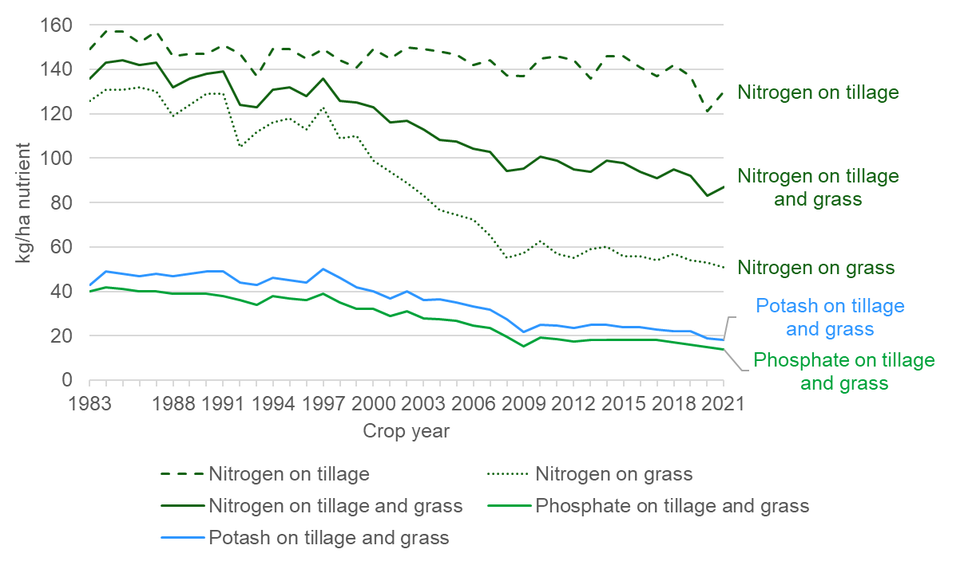

Source: Defra © Crown copyright 2022.

Section 2 – Short term analysis of major nutrients

2.1 Nitrogen
Table 2.1: Overall application rate for nitrogen (kg N/ha), Great Britain, 2017 – 2021
kilograms per hectare
Crop year | Tillage crops | Grass | All crops and grass
2017 | 137 | 54 | 91
2018 | 142 | 57 | 95
2019 | 137 | 54 | 92
2020 | 121 | 53 | 83
2021 | 130 | 51 | 87

In 2021 there was a 4 kg/ha increase in the overall application rate for nitrogen on crops and grassland (Table 2.1). This was driven by a 9 kg/ha increase in the overall rate on tillage crops and a 2 kg/ha decrease in the overall rate on grassland. The overall application rate for nitrogen on tillage crops of 130 kg/ha was again lower than the typical 140-150 kg/ha range seen over the majority of the 39 years of the Survey.

2.2 Phosphate and Potash
Table 2.2: Overall application rate for phosphate (Kg P2O5/ha) and potash (Kg K2O/ha), Great Britain, 2017 - 2021
Potash
kilograms per hectare
Crop year | Tillage crops | Grass | All crops and grass
2017 | 37 | 12 | 23
2018 | 35 | 12 | 22
2019 | 34 | 11 | 22
2020 | 29 | 11 | 19
2021 | 28 | 11 | 18

Phosphate
kilograms per hectare
Crop year | Tillage crops | Grass | All crops and grass
2017 | 30 | 8 | 18
2018 | 27 | 8 | 17
2019 | 26 | 8 | 16
2020 | 24 | 8 | 15
2021 | 22 | 7 | 14

The overall application rates on tillage crops have fallen in each year from 2018 onwards for both phosphate and potash, with 2021 rates of 22kg/ha and 28kg/ha respectively (Table 2.2). The phosphate and potash rates on all crops and grass have also generally declined each year, but to a lesser extent, with 2021 rates of 14kg/ha for phosphate and 18kg/ha for potash. Overall application rates on tillage crops are around three times higher than on grass for both nutrients.

2.3 Sulphur
Table 2.3: Overall application rate for sulphur (kg SO3/ha), Great Britain 2017 - 2021
kilograms per hectare
Crop year | Tillage crops | Grass | All crops and grass
2017 | 34 | 3 | 17
2018 | 35 | 4 | 18
2019 | 35 | 5 | 18
2020 | 31 | 5 | 16
2021 | 30 | 5 | 16

The overall application rate for sulphur on tillage crops was 30 kg/ha in 2021, a decrease of 1kg/ha from 2020 (Table 2.3). The equivalent rate for grass was much lower at 5 kg/ha, mainly due to the low proportion of grassland receiving a sulphur dressing.

Section 3 – Organic manures

Organic manures applied to agricultural land are mostly produced on farms by livestock as slurries, farmyard manure (FYM) and poultry manures. Those generated off-farm include treated sewage sludge (also called bio-solids) and some industrial ‘wastes’ such as compost, paper waste or brewery effluent. The nutrient levels in organic manures vary but can provide a valuable recycled supply of nitrogen, phosphorus and potassium.

Table 3.1: Organic manures applied in Great Britain, 2021
Type of manure applied | Applied by % of all farms | Volume of solid  manures (Mt) | Share of solid  manures | Volume of liquid  manures (Mm3) | Share of liquid  manures
Farms not applying manure | 35% | n/a | n/a | n/a | n/a
Farms applying some manure | 65% | 51.4 | 100% | 52.6 | 100%
Cattle FYM (Mt) | 49% | 38.0 | 74% | n/a | n/a
Pig FYM (Mt) | 1% | 2.1 | 4% | n/a | n/a
Layer manure (Mt) | 1% | 0.4 | 1% | n/a | n/a
Broiler/turkey litter (Mt) | 3% | 0.8 | 2% | n/a | n/a
Other FYM (Mt) | 6% | 2.1 | 4% | n/a | n/a
Other farm manure (Mt) | 1% | 0.6 | 1% | n/a | n/a
Bio-solids (Mt) | 1% | 3.4 | 7% | n/a | n/a
Other non-farm (Mt) | 3% | 4.0 | 8% | n/a | n/a
Cattle slurry (Mm3) | 18% | n/a | n/a | 50.7 | 96%
Pig slurry (Mm3) | 1% | n/a | n/a | 1.9 | 4%
Footnotes:
- Some farmers may apply more than one type of organic manure.
- Mt = million tonnes, Mm3 = million cubic metres.

In 2021, 65% of farms in the Survey population applied organic manures to at least one field on the farm (Table 3.1). Cattle manure represents by far the largest volume of manure type generated in Great Britain and accounted for 74% of solid manure and 96% of liquid manure applied in 2021. The proportion of farms applying cattle FYM and cattle slurry was 49% and 18% of farms respectively in 2021.

Section 4 - About these statistics

4.1 Survey Background and Methodology
The British Survey of Fertiliser Practice (BSFP) is the primary source of data on inorganic and organic fertiliser use in Great Britain. Its main purpose is to estimate average application rates of nitrogen, phosphate and potash used for agricultural crops and grassland. Information is also collected on applications of sulphur fertilisers, organic manures and lime. The survey data are used by Government, industry and the wider agricultural community to monitor best practice, to assess potential environmental impacts and mitigation strategies and provide important evidence to estimate greenhouse gas emissions from agriculture to inform policy.

The full report with detailed methodological information plus separate key datasets are available on GOV.UK here.

The BSFP is a voluntary annual survey of a sample of farmers selected from a population of agricultural holdings compiled using the June Agricultural Survey. The target sample size is 1,500 farms, designed to achieve a statistically representative sample at the national level. Holdings with less than 20 hectares in total of crops and grassland are not included in the sample. Whilst holdings below the threshold account for a significant proportion of all holdings in terms of numbers, they cover a much smaller proportion of the total area of crops and grass.

Data collection is undertaken through telephone or face to face interviews with individual farmers and in 2021 the achieved sample size was 1,310. The underlying sample design of the BSFP is constructed to measure manufactured fertiliser usage and therefore may not as reliably represent the population of farmers using organic manures.

The overall application rate is a measure of the fertiliser nutrient application rate over the sown area of all fields, irrespective of whether they received dressing of that nutrient or not. Overall application rate is measured in kilograms of nutrient per hectare (kg/ha).
Detailed methodology is provided in the full BSPF 2021 report.

4.2 Feedback
Feedback on the publication and the survey is welcome and can help us improve future editions. Contact information for feedback or questions is provided between the contents and Section 1 under ‘What you need to know about this release’.

4.3 Other statistics of interest
Defra’s Farm Practices Survey for England may be of relevance and interest to fertiliser use and related practices, and can be found on GOV.UK here.

Data on fertiliser use are also a key element of soil nutrient balances. Soil nutrient balances provide a method for estimating the annual nutrient loadings of nitrogen and phosphorus to agricultural soils. They give an indication of the potential risk associated with losses of nutrients to the environment; losses which can impact on air and water quality and on climate change. Soil nutrient balances estimates are published under the heading “Soils” on GOV.UK here.

