Interim Order Decision
Inquiry Held on 24 & 25 May 2022
by K R Saward Solicitor
an Inspector appointed by the Secretary of State for Environment, Food and Rural Affairs
Decision date: 15 July 2022

Order A: ROW/3228625
- This Order is made under Section 53(2)(b) of the Wildlife and Countryside Act 1981 and is known as The Surrey County Council Footpath No. 643 (Banstead) Definitive Map Modification Order 2018.
- The Order is dated 21 March 2018 and proposes to modify the Definitive Map and Statement for the area by adding a footpath as shown in the Order plan and described in the Order Schedule.
- There was one objection outstanding when Surrey County Council submitted the Order to the Secretary of State for Environment, Food and Rural Affairs for confirmation.
Summary of Decision: The Order is not confirmed.
Order B: ROW/3228626
- This Order is made under Section 53(2)(b) of the Wildlife and Countryside Act 1981 and is known as The Surrey County Council Footpath No. 644 (Banstead) Definitive Map Modification Order 2018.
- The Order is dated 21 March 2018 and proposes to modify the Definitive Map and Statement for the area by adding a footpath as shown in the Order plan and described in the Order Schedule.
- There was one objection outstanding when Surrey County Council submitted the Order to the Secretary of State for Environment, Food and Rural Affairs for confirmation.
Summary of Decision: The Order is not confirmed.
Order C: ROW/3228627
- This Order is made under Section 53(2)(b) of the Wildlife and Countryside Act 1981 and is known as The Surrey County Council Footpath No. 643 (Banstead) Definitive Map Modification Order 2018.
- The Order is dated 28 August 2018 and proposes to modify the Definitive Map and Statement for the area by adding a footpath as shown in the Order plan and described in the Order Schedule.
- There was one objection outstanding when Surrey County Council submitted the Order to the Secretary of State for Environment, Food and Rural Affairs for confirmation.
Summary of Decision: The Order is confirmed.
Order D: ROW/3228628
- This Order is made under Section 53(2)(b) of the Wildlife and Countryside Act 1981 and is known as The Surrey County Council Footpath No. 644 (Banstead) Definitive Map Modification Order 2018.
- The Order is dated 28 August 2018 and proposes to modify the Definitive Map and Statement for the area by adding a footpath as shown in the Order plan and described in the Order Schedule.
- There was one objection outstanding when Surrey County Council submitted the Order to the Secretary of State for Environment, Food and Rural Affairs for confirmation.
Summary of Decision: The Order is proposed for confirmation subject to modifications.

Procedural Matters
- An application was made by Mrs Catherine O’Brien in August 2015 to add public footpaths to the Definitive Map and Statement (‘DMS’) on land to the east of Rectory Lane, Woodmansterne. The application routes included a section of claimed path over land within the London Borough of Croydon (‘LBC’). Permission was given by LBC to allow Surrey County Council (‘SCC’) to research the claim for the section in LBC’s area. Following investigation, Orders were made simultaneously by SCC and LDC on 21 March 2018 to add the claimed paths to the DMS for each area.
- In response to publication of the notice of the Orders, one objection was received by SCC to Orders A and B from the owners whose land is affected by most of the claimed route. No objections were made to the Order within the area for LBC.
- The first ground of objection concerned an error in the drafting of the Orders which were expressed to come into effect 21 days from the date of confirmation rather than on the date of confirmation. SCC agreed this was incorrect and due to the errors, the Orders were re-made on 28 August 2018. Again, one objection was made to the corrected Orders (C and D) by the same landowners.
- I am invited by SCC not to confirm the first two Orders A and B. I see no reason to disagree given that the March 2018 Orders were effectively replaced by those made in August 2018. Therefore, for the purposes of these decisions I shall focus on Orders C and D.
- A copy of the Order Maps for C and D are attached for reference purposes.
- The Inquiry was scheduled to take place as a physical event opening on 29 June 2021. When Covid-19 related restrictions were not lifted as anticipated, the Inquiry was postponed. Instead, I chaired a virtual case management conference on 29 June 2021 with representatives of the objectors and SCC to fix a new date and discuss measures to facilitate the smooth running of the Inquiry. No discussion took place on the merits of the Orders or the evidence submitted.
- Following the case management conference, the parties agreed a bundle of documents for use at the Inquiry. The parties also agreed a form of wording to modify Order D in the event that I find in favour of part of the route only along the uncontested stretch between C-F.
- I carried out an unaccompanied site visit the day before the Inquiry opened. I was able to walk Order route C in its entirety. The claimed path around the perimeter of the field in Order D was obstructed by fencing and works of construction which prevented access to the whole route between points B to F. I was able nevertheless to observe part of the field boundary along that stretch and see the surroundings from point F which is at an elevated level. At the close of the proceedings neither party considered that a further site visit was required.
- There is a typographical error in Order D. Claimed public footpath No 644 (‘FP 644’) is incorrectly described as Footpath No. 643 (‘FP 643’) in paragraph 3. SCC agrees that this requires modification should the Order be confirmed. The statutory objectors agree that it is a minor clerical error capable of correction.
- The existence of a public path between A-B-C (Order C) is admitted by the objecting landowners. In the words of their professional agent: “The Objectors do not oppose the recording of a route on the southern edge of the field as this is clearly established and well used by the public”. The agent further comments that this “path does provide a direct access between two areas of residential development.” At the start of the Inquiry the only ground of objection to Order C concerned the alignment of the section of path between points B and C where it passes north-west of the allotments.
- On the first morning of the Inquiry, Mrs Valiant gave evidence for SCC confirming that the dashed line marked on Order map C represents the centre line for the claimed path which had been plotted utilising the 2006 aerial photograph in which a trodden line is visible. Following this evidence, the objectors withdrew their objection to the alignment as recorded in Order C at the start of the afternoon session. This was on the basis that there is acknowledged baseline evidence of the precise alignment to which the landowners can refer in the event of issues in the future. In consequence of the landowners’ concession, there are no outstanding objections to Order C. The parties agree that Order C should be confirmed as made. Having reviewed the evidence of use and aerial images, I agree. The remainder of the Inquiry focussed on Order D.
- On the basis that the route shown in Order D mirrors the physical route set out on the ground and is used by the public, there is no objection to confirmation of the Order route between points C and F. It is acknowledged that this provides a well-used route linking Lyndhurst Road to the public path network north of point F. The objection to Order D relates only to the section of claimed route from B to F.

Main Issues
- Each Order has been made under section 53(3)(c)(i) of the Wildlife and Countryside Act 1981 (‘the 1981 Act’) which requires me to consider whether, on the balance of probabilities, the evidence shows that a footpath subsists along the Order route.
- The main issue outstanding is whether the discovery by the authority of evidence which (when considered with all other relevant evidence available) is sufficient to show that a right of way which is not shown in the map and statement subsists between points B and F as shown on the map for Order D.
- The evidence adduced is of claimed use by the public. Therefore, it is necessary for me to consider whether dedication of the way as a public footpath has occurred through public use. This may be either by presumed dedication as set out in the tests laid down in section 31 of the Highways Act 1980 (‘the 1980 Act’), or by implied dedication at common law.
- I must consider whether the evidence shows that in the past, the Order route has been used in such a way that a public footpath has been established around the field perimeter between points B and F.
- Under section 31 of the 1980 Act, there must have been use of the claimed route by the public as a footpath ‘as of right’ (meaning without secrecy, force, or permission) and without interruption, over a period of 20 years immediately prior to its status being brought into question so as to raise a presumption that the route had been dedicated as a public footpath. This may be rebutted if there is sufficient evidence that there was no intention on the part of the relevant landowner/s during the 20 year period to dedicate the way for use by the public.
- Should the test for statutory dedication fail under section 31, then it may be appropriate to consider if there was dedication of the way at common law. This requires consideration of three issues: (i) whether any current or previous owners of the land had capacity to dedicate a highway (ii) whether there was express or implied dedication by the landowners and (iii) whether there is acceptance of the highway by the public. There is no fixed period of use at common law and depending on the facts of the case it may range from a few years to several decades. There is no particular date from which use must be calculated.

Reasons

Background
- The claim relies solely upon evidence of use. The application was accompanied by 76 user evidence forms (‘UEFs’) for 77 users. Another 9 UEF’s were added later but one user has completed two forms and so there is a total of 84 UEFs from 85 users. Some users also made witness statements and proofs of evidence. Five users attended the Inquiry to give evidence in support of the Orders.
- The land affected by the claimed routes is a field belonging, in the most part, to the Drake family who are the statutory objectors. Their ownership encompasses the land adjacent to Rectory Lane stretching north-east where it borders a plantation and a small number of dwellings in Lyndhurst Road. Part of the field (lying behind other properties in Lyndhurst Road and continuing beside the south-eastern boundary) was sold by the Drake family to Sutton and East Water PLC who in recent years has built a lagoon on the land. The water company also leases a roughly square shaped portion of the field in the south-western corner from the Drake family. A small wedge next to the public highway between points A and B is owned by Surrey County Council.

Statutory dedication

Bringing into question
- Before a presumption of dedication can be inferred under statute, section 31(2) of the 1980 Act requires the relevant period of use "to be calculated retrospectively from the date when the right of the public to use the way is brought into question, whether by notice … or otherwise". Use during that period must be shown to have been actually enjoyed as of right, without interruption, and to have continued for a full period of 20 years.
- Thus, the period of 20 years is calculated retrospectively from the date when the right of the public to use the way is brought into question. Accordingly, the first matter to be established in relation to section 31 is when the public’s rights were brought into question.
- In order for the right of the public to use the Order route to have been brought into question for the purposes of section 31(2), some action must have been taken, or an event occurred, which alerts at least some of those using the path that their right to do so is being challenged. There is not an exhaustive list identifying the means by which such a challenge can occur. Whatever means are employed must be sufficiently overt to bring that challenge to the attention of the public using the route so that they might be apprised of the challenge and have a reasonable opportunity of meeting it.
- SCC and the statutory objectors disagree on the date. Three potential dates were mooted and on which evidence was heard. I have also considered whether any other dates might be applicable.
- The first date, advanced by the objectors, is 1992 being the year when there was an unauthorised gypsy and traveller encampment on the field. According to the objectors, gates were locked afterwards to prevent any access to the field. To support this, correspondence is produced between Mr A.G. Drake, the landowner at the time, and his land agent who gave details of the measures taken to secure the field. SCC disputes there were locked gates preventing use of the Order routes, or if there were, there is no evidence that they were intended to prevent pedestrian (as opposed to vehicular) access.
- At the start of the second day of the Inquiry, the objectors accepted that no other evidence had emerged of locked gates having come to the attention of the public in a manner that would show their use of the path was being challenged. That being so, the objectors accept that 1992 requires no further consideration. I agree. Metal gates remain along the boundary between the objectors’ field and neighbouring pub car park in the position described in the correspondence from 1992. There is no evidence that the locking of these gates prevented pedestrian access or were intended to do so. I dismiss 1992 as the date of calling into question.
- The second date relied upon by the objectors is 2006. Reliance is placed on a letter of 29 August 2006 to Mr Dixon of the Woodmansterne Green Belt Residents Association (‘WGBRA’) from the land agent for Mr Drake as owner of the field described as ‘Land to the Rear of the Midday Sun’. The Midday Sun is a public house which still exists. There is no dispute that the field in question is the one behind the pub over which the public footpaths are now claimed. The letter explains that the field was let to a local farmer and neither the tenant farmer nor Mr Drake have given permission to the owners of horses kept on the land who had ‘cut off my client’s padlock’. In the final paragraph the agent states:

“I am not sure to which public footpath you refer. There is no public footpath crossing or abutting my client’s land. Of course this point is slightly academic given my answer to your first question.”
- Both advocates agreed that the statement made on behalf of the landowner that there is no public footpath crossing his land could suffice to bring the public use into question. They disagree on whether that is the effect in this instance.
- It is suggested by the objectors that the WGBRA operates in similar manner to the role of a parish council. The objectors contend that whilst it would have been better had the landowner proceeded to erect signage on the land, the statement is unequivocal that no public footpath exists or is recognised.
- The objectors acknowledge that the issue is one of whether the WGBRA is considered to be sufficiently representative of those likely to be using the field so as to be deemed to have brought the challenge home to the public.
- The profile taken from a social media site in 2020 describes the aims of WGBRA as to provide a platform to voice, discuss and where possible, resolve issues which directly affect local residents as well as the community. It says the WGBRA works on behalf of the village on a variety of local issues and is non-political and non-profit making. Along with its website, it aims to provide a central information point for anyone wishing to find out about Woodmansterne. This is achieved by holding monthly meetings in the village hall, producing a newsletter twice a year with distribution of 1,500 copies (except during Covid-19) and holding an Annual General Meeting in April every year to which all residents are invited.
- The current Acting Chair of the WGBRA, Mrs Hext, attended the Inquiry and answered questions on the status and role of the organisation. Whilst not on the committee in 2006, she believes that Mr Dixon was either the Secretary or Chair of the WGBRA at that time.
- It is apparent that WGBRA engages in a wide variety of activities on behalf of the local community including commenting on planning applications in which it has registered an interest and taking up points of concern on behalf of residents. This can be seen from the Spring 2016 Newsletter published by WGBRA along with the content of an email sent on its behalf in 2015 and its website.
- Taken on its face, the letter to Mr Dixon in 2006 makes plain that the landowner does not acknowledge the existence of any public right of way.
- I am not swayed by SCC’s contention that the context of the letter makes a material difference because it was addressing the presence of horses on the field rather than the existence of public rights of way. It is far more compelling that the WGBRA is not a statutory body with any role concerning public rights of way and it only represents the residents of Woodmansterne whereas a large proportion of the users lived elsewhere. Notably, the neighbouring dwellings in Lyndhurst Road whose gardens immediately abut the field are not in Woodmansterne but the neighbouring parish. Indeed, given the location of the parish boundary, in excess of 30 users were residents of Coulsdon and there are others from further afield.
- Furthermore, there is no evidence that either Mr Dixon or the WGBRA disseminated the information contained in the letter regarding the footpath. After giving her evidence, Mrs Hext searched the WGBRA archive and produced a typed-up note of the minutes regarding horses on Drake’s field in 2006. These minutes record how concerns were raised by residents in June 2006 about travellers’ horses on the field which was discussed again at meetings in July and August 2006 resulting in the letter to Mr Drake. At the meeting of 20 September 2006, the letter of reply from Mr Drake’s agent was reported but no mention of the final paragraph containing the landowner’s denial of any public footpath crossing his land is minuted.
- In this instance I am not satisfied that WGBRA was truly representative of the public using the path given how many users lived outside Woodmansterne or that steps had been taken in any event to communicate to the public that no public footpath existed. It is not enough that the letter was sent if the content was not disseminated more widely among those members of the public likely to be using the field. In the circumstances, it is highly questionable how any members of the public could have known that the landowner had failed to acknowledge the existence of any public path across his land. Accordingly, I dismiss 2006 as the date of calling into question.
- The third date, favoured by SCC, is in 2015 when the application for the DMMO was made. The objectors agree that such occurrence amounts to a ‘calling into question’ but considers it to be the latest possible date.
- Where no other event is identified, the matter bringing the right of the public to use a way into question may be taken as the application for the DMMO and the date for the purposes of section 31(2) is treated as the date on which the application was made (section 31(7A) and (7B) of the 1980 Act). The application made to SCC to record the Order route as a public footpath is dated 28 August 2015. Having discounted the other earlier dates, I regard this as the date upon which the public use of the claimed route was brought into question.
- Therefore, for the purposes of section 31 I intend to consider the 20-year period from August 1995 to August 2015.

Evidence of use by the public
- All of the users have hand drawn the route/s that they walked on a map attached to their UEF. SCC plotted all the routes that users claimed to have used. This revealed numerous entry points and multiple walked lines criss-crossing the entire field.
- SCC accepts that walkers used other routes over the field but say that Order routes C and D were, by a large measure, the most popularly recorded paths. By the same token, it was acknowledged by SCC and other supporters that Order route D was not used as much as Order route C.
- Not all users walked both Order routes. Around 43 have clearly marked a route on their UEF map which may be construed as including points B to F on Order route D. Another 7 or so indicate use of part only of this stretch.
- From the evidence, section B to F was most commonly used by dog walkers as part of a circular route around the perimeter of the entire field by combining both Order routes C and D. The most vivid recollections were by dog owners who were able to recount their use of the route with reference to the year they had a particular dog.
- Mrs Thorpe gave evidence of daily use whilst dog walking prior to the relevant between 1977 to 1991. From 1996 to 2010 her estimated use was about 300 times per year walking the perimeter anti-clockwise. From 2010 to 2015, her use became less frequent and only when dog sitting which was about once or twice per week.
- Mr Lehmann, whose house backs onto the field, gave clear and firm evidence that he entered the field with his dog via a gate in his fence midway between points C and F to walk the whole perimeter in an anti-clockwise direction. He did this 3-4 times per week between 2007 to 2015 (and beyond). His evidence was wholly consistent with his UEF even though he had forgotten completing it.
- Mr Poore had completed a UEF showing Order route C only, but in evidence said that he had also walked B to F probably once a week from September 1984 until his first dog died in 1998. Mr Poore got a second dog in 2011 and said that from 2012 to 2015 he walked all the paths on a fairly regular basis. He estimated his use of the section from F to B as once or twice per week over that period.
- The UEF for Mrs Auston indicated use between 1971 to 2015 of the whole perimeter path plus another route. In evidence, she referred to use since having German Shepherd dogs in 1976. She walked the perimeter a couple of times per week taking a clockwise direction as there were nicer views from points F to C. Upon returning to work in 1989 Mrs Auston usually entered the field at point A and walked partway up towards point F during her lunch breaks on at least 3 workdays. She would sometimes enter the field midway between B and F. In addition, she would use the route at least once over every weekend from 1989. This pattern continued up until losing her last dog a couple of years ago. She described the path as always quite narrow between points B and F but suitable for single file walking.
- The UEF completed by the applicant, Mrs O’Brien, has numerous routes hand-drawn on the map including the Order routes. Whilst her UEF indicates use from 1953 to 2015, Mrs O’Brien confirmed her use of Order route C was 1976-78 and her use of Order route D began in 1989 when the family got its first dog. Mrs O’Brien walked the dog once a week from B-F-C-B between the years 1989 to 1999 unless the weather was not so good when she would take a shorter walk diagonally across the field. When her grandson was active, Mrs O’Brien said she walked the perimeter (including F-B) weekly from 2003 to 2011 and ‘occasionally’ thereafter.
- The objectors highlight how Mrs O’Brien’s first witness statement stated that “when the field is in crop people stick to around the edge but when it is not cropped they walk anywhere”’ They take this as confirmation that users wandered across the field when it was not in crop and suggest that it is telling how this statement was omitted from Mrs O’Brien’s proof of evidence. Under cross examination, Mrs O’Brien explained that what she meant was that there were other paths available to use when the field was uncropped.
- All the witnesses were questioned by the objector’s advocate about photographs taken by SCC in 2015 from point F of the field boundary towards point B. In one photograph, the hedgerow appears overgrown and there is no visible walked line unlike the section from C to F. In another, the field can be seen in crop right up to the hedge. A narrow walked line is visible through the crop in a position parallel with but away from the hedge line. The objectors suggest this is evidence that the path was not always in the same place and flush against the hedgerow as users indicate.
- To my mind, the photographs reveal nothing more than the absence of an obvious walked line for a short distance along the claimed alignment at that point in time. Bearing in mind that the photographs coincide with the time of calling into question, I do not find the photographs to be of any real significance. I am also mindful that Mr Lehmann was insistent that something had changed at that time with how the field was cropped and the users were united in saying that was not how the field usually appeared. Moreover, various witnesses refer to the farmer always leaving the perimeter uncultivated. Indeed, this is reinforced by the objectors’ own evidence that a ‘margin is inevitably left around a field that is cropped’.
- All those who gave evidence at the Inquiry insisted they stuck to the same perimeter path without wandering across the field. They were consistent in saying there was always a clear walked line unless the field was cropped, which was only occasionally. Mrs Auston provided the greatest clarity that the path from B to F was narrower than elsewhere around the field and allowed for single file walking.
- Aside from those who gave oral evidence, a small number of other users have signed and dated witness statements taken by SCC. In a joint statement, Mr Kidman and Ms Gately refer to having walked ‘a full lap of the field daily’ since they got dogs in 2010. However, Mr Kidman mentions in his UEF meeting the farmer on one occasion who ‘did not approve of walking around the whole field’. Whether or not he was turned back or quite what was said and when it occurred is unknown. This limits the weight I can give to this witness statement.
- Mrs Martins refers to having ‘walked all the way around the field for at least 5 years 4-5 times a week.’ Even if this means sections B to F, it is not entirely clear which years that use relates.
- Mr Morgan is an adjoining owner of land lying between the public house and allotments to the south of Order C. Whilst his witness statement has a typed signature, he was present at the Inquiry and confirmed the statement to be correct. Most of his witness statement concerns other sections of path but he refers to walking the whole of B to F (which he calls path 3) about 3-4 times and having noticed various ways in which it links to Rectory Lane. He states that he has seen people walking this path since first coming to the land in 2004.
- A signed witness statement dated 9 November 2016 made on behalf of Sutton and East Surrey Water PLC confirms the company acquired an interest in part of the field about 18 months before and received planning permission for soakaway lagoons on the land. The statement says ‘we have seen very little signs of walked paths’ except at the bottom of the field which links Rectory Lane and Lyndhurst Road (i.e., Order route C). It does not state which period of time is being referred to and may have been after the relevant period. The information is also vague. As such, I give the statement little weight.
- It became apparent in live evidence that users walked some routes more frequently than others. Where witnesses attended, it could be clarified where they walked, how often and over what period.
- The UEF’s are in standard form and provide only a brief summary of use. A small number have helpfully identified on their UEF the period and frequency of their use with reference to sections of the route. Most have not done so. The dilemma is identifying whether the answers given over frequency and period of use relate to the whole route claimed or part only.
- SCC suggests that the oral evidence suffices when also considering the witness statement and high volume of UEF’s. My attention is drawn to how 50 of the 85 users who completed UEF’s have used B to F in the period 1995-2015. From my analysis, not all claimed the whole length of B to F with some using it as a link to or from Rectory Lane. SCC points to there being 25 users having used B to F for the full 20 year period which at the start of the period amounted to 26 users which had risen to 43 users by 2015. The average frequency is calculated at 113 trips per week over the 20 year period and would rise considerably, SCC says, if including those users of part only.
- However, it became apparent from hearing evidence that users had not necessarily walked the section from F to B or vice versa throughout the period marked on their UEF or at the frequency indicated. This gives me cause for hesitance in how much reliance can be placed on the UEF’s when reference is made to multiple routes and clarification has not been provided by more witnesses over their use of the contested section in Order D. In most cases it is simply unclear whether the answers apply equally to all routes marked. For instance, there are examples of users referring to B to F being used less often than another section and yet the answer in their UEF gives the same frequency of use. In two UEF’s the users say that the owner was happy to let people walk their dog around the field which could signify that those two users at least had permission.
- The objectors assert that depending on crop rotation, the field reverted to an open area over which people were free to wander. This could feasibly be the case for some users depending on the ultimate destination and purpose of the walk. Based on the evidence of users there were long spells when the field was uncropped.
- By the same token it is plausible that if the purpose of a walk is for exercise that users, particularly dog walkers, would take a longer circuitous route around the field using a perimeter path including B to F. This is reflected in the user evidence that I heard. Of those five users who gave their accounts, Mrs Auston claimed use of B to F throughout the relevant 20 year period and Mrs Thorpe for 19 of those years from 1996. Other use for that section was for lesser periods at differing times.
- The picture emerging is of the presence of a field edge path between points B to F which was more heavily used in the latter years and less frequently than other paths between points A to C and C to F. Whether that path was used continuously by sufficient members of the public to give rise to the presumption in favour of dedication is difficult to gauge.
- Whilst there is a high number of UEF’s claiming use of B to F, only a small proportion of that evidence was tested under cross-examination at the Inquiry. That is not in itself an issue, but my concern arises over the lack of clarity in the UEF’s when it is uncertain if the answers relate to all parts of the route being claimed and its continuity. The limited capacity of the standard forms to secure specific details over use of each section leaves many questions unanswered.
- It is also apparent that some users walked only partway along B to F where it provided links to Rectory Lane. From the information before me there is insufficient clarity of evidence to be satisfied of a partial route only between these points.
- There is no suggestion that use by the public was anything other than open and without force or permission.

Conclusion on statutory dedication
- There is a large body of consistent evidence supporting statutory dedication for uncontested Order C which provides a direct link between residential areas to the west of Rectory Lane and Lyndhurst Road to the east. Many users refer to this as providing access to places such as the railway station and shops.
- In terms of Order D, no evidence was brought by the objectors to dispute dedication of the section of claimed path between points C to F which follows a clearly defined line beside the field edge. I am satisfied that there is sufficient evidence of public use throughout the relevant 20-year period to raise a presumption in favour of statutory dedication for this stretch of claimed path.
- However, the evidence for Order D in respect of route sections B to F falls short of the quality required to meet the statutory tests for dedication. It has not been demonstrated, on the balance of probabilities, that there was sufficient continuous public use of the claimed path between points B and F in Order D throughout the 20-year period from 1995 to 2015 prior to it being brought into question to raise a presumption of a public footpath under statute. Therefore, the first part of section 31 of the 1980 Act is not satisfied in terms of B to F and there is no need for me to consider the issue of statutory dedication further.

Common law
- An inference that a way has been dedicated for public use may be drawn at common law where the actions of landowners (or lack of action) indicate that they intended a way to be dedicated as a highway and where the public accepted it.
- The onus of proof is on the person claiming a way as public to show the facts, taken as a whole, are such that an inference can be drawn that there was an intention to dedicate the way as public. The onus is not on the landowners to prove a lack of intention to dedicate.
- Inference of dedication depends on the facts. The use must be ‘as of right’ but a lesser period of 20 years may suffice. Case law has found that the more intensive and open the user, and the more compelling the evidence of knowledge and acquiescence, the shorter the period need be for dedication to be inferred.
- There are no issues raised over the capacity of the landowners to dedicate and there is no suggestion of express dedication of B to F as a public path. The issue turns to whether dedication by the landowner may be implied at common law.
- SCC argues that as the landowners accept use of public rights ‘as of right’ over the other sections from F to C and A to C it is probable the landowner was also aware of public use between B and F and took no steps to prevent the use. The landowner simply acquiesced in the use. By reason of the inaction by the landowner, in the face of such user, it is submitted that dedication can be inferred and the act of user evidences the acceptance of the dedication.
- However, it does not automatically follow that just because the landowner accepts public use of two boundaries of the same field that the landowner knew and acquiesced in the use of another boundary also. That is an assumption too far.
- It is acknowledged by SCC that the use of B to F was not as great as the other two stretches. Moreover, the land has been tenanted for a considerable period of time.
- Of the five users whose evidence was tested, two began use in the 1970’s and two others began use in the 1980’s with the fifth commencing use in 2007. Over those years there are gaps in time when three of the users had years when they did not use the path. There is a reasonable volume of written user evidence, but the same issue arises over the quality of that evidence in terms of B to F as outlined above. The users do not claim to have walked solely from B to F or vice versa but claim to have used the route along with others. It is simply too uncertain how much use B to F attracted and over what periods of time from the answers provided. The content of the UEF’s has not been verified one way or the other where individuals did not give oral evidence to explain their use of the land.
- In summary, there is some evidence of use of B to F going back many years but the tested evidence reveals low levels of use covering different periods. The UEF’s are not sufficiently clear on use of this stretch for much weight to be attached. Overall, the evidence does not suffice to make a finding of dedication at common law.

Conclusions
- Having regard to these and all other matters raised at the Inquiry and in the written representations, I make the following conclusions:
- Orders A and B should not be confirmed, as requested by SCC, as they were effectively replaced by Orders C and D to correct drafting errors.
- Order C should be confirmed, the statutory objectors having withdrawn their objections to this Order.
- Order D should be confirmed between points C and F only subject to a minor modification to correct the typographical error explained in my procedural note. Order D should not be confirmed between points B and F.
- Confirmation of part of Order route D would result in a cul-de-sac path as there is no current exit point onto Rectory Lane at point F. However, from point C the path rises uphill and upon reaching point F the elevated position offers far reaching views over the field and surroundings which users evidently appreciate. The objectors also acknowledge that point F ‘is plainly a place the public access’. I see no reason not to confirm Order D insofar as it relates to points C to F.

Formal Decision

Order A
- I do not confirm the Order.

Order B
- I do not confirm the Order.

Order C
- I confirm the Order.

Order D
- I propose confirmation of the Order subject to the following modifications:-

In paragraph 3 of the Order:
- Delete “No. 643” and substitute “No. 644”.

On the Order map:
- Amend the line of the footpath to be added by removing the section from B to F.

The Schedule: Part I
- Delete the description of the path to be added and substitute the following:

Footpath No. 644 (Banstead) in the Borough of Reigate and Banstead, shown by a bold broken line on Drawing No. 3/1/36/H48, commencing at the northern corner of the field at point F (Grid Ref: 527954 159044) and running in a south-south-easterly direction for 321 metres to point C (Grid Ref: 528224 159294). The width is 1.5m

The Schedule: Part II
- Delete the Table and substitute the following:

R/W  No | Status & Width Claimed | Description (Limitations shown in bold) | Width Fence to Fence | Condition or Surface | Remarks | Map No.
644 | FP  1.5m | FROM the northern corner of a field in south-south-easterly direction  Path  TO the south eastern corner of a field at the County boundary | 1.5m | Earth | MMO 2018 | TQ25

- Since the confirmed Order would (if modified) not show a way as it is shown in Order D as made, Paragraph 8(1)(b) of Schedule 15 to the 1981 Act requires that notice shall be given under Paragraph 8(2) of the proposal to modify Order D and to give an opportunity for representations and objections to be made with respect to the proposal. A letter will be sent to interested persons about the advertisement procedure.

KR Saward

INSPECTOR

APPEARANCES

For Surrey County Council:

Mr Trevor Ward of Counsel, instructed by Nancy El-Shatoury,
Solicitor, Surrey County Council

who called:  Catherine Valiant  Christine O’Brien  Mrs P Thorpe  Mr D Poore  Mrs J Auston  Other supporters:  Mrs P Hext  Mr R Lehmann  Objectors:  Mr Michael Wood  who called:  Leo Hickish | Countryside Access Officer  Applicant  Local resident  Local resident  Local resident  Acting Chair, Woodmansterne Green Belt  Residents’ Association  Local resident  ET Landnet Ltd  Chartered Surveyor
Others who spoke:

Mr L White Local resident

DOCUMENTS submitted at the Inquiry

1. Signed witness statement of Mr Kidman and Ms Gately dated 2 September 2016
2. Signed witness statement of Mrs O’Brien dated 12 September 2016
3. Signed witness statement of Mrs Martins dated 15 September 2016
4. Signed witness statement of Mrs Thorpe dated 10 September 2016
5. Signed witness statement of Mr & Mrs Poore both dated 16 September 2016
6. Witness statement of Peter Morgan dated 16 September 2016 with typed
signature (verbally confirmed as correct at the Inquiry)
7. Signed witness statement of Mr P Isherwood (dated 9 November 2016) &
Mr C Stanbridge (dated 8 November 2016) both of Sutton and East Surrey
Water PLC
8. Script from Mrs Hext, Acting Chair, Woodmansterne Green Belt
Resident’s Association (‘WGBRA’)
9. Email from Mr Colebrook to SCC on 13 September 2017 approving his draft
witness statement
10. Typed up extracts of WGBRA minutes regarding horses on Drake’s Field in
2006
11. Closing submission for the objectors
12. Closing submission for SCC

ROW/3228625 (A)
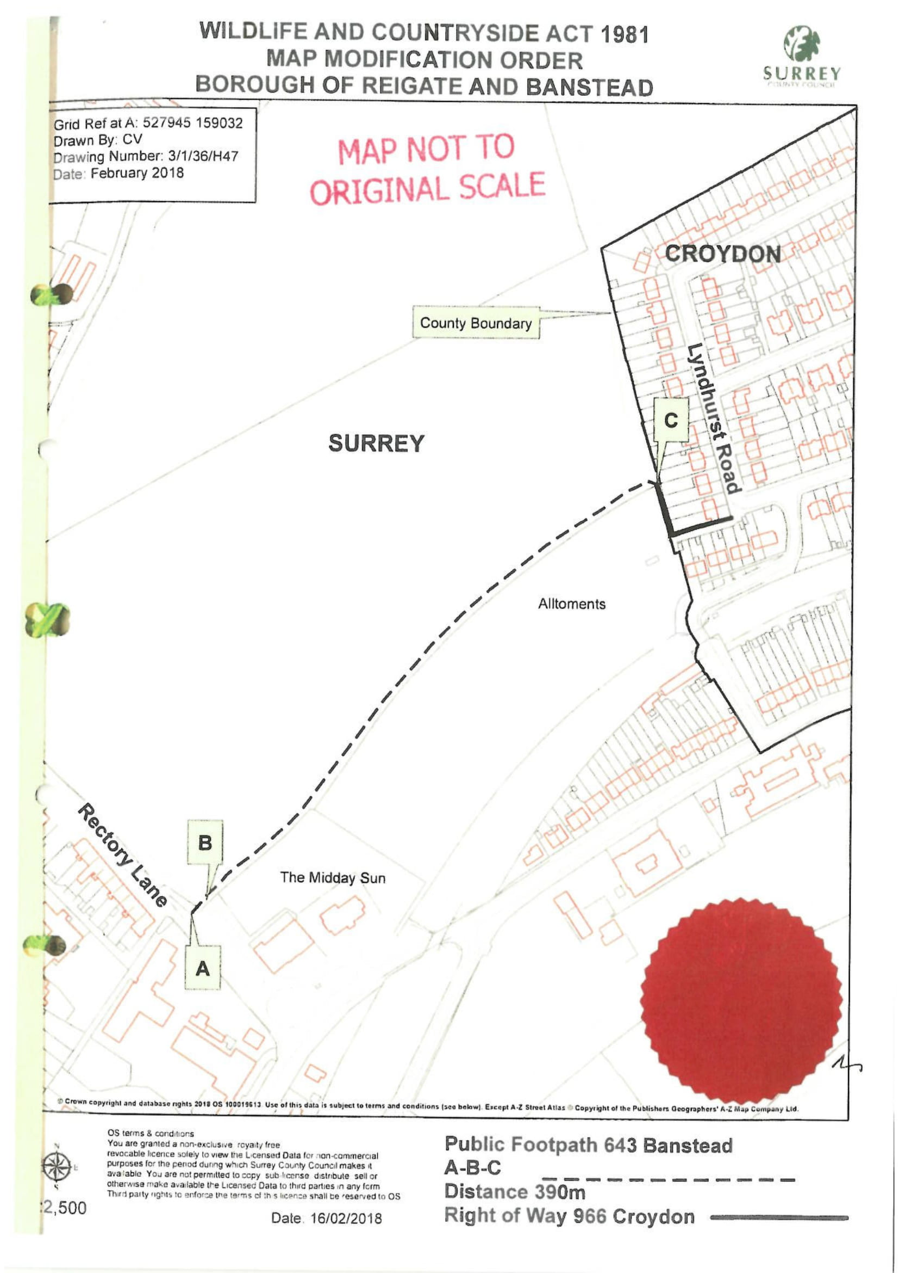

ROW/3228626 (B)
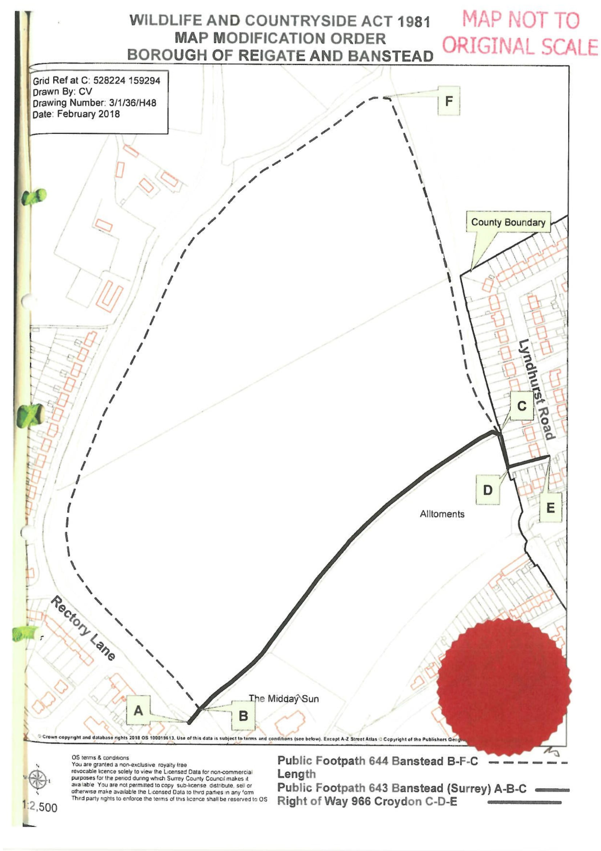

ROW/3228627 (C)
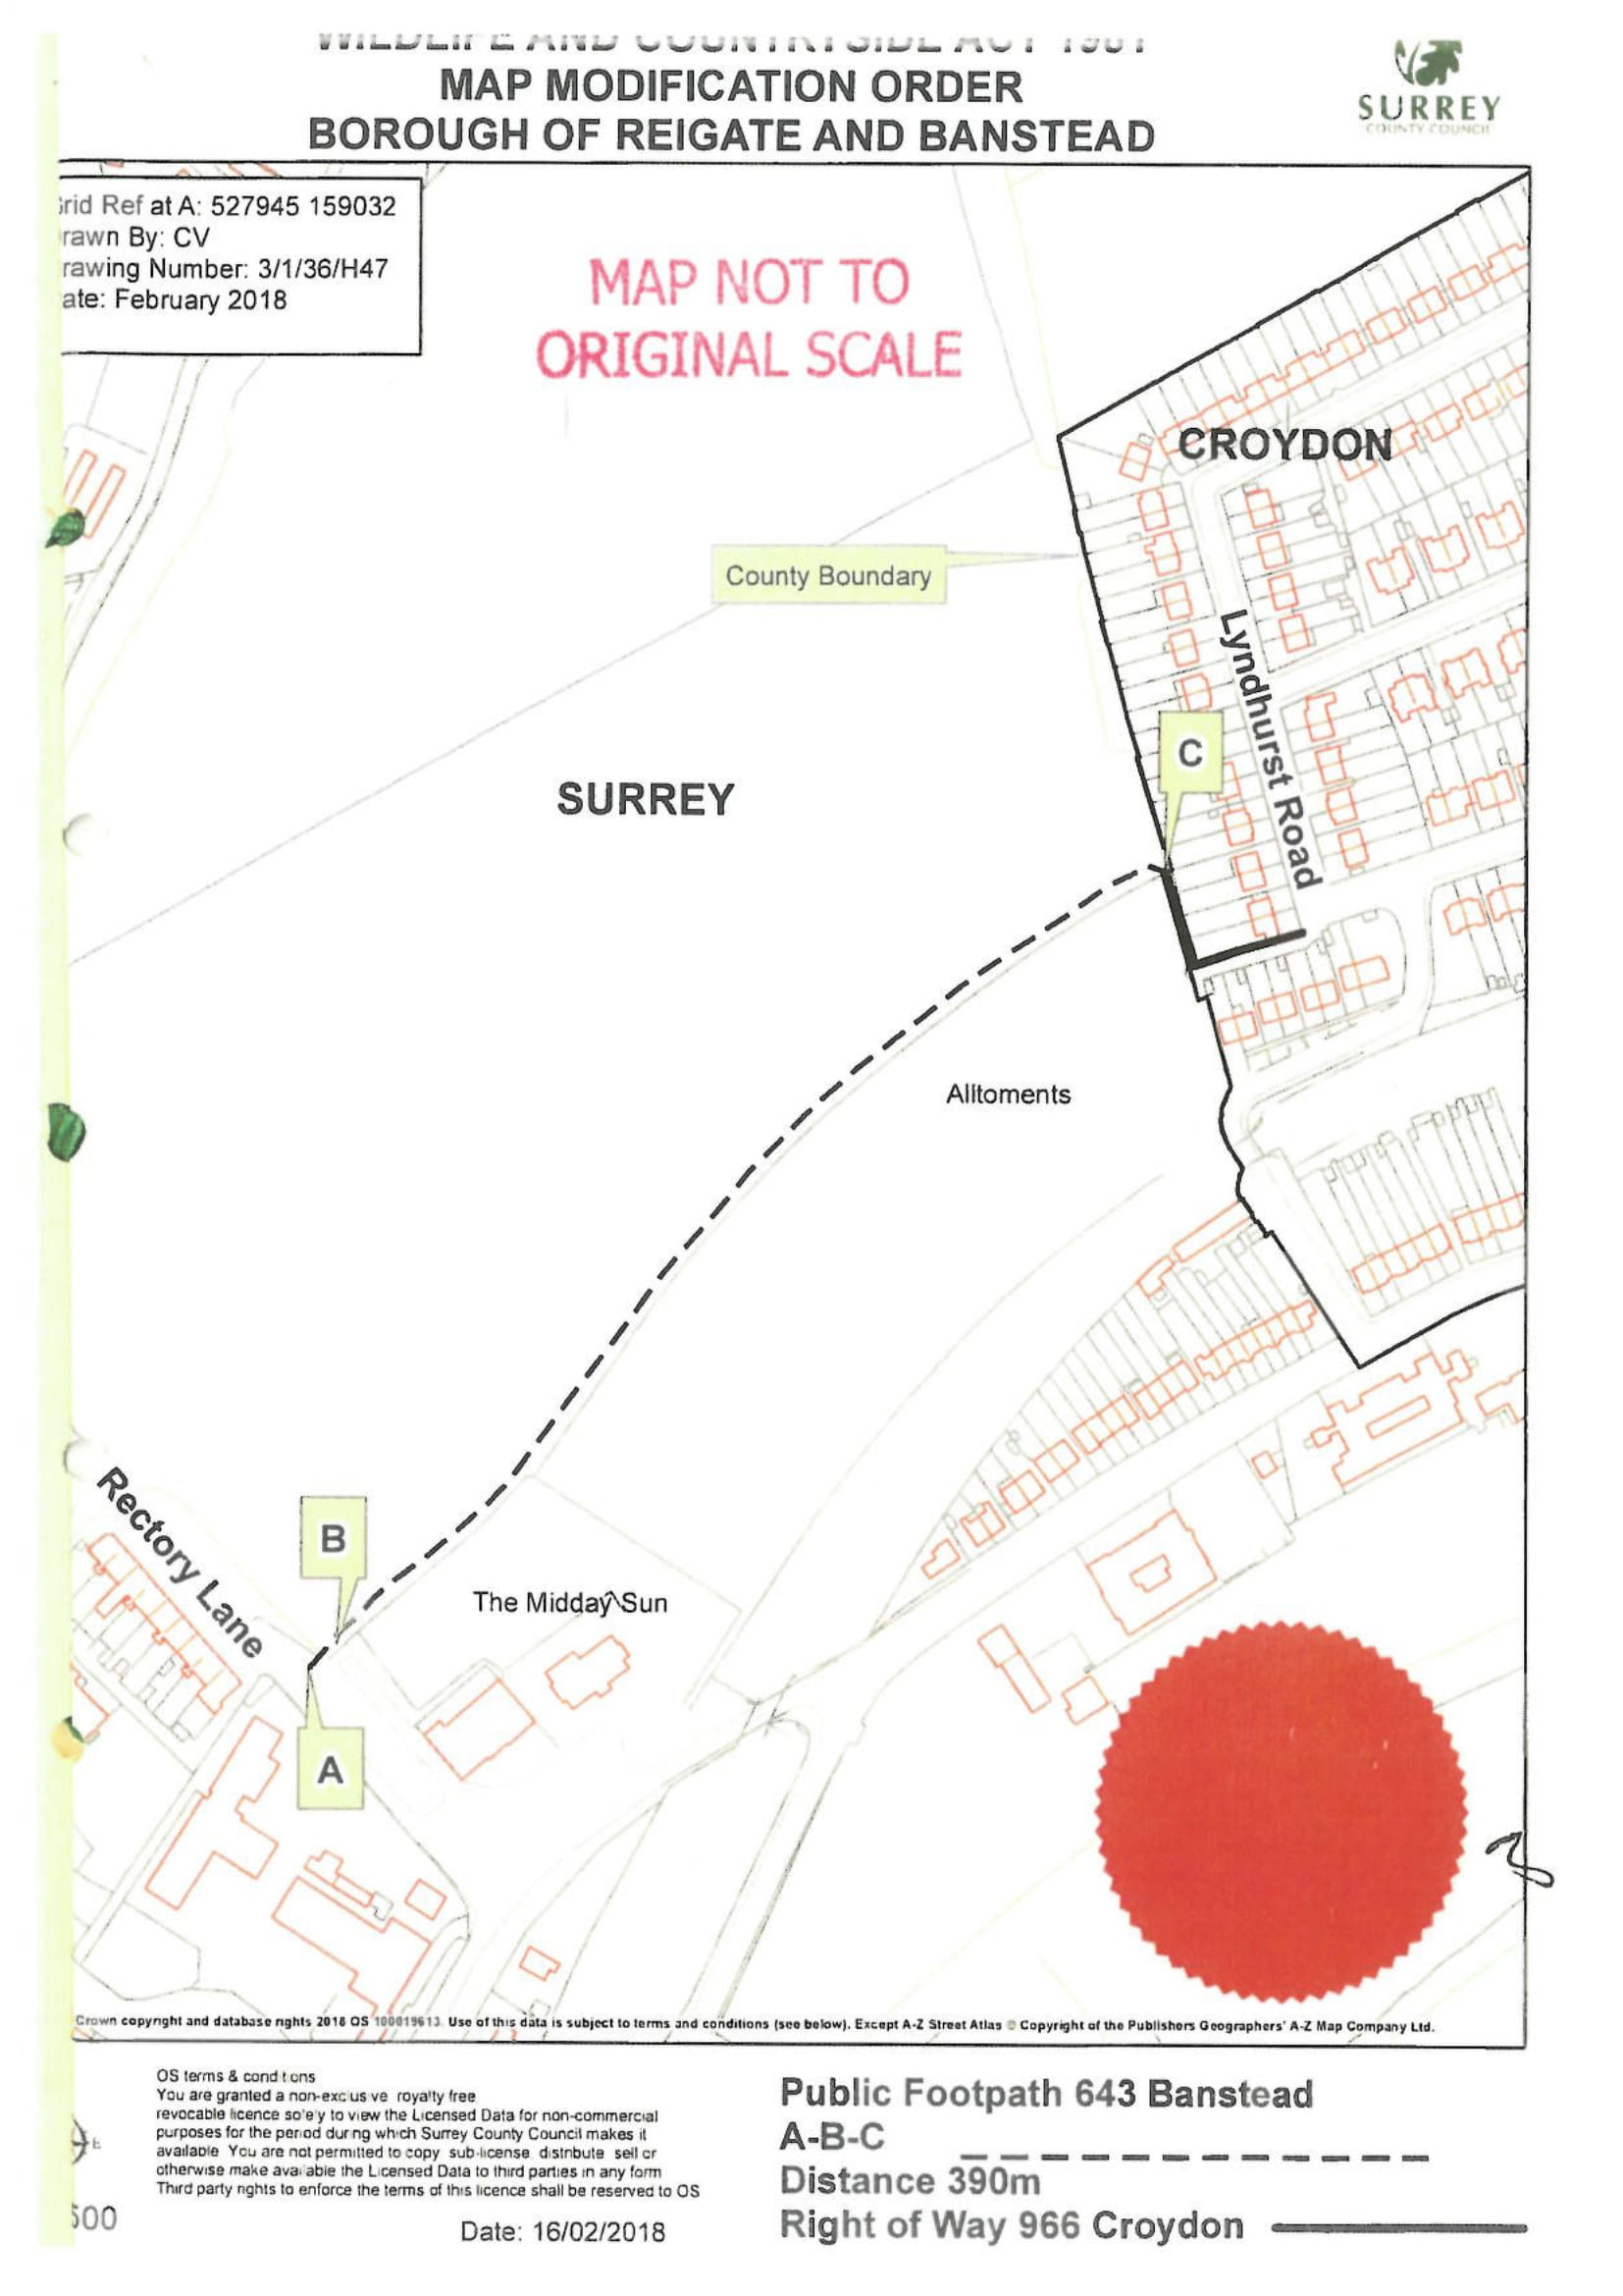
ROW/3228628 (D)
