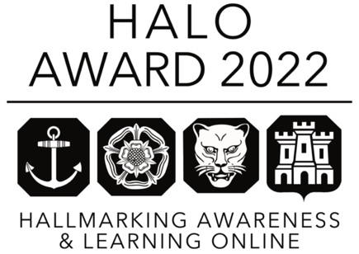
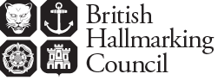

HALO Award
Hallmarking Awareness and Learning Online
Retailer submission

Hallmarking protects both the consumer and the trade. The HALO Award recognises online retailers who have best promoted the importance and reassurance of the UK Hallmark to potential customers and thereby used their compliance with hallmarking legislation to benefit the business.

Please send your submission to:

British Hallmarking Council Secretariat
britishhallmarkingcouncilsec@gmail.com

Submission deadline: 16 September 2022

The winner of the HALO Award will be the retailer judged to have delivered the most effective online initiative/s to promote the education of potential customers about hallmarking and display of the hallmarking Dealers Notice.

You should ensure, when completing your submission, that you comprehensively address each listed item individually and specifically.

Retailer details:

Business Name | Website/E-commerce Store
Contact | Position
Telephone No. | Email
Main Business Address | Postcode

We are looking to recognise simple and creative initiatives that assist with the education and promotion of hallmarking in the UK. We will take into account the size of the business and resources it may be able to allocate.

Submission content

In your submission you should set out:

Section 1 A description of the activities undertaken to educate potential consumers about hallmarking

Section 2 Details of what information on hallmarking you have provided in your online retail site

Section 3 How this promotes the importance and reassurance of the UK hallmark to potential customers Please note that particular importance is attached to this Section

Section 4 Details of any social media campaigns, press campaigns, printed materials, and any other initiatives you have undertaken, setting out:
- The objective of the activity
- The target audience
- A description of the activity
- Outcomes of the activity

Section 5 Any suggestions you can make to raise the profile of hallmarking to consumers in the UK.

Examples

Some examples of areas where we would be looking for creative input:
- Prominence of ‘Dealers Notice B’ or other explanation of hallmarking in your online store
- Social media content/posts/shares/likes promoting hallmarking
- How you demonstrate your business’s commitment to UK hallmarking
- Any links to additional pages where more information can be found – either internal or external links
- Details of any external press coverage
- Printed material eg inserts into shipment packages

How submissions will be judged

Marks will be awarded for each Section listed above against criteria designed to measure the most effective initiative.

Please note that your entry will be marked entirely on the information which you include in the application and judges will not take account of any other knowledge that they may have of your activities.

There is no word limit on the submission but please be mindful that content is more important than brochure quality presentation. The judges’ principal responsibility is to consider the scope, effectiveness and outcomes related to the submission. It is important to include supporting evidence of all the good work that you have done.

The BHC reserves the right not to grant the award, if it is of the opinion that none of the submitted applications merits an award.

Announcement and presentation of the HALO Award

All submissions will be acknowledged by the BHC Secretariat.

Winners will be notified by email to the email address set out in the submission. The award will be presented at the NAJ’s Benevolent Ball on 8 December 2022.

The prize includes:
- A magnificent silver salver, to be held for one year
- A year’s subscription to the Assay Assured scheme
- The use of a banner on the winner’s website and other marketing material proclaiming “Winner of HALO Award 2022 for online excellence in consumer protection”.

