Contract Trends in the UK Labour Market
HMRC
May 2022
Report authors: David Power, Lorna Adams, Rory Jackson, Andrew Price. IFF Research

The views in this report are the author’s own and do not necessarily reflect those of HM Revenue and Customs.
Research report number: 652

© Queen’s Printer and Controller of HMSO 2022
This publication is licensed under the terms of the Open Government Licence v3.0 except where otherwise stated. To view this licence, visit nationalarchives.gov.uk/doc/open-government-licence/version/3.
Where we have identified any third party copyright information you will need to obtain permission from the copyright holders concerned.
Published by HM Revenue and Customs, July 2022

Contents
1 Glossary 4
2 Executive Summary 5
3 Background 7
4 Methodology 10
5 The screened in group in the population 13
6 Working arrangements 25
7 Contractual arrangements 33
8 Nature of work 40
9 Knowledge of tax contributions and employment status 47
10 Appendix A – Technical appendix 55
11 Appendix B – Figures as tables 58
12 Questionnaire 86

Glossary
This glossary provides definitions for key terms used throughout this report:
- CATI – Computer-assisted telephone interviewing. A survey technique where the interview is conducted over the telephone using software that provides the script and automatically updates the flow of the questionnaire based on respondent answers, and allows for data collection
- Gig economy – Work that is characterised by short term arrangements and/or ‘on demand’ arrangements. Gig workers include independent contractors, online platform workers, contract firm workers, on-call workers and temporary workers. It should be noted this definition differs from the one used in 2018 research undertaken on behalf of the Department for Business, Energy and Industrial Strategy
- HMRC – Her Majesty’s Revenue and Customs. A non-ministerial department of the UK Government responsible for collecting tax
- NI – National Insurance. A mandatory tax on earnings, which qualifies an individual for certain benefits and the State Pension
- ONS – Office for National Statistics. A non-ministerial department of the UK Government that produces official statistics relating to the economy, population and society at national, regional and local levels
- PAYE – Pay As You Earn. The system used by employers and pension providers to deduct Income Tax and National Insurance contributions before they pay an individual’s wages or pension
- RDD – Random digit dialling. A method of creating a list of phone numbers, by randomly generating landline and mobile telephone numbers
- Screened in group – The primary population of interest for this research
Workers were categorised as ‘screened in’ and asked additional questions based on their working arrangements. Specifically, if they had freedom to choose their own working hours and if tax and NI contributions were deducted from their pay before they received it
- Zero-hour contracts – A type of contract whereby the employer does not have to guarantee the employer a minimum number of working hours. The employee is not obliged to accept the work offered by the employer

Executive Summary
Introduction

  - HM Revenue and Customs (HMRC) commissioned IFF Research to conduct quantitative research to gain a greater understanding of the prevalence of different types of employment contract within the working population of the UK. Specifically, the research was concerned with the more flexible ways workers provide their services and the ways employers engage them to carry out work.
  - The number of people working in the ‘gig economy’ and on zero-hours contracts has risen substantially over the past 10 years, as has the number of people finding work through digital platforms. To understand how the tax system applies to current contractual and technological developments, HMRC requires a greater understanding of these different types of employment arrangements.
  - As well as establishing the prevalence of different types of employment contract, the research was also concerned with the nature of the work being carried out by those considered to be engaged in these more flexible employment arrangements.
  - The results are based on a representative survey of the working population in the UK. 4,001 interviews were conducted via a CATI (Computer Assisted Telephone Interviewing) approach using randomly generated phone numbers to ensure a representative spread. Fieldwork took place from 12 August 2021 to 20 September 2021.
Prevalence rate of the screened in group
  - Workers who stated that they had choice over the hours and days that they worked (either that they had total choice or generally had choice) and who had tax and NI (National Insurance) contributions deducted from their pay before they received it, were categorised as the ‘screened in group’ (broad definition). A subset of this group who had ‘total choice’ to choose the days and hours that they worked were defined as meeting the narrow definition of the screened in group.
  - 16% of respondents met the broad definition of the screened in group. Based on a total working population of approximately 32.5 million in the UK, this equates to 5.2 million people engaged in the working arrangements of the screened in group. That is, they have choice over their working pattern and that tax and NI is deducted from their pay.
  - 5% of respondents met the narrow definition of the screened in group. This equates to 1.6 million people who have total choice over their work pattern and who have tax and NI deducted from their pay.

Contractual arrangements and nature of the screened in group
  - Respondents from the screened in group were asked additional questions related to their contractual arrangements and the nature of their work. The following points set out some of the key findings:
- despite tax and NI being deducted from their pay, 5% of the screened in group state that they were not entitled to any employment rights or benefits. Amongst those who met the narrow definition this was significantly higher as 12% state they are not entitled to any employment rights or benefits
- 21% of the screened in group make themselves available to work by logging on to an app or website. This is most common in the Wholesale and Retail sector, in which 38% make themselves available by logging on to an app or website
- the vast majority, 89%, of the screened in group see their job as stable
- 46% of the screened in group can have their performance publicly rated by end-clients. This is most common in Accommodation and Food Service sector where 70% can have their performance publicly rated
Knowledge of employment status and understanding of tax obligations
  - There was potential complexity in regard to employment status and tax collection that could arise as a result of arrangements that do not fit easily into existing categories of employment. For this reason, an important objective of the research was to understand the extent to which the screened in group had been informed and understood such matters.
  - The screened in group were asked whether they had had a conversation with their employer or if they had been given information regarding their employment status – 55% stated that they had not had such a conversation or information about their employment status. Despite this, regardless of whether they had had such a conversation or information, the vast majority (98%) were confident that they understood their employment status.
  - The vast majority of the screened in group (90%) were confident that they understood their tax obligations.

Background
Context

  - HMRC commissioned IFF Research to conduct quantitative research to gain a greater understanding of the prevalence of different types of employment contract within the working population of the UK.
  - The UK labour market has changed markedly in recent years, adapting to the more flexible way individuals want to provide their services and the more flexible ways engagers want to contract workers for those services.
  - This has resulted in more flexible hiring models and contractual arrangements that are different from those seen in the relatively recent past. For instance, according to the ONS (Office for National Statistics) Labour Force Survey, the number of people with zero-hour contracts increased fivefold since 2001, whilst the number of people self-employed has increased from 3.3 million in 2001 to 4.8 million in 2017.
  - However, the picture in 2021 (when this research took place) was less clear as it has been reported that there has been a decrease in self-employment since the onset of the Covid-19 pandemic. It should be noted that full-time employment is the main type of work found in the labour market.
  - There has also been a steady increase in the use of digital platforms through which individuals access work across a range of industries and sectors. For example, research from the Foundation for European Progressive Studies (FEPS) indicated the number of adults in the UK performing paid tasks via online platforms doubled from 4.7% in 2016 to 9.6% in 2019.
Employment status
  - There are three types of employment status for employment rights purposes:
- Employees
- Workers
- The Self-Employed
The government provides guidance for employment status to help individuals and those employing them understand what their rights are.
  - Employment legislation defines employment status for the purposes of most employment rights and protections, is set out in the Employment Rights Act 1996, section 230. In a similar way to the tax framework, the courts have provided an interpretation of the legislation to form a body of case law which underpins the definition of employment status for rights. Employment status is not just a matter of what a contract (whether oral or in writing) states; it is determined by the reality of the working relationship between employer and individual, taking account of all the circumstances.
  - All workers have employment rights, although employees have more employment rights than workers. Generally, the self-employed do not have statutory employment rights but are entitled to some health and safety protections/obligations as well as anti-discrimination rights when they are contracted by a customer or client.
  - For tax purposes, there are two types of employment status: Employed and Self-employed. For most occupations, the rules that determine employment status for tax purposes are not set out in legislation, and instead rely on a body of case law that has developed over many decades. Case law requires employment status to be determined by consideration of a broad set of factors that point towards one status or another. This means that employment status cannot be determined according to a single factor. It is necessary for the facts of individual cases to be considered against other relevant factors.
  - The government provides guidance and support to help people understand employment status for both employment rights and tax purposes. It is usually quite clear to an individual, and to the organisation paying that individual what their employment status should be based on their contracts and the working arrangements. However, as individuals move into more flexible working arrangements (see 2.2) it may become less apparent to them what the employment status for the work they do should be. This could create difficulties in relation to access to employment rights and benefits, and the declaration and payment of any taxes that should be due.
Objectives
  - To understand how the tax system applies to current contractual and technological developments, HMRC requires a greater understanding of the prevalence of workers’ more flexible contractual arrangements.
  - The specific objectives of the research were:
- establish a prevalence rate of individuals in the UK workforce whose work contracts allow them to set their own working pattern, and who can choose to accept or refuse work being offered
- estimate the number of individuals in the UK workforce who work in this way and who also use a digital platform or their engagers’ website to get access to paid work
- understand the tax treatment applied for such engagements, i.e. whether the pay is subject to PAYE (Pay As You Earn) deductions
- to get a better understanding of: a) whether such individuals have ever considered their employment status for tax; b) how individuals who are working in these ways perceive their employment status for tax; and c) which sources they use to get their information on employment status for tax from.
- establish the sectors of the economy in which these arrangements and workers are most commonly found

Methodology

  - This report is based on a survey of the working population in the UK. The survey was conducted via a CATI (computer assisted telephone interviews) approach. A total of 4,001 interviews were completed with a representative cross-section of the working population. Prior to the mainstage fieldwork, a development phase was conducted that included a round of cognitive interviews and a pilot of the questionnaire. This chapter provides further details of the development phase, mainstage fieldwork, and analysis and reporting phase.
Development phase
Questionnaire design
  - The questionnaire used for the survey was drafted by IFF Research in the first instance and was subjected to an iterative and collaborative process of review and amends between IFF Research and HMRC. A primary focus of the questionnaire design was to establish the prevalence rate of the screened in group in the UK, as well as to gather details as to the nature of this type of work. For this reason, the questionnaire was effectively split into two parts.
    - The purpose of the first part of the questionnaire was to identify respondents whose work arrangements meant they could be ‘screened in’ to the second part of the questionnaire.
    - The second part of the questionnaire was administered only to those categorised as the ‘screened in group’ and was related to the nature of their work. Specifically, this included questions on firmographic information, job stability and availability of work, how they make themselves available for work, whether their work can be publicly rated/reviewed, choice over working pattern, and the obligation to accept work offered.
  - A consideration that had an impact upon the design of the questionnaire was the need to accommodate those with multiple jobs. By doing this, respondents who engaged in work practices characteristic of the screened in group alongside their ‘main job’ could also be screened in and would not be missed in the analysis.
  - The questionnaire also aimed to take into account the impact of the coronavirus pandemic. Respondents who were currently not in work were still able to take part in the survey if they were in work in February 2020 i.e. before the coronavirus pandemic. To account for these considerations, additional questions were asked and sections were repeated depending on the respondent’s answers. In total, respondents had the opportunity to answer questions for up to six jobs.
Cognitive interviews
  - After the initial design phase, 8 cognitive interviews were held. The purpose of the cognitive interviews was to gauge respondent comprehension of questions and answer options as well as their views on survey relevance and flow. Improving these aspects of the questionnaire should have the effect of improving the overall quality of data collected in the survey. The interviews lasted approximately 45 minutes and were held over video call. Respondents were asked the survey questions as well as additional open-ended questions about the survey and their thought processes when formulating answers. After analysis of the cognitive interviews a number of changes were made to question wording and order.
Pilot and Mainstage fieldwork
  - The survey was administered via a CATI approach using a combination of randomly generated landline phone numbers (RDD – random digit dialling) and randomly generated mobile phone numbers (Mobile RDD) to ensure representative coverage. The randomly generated numbers were supplemented with ‘lifestyle’ sample which is a large database of individuals compiled from different sources with some demographic data attached. Using lifestyle sample as a supplement to the RDD allowed for some targeting of underrepresented groups during fieldwork.
  - All interviews were conducted through IFF’s in-house field department.
Pilot
  - Between 26 July 2020 to 30 July 2020, 50 pilot interviews were conducted. These interviews were administered in exactly the same way as the mainstage interviews. This provided the opportunity to test the process and to monitor response patterns.
Mainstage
  - The mainstage fieldwork was conducted between 12 August 2021 to 20 September 2021. A total of 4,001 interviews were completed at an average length of 12 minutes and 27 seconds.
Analysis and reporting
Weighting
  - On completion of fieldwork, calibration weights were applied by age, gender, ethnicity, and region to bring the sample in line with the profile of the working population. The weights were based on the most recently available data from the ONS Labour Force Survey. Details of the calibration weights are included in the technical appendix.
How to read this report
  - Where a difference between sub-groups is referred to as significantly different, this indicates 95% confidence that a ‘real’ difference exists between this sub-group and the other group of comparison. Such significant differences are also shown with an asterisk ‘*’ in the charts.
  - If respondents had more than one job, they had the opportunity to answer questions for up to a total of six jobs. Data is reported at the respondent level throughout, not the job level – this means that totals for single choice questions relating to jobs can exceed 100%. The average number of jobs in the total sample was 1.1 – analysis of data at the job level showed no/little difference in results and was therefore not considered to be of additional value to include in the report.
  - Throughout the report, findings are reported for the ‘screened in group’ at the level of the ‘broad definition’ and the ‘narrow definition’ (see Figure 4.2). As the broad definition encompasses all of the screened in group, references to ‘the screened in group’ relate to the broad definition. When reporting on findings relating to the narrow definition or comparing the definitions against each other, the report will specifically indicate which of the definitions is the subject.
  - The report makes reference to employment rights and benefits. ‘Employment rights’ refers to statutory employment rights, and statutory payments that employees are legally entitled to. ‘Benefits’ refers to non-statutory benefits that an employer may offer to their employees.
  - This research was commissioned to inform the tax framework only, and all survey responses that refer to employment status are assumed to refer to the tax framework.
  - Below each figure there is a link to a corresponding table in the annex.

The screened in group in the population
Key findings:
16% of the working population were categorised as the ‘screened in group‘, as they had tax automatically deducted from their pay and were able to choose their own working pattern (here described as having met the ‘broad’ description of the screened in group). This equates to 5.2 million people
5% of the working population reported they had ‘total choice’ to set their own working pattern and had tax automatically deducted from their pay (here described as having met the ‘narrow’ definition of the screened in group, they are also included in the ‘broad’ group). This equates to 1.6 million people
workers aged 65 and older were particularly likely to be in the screened in group (21% met the broad definition compared to 16% overall; 11% met the narrow definition compared to 5% overall)
there was little difference in the profile of the screened in group compared to all workers (or between those who met the broad and narrow definitions) by gender, health / disability status, ethnicity or region / nation
the screened in group were most likely to be in the Human Health and Social Work sector (18% of those who met the broad definition and 23% of those who met the narrow)
the screened in group were more likely than workers in general to be corporate managers and directors or other managers and proprietors (17% who met the broad definition and 24% who met the narrow compared to 10% overall). The screened in group were also more likely to have an income over £40,000 (23% of both those that met the broad and narrow definitions compared to 17% of all workers)

  - This chapter begins by establishing the definition of the screened in group that this report is based on. It then sets out incidence rates of the screened in group within the overall working population using both the broad definition and narrow definitions, shows the incidence rates of workers engaging in this type of work within specific demographic groups, and profiles the makeup of the screened in group.

The screened in group
Definitions
  - Research participants were asked a series of questions about their ‘main job’, in order to establish whether it was in the ‘screened in group’. Those with multiple jobs were also asked these questions for up to five jobs in addition to their ‘main’ job.
  - Workers were categorised as meeting the broad definition of the ‘screened in group’ if at least one job met two conditions: tax was deducted from their pay before they received it; and they were able to choose their own work pattern. The specific question wording is set out below:
- A2/B4 –Thinking about your job, are tax and National Insurance Contributions deducted from your pay before you receive it?
(1) Yes, they are deducted from my pay
(2) No, they are not deducted from my pay
- A11/B2 –Which of the following statements best describes the amount of control you have over the days and hours you work?
(1) I have total control to work the hours/days I choose and I do not have to notify or make arrangements with my employer and/or client(s) in advance i.e. I am solely able to decide when I work, whether that be day or night, and it can be any day of the week
(2) I am generally able to choose the hours/days I work but I am expected to give my employer and/or client(s) notice and/or be available at certain times
(3) I generally have to work the hours/days my employer and/or client(s) requests unless agreed in advance
(4) I always have to work the hours/days that my employer and/or client(s) requests
  - The screened in group were then further categorised into a ‘narrow’ definition if they had ‘total choice’ over their work pattern (A11/B2 = 1).
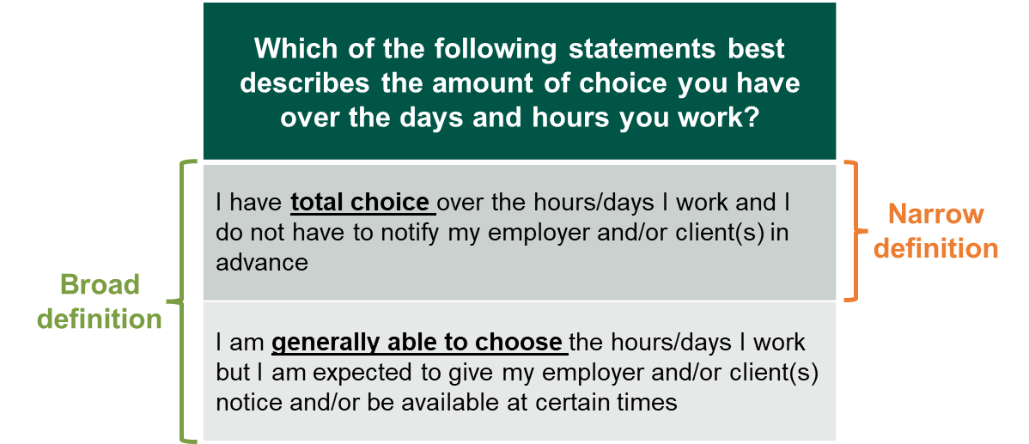
Figure 4.1 Narrow and broad definitions of the screened in group

A2/B4. Now, thinking about your job, are tax and National Insurance Contributions deducted from your pay before you receive it? Base: All respondents (4,001) / A11/B3. Which of the following statements best describes the amount of control you have over the days and hours you work? Base: All respondents (4,001)
Data from Figure 4.1 as a table in the appendix
Exclusions from the screened in group
  - 62 workers were excluded from the analysis of the screened in group, despite meeting the criteria above, for one of or both of the following reasons (the groups were not mutually exclusive):
- 25 were self-employed and worked in the construction industry. These respondents were subject to the Construction Industry Scheme which has different rules to most working arrangements
- 54 were self-employed and received no employment benefits. This small number of respondents gave responses that were contradictory (i.e. they reported that tax and National Insurance contributions were deducted from their pay and that they were self-employed), so their working arrangements were unclear
Incidence rate
  - Around one in six (16%) UK workers had at least one job which meant they met the broad definition of the screened in group and five per cent met the narrow definition (as shown in Figure 4.2). Similarly, of those who were not in work at the time of research but were in work prior to the Covid-19 pandemic (in February 2020), one in five (19%) met the broad definition of the screened in group and six per cent met the narrow definition. The make-up of the pre-pandemic and post-pandemic categories here are not directly comparable as the pre-pandemic data is exclusively for people who were no longer working by the time of the survey.

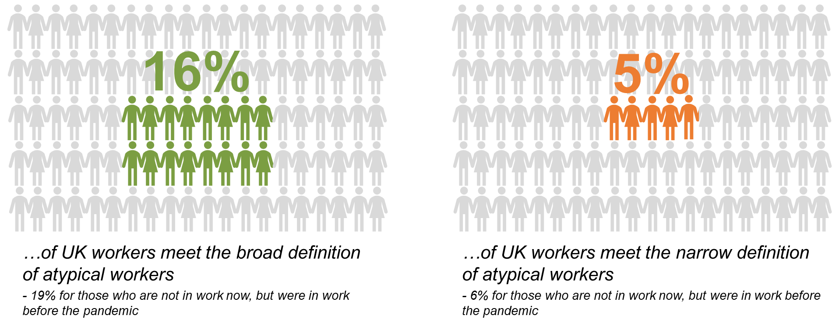
Figure 4.2 Incidence rate of broad and narrow definitions of the screened in group
…of UK workers meet the broad definition of the screened in group
- 19% for those who are not in work now, but were in work before the pandemic
…of UK workers meet the narrow definition of the screened in group
- 6% for those who are not in work now, but were in work before the pandemic

A2/B4. Now, thinking about your job, are tax and National Insurance Contributions deducted from your pay before you receive it? Base: All respondents (4,001) / A11/B3. Which of the following statements best describes the amount of control you have over the days and hours you work? Base: All respondents (4,001)
Data from Figure 4.2 as a table in the appendix

  - Based on an overall UK working population of approximately 32.5 million people, 16% of workers meeting the broad definition equates to 5.2 million people and 5% of workers meeting the narrow definition equates to 1.6 million people.

Incidence rates of the screened in group within demographic groups
  - The next section looks at the incidence of the screened in group by gender, age, region, ethnicity, and health/disability status.
Gender

  - Similar proportions of male (16%) and female (15%) workers met the broad definition of the screened in group (as shown in Figure 4.3). The same proportions of male (5%) and female (5%) workers met the narrow definition.

Figure 4.3 Proportion of workers of each gender that were screened in group
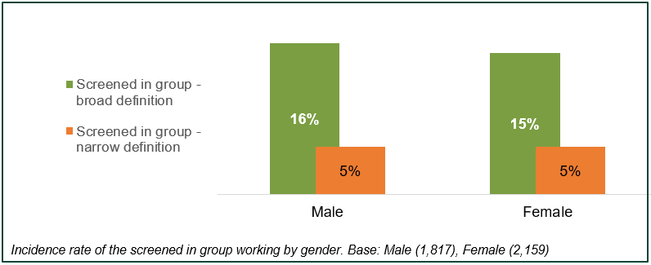
Data from Figure 4.3 as a table in the appendix

Age
  - Workers aged 65 and older were the age group most likely to meet the broad (21%) and narrow (11%) definitions of the screened in group (as shown in Figure 4.4 There was a significant difference between the proportion of the 16-24 age group meeting the narrow definition (3%) compared to the 6% meeting the narrow definition in both the 45-54 and 55-64 age groups. .4). Relatively similar proportions of workers from younger age groups met the broad definition (between 14% and 18% in-line with 16% across all age groups). There was a significant difference between the proportion of the 16-24 age group meeting the narrow definition (3%) compared to the 6% meeting the narrow definition in both the 45-54 and 55-64 age groups.
Figure 4.4 Proportion of workers in each age group that were the screened in group
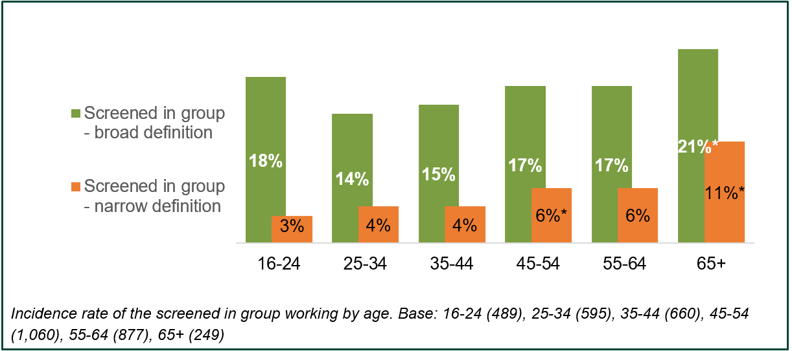
Data from Figure 4.4 as a table in the appendix

Ethnicity
  - There was some variation in the incidence by ethnic group but these differences were not statistically significant. As shown in Figure 4.5, 22% of those from Mixed / Multiple ethnic groups met the broad definition of the screened in group, but this was not significantly different from the 16% of White workers who did so. Similarly, the 8% of Black / African / Caribbean / Black British workers that that met the narrow definition of the screened in group was not significantly higher than the 3% of workers each with Mixed/ Multiple ethnicity or Asian/Asian British ethnicity.
Figure 4.5 Proportion of workers in each ethnic group that were the screened in group
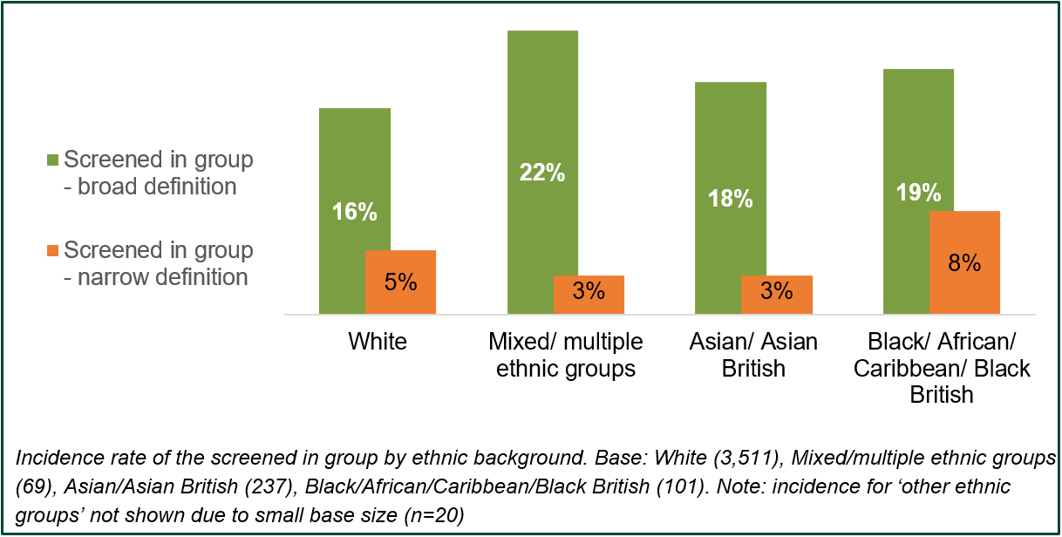
Data from Figure 4.5 as a table in the appendix

Region
  - There was little difference in the likelihood of workers from each of the UK regions or nations to have met the broad or narrow definition of the screened in group (as shown in Figure 4.6). A fifth of workers in London (19%) met the broad definition, which was significantly higher than the 12% of workers in the East of England.

Figure 4.6 Proportion of workers in each UK region / nation that were the screened in group
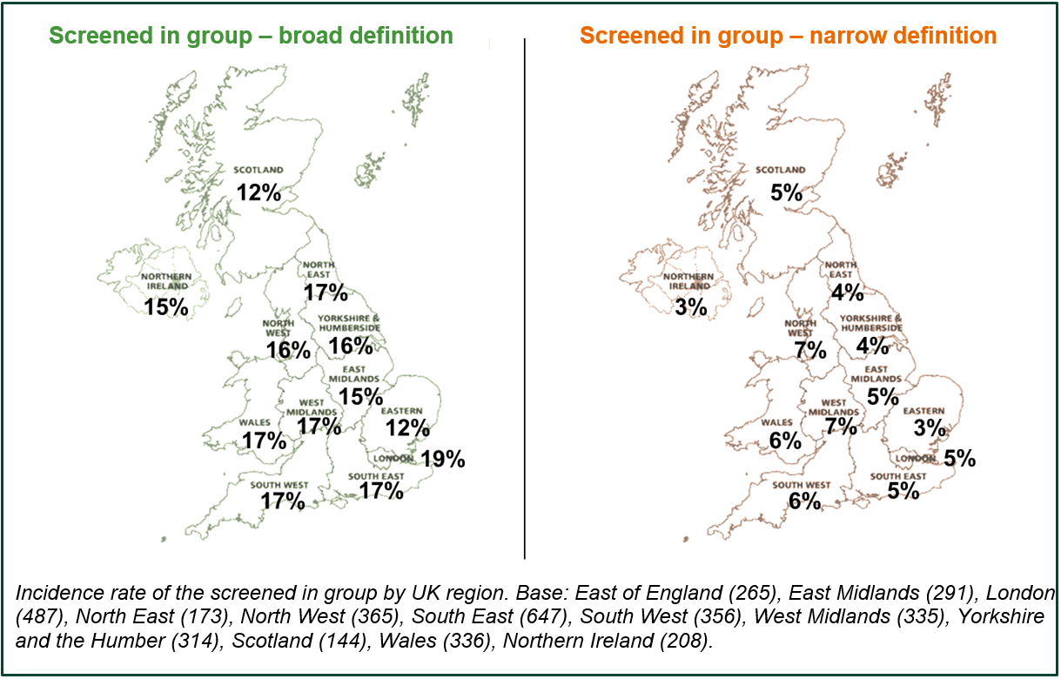
Data from Figure 4.6 as a table in the appendix

Long-term illness, health problem or disability status
  - Workers who had a long-term illness, health problem or disability were similarly likely to be part of the screened in group as those who did not. Fewer than one in six workers (14%) with such a condition met the broad definition of the screened in group, while five per cent met the narrow definition (as shown in Figure 4.7). Similarly, for the proportions of workers without a long-term illness, health problem or disability, around than one in six (16%) met the broad definition and 5% met the narrow definition of the screened in group.
Figure 4.7 Proportion of workers who had a long-term illness, health problem or disability that were the screened in group
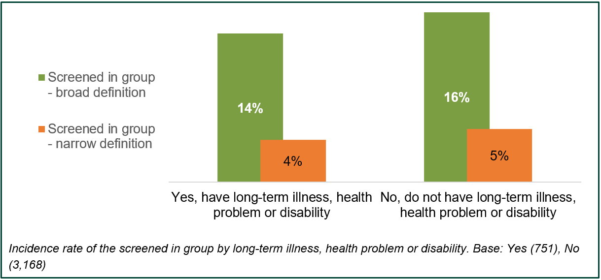
.
Data from Figure 4.7 as a table in the appendix

Sector, occupation, and income

Sector
  - Human Health and Social Work was the most common sector for the screened in group to work in (18% of those who met the broad definition and 23% of those that met the narrow definition), as shown in Figure 4.8.
  - Those who did not qualify for the screened in group were not asked the question regarding the sector in which they work. However, ONS data for September 2021 provides a useful point of comparison for the screened in group against the working population as a whole. The proportion of the screened in group that work in Human Health and Social Work is higher than the overall working population with 13% of the total UK workforce employed in this sector.
  - Another area of difference against the overall working population is in Wholesale and Retail Trade – 9% of the screened in group work in this sector (9% for the narrow definition) compared to 14% for the total UK workforce. The screened in group were also less likely to work in Administrative and Support Service Activities with 4% (5% for the narrow definition) working in this sector compared to 9% for the total UK workforce. Aside from these differences (which would be statistically significant had they been replicated in this survey), the sectoral distribution of the screened in group was broadly comparable to the UK workforce as a whole.
  - While the proportions in most sectors were similar across those who met both broad and narrow definitions of the screened in group, some significant differences did exist. Those that met the broad definition were more likely than those that met the narrow definition to have worked in Public Administration and Defence (10% vs. 4%). Those that met the narrower definition were more likely than those that met the broad definition to work in construction (7% vs. 4% respectively) or transportation and storage (7% vs. 4% respectively), both small but significant differences.
Figure 4.8 Sector profile – the screened in group
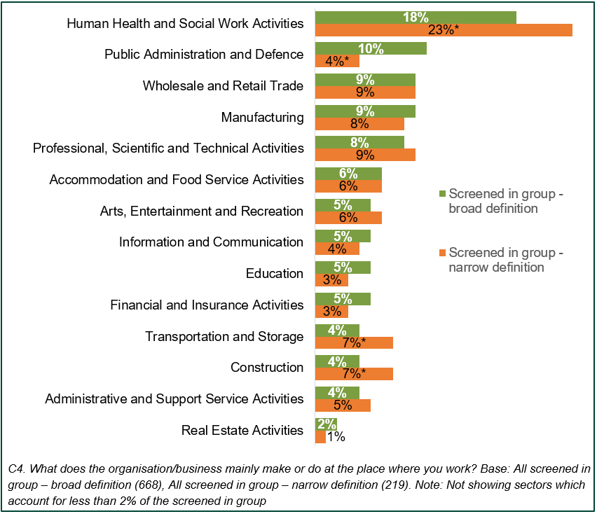
Data from Figure 4.8 as a table in the appendix
  - In terms of organisation type, around seven in ten of those that met the broad and narrow definitions of the screened in group worked for a business or private sector organisation (68% and 75%) (as shown in Figure 4.9).
  - Those that met the broad definition were significantly more likely to work for central or local government (18%) compared to those who met the narrow definition of the screened in group (9%). This reflects the smaller proportion of those that met the narrow definition who worked in public administration and defence and the higher proportion that worked for a business or private sector organisation.
  - A similar proportion of those that met the broad and narrow definition reported they worked for a charity or not-for-profit organisation (9% and 10% respectively).
Figure 4.9 Sector type profile - the screened in group
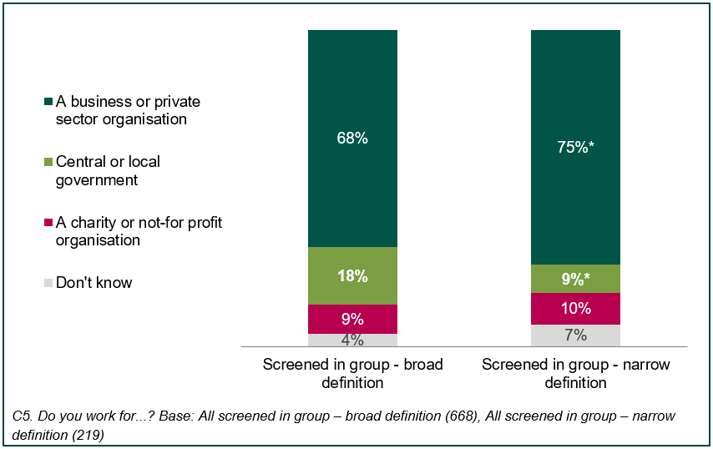
Data from Figure 4.9 as a table in the appendix

Occupation
  - The screened in group were notably more likely than the working population as a whole to be corporate managers and directors (9% who met the broad definition and 14% who met the narrow definition compared to 5% of all workers), they were also more likely to be other managers or proprietors (8% who met the broad and 10% who met the narrow definition compared to 5% overall). Together, 24% of those who met the narrow definition and 17% who met the broad were in one of these two generally higher skilled occupational groups compared to 10% of all workers.
  - The screened in group that met the broad definition were more likely to work as business and public service associate professionals (11% vs. 8% of all workers). A greater proportion of the screened in group that met the narrow definition worked in caring personal services occupations than amongst all workers (14% vs. 9% of all workers).
  - The screened in group were less likely to work as teaching and educational professionals (3% who met the broad definition and 2% who met the narrow definition compared to 6% of all workers).
Figure 4.10 Occupational profile - all workers and the screened in group
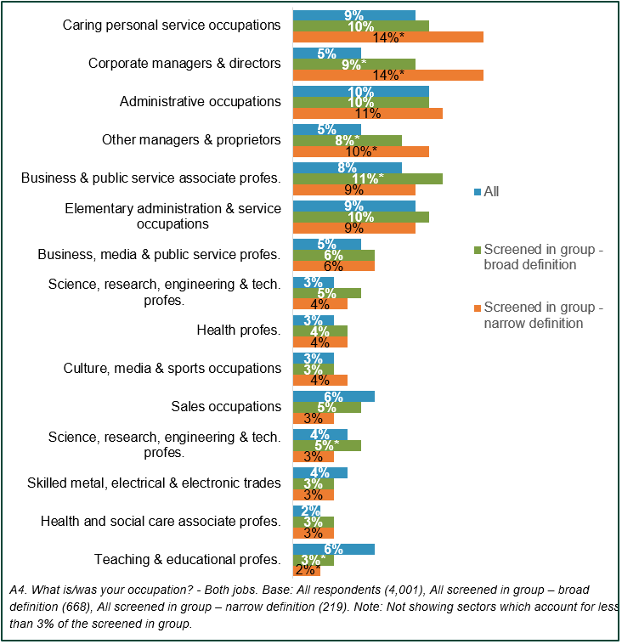
Data from Figure 4.10 as a table in the appendix

Income
  - Among those who provided their income, the screened in group were more likely to have a higher income, and less likely to have a lower income, than all workers (as shown in Figure 4.11). Around two fifths of those that met the broad (39%) and narrow (36%) definitions of the screened in group earned over £30,000 per annum gross but this applied to j one in three (32%) workers in general. At the higher end of the income scale, 17% of the screened in group (18% for the narrow definition) earned over £50,000 which was significantly higher than 11% of workers in general who were in this income bracket. While just over two thirds (68%) of all workers earned £30,000 or less, which is significantly different to the six in 10 (61% for the broad definition and 64% for the narrow definition) of the screen in group who earned £30,000 or less.
Figure 4.11 Income profile - all workers and the screened in group
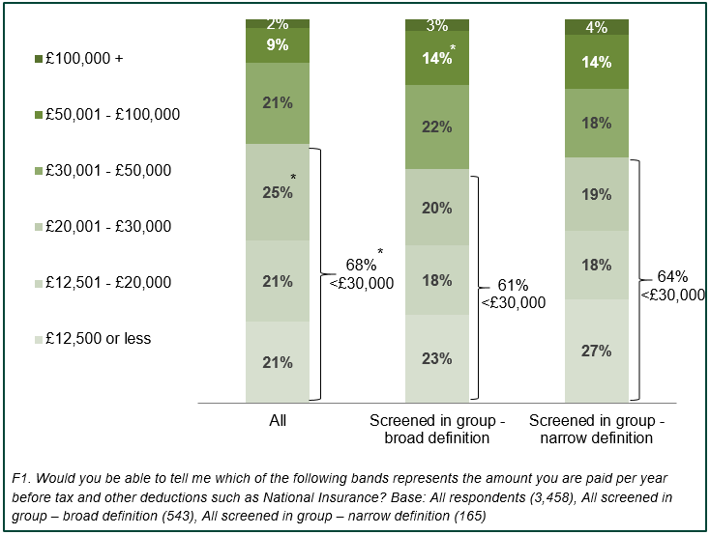
Data from Figure 4.11 as a table in the appendix

Working arrangements
Key findings:
based on analysis carried out to test the extent to which the screened in group had working arrangements that gave them some choice over their work pattern and earnings, 13% had total choice, 77% had partial choice and 10% had little/no choice of when to work
within the narrow definition 22% had total choice over their work pattern and earnings, 67% had partial choice and 11% had little/no choice for when to work
the screened in group with little/no choice were more likely to earn an income under £12,500, were more likely to be between the ages of 16-24 and over 65 and were less likely to identify as White than the screened in group with more choice over their work pattern and earnings
based on analysis carried out to categorise respondents on the dynamics of the employee – employer relationship, 61% were categorised as having ‘little/no commitment’, 19% ‘employer obligation’ (i.e. the employer was committed to offer work), 23% ‘employee commitment’ (i.e. the employee was committed to accept work), and 7% ‘common commitment’

  - This chapter seeks to establish the extent to which the screened in group could choose their working pattern and earnings, and the ability of the screened in group to accept or turn down work offered to them.

Choice
  - While respondents were asked about the extent to which they had choice over their working hours as part of the categorisation process for the screened in group, this test for choice is separate to that. The test covered in this section provides a more refined measure of choice based on a range of variables. The screened in group were categorised as having ‘total choice’, ‘partial choice’, or ‘little / no choice’ over their work pattern based on their answers to three questions:
- D1 – Can you conduct the work at any time you choose?
(1) Yes
(2) No
(3) To some extent

- D2 – Does the amount of work available to you fluctuate throughout the day?
(1) Does not fluctuate
(2) Does fluctuate but not much
(3) Fluctuates a lot
- D8 – Is the amount you are paid for your work predictable?
(1) Very predictable
(2) fairly predictable
(3) fairly unpredictable
(4) very unpredictable

  - As shown in Figure 5.1, 29% of the screened in group could conduct their work at any time that they chose. For those in the narrow definition this was significantly higher at 43%.
Figure 5.1 Can you conduct the work at any time you choose?
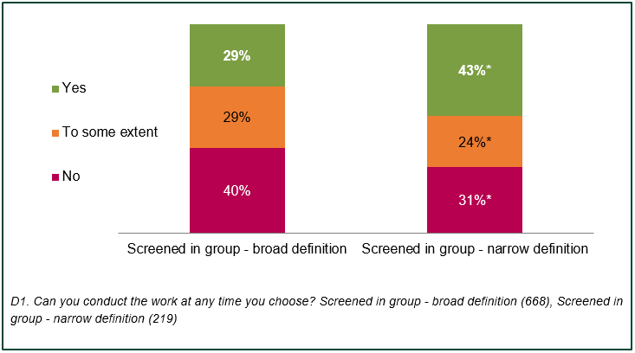
Data from Figure 5.1 as a table in the appendix
  - For 57% of the screened in group the work available to them throughout the day did not fluctuate, however the availability of work fluctuated a lot for 14%. The proportions for those in the narrow definition were similar as shown in Figure 5.2.
Figure 5.2 Does the amount of work available fluctuate throughout the day?
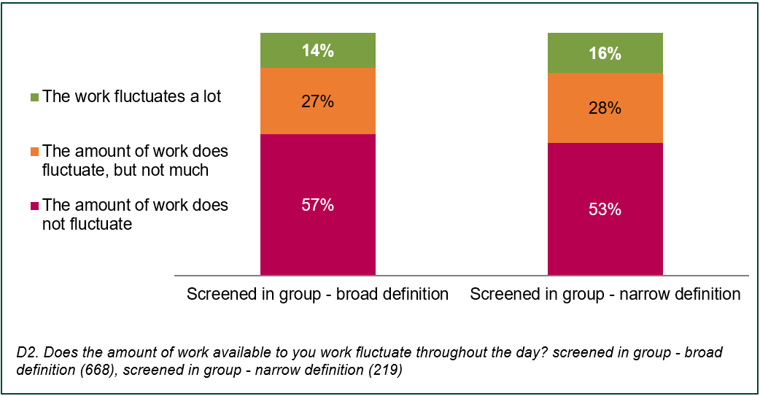
Data from Figure 5.2 as a table in the appendix

  - Three quarters (75%) of the screened in group stated that they were paid a very predictable amount for the work they do, with only 3% and 1% saying that their pay was fairly unpredictable or very unpredictable respectively. While still a large majority, only 69% of those in the narrow definition said that they were paid a very predictable amount, which is a significant difference compared to the broad definition. The full breakdown is shown in Figure 5.3.
Figure 5.3 Is the amount you are paid for your work predictable?
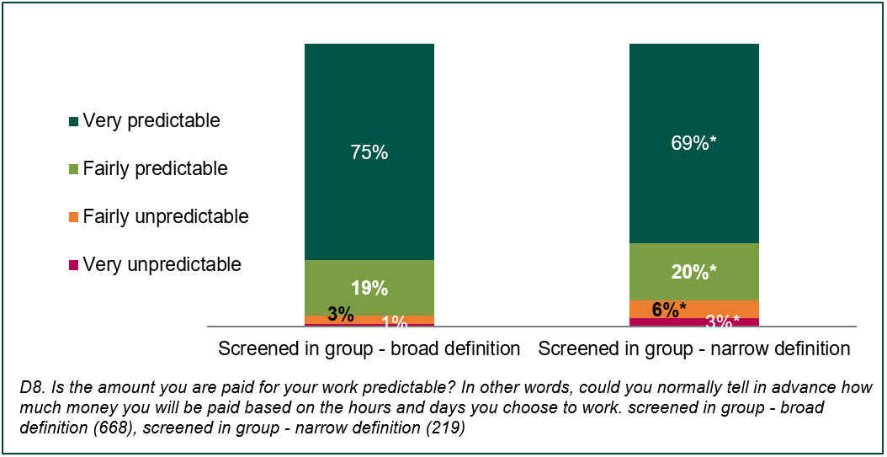
Data from Figure 5.3 as a table in the appendix
  - Those in the screened in group were categorised as having ‘total choice’ if they answered option 1 for each of the three questions outlined in paragraph 5.2. In other words, they were considered to have total choice if they could work at any time they chose, if the availability of work did not fluctuate, and if their pay was very predictable. They were considered to have ‘partial choice’ if at least one but not all of those conditions were met. They were considered to have ‘little / no choice’ if none of these conditions were met.
  - Based on this categorisation process, 13% of the screened in group had ‘total choice’ over their working pattern, 77% had partial choice, and 10% had little/no choice. When looking at the narrow definition, 22% had total choice which is significantly different from the broad definition, 67% had partial choice (also significantly different) and 11% had little/no choice over their working pattern.
Figure 5.4 Choice over working patterns
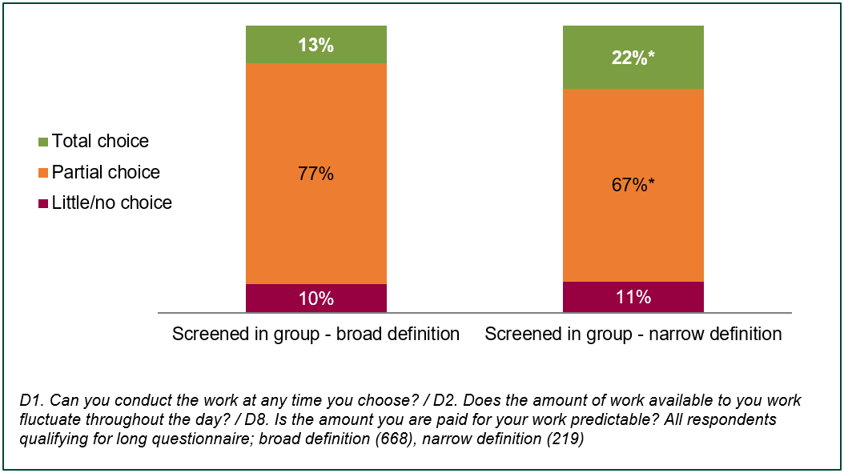
Data from Figure 5.4 as a table in the appendix
  - When looking at the characteristics of those in the different categories, there are a few significant differences of note:
- there were differences in income between the different categories, with those with little choice more likely to earn less than those with higher levels of choice. 37% with little/no choice earned less than £12,500 compared with 18% of those with partial choice and 12% of those with total choice. 58% with little/no choice earned £20,000 or less, compared with 32% of those with partial choice and 28% of those with total choice
- age is another area in which those with little/no choice differed from those with higher levels of choice. Those with little/no choice were significantly more likely to be at opposing ends of the age spectrum with 25% between the ages of 16-24 and 12% 65 or older. For those with partial choice the corresponding percentages were 10% and 5%; and for those with total choice it was 16% and 2%
- those with little/no choice were also more likely to identify as Non-White - 21% compared to 14% for those with partial choice and 10% for those with total choice

Commitment
  - The screened in group were also categorised based on the level of commitment between themselves as an employee and their employer. The categorisation was based on the following two questions –
- D5 – Are you able to turn down work that is offered to you?
(1) Yes, I can turn down work and there would be no repercussions
(2) Yes, I can turn down work but there may be repercussions
(3) No, I cannot turn down work
- D9 – If you were unable to carry out the work, or you chose to not do the work, would the [employer / client / customer] still be able to operate or carry out the intended task/service without you?
(1) Yes, they would be able to carry on as normal
(2) Yes, but to a lesser extent or they would need to adapt significantly
(3) No, they could not carry on as normal

  - As shown in Figure 5.5, a majority of the screened in group felt they were able to turn down work that was offered to them, though roughly one in ten of the screened in group felt they would face repercussions for doing so. The screened in group in the narrow definition were more likely to be able to turn down work without repercussions than the broad definition at 58% and 49% respectively. A quarter were unable to turn down work offered to them, however within the narrow definition this was significantly lower at 20%.
Figure 5.5 Employee ability to turn down work
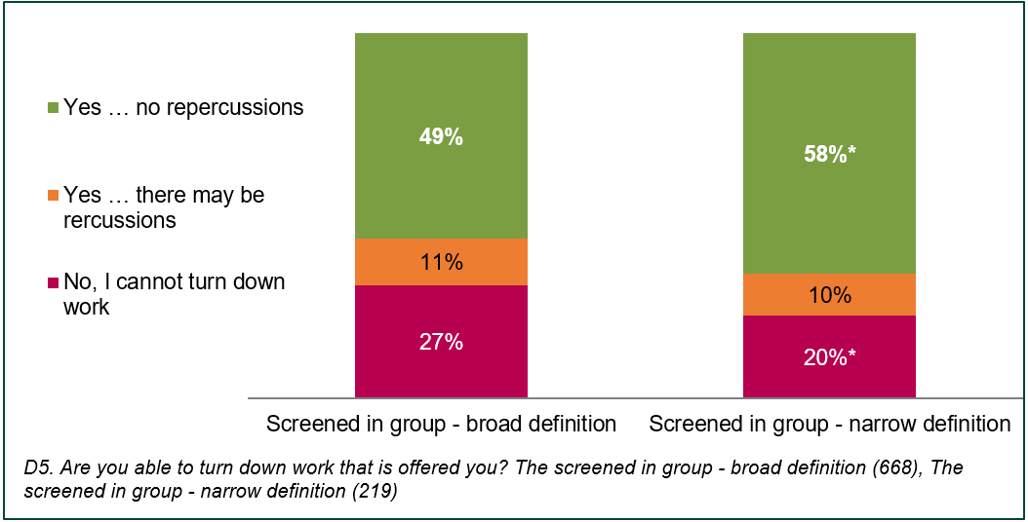

Data from Figure 5.5 as a table in the appendix

  - According to the screened in group, around half of their employers would be able to operate completely as normal if they were to turn down work that the employer offered to them. 15% of the screened in group said that their employer would not be able to carry on as normal without them. (Figure 5.6).
Figure 5.6 Employer ability to carry on without employee
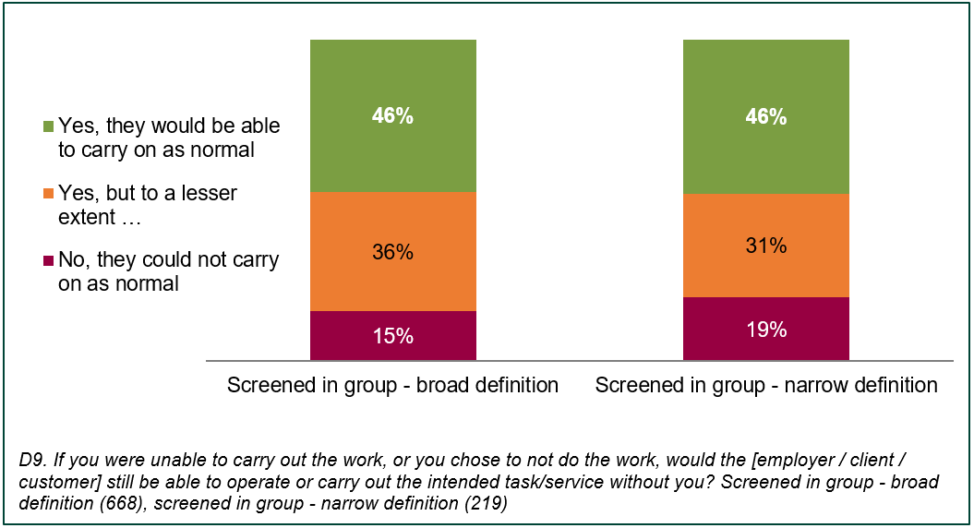
Data from Figure 5.6 as a table in the appendix
  - The screened in group were placed into one of four categories based on their answers to the questions set out in paragraph 5.9.
- ‘common commitment’ if the employee was unable to turn down work and the employer was unable to carry on as normal without them
- ‘employee commitment’ if the employee was unable to turn down work but the employer was able to carry on as normal without them
- ‘employer commitment’ if the employee was able to turn down work but the employer would be unable to carry on as normal without them
- ‘little/no commitment’ in which there was no significant commitment in either direction
  - Table 5.1 sets out the matrix through which respondents were categorised. The labels ‘D5’ and ‘D9’ refer to the question numbers as set out in the questionnaire which is included in the appendix.
Table 5.1 Commitment categorisation matrix
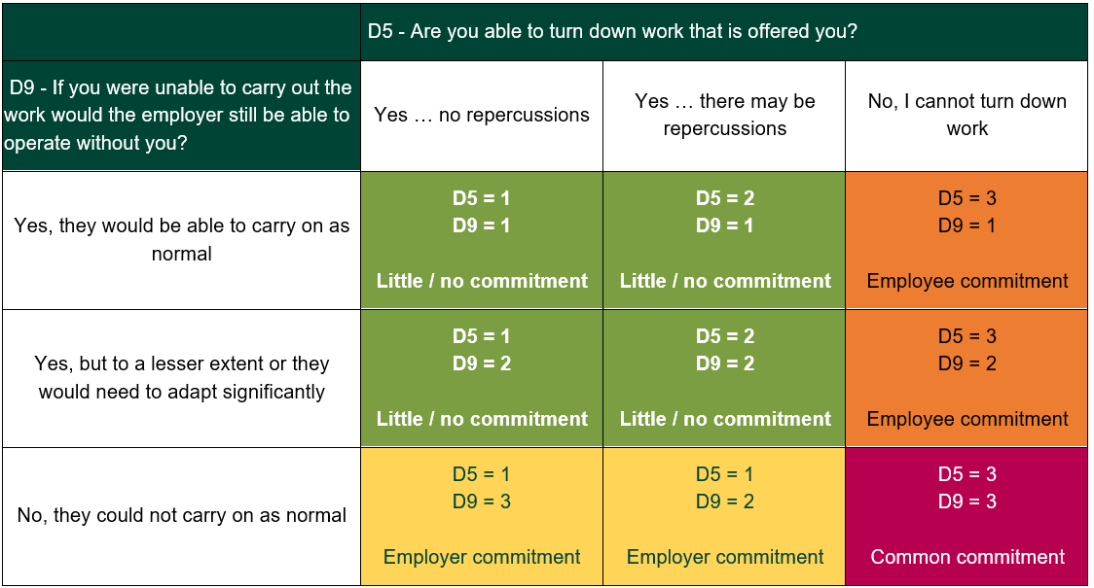
  - The majority of the screened in group, 61%, were in the ‘little/no commitment’ category, 9% were in the ‘employer commitment’ category, 23% ‘employee commitment’, and 7% in ‘common commitment’. For those in the narrow definition, the corresponding figures were 65%, 12%, 17% (which is significantly lower) and 7%.

Figure 5.7 Common commitment
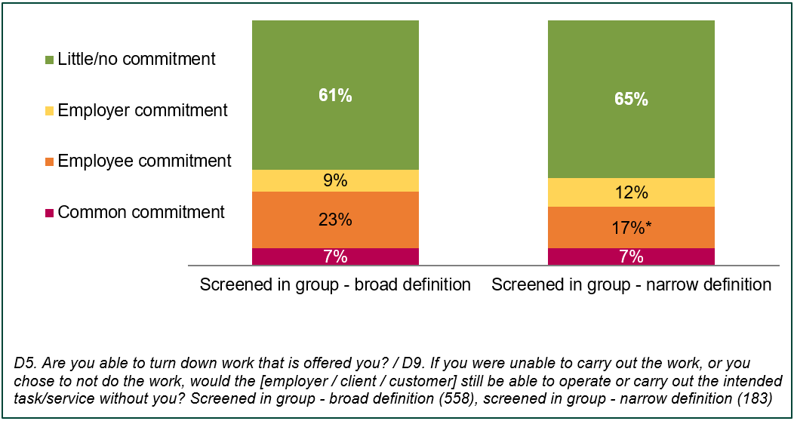
Data from Figure 5.7 as a table in the appendix

Contractual arrangements
Key findings:
overall 84% of workers said they worked for an employer, 15% said they were self-employed. Relatively few had jobs which involved zero hours contract work (7%), the ‘gig economy’ (5%) and / or working through an agency (4%)
the screened in group were as likely as all workers to work for an employer (87%) and were less likely to consider their work as self-employment (7%). Those who met the narrow definition were similarly likely to consider their work as working for an employer (81%) but were more likely to describe it as self-employment (15%)
the screened in group (both the broad and narrow definitions) were more likely than all workers to describe their work as involving zero hours contracts, working through an agency or in the ‘gig economy’
the screened in group who met the narrow definition were almost twice as likely to report they had no written contract (28% compared to 15% who met the broad definition and 16% of all workers)
4% of all those working at the time of research, and of those meeting the broad definition of the screened in group, said they were paid mainly through share of profits and dividends. Amongst the narrow definition of the screened in group this rose to 10%
overall 12% of workers reported they did not receive any employment rights (e.g. paid holiday) or benefits, as did 5% of those who met the broad definition of the screened in group. Amongst those who met the narrow definition,12% said they did not receive any employment rights or benefits

  - This chapter presents self-perceived employment status and the proportion of people who have written contracts. It explores how these varied for the screened in group. This chapter also covers the types of payment and employment rights and benefits received, exploring the profile of those paid through share of profits and dividends and differences between those who did and did not receive employment rights or benefits.

Employment status

  - Overall, 84% of workers described themselves as working for an employer in at least one job, as shown in Figure 6.1. 15% of workers reported their jobs involved self-employment.
  - The screened in group who met the broad definition were also highly likely to work for an employer (87% compared to 84% overall). Similarly, 81% of those that met the narrow definition considered they worked for an employer. This group were significantly more likely to report their work as self-employment, 15% compared to 7% of those who met the broad definition (and 15% overall).
Figure 6.1 Employment status / types of work
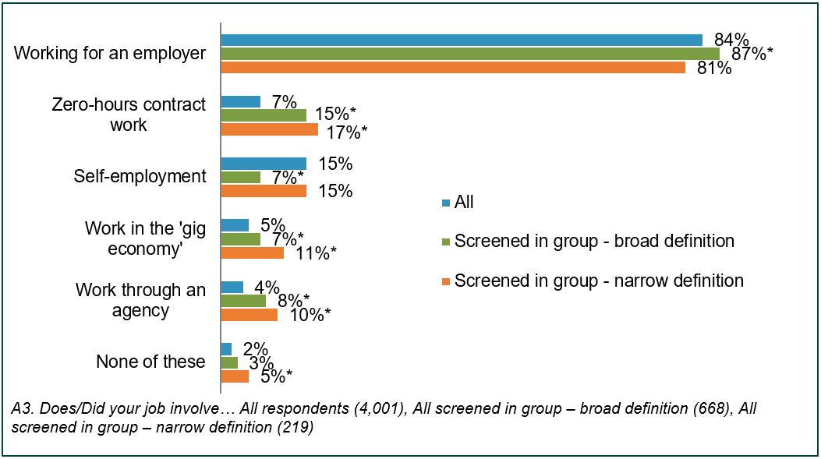

Data from Figure 6.1 as a table in the appendix

  - Overall small proportions said their jobs involved zero hours contract work (7%), working in the ‘gig economy’ (5%) and / or through an agency (4%). All of these forms of employment were more common amongst the screened in group, especially those who met the narrow definition.
- 15% and 17% respectively of those who met the broad and narrow definitions of the screened in group had jobs which involved zero hours contract work (compared to 7% overall)
- 8% and 10% respectively of those who met the broad and narrow definitions had jobs which involved agency work (compared to 4% overall)
- 7% and 11% respectively of those who met the broad and narrow definitions had jobs which involved working in the ‘gig economy’ (compared to 5% overall)
  - None of these forms of employment fitted for 2% of workers (or for 3% of those who met the broad definition of the screened in group, 5% who met the narrow definition).

Written contracts
  - Overall, 84% of workers confirmed they had a written contract for their jobs which stated their terms and conditions of employment. Those who worked through an agency were reminded that this written contract may have been with the agency rather than the organisation they worked for. 2% of all workers were unsure if they had such a written contract or refused to answer.
  - The screened in group who met the broad definition were also highly likely to have a written contract (87%), as shown in Figure 6.2 but those who met the narrow definition were significantly less likely to do so (78%). Almost three-in-ten (28%) of those who met the narrow definition did not have a written contract for their jobs compared to 16% overall and 15% of those who met the broad definition. Among workers in general, 2% of those who met both the broad and narrow definitions of the screened in group were unsure if they had a written contract.

Figure 6.2 Whether workers had written contract for jobs and length of contract amongst those with a contract - all and the screened in group
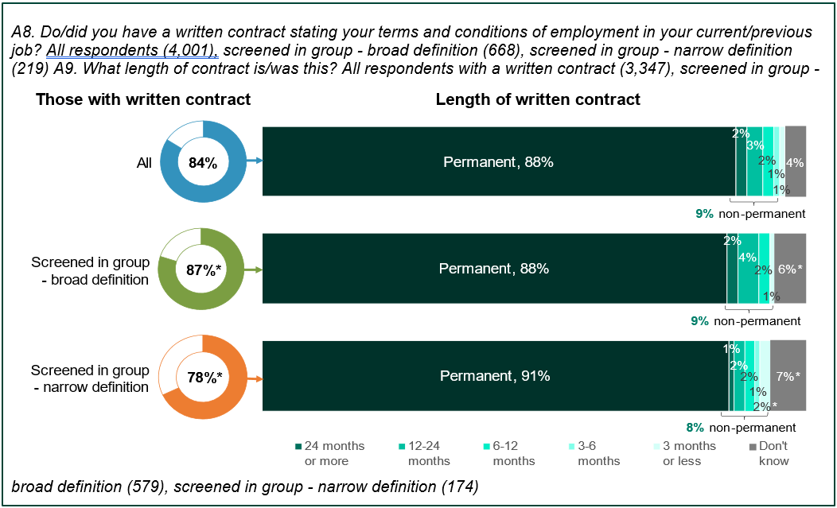

Data from Figure 6.2 as a table in the appendix

  - The vast majority (93%) of those who considered they worked for an employer (or had done so pre-pandemic) had a written contract. Amongst those who worked through an agency, did zero hours contract work and / or worked in the ‘gig economy’ written contracts were less common (78%, 72% and 62% respectively). Three in ten (30%) of those who described their work as self-employment had a written contract.

  - The majority of workers who had a written contact had a permanent contract (88%), as shown in Figure 6.2. Small proportions had contracts for set periods: 2% 24 months or longer, 3% between 12 and 24 months, 2% between six and 12 months, 1% between three and six months and 1% 3 months or less. 4% of those with written contracts were unsure of the length.

  - The screened in group who had written contracts were likely to have permanent contracts, 88% of those who met the broad definition and 91% of those who met the narrow (in-line with 88% of all workers). The screened in group who met both the broad definition and the narrow definition, were more likely to be unsure of their contract length, 6% and 7% compared to 4% overall.

  - Nine in ten (90%) of those who described their job as working for an employer and had a written contract had a permanent contract. This was considerably higher than those who had written contracts but described their employment status differently: 70% of those whose job involved zero hours contract work, 63% of those who worked in the ‘gig economy’ and 57% each of those who worked through an agency and / or considered themselves self-employed.

Payment
  - As shown in Figure 6.3, over nine in ten (93%) workers who were in work at the time of research were paid wages, salary, or a fee (and if they were paid profit-related pay, employee share options or dividends then they were a smaller part of their pay). Being mainly paid through a share of profits or dividends was generally uncommon and applied to only 4%. Small proportions reported that being paid was not applicable (3%) to their circumstances (while not explicitly probed, this may be due to receiving different forms of payment for their work i.e. goods or services) or were unsure how they were paid (1%).

  - Payment through share of profits or dividends was more common amongst the screened in group who met the narrow definition, 10% compared to 4% of those who met the broader definition and 4% overall.

Figure 6.3 Main payment method for jobs – all, the screened in group and by employment status
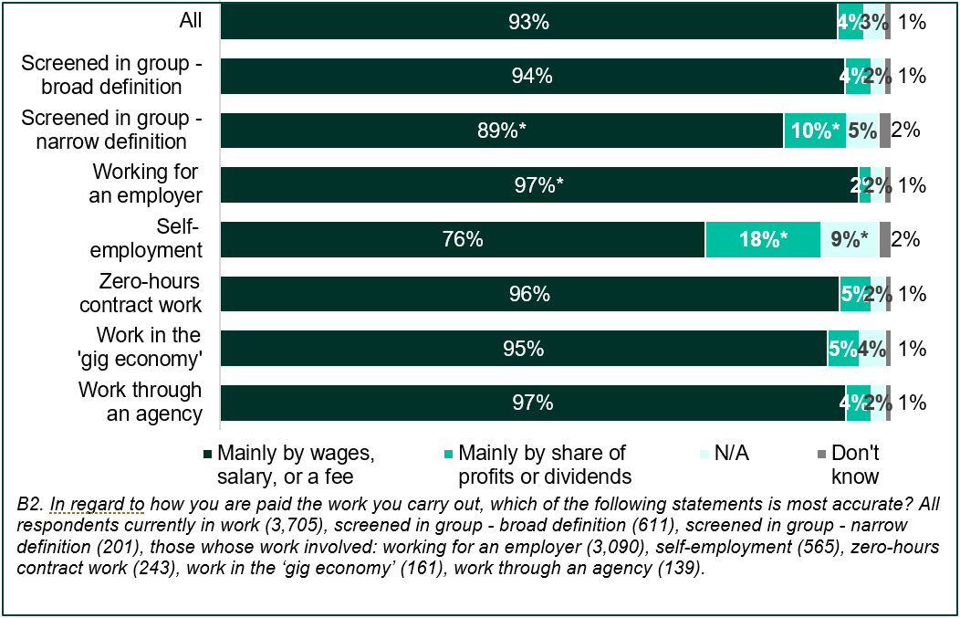

Data from Figure 6.3 as a table in the appendix

  - Overall, workers who were particularly likely to be mainly paid through share of profits and dividends included those in the following groups:
- those who were self-employed (18% compared to 2% who consider they worked for an employer)

- aged 65 or older (12% compared to 3% of younger workers)

- high earners (12% of those with income over £100,000 compared to 3% with lower incomes)

- in smaller workplaces (26% with one employee at their site, 15% with between two and nine compared to 2% in larger organisations)

- in the Professional, Scientific and Technical Activities (17%), Construction (12%) or Manufacturing (11%) sectors

Employment rights and benefits
  - All workers were read a list of statutory rights and benefits that come with employment and some non-statutory benefits an employer may offer. They were asked to confirm which, if any, they were entitled to. The majority were aware that they were entitled to paid holiday (80%), pension contributions (75%), paid sick leave (70%) and / or paid parental leave (63%). Substantial minorities also thought they were entitled to paid overtime (49%), staff discounts (39%) and / or profit sharing or a performance related bonus (26%), as shown in Figure 6.4. Very small proportions (no more than 2%) also specified additional, unlisted benefits such as a car allowance, insurance, cycle to work, gym membership, and other expenses or allowances.

Figure 6.4 Entitlement to employment rights and benefits
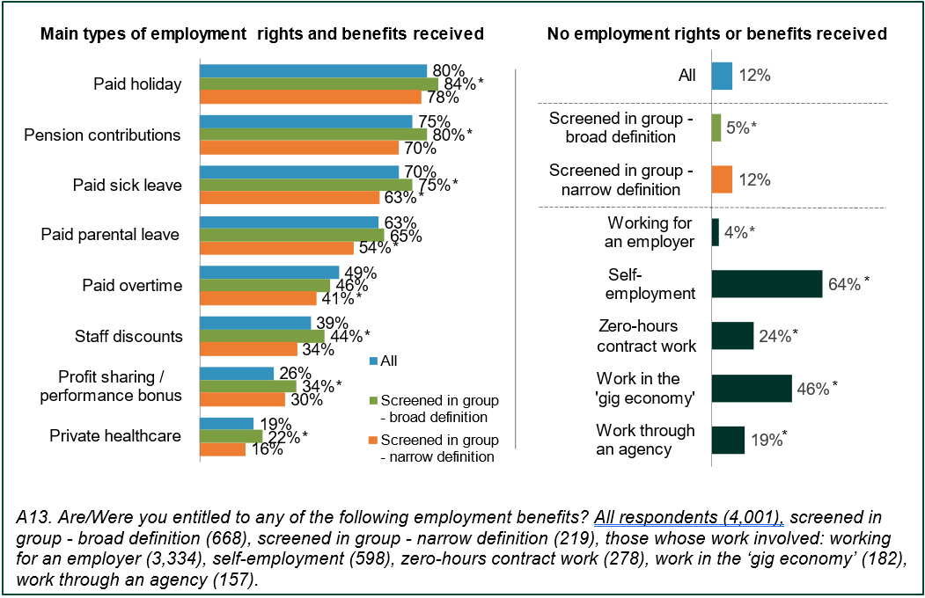

Data from Figure 6.4 as a table in the appendix

  - Around one-in-eight workers (12%) reported they were not entitled to any of these employment rights or benefits, as shown in Figure 6.4. The same proportion of the screened in group (12%) who met the narrow definition also reported they were not entitled to any employment rights or benefits while a significantly lower proportion of those that met the broad definition (5%) reported they were not entitled to employment rights or benefits.

  - Workers who said they were self-employed were especially likely to state they were not entitled to any employment rights or benefits (64% compared to 12% overall), as were to a lesser extent those whose job involved work in the ‘gig economy’ (46%), zero hours contract work (24%) and working through an agency (19%). Four per cent of those who reported they worked for an employer did not think they were entitled to any employment rights or benefits.

  - Workers in the following groups were particularly likely to state they were not entitled to any employment rights or benefits compared to 12% of all workers
- those with more than one paid job (46%)

- those aged 65 or older (29%)

- those with an income of £12,500 or less (22%)

Nature of work
Key findings:
21% of the screened in group make themselves available to work through an app or website. This is most common in Wholesale and Retail sector, where 38% make themselves available through an app
the vast majority, 89%, of the screened in group see their job as stable
46% of the screened in group can have their performance publicly rated by end-clients. This is most common in Accommodation and Food Service sector where 70% can have their performance publicly rated

  - This chapter explores various aspects of the nature of work that the screened in group are engaged in. This includes the ways in which they make themselves available for work or find out about work, the perceived stability of their work, and whether their performance can be publicly rated.

Availability of work
  - The screened in group made themselves available for work through a variety of methods. As shown in Figure 7.1, the most common method was letting their known employers or customers know about their availability directly (39%). Around one in five also let employers and customers know they were available by logging on to an app or website (21%) or by approaching potential employers or customers (21%).

Figure 7.1 Methods of making themselves available for work for the screened in group
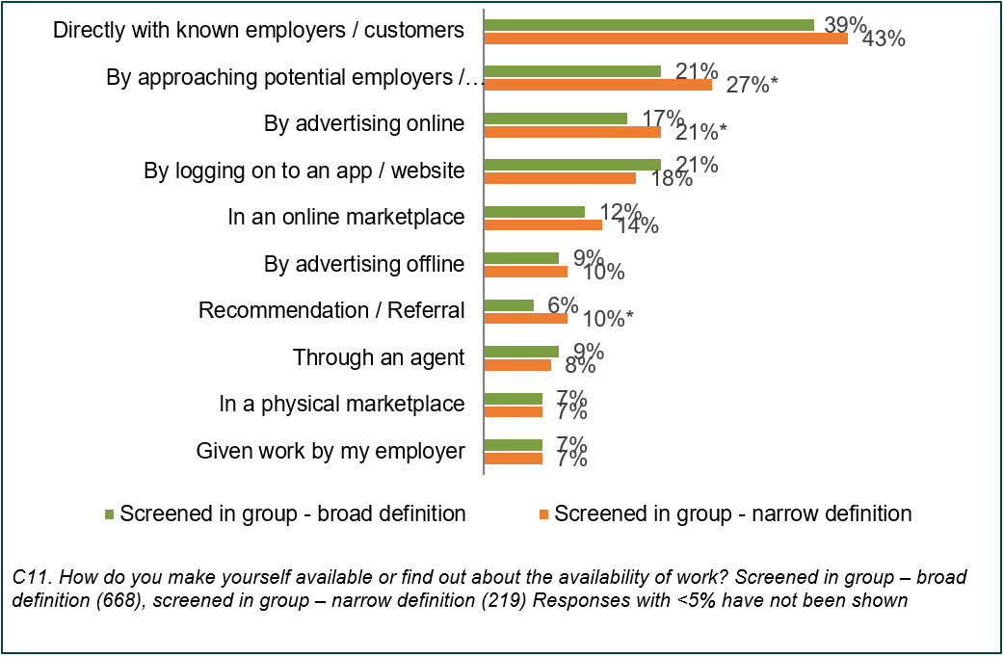
Data from Figure 7.1 as a table in the appendix
  - Methods of letting employers and customer know of their availability varied by sector, particularly for those who did so either directly or by logging on to an app. As shown in Figure 7.2, the screened in group from the Financial and Insurance (62%) or Education (56%) sectors were most likely to have let their known employers or clients know about their availability directly, whilst less than one in five (19%) of the screened in group in the Information and Communication sector did so.

  - The screened in group in the Wholesale and Retail sector were most likely to have let clients know about their availability by logging on to an app or website (38%), whereas very few working in Manufacturing (6%) or Professional, Scientific and Technical activities did this (7%).
Figure 7.2 Percentage of the screened in group informing about their availability either directly or through an app or website, split by sector
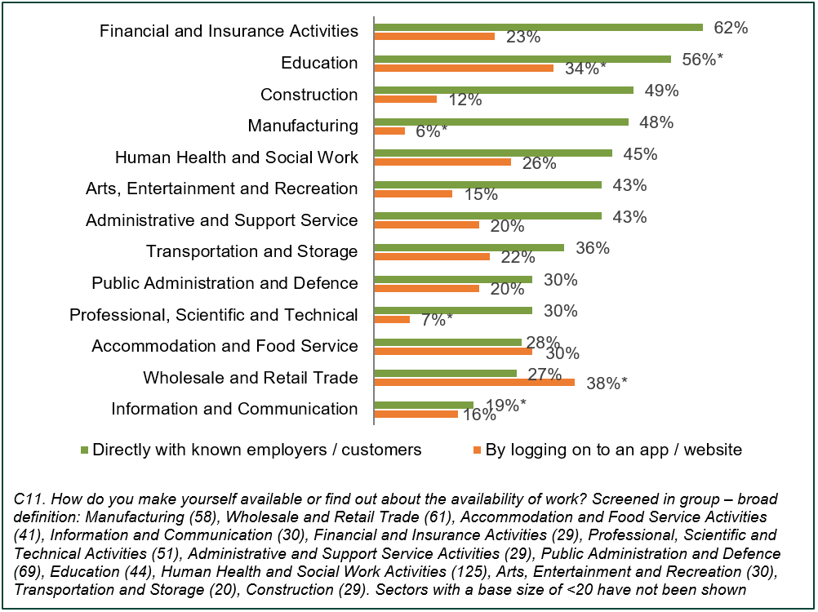
Data from Figure 7.2 as a table in the appendix
  - Other notable differences by sector include:
- by advertising online – 31% Wholesale and Retail Trade, compared to 17% on average for the screened in group
- by advertising offline – 29% Financial and Insurance, compared to 9% on average for the screened in group
- through an agent – 24% Financial and Insurance and 16% Human Health and Social Work, compared to 9% on average for the screened in group
- in an online marketplace – 19% Accommodation and Food Services Activities, compared to 12% on average for the screened in group
- in a physical marketplace – 27% Financial and Insurance Activities, compared to 7% on average for the screened in group
- recommendation and referral – 23% Professional, Scientific and Technical Activities, compared to 6% on average for the screened in group

Job stability and fluctuation
  - Most (89%) of the screened in group considered their job to be stable. As shown in Figure 7.3, over half (57%) of the screened in group thought their job was very stable, with close to one in three (32%) who stated it was fairly stable. Those who met the narrow definition were significantly more likely to consider their job as very unstable (6% vs 3%) and they were also significantly less likely to consider their job as fairly stable (27% vs 32%).

Figure 7.3 Perceived stability of the screened in group’s jobs
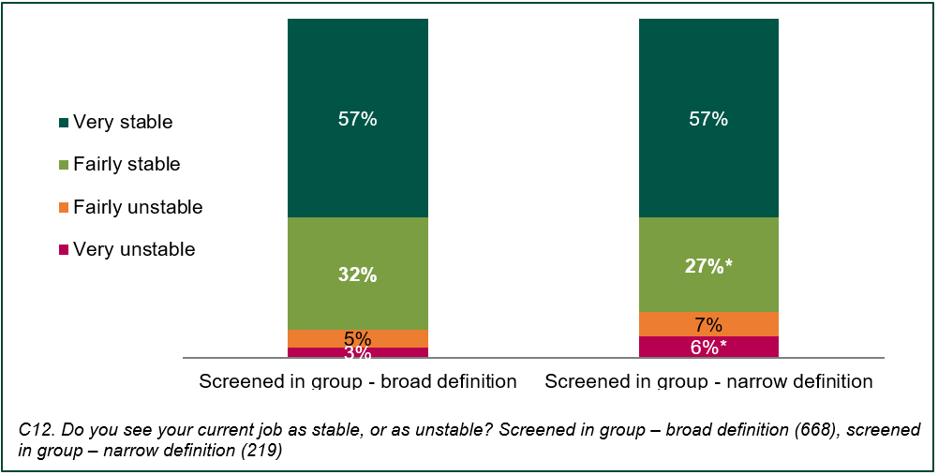
Data from Figure 7.3 as a table in the appendix
  - Just over half (52%) of the screened in group reported that there was at least some fluctuation in the amount of work available to them throughout the year, increasing to 60% among those meeting the narrow definition of the screened in group. As shown in Figure 7.4, 39% of the screened in group reported some fluctuation, whilst a further 13% said there was a lot of fluctuation.
Figure 7.4 Fluctuation of available work throughout the year for the screened in group
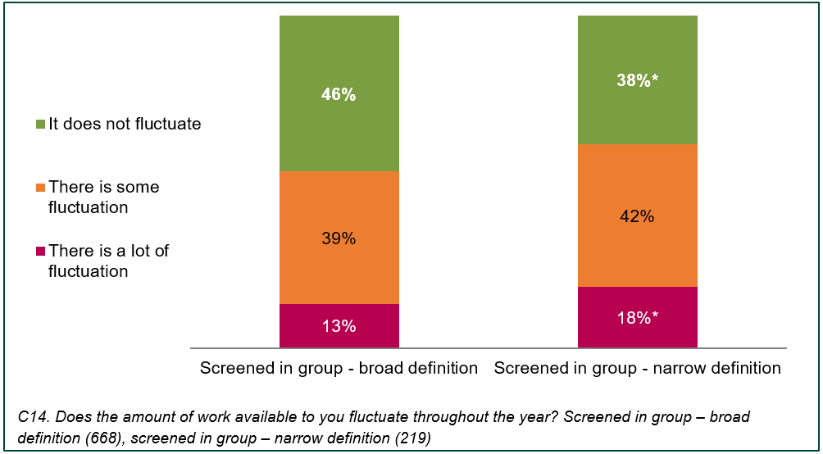
Data from Figure 7.4 as a table in the appendix

  - Job stability and work fluctuation for the screened in group remained relatively consistent across most sectors. The main sectors of note included:
- Administrative and Support Service – Whilst still considered by most to be stable, just 77% said their job was at least fairly stable, compared to 89% of the screened in group on average. Furthermore, the screened in group were most likely to have said there was a lot of fluctuation throughout the year, more than three times more likely than the average (42% compared with 13%)
- Education – significantly fewer people working in this sector considered their job stable in comparison to the average, although more than three in four (79%) the screened in group in the Education sector said that their job was at least fairly stable
- Accommodation and Food Services Activities – The screened in group in this sector were most likely to have said there was at least some fluctuation in their job (71%), compared to the average (52%)
- Financial and Insurance Activities – Instability and fluctuation was not common for jobs in this sector. More than three quarters (79%) of the screened in group in the Financial and Insurance Activities sector felt that their job was very stable (compared to 57% of the screened in group on average), Whilst two in three (66%) said there was no fluctuation (compared to 46% of average)

End client ratings
  - As shown in Figure 7.5, the majority (71%) of the screened in group’s end clients are individuals or the general public. For 42%, their end clients are businesses or private sector organisations, and 28% have charities or the public sector as end clients.
Figure 7.5 The screened in group’s end clients
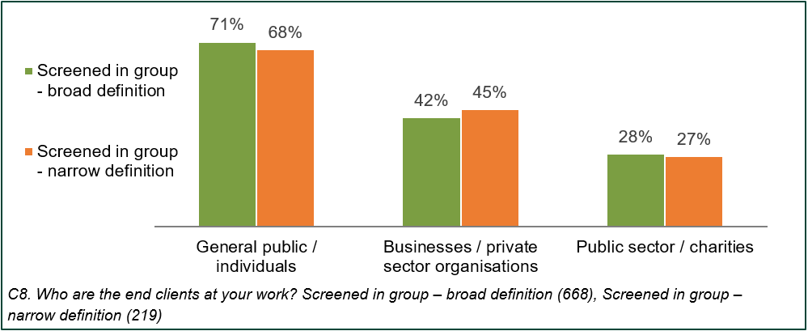
Data from Figure 7.5 as a table in the appendix
  - Close to half (46%) of the screened in group could have their performance publicly rated by their end clients. As shown in Figure 7.6, the screened in group in the Accommodation and Food Services Activities (70%), Wholesale and Retail (61%), and Human Health and Social Work (55%) sectors were more likely to be able to have had their clients rate their performance than average. Those working in the Public Administration and Defence (26%) sector were less likely than average to have their performance publicly rated by their end clients.

Figure 5.6 The screened in group whose end clients can rate their performance
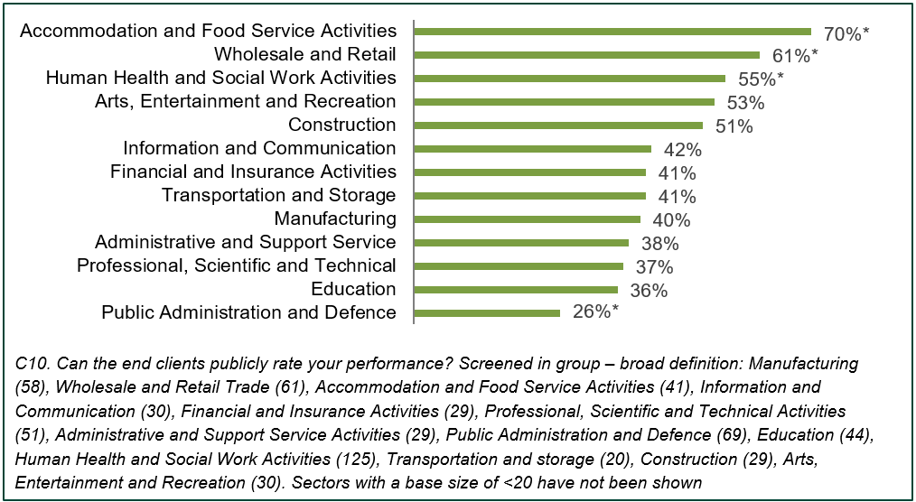
Data from Figure 7.6 as a table in the appendix

Knowledge of tax contributions and employment status
Key findings:
out of the working population as a whole, 15% of people stated that they were self-employed. Of those, 35% had tax deducted before they received their pay – this combination of self-perceived employment status and tax treatment applied to 5% of the working population. Those classifying as self-employed most commonly worked in skilled construction and building trades (13%), skilled, metal, electrical and electronic trades (11%), as other managers and proprietors (11%), or corporate managers and directors (10%)
41% of the screened in group had not had a conversation or information about their employment status. Despite this, regardless of whether they have had such a conversation or information, the vast majority (98%) were confident that they understood their employment status
the vast majority of the screened in group (90%) were confident they understood their tax obligations

  - This chapter looks at the employment status and tax arrangements of different groups within the working population. It also looks at the extent to which the screened in group were confident they understood their employment status and tax obligations.

Income Tax and National Insurance contributions
  - Overall, 84% of workers had Income Tax and National Insurance contributions (NICs) deducted from their pay before receiving it, whilst 14% said they did not and 3% were unsure. As shown in Figure 8.1, those who identified as self-employed (35%), working in the ‘gig economy’ (59%), or were a zero-hours contract worker (75%) were less likely than average to have their tax and National Insurance contributions deducted before receiving their pay. Conversely, nearly all (93%) those working for an employer had tax and National Insurance contributions deducted from their pay.

Figure 8.1 Proportion of workers having tax and National Insurance contributions deducted from their pay before receiving it, by type of employment
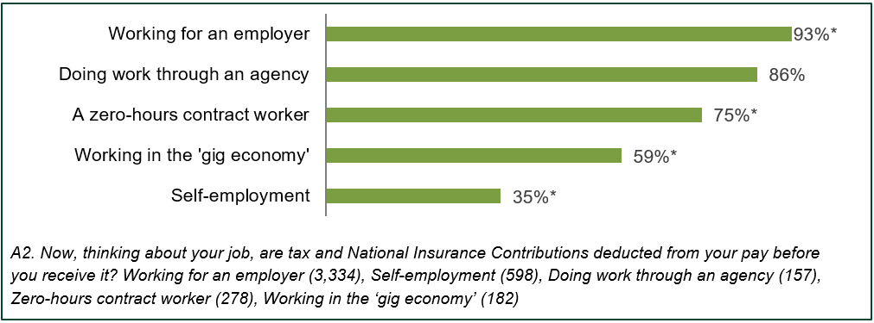
Data from Figure 8.1 as a table in the appendix
  - Overall, 15% of workers stated that they were self-employed. Of those self-employed workers, 35% had tax deducted before they received their pay; this arrangement applied to 5% of all respondents. Extrapolating this out to the entire working population, this would represent approximately 1.6 million people who stated that they are self-employed and who have tax deducted from their pay before they receive it. Demographic characteristics of these respondents were as follows:
- they were more likely to be male (67%) than workers in general (52%)
- their age profile mostly reflected that of the working population as a whole. They were slightly older than workers in general as they were less likely to be aged 16 to 24 (7% compared to 11% of average) and more likely to be aged 35 to 44 (41% compared to 33% average)
- ethnicity and regional profiles closely reflected the average for the working population
  - Workers who identified as self-employed and had their tax deducted before they received their pay worked in a wide range of occupations, but some of the more common occupations included skilled construction and building trades (13%), skilled, metal, electrical and electronic trades (11%), other managers and proprietors (11%), and corporate managers and directors (10%).

  - Figure 8.2 below shows the occupational breakdown of workers who identified as self-employed and had their tax deducted before receiving their pay.
Figure 8.2 Occupational breakdown of workers who identified as self-employed and had their tax deducted from their wage
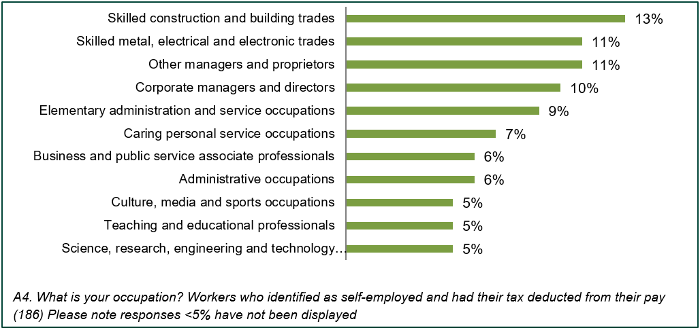
Data from Figure 8.2 as a table in the appendix
  - Figure 8.3 shows the earnings of workers who provided their income and who identified as self-employed and had their tax deducted before receiving their pay, compared to the average. Overall, 68% of workers earned £30,000 or less per year, compared to 63% of those who identified as self-employed and had tax deducted from their pay; however, these figures are not significantly different. Workers who identify as self employed are significantly less likely to earn an income between £20,001 - £30,000 but are significantly more likely to earn an income between £30,000 - £50,000.
Figure 8.3 Annual earnings of workers who identified as self-employed and had their tax deducted from their wage, compared to the national average of workers
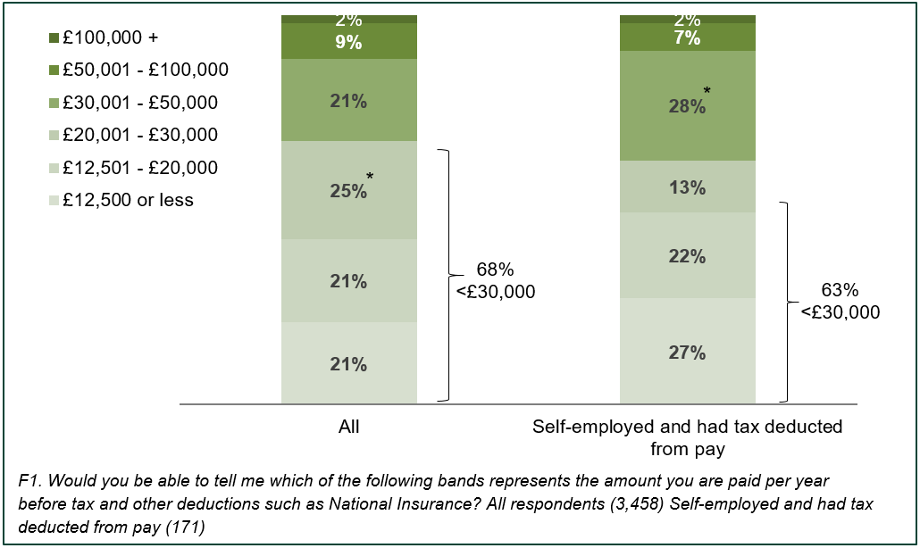
Data from Figure 8.3 as a table in the appendix

The screened in group - discussions about employment status
  - As shown in Figure 8.4, fewer than half (41% broad and 43% narrow definition) of the screened in group had had a conversation or received information from the companies or organisations they worked for regarding whether they were employed or self-employed.

  - There were few differences between sectors, with the exception of those who worked in the Public Administration and Defence sector, where around one in four (26%) had had a conversation or information about their employment status.

Figure 8.4 Proportion of the screened in group who have had a conversation or information about their employment status
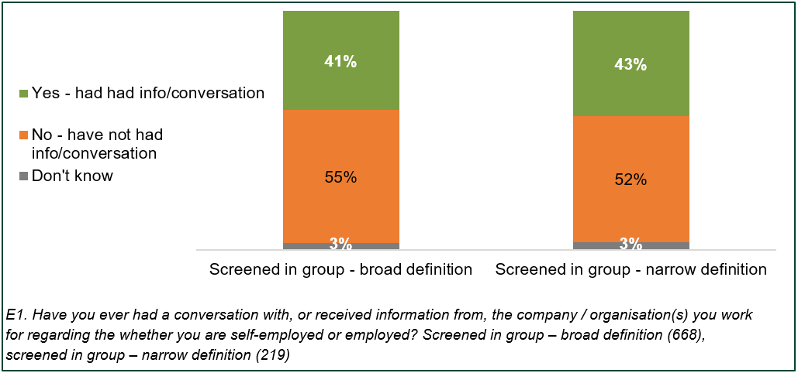
Data from Figure 8.4 as a table in the appendix
  - Nearly all (99%) the screened in group, who had had a conversation or received information regarding their employment status, felt they had a good understanding of the nature of their employment status as a result. As shown in Figure 8.5, nearly nine in ten (88%) of the screened in group considered themselves to be employed. Among the screened in group meeting the narrow definition, close to eight in ten (78%) stated they were employed, with around one in ten (11%) considering that they were self-employed.

  - The results were similar for the screened in group who had not had a conversation or information regarding their employment status; the vast majority (98%) felt they had a good understanding of the nature of their employment status.

  - As shown in Figure 8.5, 88% of those in the broad definition who had had a conversation or information about their employment status thought that they were employed. Of those in the narrow definition 78% considered themselves employed (a significant difference). Furthermore, 4% of those in broad definition considered themselves to be self-employed, which is significantly fewer than around one in ten (11%) of the narrow definition who considered themselves to be self-employed.

Figure 8.5 The screened in group’s understanding of the nature of their employment – where they had a conversation or received information about their employment status
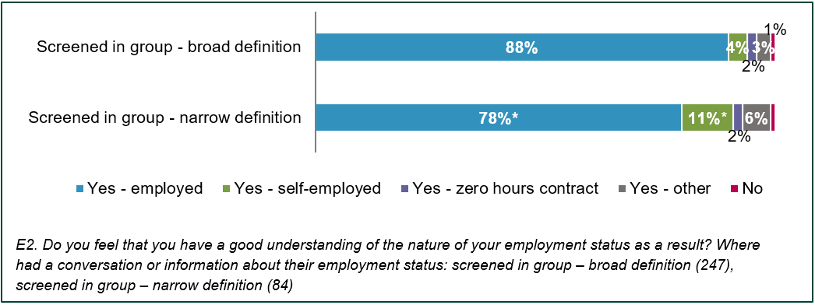
Data from Figure 8.5 as a table in the appendix
  - As shown in Figure 8.6, those who had not had a conversation or information regarding their employment status were less likely to consider themselves to be employed (79% vs 88% for those who had had a conversation). For the narrow definition this was less likely still at 73%.
Figure 8.6 The screened in group’s understanding of the nature of their employment – where have not had a conversation or information about their employment status
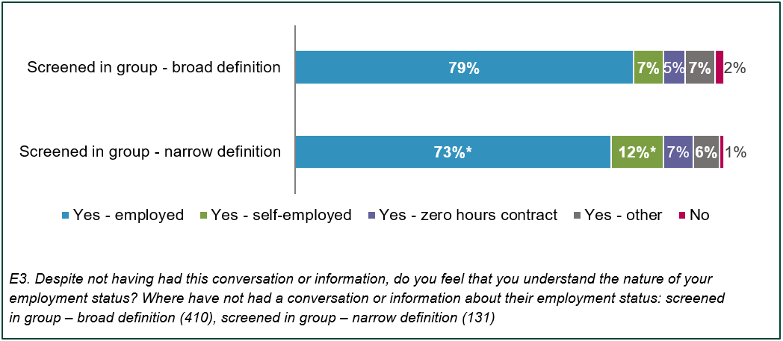
Data from Figure 8.6 as a table in the appendix
  - Differences in understanding employment status for tax or rights purposes did not vary much by sector. The most notable differences between sectors were those in the screened in group in the Accommodation and Food Service sector, who were more likely to state they were on a zero hours contract (14%).

The screened in group - understanding tax obligations
  - The vast majority (90%) of the screened in group were very or fairly confident they understood their tax payment responsibilities. As shown in Figure 8.7, over half (55%) were very confident, increasing to nearly two in three (63%) of the screened in group using the narrow definition. Overall, 4% of the screened in group meeting the broad definition were fairly unconfident and 2% were very unconfident, compared with 2% and 1% of those meeting the narrow definition, respectively.

Figure 8.7 The screened in group’s confidence that they understand their responsibilities in relation to the payment of taxes
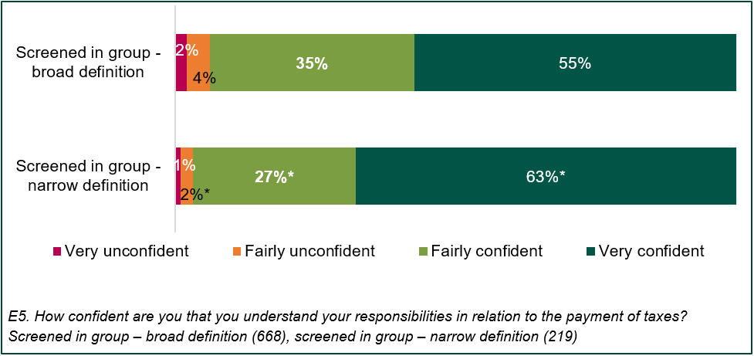
Data from Figure 8.7 as a table in the appendix
  - As shown in Figure 8.8, confidence that they understood their responsibilities in relation to the payment of taxes was high amongst the screened in group from different sectors. The screened in group in the Education or Wholesale and Retail sectors were more likely to be confident than average, whereas those working in Administrative and Support service or Human Health and Social Work Activities sectors were less likely.

Figure 8.8 The screened in group’s confidence that they understand their responsibilities in relation to the payment of taxes, by sector
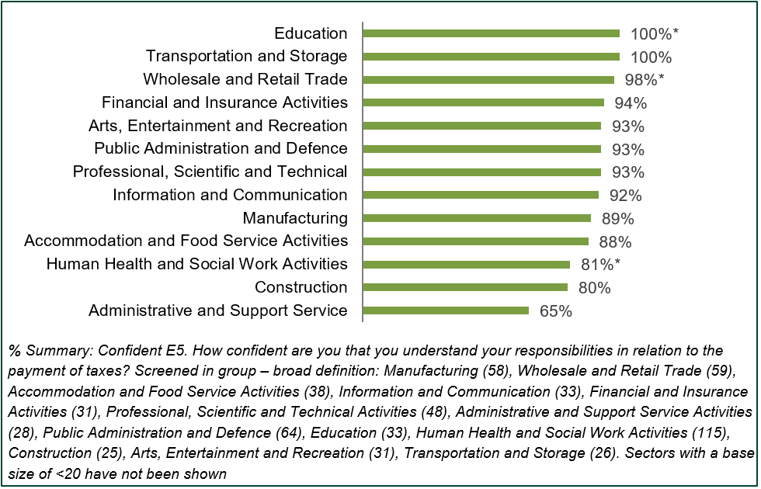

Data from Figure 8.8 as a table in the appendix
  - The main reasons given by the screened in group for being confident that they understood their responsibilities in relation to the of taxes included:
- had a good amount of expertise or experience in taxes (17%)
- their taxes were deducted from their pay before they received it (15%)
- their taxes were handled by their employer (13%)
- their taxes were handled by an accountant or third party (11%)
- they understood their obligations as a tax payer (11%)

Appendix A – Technical appendix

  - This technical annex provides information on the weighting strategy and error margins.

Weighting
  - The data was weighted to match the demographic characteristics of the working population based on the most recently available data from the ONS Labour Force Survey. The data was retrieved from Nomis in July 2021. The weights are set out in the tables below.
Table 9.1 Age and gender weights
Age and gender | %
16-19: Male | 1.4%
16-19: Female | 1.4%
20-24: Male | 4.2%
20-24: Female | 4.1%
25-34: Male | 12.2%
25-34: Female | 11.0%
35-49: Male | 17.4%
35-49: Female | 15.9%
50-64: Male | 14.7%
50-64: Female | 13.7%
65+: Male | 2.3%
65+: Female | 1.7%

Table 9.2 Region weights
Region | %
North East | 3.7%
North West | 10.6%
Yorkshire and The Humber | 7.9%
East Midlands | 7.3%
West Midlands | 8.5%
East of England | 9.5%
London | 14.3%
South East | 14.2%
South West | 8.6%
Wales | 4.5%
Scotland | 8.2%
Northern Ireland | 2.7%

Table 9.3 Ethnicity weights
Ethnicity | %
White | 87.4%
Mixed | 1.1%
Indian | 2.8%
Pakistani / Bangladeshi | 2.2%
Black | 3.1%
Other ethnic groups | 3.3%

Error Margins
  - The achieved sample size of 4,001 enabled statistically robust analysis at both a total level and at subgroup level. The table below shows the error margins at a confidence level of 95% for the key groups of analysis.
Table 9.4 Error margins
On a statistic of… | Error margin | Error margin | Error margin
Audience: Base size | All:  4,001 | The screened in group – broad definition: 687 | The screened in group – narrow definition: 233
5% or 95% | ±0.7% | ±1.6% | ±2.8%
10% or 90% | ±0.9% | ±2.2% | ±3.9%
20% or 80% | ±1.2% | ±3.0% | ±5.1%
30% or 70% | ±1.4% | ±3.4% | ±5.9%
40% or 60% | ±1.5% | ±3.7% | ±6.3%
50% (standard error) | ±1.5% | ±3.7% | ±6.4%

Appendix B – Figures as tables
Table for Figure 4.1: Narrow and broad definitions of the screened in group
Which of the following statements best describes the amount of choice you have over the days and hours you work? | Narrow definition | Broad definition
I have total choice over the hours/days I work and I do not have to notify my employer and/or client(s) in advance | Yes | Yes
I am generally able to choose the hours/days I work but I am expected to give my employer and/or client(s) notice and/or be available at certain times | No | Yes

A2/B4. Now, thinking about your job, are tax and National Insurance Contributions deducted from your pay before you receive it? Base: All respondents (4,001) / A11/B3. Which of the following statements best describes the amount of control you have over the days and hours you work? Base: All respondents (4,001)

Table for Figure 4.2: Incidence rate of broad and narrow definitions of the screened in group
 | % of UK workers that meet the definition | % for those who are not in work now, but were in work before the pandemic
Broad definition | 16% | 5%
Narrow definition | 19% | 6%

A2/B4. Now, thinking about your job, are tax and National Insurance Contributions deducted from your pay before you receive it? Base: All respondents (4,001) / A11/B3. Which of the following statements best describes the amount of control you have over the days and hours you work? Base: All respondents (4,001)
Table for Figure 4.3: Proportion of workers of each gender that were the screened in group
 | Screened in group - broad definition | Screened in group - narrow definition
Male | 16% | 5%
Female | 15% | 5%

Incidence rate of the screened in group working by gender. Base: Male (1,817), Female (2,159)

Table for Figure 4.4: Proportion of workers in each age group that were the screened in group
Age group | Screened in group - broad definition | Screened in group - narrow definition
16-24 | 18% | 3%
25-34 | 14% | 4%
35-44 | 15% | 4%
45-54 | 17% | 6%
55-64 | 17% | 6%
65+ | 21% | 11%

Incidence rate of the screened in group working by age. Base: 16-24 (489), 25-34 (595), 35-44 (660), 45-54 (1,060), 55-64 (877), 65+ (249)

Table for Figure 4.5: Proportion of workers in each ethnic group that were the screened in group
Ethnicity | Screened in group - broad definition | Screened in group - narrow definition
White | 16% | 5%
Mixed/ multiple ethnic groups | 22% | 3%
Asian/ Asian British | 18% | 3%
Black/ African/ Caribbean/ Black British | 19% | 8%

Incidence rate of the screened in group by ethnic background. Base: White (3,511), Mixed/multiple ethnic groups (69), Asian/Asian British (237), Black/African/Caribbean/Black British (101). Note: incidence for ‘other ethnic groups’ not shown due to small base size (n=20)

Table for Figure 4.6: Proportion of workers in each UK region / nation that were the screened in group
UK region / nation | Screened in group - broad definition | Screened in group - narrow definition
London | 19% | 5%
South East | 17% | 5%
South West | 17% | 6%
Eastern | 12% | 3%
East Midlands | 15% | 5%
West Midlands | 17% | 7%
Yorkshire & Humberside | 16% | 4%
North East | 17% | 4%
North West | 16% | 7%
Scotland | 12% | 5%
Wales | 17% | 6%
Northern Ireland | 15% | 3%

Incidence rate of the screened in group by UK region. Base: East of England (265), East Midlands (291), London (487), North East (173), North West (365), South East (647), South West (356), West Midlands (335), Yorkshire and the Humber (314), Scotland (144), Wales (336), Northern Ireland (208).

Table for Figure 4.7: Proportion of workers who had a long-term illness, health problem or disability that were the screened in group
 | Screened in group - broad definition | Screened in group - narrow definition
Yes, have long-term illness, health problem or disability | 14% | 4%
No, do not have long-term illness, health problem or disability | 16% | 5%

Incidence rate of the screened in group by long-term illness, health problem or disability. Base: Yes (751), No (3,168)

Table for Figure 4.8: Sector profile – the screened in group
 | Screened in group - broad definition | Screened in group - narrow definition
Human Health and Social Work Activities | 18% | 23%
Public Administration and Defence | 10% | 4%
Wholesale and Retail Trade | 9% | 9%
Manufacturing | 9% | 8%
Professional, Scientific and Technical Activities | 8% | 9%
Accommodation and Food Service Activities | 6% | 6%
Arts, Entertainment and Recreation | 5% | 6%
Information and Communication | 5% | 4%
Education | 5% | 3%
Financial and Insurance Activities | 5% | 3%
Transportation and Storage | 4% | 7%
Construction | 4% | 7%
Administrative and Support Service Activities | 4% | 5%
Real Estate Activities | 2% | 1%

C4. What does the organisation/business mainly make or do at the place where you work? Base: All screened in group – broad definition (668), All screened in group – narrow definition (219). Note: Not showing sectors which account for less than 2% of the screened in group

Table for Figure 4.9: Sector type profile – the screened in group
 | Screened in group - broad definition | Screened in group - narrow definition
A business or private sector organisation | 68% | 75%
Central or local government | 18% | 9%
A charity or not-for profit organisation | 9% | 10%
Don’t know | 4% | 7%

C5. Do you work for...? Base: All screened in group – broad definition (668), All screened in group – narrow
definition (219)

Table for Figure 4.10: Occupational profile – all workers and the screened in group
 | All | Screened in group - broad definition | Screened in group - narrow definition
Caring personal service occupations | 9% | 10% | 14%
Corporate managers & directors | 5% | 9% | 14%
Administrative occupations | 10% | 10% | 11%
Other managers & proprietors | 5% | 8% | 10%
Business & public service associate profes. | 8% | 11% | 9%
Elementary administration & service occupations | 9% | 10% | 9%
Business, media & public service profes. | 5% | 6% | 6%
Science, research, engineering & tech. profes. | 3% | 5% | 4%
Health profes. | 3% | 4% | 4%
Culture, media & sports occupations | 3% | 3% | 4%
Sales occupations | 6% | 5% | 3%
Science, research, engineering & tech. profes. | 4% | 5% | 3%
Skilled metal, electrical & electronic trades | 4% | 3% | 3%
Health and social care associate profes. | 2% | 3% | 3%
Teaching & educational profes. | 6% | 3% | 2%

A4. What is/was your occupation? - Both jobs. Base: All respondents (4,001), All screened in group – broad definition (668), All screened in group – narrow definition (219). Note: Not showing sectors which account for less than 3% of the screened in group.

Tables for Figure 4.11: Income profile – all workers and the screened in group
 | All | Screened in group - broad definition | Screened in group - narrow definition
£12,500 or less | 21% | 23% | 27%
£12,501 - £20,000 | 21% | 18% | 18%
£20,001 - £30,000 | 25% | 20% | 19%
£30,001 - £50,000 | 21% | 22% | 18%
£50,001 - £100,000 | 9% | 14% | 14%
£100,000 + | 2% | 3% | 4%
 | All | Screened in group - broad definition | Screened in group - narrow definition
< £30,000 | 59% | 52% | 53%

F1. Would you be able to tell me which of the following bands represents the amount you are paid per year before tax and other deductions such as National Insurance? Base: All respondents (4,001), All screened in group – broad definition (668), All screened in group – narrow definition (219)

Table for Figure 5.1: Can you conduct the work at any time you chose?
 | Screened in group - broad definition | Screened in group - narrow definition
Yes | 29% | 43%
To some extent | 29% | 24%
No | 40% | 31%

D1. Can you conduct the work at any time you choose? Screened in group - broad definition (668), Screened in group - narrow definition (219)

Table for Figure 5.2: Does the amount of work available fluctuate throughout the day?
 | Screened in group - broad definition | Screened in group - narrow definition
The work fluctuates a lot | 14% | 16%
The amount of work does fluctuate, but not too much | 27% | 28%
The amount of work does not fluctuate | 57% | 53%

D2. Does the amount of work available to you work fluctuate throughout the day? screened in group - broad definition (668), screened in group - narrow definition (219)

Table for Figure 5.3: Is the amount you are paid for your work predictable?
 | Screened in group - broad definition | Screened in group - narrow definition
Very predictable | 75% | 69%
Fairly predictable | 19% | 20%
Fairly unpredictable | 3% | 6%
Very unpredictable | 1% | 3%

D8. Is the amount you are paid for your work predictable? In other words, could you normally tell in advance how much money you will be paid based on the hours and days you choose to work. screened in group - broad definition (668), screened in group - narrow definition (219)

Table for Figure 5.4: Choice over working patterns
 | Screened in group - broad definition | Screened in group - narrow definition
Total choice | 13% | 22%
Partial choice | 77% | 67%
Little/ no choice | 10% | 11%

D1. Can you conduct the work at any time you choose? / D2. Does the amount of work available to you work fluctuate throughout the day? / D8. Is the amount you are paid for your work predictable? All respondents qualifying for long questionnaire; broad definition (668), narrow definition (219)

Table for Figure 5.5: Employee ability to turn down work
 | Screened in group - broad definition | Screened in group - narrow definition
Yes … no repercussions | 49% | 58%
Yes … there may be repercussions | 11% | 10%
No, I cannot turn down work | 27% | 20%

D5. Are you able to turn down work that is offered you? The screened in group - broad definition (668), The screened in group - narrow definition (219)

Table for Figure 5.6: Employer ability to carry on without employee
 | Screened in group - broad definition | Screened in group - narrow definition
Yes, they would be able to carry on as normal | 46% | 46%
Yes, but to a lesser extent … | 36% | 31%
No, they could not carry on as normal | 15% | 19%

D9. If you were unable to carry out the work, or you chose to not do the work, would the [employer / client / customer] still be able to operate or carry out the intended task/service without you? Screened in group - broad definition (668), screened in group - narrow definition (219)

Table for Figure 5.7: Common commitment
 | Screened in group - broad definition | Screened in group - narrow definition
Little / no commitment | 61% | 65%
Employer commitment | 9% | 12%
Employee commitment | 23% | 17%
Common commitment | 7% | 7%

D5. Are you able to turn down work that is offered you? / D9. If you were unable to carry out the work, or you chose to not do the work, would the [employer / client / customer] still be able to operate or carry out the intended task/service without you? Screened in group - broad definition (558), screened in group - narrow definition (183)

Table for Figure 6.1: Employment status / types of work
 | All | Screened in group - broad definition | Screened in group - narrow definition
Working for an employer | 84% | 87% | 81%
Zero-hours contract work | 7% | 15% | 17%
Self-employment | 15% | 7% | 15%
Work in the ‘gig economy’ | 5% | 7% | 11%
Work through an agency | 4% | 8% | 10%
None of these | 2% | 3% | 5%

A3. Does/Did your job involve… All respondents (4,001), All screened in group – broad definition (668), All screened in group – narrow definition (219)

Tables for Figure 6.2: Whether workers had written contract for jobs and length of contract amongst those with a contract - all and the screened in group
 | Those with written contract
All | 84%
Screened in group – broad definition | 87%
Screened in group – narrow definition | 78%

 | All | Screened in group - broad definition | Screened in group - narrow definition
3 months or less | 1% | 1% | 2%
3-6 months | 1% | 2% | 1%
6-12 months | 2% | 4% | 2%
12-24 months | 3% | 4% | 2%
24 months or more | 2% | 2% | 1%
Don’t know | 4% | 6% | 7%

 | All | Screened in group - broad definition | Screened in group - narrow definition
Permanent | 88% | 88% | 91%
Non-permanent | 9% | 9% | 8%

A8. Do/did you have a written contract stating your terms and conditions of employment in your current/previous job?. All respondents (4,001), screened in group - broad definition (668), screened in group - narrow definition (219) A9. What length of contract is/was this? All respondents with a written contract (3,347), screened in group - broad definition (579), screened in group - narrow definition (174)

Table for Figure 6.3: Main payment method for jobs – all, the screened in group and by employment status
 | Mainly by wages, salary, or a fee | Mainly by share of profits or dividends | N/A | Don’t know
All | 93% | 4% | 3% | 1%
Screened in group – broad definition | 94% | 4% | 2% | 1%
Screened in group – narrow definition | 89% | 10% | 5% | 2%
Working for an employer | 97% | 2% | 2% | 1%
Self-employment | 76% | 18% | 9% | 2%
Zero-hours contract work | 96% | 5% | 2% | 1%
Work in the ‘gig economy’ | 95% | 5% | 4% | 1%
Work through an agency | 97% | 4% | 2% | 1%

B2. In regard to how you are paid the work you carry out, which of the following statements is most accurate? All respondents currently in work (3,705), screened in group - broad definition (611), screened in group - narrow definition (201), those whose work involved: working for an employer (3,090), self-employment (565), zero-hours contract work (243), work in the ‘gig economy’ (161), work through an agency (139).

Tables for Figure 6.4: Entitlement to employment benefits
 | All | Screened in group - broad definition | Screened in group - narrow definition
Paid holiday | 80% | 84% | 78%
Pension contributions | 75% | 80% | 70%
Paid sick leave | 70% | 75% | 63%
Paid parental leave | 63% | 65% | 54%
Paid overtime | 49% | 46% | 41%
Staff discounts | 39% | 44% | 34%
Profit sharing / performance bonus | 26% | 34% | 30%
Private healthcare | 19% | 22% | 16%

 | No employment benefits
All | 12%
Screened in group – broad definition | 5%
Screened in group – narrow definition | 12%
Working for an employer | 4%
Self-employment | 64%
Zero-hours contract work | 24%
Work in the ‘gig economy’ | 46%
Work through an agency | 19%

A13. Are/Were you entitled to any of the following employment benefits? All respondents (4,001), screened in group - broad definition (668), screened in group - narrow definition (219), those whose work involved: working for an employer (3,334), self-employment (598), zero-hours contract work (278), work in the ‘gig economy’ (182), work through an agency (157).

Table for Figure 7.1: Methods of making themselves available for work for the screened in group
 | Screened in group - broad definition | Screened in group - narrow definition
Directly with known employers / customers | 39% | 43%
By approaching potential employers / … | 21% | 27%
By advertising online | 17% | 21%
By logging on to an app / website | 21% | 18%
In an online marketplace | 12% | 14%
By advertising offline | 9% | 10%
Recommendation / Referral | 6% | 10%
Through an agent | 9% | 8%
In a physical marketplace | 7% | 7%
Given work by my employer | 7% | 7%

C11. How do you make yourself available or find out about the availability of work? Screened in group – broad definition (668), screened in group – narrow definition (219) Responses with <5% have not been shown

Table for Figure 7.2: Percentage of the screened in group informing about their availability either directly or through an app or website, split by sector
 | Directly with known employers / customers | By logging on to an app / website
Financial and Insurance Activities | 62% | 23%
Education | 56% | 34%
Construction | 49% | 12%
Manufacturing | 48% | 6%
Human Health and Social Work | 45% | 26%
Arts, Entertainment and Recreation | 43% | 15%
Administrative and Support Service | 43% | 20%
Transportation and Storage | 36% | 22%
Public Administration and Defence | 30% | 20%
Professional, Scientific and Technical | 30% | 7%
Accommodation and Food Service | 28% | 30%
Wholesale and Retail Trade | 27% | 38%
Information and Communication | 19% | 16%

C11. How do you make yourself available or find out about the availability of work? Screened in group – broad definition: Manufacturing (58), Wholesale and Retail Trade (61), Accommodation and Food Service Activities (41), Information and Communication (30), Financial and Insurance Activities (29), Professional, Scientific and Technical Activities (51), Administrative and Support Service Activities (29), Public Administration and Defence (69), Education (44), Human Health and Social Work Activities (125), Arts, Entertainment and Recreation (30), Transportation and Storage (20), Construction (29). Sectors with a base size of <20 have not been shown

Table for Figure 7.3: Perceived stability of the screened in group’s jobs
 | Screened in group - broad definition | Screened in group - narrow definition
Very stable | 57% | 57%
Fairly stable | 32% | 27%
Fairly unstable | 5% | 7%
Very unstable | 3% | 6%

C12. Do you see your current job as stable, or as unstable? Screened in group – broad definition (668), screened in group – narrow definition (219)

Table for Figure 7.4: Fluctuation of available work throughout the year for the screened in group
 | Screened in group - broad definition | Screened in group - narrow definition
It does not fluctuate | 46% | 38%*
There is some fluctuation | 39% | 42%
There is a lot of fluctuation | 13% | 18%*

C14. Does the amount of work available to you fluctuate throughout the year? Screened in group – broad definition (668), screened in group – narrow definition (219)

Table for Figure 7.5: The screened in group’s end clients
 | Screened in group - broad definition | Screened in group - narrow definition
General public / individuals | 71% | 68%*
Businesses / private sector organisations | 42% | 45%
Public sector / charities | 28% | 27%*

C8. Who are the end clients at your work? Screened in group – broad definition (668), Screened in group – narrow definition (219)

Table for Figure 7.6: The screened in group whose end clients can rate their performance
 | Percentage
Accommodation and Food Service Activities | 70%
Wholesale and Retail | 61%
Human Health and Social Work Activities | 55%
Arts, Entertainment and Recreation | 53%
Construction | 51%
Information and Communication | 42%
Financial and Insurance Activities | 41%
Transportation and Storage | 41%
Manufacturing | 40%
Administrative and Support Service | 38%
Professional, Scientific and Technical | 37%
Education | 36%
Public Administration and Defence | 26%

C10. Can the end clients publicly rate your performance? Screened in group – broad definition: Manufacturing (58), Wholesale and Retail Trade (61), Accommodation and Food Service Activities (41), Information and Communication (30), Financial and Insurance Activities (29), Professional, Scientific and Technical Activities (51), Administrative and Support Service Activities (29), Public Administration and Defence (69), Education (44), Human Health and Social Work Activities (125), Transportation and storage (20), Construction (29), Arts, Entertainment and Recreation (30). Sectors with a base size of <20 have not been shown

Table for Figure 8.1: Proportion of workers having tax and National Insurance contributions deducted from their pay before receiving it, by type of employment
 | Percentage
Working for an employer | 93%
Doing work through an agency | 86%
A zero-hours contract worker | 75%
Working in the ‘gig economy’ | 59%
Self-employment | 35%

A2. Now, thinking about your job, are tax and National Insurance Contributions deducted from your pay before you receive it? Working for an employer (3,334), Self-employment (598), Doing work through an agency (157), Zero-hours contract worker (278), Working in the ‘gig economy’ (182)

Table for Figure 8.2: Occupational breakdown of workers who identified as self-employed and had their tax deducted from their wage
 | Percentage
Skilled construction and building trades | 13%
Skilled metal, electrical and electronic trades | 11%
Other managers and proprietors | 11%
Corporate managers and directors | 10%
Elementary administration and service occupations | 9%
Caring personal service occupations | 7%
Business and public service associate professionals | 6%
Administrative occupations | 6%
Culture, media and sports occupations | 5%
Teaching and educational professionals | 5%
Science, research, engineering and technology … | 5%

A4. What is your occupation? Workers who identified as self-employed and had their tax deducted from their pay (186) Please note responses <5% have not been displayed

Table for Figure 8.3: Annual earnings of workers who identified as self-employed and had their tax deducted form their wage, compared to the national average of workers
 | All | Self-employed and had tax deducted from pay
£12,500 or less | 18% | 23%
£12,501 - £20,000 | 18% | 19%
£20,001 - £30,000 | 22% | 11%
£30,001 - £50,000 | 19% | 24%
£50,001 - £100,000 | 8% | 6%
£100,000 + | 2% | 1%
Refused | 14% | 16%

F1. Would you be able to tell me which of the following bands represents the amount you are paid per year before tax and other deductions such as National Insurance? All respondents (4,001) Self-employed and had tax deducted from pay (186)

Table for Figure 8.4: Proportion of the screened in group who have had a conversation or information about their employment status
 | Screened in group - broad definition | Screened in group - narrow definition
Yes – had had info / conversation | 41% | 43%
No – have not had info / conversation | 55% | 52%
Don’t know | 3% | 3%

E1. Have you ever had a conversation with, or received information from, the company / organisation(s) you work for regarding the whether you are self-employed or employed? Screened in group – broad definition (668), screened in group – narrow definition (219)

Table for Figure 8.5: The screened in group’s understanding of the nature of their employment – where they had a conversation or received information about their employment status
 | Screened in group - broad definition | Screened in group - narrow definition
Yes – employed | 88% | 78%
Yes – self-employed | 4% | 11%
Yes – zero hours contract | 2% | 2%
Yes – other | 3% | 6%
No | 1% | 1%

E2. Do you feel that you have a good understanding of the nature of your employment status as a result? Where had a conversation or information about their employment status: screened in group – broad definition (247), screened in group – narrow definition (84)

Table for Figure 8.6: The screened in group’s understanding of the nature of their employment – where have not had a conversation or information about their employment status
 | Screened in group - broad definition | Screened in group - narrow definition
Yes – employed | 79% | 73%
Yes – self-employed | 7% | 12%
Yes – zero hours contract | 5% | 7%
Yes – other | 7% | 6%
No | 2% | 1%

E3. Despite not having had this conversation or information, do you feel that you understand the nature of your employment status? Where have not had a conversation or information about their employment status: screened in group – broad definition (410), screened in group – narrow definition (131)

Table for Figure 8.7: The screened in group’s confidence that they understand their responsibilities in relation to the payment of taxes
 | Screened in group - broad definition | Screened in group - narrow definition
Very confident | 55% | 63%
Fairly confident | 35% | 27%
Fairly unconfident | 4% | 2%
Very unconfident | 2% | 1%

E5. How confident are you that you understand your responsibilities in relation to the payment of taxes? Screened in group – broad definition (668), screened in group – narrow definition (219)

Table for Figure 8.8: The screened in group’s confidence that they understand their responsibilities in relation to the payment of taxes, by sector
 | Percentage
Education | 100%
Transportation and Storage | 100%
Wholesale and Retail Trade | 98%
Financial and Insurance Activities | 94%
Arts, Entertainment and Recreation | 93%
Public Administration and Defence | 93%
Professional, Scientific, and Technical | 93%
Information and Communication | 92%
Manufacturing | 89%
Accommodation and Food Service Activities | 88%
Human Health and Social Work Activities | 81%
Construction | 80%
Administrative and Support Service | 65%

% Summary: Confident E5. How confident are you that you understand your responsibilities in relation to the payment of taxes? Screened in group – broad definition: Manufacturing (58), Wholesale and Retail Trade (59), Accommodation and Food Service Activities (38), Information and Communication (33), Financial and Insurance Activities (31), Professional, Scientific and Technical Activities (48), Administrative and Support Service Activities (28), Public Administration and Defence (64), Education (33), Human Health and Social Work Activities (115), Construction (25), Arts, Entertainment and Recreation (31), Transportation and Storage (26). Sectors with a base size of <20 have not been shown

Questionnaire
- Screener

IF have name on sample, OTHERS GO TO S2

S1 Good morning / afternoon / evening. Please can I speak to NAME?

IF NECESSARY: My name is NAME and I'm calling from IFF Research on behalf of the UK Government.
Respondent answers phone | 1 | CONTINUE
Transferred to respondent | 2 | CONTINUE
Hard appointment | 3 | MAKE APPOINTMENT
Soft Appointment | 4 | MAKE APPOINTMENT
Engaged | 5 | CALL BACK
No reply / Answer phone | 6
Business Number | 7
Dead line / unobtainable | 8
Request reassurance email |  | COLLECT EMAIL ADDRESS THEN CONTINUE OR MAKE APPOINTMENT  (SEE APPENDIX FOR EMAIL TEXT)

ASK ALL

S2 Good morning / afternoon, my name is NAME. I’m calling from IFF Research on behalf of the UK Government.

We are conducting a very short survey to understand more about the working arrangements that the UK population has at the moment. This is particularly important to understand given different types of work that have emerged recently which may have changed as a result of the Covid-19 pandemic.

Depending on the type of work you do, the survey will last between 5 and 15 minutes. For most people it is only 5 minutes.

ADD IF NECESSARY:
- IFF is an independent research agency.
- Our client for this study is HMRC – Her Majesty’s Revenue and Customs
Continue |  | CONTINUE
Hard appointment | 2 | MAKE APPOINTMENT
Soft appointment | 3 | MAKE APPOINTMENT
Refusal | 4 | THANK AND CLOSE
Ineligible – NOT WORKING | 5 | MOVE TO S6 TO SEE IF ANYONE ELSE IN HOUSEHOLD IS ELIGIBLE
Request reassurance email |  | COLLECT EMAIL ADDRESS THEN CONTINUE OR MAKE APPOINTMENT  (SEE APPENDIX FOR EMAIL TEXT)

S3 This call may be recorded for quality and training purposes only.
REASSURANCES TO USE IF NECESSARY
The interview will take 5-15 minutes to complete.
Please note that all data will be reported in aggregate form and your answers will not be reported to our client in any way that would allow you to be identified.
If respondent wishes to confirm validity of survey or get more information about aims and objectives, they can call:
- MRS: Market Research Society on 0800 975 9596
- IFF: Rory Jackson at rory.jackson@iffresearch.com or David Power at david.power@iffresearch.com or on 0207 250 3035
- HMRC: https://www.gov.uk/guidance/check-a-list-of-genuine-hmrc-contacts
Details of the research can be found near the top of the page under the heading ‘Phone calls’. It is titled: ‘Research about types of contract in the labour market’

ASK ALL

S4 Are you currently doing any form of paid work? For example, this could be as a full-time employee, self-employed, a zero hours contract worker, or a worker in the gig economy.
SINGLE CODE.
Yes | 1 | CONTINUE
No | 2 | CONTINUE
Don’t know | 3 | CONTINUE

ASK ALL NOT IN PAID WORK (S2=5 OR S4=2 OR 3)

S5 In February 2020, prior to the first Covid-19 lockdowns or restrictions in the UK, were you doing any form of paid work?
SINGLE CODE.
Yes | 1 | CONTINUE
No | 2 | CONTINUE
Don’t know | 3 | CONTINUE

ASK ALL NOT IN PAID WORK CURRENTLY OR IN FEBRUARY 2020 (S5=2 OR 3)

S6 Is there anyone else in your household that we could speak to who is in paid work?
SINGLE CODE.
Yes | 1 | TRANSFER AND REINTRODUCE
No | 2 | THANK AND CLOSE
Don’t know | 3 | THANK AND CLOSE

ASK IF IN PAID WORK CURRENTLY OR IN FEBRUARY 2020 (S4=1 OR S5=1 OR S6=1)

S6 Are you over the age of 16?
SINGLE CODE.
Yes | 1 | CONTINUE
No | 2 | THANK AND CLOSE
Don’t know | 3 | THANK AND CLOSE
- Contractual working arrangements

ASK all UNLESS JOB WAS BEFORE PANDEMIC (S5=1)
  - How many paid jobs do you currently have?
WRITE IN – NUMERIC
Refused | X | THANK AND CLOSE

DS: CREATE DUMMY VARIABLE ‘ONEJOB’
IF ONE JOB ONLY A1=1 | ONEJOB=1 | Label: “One job”
IF HAVE TWO JOBS A1=2 | ONEJOB=2 | Label: “Two jobs”
IF JOB WAS BEFORE COVID-19 PANDEMIC S5=1 | ONEJOB=3 | Label: “Had job before Covid-19 pandemic”
IF MORE THAN TWO JOBS A1>2 | ONEJOB=4 | Label: “More than two jobs”

ASK if more than two jobs (ONEJOB=4)
    - Please can you give us a brief description of each of your jobs, and the organisations you work for?

INTERVIEWER: WRITE DOWN JOB DESCRIPTION AND ORGANISATION. FOR EXAMPLE: “tELEPHONE iNTERVIEWER AT IFF RESEARCH”

SHOW AS MANY JOBS AS ARE ENTERED AT A1
JOB 1: (WRITE IN) | 1
JOB 2: (WRITE IN) | 2
JOB 3: (WRITE IN) | 3
JOB 4: (WRITE IN) | 4
JOB 5: (WRITE IN) | 5
JOB 6: (WRITE IN) | 6

ask ALL
  - [IF HAVE ONE JOB (ONEJOB=1): Now, thinking about your job, are tax and National Insurance Contributions deducted from your pay before you receive it?]
[IF HAD JOB BEFORE PANDEMIC (ONEJOB=3): Now, thinking about your last job in February 2020, were tax and National Insurance Contributions deducted from your pay before you received it? If you had more than one job, please think about your main job.]

[IF MORE THAN ONE JOB (ONEJOB=2 OR 4) – PIPE IN JOB DESCRIPTION GIVEN AT A1A FOR ALL LOOPS IN TURN, I.E. JOB1 TITLE FOR LOOP 1, JOB 2 TITLE FOR LOOP 2, AND SO ON]: Now, thinking about your job as [PIPE IN JOB DESCRIPTION FROM A1A] are tax and National Insurance Contributions deducted from your pay before you receive it?]

  - PROMPT IF NEEDED: If you earn less than the tax threshold of £12,570, please answer for whether you think it would be deducted if you earned more than £12,570 in this job.

Ds: show for all jobs mentioned. single code per job. READ OUT
 | JOB 1 TEXT | JOB 2 TEXT | JOB 3 TEXT | JOB 4 TEXT | JOB 5 TEXT | JOB 6 TEXT
Yes, they are deducted from my pay | 1 | 1 | 1 | 1 | 1 | 1
No, they are not deducted from my pay | 2 | 2 | 2 | 2 | 2 | 2
Don’t know (DO NOT READ OUT) | 3 | 3 | 3 | 3 | 3 | 3

ask ALL
  - [IF HAVE ONE JOB (ONEJOB=1): Does your job involve…?]
[IF HAD JOB BEFORE PANDEMIC (ONEJOB=3): Thinking again about your last job in February 2020, did your job involve…?]

[IF MORE THAN ONE JOB (ONEJOB=2 OR 4) – PIPE IN JOB DESCRIPTION GIVEN AT A1A FOR ALL LOOPS IN TURN, I.E. JOB1 TITLE FOR LOOP 1, JOB 2 TITLE FOR LOOP 2, AND SO ON]: Thinking again about your job as [PIPE IN JOB DESCRIPTION FROM A1A], did your job involve…?]

DS -show for all jobs mentioned. Multi code. READ OUT. RANDOMISE
 | JOB 1 TEXT | JOB 2 TEXT | JOB 3 TEXT | JOB 4 TEXT | JOB 5 TEXT | JOB 6 TEXT
Working for an employer | 1 | 1 | 1 | 1 | 1 | 1
Self-employment | 2 | 2 | 2 | 2 | 2 | 2
Doing work through an agency | 3 | 3 | 3 | 3 | 3 | 3
A zero-hours contract worker | 4 | 4 | 4 | 4 | 4 | 4
Working in the ‘gig economy’ e.g. work that is characterised by short term arrangements and/or ‘on demand’ arrangements | 5 | 5 | 5 | 5 | 5 | 5
None of these | 6 | 6 | 6 | 6 | 6 | 6
Don’t know (DO NOT READ OUT) | 7 | 7 | 7 | 7 | 7 | 7

ASK if more than ONE job (ONEJOB=2 OR 4)
    - Which of these would you describe as your main job? This might be the job that pays you the most money, or you spend the most time doing. If you can’t say that one job is your main job, you will have the chance to answer about your other job(s) later on in the survey.

SHOW AS MANY JOBS AS ARE ENTERED AT A1A. CODE ONE ONLY
JOB 1: (PIPE IN JOB DESCRIPTION FROM A1A) | 1
JOB 2: (PIPE IN JOB DESCRIPTION FROM A1A) | 2
JOB 3: (PIPE IN JOB DESCRIPTION FROM A1A) | 3
JOB 4: (PIPE IN JOB DESCRIPTION FROM A1A) | 4
JOB 5: (PIPE IN JOB DESCRIPTION FROM A1A) | 5
JOB 6: (PIPE IN JOB DESCRIPTION FROM A1A) | 6

ASK if more than ONE job (ONEJOB=2 OR 4)
    - Which of these would you describe as your second job?

SHOW AS MANY JOBS AS ARE ENTERED AT A1A – FOR A3C DO NOT SHOW OPTION SELECTED AT A3B. CODE ONE ONLY
JOB 1: (SHOW DESCRIPTION FROM A2A) | 1
JOB 2: (SHOW DESCRIPTION FROM A2A) | 2
JOB 3: (SHOW DESCRIPTION FROM A2A) | 3
JOB 4: (SHOW DESCRIPTION FROM A2A) | 4
JOB 5 (SHOW DESCRIPTION FROM A2A) | 5
JOB 6: (SHOW DESCRIPTION FROM A2A) | 6

ASK A4-B2 IN A LOOP – GO THROUGH UP TO 2 TIMES

[IF HAVE MORE THAN ONE JOB (ONEJOB=2 OR 4) – LOOP 1 FOR MAIN JOB: For the next few questions please answer in relation to your main job as [INSERT MAIN JOB DESCRIPTION FROM A3B].

[IF HAVE MORE THAN ONE JOB (ONEJOB=2 OR 4) – LOOP 2 FOR SECOND JOB: For the next few questions please answer in relation to your second job as [INSERT SECOND JOB DESCRIPTION FROM A3C].

ask all
  - [IF THEY HAVE AT LEAST ONE JOB CURRENTLY (ONEJOB=1, 2 OR 4): What is your occupation?]
[IF HAD JOB BEFORE PANDEMIC (ONEJOB=3): What was your occupation in February 2020?]
INTERVIEWER NOTE: PROBE FOR SPECIFICS - WHAT IS YOUR JOB TITLE? WHAT ARE YOUR MAIN DUTIES OR RESPONSIBILITIES? WHAT DO YOU MAINLY DO IN YOUR JOB? IF 'SUPERVISOR' WHO ARE THEY SUPERVISING? IF 'MANAGER', WHAT SORT OF MANAGER? PROBE FULLY.
Don't know | 1
Refused | 2

RESPONSES WILL BE CODED AFTER INTERVIEW TO STANDARD OCCUPATIONs BELOW
Manager, director or senior official | 1
Professional occupation (requiring a high level of specialist knowledge and a degree-level education, such as doctors, lawyers, teachers) | 2
Associate professional occupation (such as technicians, creative occupations, sports and fitness occupations) | 3
Administrative and secretarial occupation | 4
Skilled trades occupation (complex physical work such as builders, electricians, chefs) | 5
Caring, leisure and other service occupation (involving the provision of services, such as carers, hairdressers, cleaners) | 6
Sales and customer service occupation (such as retail assistants, call centre staff, customer service managers) | 7
Process, plant and machine operative (involving the operation of equipment, such as transport drivers, factory workers) | 8
Elementary occupation (involving routine tasks, such as postal workers, taxi or delivery drivers, waiters/waitresses) | 9
Other | 10
Don’t know (DO NOT READ OUT) | 11
Refused (DO NOT READ OUT) | 12

ask ALL
  - [IF THEY HAVE AT LEAST ONE JOB CURRENTLY (ONEJOB=1, 2 OR 4): Does your job as [INSERT JOB NAME] involve the transportation of customers or goods, such as a taxi driver or delivery driver?]
[IF HAD JOB BEFORE PANDEMIC (ONEJOB=3): In your last job in February 2020, did your job involve the transportation of customers or goods, such as a taxi driver or delivery driver?]

single code. read out
Yes | 1
No | 2
Don’t know (DO NOT READ OUT) | 3

ask THOSE WORKING AS transporter of goods or customers (A5=1)
  - [IF THEY HAVE AT LEAST ONE JOB CURRENTLY (ONEJOB=1, 2 OR 4): Do you own or supply the vehicle you use in your job or is that supplied by your employer and/or client(s)?]
[IF HAD JOB BEFORE PANDEMIC (ONEJOB=3): In your last job in February 2020, did you own or supply the vehicle you used in your job or was that supplied by your employer and/or client(s)?]

single code. READ OUT
It is my own vehicle | 1
It is a vehicle supplied by my employer | 2
Don’t know (DO NOT READ OUT) | 3

ask all
  - [IF THEY HAVE AT LEAST ONE JOB CURRENTLY (ONEJOB=1, 2 OR 4):Do you buy or produce products yourself that you go on to sell to customers? For example, you might sell products through Etsy, eBay or another marketplace]
[IF HAD JOB BEFORE PANDEMIC (ONEJOB=3): Did you buy or produce products yourself that you went on to sell to customers? For example, you might have sold products through Etsy, eBay or another marketplace]

single code. READ out
Yes, I buy or produce products that I sell to customers | 1
No, I do not buy or produce products | 2
Don’t know (DO NOT READ OUT) | 3

ask all
  - [IF THEY HAVE AT LEAST ONE JOB CURRENTLY (ONEJOB=1, 2 OR 4): Do you have a written contract stating your terms and conditions of employment in your current job?]
[IF HAD JOB BEFORE PANDEMIC (ONEJOB=3): In your last job in February 2020, did you have a written contract stating your terms and conditions of employment?]

single code. read out
  - PROMPT FOR AGENCY WORKERS IF NEEDED:
  - Please think about who you are contracted to or employed by. If you work through an agency, this may be the agency rather than the people/organisation/company you are working for
Yes | 1
No | 2
Don’t know (DO NOT READ OUT) | 3
Refused (DO NOT READ OUT) | 4

ask if have a written contract (A8=1)
  - [IF THEY HAVE AT LEAST ONE JOB CURRENTLY (ONEJOB=1, 2 OR 4):What length of contract is this?]
[IF HAD JOB BEFORE PANDEMIC (ONEJOB=3): What length of contract was this?]

single code. DO not read out
Permanent | 1
24 months or more | 6
12-24 months | 7
6-12 months | 2
3-6 months | 3
3 months or less | 4
Don’t know | 5

ask if have a written contract (A8=1)
  - [IF THEY HAVE AT LEAST ONE JOB CURRENTLY (ONEJOB=1, 2 OR 4): Does your job guarantee the same amount of hours and pattern of work every week? For example, this could be Monday to Friday 9-5, or some other typical pattern.]
[IF HAD JOB BEFORE PANDEMIC (ONEJOB=3): Did your job guarantee the same amount of hours and pattern of work every week? For example, this could be Monday to Friday 9-5, or some other typical pattern.]

single code. read out
Yes | 1
No | 2
Don’t know (DO NOT READ OUT) | 3

ask all
  - [IF THEY HAVE AT LEAST ONE JOB CURRENTLY (ONEJOB=1, 2 OR 4):Which of the following statements best describes the amount of control you have over the days and hours you work?]
[IF HAD JOB BEFORE PANDEMIC (ONEJOB=3): Which of the following statements best describes the amount of control you had over the days and hours you worked?]

read out and code one only
[IF ONEJOB=1, 2 OR 4: I have total control to work the hours/days I choose and I do not have to notify or make arrangements with my employer and/or client(s) in advance  i.e. I am solely able to decide when I work, whether that be day or night, and it can be any day of the week]  [IF ONEJOB=3: I had total control to work the hours/days I chose and I did not have to make arrangements or notify my employer and/or client(s) in advance  i.e. I am solely able to decide when I work, whether that be day or night, and it can be any day of the week] | 1
[IF ONEJOB=1, 2 OR 4: I am generally able to choose the hours/days I work but I am expected to give my employer and/or client(s) notice and/or be available at certain times]  [IF ONEJOB=3: I was generally able to choose the hours/days I worked but I was expected to give my employer and/or client(s) notice and/or be available at certain times] | 2
[IF ONEJOB=1, 2 OR 4: I generally have to work the hours/days my employer and/or client(s) requests unless agreed in advance]  [IF ONEJOB=3: I generally had to work the hours/days my employer and/or client(s) requested unless agreed in advance] | 3
[IF ONEJOB=1, 2 OR 4: I always have to work the hours/days that my employer and/or client(s) requests]  [IF ONEJOB=3: I always had to work the hours/days that my employer and/or client(s) requested] | 4
Don’t know (DO NOT READ OUT) | 5
Refused (DO NOT READ OUT) | 6

ask all
  - [IF THEY HAVE AT LEAST ONE JOB CURRENTLY (ONEJOB=1, 2 OR 4): In a typical week, on average how many hours do you work in this job? If your hours fluctuate a lot from week-to-week, your best approximation is fine]
[IF HAD JOB BEFORE PANDEMIC (ONEJOB=3): In a typical week, on average how many hours did you work in your last job? If your hours fluctuated a lot from week-to-week, your best approximation is fine

single code. prompt if necessary
35 hours a week or more (Full time) | 1
Between 21 and 35 hours a week (3-4 days a week) | 2
Fewer than 21 hours a week (up to 3 days a week) | 3
Not sure | 4 | DO NOT READ OUT

ask all
  - [IF THEY HAVE AT LEAST ONE JOB CURRENTLY (ONEJOB=1, 2 OR 4): Are you entitled to any of the following employment benefits?]
[IF HAD JOB BEFORE PANDEMIC (ONEJOB=3): In your last job in February 2020, were you entitled to any of the following employment benefits?]

multi code. RANDOMISE
Paid holiday time off | 1
Paid sick leave | 2
Pension contributions | 3
Paid overtime | 4
Profit sharing / performance related bonus | 5
Paid parental leave, including paid maternity leave and/or paid paternity leave | 6
Private healthcare | 11
Staff discounts | 12
Other (please specify) | 7 | WRITE IN
Don’t know (DO NOT READ OUT) | 8 | EXCLUSIVE CODE
None of these (DO NOT READ OUT) | 9 | EXCLUSIVE CODE
Refused (DO NOT READ OUT) | 10 | EXCLUSIVE CODE

ASK IF HAD JOB BEFORE PANDEMIC (ONEJOB=3)
  - Do you plan to return the job that you had before the pandemic?
Yes | 1
No | 2
Don’t know / not sure yet | 3

ASK IF not planning to return to job before pandemic (a15=2 or 3)
  - Do you plan to do any the following in the near future?
MULTI CODE. RANDOMISE
Work for an employer | 1
Become self-employed | 2
Do work through an agency | 3
Become a zero-hours contract worker | 4
- Work in the ‘gig economy’ e.g. work that is characterised by short term arrangements and/or ‘on demand’ arrangements | 5
Enter retirement | 9
Remain without paid work | 6 | EXCLUSIVE
Other (please specify) | 7 | WRITE IN
Don’t know (DO NOT READ OUT) | 8 | EXCLUSIVE

DS: ASk section b IF ONEJOB=1/2/4
- Stability of employment

[IF HAVE MORE THAN ONE JOB (ONEJOB=2 OR 4) – LOOP 1 FOR MAIN JOB: For the next few questions please continue to answer in relation to your main job as [INSERT MAIN JOB DESCRIPTION FROM A3B].

[IF HAVE MORE THAN ONE JOB (ONEJOB=2 OR 4) – LOOP 2 FOR SECOND JOB: For the next few questions please continue to answer in relation to your second job as [INSERT SECOND JOB DESCRIPTION FROM A3C].

ask all
  - How long have you worked in your current job?

prompt if necessary. single code
Less than 6 months | 1
6 – 12 months | 2
More than 12 months up to 2 years | 3
More than 2 years up to 3 years | 4
More than 3 years up to 5 years | 5
More than 5 years up to 10 years | 6
More than 10 years | 7
Don’t know | 8

ask all
  - In regard to how you are paid the work you carry out, which of the following statements is most accurate? Please think about your ‘normal’ work and pay, and not in relation to promotions or earning overtime etc.
SINGLE CODE. ROTATE ORDER OF 1 AND 2
I am mainly paid by way of wages, salary, or a fee for what I do. Profit-related pay, employee share options or dividends are, if I’m paid them at all, a smaller part of what I’m paid | 1
I am mainly paid by way of share of profits or dividends | 2
Not applicable | 3 | EXCLUSIVE CODE
Don’t know | 4 | EXCLUSIVE CODE

ask if more than two jobs (ONEJOB=4)
  - For each of the jobs we haven’t spoken about yet, which of the following statements best describes the amount of control you have over the days and hours you work?]

Single code

SHOW ANY JOBS NOT SELECTED AT A3B OR A3C. CODE ONE PER ROW
 | JOB 1 TEXT | JOB 2 TEXT | JOB 3 TEXT | JOB 4 TEXT | JOB 5 TEXT | JOB 6 TEXT
I have total control to work the hours/days I choose and I do not have to notify my employer and/or client(s) in advance  i.e. I am solely able to decide when I work, whether that be day or night, and it can be any day of the week | 1 | 1 | 1 | 1 | 1 | 1
I am generally able to choose the hours/days I work but I am expected to give my employer and/or client(s) notice and/or be available at certain times | 2 | 2 | 2 | 2 | 2 | 2
I generally have to work the hours/days my employer and/or client(s) requests unless agreed in advance | 3 | 3 | 3 | 3 | 3 | 3
I always have to work the hours/days that my employer and/or client(s) requests | 4 | 4 | 4 | 4 | 4 | 4
Don’t know (DO NOT READ OUT) | 5 | 5 | 5 | 5 | 5 | 5

ask B4 if able to choose own hours in one of their other jobs (b3=1 OR 2)
  - In any of these jobs in which you have total control over the hours you work, are tax and National Insurance Contributions deducted from your pay before you receive it?

  - PROMPT IF NEEDED: If you earn less than the tax threshold of £12,570, please answer for whether you think it would be deducted if you earned more than £12,570 in this job.

SHOW ANY JOBS WITH CONTROL OVER HOURS (B3=1 OR 2). single code.
 | JOB 1 TEXT | JOB 2 TEXT | JOB 3 TEXT | JOB 4 TEXT | JOB 5 TEXT | JOB 6 TEXT
Yes, they are deducted from my pay in at least one of these jobs | 1 | 1 | 1 | 1 | 1 | 1
No, they are not deducted from my pay in any of these jobs | 2 | 2 | 2 | 2 | 2 | 2
Don’t know (DO NOT READ OUT) | 3 | 3 | 3 | 3 | 3 | 3

DS: For each job asked CREATE DUMMY VARIABLE ‘JOb<x>qualify’

IF ABLE TO CHOOSE OWN HOURS (A11=1 OR 2) / (B3=1 OR 2))  AND  TAX IS AUTOMATICALLY DEDUCTED FROM PAY (A2=1) / (B4=1)  FOR THE SAME JOB | JOB1QUALIFY=1  JOB2QUALIFY=1  JOB3QUALIFY=1  JOB4QUALIFY=1  JOB5QUALIFY=1  JOB6QUALIFY=1 | Label: Job 1 qualifies  Label: Job 2 qualifies  Label: Job 3 qualifies  Label: Job 4 qualifies  Label: Job 5 qualifies  Label: Job 6 qualifies
IF DO NOT QUALIFY FOR THE ABOVE | JOB1QUALIFY=2  JOB2QUALIFY=2  JOB3QUALIFY=2  JOB4QUALIFY=2  JOB5QUALIFY=2  JOB6QUALIFY=2 | Label: Job 1 does not qualify  Label: Job 2 does not qualify  Label: Job 3 does not qualify  Label: Job 4 does not qualify  Label: Job 5 does not qualify  Label: Job 6 does not qualify

DS: Create Dummy variable ‘LONGQUESTIONNAIRE’

IF ANY JOB QUALIFIES (JOB<X>QUALIFY=1 | LONGQUESTIONNAIRE=1 | Label: “Long questionnaire”
IF NO JOB QUALIFIES (JOB<X>=2) | LONGQUESTIONNAIRE=2 | Label: “Short questionnaire”

DS: CREATE DUMMY VARIABLE (LONGQJOB): JOB THAT LONG QUESTIONNAIRE IS ASKED ABOUT

if only have one qualifying job (i.e. one where able to choose own hours and one where tax is deducted from pay – then chose this job).

if have multiPle qualifying jobs – then select one at random.

JOB 1: (SHOW DESCRIPTION FROM A2A) | 1
JOB 2: (SHOW DESCRIPTION FROM A2A) | 2
JOB 3: (SHOW DESCRIPTION FROM A2A) | 3
JOB 4: (SHOW DESCRIPTION FROM A2A) | 4
JOB 5 (SHOW DESCRIPTION FROM A2A) | 5
JOB 6: (SHOW DESCRIPTION FROM A2A) | 6

DS: ask sectionS c, D AND E IF LONGQUESTIONNAIRE=1. SKIP SECTIONS C, D AND E IF LONGQUESTIONNAIRE=2
- Choosing own work – nature of work

IF MORE THAN ONE JOB (ONEJOB=2 OR 4): For these questions I would like you to answer for your job as [INSERT DESCRIPTION OF LONGQJOB].

IF HAD JOB BEFORE PANDEMIC (ONEJOB=3): For these questions I would like you to answer about your last job in February 2020.

ask all
  - Approximately how many people work at your workplace?
By workplace, we mean the number of employees at the site you work at. Or, if you work remotely or don’t work at a fixed site, the number of people who work in your branch office or in roles that could be considered part of your team or similar to yours. We do not mean the organisation as a whole. If you would usually work at a particular site but are currently working from home because of Covid-19 restrictions, please think about the workplace you would usually be working at if those restrictions were not in place.
If you don’t know exactly, your best approximation is fine

single code. Read out
1 | 1
2 to 4 | 2
5 to 9 | 3
10 to 49 | 4
50 to 99 | 5
100 to 249 | 6
250 to 499 | 7
500+ | 8
Don’t know (DO NOT READ OUT) | 9

ask all
  - Is your workplace part of a larger organisation?

single code
Yes | 1
No | 2
Don’t know (DO NOT READ OUT) | 3

ask if workplace part of larger organisation (C2=1)
  - Approximately how many employees work for the organisation as a whole?

If you don’t know exactly, your best approximation is fine

single code. read out
Fewer than 50 | 1
50 to 249 | 2
250 to 499 | 3
500 to 999 | 4
1,000 to 4,999 | 5
5,000+ | 6
Don’t know | 7

ask all
  - What does the organisation/business mainly make or do at the place where you work (for example ‘care home’, ‘bank’, ‘construction company’, ‘supermarket’)?
WRITE IN, PROMPT FOR SPECIFICS
Don't know | 1

ask all
  - Do you work for… ?

single code
A business or private sector organisation | 1
Central or local government | 2
A charity or not-for profit organisation | 3
Don’t know (DO NOT READ OUT) | 4

ask all
  - In order to carry out your work, do you provide your own equipment (i.e. vehicles, tools, IT etc.), or does your employer provide this?

read out and code one only
  - PROMPT IF NEEDED: Do not to include vehicles used for commuting, unless the vehicle is used to travel to a customer/client
Employer provides everything I need to carry out the work | 1
Employer provides some of the equipment needed to carry out the work | 2
I provide all of the equipment needed to carry out the work myself | 3
Not applicable / no equipment required | 4
Don’t know (DO NOT READ OUT) | 5
Refused (DO NOT READ OUT) | 6

  - THERE IS NO C7

ASK ALL
  - Who are the end clients at your work? By end client, I mean the people, businesses, or organisations who primarily benefit from your work

MULTI CODE. RANDOMISE
General public / individuals | 1
Businesses / private sector organisations | 2
Public sector / charities | 3
Don’t know | 4

ask all
  - THERE IS NO C9

ASK ALL
  - Can the end clients publicly rate your performance? By this I mean they can give you a score or review that others can see (for example, some private-hire vehicle companies like Uber allow passengers to review a driver’s performance)

single code
Yes | 1
No | 2
Don’t know | 3

ask all
  - How do you make yourself available or find out about the availability of work?

multi code. RANDOMISE
Directly with known employers / customers | 1
By approaching potential employers / customers | 2
By logging on to an app / website | 3
By advertising online | 4
By advertising offline (i.e. newspapers, flyers, radio, TV) | 5
Through an agent | 6
In an online marketplace | 7
In a physical marketplace | 8
Other, please specify | 9 | WRITE IN
Don’t know | 10 | EXCLUSIVE CODE
None of these | 11 | EXCLUSIVE CODE

ask all
  - Do you see your current job as stable, or as unstable? By stable, I mean that you feel you could carry on doing the job in the long term, if you chose to do so

single code
Very stable | 1
Fairly stable | 2
Fairly unstable | 3
Very unstable | 4
Don’t know | 5

ask all
  - Does the amount of work available to you fluctuate throughout the year? For example, work may fluctuate for seasonal reasons

single code
It does not fluctuate | 1
There is some fluctuation throughout the year | 2
There is a lot of fluctuation throughout the year | 3
Don’t know | 4

- Choosing own work – control and obligation

ask all
  - Can you conduct the work at any time you choose?

single code
Yes, I can choose to work at any time during the day or night | 1
No, there are certain times during the day or night in which the work needs to be carried out | 2
To some extent, some of the work I do has to be conducted at a certain time, whilst the rest of my work can be done at any time | 5
A different arrangement, please specify | 3 | WRITE IN
Don’t know | 4

ask all
  - Does the amount of work available to you work fluctuate throughout the day? For example, it may be that work is available in the evenings but less so in the mornings

single code
The amount of work does not fluctuate i.e. it is always available | 1
The amount work does fluctuate, but not much i.e. work is usually available when I choose to do it | 2
The work fluctuates a lot i.e some times are very busy, but others are not busy at all | 3
Don’t know | 4

ask if work fluctuates (D2=2/3)
  - Why does the work fluctuate?

multi code. DO NOT READ out
Because of changes in demand from customer/clients | 1
Because of other workers who make themselves available | 2
Because of the way that the intermediary / app / platform tenders work | 3
Other, please specify | 4 | WRITE IN
Don’t know | 5
None of these | 6

ask if work fluctuates (D2=2/3)
  - Are the fluctuations in the amount of work predictable? In other words, could you normally tell in advance that certain times will be more or less busy
Very predictable | 1
Fairly predictable | 2
Fairly unpredictable | 3
Very unpredictable | 4
Don’t know | 5

ask all
  - Are you able to turn down work that is offered you?

single code
Yes, I can turn down work and there would be no repercussions | 1
Yes, I can turn down work but there may be repercussions | 2
No, I cannot turn down work | 3
Does not apply | 4
Don’t know | 5

ask if not able to / may be repercussions to turning down work (5=23)
  - Why is that, what might happen as a result of turning down work?
WRITE IN
Don't know | 1

ask all
  - Are you paid for the entire time you make yourself available for work, or are you paid for the amount of work you do i.e. per task?

single code
I am paid the entire time that I make myself available for work | 1
I am paid for the amount of work I do i.e. per task | 2
I am paid by a different arrangement, please specify | 3 | WRITE IN
Don’t know | 4

ask all
  - Is the amount you are paid for your work predictable? In other words, could you normally tell in advance how much money you will be paid based on the hours and days you choose to work

single code
Very predictable | 1
Fairly predictable | 2
Fairly unpredictable | 3
Very unpredictable | 4
Don’t know | 5

ask all
  - If you were unable to carry out the work, or you chose to not do the work, would the [employer / client / customer] still be able to operate or carry out the intended task/service without you?

single code
Yes, they would be able to carry on as normal | 1
Yes, but to a lesser extent or they would need to adapt significantly | 2
No, they could not carry on as normal | 3
Don’t know | 4

DS: CREATE DUMMY VARIABLE ‘CONTROL’
IF HAVE TOTAL CONTROL  D1=1 AND D2=1 AND D8=1 | CONTROL=1 | Label: “Total control”
IF HAVE PARTIAL CONTROL  D1=1 OR D2=1 OR D8=1 | CONTROL=2 | Label: “Partial control”
IF HAVE LITTLE / NO CONTROL  D1=2/3/5/DK AND D2=2/3/DK AND D8=2/3/4/DK | CONTROL=3 | Label: “Little/no control”

DS: CREATE DUMMY VARIABLE ‘OBLIGATION’
IF COMMON OBLIGATION  D5=3 AND D9=3 | OBLIGATION=1 | Label: “Common obligation”
IF EMPLOYEE OBLIGED ONLY  D5=3 AND D9=1/2 | OBLIGATION =2 | Label: “Employee obligation”
IF EMPLOYER OBLIGED ONLY  D5=1/2 AND D9=3 | OBLIGATION =3 | Label: “Employer obligation”
IF NO OBLIGATION  D5=1/2 AND D9=1/2 | OBLIGATION =4 | Label: “Little/no obligation”

- Choosing own work – contracts and tax

ask all LONGQUESTIONNAIRE=1
  - Have you ever had a conversation with, or received information from, the company/organisation(s) you work for regarding the whether you are self employed or employed?

single code
Yes | 1
No | 2
Don’t know (DO NOT READ OUT) | 3
Refused | 4

ask if have had information/conversation regarding employment status (E1=1)
  - Do you feel that you have a good understanding of the nature of your employment status as a result?

single code
Yes, please describe the nature of your employment status | 1 | WRITE IN
No | 2
Refused | 3

ask if have not had information/conversation regarding employment status (E1=2/3)
  - Despite not having had this conversation or information, do you feel that you understand the nature of your employment status?

single code
Yes, please describe the nature of your employment status | 1 | WRITE IN
No | 2
Refused | 3

ask ALL
  - Other than from the company/organisation(s) you work for, where else would you look for information about your employment status?
MULTICODE. DO NOT READ OUT.
Online news websites (e.g. BBC News, MailOnline) | 1
Newspapers (e.g. The Telegraph, The Guardian, The Mirror) | 2
Official government or other public sources (e.g. Gov.uk, HMRC, Acas) | 3
Social media (e.g. Facebook, Twitter) | 4
Online forums (e.g. Reddit) | 5
Work colleagues | 6
Family and/or friends | 7
Other (Please specify) | 8
None of the above, only uses the company/organisation(s) they work for | 11
Don’t know | 9
Refused | 10

ask all
  - How confident are you that you understand your responsibilities in relation to the payment of taxes?

single code
Very confident | 1
Fairly confident | 2
Fairly unconfident | 3
Very unconfident | 4
Don’t know | 5

ask ALL
  - Why do you say that?
WRITE IN
Don't know | 1

- Demographics

ask all
  - Would you be able to tell me which of the following bands represents the amount you are paid per year before tax and other deductions such as National Insurance? If your pay before tax changes from week to week because of overtime, or because you work different hours each week, think about what you earn on average. Is it...
SINGLE CODE. READ OUT

£12,500 or less | 1
£12,501 - £20,000 | 2
£20,001 - £30,000 | 3
£30,001 - £40,000 | 4
£40,001 - £50,000 | 5
£50,001 - £60,000 | 6
£60,001 - £70,000 | 7
£70,001 - £100,000 | 8
£100,001 - £150,000 | 9
£150,001 or more | 10
Refused | 11

ASK ALL
  - What is your gender?
SINGLE CODE. read out
Male | 1
Female | 2
Other, please specify | 3
Refuse to answer | 4

ASK ALL
  - What is your age?
WRITE IN (NUMERICAL)
Prefer not to say | 2

prompt if needed / CODE into following bands
16 to 24 | 1
25 to 34 | 2
35 to 44 | 3
45 to 54 | 4
55 to 64 | 5
65 or older | 6
Prefer not to say (DO NOT READ OUT) | 7

ask all
  - Which one of these best describes your ethnic group or background?
SINGLE CODE. read out primary list. Prompt with secondary list
White | English/Welsh/Scottish/Northern Irish/British | 1
 | Irish | 2
 | Gypsy or Irish Traveller | 3
 | Any other White background, write in: | 4
Mixed/multiple ethnic groups | White and Black Caribbean | 5
 | White and Black African | 6
 | White and Asian | 7
 | Any other Mixed/multiple ethnic background, write in: | 8
Asian/Asian British | Indian | 9
 | Pakistani | 10
 | Bangladeshi | 11
 | Chinese | 12
 | Any other Asian background, write in: | 13
Black/African/Caribbean/Black British | African | 14
 | Caribbean | 15
 | Any other Black/African/Caribbean background, write in: | 16
Other ethnic group | Arab | 17
 | Any other Ethnic background, write in: | 18
Prefer not to say (DO NOT READ OUT) |  |  | 19

ask all
  - Do you have any long-term illness, health problem or disability? By long-term, we mean that it can be expected to last for more than one year.
SINGLE CODE.
Yes | 1
No | 2
Prefer not to say | 3

ask if have a disability (F5=1)
  - And is this illness, health problem or disability related to...

PLEASE SELECT ALL THAT APPLY. read out
Visual impairment | 1
Other difficulties reading, speaking or understanding English | 2
Hearing impairment | 3
Mobility impairment | 4
Mental health problems | 5
Other health problem or disability (please specify) | 6
None of these | 7
Don’t know (DO NOT READ OUT) | 8
Prefer not to say (DO NOT READ OUT) | 9

ask all
  - Where in the UK do you live?

SINGLE CODE. READ OUT
East of England | 1
East Midlands | 2
London | 3
North East | 4
North West | 5
South East | 6
South West | 7
West Midlands | 8
Yorkshire and The Humber | 9
Scotland | 10
Wales | 11
Northern Ireland | 12
Prefer not to say (DO NOT READ OUT) | 13

- Thank and close

Name:  Record details of respondent who completed interview | ALLOW REFUSED OPTION
Job title: | ALLOW REFUSED OPTION
Email address: | ALLOW REFUSED OPTION

  - Thank you very much for taking the time to speak to us today. Would you be willing for us to call you back regarding:
This particular study – if we need to clarify any of the information | 1
Other research studies in this area which may be relevant to you | 2
Neither of these | 3

IF CONSENT TO recontact
  - And could I just check, is [NUMBER] the best number to call you on?
Yes | 1
No - write in number | 2

ASK ALL
THANK RESPONDENT AND CLOSE INTERVIEW

Finally I would just like to confirm that this survey has been carried out under IFF instructions and within the rules of the MRS Code of Conduct. Thank you very much for your help today.

IFF Research illuminates the world for organisations businesses and individuals helping them to make better-informed decisions.”

Our Values:

1. Being human first:
Whether employer or employee, client or collaborator, we are all humans first and foremost. Recognising this essential humanity is central to how we conduct our business, and how we lead our lives. We respect and accommodate each individual’s way of thinking, working and communicating, mindful of the fact that each has their own story and means of telling it.

2. Impartiality and independence:
IFF is a research-led organisation which believes in letting the evidence do the talking. We don’t undertake projects with a preconception of what “the answer” is, and we don’t hide from the truths that research reveals. We are independent, in the research we conduct, of political flavour or dogma. We are open-minded, imaginative and intellectually rigorous.

3. Making a difference:
At IFF, we want to make a difference to the clients we work with, and we work with clients who share our ambition for positive change. We expect all IFF staff to take personal responsibility for everything they do at work, which should always be the best they can deliver.

"The Characteristics of those in the Gig Economy, Department for Business, Energy & Industrial Strategy 2018
TUC, Gig economy workforce in England and Wales has almost tripled in last five years – new TUC research
ONS Labour Force Survey – data retrieved from Nomis July 2021
ONS, People in employment on a zero-hours contract: March 2017
ONS, Trends in self-employment in the UK
House of Commons Library, Coronavirus: Impact on the labour market
ONS, Full-time, part-time and temporary workers
Statistical Services and Consultancy Unit (SSCU), University of Hertfordshire Platform and Hertfordshire Business School (HBS), Work in the UK (2016-2019)
GOV.UK, Employment status
Employment Rights Act 1996
ONS Labour Force Survey – data retrieved from Nomis July 2021
ONS Labour Force Survey – data retrieved from Nomis July 2021
ONS workforce data September 2021 – retrieved January 2022
ONS Labour Force Survey – data retrieved from Nomis July 2021

