Appeal Decision
by D M Young JP BSc (Hons) MPlan MRTPI MIHE
an Inspector appointed by the Secretary of State for Environment, Food and Rural Affairs
Decision date: 4 July2022

Appeal Ref: FPS/Z1585/14A/23
- The appeal is made under Section 53(5) and paragraph 4(1) to the Wildlife and Countryside Act 1981 (the 1981 Act) against the decision of Essex County Council not to make an Order under Section 53(2) of that Act.
- The application was made on 19 November 2020 and was refused by Essex County Council on 13 July 2021.
- The Appellant claims that the appeal route connecting Footpath 24 and Bridleway 25 at Tiptree, Essex should be added to the Definitive Map and Statement as a public footpath.
Summary of Decision: The appeal is dismissed.

Procedural Matters
- I have been directed by the Secretary of State for Environment, Food and Rural Affairs to determine this appeal under Section 53(5) and Paragraph 4(1) of Schedule 14 to the 1981 Act.
- The appellant, requests that the Secretary of State directs Essex County Council (ECC) to make a definitive map modification order under Schedule 15 of the 1981 Act to record the route which is the subject of this appeal as a public footpath. The application was considered in a report by Essex Legal Services ref HIGH/11770 dated 13 July 2021. This appeal relates to the Council’s decision not to make an Order.
- For ease of reference, I shall refer to the points labelled on the Application Plan. This plan shows the claimed footpath commencing at Point A on Footpath 24, close to Birch Wood and then travelling in a northward direction, following the field edge, to Point B. Here the route turns roughly 90º to Point C, after which there is another 90º turn towards point D where the route intersects with Bridleway 25, also known as Park Drive.
- In addition to the submissions from the appellant and ECC, I have before me representations made by various interested parties. I have considered all these documents in forming my conclusions. I have not visited the site, but I am satisfied that I can make my decision without the need to do so.

Main Issues
- Section 53(2) of the 1981 Act requires a surveying authority to make orders to modify its definitive map and statement in consequence of certain events specified in Section 53(3). One type of event is set out in sub-section 53(3)(c)(i): “the discovery by the authority of evidence which (when considered with all other relevant evidence available to them) shows … that a right of way which is not shown in the map and statement subsists or is reasonably alleged to subsist over land in the area to which the map relates …".
- The majority of the evidence in this case relates to usage of the claimed route by local people up until the erection of barriers at point A and D in late August 2020. In respect of this, the requirements of Section 31 of the Highways Act 1980 (the 1980 Act) are relevant. This states that where a way over any land, other than a way of such a character that use of it by the public could not give rise at common law to any presumption of dedication, has been actually enjoyed by the public as of right and without interruption for a full period of 20 years, the way is deemed to have been dedicated as a highway unless there is sufficient evidence that there was no intention during that period to dedicate it. The period of 20 years is to be calculated retrospectively from the date when the right of the public to use the way was brought into question.
- The statutory test to be applied to evidence under sub-section 53(3)(c)(i) is recognised as presenting two separate questions, one of which must be answered in the affirmative before an order is made: has a right of way been shown to subsist on the balance of probability? (Test A) or has a right of way been reasonably alleged to subsist? (Test B). For the purposes of this Appeal, I need only be satisfied that the evidence meets Test B, the lesser test.
- It is also open to me to consider whether dedication of the way as a highway has taken place at common law. This requires me to examine whether the use of the route by the public and the actions of the landowners or previous landowners have been of such a nature that dedication of a right of way can be shown to have occurred expressly or, alternatively, whether dedication can be inferred. No prescribed period of use is required at common law; the length of time required to allow such an inference to be drawn will depend on all the circumstances. The burden of proof lies with the person or persons claiming the rights.

Reasons

When the right to use the way was brought into question
- In order to calculate the relevant 20-year period, it is necessary to establish the point at which the public’s use of the route was called into question. There is no dispute between the parties that the route was physically obstructed in August 2020. The latest possible 20-year period is therefore 2000-2020.
- However, there is unequivocal evidence that the landowner made a series of deposits under section 31(6) of the Highways Act 1980, the earliest being dated 18 December 2002. Consequently, there was a clear lack of intention to dedicate on the part of the landowner from the aforementioned date forward.
- Although the existence of the 2002 deposit is not disputed by the Applicant, its legality has been questioned on the basis that local people were unaware of it. However, that particular line of argument is repudiated on page 18 of the Council’s Report which cites the Fairey and Godmanchester Judgements. Accordingly, I concur that the 2002 deposit was valid at the time it was made, notwithstanding that procedures for advertising notices have evolved since that time. I therefore intend to use 1982-2002 as the relevant 20-year period in this case.

Documentary Evidence
- The Council carried out a thorough review of the documentary evidence and it is not necessary to repeat all of that information again here. What is germane is that the application route is not shown on any map including the 1953 Definitive Map nor any of the subsequent reviews in 1963, 1971 and 2002. There is also no record of any objections being received to the route’s omission from these maps.
- Neither Tiptree Parish Council nor the Ramblers Association have any knowledge of the route as a public footpath.
- There are two aerial photographs of the area pertaining to the relevant 20-year period. Neither the 1990 nor 2000 image provide particularly strong support for the existence of a walked path over the whole of the application route.
- The documentary evidence does not therefore provide any material support for the existence of a public footpath along the entirety of the claimed route during the relevant 20-year period.

Evidence of public use
- Although eight user evidence forms (UEFs) were submitted in support of the application, only one covers the whole 20-year period. Although further UEFs were submitted at a later date, these related to the period 2002 onwards.
- An undated written statement from Paul Ellis states that the application route was one of the paths he walked over the last 40 years. Assuming the statement was written in 2020, then his claimed use of the route would cover all of the 20-year period. However, since Mr Ellis did not complete a UEF, I do not know when he retired. I also do not know how frequently or over what period he used this particular path as opposed to others he refers to. I am also inclined to give reduced weight to Mr Ellis’ evidence given the inconsistency between his statement which refers to 40 years and the entry on the collated signatures form which refers to 27 years of use. 27 years from September 2020 would not cover all of the relevant 20-year period.
- I note that Mr Peter North also claims to have used the application route over the 20-year period. However, the weight to be attached to his evidence must also be reduced by his failure to submit a UEF or any other supporting evidence about his use of the route.
- Even if I were to take Mr Ellis’ and Mr North’s statements at their highest, three users (two of which are related) is clearly insufficient to demonstrate the public’s use of the route over the relevant 20-year period to raise a presumption of dedication.

Landowner evidence
- The user evidence also has to be weighed against the witness statements provided on behalf of the landowner. Mr Monk was a farmworker employed between 1945 and 1994. According to his evidence he would work long hours in the field to the south of the application route but does not recall any members of the public using it. Had they done so he would have seen them and brought it to the attention of his manager.
- Statements from Ian Thurgood, Daniel Waskett, Mick Sheen, Peter Wilkin Paul Brightwell, Nigel Stone who were all employees of the landowner for all or part of the 20-year period, are in a similar vein. The witnesses confirm that no accommodation was ever made for a footpath when the field was ploughed and planted. Moreover, despite the witnesses sometimes being in the field for long periods of time particularly in the growing season and having a good view towards the claimed route, they do not recall seeing members of the public walking along it.
- The above witnesses have provided detailed accounts of their interaction with the claimed route. The statements corroborate each other and are provided by people who shared a working knowledge of the land. In light of the foregoing, I give significant weight to the landowner evidence in this case.

Conclusions on the user evidence
- Overall, I conclude that the user evidence is insufficient to raise a presumption of dedication as a public right of way. I have not identified any other 20-year period when the route could be reasonably alleged to subsist.

Common Law
- An inference that a way has been dedicated for public use may be drawn at common law where the actions of landowners (or lack of action) indicate that they intended a way to be dedicated as a highway and where the public have accepted it. In this case, there is clear evidence from December 2002 onwards through the section 31(6) deposits to demonstrate the landowner’s lack of intention to dedicate. Bearing in mind the burden of proof lies with the person claiming the rights, there is also insufficient evidence before me to demonstrate that the landowner intended to dedicate the route prior to 2002.

Conclusions
- On the evidence before me, the evidence is clearly insufficient to lead me to conclude that it is reasonable to allege that public rights subsist along the claimed route. Accordingly, I conclude that neither Test A or Test B is met and the appeal should be dismissed.

Formal Decision
- The appeal is dismissed.

D. M. Young

Inspector

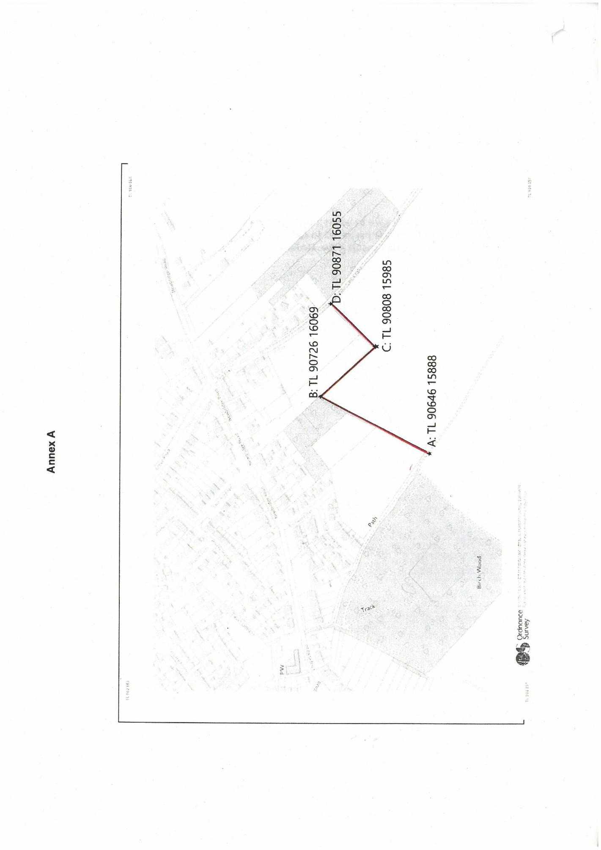

Mr Simon Frater
Wilkin & Sons Limited
See Appendices 3a-3c to the Council’s Report
Fairey v Southampton County Council (QBD)[1956] 1 All ER 419, (CA) [1956] 2 QB 439 & R (oao) Godmanchester Town Council and Drain v SSEFRA and Cambridgeshire County Council [2005] EWCA Civ 1597, [2006] 2 All ER 960, [2006] 2 P & CR 1) [2007] UKHL 28, [2007] 3 WLR 85, [2007] 4 All ER 273
Appendix 18 to the Council’s Report
Appendix 19
Penelope North
Husband of Penelope

