Appeal Decision
by A Spencer-Peet BSc(Hons) PGDip.LP Solicitor (Non Practicing)
an Inspector appointed by the Secretary of State for Environment, Food and Rural Affairs
Decision date: 24 June 2022

Order Ref: FPS/X2600/14A/5
- The appeal is made under Section 53(5) and paragraph 4(1) of Schedule 14 of the Wildlife and Countryside Act 1981 (the 1981 Act) against the decision of Norfolk County Council (the Council) not to make an Order under section 53(2) of that Act.
- The Application dated 11 February 2019 was refused by the Council on 26 March 2021.
- The Appellant claims that the definitive map and statement (the DMS) for the area should be modified by adding a Restricted Byway from Neatishead Restricted
Byway No.9 to the western termination of the Neatishead Footpath No.6.
Summary of Decision: The appeal is dismissed.

Preliminary Matters
- I have been directed by the Secretary of State for Environment, Food and Rural Affairs to determine an appeal under Section 53(5) and Paragraph 4(1) of Schedule 14 of the 1981 Act.
- I am satisfied I can make my decision without the need to visit the site. The appeal has been determined on the basis of the papers submitted.
- The application is made by Mr I Witham in respect of the route (the Application Route) from Neatishead Restricted Byway No.9 (RB9) to the western termination of the Neatishead Footpath No.6 (FP6). A copy of a map showing the Application Route is attached for reference.
- The Appellant has submitted evidence which, it is maintained, supports the existence of full vehicular rights over the Application Route in the past. However, it is not disputed that the Natural Environment and Rural Communities Act 2006 has extinguished unrecorded public right of way for mechanically propelled vehicles. A restricted byway is defined to include the rights of a bridleway as well as the right to use non-mechanically propelled vehicles.

The Main Issue
- For an addition to be made to the DMS, section 53(3)(c)(i) provides that a modification order shall be made where evidence is discovered which (when considered with other relevant evidence available) shows that a right of way which is not shown in the map and statement subsists or is reasonably alleged to subsist over land in the area to which the map relates.
- As set out in the case of R v Secretary of State ex parte Norton and Bagshaw, an Order to add a route should be made if either of two tests is met:

A: Does a right of way subsist on the balance of probabilities?

B: Is it reasonable to allege that a right of way subsists? For this possibility to exist, it will be necessary to show that a reasonable person, having considered all the relevant evidence available, could reasonably allege that a right of way subsists.
- The appeal relies on documentary evidence. Section 32 of the Highways
Act 1980 requires a court or tribunal to take into consideration any map, plan or history of the locality, or other relevant document, which is tendered in evidence, giving it such weight as is appropriate, before determining whether or not a way has been dedicated as a highway.
- The main issue in this appeal is whether on the balance of probabilities a restricted byway subsists along the Application Route or is reasonably alleged to subsist.

Reasons
- As noted above, this appeal relies on documentary evidence alone. I shall consider the main elements of each of the types of documentary evidence, in turn below.

Early Maps
- I have been provided with copies of Faden’s Map of Norfolk (1797) and the Inclosure Award and Map for Neatishead (1813 and 1811 respectively). Whilst it appears that both of these maps include the route now known as RB9, neither of these maps shows the Application Route.

Bryant’s Map 1826
- This map shows a route, which appears to be on a similar alignment to the Application Route, connecting what is now known as RB9 to a very small cluster of buildings. This route is depicted as “Lanes and Bridle Ways” on the key which accompanies that map.
- The Council have put it to me that no weight can be attributed to this map, maintaining that there are other routes shown on the map in a similar fashion and which are not considered to be public highways today. Whilst the examples given by the Council are acknowledged, and that there may not currently be any other supporting evidence to show those provided examples of nearby routes have public rights, that is not to say that those routes did not carry such rights when the map was produced.
- There was a market for selling these maps to the public. Whilst not as accurate as Ordnance Survey Maps, the submitted Bryant’s Map does indicate the existence of a route and provides some, albeit very limited, support for the Application Route being a public right of way.

Tithe Map and Apportionment
- The Appellant has provided a diocesan copy of the Tithe Map and Apportionment for Neatishead as well as the Tithe Map and Apportionment for Neatishead as held at the National Archives. The parties agree that the map that is held at the National Archives is identified as being a first class map, with the Commissioners’ seal affixed, meaning that it is reliable as a true record for the purposes for which the map was drawn.
- On the maps provided, the track which currently comprises RB9 and which connects with the western end of the Application Route, has been given the apportionment number 484. Apportionment number 484 is listed as being “Carngate Common Lane”. On the copy of the map held at National Archives, both that track, and the Application Route are uncoloured. However, on the map held by the Norfolk Records Office, both the connecting track and a majority of the length of the Application Route are coloured in light yellow.
- The Appellant maintains, by reason of the continuation of colouring shown on the second map and lack of any separate apportionment number, that this is evidence that the Application Route was a public vehicular highway at the time the map was drawn up. Nonetheless, it is also noted that both copies of the Tithe Map include a solid line feature which crosses the Application Route close to the junction with RB9, and which the Council has put to me, demonstrates that the Application Route is separate from apportionment number 484.
- Further to the above, the Council has also put it to me that the area measurement for apportionment number 484 “Carngate Common Lane” is given as being “1 rood and 38 perches”, which when converted to square metres would be significantly less than the area that would be covered if the Application Route was included within apportionment number 484.
- Tithe maps were prepared to indicate productive land rather than to indicate rights of way. Whilst the maps provided appear to confirm that a route existed on the ground at the time, in light of the above identified differences in colouration and in respect of the submissions regarding the area measurements included within the apportionment number 484, and given the purpose of producing such maps, the submitted Tithe Maps and Apportionments provide no evidence of the status of the Application Route.

Ordnance Survey (OS) Maps
- The Appellant has provided copies of OS maps from circa 1838 and from the first edition 1882. On both of these maps, the entire Application Route is shown. However, the earlier map shows the Application Route as being continuous with the track which is currently known as RB9, with the later 1882 map showing the Application Route as a separate enclosed lane with a different land parcel number. I have not been provided with any key to these maps.
- From the Council’s research, further OS maps from 1905, 1951 and 1971 show the Application Route. Whilst these maps are consistent in that regard, they differ in that the 1905 and 1971 maps show the Application Route separated from what has become RB9, by a dashed line. The 1951 OS map does not include that separation and shows the Application Route as a continuation of what is now known as RB9.
- OS maps provide good evidence of features that were present on the ground at the time, but do not indicate the status of the routes shown. Whilst I agree with the Council’s assessment that these maps are not determinative of the status of the Application Route, they suggest the physical existence of a long standing route in this area.

Bartholomew’s Map
- The Bartholomew’s Map of 1903 like the Bryant’s Map above, was produced for use by the public and shows the Application Route as being part of a continuous, uncoloured, road running between what is now known as RB9 and Neatishead Restricted Byway No.4 (RB4). The continuous road between RB9 and RB4 is described within the key as “inferior and not recommended to cyclists”.
- It is noted that the details provided on the submitted copy of Bartholomew’s map differs significantly from those provided on the OS maps described above, where the track east of the abovementioned cluster of buildings is depicted as being a footpath, rather than being part of a continuous road between RB9 and RB4. This brings into some doubt as to the accuracy of the Bartholomew’s map in describing the status of the Application Route.
- Bartholomew’s maps (1901 and 1911 editions) were considered in Commission for New Towns v J J Gallagher Ltd. The Court observed that the implication of an uncoloured inferior road on these maps would be that they are public carriageways. However, the Court also noted the disclaimer, which the parties to this appeal also agree apply to the submitted copy of the map, and which provides that “the representation of a road or footpath is no evidence of the existence of a right of way”. The Court concluded that the disclaimer underlines the fact that one cannot place much weight on Bartholomew’s maps, or indeed any map which does not have the positive function of identifying public carriageways.
- In light of the above and given the inconsistency between the submitted map and the OS maps produced before and after that Bartholomew’s map, whilst the details provided on the 1903 map should not be disregarded entirely, I treat the information that it provides with some caution.

Finance Act
- The Application Route is uncoloured on the map produced in respect of the 1910 Finance Act and is shown as being separate from the surrounding hereditaments. The Appellant has put it to me that as no valuation of this parcel was taken, it is a strong suggestion that the Application Route is a vehicular highway. However, the Council contends that the route appears to be an occupation road providing access to the surrounding hereditaments, that such occupation roads were exempt from duty under the 1910 Finance Act and, consequently, that route was left uncoloured on the map. In that regard, the absence of an outright owner or occupier of such roads might provide an explanation as to why the Application Route was not included within any of the surrounding hereditaments, with a blurring of the distinction between public roads and private occupation roads potentially having occurred over time.
- I note that the Finance Act’s primary purpose was not the identification of highways and there may be other reasons for the exclusion of the route, such as that put forward by the Council as described above, where there is some credible evidence that the Application Route was an occupation road. Consequently, the exclusion of the Application Route from the surrounding hereditaments means that this document provides little, if any, support for the Application Route being a public vehicular route.

Ministry of Food National Farm Survey
- The submitted survey map shows the Application Route being excluded from the surrounding agricultural holdings. The Appellant maintains that that exclusion is supporting evidence of the Application Route being a vehicular route. However, the primary purpose of the survey was not to record public rights of way and, consequently, the weight to be given to this evidence is very limited.

The DMS
- The Definitive Map shows FP6 connects with RB4 and that FP6 comes to an end at the Application Route, west of the cluster of buildings described above. The Definitive Statement for FP6 records the path as starting from RB4 running westwards towards the cottages, which I have described above as the small cluster of buildings. Whilst the Application Route is shown on the Definitive Map, no public rights of way are recorded over the Application Route.
- It is maintained by the Appellant that the Definitive Statement, which states FP6 ends at the cottages, cannot be relied upon as there are other examples within the area where similar descriptions have been used and which end on highways rather than at identified buildings. The Appellant also contends that the Application Route was not added to the DMS at the same time as FP6 by reason of the higher status that existed for the Application Route.
- The Council has put it to me that at the time the DMS was compiled, FP6 was considered to be a public right of way of a status lower than that of a vehicular highway. This would appear consistent with other information supplied in support of this appeal, where a variety of documents, as described above, indicate a route along the alignment of FP6 as being a footpath. The Council therefore maintains that the Application Route would have been unlikely to have public vehicular rights given that it would be connected to a lower status route, FP6, creating a dead end or cul-de-sac for public vehicular rights.
- In that regard, the Council and the Appellant have referred me to the similarities in how a further footpath, Neatishead Footpath No.7 (FP7), located to the south of FP6, was recorded on the DMS.
- Both FP6 and FP7 are recorded on the DMS as starting at RB4 and which runs westwards to cottages, with no public rights of way continuing westward of those cottages. Where these routes differ is that FP7 was not shown on the Tithe map, discussed above, but appears to have been included within a land holding of the surrounding property as shown on the Finance Act 1910 map and on the Ministry of Food National Farm Survey. As such, there does not appear to be any evidence of FP7 connecting with RB9 and this supports the contention that the Application Route did not necessarily connect FP6 with RB9.

Other Matters
- Objections have been raised by the owners of the land over which the Application Route runs. The matters raised by the landowners include the effect of the Application Route being made as a Restricted Byway on their, and their neighbours, living conditions with regards to privacy and security. Whilst I have carefully considered the landowners’ submissions, those matters fall outside the criteria set out in the relevant legislation with regards to the potential addition of a right of way to the DMS.

Conclusion
- Having assessed the submitted evidence in its entirety and in the round, I conclude that the evidence falls short of the standard of proof required to show that, on a balance of probability, a Restricted Byway subsists along the Application Route. Furthermore, and for the reasons given above, I conclude that there is insufficient evidence for the purposes of Test B, outlined above, that it could reasonably be alleged that the Application Route was used by the public for highway purposes.
- Accordingly, having regard to the submitted documentary evidence, and all other matters raised within the submitted written representations, I conclude that the appeal should be dismissed.

Mr A Spencer-Peet

INSPECTOR

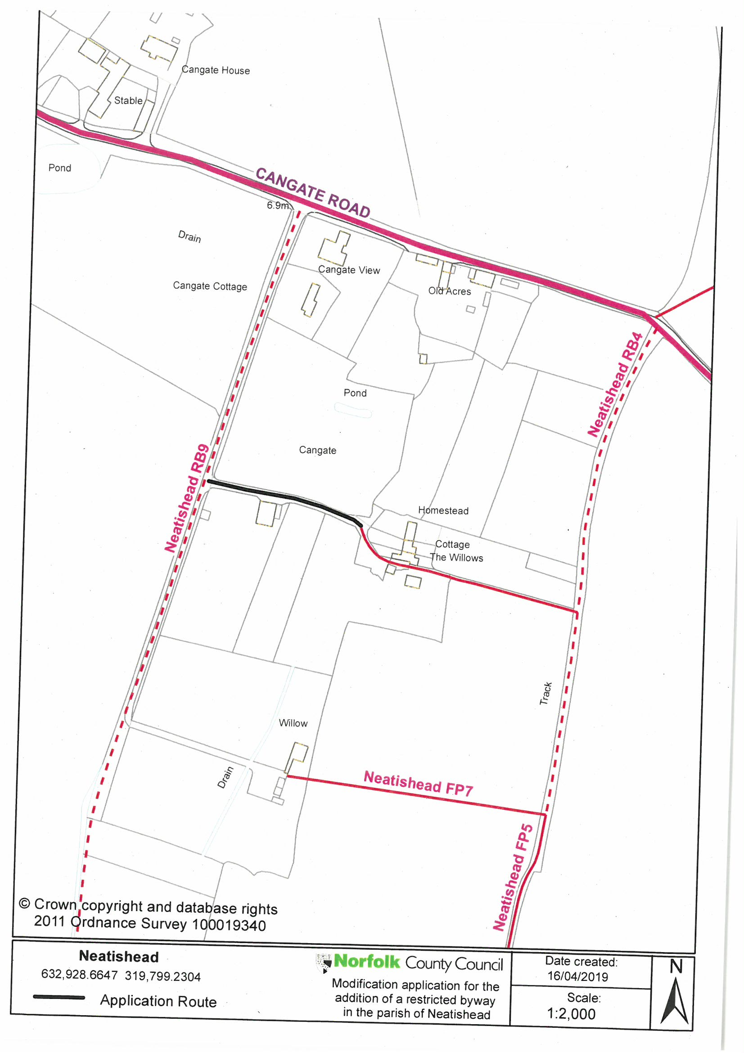

R v Secretary of State ex parte Norton and Bagshaw [1994] 68 P & CR 402
[2002] EWCH 2668 (Ch)

